
Problem Solving and Decision Making
BMSW4004
Submitted by: Dapaah Kwame Williams
Student No: 1916221
Submitted to: Balendran Kandasamy

Table of Content
1. Introduction 3
2. Definition 3
3. Importance of Decision Making 3 - 4
4. Workplace Problem 4
5. Religious Discrimination 4
I, Employment Decision Base on the Religion 4
II, Harassment 5
III, Reasonable Accommodation 5
6. Analysing Information 5
7. Fishbone Diagram 6 -7
8. Pestel Analysis 7- 8
9. Implementation of the Plan and Solution 8
10. Communication Plan to Stakeholders 8 - 9
11. Conclusion 9
12. Reference 10
13. Appendix 1 11 - 12
14. Appendix 2 13 - 16

Introduction
FITT GH is a consultant company that provides aid to organizations, employees, or individuals from various sects in all activities which involve legal issues and helping them to overcome problems by giving support in finding solutions. Where there are no unions, we give support in decision making.
In this report we will be looking for information which will lead to solve the problem of discrimination against religious people in Geo Fire Ltd which was doing well in the past but now experiencing a huge diminishing return. Directions will be given to assist the discriminated worker to decide.
Definition
Problem solving is the procedures used to understand what is happening in our organization or environment, find things which must be changed and then consider the things that need to be done to produce the desired outcome. It is connecting the gap between the way things are and the way they should be. Making decision is part of problem solving. (J. Hicks,1991)
Decision making is the act of making a choice out of the available alternatives. To solve problem in management decision making is one of the important functions needed mostly when there are two or more alternatives. Hence it is a problem-solving method of selecting a specific way of action among several alternatives to solve problems. (Morgan, 2016)
The main difference is problem solving is a process, whilst decision making is an action built on understandings derived throughout the problem-solving process. It is likely that one can choose out of numerous alternatives and decide what to do jet the problem will be there. On the contrary you can find the possible prime cause of a problem and still lack the decision-making skills to act for a successful result.
Importance of Decision Making
It is the backbone for the business management for without taking the correct decision at the right time nothing can be done. It helps to achieve organizational goals within budgeted period and employees are motivated as their expectation are met on time. Moreover, selecting the best alternative from the numerous alternatives by analysing the problem systematically using several technics makes decision making very important. “Important decisions shape our lives.” (Andrew Maund, 2017)
Workplace Problem
A survey was conducted through questionnaire given to several employees, and the report we received shows that there was a continuous discrimination against religious employees. They were derived from two main sources. The first was between the employees who teased their co-workers for wearing religious ornaments, mocking them for their faith and were not ready to team up with them. The second source was from the leadership. The way promotion was given was not fair, unfair division of work, providing facilities and equipment for work were not evenly distributed. Religious rights were denied to the extent that even a request for a reasonable accommodation were not accepted. Some have received undue treatment by standing against victimisation. The people have suffered both physical and verbal abuse due to their belief.
To understand the nature of religious discrimination one cannot do better than to take as the Equality Act 2010 of the European Union. It confirms the resolution of European Union which approves respect for human rights and freedoms for all without difference of race, sex, or beliefs. Article 18 of this declaration confirms that “Everyone has the right to freedom of thought, and faith. This right includes freedom to change religion and to manifest belief in teaching including practice , worship and observance” (Union, 2010)
Religious Discrimination in the Workplace
It is employment-related action which influence employees in divers’ ways. Religious discrimination cannot be overlooked when it comes to employment decision based on beliefs, harassment and denied of reasonable accommodation.
I. Employment decision based on the religion
Religious discrimination can reach till the point where it can affect people’s work life. In fact, there were some employees who were neither hire nor get the promotion they deserve due to their beliefs. Another factor within this category was employers deny the workers’ pay raise because of their beliefs. Some employees were permitted to do over-time all because they were not part of the religious group.
II. Harassment
In this group we find all those acts which tend to make fun of the religious deeds that a religious person must stick to. A straightforward example is when anyone at the work may make fun of the faith of another employee. In the canteen the Christians were tease for praying over their food before they eat. When they use religious adornment like a turban, they were mocked for their faith. Making fun of them in this manner is a form of harassment.
III. Reasonable Accommodation
The other discrimination occurs when the employer refused to consider rules or policies that allow a worker to do his or her religious practice without differing the orders of work. These policies that help religious people to be religious are known to be “reasonable accommodation”. (Union, 2010). For instance, the employer refused to switch the shift of an employee with another worker that did not mind taking that shift. Another fact was people were not allowed to put on the notice board religious invitations and adverts meanwhile others could put their private invitation cards, family pictures or club activities. People were compelled not to use necklets which had a cross with a symbol of Jesus Christ meanwhile, the use of football and other fun club caps and T-shirts breach no rule. Similar issues like these were going on in this organization.
Analysing Information
We would analyse the problem by using the fishbone analysis or cause- and- effect diagram which is called Ishikawa diagram as shown below. It was invented in 1960s by a statistician in quality control from Japan called Dr. Kaoru Ishikawa. It is known as fishbone for its resemblance to a fish skeleton. (Ryan Watkins, 2012)

Fishbone diagram

People: -No teamwork -absentees, industrial relations
Unity
Policies : no induction, communication

Discrimination

Place- closed to church centre
Procedure -Poor flexible working system, communication

The main problem is discrimination as stated before. The contributing factors are policies, people, procedure, and place
Policies: There are no proper policies for training. Training is by on the job base. This give chances to people of know-how to lord their skills over other. A proper induction for new employees necessary. Improper communication system between employees and the management.
People: There is poor industrial relations. The people have no unity to bring them together to work as teamwork. It is sometimes even dangerous to work in environment where understanding each other is a problem. The employees feel reluctant to go to work which creates much absenteeism. The people have different opinions and perceptions for each other. As a result of discrimination most of the religious employees were isolated and sometimes perform their duties with fear and panic.
Procedure: The shift placement is programmed on who you know bases. It does not help the employee to know where and when to work. The organization do not have flexible working system. Quality circle is necessary. The organisation should form small groups of workers who will be in charge in quality circle and must meet from time to time to discuss, analyse propose solutions to the ongoing problems.
Place: The location of this organization is very close to church premises, so the employees find it difficult hide their beliefs. There may be some situations which shall require Equal Employment Opportunity Commission (EEOC) comes in to deal with undue hardship to avoid any problems that may go against the efficiency of the company, the safety of the employers or anyone that goes against the law.

PESTLE Analysis:
PESTLE is an acronym for Political, Economic, Social, Technology, Legal, and Environment.
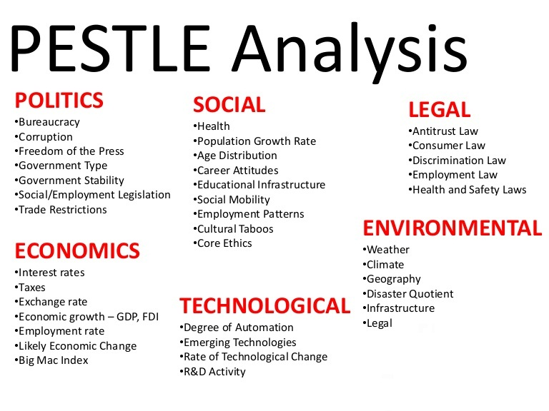
(Perera, 2017)
The PESTEL Analysis comes with factors for valuation of macro-environment through which business works.
Legal: In this organization there have been some legal disorder. They have breached some employment and discrimination laws. Some of the employees work to get endorsement and not as teamwork. This organization is not a charity or faith school which can exclude people of other religions.(EHRC, 2016). The Equal Employment Opportunity Commission (EEOC) define unfair hardship as something very expensive to administer, influences efficiency or safety, trespass employees' rights, or puts extra load on other employees who must shoulder the work.
Political: I see internal political games here. Due to that there is favouritism even in the distribution of the work.
Economic: Employees depend on their wages to decide economically so if they are denied from doing overtime, they receive nothing more than their normal pay. There is going to be economic hardship if they are paid less than they should. I recommend that the HR find a standard way to avoid favouritism in the overtime by drawing a program to meet all needs.
Social: There is no teamwork. There is division among the workers which may lead poor performance and low output.
Implementation of the Plan and Solution
I think it would be better to have people of religious background in the decision-making board. The point is we have non-religious people deciding what happens to religious people. Their frame of reference is not wide enough. We need people of religious background in the decision -making board. The HR working on these issues must remain neutral.
The employer has caused an undue hardship against some of the employees for not accepting the holy day off and even went to the extent of giving a 7-day suspension. Employer must give the accommodation unless they can show that it would be too expensive on the business. On the contrary, the employees could file a grievance through the trade union or contact the Citizen Advice Office.
Communication Plan to Stakeholders
The main stakeholders are the employers, supervisors, and the employees. I suggest implementation of a flexible working system for all employees. This will solve the problem of overtime and shift related issues. As usual implementation of any possible change will have opposition from those who benefit without the change. Some may stand against due to their parochial self-interest. Whenever change is introduced it is easy for misunderstanding to grow. Peter F. Drucker in 1954 claimed that the key hindrance to organizational growth is managers’ failure to change their attitudes and conduct as soon as they are needed. Even when managers logically know the need for changes in the way they work, they sometimes are single-mindedly incapable to make the change. Training should be enhanced and educating the workers about the outcome of discrimination. This could be one-on-one discussions or presentations to groups. There should be a task force set up to meet urgent situations. The task force must quickly identify key problems and set up cross-functional work groups to solve issues
Moreover, if anybody is being treated unfairly, bullied, or discriminated a quick action is necessary. The unsatisfied should do all the best to tell the person to stop. If this fails, the supervisor must be informed. Where it becomes necessary for the employee to proceed to inform the HM or trade union nothing prevent that. When all the above did not work then you may decide to raise a grievance and make a claim to employment tribunal. In case you may need advice contact Citizen advice office.

Conclusion
This report has considered the importance of problem solving and able to identify the problem of the organization as discrimination against religious employees the workplace. The problem was analysis by using fishbone and the PESTLE analysis. How to meet the challenge and alternative solution \as well as the pro and cons were well communicated to the stakeholders.

References
Andrew Maund, M. S. P. K., 2017. Certificate in Higher Education: Skills for the Workplace Student Yearbook. s.l.:SAGE.
Drucker, P. F., 1954. The Practice of Management, s.l.: s.n.
EHRC, 2016. WWW.equalityhumanrights.com. [Online]
Available at: www.equalityhumanrights.com
[Accessed 11 December 2020].
J.Hicks, M., 1991. Problem Solving in Business and Management. In: Problem Solving in Business Managment. s.l.:Chapman& Hall, pp. 1-5.
Morgan, P., 2016. The Business Student's Guide To Study And Employability. s.l.:SAGE.
Perera, R., 2017. The PESTLE Analysis. s.l.:s.n.
Ryan Watkins, M. W. M. Y. V., 2012. A guide to assessing needs. In: Essential tools for collecting information, making decision and achieving development results. s.l.:s.n., pp. 197-200.
Union, E., 2010. The Equality and Human Rights-EHRC, s.l.: s.n.

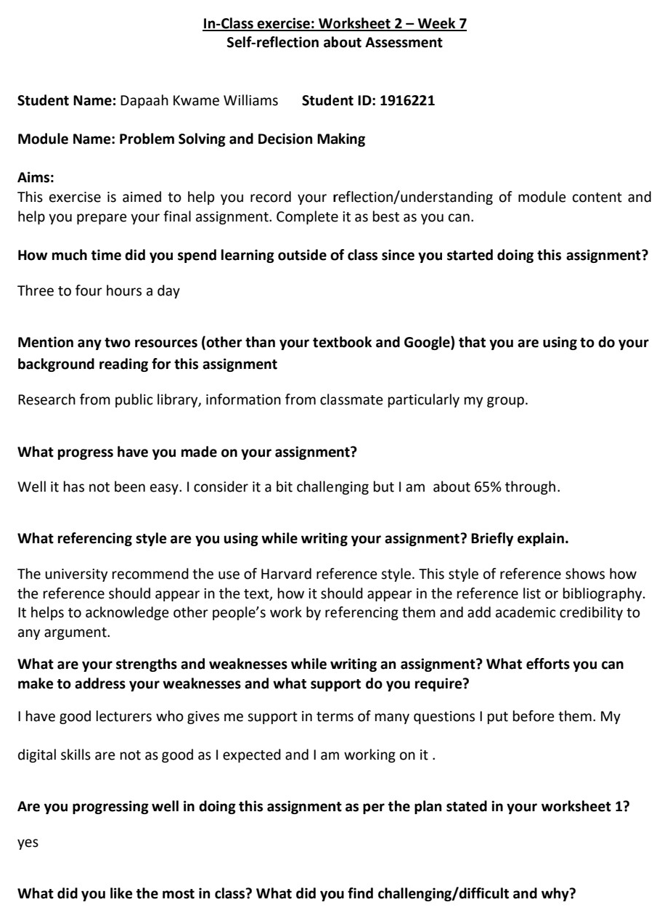
Appendix 1

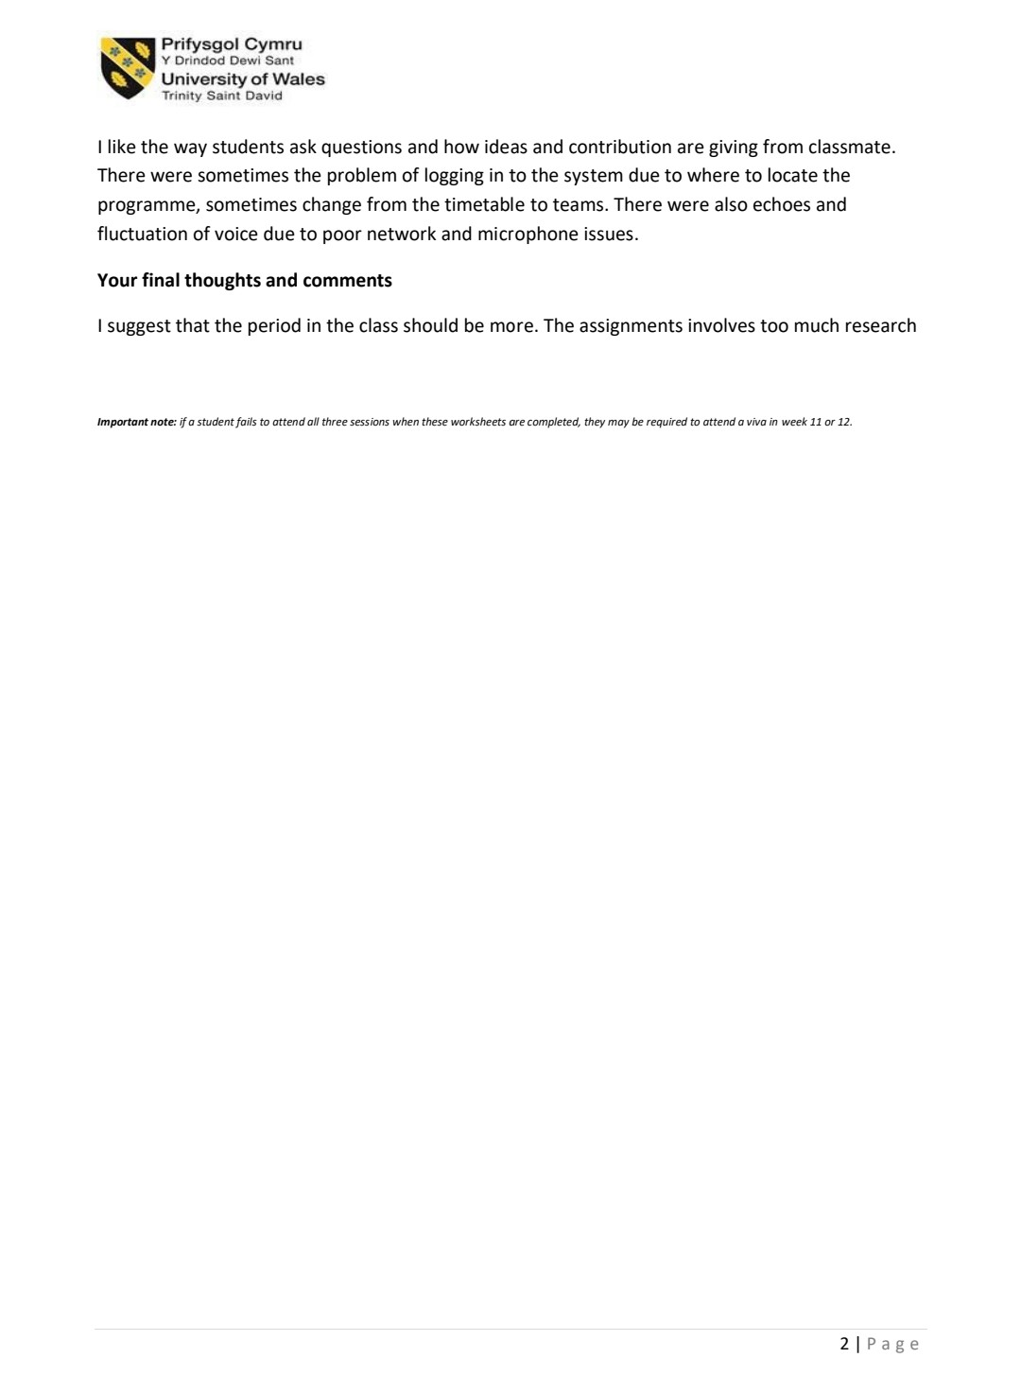

Appendix 2 

