Scarab bearing the cartouche of Thutmose III
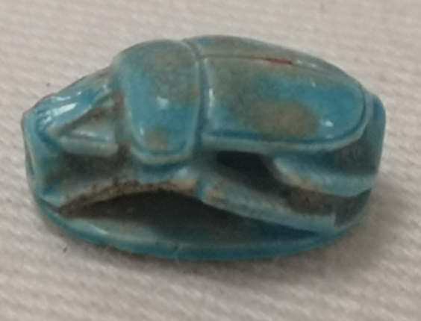
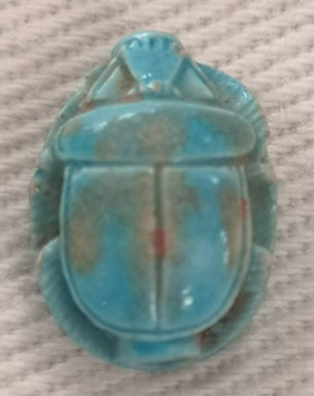
Figure 1: Aerial View of Scarab (S Daniel, 2023)
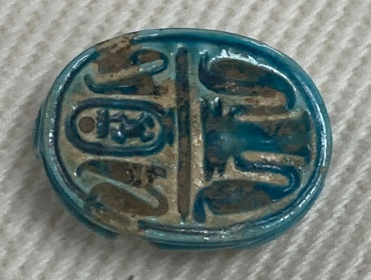

Figure 3: Side view of Scarab (S Daniel, 2023)
Figure 2: Underside of Scarab, with inscription (S Daniel, 2023)

Cyfarthfa Castle, Merthyr Tydfil – CCM 1725.004
Object type: Scarab
Object Material: Faience
Period: Pharaonic, 18th Dynasty or later
Provenance: Likely Egypt, or a place with close ties to Egypt
Dimensions: Length: 1.2cm, Width: 0.9cm, Height: 0.5cm
Inscription: Cartouche that reads “Menkheperre”. Also inscribed are the symbols for cobras, feathers, and the djed pillar.
Object analysis by Sarah Ffion Daniel

Object CCM 1725.004 is an incredibly small, stylised scarab. The measurements are- length: 1.2cm, width: 0.9cm, height: 0.5cm, and it is shaped into the traditional rounded, oval scarab beetle shape. The head of the scarab is marked with an incised line to separate it from the prothorax. Tiny markings on either side of the elytra, directly below the prothorax, likely represent the beetles humeral callosity. The prothorax of the beetle is rounded and extends slightly beyond the head and elytra it sits between. A suture runs down the centre of the back, from the prothorax to the end of the scarab, separating the elytra in two. This line is not as deep as most of the others incised into the scarab and up close looks like it was potentially carved after the glaze was applied, unlike the rest of the scarab. The scarab beetle stands on a base of the same shape and size as the scarab. The sides of the scarab are partially carved out, with spaces between each leg, giving the impression that the beetle is standing on the base. Impressively, there are no obvious joins between the scarab and its base, suggesting it was all carved out in one piece rather than created in separate parts and attached together. A hole is carved through the middle of the scarab, from the head to the bottom of the beetle, potentially allowing the scarab to be threaded, bead-like, onto a piece of jewellery. The small size of the scarab suggests that perhaps it was worn as part of a ring, or it could have been on a necklace, maybe along with several other amulets.
The underside of the scarab is flat and has several hieroglyphs engraved on it. In the top half there is a cartouche of Thutmose III in the centre. From top to bottom the cartouche has a sun-disc (re), a board game (mn), and a beetle (hpr). This spells out Menkheperre, the throne name of Thutmose III. Directly to the left of the cartouche is the feather of Ma’at and to the left of that, a cobra. This design is mirrored on the right side of the cartouche. Underneath this is a line that runs across the base, separating it into two halves. In the centre of the bottom half is a djed pillar hieroglyph. On either side of the djed pillar is a cobra. These hieroglyphs do not spell out a phrase, rather they symbolise strength and power. The djed pillar, is representative of the spine of Osiris, this hieroglyph was used to mean ‘stability’.
The scarab is made of faience, a composite consisting mostly of quartz, that is moulded and then glazed and fired. It is a bright turquoise-blue colour, a common glaze colour for faience, made with copper. Given the intricacy of the scarab and the gaps spaces going through it, it seems likely that this scarab was made by hand rather than with a mould. The glaze is worn in places, primarily around the hieroglyphs and the back suture of the beetle, revealing the sandy brown colour underneath. Also visible are small amounts of red colouration on the suture, this is likely dirt that has gotten stuck there, potentially when the glaze was applied. The scarab has some slight damage done to the top right cobra on the underside, making the head of the cobra unclear. The front left leg is also chipped.
Scarabs are the one of the most common artefacts found from Ancient Egypt, which speaks to their popularity and cultural importance. They were used in many different ways in life, such as being worn as jewellery and used as seals, and were a religious and magical symbol. However, they were also heavily connected to the funerary sphere and were placed within the layers of bandages on a mummy. Scarabs worn by people in life were also likely buried with them. Scarabs were linked with the god Khepri, who was portrayed as either a scarab beetle or a man with a scarab beetle as a head. Khepri was one of the four aspects of Ra, and was associated with the youthful aspects of the god and the rising of the morning sun. The connection with this and scarab beetles was a result of the way the beetles rolled balls of dung across the sand. The movement of these balls was associated with the movement of the sun across the sky and they became a symbol of rebirth due to the female beetles laying their eggs in these dung balls, as the larvae would later emerge from them seemingly spontaneously and this was seen as a miraculous rebirth, just like Khepri being reborn each morning with the sun rising.
A scarab granted the wearer protection, whether in life or the afterlife. Khepri and scarabs also became associated with resurrection in the afterlife because of their continual rebirth, this promise of life after death firmly cemented their place in funerary culture and their abundance on the deceased. This particular scarab also has the djed pillar inscribed into it. This purpose of this addition could potentially have been to strengthen the protection already offered by the scarab.
Issues arise with the dating of this object. The earliest possible period the scarab could be dated to is the 18th Dynasty due to the cartouche of Thutmose III, however it is possible that it dates to a later period as scarabs with this particular cartouche were still made for some time after the reign of Thutmose III. Despite this difficulty in placing the object, there are scarabs that bear remarkable similarity to this one even down to the way the legs are made, raised with hollows around them, dated to the 18th Dynasty. This could suggest that the scarab was made during or shortly after Thutmose III’s rule.

Bibliography

Adderley, Nicola, ‘Scarabs Appeals for Protection and Resurrection’, 2012
Daniel, Sarah, Aerial View of Scarab, 2023
———, Side View of Scarab, 2023
———, Underside of Scarab, 2023
‘Djed-Pillars’, JHU Archaeological Museum <https://archaeologicalmuseum.jhu.edu/staff-projects/ancient-egyptian-amulets/djed-pillars/> [accessed 27 February 2023]
Manley, Bill, Egyptian Hieroglyphs for Complete Beginners (Thames and Hudson, 2012)
Pinch, Geraldine, Egyptian Mythology. A Guide to the Gods, Goddesses, and Traditions of Ancient Egypt. (New York: Oxford University Press, 2002)
Riccardelli, Carolyn, ‘Egyptian Faience: Technology and Production | Essay | The Metropolitan Museum of Art | Heilbrunn Timeline of Art History’, The Met’s Heilbrunn Timeline of Art History <https://www.metmuseum.org/toah/hd/egfc/hd_egfc.htm> [accessed 3 March 2023]
‘Scarab Inscribed “Hatshepsut, United with Amun” | New Kingdom’, The Metropolitan Museum of Art <https://www.metmuseum.org/art/collection/search/545160> [accessed 3 March 2023]
‘Scarab Inscribed with the Name Menkheperra (Thutmose III) | New Kingdom’, The Metropolitan Museum of Art <https://www.metmuseum.org/art/collection/search/560695> [accessed 26 February 2023]
Tite, M. S., P. Manti, and A. J. Shortland, ‘A Technological Study of Ancient Faience from Egypt’, Journal of Archaeological Science, 34.10 (2007), 1568–83
Wilkinson, Richard H, Egyptian Scarabs (London: Shire Publications, 2008)

Bill Manley, Egyptian Hieroglyphs for Complete Beginners (Thames and Hudson, 2012), pg.149-153.
‘Scarab Inscribed with the Name Menkheperra (Thutmose III) | New Kingdom’, The Metropolitan Museum of Art <https://www.metmuseum.org/art/collection/search/560695> [accessed 26 February 2023].
‘Djed-Pillars’, JHU Archaeological Museum <https://archaeologicalmuseum.jhu.edu/staff-projects/ancient-egyptian-amulets/djed-pillars/> [accessed 27 February 2023].
M. S. Tite, P. Manti, and A. J. Shortland, ‘A Technological Study of Ancient Faience from Egypt’, Journal of Archaeological Science, 34.10 (2007), pg.1568–83; Carolyn Riccardelli, ‘Egyptian Faience: Technology and Production | Essay | The Metropolitan Museum of Art | Heilbrunn Timeline of Art History’, The Met’s Heilbrunn Timeline of Art History <https://www.metmuseum.org/toah/hd/egfc/hd_egfc.htm> [accessed 3 March 2023].
Tite, Manti, and Shortland; Riccardelli.
Richard H Wilkinson, Egyptian Scarabs (London: Shire Publications, 2008), pg.7.
Wilkinson, pg.7-16.
Wilkinson, pg.12-16.
Nicola Adderley, ‘Scarabs Appeals for Protection and Resurrection’, 2012.
Geraldine Pinch, Egyptian Mythology. A Guide to the Gods, Goddesses, and Traditions of Ancient Egypt. (New York: Oxford University Press, 2002), pg.152-153.
Pinch, pg.152-153.
Wilkinson, pg.10-14.
Adderley.
Wilkinson, pg.10-14.
‘Scarab Inscribed “Hatshepsut, United with Amun” | New Kingdom’, The Metropolitan Museum of Art <https://www.metmuseum.org/art/collection/search/545160> [accessed 3 March 2023].

