University of Wales Trinity Saint David
Wales Institute of Science & Art

Torsion of Shafts
Mechanics and Dynamics (ACHA4026)

Ollie Gooch
2501626
03/01/25

Contents
1 Introduction 4
2 Experiment Procedure 5
2.1 Apparatus Setup 5
2.2 Zeroing the Rotating Chuck 6
2.3 Conduction of Experiment 8
3 Results 11
4 Analysis 12
4.1 Brass Data 13
4.2 Aluminium Data 14
4.3 Steel Data 15
5 Conclusion 16
5.1 Calculated Values of G 16
5.2 Comparison Against Known Values 16
6 Evaluation 17
7 Further Work 18
8 References 19

Introduction
This report aims to determine the modulus of rigidity for several materials and compare the results with established reference values. It reviews the procedure and raw data from a previously conducted experiment, using the recorded variables to calculate key values, plot a graph, and obtain the modulus of rigidity for each material. Following the comparison with known values, the report concludes with an evaluation of the experiment and recommendations for improving its accuracy and reducing any errors.
The worksheet used during the experiment was created by (TecQuipment, 2012) and handed out by the university.

Experiment Procedure
The experiment involves twisting 3 rods made from the different metals (brass, aluminium, and steel) with a known amount of force. The angle of twist is then measured along with the length and diameter of each of the rods.

Apparatus Setup
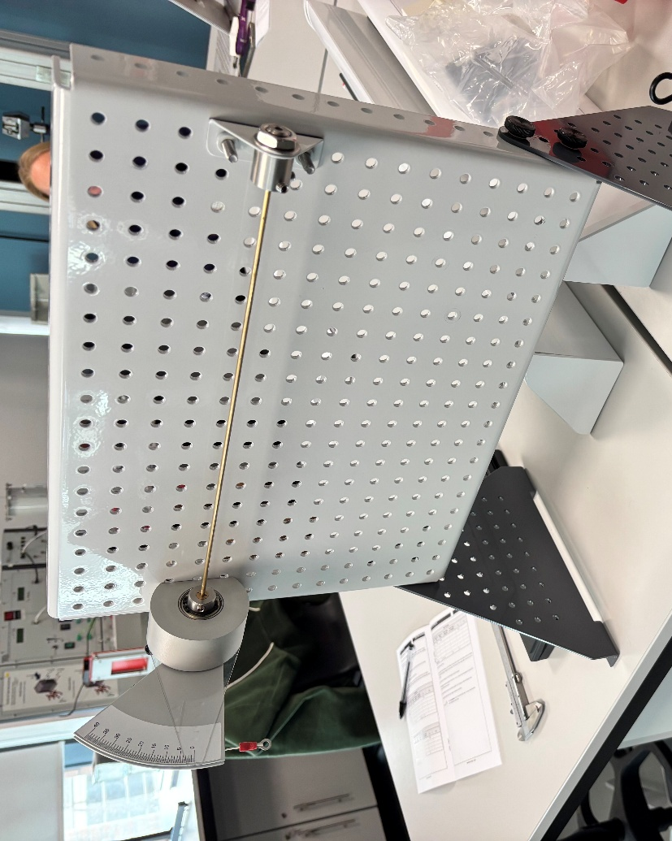
The rod must be fixed at one end and, at the other, remain fixed but be able to rotate. For this, a fixed chuck and a rotating chuck was used where each rod could be inserted into. A torque arm was attached to the rotating chuck so that weights on a string were attached to the apparatus and could twist the rod a measurable amount using the scale on the torque arm. A transparent cursor was also fixed in place so the change in angle of the torque arm was able to be measured.

Figure 2.1

Once the rod was in, the grubscrews on both chucks were tightened to ensure the rod is secure.

Zeroing the Rotating Chuck
To get an accurate reading for the angle of twist. The centre line of the torque arm must line up with the zero on the scale behind it. The first step was, after the rod had been inserted, to loosen the grubscrews at the rotating chuck. This allowed the torque arm to move freely without twisting the rod. This meant the torque arm scale could be lined up with the transparent cursor.
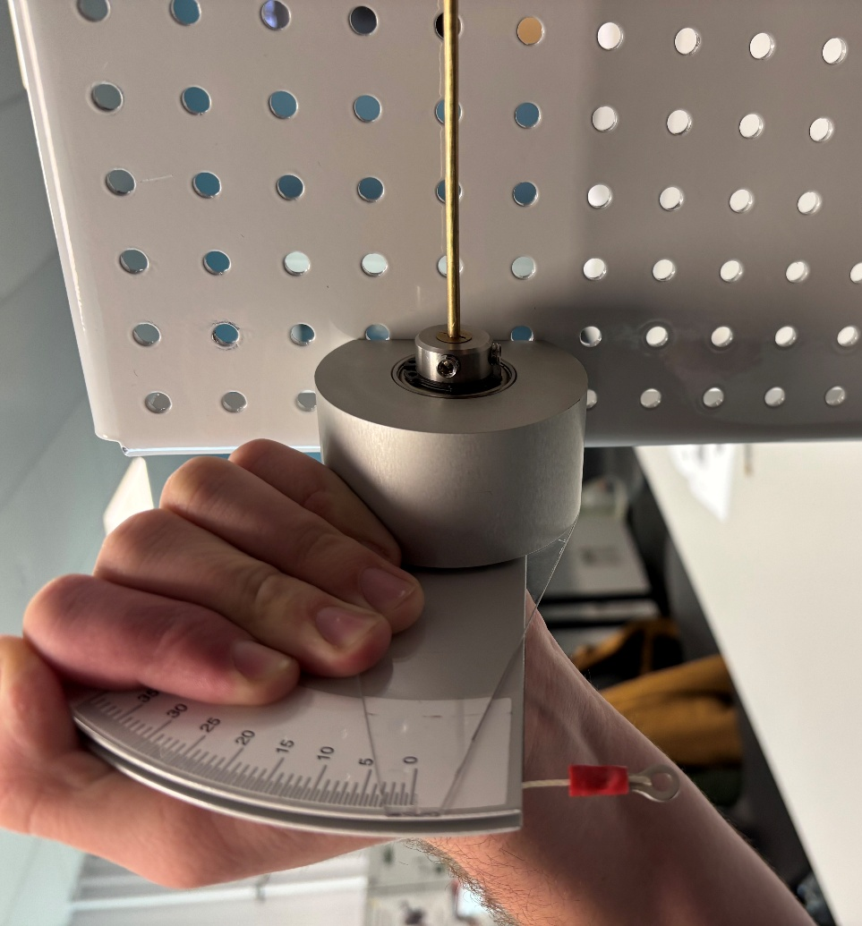
Figure 2.2

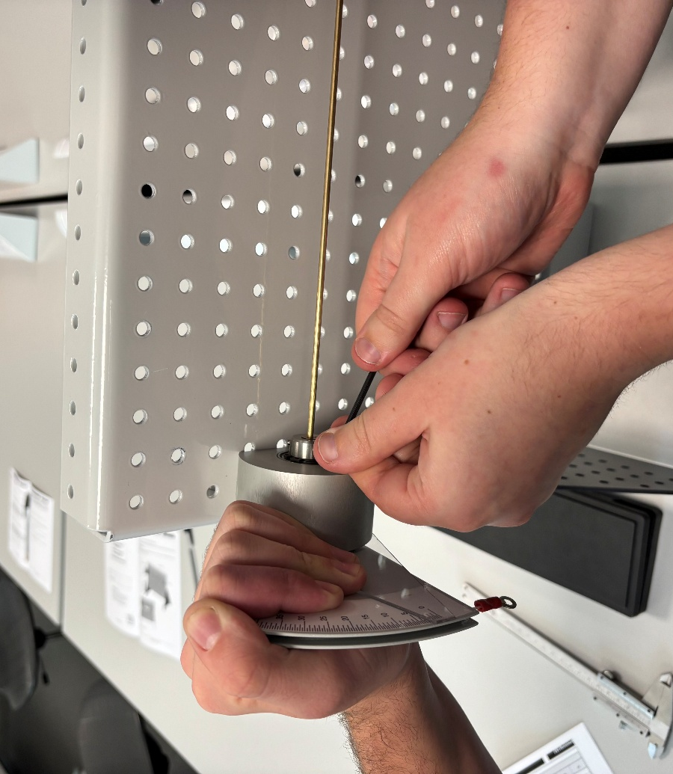
Then, while keeping the torque arm in place, the grubscrews of the rotating chuck were tightened.
Figure 2.3

After the grubscrews were tightened, the apparatus was successfully zeroed and the experiment could begin.

Conduction of Experiment
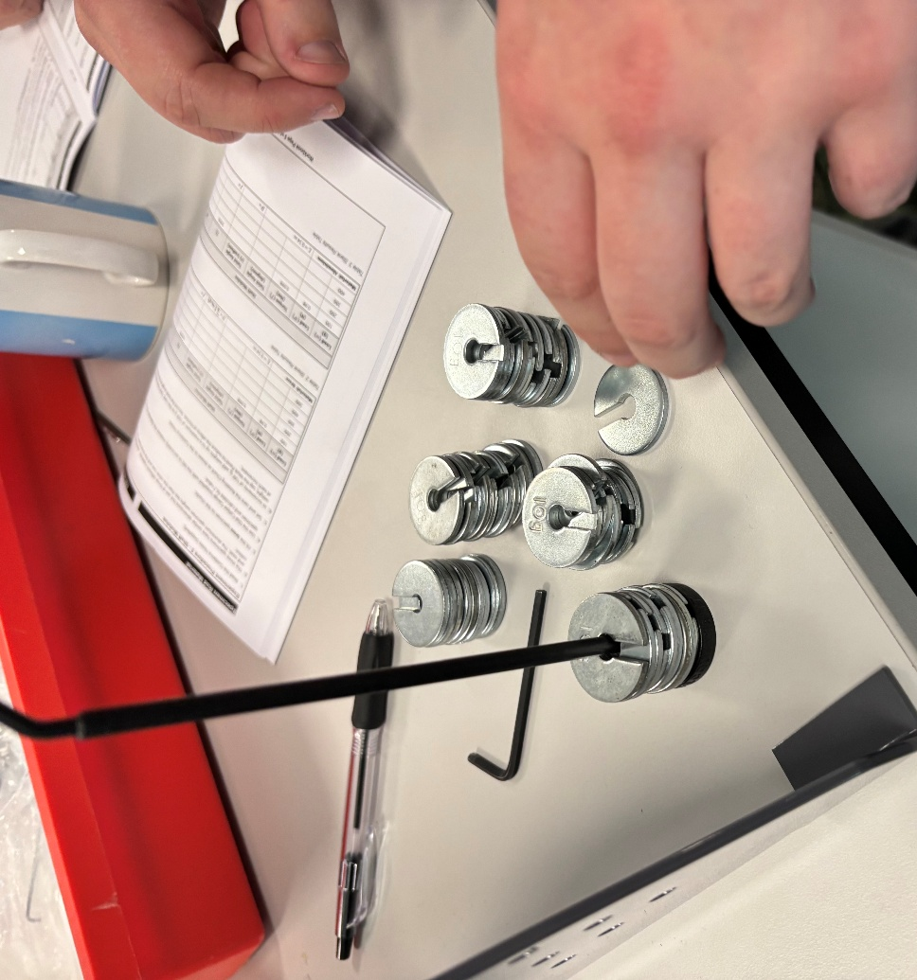
After the first rod (brass) has been inserted, the weights were set up. The weight added to the torque arm increases in increments of 100g (also starting at 100g). This consists of 9 10g plates and a 10g hooked holder for the weights to be slotted in as shown below:
Figure 2.4

This was hooked onto the string attached to the torque arm. Since the torque arm is fixed to the rotating chuck which the rod was also fixed to, the weight twisted the rod. This moved the scale on the torque arm but, since the cursor was fixed in place, it displayed the change in angle of twist:

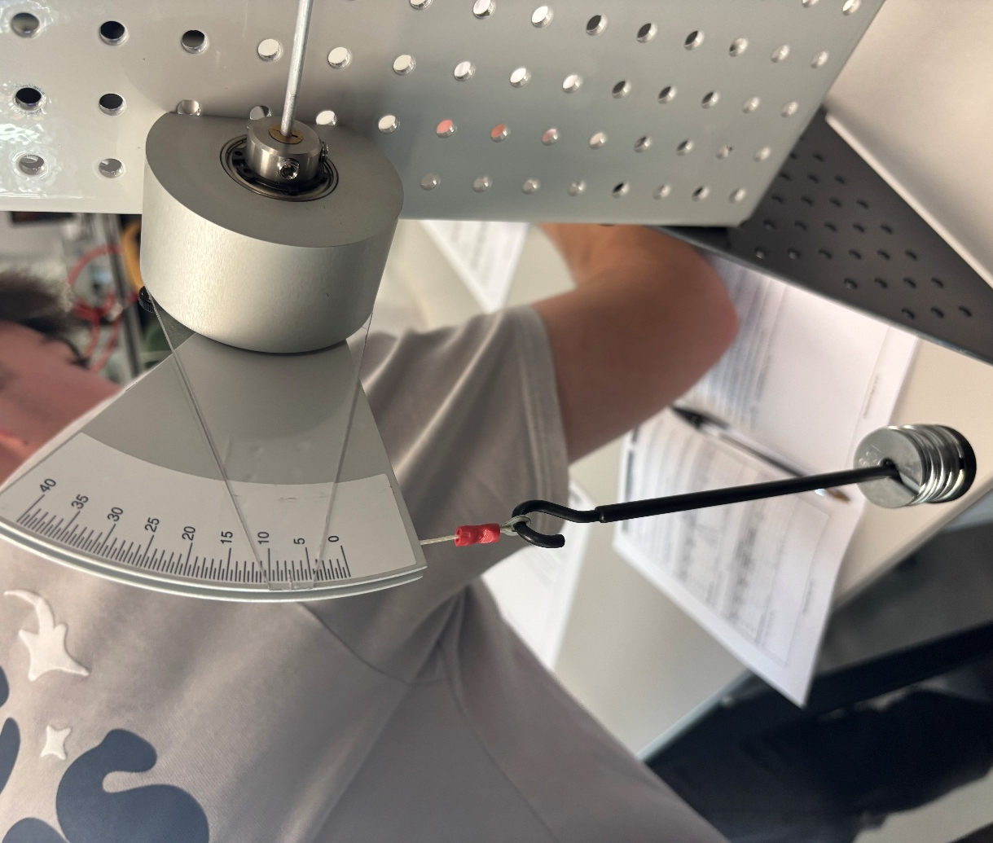
Figure 2.5

After the change in angle had been recorded, the weight was removed from the torque arm and 10 more 10g weights are added to the holder which was subsequently hooked back onto the torque arm and the change in angle was again recorded.
This process was repeated up until 500g was reached, at which point the angle of twist was far greater than when 100g was applied:

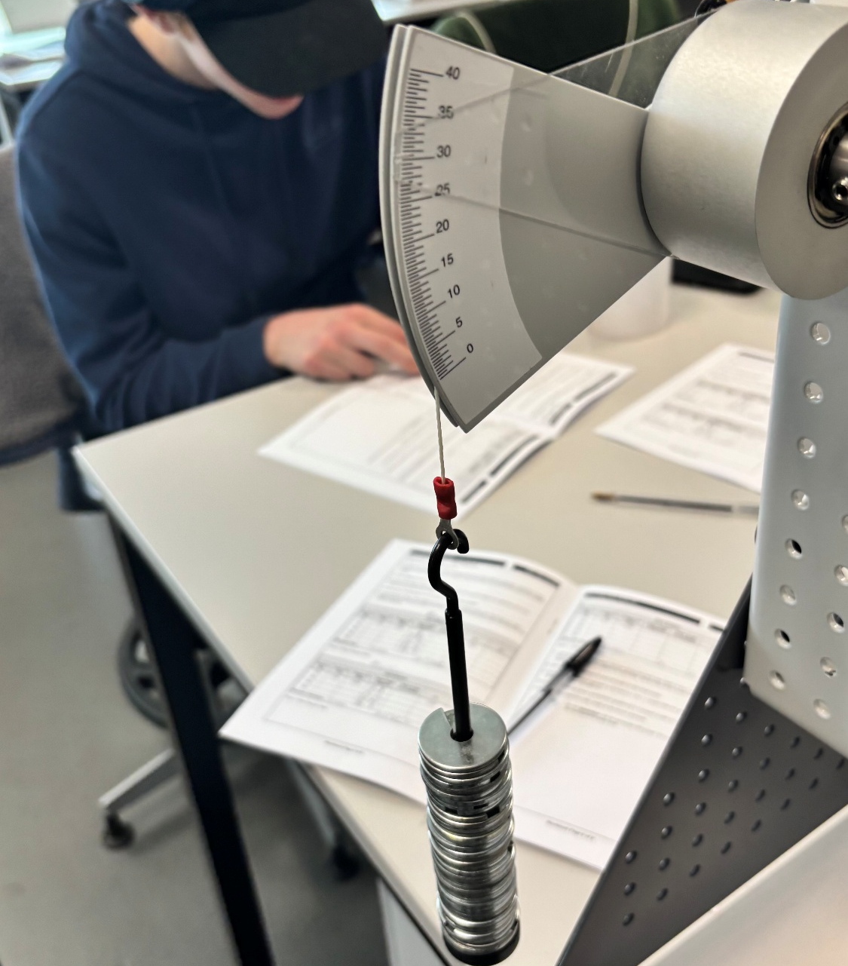
After reaching 500g, the weights were unhooked and the brass rod was removed. The entire process was repeated for both the aluminium rod and the steel rod (only going up to 400g as any more weight and the aluminium would be pushed past its elastic limit). Each time a new rod was installed, the apparatus must be zeroed in the same way.
Figure 2.6
In addition to recording the weight added and the angle of twist, the length and diameter of the rod as well as the length of the torque arm was recorded to aid in calculations.

Results
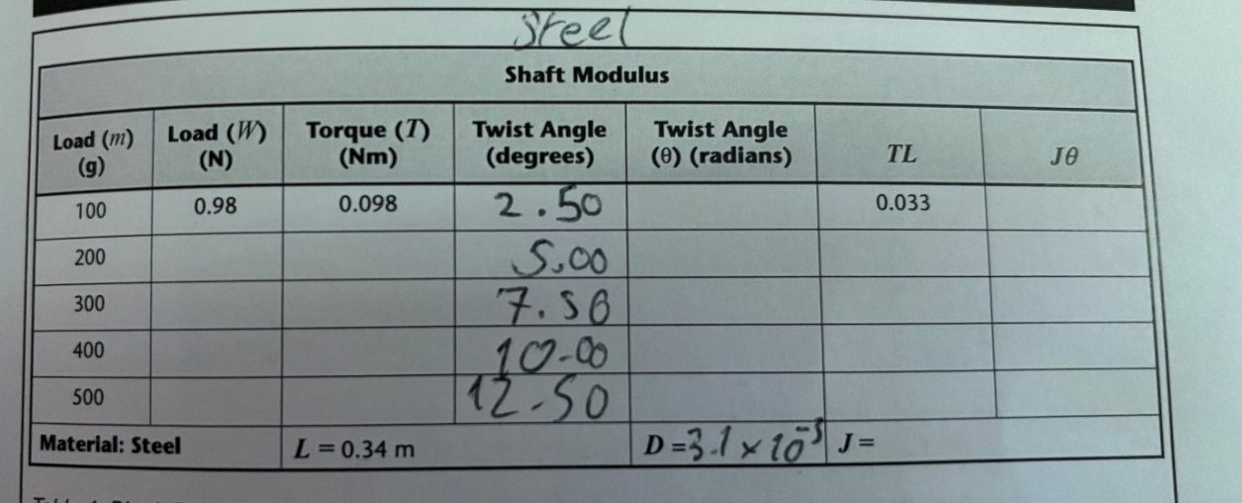
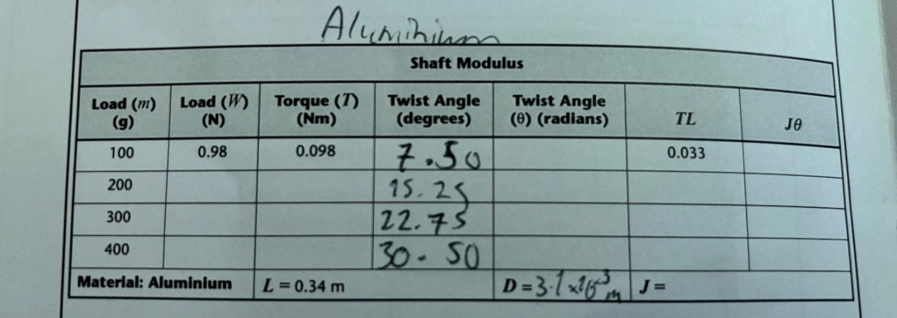
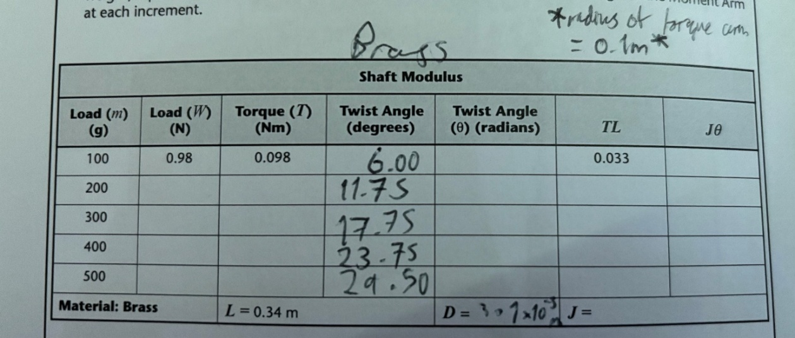
The following images show all the measurements recorded while undertaking the experiment:
Figure 3.3
Figure 3.2
Figure 3.1
Recordings written in logbook provided by (TecQuipment, 2012).

Analysis
The end value needed was the modulus of rigidity which can be calculated using the equation:
$$\frac{T}{J}=\frac{Gϑ}{l}$$
Where T = Torque
J = Polar Second Moment of Area
G = Modulus of rigidity
ϑ = Angle in Radians
l = Length of rod
To find G, the equation can be put into the $y=mx+c$ format with G as the gradient (m). This gives the final equation of:
$$Tl=GJϑ$$
This means that, if a graph of Tl against Jϑ is plotted, the gradient of the line of the trendline is G.
To plot the graph, the on-paper data were first converted into a spreadsheet on excel, this way calculations could be done much quicker.
Load was converted from grams into newtons by multiplying the mass in kg with gravity and the angle of twist in degrees was converted into radians using the RADIANS function in excel.
The torque was calculated by multiplying the force by the length torque arm and the value for J was calculated using the equation $J=\frac{πD^2}{32}$ where D is the diameter of the rod.
Using these values, the table of values was complete, and a graph could be created using the last two values of Tl and Jϑ.

Brass Data
Load (m) (g) | Load (W) (N) | Torque (T) (Nm) | Twist Angle (Degrees) | Twist Angle (ϑ) (Radians) | TL | Jϑ
100 | 0.981 | 0.0981 | 6.00 | 0.1047 | 0.0334 | 9.4946E-13
200 | 1.962 | 0.1962 | 11.75 | 0.2051 | 0.0667 | 1.8594E-12
300 | 2.943 | 0.2943 | 17.75 | 0.3098 | 0.1001 | 2.8088E-12
400 | 3.924 | 0.3924 | 23.75 | 0.4145 | 0.1334 | 3.7583E-12
500 | 4.905 | 0.4905 | 29.50 | 0.5149 | 0.1668 | 4.6682E-12
L (m) | 0.34
D (m) | 0.0031
J (m^4) | 9.0666E-12
Radius of Torque arm (m) | 0.1
Figure 4.1

Aluminium Data
Load (m) (g) | Load (W) N) | Torque (T) (Nm) | Twist Angle (Degrees) | Twist Angle (ϑ) (Radians) | TL | Jϑ
100 | 0.981 | 0.0981 | 7.50 | 0.1309 | 0.0334 | 1.1868E-12
200 | 1.962 | 0.1962 | 15.25 | 0.2662 | 0.0667 | 2.4132E-12
300 | 2.943 | 0.2943 | 22.75 | 0.3971 | 0.1001 | 3.6E-12
400 | 3.924 | 0.3924 | 30.50 | 0.5323 | 0.1334 | 4.8264E-12
L (m) | 0.34
D (m) | 0.0031
J (m^4) | 9.0666E-12
Radius of Torque arm (m) | 0.1

Figure 4.2

Steel Data
Load (m) (g) | Load (W) N) | Torque (T) (Nm) | Twist Angle (Degrees) | Twist Angle (ϑ) (Radians) | TL | Jϑ
100 | 0.981 | 0.0981 | 2.50 | 0.0436 | 0.0334 | 3.9561E-13
200 | 1.962 | 0.1962 | 5.00 | 0.0873 | 0.0667 | 7.9121E-13
300 | 2.943 | 0.2943 | 7.50 | 0.1309 | 0.1001 | 1.1868E-12
400 | 3.924 | 0.3924 | 10.00 | 0.1745 | 0.1334 | 1.5824E-12
500 | 4.905 | 0.4905 | 12.50 | 0.2182 | 0.1668 | 1.978E-12
L (m) | 0.34
D (m) | 0.0031
J (m^4) | 9.0666E-12
Radius of Torque arm (m) | 0.1

Figure 4.3

Conclusion

Calculated Values of G
The 3 values of modulus of rigidity calculated from each graph were as follows (rounded to 2SF):
Brass: $G=36 GPa$
Aluminium: $G=28 GPa$
Steel: $G=84 GPa$
*Pa is equivalent to Nm^-2*
This is at least somewhat accurate seeing as brass and aluminium are both quite soft compared to steel but to determine the accuracy of the measurements taken, they must be compared with known values of G.

Comparison Against Known Values
A list of known values from (Engineering Toolbox, 2005) can be used to compare calculated values with. The known values are as follows:
Brass: $G=40 GPa$
Aluminium: $G=27 GPa$
Steel: $G=78 GPa$
If the calculated values are within 10% of the known values, they are considered accurate. The tolerance for each of the materials are as follows
Brass: $36 GPa-44 GPa$
Aluminium: $24.3 GPa-29.7 GPa$
Steel: $70.2 GPa-85.8 GPa$
All the calculated values are within their respective tolerance which means the measurements were accurate, this would have been due to how the errors have been minimised.

Evaluation
To maintain the accuracy in the experiment, errors had to be minimised where possible. This was done in different ways:
One type of error that could occur is a parallax error when reading the scale. This is because there is a gap between the transparent cursor marking the change in angle and the actual scale on the torque arm. This means that if it were looked at from above eye level, the cursor would appear lower on the scale than it is, giving an inaccurate reading. To eliminate the parallax error, the measurements were read at eye level to the cursor.
Another chance for error to arise is when measuring the diameter of the rods. This is because the thickness may change along the length of the rod. This means that if it was measured at only one point, it might not accurately represent the diameter of the of the rod, leading to inaccurate results. This would be amplified since diameter is to the power of 4 in the calculation for polar second moment of area (J) meaning any uncertainty would be quadrupled. To try and eliminate this error, the rod was measured at multiple points along its length and an average was taken. This gives a much more accurate value for the diameter of the rod.

Further Work
As much as error was reduced, there were still inaccuracies in the final values for G meaning that there were still errors arising from the procedure. Given unlimited time and resources, there are a few changes that could be made to eliminate as much error as possible.
The first change that could be made is to replace the transparent cursor and scale with something more accurate and less susceptible to parallax error. It could be replaced with a digital angle measuring device which would be more precise and have no chance of the user misreading it like what could happen with the cursor and scale.
Another change which would take more time would be to take more measurements for the diameter of the rod. Only a few measurements were taken for an average diameter in the procedure, if more time was available then many more measurements could be taken and possibly a more accurate value for the diameter could be attained.
One large change that could be made is to increase the scale of the entire experiment. This would mean increasing the length and diameter of the rod and therefore the torque arm, weights applied, and the chucks holding the rod. The absolute inaccuracies in the measurements would remain the same but would be less significant due to the large values of the measurements. This would result in a much more accurate value of G for each rod.

References
TecQuipment, 2012, Specimen Rod Material, Torsion of Circular Sections Kit ES5, University of Wales Trinity Saint David
Engineering Toolbox, 2005, Modulus of Rigidity, https://www.engineeringtoolbox.com/modulus-rigidity-d_946.html?utm_source=copilot.com (Accessed 02/01/2025)

