

LEVEL 5

SEMESTER 1

MODULE CODE: SHSS5093

MoDule Title: Biomechanics of sport and Exercise
aSSESSMENT TYPE: Experimental Research
Assessment/Component: 2

COMPONENT WEIGHTING: 50 %

WORD COUNT: 2000

MODULE TUTOR: David Gardner

SUBMISSION DETAILS: 17th January 2020 by 3.00 pm through Turnitin

Kinematic Analysis

Conduct a biomechanical analysis of a sporting action or piece of equipment of your choice in order to evaluate performance and provide advice or recommendations sufficient to enhance performance or play characteristics.

Produce a 2000 words article (Journal of Sport science format) describing data collected and justifying your recommendations.

Tasks

Using biomechanical techniques to evaluate the performance characteristics of a performer or piece of equipment.

Develop advice or recommendations based on evidence / information collected that will enhance performance or play characteristics.

Produce a 2000 journal article (in the format of the Journal of Sport Sciences) describing your data and presenting your findings;

Abstract

Introduction

Method

Results

Discussion

Conclusions

References

Assessment Criteria

Further details relating to the specific requirements of levels grading and format for the article will be provided during lectures and tutorials.

School of Sport, Health & Outdoor Education

Assessment Feedback Sheet

Student No./Name:

Module Code: SHSS5093
Module: Biomechanics of sport and Exercise

Personal Evaluation – to support your academic progress please complete the section below BEFORE submitting your work.
What do you consider to be the best aspects of this work?
Which aspects do you consider could have been improved in this piece of work?
What have you found most satisfying whilst undertaking this submission?
ASSESSMENT CRITERIA | Learning  Outcomes |  | GRADE
ASSESSMENT CRITERIA |  |  | Poor  < 25% | Fail  26-39% | Satisfactory  40 – 49%  3rd Class |  | Good  50 – 59%  (2:2) | Very Good  60 – 69%  (2:1) | Excellent  70 – 84%  (1st) |  | Exceptional  85– 100% | %
Abstract | 1,2 |  |  |  |  |  |  |  |  |  |  | 5
Introduction | 1,2 |  |  |  |  |  |  |  |  |  |  | 15
Method | 1,2 |  |  |  |  |  |  |  |  |  |  | 15
Results | 1,2 |  |  |  |  |  |  |  |  |  |  | 30
Discussion | 1,2 |  |  |  |  |  |  |  |  |  |  | 25
Conclusion | 1,2 |  |  |  |  |  |  |  |  |  |  | 5
References | 1,2 |  |  |  |  |  |  |  |  |  |  | 5
It is expected that students will present work that is proof read, correctly referenced and adheres to the Assessment Checklist. Therefore a range of 0 – 10 marks will be deducted for non-completion of any of the points on the checklist below.
TUTOR COMMENTS:
Submission date:  via Turnitin |  | Return date:  (at least within 4 weeks) |  |  |  | Tutor: |  |  |  | Mark:
Kinematic analysis on the Impact forces in jump landing in obese people.

Abstract
It has been reported that impact forces would increase for people who are overweight and potentially could lead to knee injuries such as cruciate ligament rupture or anterior cruciate ligament (ACL) injury. (Walsh, 2012) To analyse the relationship between increased bodyweight and impact forces, 4 drop tests will be conducted. The tests will determine if there is any sort of relationship between gradually increasing bodyweight and impact forces. When the tests are completed there will be advice and recommendations which may be helpful for someone who is overweight to on how to avoid certain injuries in the knee and ankle joint.
Introduction
In a study conducted by Reijman et al (2006) reported findings showed that there was an association between increased body mass index and greater risk of both incident knee osteoarthritis and knee osteoarthritis progression. This study showed that as body mass index increases that there are increased risks to the knee which could also suggest that there could be an increased chance of injury occurring. The knee can withstand large mechanical loads during weight-bearing activities. However, unlike the hip joint which provides a great stability and places fewer demands than the knee joint does on the ligaments, muscles and capsules. (Sharma 2007) This suggests that the knee joint is not one of the strongest joints in the body and needs to be taken care of and to not put too much stain on it because of the consequences which may come from it. With increased bodyweight this may again increase the chance of an injury in the knee happening either in sport or just from carrying out an exercise in the gym. The capsule, ligaments, menisci and muscles at the knee are often required to counteract large external loads acting on the joint which could be either from a person carrying his own bodyweight to exercising with weights. If there was a dysfunction to any of the structures in the knee joint due to injury or osteoarthritis this could change the knee joint mechanics and can increase the stress put on the articular cartilage. (Schlenk, 2011) People who suffer with damage to the cartilage in the knee joint can experience inflammation, where the area around the knee will swell up, become warmer and feel painful and stiff and when landing from a certain height this may influence the symptoms and worsen them. If an overweight person was to suffer with this, it could be difficult to complete daily activities such as getting out of bed and moving up and down stairs.
In a study which was conducted by Mansuripur et al (2014) it was found out that with the increase of obesity in the United States, more orthopaedic surgeons have been treating more obesity related fractures in the ankle. Also, the obese ankle receives greater pressure from the overall bodyweight, and this can be a problem from increasing any chance of injury in the ankle joint. Apart from fracturing the ankle, obese people can also be vulnerable to injuries in the ankle such as, achilles tendon rapture and a sprain. The rupture of the achilles tendon can happen due to multiple reasons but mostly when suddenly tripping and the foot thrusts in front to break the fall or when someone falls from a significant height. (Miller, 2017) If an obese person fell and used his foot to break the fall or land from a significant height there would a higher chance of the achilles tendon rupturing because the impact force has increased meaning there is more pressure put on to the ankle joint.
The aim of the study is analysing the impact force in jump landing in obese people and see whether there is an increased force from people who carry more weight. Also, to advise the people that weigh more to lose weight due to increased risk of injury in daily activities.

Method
During the test we evaluated one person and measured their height, weight and BMI. The participant’s weight was 84kg, their height was 5’11 and healthy BMI. The test was measured just before the participant was about to conduct the test. After all the calculations were completed, we got a jump box from the gym and measured the height which was 40cm. The distance of 40cm was between the top of the jump box and the top of the force platform that will record the impact force of the jump landing on the participant. We ensured that every drop test that was completed on the programme was at 40cm to ensure that each drop test would have the same test.
Before the participant would conduct the test, he would be aware of what he was doing an shown a demonstration beforehand to lower any chance of injury occurring while conducting the test. To make sure that it was a fair test, markers would be placed on the force platform so that the participant would always jump on the same position. There would be three practice jumps competed by the participant to ensure that he knows what to do, to see if the equipment is working correctly and give the right reading that is needed.
When the participant is ready, we will record the first jump using just the weight of the participant and analyse the data to see if the jump was correct and if not, another jump must be conducted. This will be done for all 4 of the jumps to ensure all data collected will not be incorrect and unusable. Before completing the next jump, a body suit of 4kg will be placed on the participant to examine the changes in impact force when landing. Again, this will be completed with an 8kg body suit and the final one with a 12kg body suit. The participant will be made aware that dropping from that height with 12kg added to him could result in injury in case he wanted to drop out. He continued with the drop which went well, and all results collect was analysed.

Results
During the tests it was possible to see that there was more strain being put on the knee when the bodyweight was increased each time. It was possible that if the weight was to be increased greatly the chance of an injury happening to the participant would be high.
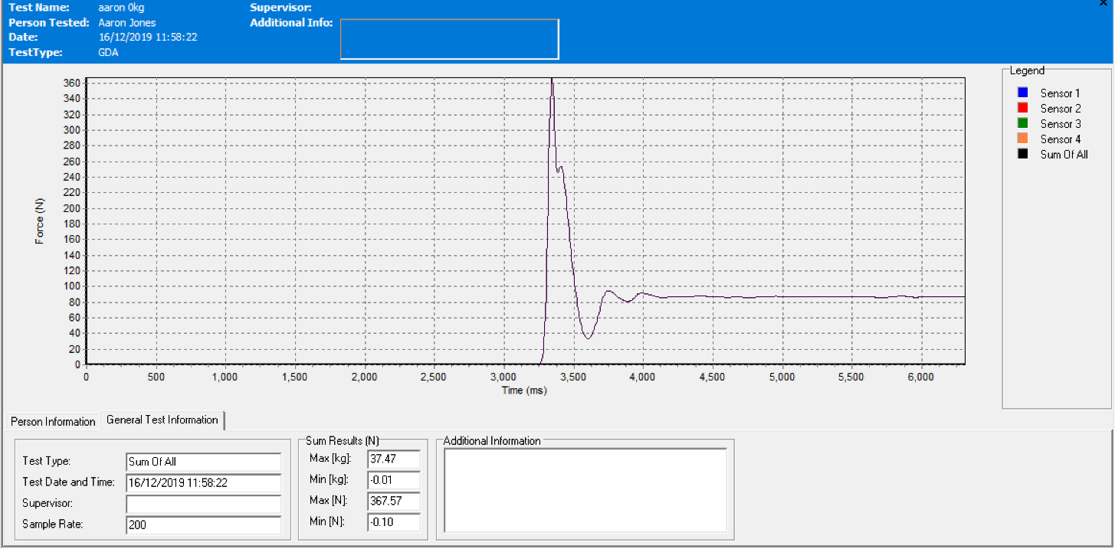

The graph from the first drop test shows that the impact force was 367.54kg from the bodyweight drop of 84kg. The impact force is high this could be due to landing flat footed and not trying to break the fall. From the graph it shows the recovery time of the landing is 0.15 seconds which should be low as the participant is not overweight.

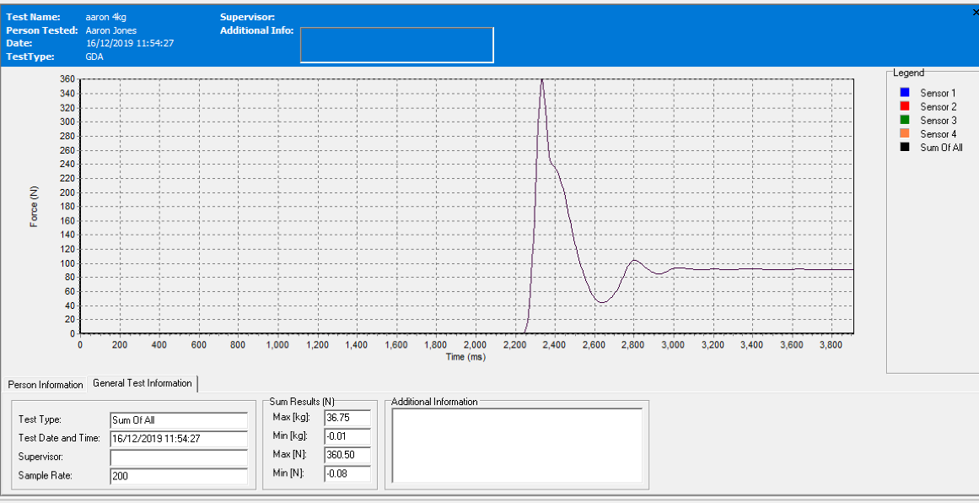

From the graph of the second drop the weight was increased by 4kg but the impact force of the drop was around 7kg less. This could be because there is a longer recovery time for the second drop of 0.2 seconds which could mean he tried to break the fall with the increased weight on him. From this data it shows that the weight does influence how the participant lands.

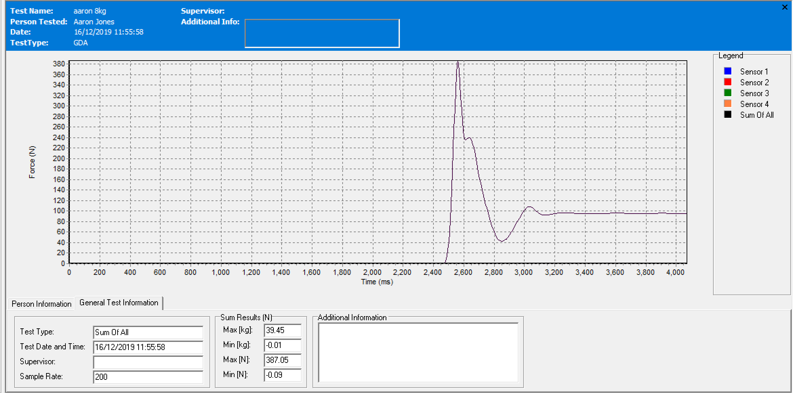
On the third drop the weight is increased to 8kg which influences the impact force greatly by going from 360kg to 387kg. This shows that even by increasing the weight slightly it has a large effect on the impact force. The recovery time of the landing has again increased by around 0.05 seconds which shows that the knee may need to flex more to absorb the impact force.
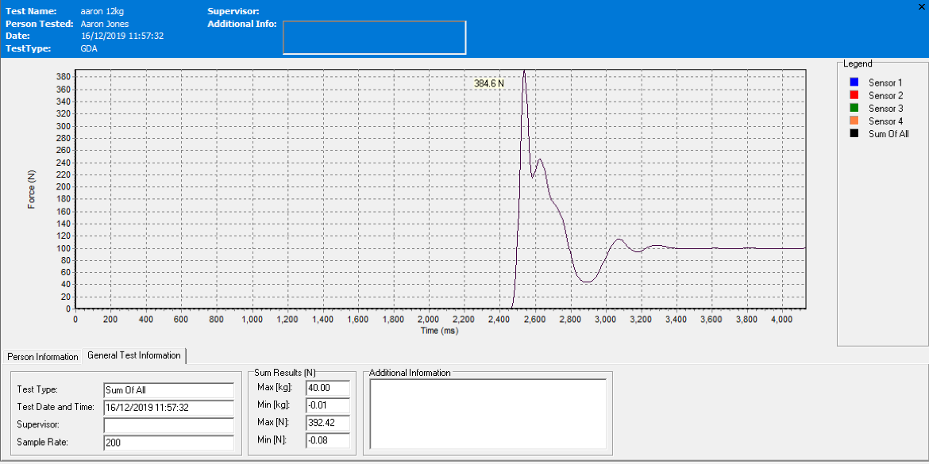
In the final drop test, the impact force yet again has increased by 5 kg showing that bodyweight does affect the impact force of landing. The recovery time of the landing also increased to 0.3 seconds which suggests that the participant may have to bend his legs more than he is used to so that no injury occurs.
From the 4-drop test that were completed it shows that by increasing bodyweight has a great influence on the impact force when landing from a significant height. Also, the knees may take more impact due to the more weight on the participant because of the increase in recovery time when landing on the force platform.
Discussion
While analysing the data it can be said that people who are overweight have more stain put on to their knees and ankles. Following multiple studies there are many recommendations which can be given to people that are overweight to reduce strain and injury in the knee and ankle joints.
A study conducted by Hewitt (2000) to see whether a six-week programme of a jumping and landing technique would help reduce the chance of a knee injury in female athletes. In the programme first two weeks, proper jump technique was demonstrated and drilled. In the middle two weeks the focus was to use the proper technique to build strength, power and ability. In the last two weeks the training focuses on achieving maximum performance where each athlete was encouraged to do as many jumps as possible using the technique before getting tired. The results of the programme helped to reduce significant knee injuries in female athletes per year. This shows that by understanding a correct technique to jump and land can help reduce a chance of a knee injury in obese people if they were to take part in any physical activity or apart of their daily activity.
In another study by Markström (2019) they showed that high level athletes display greater dynamic knee robustness than non-athletes and this may be because the athlete is more active on the knee which keeps it robust. Then Markström goes on to say that athletes direct their attention to improving both dynamic knee robustness and movement strategies during sports task, both in preparation from impact and during landing. This will help decrease the risk of ACL injury during physical activity and competing. There are several different exercises which some is overweight can do to help keep the knee robust such as, wall squats, calf raises and step ups. (Hott, 2019) These are some of the different exercises which can be done to help with the stress on the knee and decrease the chance of an injury.
Another study done by Arend (2017) was looking at how to prevent ankle injuries through weekly monitoring of Ankle Lunge Test. This study was conducted by 7 males completing an ankle stretch every other day for 15 weeks. The results of the study showed that 5 out of the 7 participants suffered an injury in the ankle which happened because of the increase in training load and intensity. From this study any that is overweight should not train the ankle many times in a week as this could considerably increase that chance of an injury.

Conclusion
To conclude this study, it can be said that a person that is overweight suffers greater strain on their knees which can come from landing from a significant height and could lead to an injury whilst being physically active or doing a simple task such as walking up the stairs or getting up off a chair. Following previous studies like Markström he suggests that exercising the knee will help reduce knee strain and decrease the risk of ACL injury. Also, Hewitt’s study where correct jumping and landing techniques can make the knee robust and avoid injuries occurring.
References

Arend, M., et al. (2017) WEEKLY ANKLE LUNGE TEST SCREENING MIGHT HELP PREVENT ANKLE INJURIES. British Journal of Sports Medicine, 51(4), pp.287.2–287.
Hewitt, T. (2000) Sports Medicine: Pre-Season Screening and Training Used to Decrease Knee Injury. Health & Medicine Week, p.23.
Hott, A. et al. 2019) Effectiveness of Isolated Hip Exercise, Knee Exercise, or Free Physical Activity for Patellofemoral Pain: A Randomized Controlled Trial. The American Journal of Sports Medicine, 47(6), pp.1312–1322.
Mansuripur, P.K. et al. (2014) Initial Management of Ankle Fractures in the Overweight and Obese: The Providence Pinch. Journal of Emergency Medicine, 47(5), pp.561–564.
Markström, J. et al. (2019) Dynamic knee control and movement strategies in athletes and non‐athletes in side hops: implications for knee injury. Scandinavian Journal Of Medicine And Science In Sports, 29(8), pp.1181–1189.
Miller, J. (2017) Injuries conditions 1: Achilles Tendon Rupture. Physioworks, available at: https://physioworks.com.au/injuries-conditions-1/achilles-tendon-rupture accessed on [10/01/2020]
Reijman M, et al. (2006) Body mass index associated with onset and progression of osteoarthritis of the knee but not of the hip. The Rotterdam Study. Ann Rheum Dis pp.158 -62.
Schlenk, E. et al. (2011) Improving Physical Activity and Function in Overweight and Obese Older Adults with Osteoarthritis of the Knee: A Feasibility Study. Rehabilitation Nursing, 36(1), pp.32–42.
Sharma, L. & Chang, A. (2007) Overweight: advancing our understanding of its impact on the knee and the hip. Annals of the Rheumatic Diseases, 66(2), pp.141–142.
Walsh, M. et al. (2012) Lower Extremity Muscle Activation and Knee Flexion During a Jump-Landing Task. Journal of Athletic Training, 47(4), pp.406–13.

