

International Business Concepts
Student Name | Kharul Alam Riad
ID | 2438577
Program | Master of Business Administration
Module Code | LCMB7034
Module | International Business Concepts
Assignment Title | Report
Lecturer Name | Akshay Narayanan

Table of Contents
Section 1: Industry and Country Report 4
1. Introduction 4
2. Industry and Country Overview 5
2.1 Country context: India’s economic and demographic environment 5
2.2 Size, scope, and economic importance of India’s smartphone industry 5
2.3 Major domestic and multinational firms and competitive positioning 6
3. Global Competitiveness Analysis Using Porter’s Diamond Model 8
3.1 Factor conditions 9
3.2 Demand conditions 10
3.3 Related and supporting industries 10
3.4 Firm strategy, structure and rivalry 11
3.5 Role of government and chance 11
3.6 Sustainability of India’s Competitive Advantage and Global Competitiveness 12
4. Evaluation of Samsung’s Operations in India: Country Attractiveness and Key Success Factors 13
4.1 Samsung in India: Background and Strategic Position 13
4.2 Political and Policy Environment 14
4.3 Economic environment 15
4.4 Social and cultural environment 16
4.5 Technological environment 16
4.6 Legal and regulatory environment 17
4.7 Environmental and sustainability considerations 17
4.8 Overall market attractiveness and implications for Samsung 18
5. Conclusion 20
Section 2: Reflective Account Using Gibbs’ Reflective Cycle 21
Introduction to Reflective Framework. 21
Description: What Was Done 21
Emotions: Preliminary Reactions and Emotions. 22
Reflection: What Went Well and What Went Wrong. 22
Analysis: The Making Sense of the Experience. 22
Conclusion: Major Lessons Learned. 23
Action Plan: Better Future Research and Writing. 23
References 25

Table of Figures
Figure 1 India's GDP 2020-2024 5
Figure 2 India's Smartphone Shipments 6
Figure 3 India's Smartphone Market Share 7
Figure 4 Porter's Diamond Model 9
Figure 5 Samsung's Noida Factory 13
Figure 6 Samsung's Make for the World 14

Section 1: Industry and Country Report

1. Introduction
This report evaluates the global competitiveness of the smartphone market in India and specifically the Samsung Electronics as one of the leading foreign multinational enterprises (MNE) in India. Due to the fast economic development, demographic and specific industrial policies, India has become not only one of the largest smartphone markets in the world, but also one of the most important manufacturing centres in the world in relation to mobile phones. The report starts by giving an overview of India and the smart phone market in the country in terms of size, scope, economic relevance and major competitors. It then uses the Diamond Model of National Advantage formulated by Michael Porter to evaluate the competitiveness of smartphone industry in India. Continuing on this, the report critically assesses the success of Samsung in India based on a PESTLE based analysis and using course concepts and ends with a self-reflection using Gibbs model.

2. Industry and Country Overview

2.1 Country context: India’s economic and demographic environment
India is the most populous democracy in the world and has an estimated population of approximately 1.45 billion individuals in the year 2024 (World Bank, 2024). According to the World Bank national accounts data, India is projected to have a GDP of about US3.91 trillion in 2024, compared to about US3.64 trillion in 2023, in current US dollars (World Bank, 2024). A combination of these aspects of scale and sustained growth forms the foundation of a fast-growing consumer market, especially in the market of digital and technology intensive goods like smartphones.
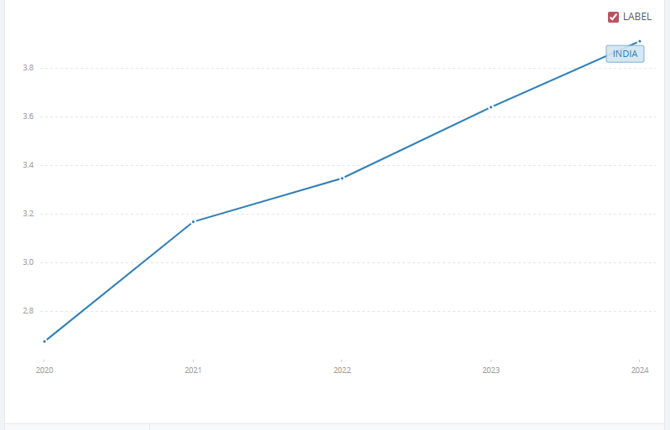
Figure 1 India's GDP 2020-2024
Source: World Bank
In terms of politics, India is a stable federal parliamentary democratic country with a relatively stable central government even though the policy execution and investment environment may be different in various states (Pestleanalysis, 2024). Post-1991 reforms have also led to progressive liberalisation of trade and investment in favour of foreign direct investment (FDI) and encouraged the privatisation of enterprises, making India increasingly a part of international markets (Pestleanalysis, 2024).

2.2 Size, scope, and economic importance of India’s smartphone industry
India has emerged as the largest smart phone market in the world with the highest volume and a leading market in terms of value. According to the Monthly India Smartphone Tracker by Counterpoint, in the year 2023, India recorded approximately 152 million smartphone shipments which are virtually the same as in 2022 meaning that the market has stabilised in terms of volume (Counterpoint Research, 2024).
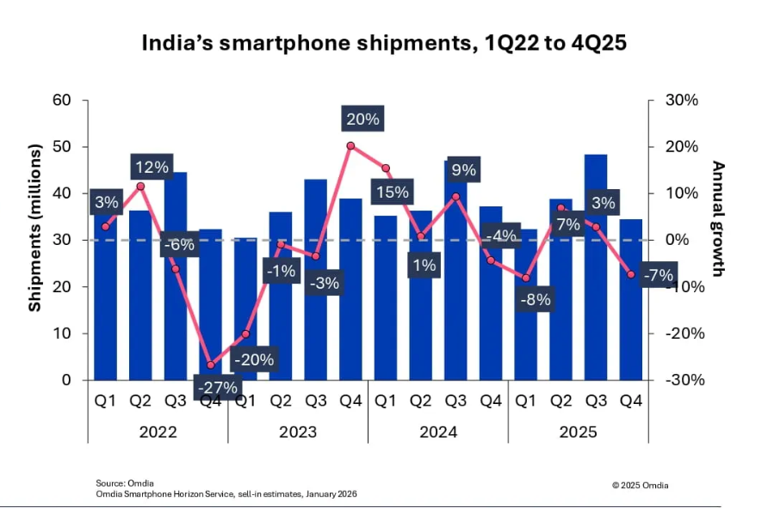
Figure 2 India's Smartphone Shipments
Source: Omdia
India has also become a big manufacturing base of smartphones on the supply side. According to the official data presented by the Ministry of Commerce, which Business Standard and Hindustan Times refer to, this represents a year-on-year growth of about 42 percent as smartphone exports in India hit US$15.6 billion, becoming one of the largest export goods in India (Ministry of Commerce, 2024). It is mentioned in the same report that the total production of mobile phones in FY2023-24 totalled about US$49.16 billion, which is a reflection of the fast-growing domestic production capacity (Ministry of Commerce, 2024).

2.3 Major domestic and multinational firms and competitive positioning
Smartphone business in India is very competitive with multinational companies in South Korea, China and the US taking the lead with a few domestic producers. Counterpoint Research estimates that Samsung controlled the Indian smartphone market (18% of unit shipment) in 2023, Vivo (17%), and Xiaomi was at position three, with Apple with record-breaking shipments and leading the market in terms of revenue (Counterpoint Research, 2024).
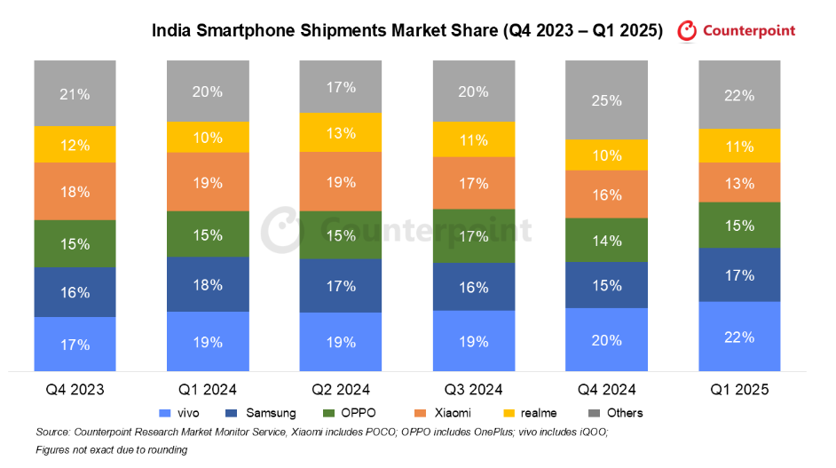
Figure 3 India's Smartphone Market Share
Source: Counterpoint Research
Samsung (South Korea)
Samsung is a diversified international electronics MNE that is competing in various price points but has recently concentrated on the middle and high-end smartphones in India especially its Galaxy A brands and flagship S brands. Counterpoint acknowledges that Samsung leadership in 2023 was motivated by good performance of A series, intensive offline marketing and intensive push on premium price segment (Counterpoint Research, 2024). The deep local manufacturing in the form of its Noida and Sriperumbudur plants and the implementation of India as an export hub within the program of Make for the World also helps Samsung to increase cost-efficiency and reliability of its supply chains (Samsung, 2018; IBEF, 2025).
Vivo, Xiaomi, Oppo, Realme (China)
These Chinese brands all occupy a significant portion of the Android entry and mid-range segment, competing intensely based on price performance ratio, camera and camera design. Counterpoint reports Vivo as owning a share of approximately 17 per cent in 2023, assisted by a highly robust offline footprint and concentrate on the less expensive premium segment (between INR 30,000-45,000) with its V series, and Xiaomi dropped to position in the entire year but topped the pack in Q4 2023 following its refocus on less expensive 5G products and growing offline retail (Counterpoint Research, 2024).
Apple (United States)
Apple is a high-end player that is a niche but quickly growing in India. According to the tracker of Counterpoint, Apple crossed more than 10 million units of shipments in India in 2023, and the company took the lead in smartphone revenue during the calendar year, which is due to the increased demand of the new and older models of the iPhone (Counterpoint Research, 2024). The volume share is still single digit, although its market value share was approximately 23 percent due to the great average sale price of Apple products (CNBC TV18, 2024).
Performance and strategic positioning can be distinguished on several dimensions:
- Market segments (price levels) - A large portion of the lower end and middle of the Android market is dominated by Chinese vendors like Xiaomi, Vivo, Oppen and Realme, with the price sensitivity being very high and competition being largely based on specifications and value (Counterpoint Research, 2024; Canalys, 2024). Samsung holds business in any number of segments but has moved to mid-range and high end, retaining some low-end presence, and Apple is almost all high end and ultra-premium customers and disproportionate share of revenue compared to its volume share (Counterpoint Research, 2024; CNBC TV18, 2024).
- Footprint/localisation level - Samsung has two big manufacturing plants in India and it exports a large portion of its India manufactured smartphones, whereas Apple has contract manufacturers that have quickly developed local assemblies, which makes Apple and Samsung jointly export almost all smartphone export value out of India (Samsung, 2018; IBEF, 2025; Ministry of Commerce, 2024). Local Chinese brands like Xiaomi, Vivo, Oppo and Realme also manufacture devices locally on the basis of the PLI model, usually through contract manufacturers (IBEF, 2025; Ministry of Commerce, 2024).

3. Global Competitiveness Analysis Using Porter’s Diamond Model
The diamond of the smartphone industry in India dictates an intense but unbalanced national advantage whereby India is very competitive in terms of mass assembly and demand sophistication, but extremely weak in the area of high value components and sophisticated hardware capabilities, which casts doubt on the sustainability of its stance past assembly.​
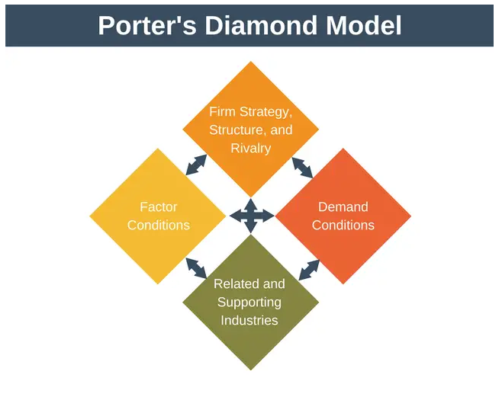
Figure 4 Porter's Diamond Model
Source: Expert Program Management

3.1 Factor conditions
Labour and skills
India has an extremely huge and comparatively cheap labour force, and a considerable number of engineers and IT experts. The history of the Indian IT and telecom industries has generated human capital within the software development, testing, design and support services, which smartphone companies can use to localise, apps and services (Pestleanalysis, 2024). Nonetheless, India lags far behind in sophisticated hardware design and semiconductor technology; much of the high end SoC, memory and display subsystems, are still designed and produced outside the country and this limits the ability to deeply localise high value-added portions of the smartphone value chain (Tien, Dat & Chi, 2019). This implies that the factor-based advantage of India is now focused in assembly and part mid-level manufacturing, as opposed to frontier hardware innovation.
Physical and cyber infrastructure.
Telecom infrastructure has developed with tremendous growth, and 4G coverage is large, and 5G is being rolled out and has the capability to use high volumes of data as well as considerable smartphone usage (Revolution in Data Market, 2024). Industrial corridors, special economic zones and areas dedicated to electronics have also improved manufacturing infrastructure, but logistics bottlenecks, uneven power supply, and regional differences in the quality of infrastructure also continue to frustrate time sensitive global supply chains (Pestleanalysis, 2024). These weaknesses increase the costs and may also diminish the appeal of India with very high complexity just in time production though it is performing in large batch assembly.

3.2 Demand conditions
Market size and growth
India is a huge smartphone market experiencing shipments of approximately 150-152 million units in 2023, but generally flatly compared to the previous year (Counterpoint Research, 2024; Canalys, 2024). Although the unit volumes have been flat, the absolute size of home demand is immense that gives manufacturers a huge foundation on the economies of scale and learning (Chang, 2006).
Demographic profile
Young, urbanising population and a growing middle class contribute to the need to have digital lifestyles, which can be social media, short form video, mobile gaming, digital payments and online education (Pestleanalysis, 2024). This variety of applications keeps smartphones in demand among low-end users (first time) and high-end users (professionals) alike, multi segment strategies have been enabled by Samsung, Vivo and Apple, among others (Counterpoint Research, 2024).
Nevertheless, since much of the sophistication is realized through the use of devices and not in local tastes towards nationally designed hardware or software ecosystems, it does not necessarily drive firms or the national system towards high end component innovation.

3.3 Related and supporting industries
PLI initiative in electronics is also slowly stimulated in the creation of local charger, and accessories ecosystems, printed circuit board assembly, and certain modules (Government of India, 2021; IBEF, 2024). However, the importation of high value items like processors, memory, advanced displays and many RF parts continues to be important to India and this limits the upstream capturing of value as well as the industry to external shocks.
In this way, India possesses well-related sectors on the digital services front but somewhat weak penetration in vital hardware supplies. Such asymmetry provides competitiveness in assembling finished devices and software-based differentiation, but limits the shift to the most lucrative technology domains of the global smartphone value chain.

3.4 Firm strategy, structure and rivalry
Multi segment competition
The companies are competing on ultra-budget, budget, mid-tier and premium markets and this requires them to constantly enhance the specifications of their hardware, the features and design of their software. Chinese brands are strong in the lower segments on price performance, Samsung is in the mid to premium range with a strong brand, and Apple is in the high-end market and takes a disproportionate share of the revenues (Counterpoint Research, 2024; CNBC TV18, 2024). This multi polar competition minimizes complacency and makes all the players optimize product portfolios and positioning.
Localisation and Make in India.
In order to, obtain all the benefits of lower taxes bigger players have constructed their own assembly centres in India (IBEF, 2025). This prompts companies to entrench operations within local supply chain, as well as to invent India peculiar models and features. Meanwhile the strategic and operational complexity of meeting local content requirements and paying other incentives favour those firms that have high internal strengths and are committed to the long term.
Altogether, Indian competition is tough and structurally sound, which pushes cost discipline, fast feature diffusion as well as channel innovation. The smartphone players in India are MNC’s and most of their core technology and operations are offshore. As a result, this constrains the degree to which competition can result in domestically based global champions (Jain et al., 2019).

3.5 Role of government and chance
The Indian government determines competitiveness by incentives in PLI, tariff regimes, export promotion programs and digital infrastructure programs (Ministry of Electronics and IT, 2020; Government of India, 2024). The changes, including the introduction of the Goods and Services Tax (GST) and continuous improvement in the ease of doing business, have an impact on the cost of logistics and investment choices (Pestleanalysis, 2024). The industrial policy has obviously made the process of smart phone assembly and exports to grow faster yet it also implies that some of the current advantage India has is policy made and not entirely market based.

3.6 Sustainability of India’s Competitive Advantage and Global Competitiveness
On the bright side, India has created a strong position on large scale assembly and export-oriented manufacturing. PLI-driven investment combined with rapidly expanding and more advanced domestic demand has seen India rise to become one of the largest smartphone manufacturing destinations by volume and also to experience over US15 billion in exports by FY2023-24 (Ministry of Commerce, 2024). The existence of the world leaders like Samsung and Apple who now rely on India as an important export base implies that the competency level in assembly, quality control and logistic has attained a global competitive level (IBEF, 2025).
But this national advantage is very narrow and conditional, in at least three aspects:
- It is very incentive contingent: The structural disadvantages are backed with PLI and policies without which companies might relocate to other low-cost alternative countries (Ministry of Electronics and IT, 2020; ElectronicsForYou, 2025).
- It is component-based: Due to the import of high value components India is prone to supply shock and captures only a small portion of the overall smartphone value. Moreover, companies in India are stuck at smaller margins and facing competition from similar destinations. (Government of India, 2021; IBEF, 2024)
- It is logistics sensitive: India faces transportation and power bottlenecks which may interrupt any expansion from sensitive and intricate operations of well-coordinated supply chains (Pestleanalysis, 2024).
The smart phone industry of India is well placed, now as a regional and increasingly a global assembly and export market, but the long term national competitive edge will be whether it can transcend its current assembly intense engagement to greater technological and designing capabilities. To be sustainable in competitiveness would need:
- Slowly increasing local ecologies of greater value elements and modules and decreasing reliance on imports by increasing local value capture.
- Using the opportunities that India has in the field of IT and software to have even more India based R&D to create more India based device design.
- Negotiating and entrenching longer term commitments of MNCs, including co development with current windows of opportunity created through global diversification other than China, local engineering centres and supplier development programmes (IBEF, 2025; ElectronicsForYou, 2025).

4. Evaluation of Samsung’s Operations in India: Country Attractiveness and Key Success Factors
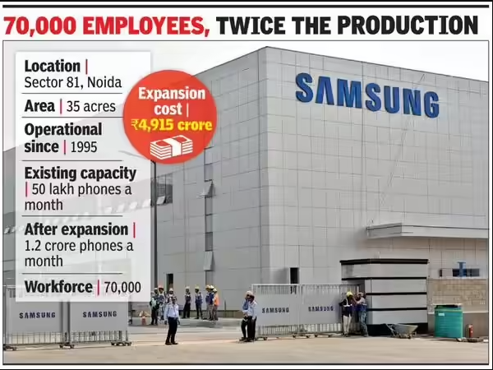
Figure 5 Samsung's Noida Factory
Source: The Times of India

4.1 Samsung in India: Background and Strategic Position
Samsung had entered India in the mid-1990s and had been enjoying a spot as one of the leading consumer electronics and smartphone brands in the country since that time. In 2018, it opened a factory that it claimed to be the biggest mobile phone facility in the world in Noida, Uttar Pradesh with an investment of approximately 4,915 crores to increase the capacity of the factory to 120 million mobile phones annually, compared to 68 million (Samsung, 2018; Business Today, 2018; New Indian Express, 2018).
Samsung has got two large production plants (Noida and Sriperumbudur), five research and development centres and one design centre in India, which are supported by one of the largest electronics retail and service networks in the country (Business Today, 2018; Samsung, 2018). Samsung dominated India smartphone market, with an approximate volume share of 18 percent as at 2023, the first time in six years, by strong Galaxy A series sales and targeting the high-end market (Counterpoint Research, 2024; GSMArena, 2024).
- Decision 1 - To establish a major, export focused manufacturing hub (Noida "Make for the World") to meet the requirements of the PLI incentives and tariff regimes, minimizing the unit costs, and allowing India based exports (Samsung, 2018; FoneArena, 2018).
- Decision 2 - Creation of segmented Galaxy portfolio (A, M, F, S and foldables) to balance the price sensitivity in India with the increasing high-end demand (Counterpoint Research, 2023; Counterpoint Research, 2024).
- Decision 3 - Proceeding with an offline anchored but hybrid channel, with training of thousands of offline retailers to sell online, to take advantage of the offline high retailing structure in India and the emergence of e commerce (Samsung, 2020).
- Decision 4 - Localisation of R&D and software/UI development in India, where local engineering expertise is being used to localise products and services to the Indian usage patterns (Business Today, 2018).

4.2 Political and Policy Environment
For Samsung, there are opportunities and threats in the political and policy environment in India.
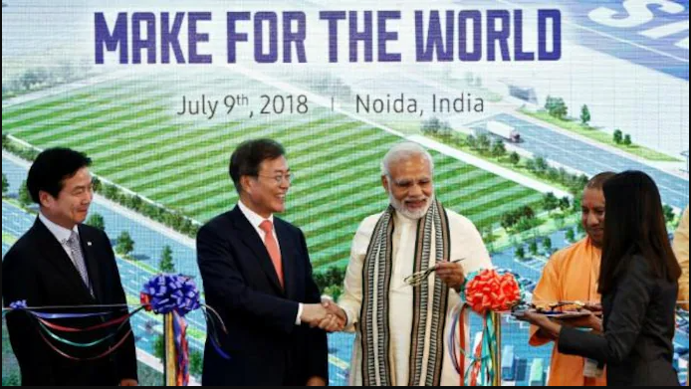
Figure 6 Samsung's Make for the World
Source: India Today

Political stability and governance.
In India, there has been a relative political continuity at the centre since 2014, and the federal democratic structure has a comprehensive pro-business orientation (Pestleanalysis, 2024). This consistency was the force behind Samsung investing in the large, long-term capital in its Noida expansion and Sriperumbudur plant. But there are significant differences in regulatory regimes across states. The plants of Samsung are forced to negotiate between the various incentives and labour regulations and industrial policies at the state level, and this impacts site location and costing models.
Industrial and trade policy
There is a favorable policy backing in electronics manufacturing. The output tied fiscal benefits and the promotion of local value addition through schemes like, Make in India and the PLI scheme on mobile phones and electronics (Ministry of Electronics and IT, 2020; Government of India, 2024). The presence of high customs on finished smartphones and a few of their components encourages companies to assemble them domestically.
These conditions are directly exploited in decision 1 (Noida expansion and export focus): doubling capacity in Noida and introducing Make for the World has made Samsung aligned with the PLI incentives and tariff driven localisation. (Samsung, 2018; FoneArena, 2018; IBEF, 2025).

4.3 Economic environment
The macro environment and market in India presents the major opportunities of Samsung.
Earnings and macroeconomic development.
The Indian market can best be described as a big yet highly stratified smart phone market: a small but rapidly expanding high-end market and a mass market, price sensitive (Pestleanalysis, 2024). This is answered by Samsung in decision 2 (premium focus segmentation of the Galaxy portfolio). A series is focused on high end middle range and low-end premium customers, the M and F series are aimed at online focused and cost-conscious clients, and S series and foldables are aimed at high-end customers (afaqs!, 2023).
Smartphone market dynamics
Although the total volumes of smartphones did not shift in any direction in 2023 to stand at approximately 152 million units, the premium segments increase at a rate much higher than the entire market, and Samsung and Apple became the primary beneficiaries (Counterpoint Research, 2024; GSMArena, 2024). Simultaneously, the presence of strong Chinese competition in the mid and value segments exerts pressure on the margins and requires constant renewals. For Samsung this implies that better and higher mid-tier devices (S and higher end A series) achieve higher profit rates and brand equity.

4.4 Social and cultural environment
Localisation and urban-rural separation.
There are major disparities between consumers in urban and rural regions in relation to income, connection and access to retail. City customers usually focus on brand image, superior features, whereas the rural and small-town customers focus on durability, battery life, and prices. Multilingualism and cultural diversity will require ensuring a variety of languages and content that refers to a specific region (Pestleanalysis, 2024).
Samsung can respond to these varied expectations by implementing the features of the decision 4 (local R&D and UI localisation), which gives Samsung the ability to add India specific features, including: regional language interfaces, camera features tailored to local lighting/skin tones, or features built around local payments and local content consumption (Business Today, 2018). This makes it look more relevant and does contribute to differentiating Samsung with generic global Android brands.
Brand perception and trust
Samsung has a long tradition in India and is viewed as a stable, aspirational but quite accessible brand. This is unlike some of the Chinese competitors that have periodic issues with data security or political tensions. Simultaneously, Chinese brands are thought to feature more aggressive specifications at a particular price. The issue that faces Samsung would then be to subsidize an average premium by brand trust, after sales support and ecosystem value and not bare hardware specifications (Baber et al., 2020).

4.5 Technological environment
Information and infrastructure.
The fast growth of 4G and 5G has massively enhanced the level of data consumption, as it has facilitated high-level applications like streaming, gaming and remote work (Revolution in Data Market, 2024). This stimulates the desire to buy faster performance devices and explains why Samsung pays much attention to AMOLED screens, multi cameras and 5G chipsets in a lot of A series and S series phones.
Local innovation and R&D
Indian R&D centres of Samsung focus on software, artificial intelligence, customisation of the user interface (e.g., One UI localisation) and services integration (Business Today, 2018). India has a vast amount of skilled workers in the form of engineers, and India unique UX is required, the result is price saving global R&D (with relatively lower cost Indian talent) and a more appropriate Galaxy devices to Indian usage habits, which also lead to brand stickiness (Mukhopadhyay & Mandal, 2019).

4.6 Legal and regulatory environment
Trade and investment policies.
The FDI regime in electronics and single brand retail in India is liberalised to permit majority or full ownership of foreign investors in most instances, which means that Samsung owns and operates its factories, brand stores and services centres with licensing and approvals (Pestleanalysis, 2024). The difficulty of the procedures in land acquisitions and environmental approvals is also a constraint and raises the lead time in expansions.
Taxation and compliance
Indirect taxation has been harmonized under the Goods and Services Tax (GST) making the interstate logistics easy, helpful to the manufacturers who have pan India distribution as in the case of Samsung (Pestleanalysis, 2024). Nonetheless, there are issues of classification, rate changes and compliance which requires robust in-house tax and legal functions.

4.7 Environmental and sustainability considerations
E waste regulation
The e-waste regulation in India imposes the duty of collecting and recycling on the end-of-life devices on the manufacturers (EdrawMax, 2025). In case with Samsung, it means investing in take back programmes, approved recyclers and consumer education, as well as an opportunity to strengthen its brand as the responsible producer.
Eco design and packaging
There is a growing demand among global and local stakeholders to use less plastic, ensure materials are more sustainable and have increased life cycles of the devices. The global sustainability initiatives of Samsung including the use of recycled materials in the devices and simple packaging can be localised to India and this will offer a differentiation against the competitors who do not spend much on overt sustainability (Bakan and Dogan, 2012).​

4.8 Overall market attractiveness and implications for Samsung
Putting the PESTLE analysis altogether, India presents Samsung with:
Major strengths/opportunities,
- The immense and ever-advanced size of a consumer base that can be relied upon to sustain the low, mid and high ends of demands.
- Powerful industrial and digital policies (Make in India, PLI) where local manufactures and exports are rewarded, which Samsung has taken advantage through its Noida and Sriperumbudur plants (Samsung, 2018; IBEF, 2025).
- Low cost of labour and increasing infrastructure that supports mass production.
Key challenges/risks,
- Vigorous price war with Chinese players on the mass and mid segments that will cut margins and pose a share risk.
- High regulatory and bureaucratic levels at central and state level, which demand good ability of the local management.
- Continuous use of imported high value components which exposes Samsung to international supply and price shocks.
- Increasing protection of data, consumer and environmental policies which increase compliance costs but are inevitable with a high-end brand.
The macro attractiveness of India has resulted in practical outcomes in terms of Samsung regaining the volume leadership, good premium segment performance and meaningful export base because of its past strategic choices: large scale local manufacturing and exports (Decision 1), segmented product architecture (Decision 2), hybrid offline-online distribution (Decision 3) and localised R&D (Decision 4) (Counterpoint Research, 2023; GSMArena, 2024; IBEF, 2025).
Nonetheless, with growing competition and the market transitioning to an innovation race in other directions like 5G, AI enhanced devices, ecosystem lock in and sustainability compliance, the next strategic imperative of Samsung in India is to shift its focus off a more hardware/price-channel focused model, to a more ecosystem centred, innovation led model. Concretely, this means:
- Bringing AI and ecosystem services (payments, cloud, wearables, smart home) closer together into mid-range and luxury Galaxy devices designed specifically for India.
- It uses its Indian R&D base to develop India first software and AI capabilities which can then be extended to a global scale.
- Intensifying the local supplier development in order to increase domestic value added and enhance resilience.
- Realizing the advancements in the sustainability measures (e waste, energy, materials) to remain in the lead of the stricter regulation and demands of the consumers.

5. Conclusion
India is truly competitive in mass smartphone assembly and export-oriented production, supported by a gigantic, rapidly developing home market, robust policy encouragement by schemes like PLI, and stiff competition, compelling companies to be innovative in pricing, channels as well as features (Counterpoint Research, 2024; IBEF, 2025). Nonetheless, it is not competitive in prestigious value parts and superior hardware abilities yet because it remains deeply dependent on imported semiconductors and exhibits and fiscal support to compete cost disadvantages with China and Vietnam (Government of India, 2021; Policy Circle, 2026). The national strong suit of India in smartphones is hence robust at the assembly/ export level but less pronounced and contingent than that of those with strong ecosystems of components.
In this context, Samsung fits well as a strategic target in India: it has adjusted its large manufacturing facilities in Noida and Sriperumbudur to PLI subsidies and tariffs and has developed a segmented portfolio of Galaxy products that align with the income distribution of India and has used well-developed offline channels and its local R&D to ensure volume leadership and a dominant position in the high-end market (Samsung, 2018; Counterpoint Research, 2023; GSMArena, 2024). Meanwhile, Samsung is still facing three threats, namely a fierce price rivalry of Chinese brands at the mass and mid-tier; reliance on imported high value components; and vulnerability to policy changes in the incentive regime in India (ElectronicsForYou, 2025; Policy Circle, 2026).

Section 2: Reflective Account Using Gibbs’ Reflective Cycle

Introduction to Reflective Framework.
The reflective narrative is based on the Reflective Cycle, a 6-stage framework of experience-based learning in Gibbs, which includes a description section, feelings section, evaluation section, analysis section, conclusion and action plan section (Gibbs, 1988; EBSCO, 2012). The cycle promotes the systematic thinking regarding what occurred, how it was experienced, what worked or failed, why it occurred in that manner, and how the future practice should be different (SimplyPsychology, 2025).

Description: What Was Done
The assignment is what led to the start of the work, as the task was to choose a country-industry pair and a real multinational company. My selection was the smart phone industry in India and the operations of Samsung in India. I did an exploratory search of secondary materials beforehand to verify that there was enough public information on market volume, major competitors, policy and presence of Samsung. This scan meant that reports in the industry, government reports, trade statistics and reputable news sources might provide sufficient coverage.
The report was then organized to reflect the assignment: introduction; industry and country overview; Porters diamond analysis; and analysis of a foreign MNC using PESTLE and other frameworks; conclusion; and reflections. The development of research occurred in phases. To begin with, the macroeconomic and demographic data about India were collected using high credibility sources, which include the World Bank and the official government publications (World Bank, 2024; Government of India, 2024). Second, the data on smartphone shipments, market shares and exports in the industry were gathered with the help of respected pieces of research and official export data sources, in particular, Counterpoint Research and IBEF (Counterpoint Research, 2024; IBEF, 2025).
Third, I analysed conceptual literature about Porters Diamond, PESTLE and Reflective Cycle, through academic texts and curated explainers (Porter, 1990; Gibbs, 1988; EBSCO, 2012; SimplyPsychology, 2025). Only to achieve clarity in applications, non-academic summaries (e.g., business explainers) were consulted not as a theoretical authority. The analytical sections were then drafted in accordance to these frameworks.

Emotions: Preliminary Reactions and Emotions.
I was initially excited and scared. It was personally interesting and directly connected to the international business theory as the topic was subjective and seemed to be based on the fast-growing, digitally-driven, smartphone market in India and the role of Samsung. I was also concerned especially with the possibility of finding recent and reliable quantitative data on exports, growth and policy effects of the premium segment.
The more quality sources I found (the specific trackers of Counterpoint or the export summaries and official documentation of PLI at IBEF), the more confident I became. The availability of actual figures in terms of shipments, market shares and export value also helped to base arguments in factual statements as opposed to guesses.

Reflection: What Went Well and What Went Wrong.
A number of factors of the process were successful:
- The selection of the smartphone industry in India and Samsung provided a plentiful amount of up-to-date data and an obvious connection to the theories of national and firm level competitiveness, which allowed conducting a rather strong empirical analysis.
- The structuring of the analysis by Porters Diamond and PESTLE provided the report with a logical framework and allowed critical competitiveness dimensions, risk and strategy of the firm to be approached systematically.
But there were aspects that were not as effective:
- I was first taking a lot of time going through generic blogs and the sites with low rigour of PESTLE and then reducing to high-quality sources. This non-structured form of doing things slowed the analysis process and enhanced the possibility of blindly barrelling weaker claims.
- The writing would at various points slip into general description (e.g., of the economy of India or digitalisation) that was not directly relevant to the central point on smartphone competitiveness or the strategic suitability of Samsung.

Analysis: The Making Sense of the Experience.
First, the scoping challenges have been indicative of a general issue in international business, namely an overwhelming mass of macro level information that is inviting to contextualisation. Since I did not begin with a tightly defined argument map, such as a one-page outline of the 3-4 main arguments I wanted to make about national competitiveness of India and strategic fit of Samsung, it did not take much effort to incorporate some interesting but peripheral background.
Second, the fact that analytical depth rose with the increase in the quality of the source proves the fact that the quality of evidence directly mediates theoretical understanding. I was able to make more specific decisions (e.g., regarding assembly led competitiveness, premium segment growth and export concentration) and interrelate them in a more convincing way to the determinants suggested by Porter.

Conclusion: Major Lessons Learned.
Out of this project, there were some lessons that were learnt specifically:
- Early choices and operationalisation of frameworks are to be made. By making a decision at the beginning that Porters Diamond would be applied to the particular assessment of the extent and feasibility of advantage beyond assembly in India and PESTLE would be applied to assess firm-environment fit in Samsung would have made the filtering of information later more disciplined.
- Scope needs to be consciously excluded. Explicitly stating what would not be discussed by the report (e.g., an in-depth examination of the entire electronics industry in India, non-relevant macro issues) would have minimized the descriptive drift and allowed more words to be devoted to critically discussing the value chain position and sustainability of PLI-driven competitiveness and strategic weaknesses of Samsung.

Action Plan: Better Future Research and Writing.
In accordance with the last stage of Gibbs, I will translate these lessons into quantifiable modifications that can be used in the future projects (Gibbs, 1988; SimplyPsychology, 2025).
- Present a formal filter of the quality of the sources (before detailed reading).
- Prepare 1 page source policy on each major assignment, and state that:
- A minimum of 70-80 percent of references is required to be of Tier 1 and Tier 2 quality (peer reviewed articles, official statistics, central bank/government reports, recognised industry research such as Counterpoint or IDC).
- From higher education advice on encyclopaedias, all tertiary sources (e.g., Wikipedia, generic PESTLE blogs) are treated as background, and not as authorities.
- To the (examples of) each major analytical claim (e.g., "India has a smartphone advantage that is led by assembly and incentive-dependent) create a straightforward table with the following columns: Claim - Theoretical lens - Source 1 - Source 2 - Data points.
- Ask myself to have a minimum of two independent and high credibility sources to each central claim to complete before finalising the argument which will help avoid over reliance on a single report.

References
Adeani, I.S., Febriani, R.B. and Syafryadin, S. (2020) ‘Using Gibbs’ reflective cycle in making reflections of literary analysis’, Indonesian EFL Journal, 6(2), pp. 139–148.
afaqs! (2023) ‘Samsung India Case Study: Marketing Strategy, Distribution’, afaqs!. Available at: https://www.afaqs.com (Accessed 6 March 2026).​
Baber, R., Upadhyay, Y., Kaurav, R.P.S. and Baber, P., 2020. Application of'masstige'theory and approaches for the marketing of smartphone brands in India. International Journal of Business and Emerging Markets, 12(3), pp.296-312.
Bakan, İ. and Doğan, İ.F. (2012) ‘Corporate social responsibility practices of Samsung in the world and in Turkey’, Procedia – Social and Behavioral Sciences, 58, pp. 734–743.​
Business Today (2018) ‘Samsung expands manufacturing facility in Noida; to produce 120 million units annually’, Business Today, 7 July. Available at: https://www.businesstoday.in [Accessed 11 February 2026].​
Canalys (2024) ‘India smartphone market remains stable in 2023 as shipments fall 2% to 148.6 mn units’, ET Retail, 17 January. Available at: https://retail.economictimes.indiatimes.com [Accessed 6 March 2026].​
Canalys / ET Telecom (2023) ‘India’s premium smartphone segment surges 112% even as overall market slips in Q2: Counterpoint’, ET Telecom, 30 July. Available at: https://telecom.economictimes.indiatimes.com (Accessed 6 March 2026).​
Chang, D.O., 2006. Samsung moves: A portrait of struggles. Labour in globalising Asian corporations: A portrait of struggle, 8.
CNBC TV18 (2024) ‘Apple tops India smartphone market in revenue share in 2023, Samsung in volumes: Counterpoint’, CNBC TV18, 30 January. Available at: https://www.cnbctv18.com [Accessed 6 March 2026].​
Counterpoint Research (2023) ‘India Premium Smartphone Segment Grows 112% YoY in Q2 2023; India Now Among Apple’s Top 5 Markets’, Counterpoint Research, 30 July. Available at: https://www.counterpointresearch.com (Accessed 6 March 2026).​
Counterpoint Research (2024) ‘India Smartphone Market Remains Flat in 2023; Apple Shipments Cross 10 Million for First Time’, Counterpoint Research, 30 January. Available at: https://www.counterpointresearch.com [Accessed 11 February 2026].​
Counterpoint Research (2024) ‘India Smartphone Market Remains Flat in 2023; Apple Shipments Cross 10 Million for First Time’, Counterpoint Research, 30 January. Available at: https://www.counterpointresearch.com (Accessed 11 February 2026).​
EBSCO (2012) ‘Gibbs’ reflective cycle’, Research Starters – Education, 15 October. Available at: https://www.ebsco.com [Accessed 11 February 2026].​
EdrawMax (2025) ‘Detailed PESTEL Analysis of India’, EdrawMax Online, 10 November. Available at: https://edrawmax.wondershare.com [Accessed 11 February 2026].​
ElectronicsForYou (2025) ‘India’s Smartphone Exports Overtake Traditional Goods’, Electronics For You, 19 May. Available at: https://www.electronicsforyou.biz [Accessed 11 February 2026].​
ElectronicsForYou (2025) ‘India’s Smartphone Exports Overtake Traditional Goods’, Electronics For You, 19 May. Available at: https://www.electronicsforyou.biz (Accessed 11 February 2026).​
FoneArena (2018) ‘Samsung opens world’s largest mobile factory in India, launches “Make for the World” initiative’, FoneArena, 8 July. Available at: https://www.fonearena.com (Accessed 6 March 2026).​
FoneArena (2018) ‘Samsung opens world’s largest mobile factory in India, launches “Make for the World” initiative’, FoneArena, 8 July. Available at: https://www.fonearena.com (Accessed 6 March 2026).​
FoneArena (2023) ‘Indian smartphone shipments decline 3% YoY in Q2 2023, premium segment up 112% YoY: Counterpoint’, FoneArena, 30 July. Available at: https://www.fonearena.com [Accessed 11 February 2026].​
FoneArena (2023) ‘Indian smartphone shipments decline 3% YoY in Q2 2023, premium segment up 112% YoY: Counterpoint’, FoneArena, 30 July. Available at: https://www.fonearena.com (Accessed 11 February 2026).​
Gibbs, G. (1988) Learning by Doing: A Guide to Teaching and Learning Methods. Oxford: Oxford Polytechnic.​
Government of India (2021) ‘Production Linked Incentive (PLI) Scheme for Large Scale Electronics Manufacturing’, Ministry of Electronics and Information Technology. Available at: https://pli.ifciltd.com [Accessed 11 February 2026].​
Government of India (2024) ‘Make in India’s Leap in Electronics Manufacturing & Exports’, Press Information Bureau, 30 November. Available at: https://www.pib.gov.in [Accessed 11 February 2026].​
GSMArena (2024) ‘Samsung is the best-selling smartphone company in India for 2023’, GSMArena, 31 January. Available at: https://www.gsmarena.com (Accessed 6 March 2026).​
Hindustan Times (2024) ‘Smartphones are now the 4th largest export item in India with 42% growth in 2024 – Report’, Hindustan Times Tech, 23 May. Available at: https://www.hindustantimes.com [Accessed 6 March 2026].​
IBEF (2024) ‘India’s share of electronics exports rose in FY24, driven by Apple, says Economic Survey’, India Brand Equity Foundation, 22 July. Available at: https://www.ibef.org [Accessed 11 February 2026].​
IBEF (2024b) ‘India fastest growing premium smartphone market globally in 2023: Report’, India Brand Equity Foundation, 3 January. Available at: https://www.ibef.org/news/india-fastest-growing-premium-smartphone-market-globally-in-2023-report (Accessed 6 March 2026).
IBEF (2025) ‘India’s Rise as the Second Largest Smartphone Manufacturer’, India Brand Equity Foundation, 20 January. Available at: https://www.ibef.org [Accessed 11 February 2026].​
India Brand Equity Foundation (IBEF) (2025) ‘India’s smartphone exports soar, surpassing petroleum, diamonds in FY25’, IBEF, 19 May. Available at: https://www.ibef.org [Accessed 6 March 2026].​
Jain, V., Chawla, C., Arya, S., Agarwal, R. and Agarwal, M., 2019. An Empirical Study of Product Design for New Product Development with Special Reference to Indian Mobile Industry. TEST Engineering & Management, 81, pp.1241-1254.
Ministry of Commerce (2024) Smartphone Export and Production Statistics FY2023–24, Government of India (data cited in Business Standard and Hindustan Times reports on smartphone exports).​
Ministry of Electronics and Information Technology (2020) ‘Assessing the PLI Scheme for Mobile Manufacturing in India’, The India Forum, 22 July (discussion of PLI scheme). Available at: https://www.theindiaforum.in [Accessed 11 February 2026].​
Mobile Phone Usage Pattern (2021) ‘Mobile phone usage pattern among youth in the urban and rural area’, Zenodo, 27 February. Available at: https://zenodo.org [Accessed 11 February 2026].​
Mukhopadhyay, D. and Mandal, A.K., 2019. Smartphone, Internet and Digitalization in India: An Exploratory Analysis. PRAGATI: Journal of Indian Economy, 6(2).
Pestleanalysis (2024) ‘PESTLE Analysis of India [2024 Updated]’, Pestleanalysis.com, 25 July. Available at: https://pestleanalysis.com [Accessed 11 February 2026].​
Policy Circle (2026) ‘Smartphone exports surge, but electronics value addition remains thin’, Policy Circle, 20 January. Available at: https://www.policycircle.org (Accessed 6 March 2026).​
Porter, M.E. (1990) The Competitive Advantage of Nations. New York: Free Press.
Revolution in Data Market (2024) ‘Revolution in Data Market: A Study on Data Consumption in India’, International Journal of Current Science Research and Review, 27 May. Available at: https://ijcsrr.org [Accessed 11 February 2026].​
SamMobile (2024) ‘In 2023, Samsung led the mobile market in India for the first time in 6 years’, SamMobile, 31 January. Available at: https://www.sammobile.com [Accessed 11 February 2026].​
Samsung (2018) ‘Samsung Inaugurates World’s Largest Mobile Factory in India’, Samsung Newsroom India, 8 July. Available at: https://news.samsung.com/in [Accessed 11 February 2026].​
SimplyPsychology (2025) ‘Gibbs Reflective Cycle’, SimplyPsychology, 25 March. Available at: https://www.simplypsychology.org [Accessed 11 February 2026].​
The New Indian Express (2018) ‘Samsung opens world’s largest phone factory in India’, The New Indian Express, 8 July. Available at: https://www.newindianexpress.com (Accessed 11 February 2026).​
Tien, N.H., Dat, N. and Chi, D.T.P., 2019. Product policy in international marketing comparative analysis between Samsung and Apple. Int. J. Res. Mark. Manag. Sales, 1, pp.129-133.
Times of India (2024) ‘Samsung lead smartphone market in India for all of 2023: Report’, The Times of India, 5 February. Available at: https://timesofindia.indiatimes.com (Accessed 11 February 2026).​
World Bank (2024) ‘GDP (current US$) – India’, World Bank Open Data. Available at: https://data.worldbank.org/indicator/NY.GDP.MKTP.CD?locations=IN [Accessed 11 February 2026].​
World Bank (2024b) ‘India – Country overview’, World Bank Group. Available at: https://www.worldbank.org/en/country/india (Accessed 6 March 2026).​
World Bank (2024c) Becoming a High-Income Economy in a Generation: India Country Economic Memorandum 2024. Washington, DC: World Bank.​

