Andrew Davies
2213112@student.uwtsd.ac.uk

NOSS Coursework 1
Andrew Davies

Contents
Task 1 2
Hypervisor 2
IP Addressing: 2
Routing 3
Network Services 4
Task 2 5
Bibliography 10

Task 1

Hypervisor
A hypervisor is a specialised system software that’s designed to run multiple virtual machines, whilst minimising overheads by efficiently allocating and managing system resources [1]. They are classified by their architecture into two main types: Type 1 (bare metal) hypervisors, which run directly on the hardware and Type 2 (hosted), which operate on top of an existing operating system [1].
Type 1 hypervisors are generally considered to be more efficient and secure in comparison to Type 2 as they don’t rely on an underlying operating system. The increase in efficiency is because of the direct connection between the hypervisor and the hardware, which reduces overhead and allows for better resource allocation [2]. Since the hypervisor manages guest operations, a single virtual machine cannot affect the hypervisor it runs on. If a VM crashes, it only impacts itself, while other VMs and the hypervisor continue running without any issues [2].
However, Type 1 hypervisors require dedicated hardware to operate on, which makes them more suitable for environments that require large-scale virtualisation i.e. not for personal use or testing environments.
In contrast, as Type 2 sits on top of the operating system, they don’t require specific hardware to run, therefore, are more suitable for smaller scale environments and personal use due to their ease of installation and lower system requirements [3]. They can support a wide range of hardware, as they inherit compatibility from the host operating system [2]. Additionally, much of the hardware configuration, such as networking and storage, is already managed by the OS [2], therefore the set up and the management of the hypervisor is a lot easier, in comparison to Type 1.
Given the above information, the type of Hypervisor you’d choose would be based on your specific needs. If efficiency and security are the main priorities, then a Type 1 hypervisor would be the better option. On the other hand, if ease of setup and hardware compatibility are more important, then a Type 2 would be better. Whichever option is chosen, there are several solutions available in the market. For Type 1 hypervisors, popular options include VMware ESX, Citrix Xen and Microsoft Hyper-V among others. They all provide efficient performance and robust security. For Type 2 hypervisors, there are several solutions, such as, VMWare Workstation and Oracle VirtualBox.

IP Addressing:
The TCP/IP protocol governs how data travels between computers on the internet, using a layered divide & conquer approach, where each layer handles a specific aspect of communication [4]. For data to move successfully, each device must have a unique identifier, known as an IP address, which enables accurate data transmission. Every data packet that’s sent over the internet will contain a source IP address and a destination IP address, both of which are encompassed in the header of the packet [5]. A router will use these addresses to determine the best path to send the payload across the internet. It will do so by checking its routing table. If a known route is available, the router will send the payload accordingly. If not, it will use a shortest path algorithm to determine the next best hop towards its destination [6].
Routers direct data between local area networks (LAN) and wider area networks (WAN), while switches operate within the LAN, forwarding packets based on MAC addresses. Unlike routers, switches use MAC address tables and, if the destination is unknown, broadcast data until the correct device responds.
IPv4 is the most common IP addressing system used today. Its structure consists of four 8-bit sections. The address is divided into the Network ID and the Host ID. A subnet mask is used to determine which bits of the address belong to the network and which belong to the host [5]. IPv4 uses NAT (Network Address Translation) to allow multiple devices on a private network to use a single public IP address when accessing the internet, which in turn, helps conserve IP addresses. Despite IPv4 being an effective and widely used addressing system, Dr Padore et al. argues that the need to adopt NAT to overcome the 32-bit limitation highlights IPv4’s limitations in terms of scalability and efficiency [7]. While NAT can help conserve address space by allowing multiple devices within a private network to share a single public IP address, it can cause IP address conflicts between peer-to-peer communication.
IPv6 was developed to overcome IPv4’s constraints, using a 128-bit format that eliminates the need for NAT. It also introduces automatic address configuration [8] and security upgrades including IPsec encryption and authentication [9]. Despite IPv6 offering these improvements, Bakon argues that the adoption of IPv6 has been slow due to compatibility issues with legacy IPv4 systems, high-cost upgrades, and reluctance from organisations to transition [10].
While IPv6 solves IPv4’s scalability and security issues, both addressing systems must remain due to the slow adoption of IPv6. Until full IPv6 adoption is practical, IPv4 remains essential in modern networks.

Image depicting data flow through a network (figure1)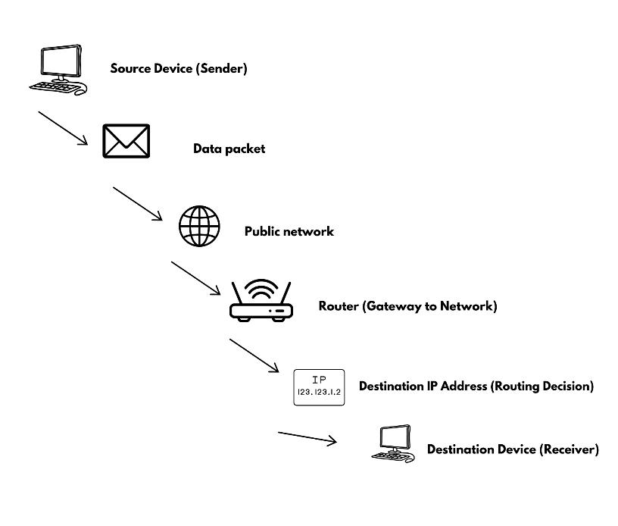

Routing
Routing protocols operate at the network layer of the TCP/IP model. Their fundamental role is to determine how data packets move between networks. They enable routers to dynamically exchange information, helping determine the most efficient path for data transmission [11].
Routing can be categorised into static or dynamic routing. Although not a routing protocol, a static route performs a similar role to a dynamic routing protocol by directing packets along a predefined path [12]. The key difference is that static routes are manually configured and updated by a network administrator [13]. This makes them suitable for small networks where routes rarely require changing, such as, a home or an office which has a limited number of devices. Dynamic routing on the other hand, allows routers to learn and adjust routes based on network conditions [14]. This is essential for larger networks where failures and congestion are common. Whenever network topology changes, the routing table updates automatically to reflect the optimal path [11].
Dynamic routing can be split into distance-vector protocols and link-state protocols [11]. Distance-vector protocols rely on routers sharing routing tables with neighbours to determine the best path based on hop count. They use shortest-path algorithms, such as the Bellman-Ford algorithm, to dynamically calculate and update these routes. An example of a distance-vector protocol is the Routing Information Protocol (RIP), where the best network path is determined by the number of hops [11]. The RIP protocol would typically be used in smaller networks, due to its ease of configuration. Despite the ease of configuration, RIP’s 15 limit hop count makes it unsuitable for larger scale networks. Distance vector routing tends to focus strictly on the number of hops between routers, and neglects factors such as latency and bandwidth [11] which can lead to delays within the network due to the traffic these routes with the lower hop count might experience.
In contrast, link-state protocols take a different approach to routing by maintaining a map of the network topology [11]. They take into consideration the link state information from all routers within the network, which would include information such as bandwidth and congestion levels. An example of a link-state protocol is the Open Shortest Path First (OSPF), which uses Dijkstra’s shortest path algorithm to determine the best path through a network [15]. Consequently, link-state protocols are better suited to larger and more complex networks due to their adaptability.
The choice of which protocol to choose is reliant on the network itself. For smaller more stable networks, RIP may be preferred due to its ease of configuration. However, for larger, high traffic networks, OSPF would be a more robust solution.

Network Services
A Virtual Private Network (VPN) enables the creation of a private network over a public network, such as the internet, using virtual connections [16]. Despite not having a physical presence, these connections securely transmit data through routed packets across various machines. The communication between the devices and networks are encrypted, which makes the exchange of information secure and private [16]. VPNs communicate by enclosing data in a secure layer, keeping it private whilst it moves through untrusted networks. To ensure optimal VPN implementation, best practices include using strong encryption protocols such as AES-256 to protect data [17], setting up 2 factor authentication protocols so that users must provide an additional verification step beyond just a password [18] and regularly updating VPN software.
DHCP is a network management protocol, situated on the application layer of the TCP/IP model, which is responsible for automatically assigning IP addresses and network configurations to devices on a network [19]. The protocol essentially acts as an automated network administrator, as it dynamically applies IP addresses, subnet masks, default gateways etc. This automation eliminates the need for manual IP configuration. To ensure best practise, DHCP should have well-set lease times which help manage IP address allocation, reserved IPs for important devices, and security features like DHCP snooping to block unauthorised access [19].
Active Directory Domain services, such as, access controls and user authentication allow organisations to centrally manage their users and devices. Instead of having to individually configure each device, administrators can apply policies and permissions across the entire network, making it easier to manage large groups of devices and users.
Certificate authorities tie into the above by providing the authentication and encryption methods necessary to secure user identities and network communications [20].

Task 2
C-Server IP addresses WAN + LAN (image below)
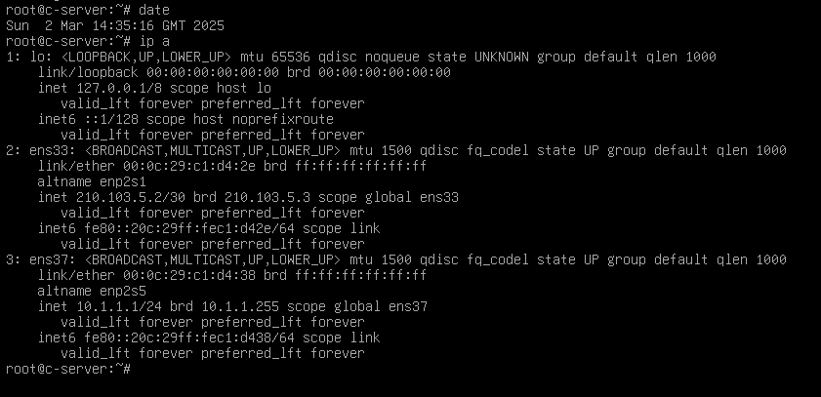
C-Server LAN IP configuration (image below)
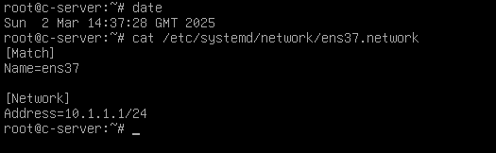
C-Server WAN IP configuration (image below)
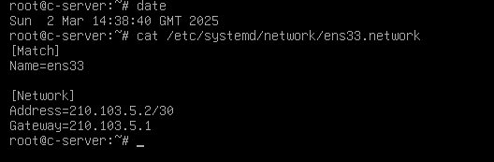
Ping C-Client from C-Server (image below)
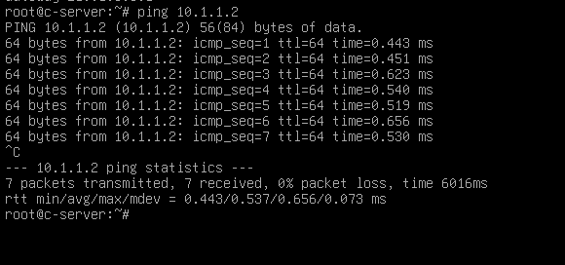
Ping S-Server from C-Server (image below)
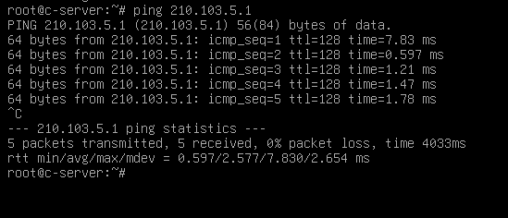
IP addresses for C-Client (image below)
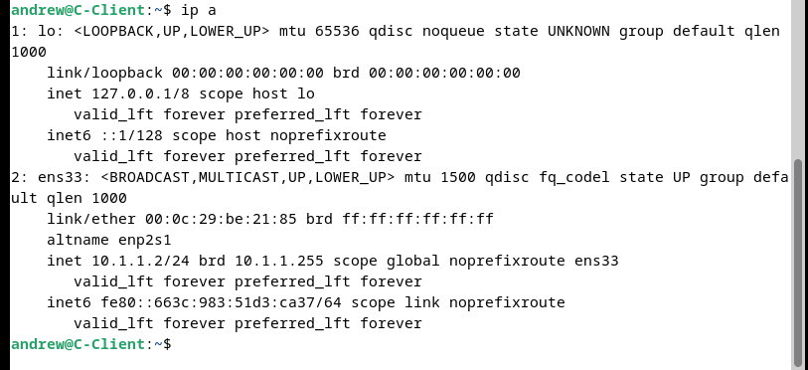
Ping C-Server from C-Client (image below)
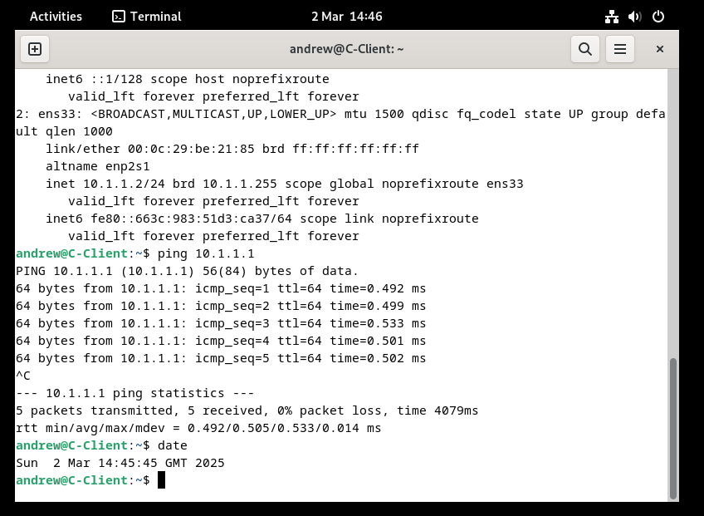
Ipconfig for S-Server (image below)
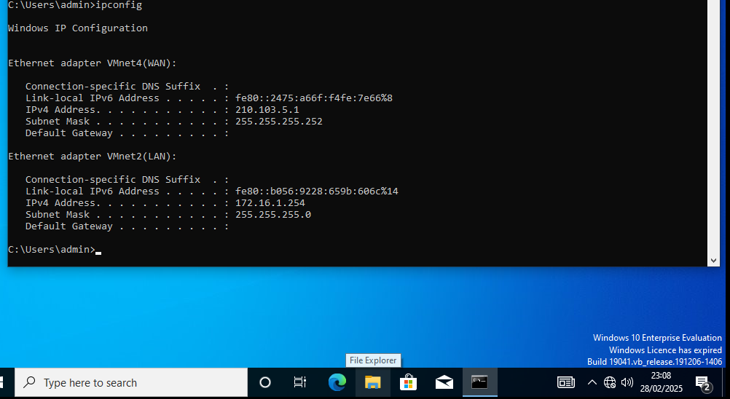
Ping C-Server from S-Server (image below)
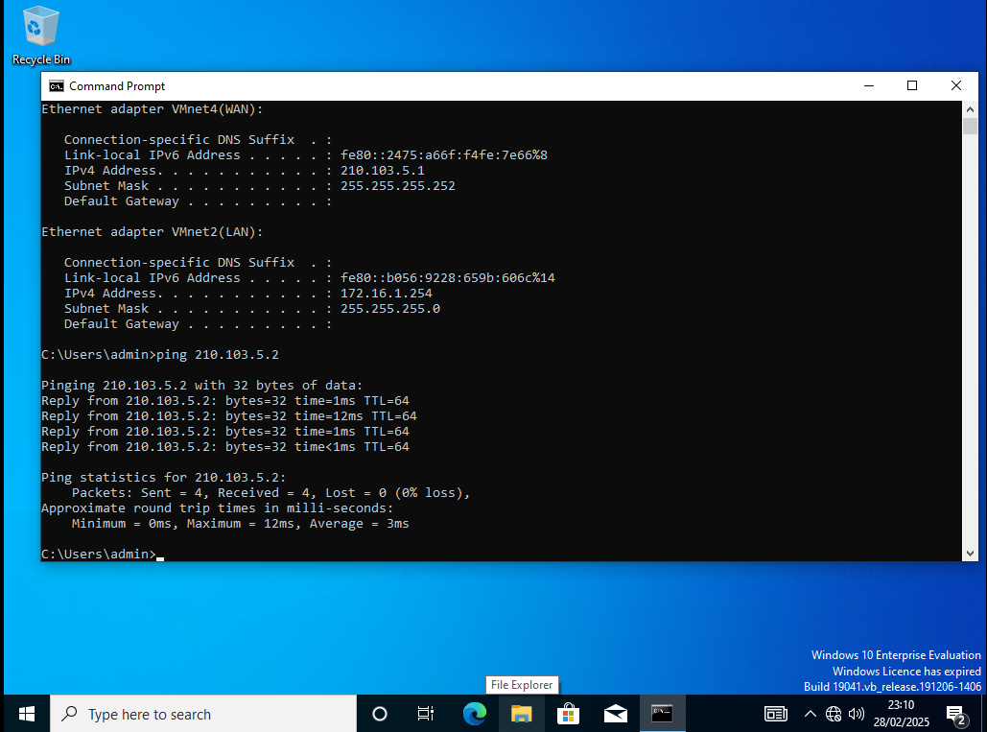
S-Server firewall disabled to enable Ping. Same was done with S-client (image below)
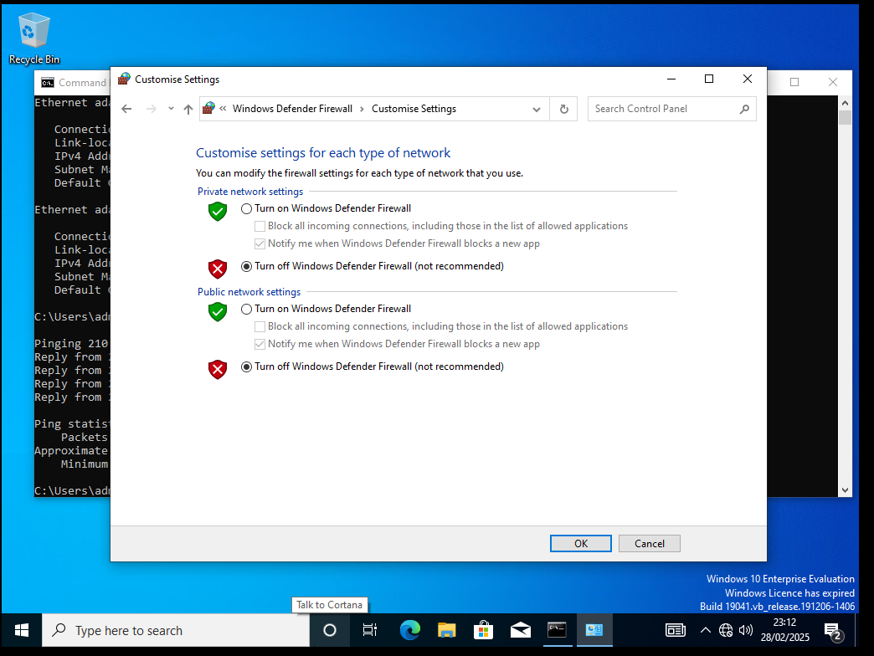
Ping S-Client from S-Server (image below)
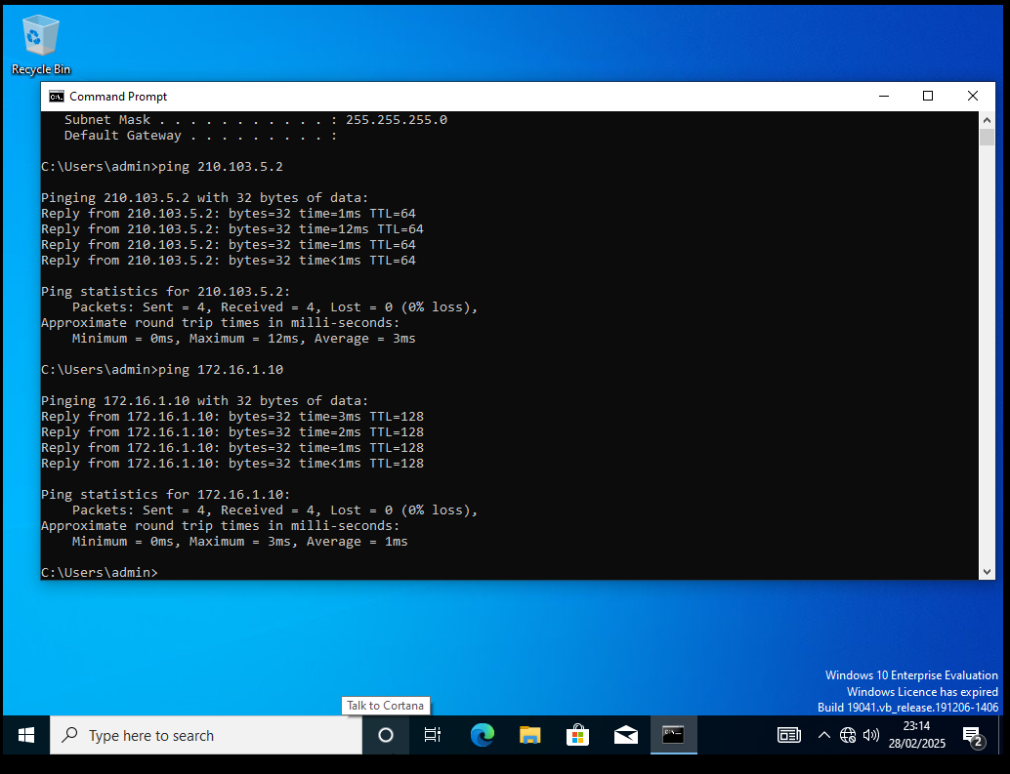
Ipconfig for S-Client (image below)
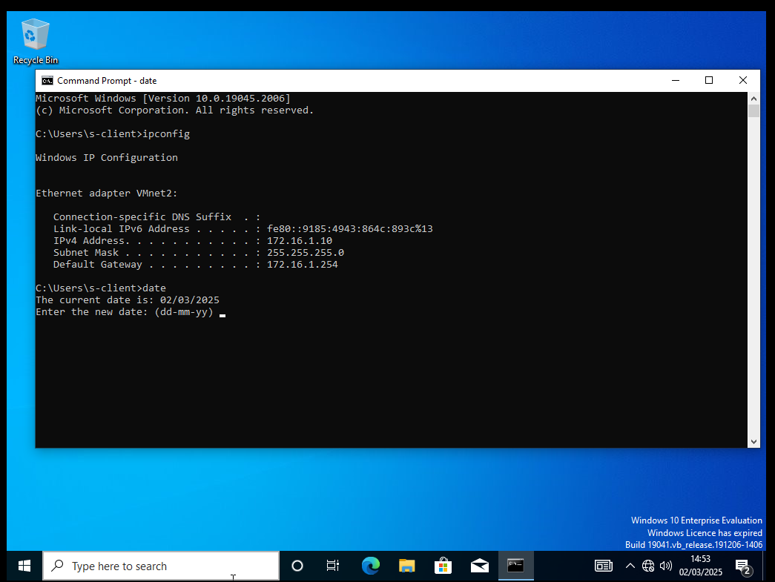
Ping S-Server from S-Client (image below)
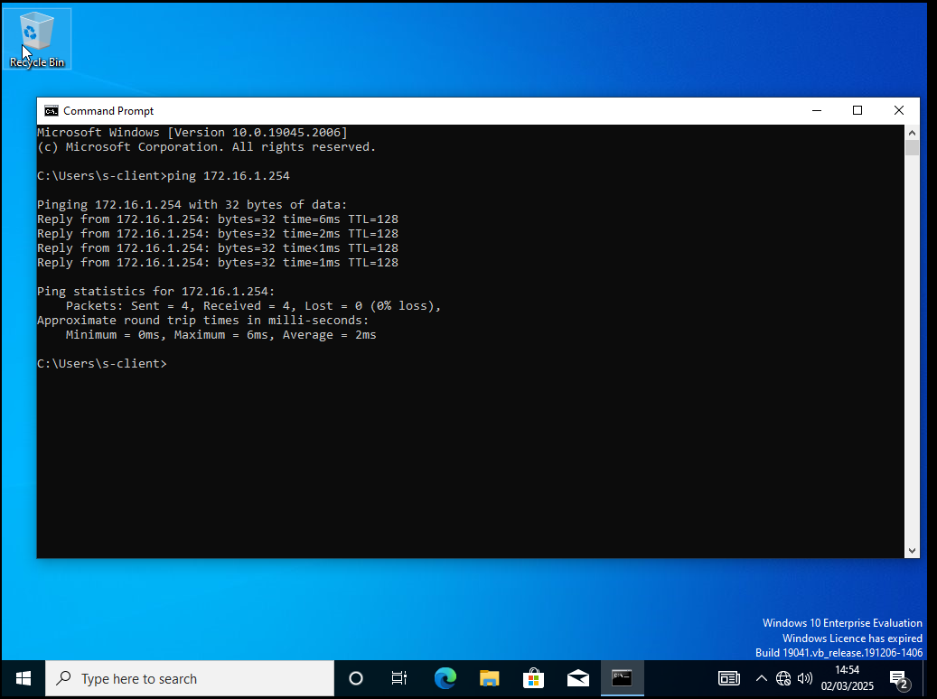

Bibliography

[1] | J. N. D. T. Edouard Bugnion, Hardware and software support for virtualization, Morgan & Claypool Publishers, 2018.
[2] | F. Douglis and O. Krieger, Virtualization, IEEE, 2013.
[3] | “What’s the Difference Between Type 1 and Type 2 Hypervisors?,” AWS, [Online]. Available: https://aws.amazon.com/compare/the-difference-between-type-1-and-type-2-hypervisors/#:~:text=Type%201%20hypervisors%20directly%20access,process%20slower%20and%20less%20efficient.. [Accessed 17 February 2025].
[4] | S. P. a. S. M. Book by Jeong-dong Ryoo, TCP/IP Essentials: A Lab-Based Approach, Cambridge University Press, 2004.
[5] | M. E. D. Tim Rooney, IP Address Management, Wiley, 2021.
[6] | K. R. Deep Medhi, Network Routing (Second Edition), Morgan Kaufmann, 2018.
[7] | P. K. L. R. D. J. a. M. N. DR. MAMTA PADOLE, “An Insight into IP Addressing,” ORIENTAL JOURNAL OF COMPUTER SCIENCE & TECHNOLOGY, vol. 10, no. 1, 2017.
[8] | “Address Autoconfiguration,” Science Direct, 2021. [Online]. Available: https://www.sciencedirect.com/topics/computer-science/address-autoconfiguration. [Accessed 7 February 2025].
[9] | S. Goswami, “Understanding IPv4 vs IPv6: Key Features and Differences,” Cloud Ways, December 2024. [Online]. Available: https://www.cloudways.com/blog/ipv4-vs-ipv6/#differences. [Accessed 7 February 2025].
[10] | K. A. Bakon, “A STUDY ON IPv4 and IPv6: THE IMPORTANCE OF THEIR CO-EXISTENCE,” International Journal of Information System and Engineering , vol. 4, no. 2, 2016.
[11] | L. Huawei Technologies Co., DATA COMMUNICATIONS AND NETWORK TECHNOLOGIES, Hangzhou: Springer, 2023.
[12] | M. B. &. N. Ryce, Day One: Routing the Internet Protocol, Juniper Networks Books, 2015.
[13] | R. Graziani, Routing protocols and concepts: CCNA exploration, Cisco Press, 2012.
[14] | “Dynamic Routing,” Catchpoint, [Online]. Available: https://www.catchpoint.com/dynamic-routing-protocols#:~:text=Dynamic%20routing%20is%20a%20mechanism,identify%20and%20announce%20network%20paths.. [Accessed 9 February 2025].
[15] | https://www.juniper.net/documentation/us/en/software/junos/ospf/topics/topic-map/ospf-overview.html, “Introduction to OSPF,” Juniper Networks, 5 June 2024. [Online]. [Accessed 9 February 2025].
[16] | P. W. M. E. Charlie Scott, Virtual Private Networks, Second Edition, O'Reilly, 1999.
[17] | “Everything You Need to Know About AES-256 Encryption,” Kiteworks, [Online]. Available: https://www.kiteworks.com/risk-compliance-glossary/aes-256-encryption/. [Accessed 18 February 2025].
[18] | A. R. A. R. karen Li, “Usable Security Model for Industrial Control Systems - Authentication and Authorisation Workflow,” in EuroUSEC 2023, 2023.
[19] | R. D. a. T. Lemon, The DHCP Handbook Second Edition, Indiana: SAMS, 2003.
[20] | S. S. Team, “What is a Certificate Authority (CA)?,” SSL, 5 January 2024. [Online]. Available: https://www.ssl.com/article/what-is-a-certificate-authority-ca/. [Accessed 18 February 2025].

