Marketing Fundamentals
Blogging to communicate
Task 1

Module code: LCBB4004
Student: 2131598 Silviya Petkova
UWTSD London

Submitted on the 15/11/2022

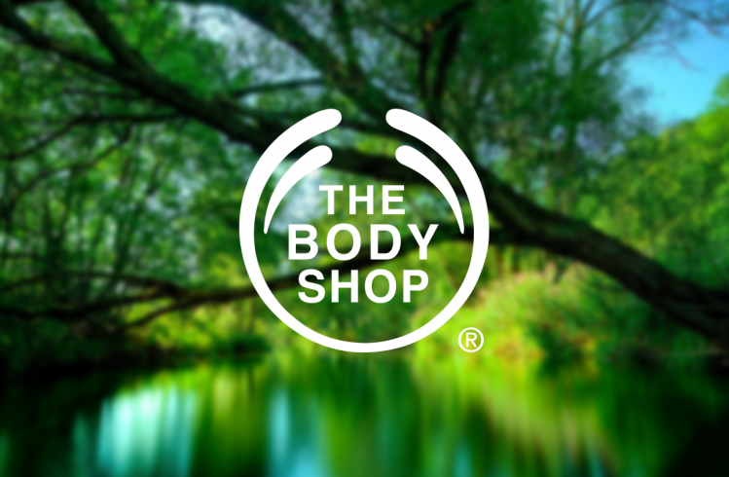

The Bodyshop
“Works for creating better and more beautiful world”
We not only enhance your beauty but also the beauty of the world.

Our Brand Story  The first store of Bodyshop was opened on 26th march 1976 in Brighton. By 1978, the Kiosk was the first franchise of the company and after two years the next shop was opened. The main motto of Bosyhop was green peace and for this in 1986 as a public company, they sponsored the poster of Greenpeace. The Body Shop's first significant window campaign was "Save the Whale" in 1986 with Greenpeace, and the following year it established its own Environmental Projects Department.  In 1986, a vendor in southern India makes a Footsie Roller for The Body Shop as the company's first Community Trade product. After years of trading Footsie Rollers with Teddy Exports in India, one of our most important Community Trade suppliers, the relationship between the two companies grew into what it is now. Demand for The Body Shop's® goods skyrocketed, leading to the company's rapid development; by 1990, just a year after debuting in the United States, 2,500 franchise applications had been submitted. The Body Shop Foundation, a charitable organization that supports organizations working to advance human rights and safeguard the environment, was founded in 1990. In 1991, as an initiative of The Body Shop Foundation, "The Big Issue," a newspaper for the homeless, is published for the first time. The Body Shop Foundation spotted potential in The Big Issue and helped support its 1998 Los Angeles debut thanks to the publication's popularity in the UK (Imms, 2016).  The company has now more than 1000 range of products and they have almost 3000 stores around the world. They take creative initiatives to protect the environment and also, they don’t use any harmful materials to manufacture their products. This attracts the customers most and hence the demand for the products of Bodyshop is increasing day by day. They have outlets in more than 65 countries. They have 10,000 employees around the world. Their yearly revenue is £5.3 billion (Body Shop, 2022).  Mission statement: Our main mission is to work for a fairer and more beautiful world. We want to empower women and girls. They want to make sure that everyone is beautiful with their internal power. (The Body Shop, 2022). | 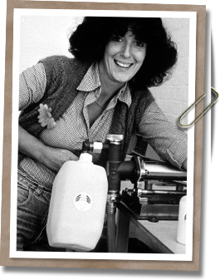  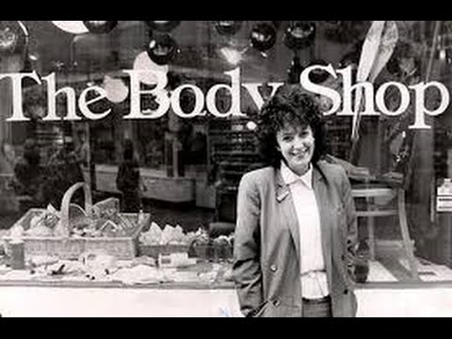  A 33-year-old lady… whose name is Roddick faced immense challenges in opening a new store for her brand. She was rejected for a loan because nobody wanted to help a hippie chick dressed like Bob Dylan T-shirt who makes money by selling cocoa butter cream- she said
What do we offer????  (Our products)  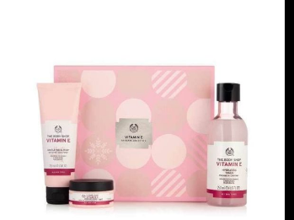  Body care………  We understand the importance of all your body organs and for this, we have brought body care products too to make your body's skin feel better. Our body care products also do not use any harsh chemicals instead we use flower and fruit extract. Also, any fatty acids collected from animals don’t get used in our products. We have different types of body care items and these are shower gels, body scrubs, bath salt, etc. Our body butter and mango body butter have special places in the hearts of the customers. Make your shower time special with our products full of fresh and organic smell. With our British rose body care range, you can always have a special rosy bath.  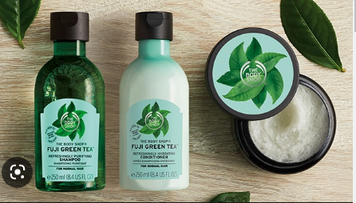  Hair Care….  We know that good hair can easily boost your mind and for that, we collected natural ingredients to make shampoos and conditioners for your hair care. We have hair masks, hair serums, and hair scrubs that will easily make sure you have a good hair day. We use bananas, gingers, and apples for making hair care products. Our tea tree shampoos are truly gems for your hair. Bananas will help to make your hair more nourished and ginger will help you to protect your scalp. Our coconut oils will make your hair silkier and more nourished. Our products will make your hair smooth enough to flip like you just don’t care (Gupta & Gupta, 2019).  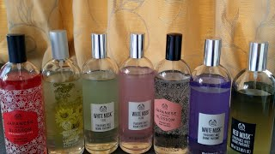  How much do you have to pay  (Our Pricing Strategy)  Bodyshop is one of the most renowned brands and also the products are made of natural ingredients so the price is quite luxurious. We offer a competitive pricing strategy so that we can gain competitive advantages. For women who are more curious about their skin and health care and who want to get the best products for their skin and body care for them, we are the best choice. We believe buying good products for our skin and body is a kind of investment not any type of waste of money. So, you can have the best deal on products at a good price from us (Hitesh Bhasin, 2021).  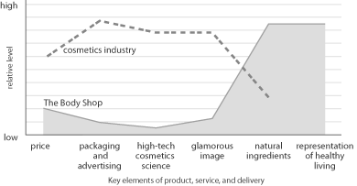  Our Distribution channels  Our robust supply chain allows us to efficiently import raw materials and deliver finished goods to our clients on time, every time. We can get supplies from nearby neighbourhoods with the aid of our well-established network of wholesalers. We are committed to the franchise model, and our stores, with their soothing decor and friendly staff, have proven to be quite successful. We also sell our goods through the network marketing platform 'The Body Shop At Home.' Established in 1994, this system allowed consultants and distributors to expand their businesses by teaming up with new sales agents. In 2008, a report stated that consultants were offered a discount of 25% off the retail price of products when using this distribution channel, which had previously been tested in Australia and then expanded to other countries, including New Zealand, Canada, Germany, Mexico, France, South Korea, and the Netherlands  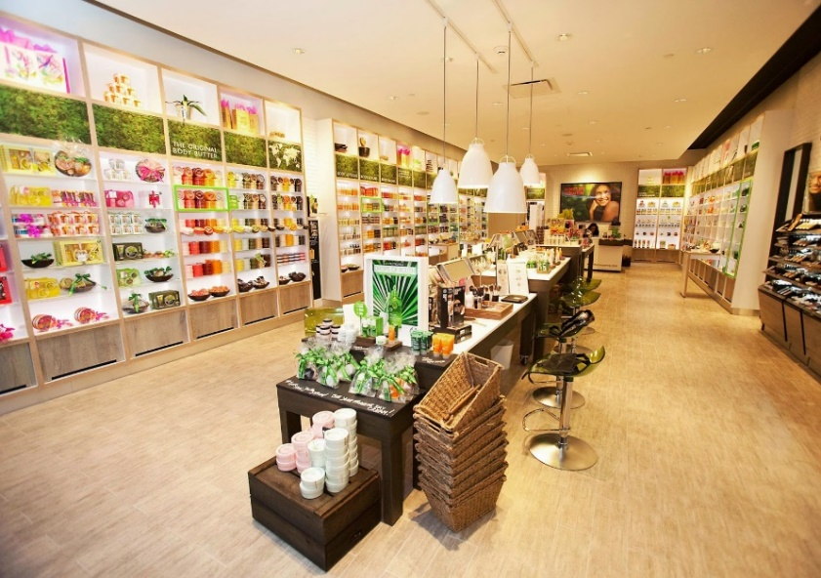 | We offer 900+ skin care, body care, and hair care products inspired by nature  Face Care……  We believe that your face is your love, your asset and to take care of your priceless asset we offer several skin care products. All the products are cruelty-free and made with organic materials like cocoa butter, aloe vera, orange extract, etc. We have a range of products for face care such ad moisturizers, exfoliators, toners, cleansers, etc. To get your happiest and healthiest skin use the products regularly in the morning and night skincare routine. We know that women have different types of skin and we have products for all types of skin- sensitive, dry, and oily. Our skills will help you enhance your beauty and boost your inner confidence.  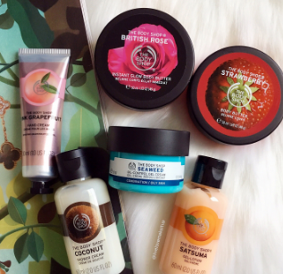  Fragrance………  We offer different fragrances for you and we try to produce the fragrance out of nature. We believe that nature is the best source of fragrance and for this, we try to use natural products like red mus, white musk, etc. Also, we use coconut, strawberries, and cocoa butter to make the fragrances. We have perfumes for both males and females and our fragrance can refresh your mind.  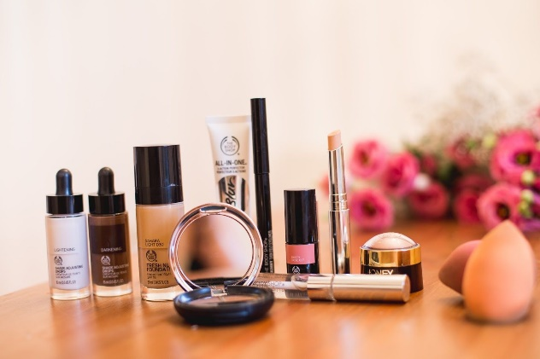  Makeup items…  The makeup items of our brand will naturally enhance your beauty. We have several products like a lip tint, BB cream, foundation, bronzer, etc. and these products are good enough to boost your confidence. We do not use any harsh chemicals or cruel items in our products so these are harmless and you can use them as much as you want to.  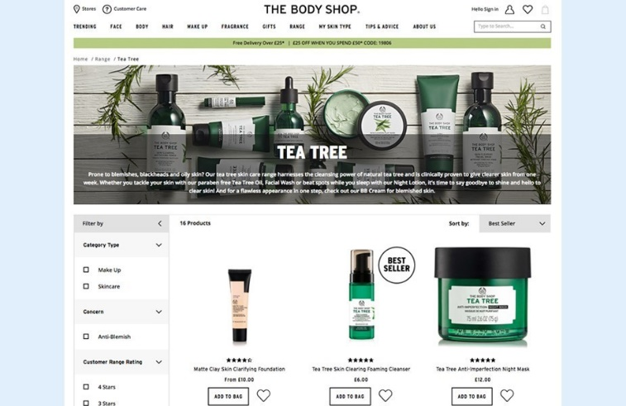  We provide discounts and sales offers for customers which make sure that people from all over the world get our product at a minimum price. We have our outlets in different countries where people have mid-level income and for them, we have launched a medium range of products. Since our products are made of natural ingredients, they cause no harm to the environment so customers who want to use products without feeling any guilty prefer our products.  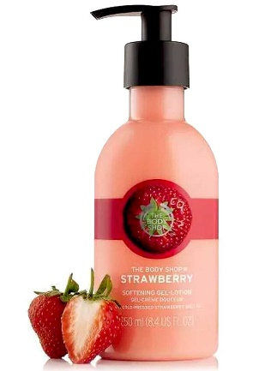  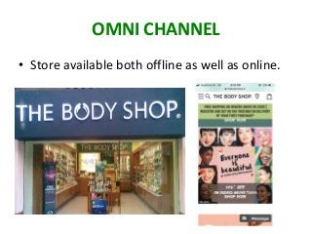  We provide both online and offline. You can find our products easily at your nearest places and also on our websites you can place an order for the products. We tried to keep the buying process convenient for our customers. Also, people from different areas of the world can find us easily through our websites and our outlets.
Promotion  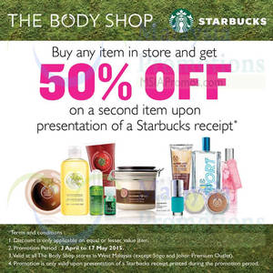  We try to make good sales offer periodically to make sure the customer can afford our products. We provide 50%, 30%, and free shipping offer to make sure the customers can afford the products easily.  There are several campaigns we have arranged to make people alert to protect the environment. Most of our products are made of natural products and the products are cruelty-free which make the customers attracted to the brands. If you want to join the team of cruelty-free you can start using our brands. One of The Body Shop's missions is to revolutionize the cosmetics industry. The "Forever Against Animal Testing" campaign has just begun and will continue until 2019 with the same messaging. For this campaign, they collaborated with "Game of Thrones" actress Maisie Williams and several social media influencers. | 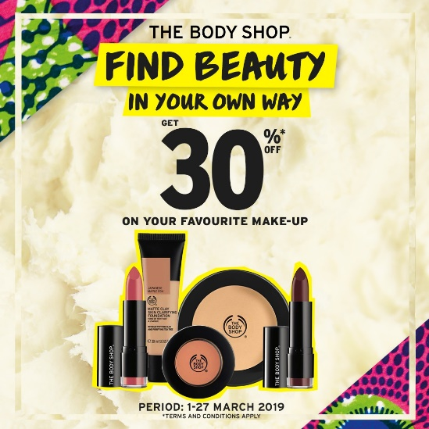  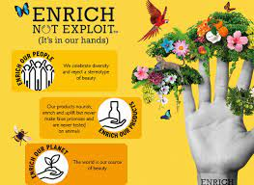  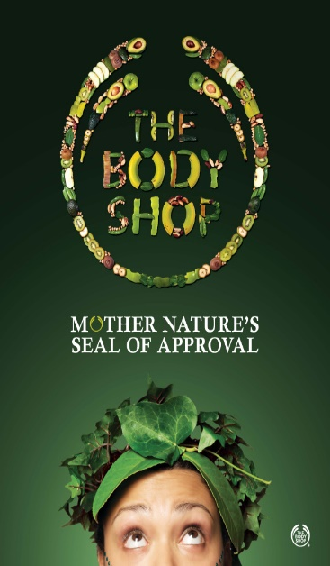
References
Alam Khan, M.S. (2019) “Promotional tools: Household marketing strategy and its effectiveness,” Business and Management Research, 8(2), p. 32. Available at: https://doi.org/10.5430/bmr.v8n2p32.
Body Shop (2022) Cosmetic & Beauty Products: Make-Up & Skincare: Vegan & Vegetarian: The body shop, Bangladesh, The Body Shop. Available at: https://www.thebodyshop.com.bd/ (Accessed: November 12, 2022).
Gupta, A. and Gupta, A. (2019) The Life and Times of Anita Roddick: Founder of Body Shop, philanthropist, Qrius. Available at: https://qrius.com/remember-the-titans-anita-roddick-the-cosmetics-mogul-with-a-divine-soul/ (Accessed: November 12, 2022).
Hitesh Bhasin (2021) Shop by range: Beauty Range: The body shop®, Shop By Range | Beauty Range | The Body Shop®. Available at: https://www.thebodyshop.com/en-gb/range/h/h00007 (Accessed: November 12, 2022).
Imms, A. (2016) The Body Shop's founder Dame Anita Roddick remembered 40 years after it opened in Brighton, The Argus. The Argus. Available at: https://www.theargus.co.uk/news/14391162.the-body-shops-founder-dame-anita-roddick-remembered-40-years-after-it-opened-in-brighton/ (Accessed: November 12, 2022).
The Body Shop (2022) Our brand purpose: Our manifesto: The body shop®, Our Brand Purpose | Our Manifesto | The Body Shop®. Available at: https://www.thebodyshop.com/en-gb/about-us/our-story/brand-purpose/a/a00003 (Accessed: November 12, 2022).

