

T-test to Investigate the Influence of Own-Race Bias on Ability to Correctly Recall Faces

Louisa Smith
University of Wales Trinity Saint David
0173005

Abstract
Own-Race Bias has been shown to affect a person’s ability to correctly recall a person’s face if they are of a different race. A study was carried out with twenty-nine first-year students at the University of Wales Trinity Saint David to investigate this. The study involved participants viewing a PowerPoint presentation of black and white faces, and recording how many they were able to correctly recall. The results of the study were calculated by hand using a t-value and showed that the initial hypothesis was rejected. However, there are limitations found within the study, such as the fact it was conducted within a group setting and the single ethnicity shared by all participants, which mean the results should not be used to make a generalisation of a wider population.

Introduction

The Own-Race Bias (or Cross-Race Effect) is known as the tendency within individuals to better recognise and recall the faces of people of their own race than those of another race (Wright, Boyd &Tredoux, 2001). Own race bias has been shown to have real world implications, most notably within the criminal justice system and cross-racial identification. Once such example is the 1971 case of the “Quincy Five” (cited in Meissner and Brigham, 2001) a case in which five black men from Tallahassee, Florida, were wrongfully convicted of robbery and murder via testimony from five white eyewitnesses, despite a lack of physical evidence against them. Later investigation by the defence of one of the men resulted in the real perpetrators being identified and convicted following fingerprint identification. When further questioned, one eyewitness even admitted to believing that all black people looked alike. Similarly, a study conducted by Brigham and Ready (1985) found that Own-Race Bias seemed to influence how people constructed a police line-up. The study found participants were likely to say that more faces looked similar to the “suspect” if the suspect was of a different race to the participant. Cases like this highlight the need for further research into Own-Race Bias in order to prevent innocent people being convicted of crimes via false identification.
The cause of Own-Race Bias is still unclear, however researchers at Miami University (Bernstein, Young & Hugenburg, 2007) have attempted to investigate Own-Race Bias as a consequence of in-groups vs. out-groups. This study did find that faces of the perceived in-group were recognised better that those of the out-group, this would suggest that self-categorization of race may be more influential than genetically inherited race in recalling faces. Therefore, in a study where all of the participants identify themselves as white, the hypothesis would be that the participants will be able to correctly recall more white faces than black faces.

Method

Participants
A total of 29 participants took part in the recall task. These were a convenience sample of first year psychology students studying psychology at University of Wales Trinity Saint David. The participants comprised of 7 males and 22 females who all identified their ethnicity as white. The participants ages ranged between 18 and 60 (M = 27.31, SD = 10.81).

Design
The study used within subjects to investigate the hypothesis. The experiment focused on just one independent variable (IV) which was the ethnicity of the participants. The dependent variable (DV) was the number of faces correctly recalled. The conditions of the IV and DV were black and white faces. A paired samples T-test was used to analyse the results of the experiment. A t-test was used as this allows for the group’s data to be compared to another group in potential future studies, to compare differences. The calculations were done by hand and not using any statistical software. (Appendix A)

Materials
The experiment itself used a power point slide presentation (Appendix B) to display information and images to the participants. The presentation was shown in two parts. Part one showed twelve faces on individual slides for two seconds each (six black, six white). In part two, there was again an even distribution of black and white faces. Thirty-six faces where shown in total in part two, with six numbered faces shown per slide, including faces that had not been shown on the previous slides. Each of the slides showing six faces was displayed for twelve seconds each (two seconds per face as in part one). In both parts the slides were successive with no interval between them. A response sheet (Appendix C) was used for participants to record their responses. Responses were collected in a specified section of the sheet, above this, participants were asked to enter their own demographic data (age, gender and ethnicity).

Procedure
The study took place within a large teaching room and in a group setting. Participants were given a consent form to read and sign (Appendix D). The form included brief details of what the study would involve (looking at faces, recall task, etc.). The form also reminded the participants of their right to withdraw the study and how their data would be stored. Once the participant had signed the form, this was collected by one of the researchers. Participants were advised by one of the researchers of the need for silence while the study was being carried out to minimize distraction. The power point presentation was then displayed on a large projector at the front of the room. The instructions of the study and what would be required was displayed on the first slide.
A countdown was played to the beginning on part one of the presentation. During part one, participants simply had to watch the slides passively and look at the faces shown. After part one, one of the researchers spoke to the group for approximately one minute, giving information about the study and report. Following this distraction, participants were again asked to look at the slides in silence for part two. For part two, participants were instructed to write down on the response sheet the number corresponding to the face on the slides that they recalled from part one. After the slides had timed out, a final debrief slide (Appendix E) appeared stating that the task was complete and to inform the researcher if participants had any questions.

Results

The t-test result was t(28) = 3.12, p < 0.05 which indicates that this result is significant. The results found that participants were better able to recall more black faces (M = 3.34, SD = 2.42) than white faces (M = 2.67, SD = 1.97). This means that the original hypothesis has been found to be null, and is therefore rejected.

Discussion

The results do reject the hypothesis that the white participants would be able to recall white faces than black faces, as the number of black faces recalled correctly was higher than the number of white face recalled correctly. These results contradict the results found in the studies discussed in the introduction, whose results strongly supported the Own-Race Bias. This study would seem to be an anomaly within research of Own-Race Bias, however a number of factors may have affected the study and potentially the results. The group setting of the study may have meant that not all of the participants had the same view of the projection of the slide, this could mean that participants were not able to clearly see all of the face being displayed in both part one and part two. For example, in a study by Malpass and Kravitz (1969), participants were alone in a room with the images they were instructed to look at, meaning they could pick up the images and look at them in a manner that allowed them to potentially notice more details about the face. This also meant the all of the participants had the opportunity to view the images in the same way and potentially pick up more details when compared to the participants of this study. In part two the slides depicted six faces each, in contrast with part one which showed only one face per slide. This introduction of much more visual information per slide combined with the reduction in size of the pictures to fit six on each slide could have negatively impacted the participant’s ability to process the features of each face in order to decide if the face had been seen before. It should also be noted that conducting a study of this nature in an ecologically valid way would be extremely difficult, as participants would need to consciously state whether or not they are able to remember a face, and so would result in the participant paying much more attention to the face than they may have done in a real-world setting.
In conclusion, though the results would reject the initial hypothesis, the way the study was conducted cannot mean that a generalisation can be made. A small sample size of twenty-nine participants of only one identified ethnic background is not representative of the general population, and less representative again of potential differences between genders. A suggestion for future studies could be to conduct the study with participants on an individual basis, with each face shown separately and equal in size. This would remove the issues of participants not being able to view the pictures in the same way as other participants. Another suggestion would be to include a similar study with a wider range of ethnicities to be able to make a generalisation of the Own-Race Bias.

References

Malpass, R. & Kravitz, J. (1969). Recognition for faces of own and other race. Journal of Personality and Social Psychology, 13(4)
Meissner, C. & Brigham, J. (2001). Thirty years of investigating the own-race bias in memory for faces: A meta-analytic review. Psychology, Public Policy, and Law, 7(1)
Brigham, J. & Ready, D. (1985). Own-race bias in lineup construction. Law and Human Behavior, 9(4)
Bernstein, M., Young, S. & Hugenberg, K. (2007). The Cross-Category Effect. Psychological Science, 18(8)
Wright, D., Boyd, C. &Tredoux, C. (2001). A field study of own-race bias in South Africa and England. Psychology, Public Policy, and Law, 7(1)

Appendices
Appendix A)
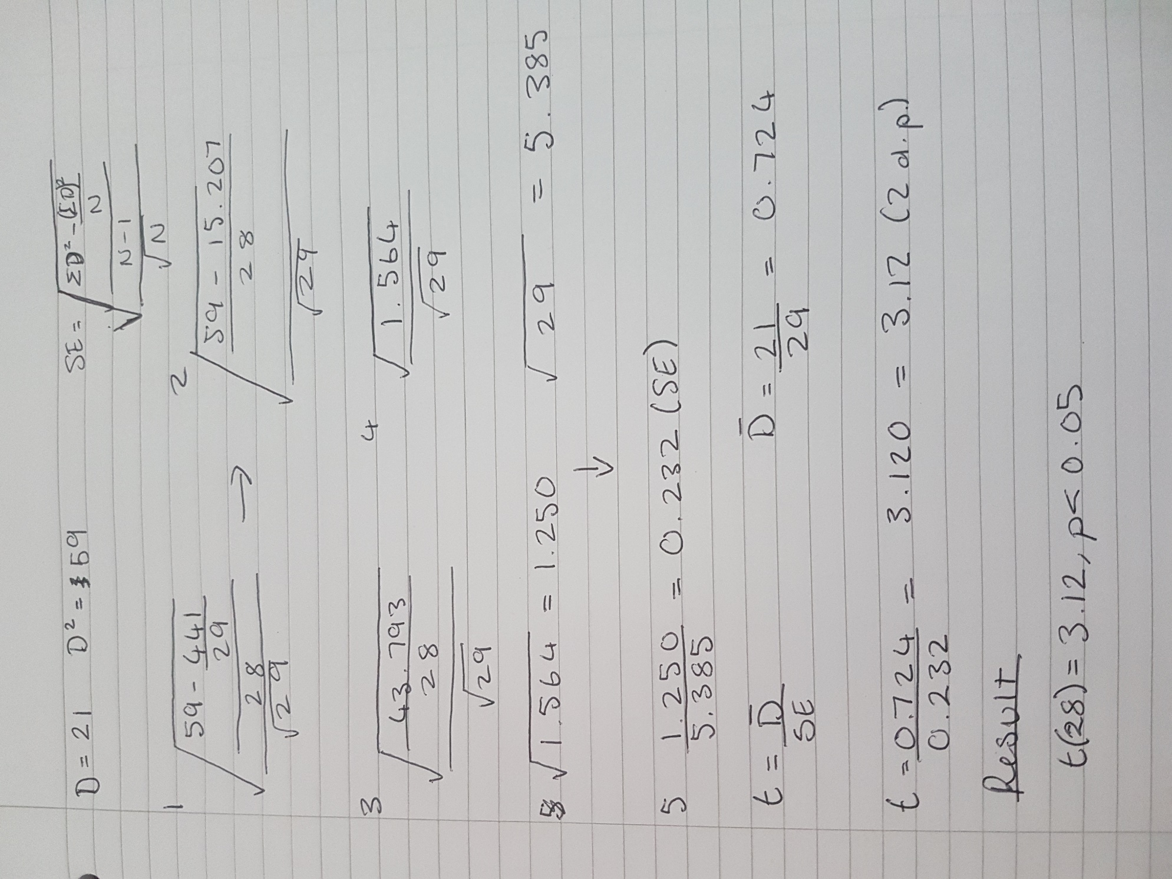

Appendix B)




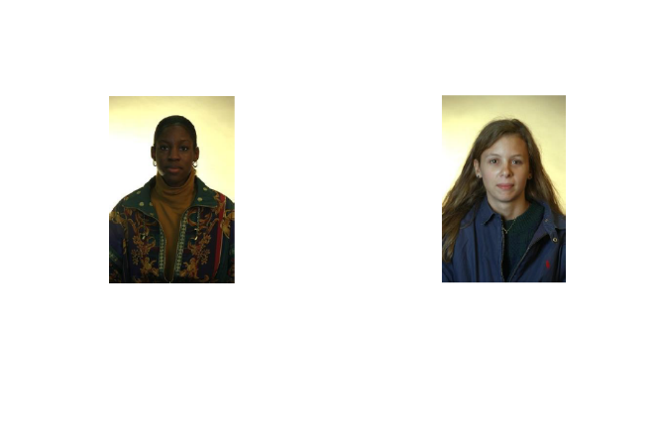

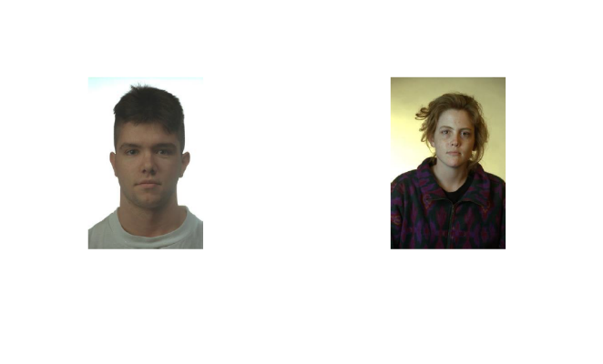
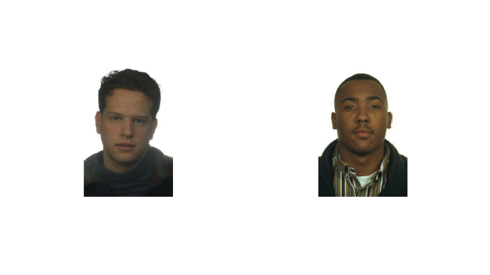

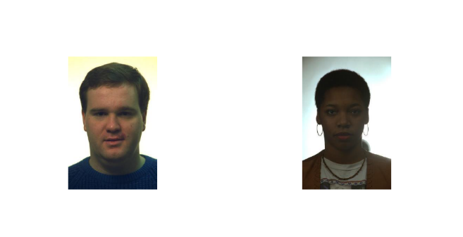
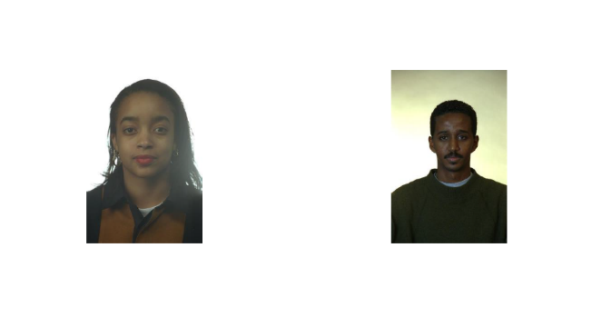


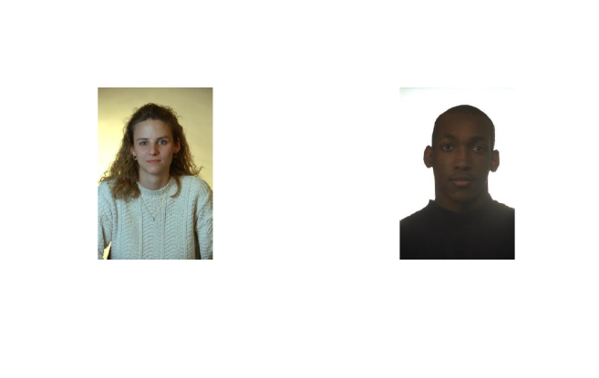




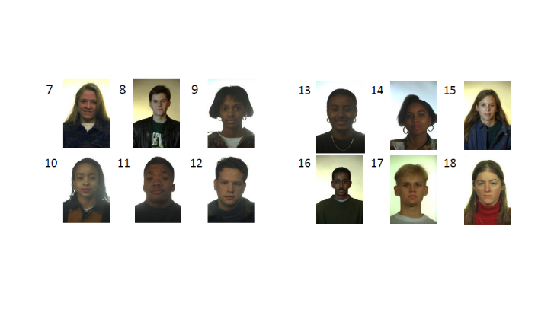
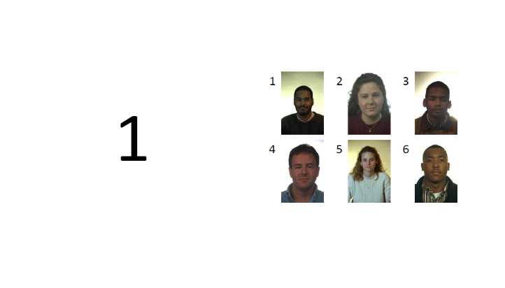


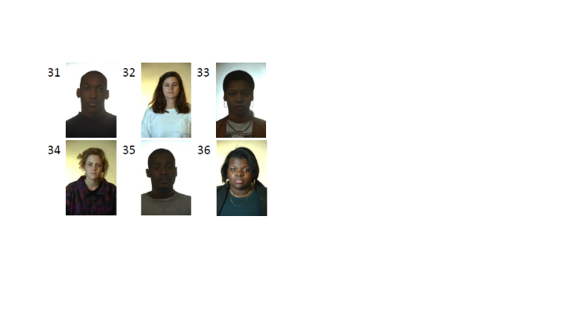
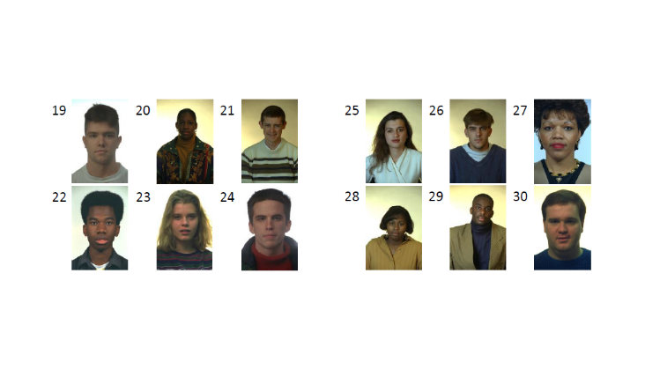



Appendix C)
Research Methods Data Collection Study

Please specify your gender:
- Male
- Female
- Other
- Prefer not to say

Please state your age: _______________________________

Please state your ethnicity: ___________________________

Please use the space below to record your responses to Part Two of this study.

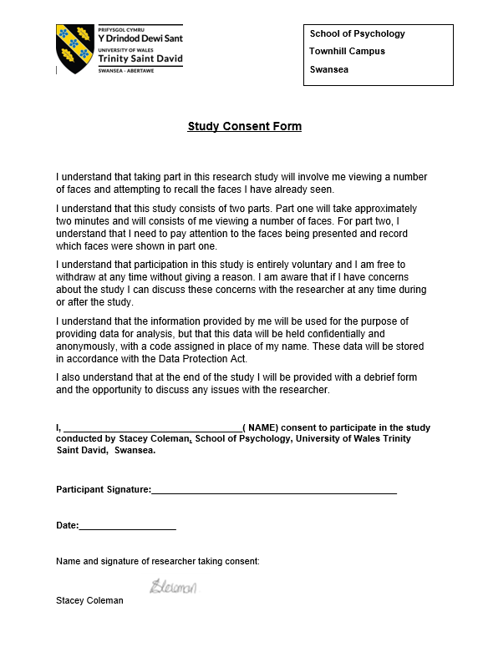
Appendix D)

Appendix E)
Debrief information

Thank you for taking part in this study.
The main aim of this study was to explore whether people are better able to recall and identify faces that belong to the same ethnicity as them – their ‘in-group’. We specifically hypothesised that participants would be able to recall significantly more faces that belonged to their in-group than their out-group.
If you wish to withdraw your data from the study you must tell the researcher now. After this point, all of your data will remain confidential and we will not trace it back to you.

