

LOCATION: Swansea | LLEOLIAD: abertawe
LEVEL 5 | LEFEL 5
EXAMINATION PERIOD | CYFNOD ARHOLIADAU
January 2025 | Ionawr 2025

MODULE CODE: ACDA5001
Electrical Engineering

TIME: 2 HOURS
answer ALL THE questions

Equipment or materials required – Calculator
Adnoddau neu ddefnyddiau sydd eu hangen - Cyfrifiannell

ANSWER ALL THE QUESTIONS
Question 1 [25 marks]
- An Alternating voltage, used to power an AC motor is described by the equation $V=100Sin (150πt-0.25)$. Determine the following parameters to evaluate the motor’s power supply characteristics.
- Peak to peak voltage [2 Marks]
- RMS voltage [2 Marks]
- Frequency [2 Marks]
- Phase Angle [2 Marks]
Answer:
- peak to peak voltage
$Peak to Peak Voltage = 2×Amplitude$ $=2×100$ [1 Mark]
$Peak to Peak Voltage=200V$ [1 Mark]
- RMS value
$V_{RMS}=\frac{V_{m}}{\sqrt{2}}=\frac{100}{\sqrt{2}}$ [1 Mark]
$V_{RMS}=70.7V$ [1 Mark]
- Frequency
We know that $ω=2πf=150π$
$2πf=150π$ [1 Mark]
$2f=150$
$f=75Hz$ [1 Mark]
- Phase angle
$ϕ=0.25 radians laggin$g
$0.25 radians={\left(0.25×\frac{180}{π}\right)}^{o}$ [1 Mark]
$ϕ={14.32}^{o}$ [1 Mark]
- A coil with an inductance of $0.1H$ and a resistance of $5Ω$ is used in a relay circuit. When this circuit is switched on to a 220V supply. Calculate the steady state current in the circuit and the rate of rise of current at t=0 and at $t=2τ$and analyse the results. [where $τ=\frac{L}{R}$] [13 Marks]
Answer:
The Steady state current $I_{0}=\frac{V}{R}=\frac{220}{5}=44A$ [2 Marks]
To Find rate of Rise of current at t=0
The rise in Current is given by
$i=I_{0}\left(1-e^{-t/τ}\right)$ [1 Mark]
$i=\frac{V}{R}\left(1-e^{-{Rt}/L}\right)$
$i=\frac{220}{5}\left(1-e^{-{5t}/{0.1}}\right)$ [1 Mark]
$i=44\left(1-e^{-50t}\right)$
$i=44-44e^{-50t}$
The rate of change of Current with respect to time can be determined by differentiating the above equation with respect to t.
$\frac{di}{dt}=0-44(-50)e^{-50t}$ [2 Marks]
$\frac{di}{dt}=2200e^{-50t}$
At t=0
$\frac{di}{dt}=2200e^{-50×0}$ [1 Mark]
$\frac{di}{dt}=2200e^{0}$
$\frac{di}{dt}=2200 A/Sec$
At t=0, the rate of rise of Current is 2200A/Sec [2 Marks]
At t=$2τ$
$\frac{di}{dt}=2200e^{-50×2τ}$ [1 Mark]
$\frac{di}{dt}=2200e^{-50×2\frac{L}{R}}$
$\frac{di}{dt}=2200e^{-50×2\frac{0.1}{5}}$
$\frac{di}{dt}=2200e^{-2}$
$\frac{di}{dt}=2200×0.135$
$\frac{di}{dt}=297A/Sec$
At t=$2τ$, the rate of rise of Current is 297A/Sec [2 Marks]
Rate of rise of current has reduced when t=$2τ$ [1 Mark]
- Describe eddy current loss in a transformer. List one technique to minimise eddy current loss. [4 Marks]
Answers:
Eddy current loss in a transformer occurs when circulating currents, known as eddy currents, are induced in the core due to the alternating magnetic field. These currents generate heat as they flow through the core's resistance, leading to energy loss. [3 Marks]
Eddy current loss can be minimised by laminating the core. [1 Mark]
Question 2 [25 marks]
- A supply voltage of $V_{1}=25V$ is given to the circuit shown in fig:1. Determine the following
- Calculate the load current. [9 Marks]
- Determine the value of load resistor for maximum power transfer across the load. [3 Marks]
- Draw a simplified circuit diagram for the circuit shown in fig.1 [3 Marks]
- Calculate the Maximum power transferred across the load ($P_{L})$. [4 Marks]
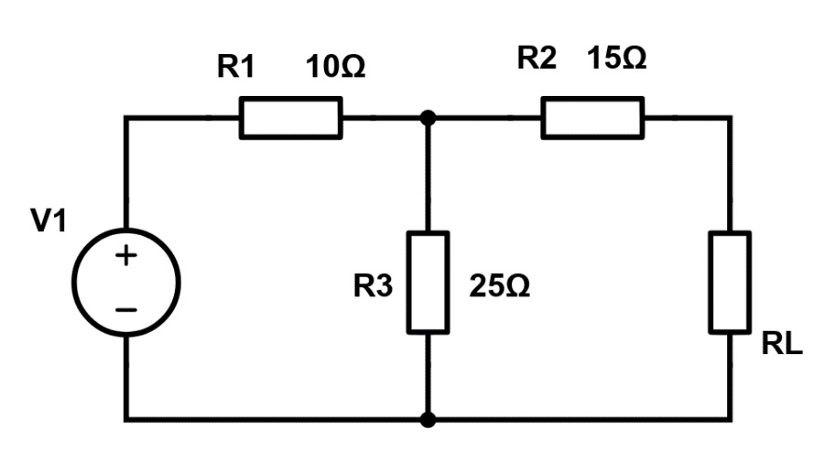
Fig: 1
Answer:
- The Load Current,
Voltage across 25$Ω$ resistor,
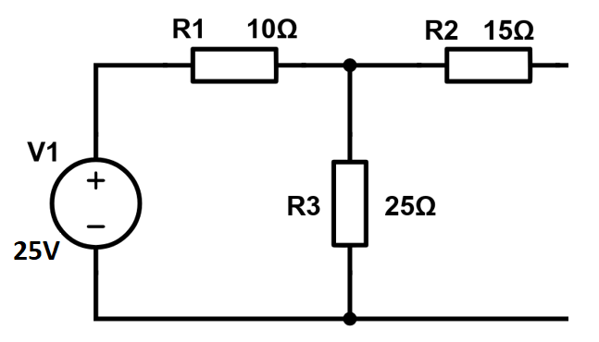
To find current in the loop,$I=\frac{25}{35}=0.71A$
$V_{25Ω}=0.71×25=17.75V=V_{th}$ [3 Marks]
To Find $R_{th}$
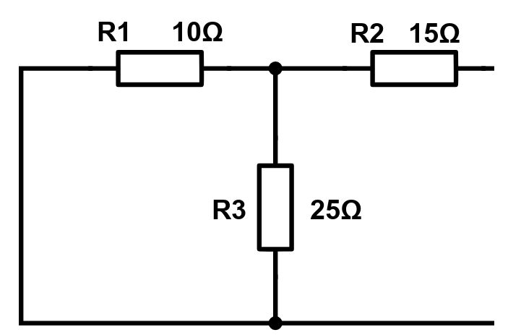
$R_{1}$ parallel to $R_{3}$=7.143Ω
7.143Ω series with $R_{2}$=22.143 Ω
$R_{th}=22.143Ω$ [3 Marks]
$I_{L}=\frac{V_{th}}{R_{th}+R_{L}}=\frac{17.75}{22.14+22.14}=0.401A$ [3 Marks]
- Value of load resistor, when maximum power is transferred across the load,
According to Maximum power transfer theorem, maximum power will be transferred across the load, when the Load resistor is equal to internal resistance. Hence Internal resistance is $22.143 Ω$ [3 Marks]
- Draw a simplified circuit diagram for the circuit shown in fig.1
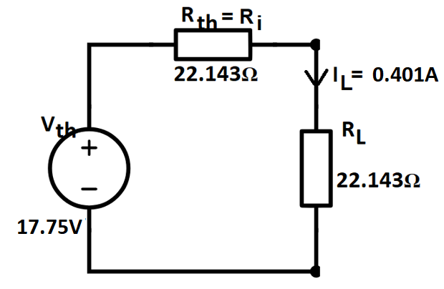
[3 Marks]
- The maximum power transferred across the load ($P_{L})$.
$P_{L}=I_{L}^{2}R_{L}={0.242}^{2}×22.143$ [3 Marks]
$=1.2968W$ [1 Mark]
$This is the maximum power transfered across the load$.
- Describe the functions of the following components used in DC machines
- Field System [3 Marks]
- Armature [3 Marks]
Answers:
  - Field System
It consists of number of poles bolted inside the circular frame .It provide uniform magnetic field. [1 Mark]
The mmf (magnetomotive force) produced by the field windings provides a magnetic flux that passes through the pole pieces, the air gap, the armature and the frame. [2 Marks]
  - Armature
The armature consists of coils of wire wound around a metal core. When the armature rotates within the magnetic field created by the stationary field magnets, an electromagnetic force (EMF) is induced in the armature coils due to electromagnetic induction. [3 Marks]
Question 3 [25 marks]

- A $400V$, three phase star connected alternator supplies a delta – connected load as shown in fig: 2. Each phase of which has a resistance of $30Ω$ and inductive reactance $40Ω$. Analyse the system and:
- Calculate the current supplied by the alternator, [7 Marks]
- Determine the output power of the alternator, [4 Marks]
- Calculate the Apparent power (kVA) of the alternator. [3 Marks]
Neglect the losses in the line between the alternator and the load.

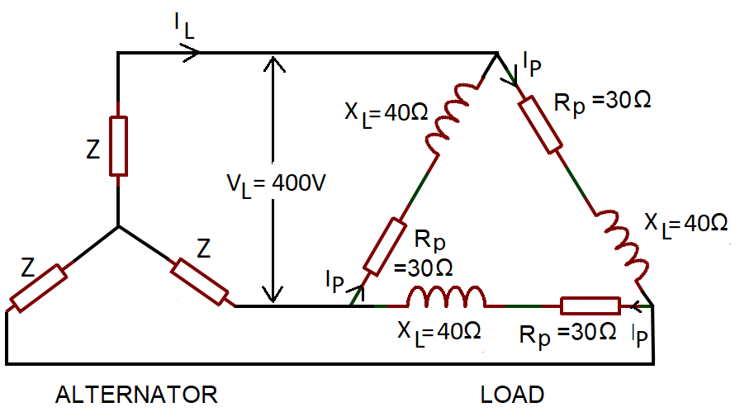
Fig: 2
Answer:
- the current supplied by the alternator,
Consider the Load: Phase Current =$I_{p}=\frac{V_{p}}{Z_{p}}$
$V_{p}=V_{L}$ for delta connection. Hence $V_{p}=400V$ [1 Mark]
Phase impedance, $Z_{p}=\sqrt{{(R}_{p}^{2}+X_{L}^{2})}=\sqrt{{30}^{2}+{40}^{2}}=50Ω$ [2 Marks]
Hence, $I_{p}=\frac{V_{p}}{Z_{p}}=\frac{400}{50}=8A$ [2 Marks]
For delta connection line current, $I_{L}=\sqrt{3}I_{p}=\sqrt{3}×8=13.86A$ [2 Marks]
13.86A is the current supplied by the alternator.
- the output power of the alternator,
Alternator output power is equal to the power dissipated by the load .
$P=\sqrt{3}V_{L}I_{L}Cosϕ$ [1 Mark]
Where $cosϕ=\frac{R_{P}}{Z_{p}}=\frac{30}{50}$
$cosϕ=0.6$ [1 Mark]
Hence, $P=\sqrt{3}×400×13.86×0.6$ [1 Mark]
$P=5.76KW$ [1 Mark]
- the kVA of the alternator.
Alternator Output kVA, S=$\sqrt{3}V_{L}I_{L}$ [1 Mark]
$S=\sqrt{3}\left(400\right)\left(13.86\right)$ [1 Mark]
$S=9.60kVA$ [1 Mark]
- A 415V, three phase AC motor has a power output of 12.75kW and operates at a power factor of 0.77 lagging and with an efficiency of 85%. If the motor is delta-connected, Apply you knowledge to determine the following,
- Input Power [3 Marks]
- Line current [3 Marks]
Answer:
- The Power input
$Efficiency=\frac{Power Output}{Power Input}$
$\frac{85}{100}=\frac{12750}{Power input}$ [1 Mark]
$Power Input=\frac{12750 ×100}{85}=15000W$ [2 Marks]
- The Line current
$I_{L}=\frac{P}{\sqrt{3}\left(415\right)\left(0.77\right)}=\frac{15000}{\sqrt{3}\left(415\right)\left(0.77\right)}$ [2 Marks]
$I_{L}=27.10A$ [1 Mark]

- A generator is connected to a $60Ω$ load and supplied with a current of 8A. If the armature resistance is 5$Ω.$ Calculate the terminal voltage and the generated e.m.f. [5 Marks]
Answer:
Terminal Voltage: $V=I_{a}R_{L}=8×60$ [1 Mark]
$V=480V$ [1 Mark]
Generated EMF, $E=V+I_{a}R_{a}=480+(8×5)$ [2 Marks]
$E=520Volts$ [1 Mark]
Question 4 [25 marks]
- A RLC series circuit consists of $R=75Ω$, $L=125mH$ and $C=200μF$. The circuit is excited by a sinusoidal source of voltage $115V, 60Hz$. Using Complex functions analyse and determine the following.
- Impedance in the circuit [7 Marks]
- Current across the circuit [2 Marks]
- Voltage across each element [6 Marks]
- Apparent power [2 Marks]
- Active Power [2 Marks]
- Reactive power [2 Marks]
- Construct a Phasor diagram to represent the circuit [4 Marks]
Answers:
- Impedance in the circuit
Inductive Reactance= $jX_{L}=j2πfL$
$=j2π×60×125×{10}^{-3}=j47.124Ω$ [1 Mark] Capacitive Reactance= $-jX_{C}=-j\frac{1}{2πfc}$
$-jX_{C}=-j\frac{1}{2π×60×200×{10}^{-6}}=-j13.263Ω$ [1 Mark]
Total Reactance$=jX=jX_{L}-jX_{C}=j47.124-j13.263=j33.861Ω$ [1 Mark]
Impedance, $Z=R+jX=75+j33.861$ [1 Mark]
To find the polar form
$Z=\sqrt{R^{2}+X^{2}}=\sqrt{{75}^{2}+{33.861}^{2}}=82.29Ω$ [1 Mark]
$ϕ=\tan^{-1}\left(\frac{X}{R}\right)=\tan^{-1}\left(\frac{33.861}{75}\right)={24.3}^{o}$ [1 Mark]
Impedance=$82.29∠{24.3}^{o}Ω$ [1 Mark]
- Current across the circuit
Voltage= $115∠0^{o}V$
By Ohm’s Law,
$I=\frac{V}{Z}=\frac{115∠0^{o}}{82.29∠{24.3}^{o}}=1.397∠0^{o}-{24.3}^{o}=1.397∠-{24.3}^{o}A$ [2 Marks]
- Voltage across each element
$V_{R}=I×R=1.397∠-{24.3}^{o}×75=104.78∠-{24.3}^{o}V$ [2 Marks]
$V_{L}=I×jX_{L}=1.397∠-{24.3}^{o}×j47.124$
$V_{L}=1.397∠-{24.3}^{o}×47.124 ∠{90}^{o}=65.832$ $∠{65.7}^{o}V$ [2 Marks]
$V_{C}=I×(-jX_{C})=1.397∠-{24.3}^{o}×(-j13.263)$
$V_{C}=1.397∠-{24.3}^{o}×13.263 ∠-{90}^{o}=18.528$ $∠-{114.3}^{o}V$ [2 Marks]
- Apparent power
$S=VI=115×1.397=160.66VA$ [2 Marks]
- Active Power
$P=VICosϕ=115×1.397Cos{24.3}^{o}=146.47W$ [2 Marks]
- Reactive power
$Q=VISinϕ=115×1.397sin{24.3}^{o}=66.1VAR$ [2 Marks]
- Construct a Phasor diagram to represent the circuit
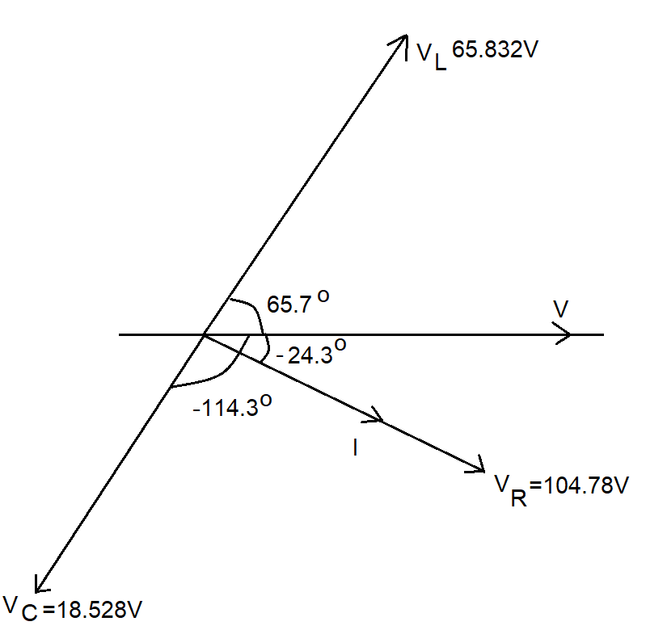
[4 Marks]

Diwedd/End

