

By Florenta Anisoara Chistol

Student ID 2422978

Lecturer: Zarah Ahmed

6TH of July 2026
Programme: BSc Health and Social Care Module: Changemakers: Creativity and Value Creation Module code: BMHP5014
Component 2: Written Assignment
Poster and Pitch
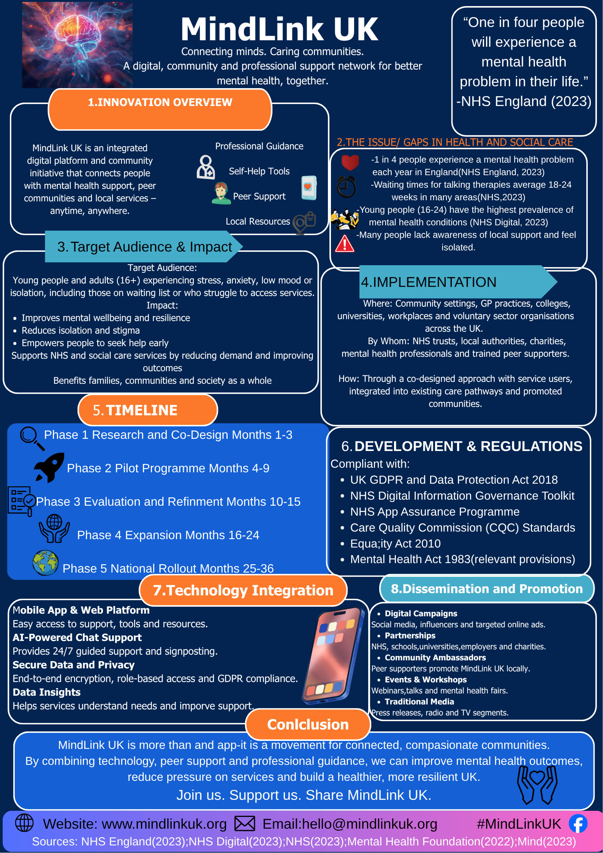
Introduction

Mental health is an essential component of overall health and well-being, however millions of people in the United Kingdom continue to suffer barriers to receiving timely, adequate, and compassionate care. MindLink UK, the proposed innovation, is a digital and community-based mental health support network that aims to bridge the gap between individuals, healthcare providers, and local agencies. Building on the information offered in the poster, this pitch outlines why the effort is necessary, how it fits into current UK health policy and regulation, and why the public should actively support and participate in the campaign.

The Need for Innovation

Mental health issues are one of the primary causes of disability in the UK. According to NHS England (2023), roughly one in every four people will encounter a mental health condition each year. Referrals to NHS talking treatments grew by approximately 30% between 2019 and 2023. However, many people still suffer months-long wait times for treatment, and some do not seek help at all because of stigma, a lack of understanding, or difficulties accessing resources (Mind, 2023).
The situation is most serious among young people aged 16 to 24, who have some of the highest rates of anxiety, depression, and loneliness in the population (NHS Digital, 2023). The COVID-19 pandemic exacerbated these issues, leading to increasing stress, financial insecurity, and social isolation (Mental Health Foundation, 2022).
MindLink UK tackles these challenges by providing early intervention, peer support, and clear referrals to suitable agencies. Rather of displacing existing NHS care, the platform supplements professional services by assisting people in obtaining the right support at the right time.
Who Will Benefit?
The primary target group is young people and adults aged 16+ who are experiencing stress, anxiety, low mood, loneliness or difficulties accessing support. The initiative will also benefit:
- University and college students.
- Individuals on waiting lists for NHS talking therapies.
- People living in rural or underserved communities.
- Carers and family members seeking information and support.
- Employers and educational institutions aiming to improve staff and student wellbeing.
By providing accessible digital tools, peer support groups and direct links to local services, MindLink UK can improve mental wellbeing, resilience and social connectedness. Research demonstrates that early intervention and social support are associated with better mental health outcomes and reduced demand on crisis services (National Institute for Health and Care Excellence, 2022).
How the Innovation Supports Health and Wellbeing
MindLink UK incorporates several features designed to improve health outcomes:
Self-help resources
Evidence-based tools such as mood tracking, cognitive behavioural therapy (CBT) exercises and mindfulness activities can help individuals manage symptoms before they escalate (NICE, 2022).
Peer support communities
Connecting with others who have similar experiences reduces isolation and encourages help-seeking behaviour (Mental Health Foundation, 2022).
AI-assisted signposting
Users can receive immediate guidance towards appropriate local services, crisis support or self-management options.
Educational content
Improving mental health literacy helps people recognise symptoms earlier and seek support sooner.
These features contribute to the common good by reducing pressure on overstretched services, promoting prevention and supporting healthier communities.
Alignment with UK Policy and Legislation
For MindLink UK to be credible and sustainable, it must align with existing UK policy and legal frameworks.
Key legislation and policy alignment
UK compliant
Data protection
The platform must comply with the UK General Data Protection Regulation(UK GDPR) and the Data Protection Act 2018 to ensure that personal information is collected, stored and processed securely (Data Protection Act 2018; Information Commissioner’s Office, 2024).
NHS digital standards
If integrated with NHS pathways, MindLink UK would need to meet the requirements of the NHS Digital Information Governance Toolkit and the NHS App Assurance Programme.
Care Quality Commission standards
Any regulated activities involving healthcare advice or treatment would need to comply with standards set by the Care Quality Commission (Care Quality Commission, 2023).
Equality and accessibility
The initiative must adhere to the Equality Act 2010 by ensuring accessibility for people with disabilities and by avoiding discrimination (Equality Act, 2010).
Mental Health Act considerations
Where users are directed to crisis or safeguarding services, processes must be consistent with relevant provisions of the Mental Health Act 1983 (Mental Health Act, 1983).
By including these principles throughout the design phase, MindLink UK can build trust among users, healthcare professionals, and partner organizations.
Professional Services Involved
Successful implementation requires collaboration across the health and social care system. Key professional groups include:
GPs play an important role in MindLink UK by making referrals and directing people to relevant mental health services.
Mental health nurses participate by providing clinical advice and ensuring that safeguards are in place for service users.
Psychologists and therapists help MindLink UK generate evidence-based mental health information and interventions.
Social workers assist vulnerable people by helping and connecting them with appropriate care and services.
Organisations in the voluntary sector help to enhance mental health by supporting peer support initiatives and community participation.
MindLink UK is supported by universities and colleges, which promote student well-being and encourage access to mental health resources.
Local authorities play an important role by coordinating public health initiatives and supporting the delivery of mental health services within the community.
This multidisciplinary approach reflects the NHS Long Term Plan’s emphasis on integrated, person-centred care (NHS England, 2019).
Encouraging Public Involvement
Public participation is essential to the success of MindLink UK. Mental health affects not only individuals but also families, workplaces, schools and communities. The campaign encourages the public to become involved in several ways:
- Download and use the platform: Individuals can access self-help resources and support networks.
- Share campaign messages: Social media engagement can increase awareness and reduce stigma.
- Become a community ambassador: Trained volunteers can promote the initiative locally.
- Participate in workshops and webinars: Educational events can improve mental health literacy.
- Support fundraising and partnerships: Public support can help expand services into additional communities.
Community involvement is vital because mental health support works best when it is normalized and integrated into daily life. Reducing stigma enables people to seek care earlier, potentially preventing diseases from worsening (Mind, 2023).
Why Stakeholders Should Support the Innovation
MindLink UK offers clear benefits for multiple stakeholders:
Patients and service users
- Faster access to information and support.
- Reduced feelings of isolation.
- Greater confidence in managing wellbeing.
Healthcare professionals
- Improved signposting pathways.
- Better-informed patients.
- Potential reduction in unnecessary appointments.
NHS and local authorities
- Support for prevention and early intervention.
- Reduced pressure on crisis services.
- Enhanced community engagement.
Society
- Improved productivity and educational outcomes.
- Stronger social connections.
- Reduced economic burden associated with untreated mental illness.

Conclusion

MindLink UK is an innovative and practical answer to the growing mental health concerns confronting the United Kingdom. By combining digital technology, peer assistance, and professional supervision, the effort aims to increase support access, eliminate stigma, and strengthen community resilience. The idea is consistent with current NHS aims, national legislation, and public health objectives, while enhancing rather than duplicating existing services.
The success of the program relies on collaboration among healthcare providers, local governments, educational institutions, charities, and the public. Supporting MindLink UK entails investing in early intervention, healthier communities, and a more sustainable health and social care system. Everyone has a role to play, whether it's by using the platform, sharing information, volunteering as a community ambassador, or simply encouraging open dialogue about mental health. MindLink UK can help build a society in which requesting help is normal, accessible, and stigma-free.

References

Care Quality Commission (2023) Regulation 12: Safe care and treatment. Newcastle upon Tyne: CQC.
Data Protection Act 2018. London: The Stationery Office.
Equality Act 2010. London: The Stationery Office.
Mental Health Act 1983. London: The Stationery Office.
Mental Health Foundation (2022) Mental health in the pandemic: Research findings. London: Mental Health Foundation.
Mind (2023) Mental health facts and statistics. London: Mind.
National Institute for Health and Care Excellence (2022) Depression in adults: treatment and management (NG222). London: NICE.
NHS Digital (2023) Mental Health of Children and Young People in England 2023. Leeds: NHS Digital.
NHS England (2019) The NHS Long Term Plan. London: NHS England.
NHS England (2023) Mental health services monthly statistics. London: NHS England.
UK General Data Protection Regulation (2021) Data protection and privacy legislation. London: Information Commissioner’s Office.

