Visual Studies Coursework

Andrew Foxall – 2517335
Animation & VFX – Visual Studies
19/01/2026

Table of Contents
CW2 1
CW1 2
Perspective Drawings 2
One Point Perspective 2
Two Point Perspective 2
Three Point Perspective 2
Anatomy Drawing 2
Hand Sketches 2
Headshot Sketches 2
Full Body Sketches 2
Line Of Action Drawing 2
Photo-Compositing 2
Mood Board Creation 3
Colour Theory 3

CW2
Portfolio Link: https://a2517335.myportfolio.com/

CW1

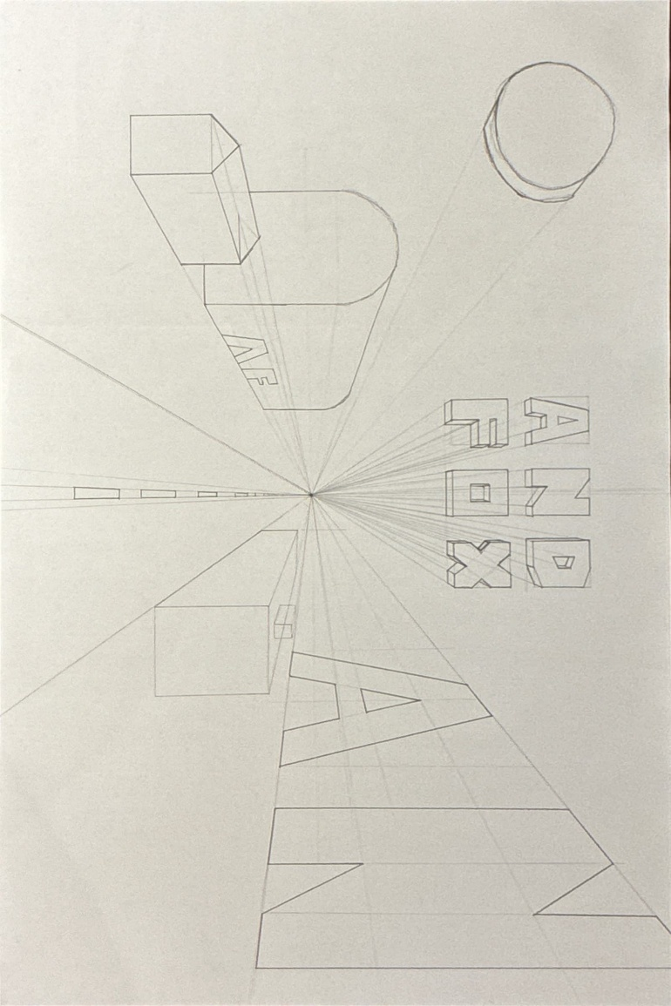
Perspective Drawings

One Point Perspective
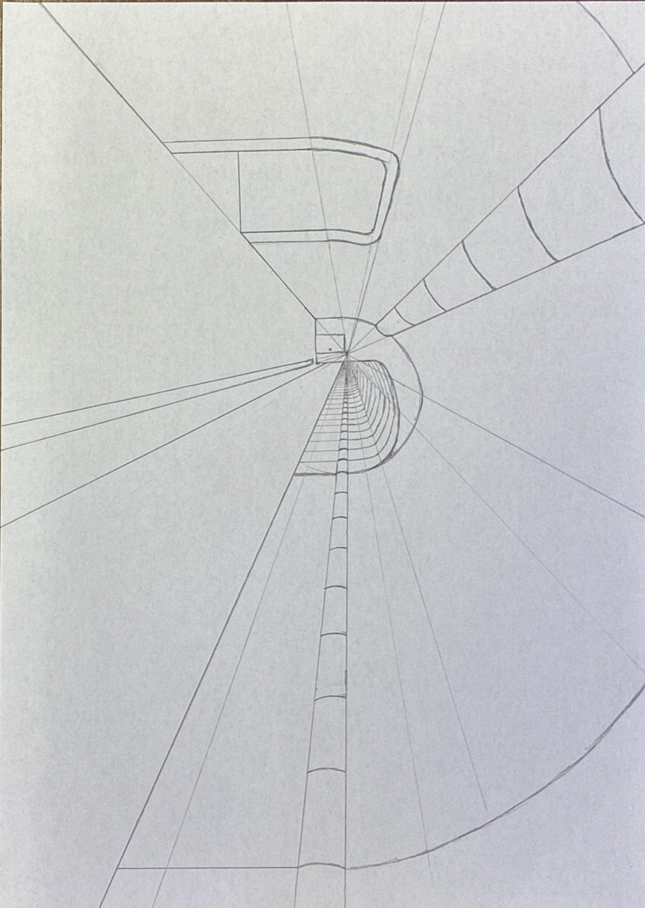
Initial Practice:
Sketch with Secondary Research Reference:
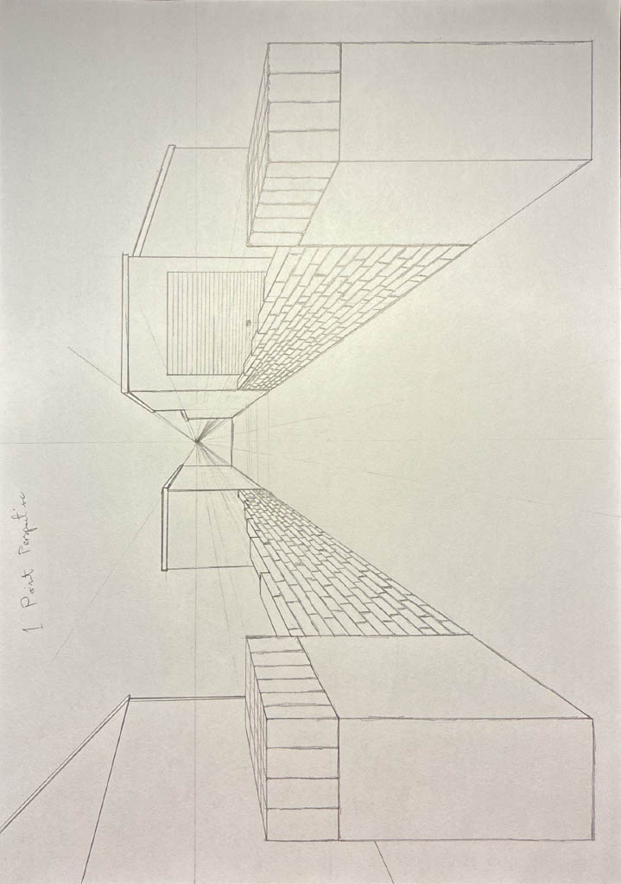
Sketch with Primary Research Reference:
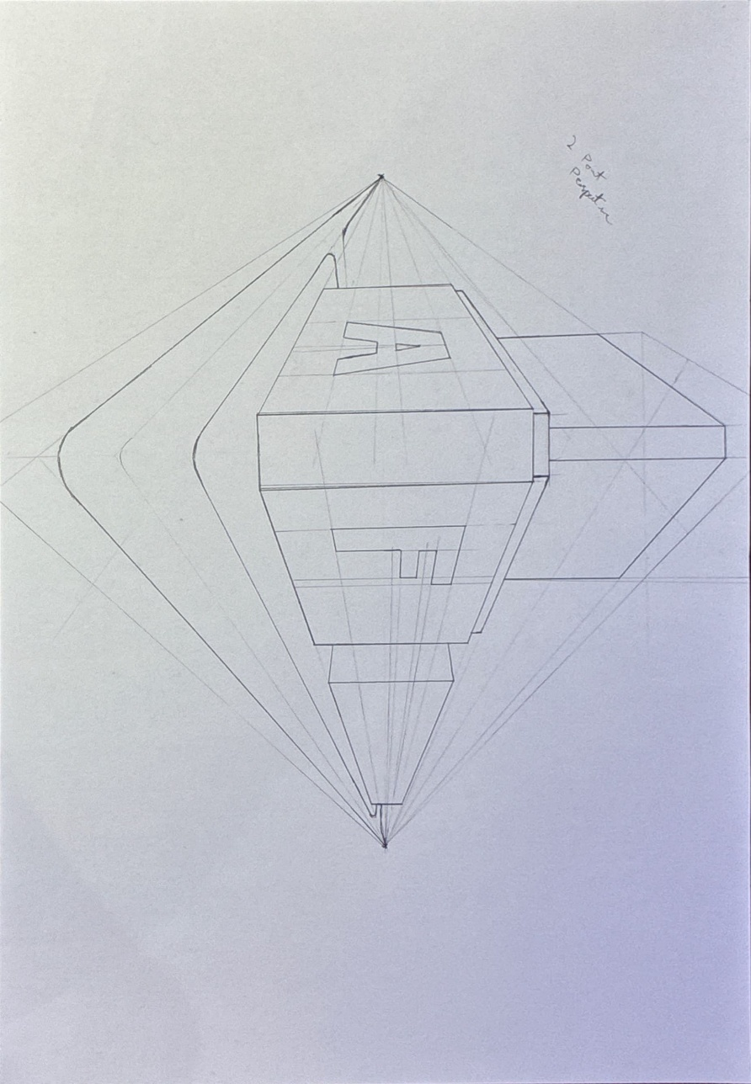

Two Point Perspective
Initial Practice:
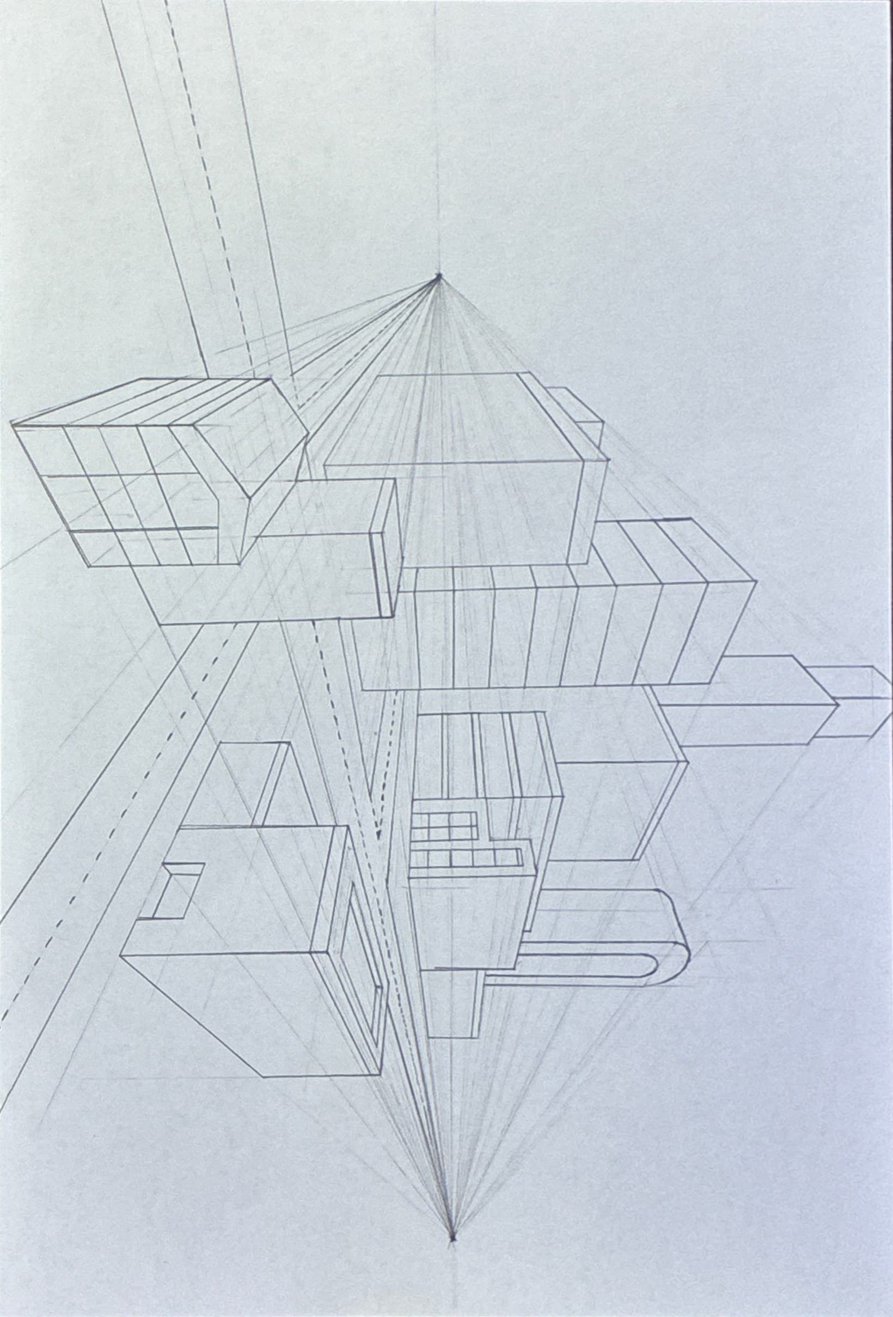
Sketch with Secondary Research Reference:

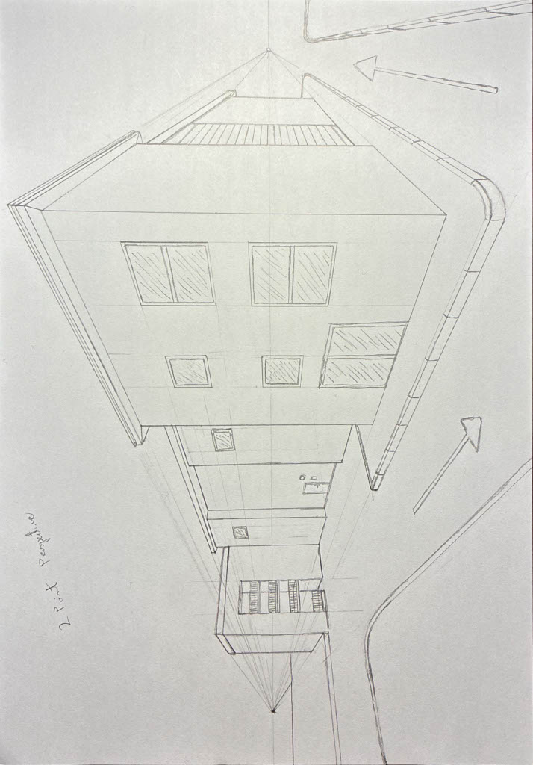
Sketch with Primary Research Reference:

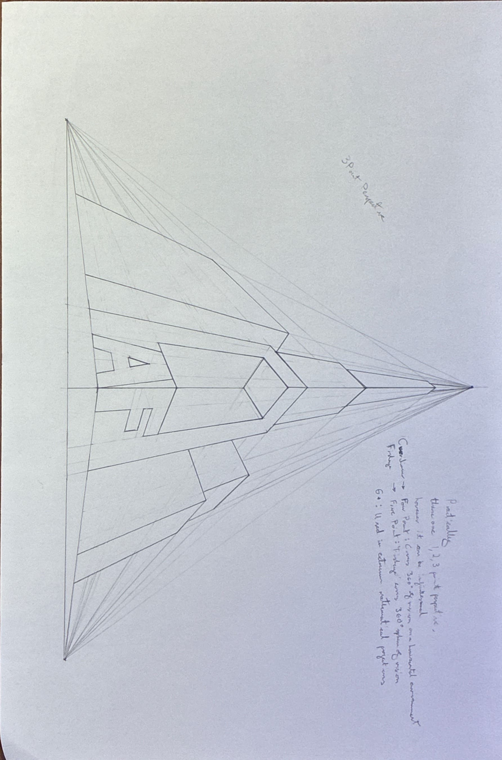
Three Point Perspective
Initial Practice:
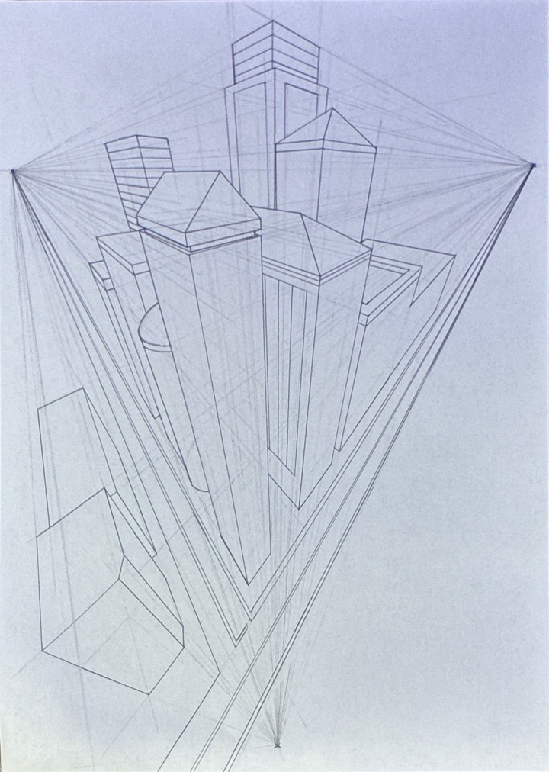
Sketch with Secondary Research Reference:

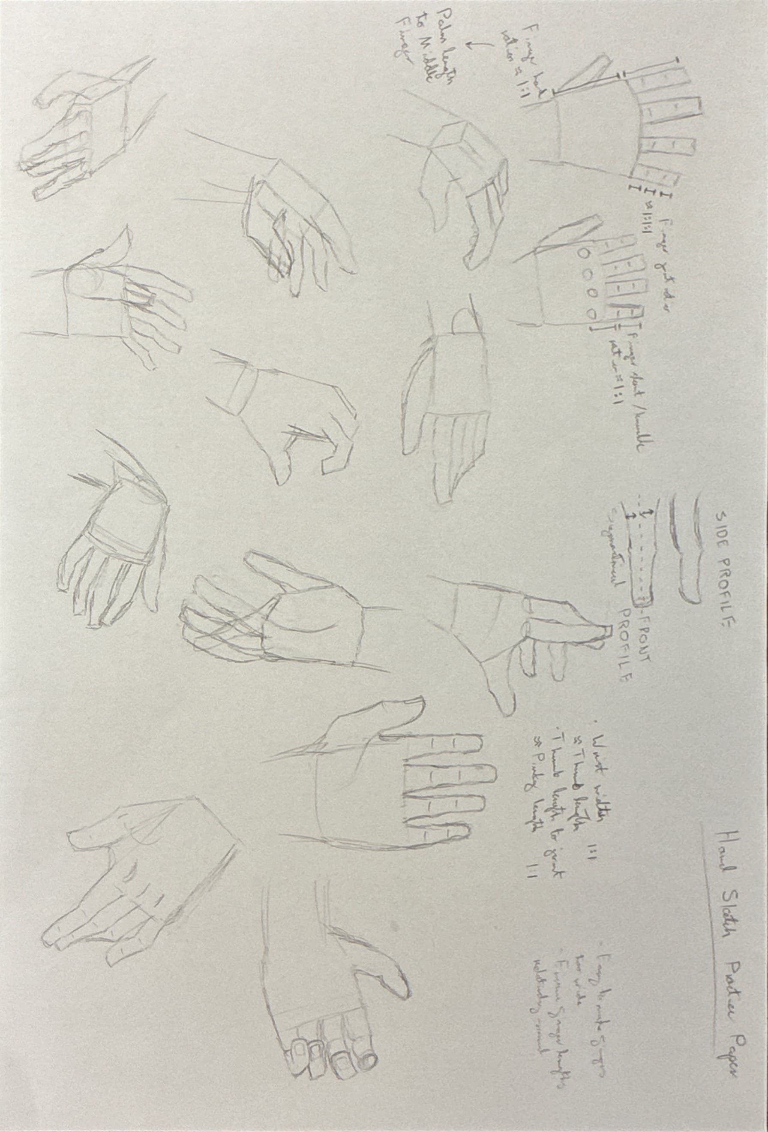
Anatomy Drawing

Hand Sketches
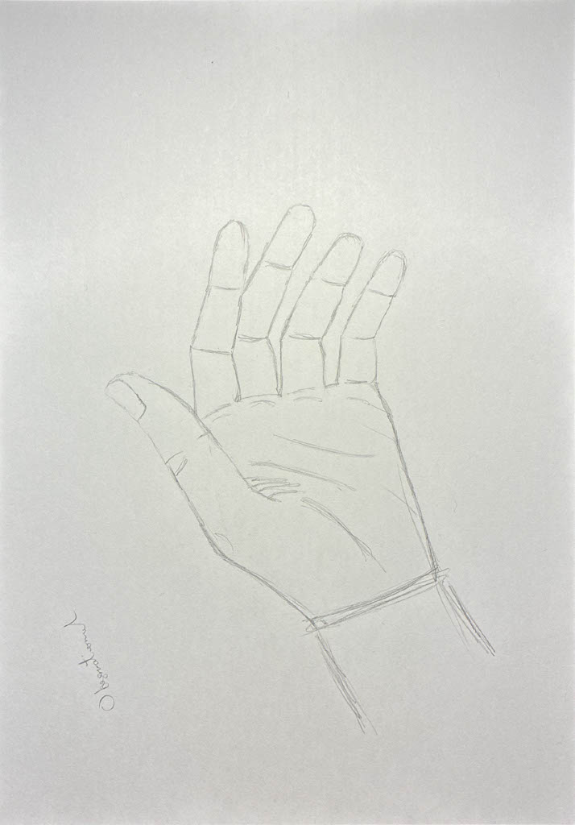
Initial Practice:
Sketch with Primary Research (Still Life) Reference:
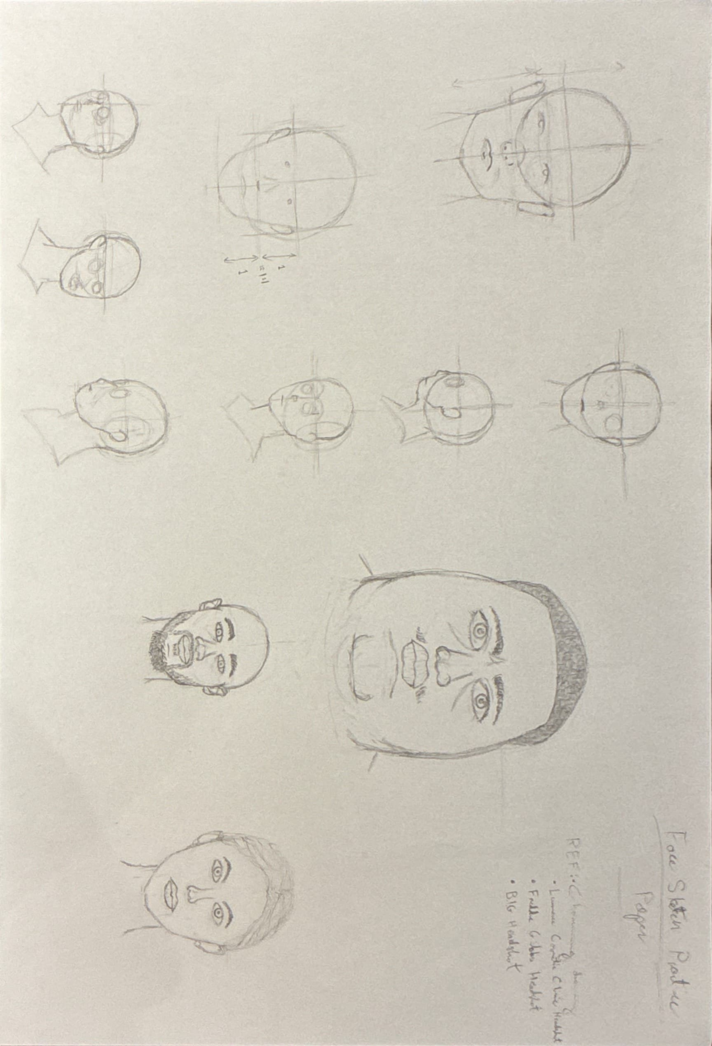

Headshot Sketches
Initial Practice:
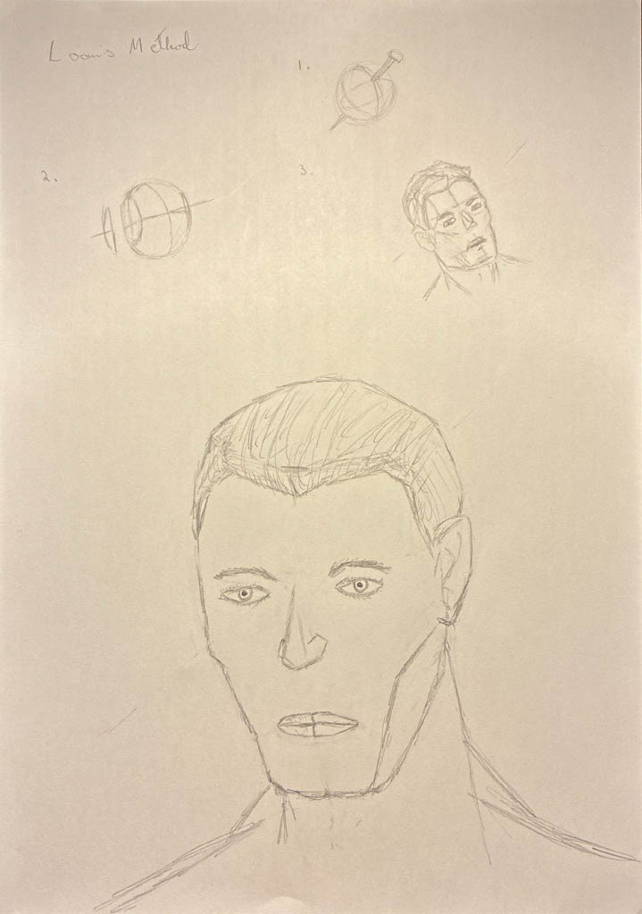
Sketch with Secondary Research Reference:

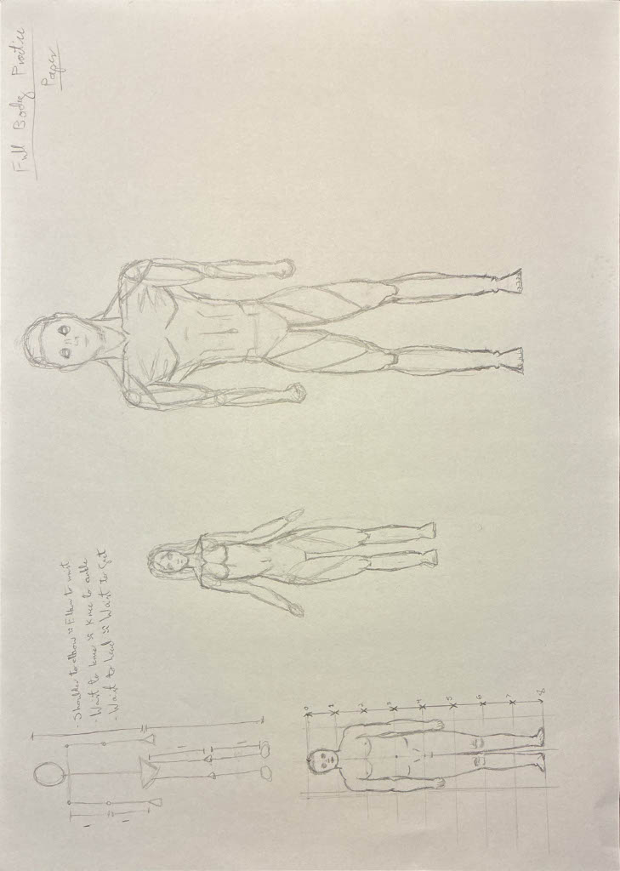
Full Body Sketches
Initial Practice:
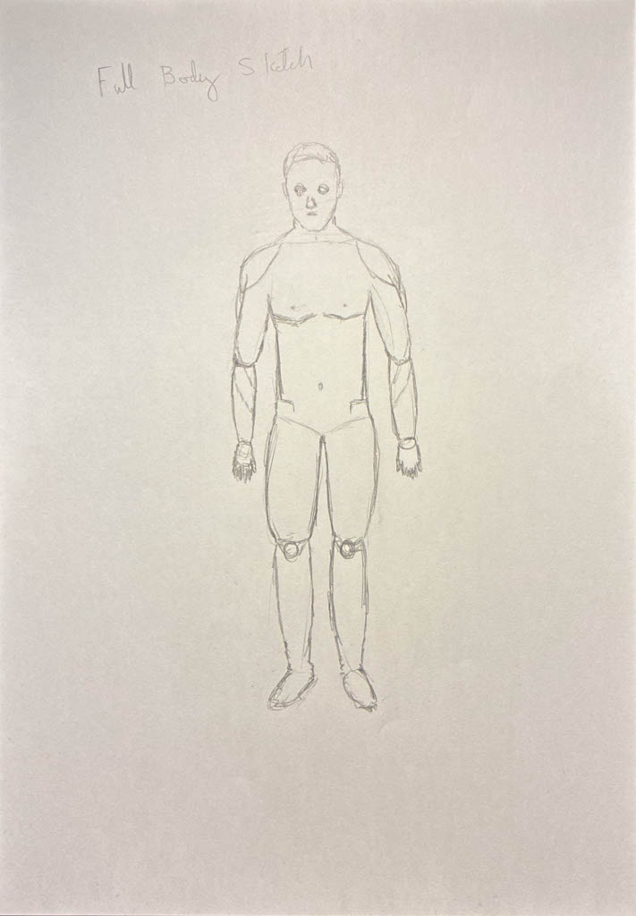
Sketch with Secondary Research Reference:

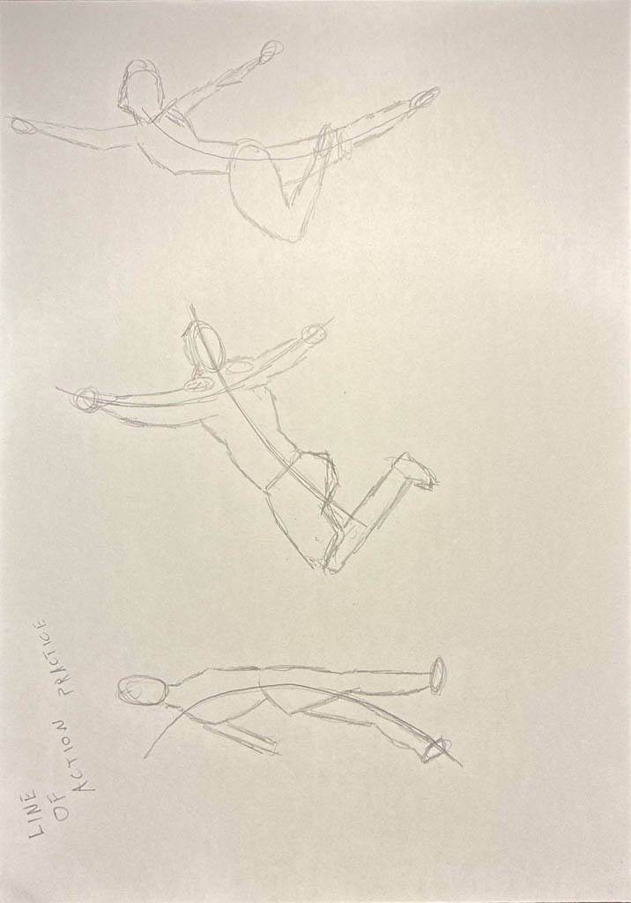
Line Of Action Drawing
Initial Practice:
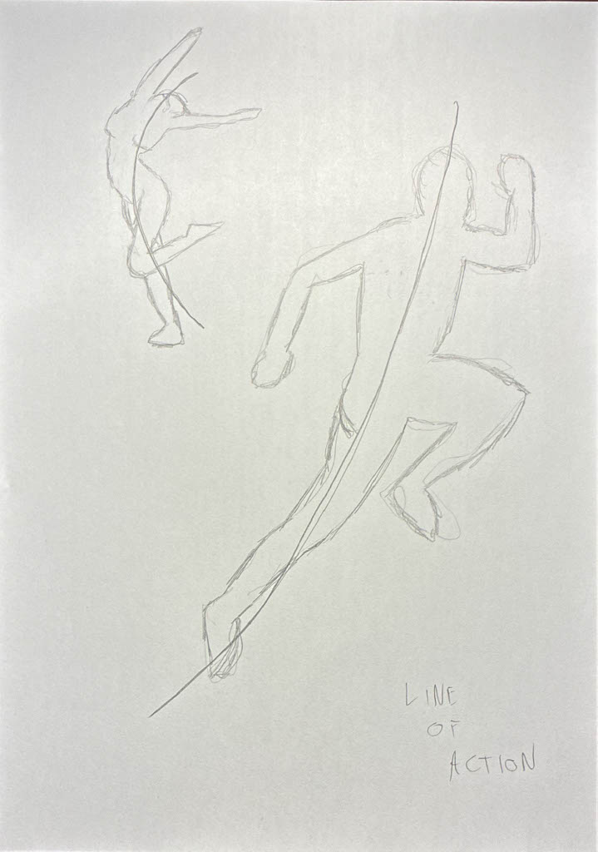
Sketch with Secondary Research Reference:

Photo-Compositing
Initial Practice:
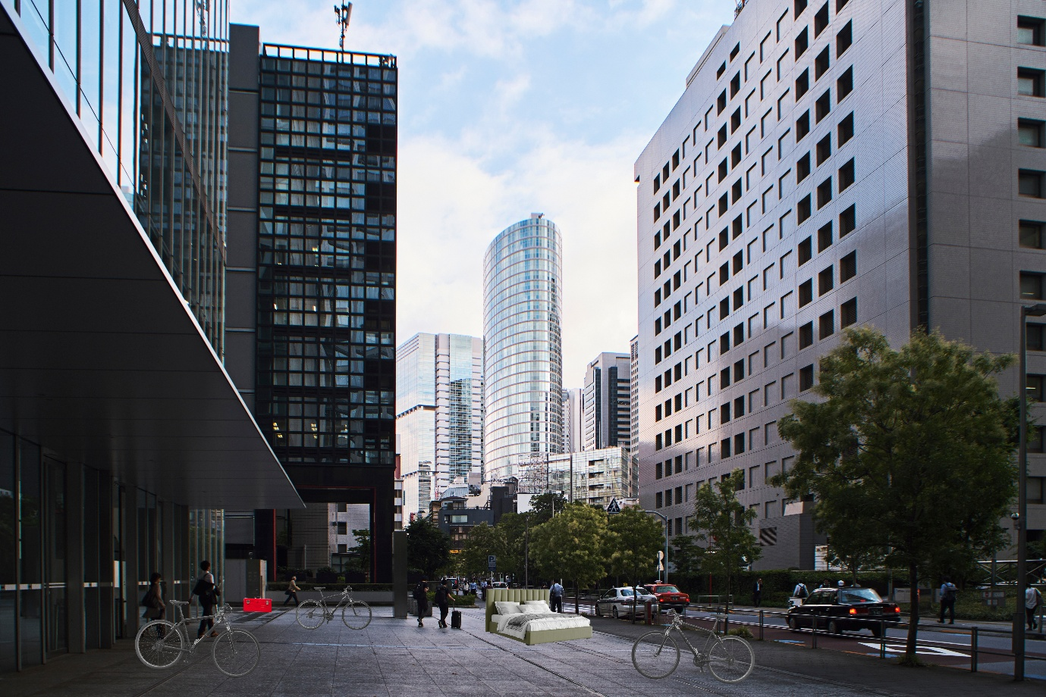
Digital Compositions using Primary and Secondary Research References:
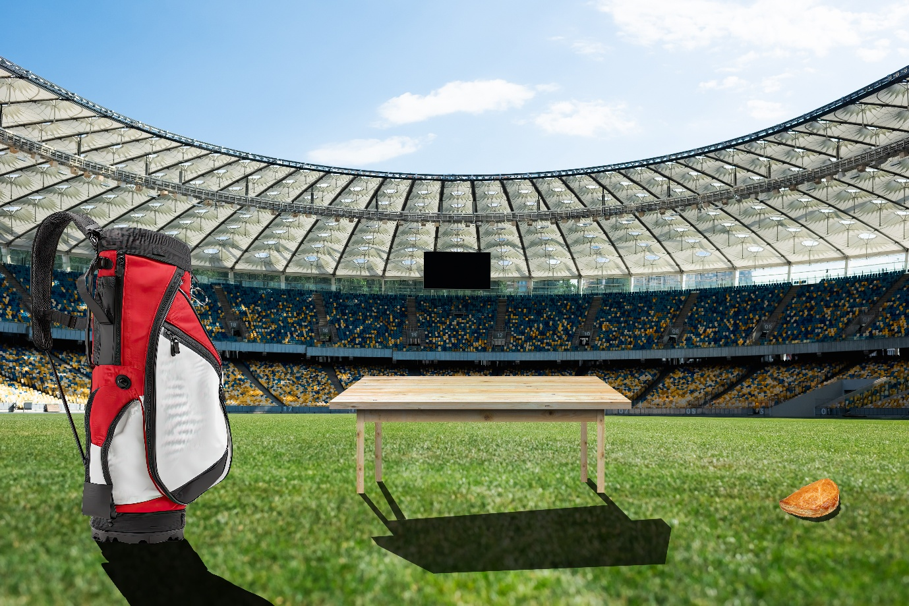
AI Generation Aided Photocomposition:


Mood Board Creation
Digital Mood Boards using Primary Research References:
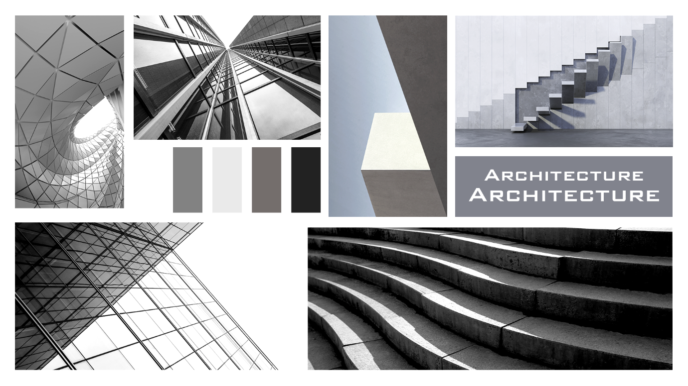


Colour Theory
Colour Palettes:
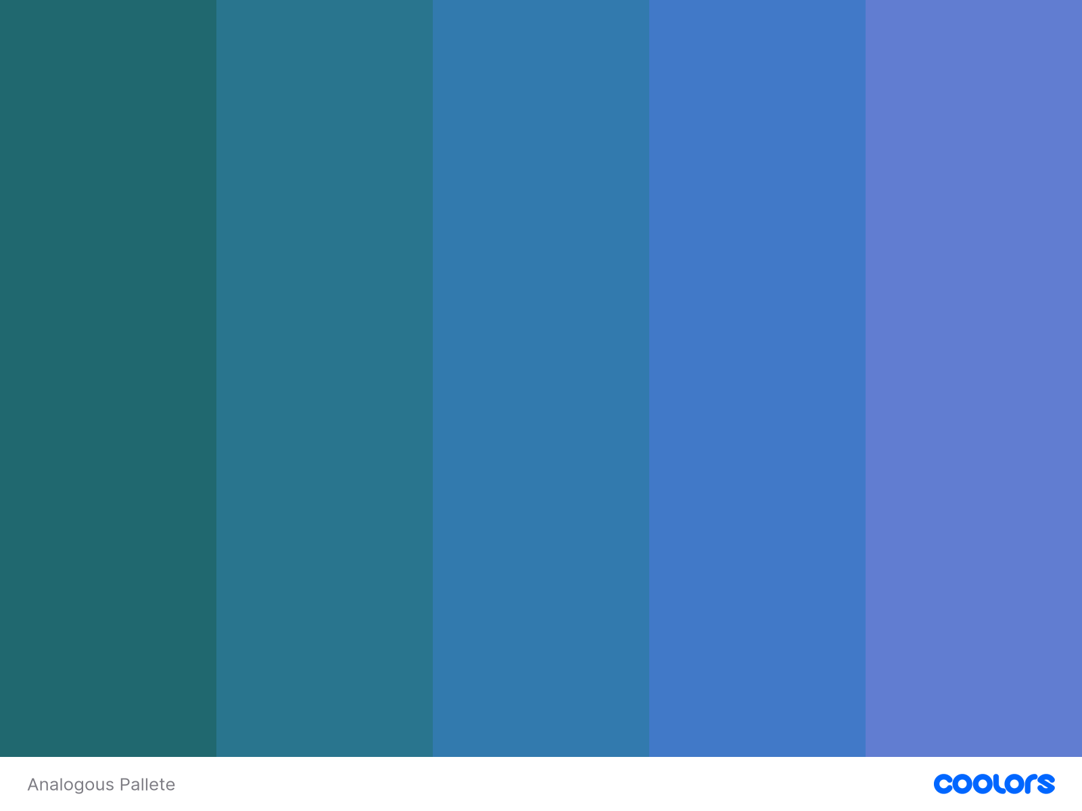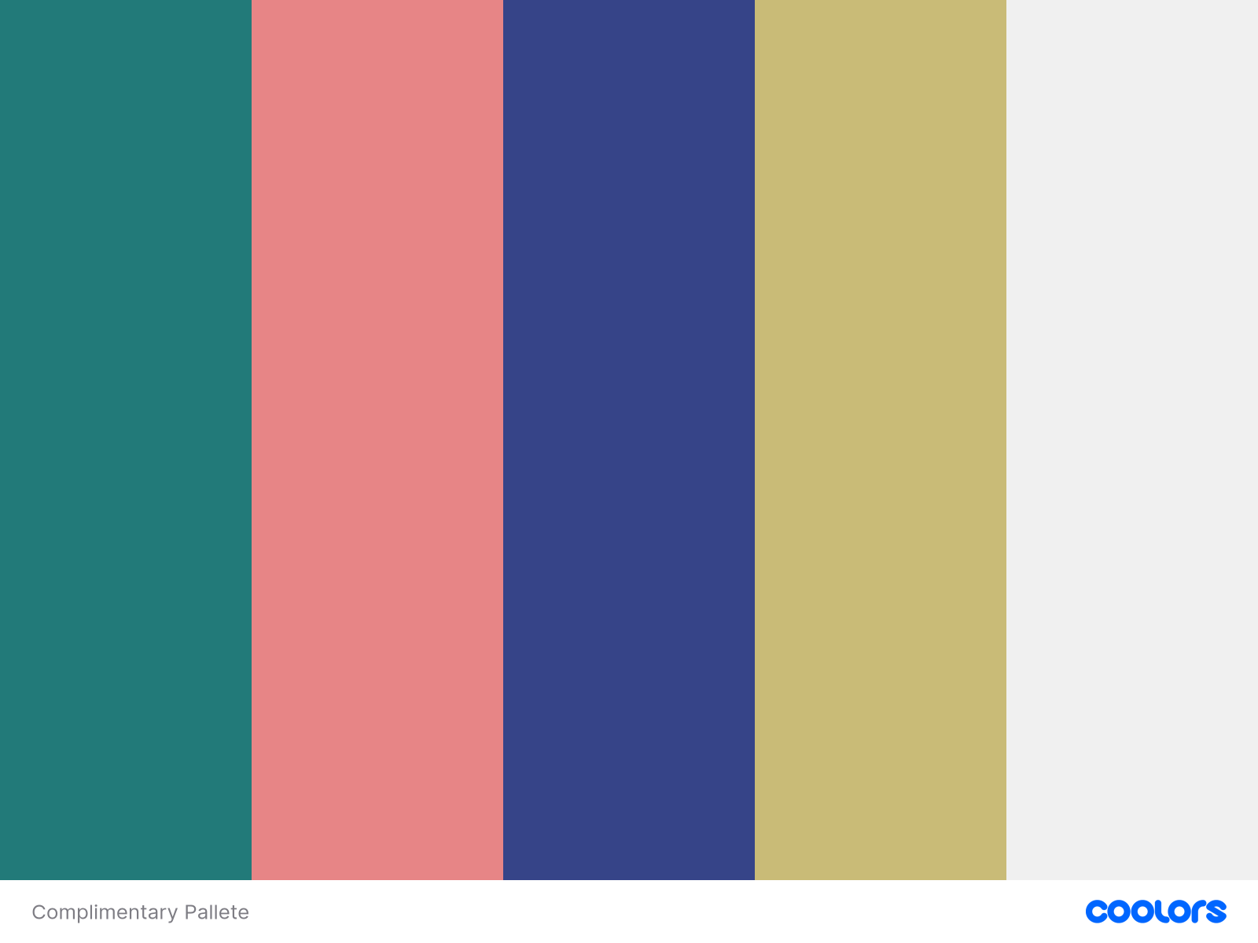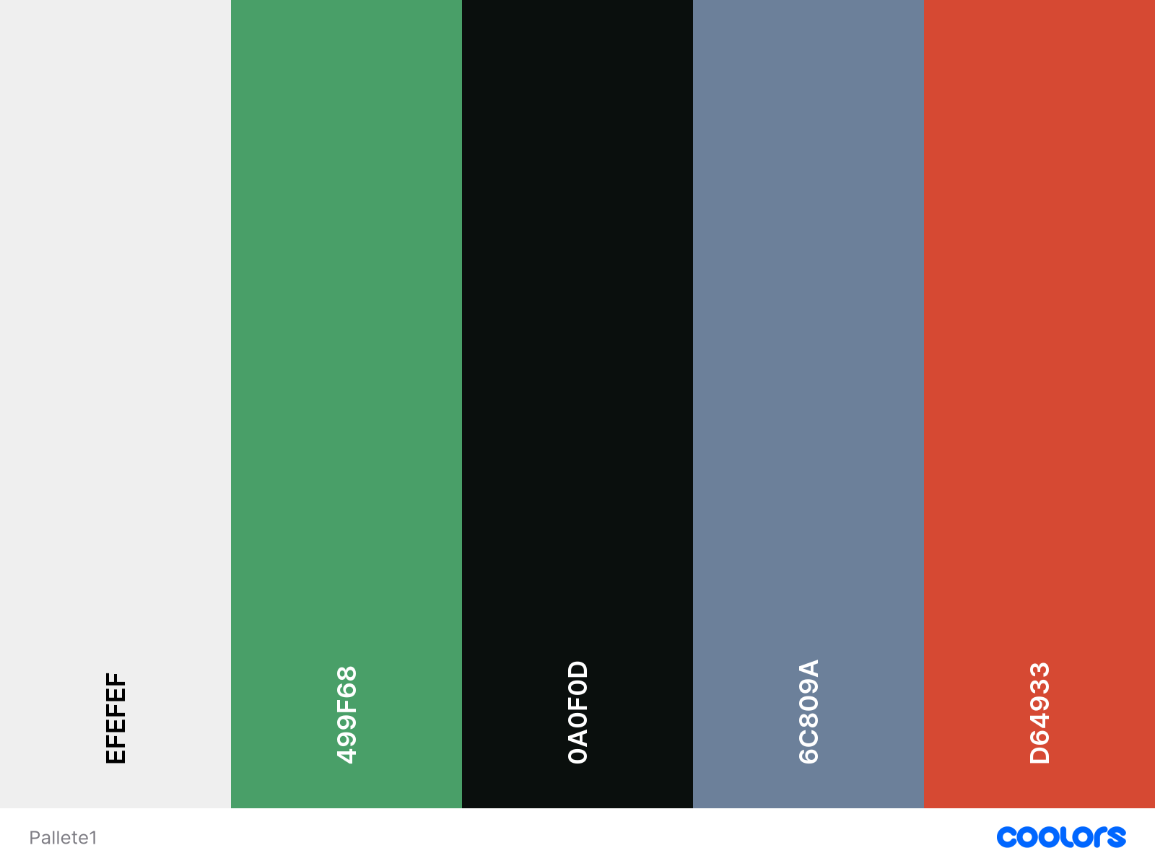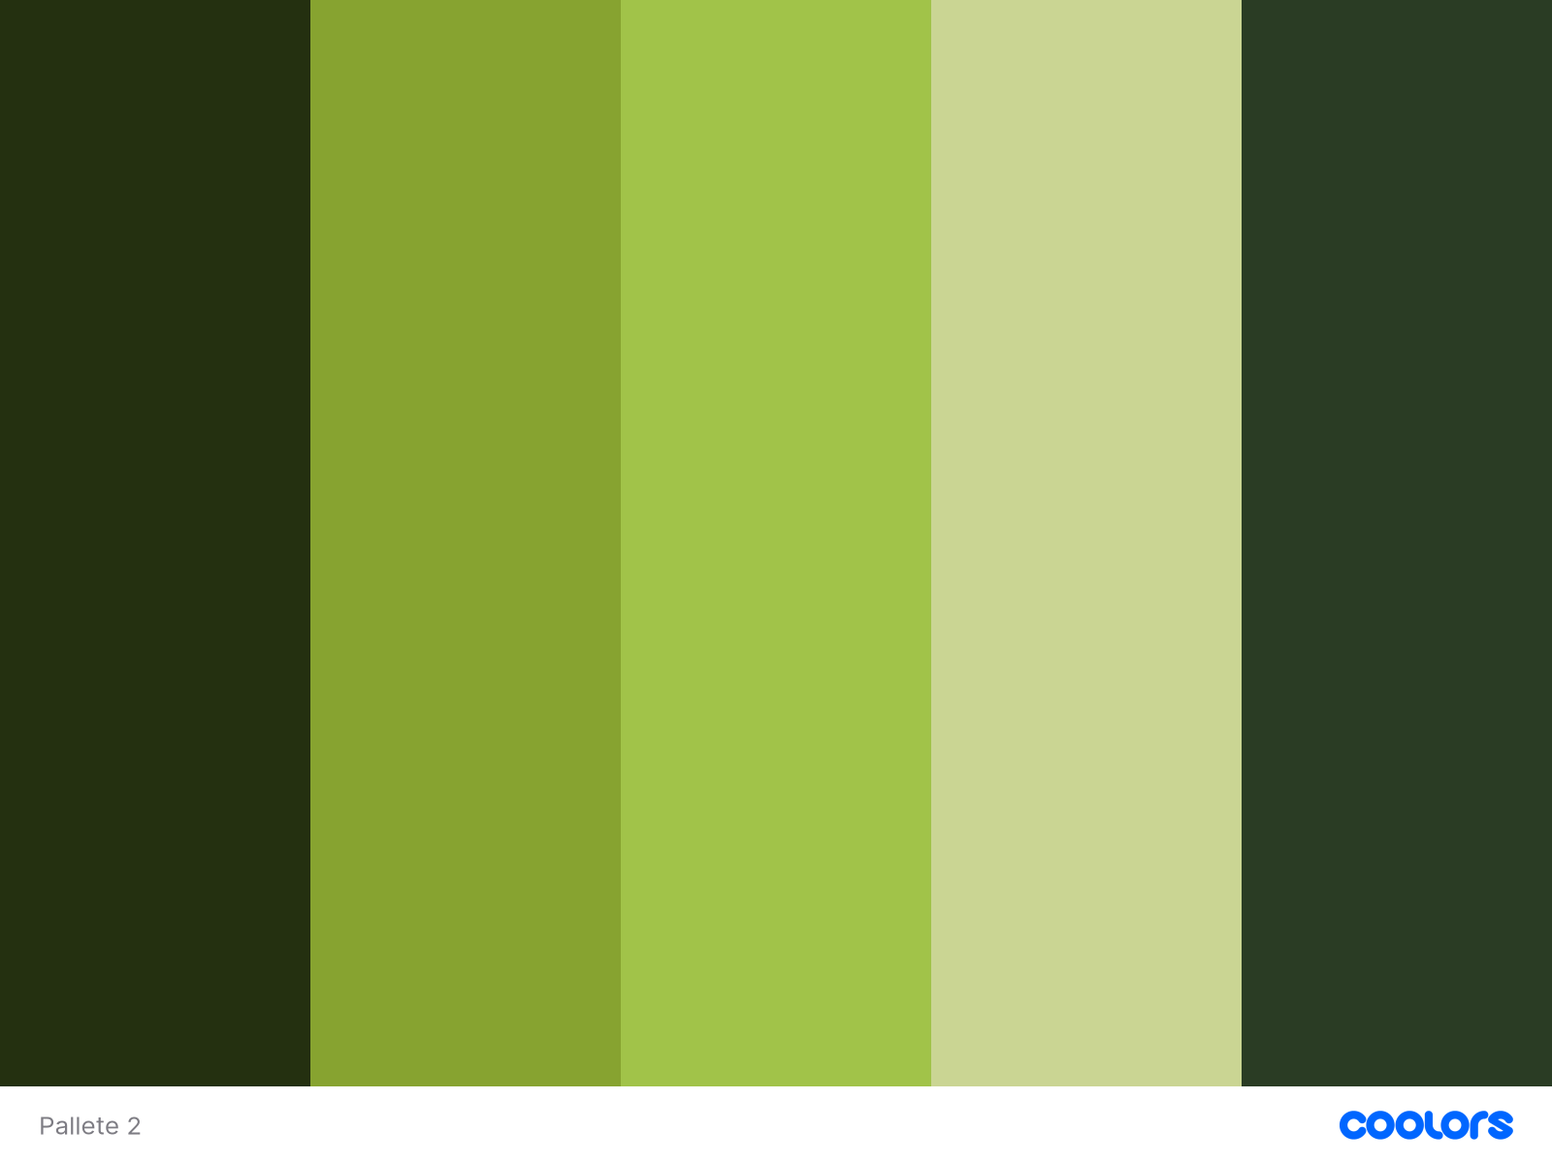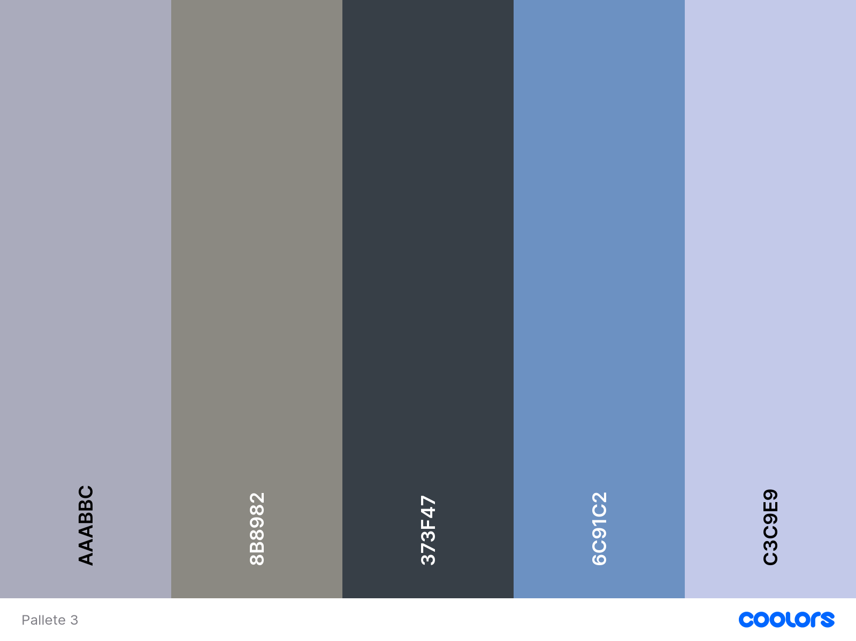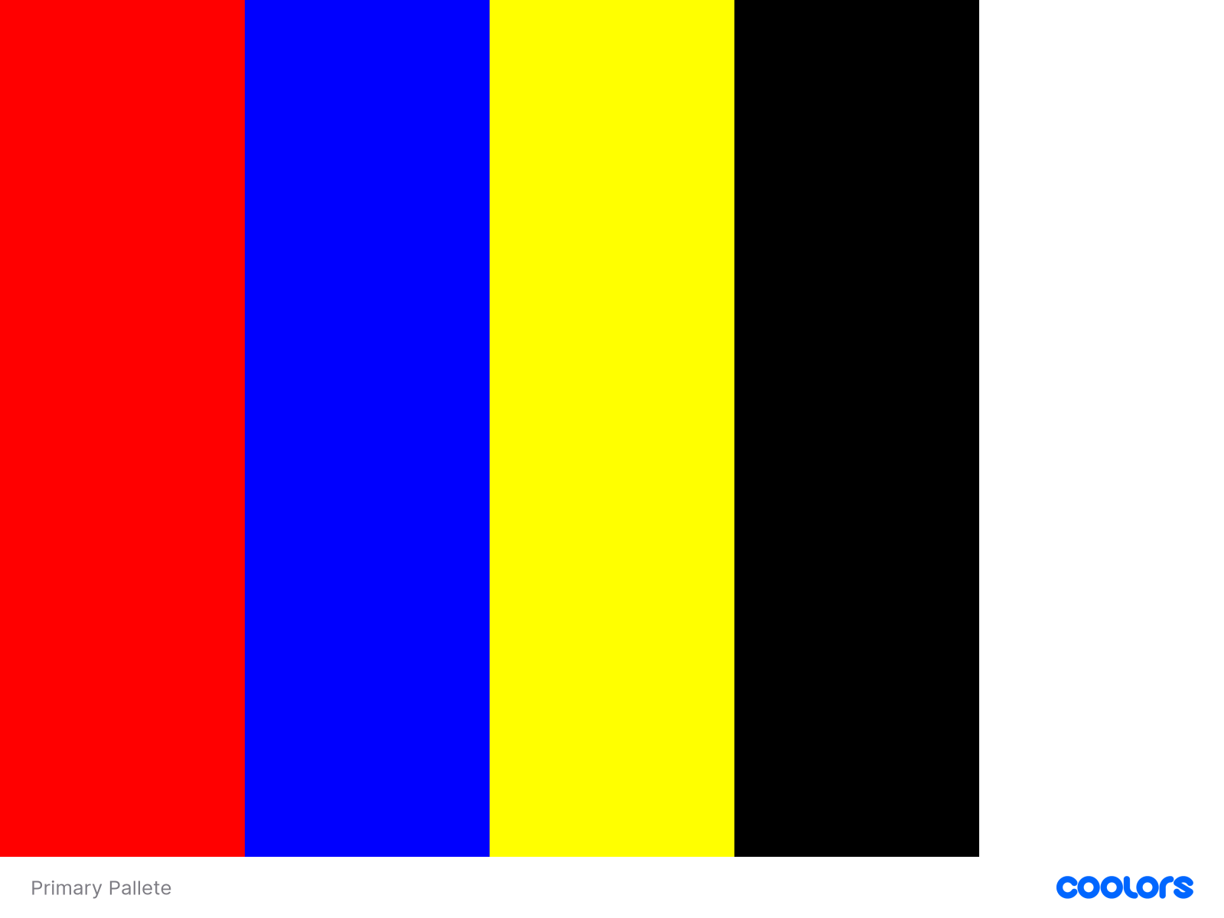
Application of Palettes on Primary References:



