Leadership and Management Skills in the Workplace

Part 1: Wedding Project

Nazia Choudhury
1817657

Vajira Balasuriya

Contents
Introduction 1
Part 1- The project management plan 2
Project Scope 2
Project goal 3
Total Cost Plan 3
Budget 4
Scope of deliverables 4
Work Breakdown Structure 5
Stakeholder analysis 7
Network diagram in project management 8
Gantt chart 10
Quad chart 12
Risk management 13
Conclusion 16
References 17
Appendix 1 19
Appendix 2 mind mapping………………………………………………………………….20

Introduction
This project will look at planning a wedding for a couple with a budget in a time frame set by them. The project would include vendors from a range of different professions and functional areas to collaborate on a range of projects of varying sizes and stages of expertise depending on context of the situation (Perry, 2011). The preparation of a wedding requires the participation of a strong team of reliable vendors like caterers, care hire, wedding gown stylists, cake bakers, and event coordinators, among others for different events leading up to the wedding. As part of the presentation's scope, attendees will get an understanding of effective methods for organizing and managing a wedding ceremony project using a stakeholder analysis, work breakdown structure, project budget, Gannt chart, quad chart, project schedule and a risk assessment. No unexpected interactions with the authorities will occur as a result of the good procedures that have been put in place and the wedding should run smoothly.

Part 1- The project management plan

Project Scope
A wedding is known as an event or ceremony where two people are united in marriage or a similar institution (Tomczyk, 2016). These ceremonies are often performed following a significant traditional system from the different cultures, ethnic groups, family traditions, locations and religions of the brides and groom’s family. However, even though the wedding ceremony is an event for one or more days it requires other arrangements, receptions, guest lists and allocation of different sorts of resources. Generally, people start to plan for a wedding almost a year before the actual event and large wedding ceremonies are often arranged by a project manager who is given the charge of planning, organising, securing and managing all the resources which are needed for the successful accomplishment of the goals and objectives within the budget to take the stress off the bride and groom (Jones, Bruce, Foxley and Munat, 2006). A strong project manager will design and look at the scope of the project having clear objectives to appraise its feasibility and implementation then do a project evaluation to see if the stakeholders are happy and goals met whilst always documenting the process to avoid scope creep (Khan, 2006).
The nature of this project is to give a detailed representation of a wedding ceremony events and activities for 450 guests which will be held on March 28th, 2022 at the location Ramada Park hotel in Wolverhampton. An initial meeting with the client is the planning phase with the bride and groom, to find out their needs and goals and setting up a management plan setting out the main advantages and parameters of the project plan giving the benefits in terms of money or service (Novianti et al, 2019). Project details will include the plans of the activities by setting a schedule of the engagement party, bridal shower, bachelor party and the activities for the actual wedding day where the starting point of all the activities will be the engagement party and the invitations, bridal dress and catering (Baguley, 2008).
Moreover, this project will also require several individual professionals who are an essential part of the wedding like videographer and photographer (Seymour and Hussein, 2014).

Project goal
The focus of this project is to the bride and groom’s biggest moment by offering effective service of the wedding for a 7-course meal for 45 tables hosting 450 guests at the Ramada Park Hotel on 28th March 2022. They also require a wedding cake, entertainment, wedding rings, wedding outfits, decoration of the venue, flowers, invitations, makeup artist, hairstylist, transport, videography and photography. The completion of this project by the manager should facilitate and ensure satisfactory service according to the bride and groom’s expectations within the proper time and budget of the event. In order to do this, the main goal is to provide the couple with inspiration, guidance, and assistance in planning a flawless series of activities that will culminate in a memorable day for their guests (Slater, 2012) keeping them updated with good communication so that there are no misunderstandings or information overload. From the planning of the occasion to the end result is expected to be a successful wedding ending with couple leaving for their honeymoon safely (Cobb, 2015). Through all the objectives the wedding plan is expected to begin on 2nd July 2021 and be completed by 1st April 2022 by paying off all vendors with the aim to not exceed the budget of £80,000

Total Cost Plan
The costs of the event are one of the key considerations for setting up a marriage budget. For many people, it is difficult to plan the wedding properly, especially when other financial tasks are juggled, such as raising children, paying a mortgage, etc. the client has asked for the events of the wedding to be costed only, all other activities like bridal shower, honeymoon etc will just be planned as they will be paid for as gifts from other guests. The wedding activities are estimated at a cost £72,000 has been arranged on the customers' behalf in order to fulfil their needs. It is essential to allocate resources for the event in accordance with the anticipated budget for the occasion. Because of this, the following financial estimates for the event have been generated as the budget is considered the most important task for many people.
It will thus be recommended to use the following estimations of the expenses of the wedding plan:

Budget

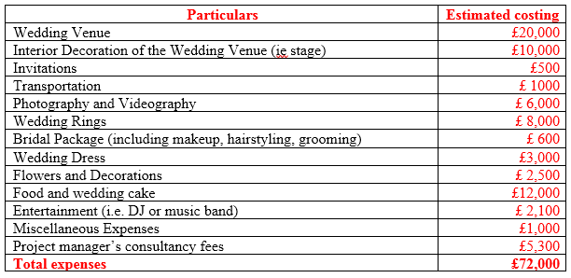

Scope of deliverables
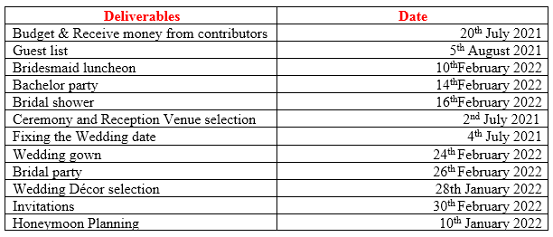
Budget & Receive money from contributors - The first schedule involves the budgetary marriage plan procedure and the business management application (Weiss, 2011). Budget planning attempts to minimize the likelihood of a business having worse financial outcomes than anticipated (Tomczyk, 2016).
Guest list – Preparing the list of guests is important stage in this planning for wedding.
Bridesmaid luncheon - This ceremony is often seen as an opportunity to express gratitude to the bride for her efforts and support during the wedding preparation process (Perry, 2011).
Bachelor party – Another wedding celebration is conducted in honour of the groom known as a bachelor part or stag weekend.
Bridal shower - A bridal shower is a pre-marriage ceremony arranged for the bride. In customs history, the provision of goods and financial support for marriages are not necessarily dependent on the giving of presents for the upcoming marriage (Weiss, 2011).
Ceremony and Reception - When a couple is married, it is considered to be the formal occasion in which they become husband and wife. The festivities begin immediately after the wedding (La'Brooy, 2010).
Fixing the Wedding date - In general, family members like parents have selected weddings for persons other than couples (Sutt, 2011).
Bridal party - A bridal party is a group of people called by newlyweds during the marriage ceremony (Gattorna, 2012). The traditional celebrations of marriage include bridal sisters, groomers, flower girls and ring bearers.

Work Breakdown Structure
By talking to the couple, we can identify some of the tasks that need to be done by making a mind map (Buzan, 2006) which can be seen in appendix 2, based on this a work breakdown structure can be created.
The work breakdown structure is a tool that is used for managing the different phases (appendix 1) and activities of a project in a sequential and organised manner for achieving the required deliveries of the project (Brotherton et al, 2008). This structure is created in such a way that it can properly illustrate each task individually performed in a definite date and time (Curran, 2013). For this big wedding ceremony, this breakdown structure can be used to effectively chart the work to be executed by the project for accomplishing the objectives of the event effectively.
WBS Approach
Thus, the method of creating a WBS forward this event is demonstrated below

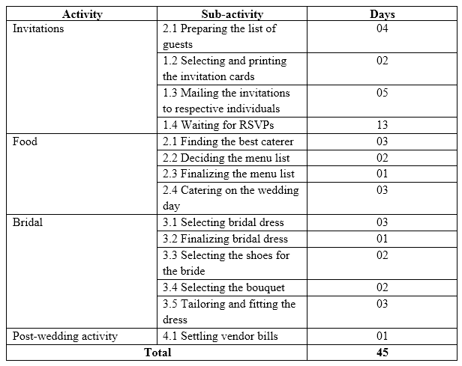

Stakeholder analysis
The individuals, group, party of an organisation which influence the activities of a project directly or indirectly are known as the stakeholders. Every stakeholder does not have the same level of power or involvement over the choices and plantings of a task or a project. For effective performance in achieving the objectives, the managers need to understand what level of importance they should give upon the different types of stakeholders (Brugha and Varvasovszky, 2000). By effectively engaging with the right stakeholders help to involve their need in the goal of the project along with effective development of the strategies and decision making (Baron, 2013). Therefore, the different power of the stakeholders for this wedding event is analysed in the table below:

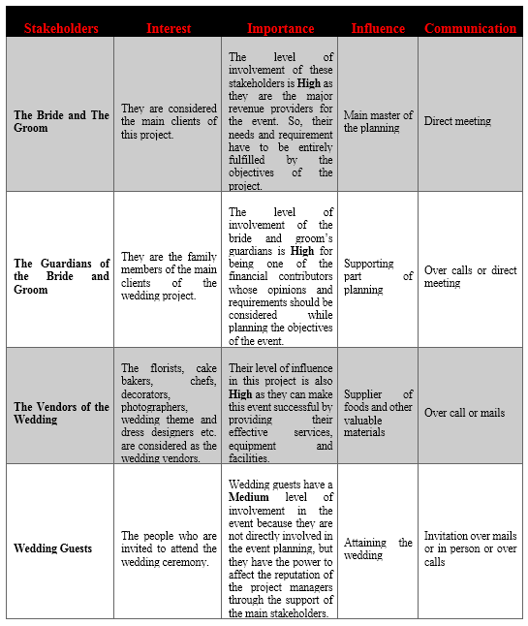

Network diagram in project management
The sequential and logical connection between the job is shown by a project timetable network schedule. This graphic illustrates the connectivity of tasks in a project context. The ability to properly depict the sequence of activities and happenings must be shown to ensure that this visualization is effective (Slater, 2012). The network diagram tool is necessary in order to plan the project's planning and working process and keep track of the development of the project throughout each phase – until the completion of the project (McCahon and Lee, 1988). A network chart is important to show the scope of the project, it covers all the main actions that have to be carried out during the project lifespan.
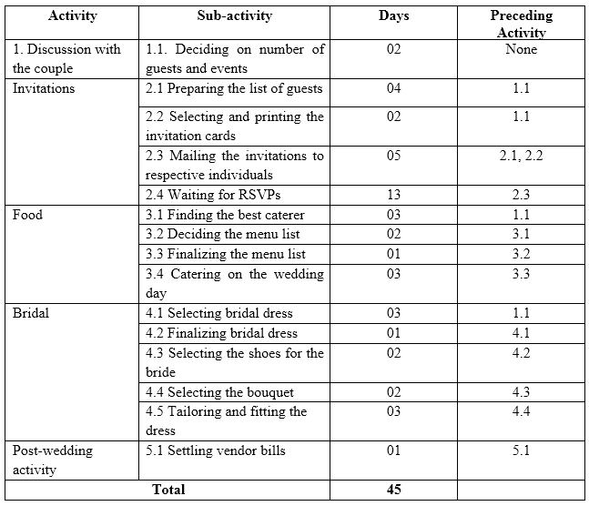

Network diagram
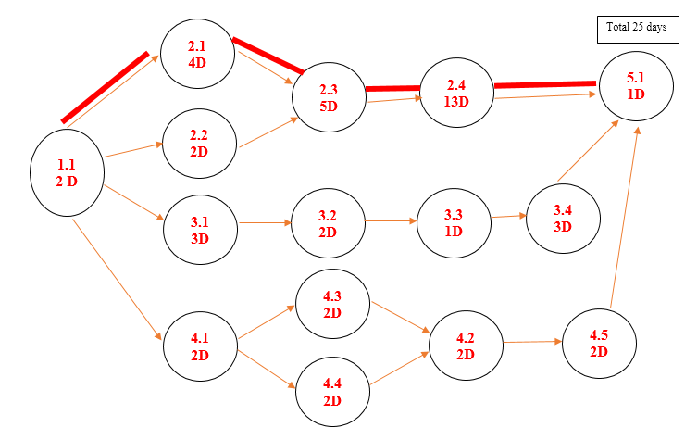

The network diagram shows how some of the tasks of the project can be completed quicker in 25 days through activity 1.1 > 2.1 > 2.3 > 2.4 > 5.1 and doing the other activities concurrently in those days instead of doing each activity one by one which would take 45 days. This would save 20 days in time so the project could be completed in a more efficient and quick manner.

Gantt chart
Another important aspect for the managers to prepare the wedding planning project effectively is to prepare a time schedule of the based on the prepared WBS. And one of effective way is to create a Gantt chart for the entire schedule of the wedding which would break the whole project into smaller tasks (Seymour and Hussein, 2014) so the employees who will work for this project can follow it accordingly. A sample of the Gantt chart for this type for project is shown in the table below:
Events of the projects | 1sttwo months | 2ndtwo months | 3rdtwo months | 4th Two months | 5th Two months | Final two months | Final Day
Preparation of Engagement Party
Engagement Party
Sending invitation cards
Pre-wedding planning
Bridal Shower
Final wedding planning
Rehearsal dinner
The main Wedding day

Quad chart
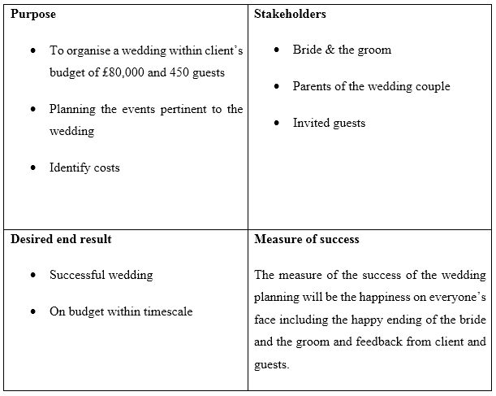
Project success criteria
Whether and how to perform a job is the second criteria. The criteria for success are often an analysis which describes the features of a project. This is an excellent method to perform what a manager needs to do continuously (Kim, 2010). In future, it is important for the success of other project participants to understand and use knowledge correctly and effectively. The managers may use the SMART model to evaluate the effectiveness of a specific company initiative:
- All tasks and purposes should be specified and communicated throughout the wedding ceremony. Management opposes the intended outcomes.
- In order to measure the successor criterion, all essential criteria are established for assessing how effectively each goal is accomplished (Abraham, 2014). However, the management cannot evaluate the performance and effectiveness of the job done, since women are not being inspected.
- However, the efforts will not succeed in some time even if the objectives are clear and measurable. This requires managers to set project objectives that properly represent staff performance (Worsley and Worsley, 2019).
- Managers should also ensure that the company's skills are unique to every objective. Workers' skills and ability should never hinder the goal.
- For each project objective, managers must set a specified timeline. The workforce's effectiveness will be enhanced over a certain period of time and also enables to focus and assess their objectives (Bright, 2015).

Risk management
Despite meticulous planning and preparing before the event, there might be possibilities of some sort of limitation for unexpected situations during the ongoing process of event management (Lyons and Skitmore, 2004). Risk management is eliminating the risks but identifying them and minimising their effects through awareness of occurrence.
The challenges for successful project management could be funding, incompetency of management team, lack of communication skills, time and cost over runs, etc (Slater, 2012). These limiting factors can impact negatively the quality delivery and overall success of the project (Kim, 2010). For example, in the wedding budget there might be an over budget due to some unexpected additional expenses. So, for this kind of situation, the managers must be aware of the constraints and exclusions beforehand to preplan alternate strategies to overcome them like keeping extra funding for miscellaneous expenses. Generally, in a project there are 4 constraints that the manager should always be aware of which are discussed below called The Iron Triangle (Kwon and Kang, 2019):

Time:
One of the significant factors of the client's consideration in a project is time. In order to satisfy the stakeholder’s needs, the managers must make sure that the project is completed on time and prepare for all kinds of situations that can cause the objective's complications to be delayed. For instance, the priest for the wedding ceremony might not be able to reach the venue in time which might result in the dissatisfaction of the clients therefore a nearby church should be found.
Cost:
Even though proper research of the cost and expenditure of every service and resource which are required to be purchased for the event is analysed, the costs might fail to be met within the budget. For example, due to an item on the food menu not being in season, the prices of foods can increase which might increase the costs so extra funding would be kept in the budget under miscellaneous.
Scope:
Even though some scopes can be identified, most of them cannot be estimated before the event. Like on the actual day of the wedding the baker of the wedding cake might not turn up with the cake which can cause the wedding to be disrupted as it cannot be estimated earlier so an alternative cake would have to be sourced from a supermarket.
Quality:
The quality of the product or services is another limiting factor of a project. Managers are expected to provide consumers the best quality goods and services (Abraham, 2014). Generally, clients tend to expect a specific quality of the product and services offered by a manager. But if the quality is not maintained as the expectation then the company reputation might fall downwards by negative feedback (Sutt, 2011). For instance, if the wedding gown does not meet the expectation of the bride from its initial design and there might not be sufficient time to redesign it again.
To combat these problems, the planner must identify alternatives, ask for recommendations from other experts, conduct cost/benefit analysis and complete a project analysis.
The following table presents the mitigation strategies.
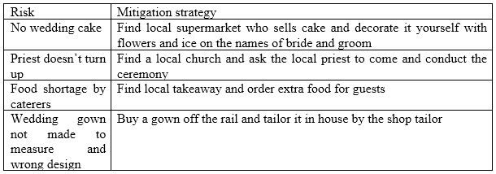

On the wedding day there was a shortage of food due to the lack of forsight in arranging food for the vendors like the chaffeurs, etc. This could have been avoided at the planning stage when calculating number of meals for catering not just the number of guests.
The extra costs of the alternative solutions to these risks was covered by the extra miscellaneous budget and the refund received later from the cake baker.

Conclusion
Planning of a project cannot be done within a day. It requires a lot of practice planning research and analysis of the significant resources related to it. A successful project planner will make the plan efficiently saving time and money with a clear and shared vision and understanding of what is required. Through the network chart we can see how time can be saved through doing tasks together simultaneously. Even still there might be some limitations in the project which cannot be fully overcome, but with effective team strategies and effort and fining alternative solutions, the client's expectations can be achieved as was shown in this project which achieved all its goals and came under budget (£72,000) for the clients total budget of £80,000 and was completed in the expected timeframe of the start date of 2nd July 2021 to the end date of 1st April 2022, which will result in increasing the confidence and productivity of the employees working for it in the workplace and the clients (Weiss, 2011). The result of a successful wedding planning project is good reputation and maintaining the effectiveness of an organisation.

References

- Abraham, A., 2014. Project planning and management.
- Baguley, P., 2008. Project management. [New York]: McGraw-Hill.
- Baron, D., 2013. Business and its environment. Boston: Pearson.
- Bright, D., 2015. The wedding planner. Los Angeles: Nash.
- Brotherton, Shelly A., Robert T. Fried, and Eric S. Norman. "Applying the work breakdown structure to the project management lifecycle." In PMI Global Congress Proceedings, pp. 1-15. 2008.
- Brugha, R. and Varvasovszky, Z., 2000. Stakeholder analysis: a review. Health policy and planning, 15(3), pp.239-246.
- Buzan, T., 2006. Mind mapping. Pearson Education.
- Cobb, C., 2015. The project manager's guide to mastering agile. Hoboken: Wiley.
- Curran, T., 2013. IBM Cognos Framework Manager. Birmingham: Packt Publishing.
- Graham, N. and Portny, S., 2012. Project management for dummies.
- Jones, W., Bruce, H., Foxley, A. and Munat, C.F., 2006. Planning personal projects and organizing personal information. Proceedings of the American Society for Information Science and Technology, 43(1), pp.1-24.
- Khan, A., 2006. Project scope management. Cost engineering, 48(6), pp.12-16.
- Kim, K., 2010. The Wedding Photographer's Planner. Hoboken: John Wiley & Sons.
- Kwon, H. and Kang, C.W., 2019. Improving project budget estimation accuracy and precision by analyzing reserves for both identified and unidentified risks. Project Management Journal, 50(1), pp.86-100.
- La'Brooy, M., 2010. The wedding planner. London: Piatkus.
- Lester, A., 2014. Project Management, Planning and Control, 7th Edition.
- Lester, A., 2015. Project Management, Planning and Control,. 7th ed.
- Lyons, T. and Skitmore, M., 2004. Project risk management in the Queensland engineering construction industry: a survey. International journal of project management, 22(1), pp.51-61.
- McCahon, C.S. and Lee, E.S., 1988. Project network analysis with fuzzy activity times. Computers & Mathematics with applications, 15(10), pp.829-838.
- Novianti, E., Susilawati, E.A., Sesunan, M.F., Syamsiyah, N. and Astuty, E.Y., 2019, December. Development wedding planner using extreme programming method. In IOP Conference Series: Materials Science and Engineering (Vol. 673, No. 1, p. 012049). IOP Publishing.
- Perry, J., 2011. Wedding planner. Chandni Chowk, Delhi: Global Media.
- Seymour, T. and Hussein, S., 2014. The history of project management. International Journal of Management & Information Systems (IJMIS), 18(4), pp.233-240.
- Slater, R., 2012. The guide to event management. Luton: Andrews UK.
- Sutt, J., 2011. Manual of construction project management for owners and clients. Chichester, West Sussex, UK: Wiley-Blackwell.
- Tomczyk, C., 2016. Project Manager's Spotlight on Planning.
- Weiss, A., 2011. Key business solutions. Harlow, England: Financial Times Prentice Hall.
- Worsley, L. and Worsley, C., 2019. Adaptive Project Planning. New York: Business Expert Press.

Appendix 1
The Target of each phase:
9-12 Months Before
- Buying the Engagement ring
- Engagement Party
- Booking the wedding venue
- Tasting different food for the menu
- Finalising the 12 courses menus
- Pre-photoshoot
- Arranging the guest lists.
- Selecting designs for the invitation cards
6-9 Months Before
- Finalising guest list and invitation card design
- Sending out invitation cards for the wedding
- Selecting the cake design
- Booking car rental company
- 1st Fitting session.
- Selecting decorator, florists and photographer for the wedding
1-3 months before:
- Final fitting sessions
- Finalising the decorator, florists, rental car company, music entertainer and photographer for the wedding
- Confirming honeymoon reservations
- Bridal Shower event
- 50% deposits to the decorator, catering service, florists, rental Car Company, music entertainer and photographer.
- Rehearsal dinner

The Actual Wedding day:
- Arrangements and decorations in the venue
- Bridal makeup
- Dress up of bride and groom
- Wedding ceremony
1 day after the wedding:
- Paying the rest of the deposits.

Appendix 2 mind mapping


