Rhodri Williams - 1910918

Designing a race car rear wing: Structural Design
Structural & Fluid Analysis ACMA6010

Contents Page
- Introduction 3
- Finite Element Analysis 4
  - History of Finite Element Analysis 4
  - Finite element Analysis Techniques 4
  - CAD Vs CAE Led Optimisation 5
  - Future of Finite Element Analysis 5
- Design Studio 6
  - Setting up the Baseline Properties 6
  - Optimised Design 8
  - Discrete optimisation 10
- Prototype testing 12
- Regulations 13
- Conclusion 15
- Bibliography 16
- Appendix 18
  - Appendix A – CFRP properties 18
  - Appendix B 18
    - Mass Reduction 18
    - Constraint Violation 19
    - Variable Thickness 19

- Introduction
This report primarily focuses on the optimization of a race car rear wing constructed from carbon fibre-reinforced plastic, with the aim of achieving the maximum permissible deflection as stipulated by the 2024 FORMULA 1 TECHNICAL REGULATIONS whilst aiming to minimize the weight of the rear wing. The optimization process will be carried out using a specialized finite element analysis (FEA) software package. This software enables the systematic adjustment of various design parameters to efficiently fine-tune the wing's performance characteristics. Additionally, this report encompasses the testing of a prototype wing, employing data acquisition technology to compare real-world results with theoretical analysis. This comparative study serves to validate the effectiveness of the design process. Moreover, the report delves into an exploration of the evolution of different FEA methods over the years, highlighting their historical development. Furthermore, it contemplates the potential for future advancements and innovations within the field of finite element analysis.
2. Finite Element Analysis
2.1. History of Finite Element Analysis
Over the past eighty years, Finite Element Analysis (FEA) has gained increasing significance due to technological advancements. In the 1940s, the integration of FEA into the Finite Element Method (FEM) was pioneered, leading General Motors (GM) and IBM to create DAC-1 (Design Augmented by Computers). This computer system facilitated car designs (Crahmaliuc, 2023). Subsequently, NASA developed its own structural analysis solver, NASTRAN (NASA Structural Analysis), which became commercially available by the late 1960s, marking the first generation of FEA software (Esrd, 2023). By 1999, NASTRAN replaced existing tools for analysing composite aircraft structures, setting industry standards for modelling and simulations, still adhered to today (Crahmaliuc, 2023)
Historically, concept designs were hand-drafted, and substantial time was devoted to designing. The process required the manufacturing of appropriate tooling to produce the design (Chen et al., 2019). Only after manufacturing, testing would take place, and errors would be identified, necessitating iterative improvements for an optimized design. This approach proved time-consuming and costly, analogous to the identification of "7 wastes" in the process, allowing for potential enhancements (Arunagiri & Gnanavelbabu, 2014)
2.2 Finite Element Analysis Techniques
Topology optimization stands out as one of the most prevalent approaches within the realm of Finite Element Analysis (FEA) techniques. This technique is integrated within design studios and is utilized here to optimize the rear wing. Topology optimization involves mathematically optimizing the distribution of material within a specified domain. The mesh of the design space is analysed to assess stress distribution, enabling the identification of sections exposed to different strain energies (Rosinha et al., 2015). The result is more efficient and cost-effective components. However, manufacturing these components may still be expensive due to the necessity of additive manufacturing (Velling, 2023).
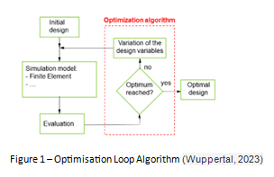
Alternatively, topography optimization allows for the optimization of shapes to enhance structural integrity. It is similar to topology optimization, but in topography optimization, the elements are offset from the component's mid-plane, whereas in topology optimization, the weight is altered at various sections. Both methods can consider composite or steel materials to determine how their properties are affected under applied stress (Pagadala, 2015). The optimization algorithm can be defined as shown in Figure 1.

2.3. CAD Vs CAE Led Optimisation
The design process saw significant advancements by transitioning to Computer-Aided Design (CAD) as the primary tool. Detailed 3D CAD models were created and assessed using Computer-Aided Engineering (CAE). Based on CAE results, the design underwent modifications iteratively until achieving an optimized final design (Zitzewitz, 2023). The introduction of CAD and CAE represented a significant improvement over traditional methods.
Further progress was made by adopting CAE-driven optimization. This approach allows for the creation of a concept design that can be optimized to meet customer criteria even before any manufacturing commences. Once approved by the customer, the concept is effectively translated into a 3D model manufactured, tested, and approved. This CAE-driven optimization yields the most substantial time savings, resulting in reduced labour and tooling costs throughout the process (Belhe, 2014).

2.4. Future of Finite Element Analysis
The future of FEA optimization lies in its integration with new industrial revolutions, particularly in the additive manufacturing markets, and its application to multi-material designs. As technology advances, the ability to optimize a concept and create a 3D model could be achieved in as little as a day, significantly streamlining the design process (Wood, 1992). However, there are currently some unresolved challenges, such as multi-material topology optimization, fluid-structure topology, and fluid-thermal topology. Overcoming these limitations, along with incorporating additive manufacturing (AM) and leveraging artificial intelligence, will pave the way for the next generation of manufacturing (Roade, 2020).

- Design Studio
  - Setting up the Baseline Properties
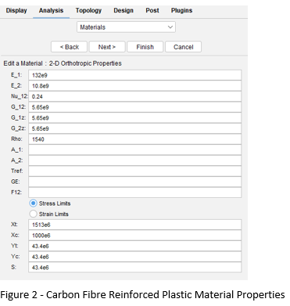
In the provided NASTRAN deck, the ends of the wing are fixed to side supports, and we can consider these connections to be rigidly fixed in all six degrees of freedom. Additionally, the material was initially specified as steel, but now we need to update it to represent carbon fibre-reinforced plastic (CFRP). To achieve this, we must define a new material in the materials section. CFRP is a composite material and is defined as 'MAT8/PSHELL/PCOMP,' which specifies the algorithm for orthotropic materials. Detailed properties for CFRP are illustrated in Figure 2, with further elaboration provided in Appendix A.
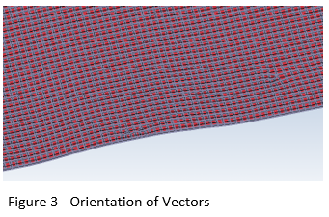
To ensure the accuracy of our results, it is crucial to align the element properties correctly according to the specification requirements. This adjustment is made within the elements section, where we can modify the element's orientation angle to align it with the Y-plane, as depicted in Figure 3.
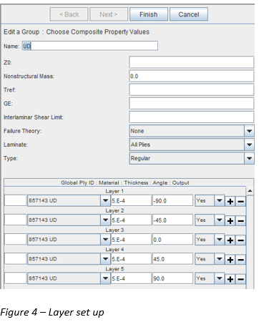
Another requirement is to accurately define the material thicknesses and orientations for the composite material. The choice of angles plays a crucial role in specifying the material distribution across the component. The material is structured at -90 degrees, -45 degrees, 0 degrees, 45 degrees, and 90 degrees, ensuring uniform material thickness throughout the baseline model of the wing. This thickness is achieved by composing 25 plies, where each individual ply measures 0.1mm in thickness. Consequently, there is a cumulative thickness of 0.5mm at each angle, as illustrated in Figure 4. Consequently, the wing exhibits a total thickness of 2.5mm.
By configuring these parameters, a single analysis operation becomes capable of assessing the deflection resulting from the applied data and calculating the mass of the wing. This functionality enables a comparative evaluation of the steel and CFRP baseline models to gauge the impact of material properties on deflection. Table 1 reveals the baseline results, illustrating the thickness, deflection, mass, load stiffness and stiffness to weight ratio between the two baselines. However, it's worth noting that CFRP is far lighter than steel, offering the potential for optimization to achieve the desired deflection.

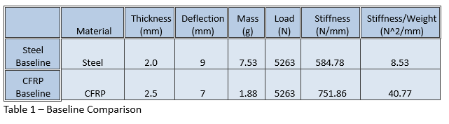

  - Optimising The Design
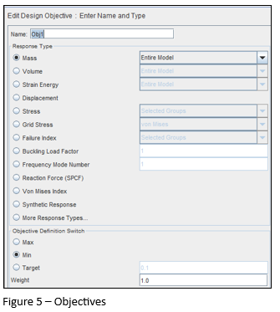
To optimize the structure effectively, three crucial parameters need to be defined: objectives, constraints, and variables. The primary objective is to minimize the mass of the wing, emphasizing the need for lightweight design, as illustrated in Figure 5.
A key constraint for this wing is to limit the maximum deflection to 6mm. This constraint is incorporated within the displacement section by specifying an 'upper bound' of 6.e-3m, as shown in Figure 6. It is essential to note that all parameters must be expressed in the International System (SI) units to ensure the accuracy of the results.
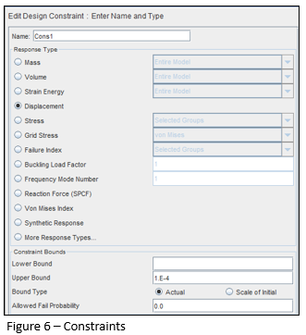
Finally, we must define the design variables. The initial value is configured at 0.5mm, aligning with the ply thickness of 0.1mm, which serves as the lower bound parameter. Meanwhile, the upper bound parameter is established at 1mm, specifying the maximum allowable thickness. These bounds are applicable to all five thickness parameters being employed. As depicted in Figure 7, the 'I' in the description signifies "Independent variables.
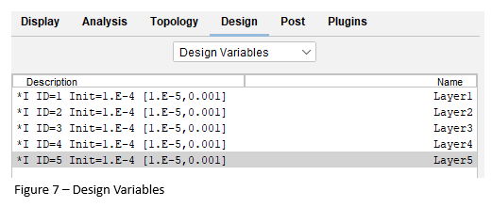

 | Material | Thickness (mm) | Deflection (mm) | Mass (g) | Load (N) | Stiffness (N/mm) | Stiffness/Weight (N^2/mm)
Steel Baseline | Steel | 2.0 | 9 | 7.53 | 5263 | 584.78 | 8.53
CFRP Baseline | CFRP | 2.5 | 7 | 1.88 | 5263 | 751.86 | 40.77
CFRP Optimised | CFRP | 2.8 | 5.9 | 1.95 | 5263 | 892.03 | 46.63
Table 2 – Comparison with Optimised
Table 2 presented above provides a comparison of results between the optimized analysis, CFRP, and steel baseline models. The findings indicate that the imposed constraint of a 6mm deflection has been successfully met. However, achieving this constraint has necessitated an increase in the structure's thickness. The thickness of this optimized design now exceeds that of the CFRP baseline and surpasses the steel model by nearly 50%. Despite this, the optimized structure remains almost four times lighter than steel, yet it is heavier than the CFRP baseline. In summary, this model's efficiency outperforms the baseline model, and is nearly five and a half times more efficient than the steel model.
Optimised – Independent Variables
Design Cycle | Angle | Thickness (mm) | Thickness (ply’s)
10 | -90 | 0.45 | 1.3
10 | -45 | 0.71 | 4.29
10 | 0 | 0.5 | 15
10 | 45 | 0.7 | 4.23
10 | 90 | 0.44 | 1.29
Total |  | 2.8 | 26.1
Table 3 – Optimised Thickness

Table3, as displayed above, outlines the proposed construction of the wing, specifying varying thicknesses for different sections. However, it is worth noting that the proposed design suggests a total of 26.1 plies. In practice, ply layers must be whole numbers for manufacturing feasibility. A typical detailed layer configurations and the occurrences of violations per design cycle can be found in Appendix B

  - Discrete Optimisation

While the results demonstrate the attainment of set targets, it is crucial to acknowledge that manufacturing considerations have not been factored in, as evident in Table 3. To address this, a transition from independent variables to discrete variables is necessary. The initial discrete variable should be established at 1e-4m with an increment of 1e-4m. In the design variables section, a summary of variables will denote 'D' in place of 'I' to signify the activation of discrete variables.
Optimizing the design with discrete values ensures that more precise values are generated, accounting for manufacturing considerations. The primary distinction in this optimization process occurs when the software recognizes that the discrete values are met. Until the twelfth design cycle, the optimized independent and discrete values remain identical, at which point the independent variables cease, and the discrete variables are adjusted to accommodate manufacturing aspects.

 | Material | Thickness (mm) | Deflection (mm) | Mass (Kg) | Load (N) | Stiffness (N/mm) | Stiffness/Weight (N^2/mm)
Steel Baseline | Steel | 2 | 9 | 7.53 | 5263 | 584.78 | 8.53
CFRP Baseline | CFRP | 2.5 | 7 | 1.88 | 5263 | 751.86 | 40.77
CFRP Optimised | CFRP | 2.8 | 5.9 | 1.95 | 5263 | 892.03 | 46.63
CFRP Discrete | CFRP | 2.6 | 5.9 | 1.92 | 5263 | 892.03 | 47.36
Table 4 - discrete value Optimisation
Table 4 reveals the outcome of a re-optimization process tailored to meet manufacturing tolerance requirements. Consequently, a slight reduction in thickness and mass has been observed. The deflection, while just under the target, indicates the potential for further reduction in design thickness. Moreover, the efficiency of the design has increased, with a minor increase in the stiffness-to-weight ratio. In summary, the design now demonstrates a substantial 5.55x in efficiency compared to steel. Foran overview of a typical entire design cycle, encompassing the attainment of objectives and resolution of design violations, please refer to Appendix B
Discrete
Design Cycle | Angle | Thickness (mm) | Thickness (ply's)
13 | -90 | 0.4 | 1
13 | -45 | 0.7 | 5
13 | 0 | 0.5 | 15
13 | 45 | 0.7 | 5
13 | 90 | 0.4 | 1
Total |  | 2.6 | 27
Table 5 - Manufacturable thickness from discrete optimisation

Table 5 illustrates the adjustment of ply layers to whole numbers, reflecting the software's consideration of manufacturing tolerances as per the provided information. A detailed account of the design cycle for this specific thickness adjustment is provided in its entirety within Appendix B.

- Prototype Testing
To test the Rear Wing Mainplane Flexibility and ensure compliance with the specified deflection limit of 6mm, the following steps and procedures are undertaken:
Setup: Prepare the rear wing assembly and secure it in a testing rig or fixture. Ensure that the rear impact structure is in place and aligned correctly with the rear wing profiles.
Use suitable adaptors, as supplied by the team, to apply the specified loads to the rear wing profiles. Loads vertically in the Z axis will be applied simultaneously at [XR=375, ±300, 910]. (de l’Automobile, 2023 3.15.9a)
Instrument the rear wing profiles with appropriate sensors to measure deflection. Use four pads to support tracking targets at the specified locations: [XR, Y] [350, ±150], and [350, ±450] (de l’Automobile, 2023 2.11). Collect data using a data acquisition system during the testing process.
Apply the loads to the rear wing profiles through the adaptors and record the resulting deflections at the specified locations. Measure deflections along the loading axis and in the Y-plane to determine compliance with the limits of 6mm and 1.0°, respectively. (de l’Automobile, 2023 3.15.9)
Compare the measured deflections with the specified limits. If the deflections meet or are below the prescribed limits, the rear wing passes the flexibility test. If the deflections exceed the limits, the rear wing may need modifications or adjustments to achieve compliance. . If there is less than 6mm deflection, then there may be room for improvement in the optimization of the material, or an error between the test setup and FEA analysis.
Record all test results, including the deflection measurements and any modifications made during the testing process.
Quantitative comparisons can be made by assessing the deflection of the wing with the load applied. Once all measurements are recorded, they can be plotted onto a graph and compared to the simulation results. If the data from both techniques correlate, the simulation results can be deemed reliable. However, if the data does not align, it suggests a potential problem within the CFD program that needs to be addressed and adjusted.

- Regulations
The following sections highlight critical aspects in the design and analysis of a CFRP race car rear wing. These elements are interlinked, working in concert to ensure the wing's optimal performance and structural integrity.
3.10.1 - This refers to a specific requirement or regulation regarding the shape, dimensions, and geometry of the rear wing. The profile plays a critical role in determining the aerodynamic performance of the wing, affecting downforce, drag, and overall stability. (de l’Automobile, 2023 3.10.1)
3.15.9 - Rear wing deflection refers to how much the wing flexes or deforms under aerodynamic loads. Controlling deflection is crucial to maintaining consistent aerodynamic performance and stability. Excessive deflection can lead to unpredictable handling characteristics and reduced downforce. (de l’Automobile, 2023 3.15.9)
15.3.3 - This section refers to the material properties of the CFRP used in the rear wing construction. Tensile strength and modulus are key mechanical properties that describe the material's ability to withstand tension without breaking and its stiffness, respectively (de l’Automobile, 2023 15.3.3)
2.11 - A defined coordinate system is essential for accurately designing and analysing the rear wing. It ensures consistent measurements, angles, and positions, which are critical when assessing factors like aerodynamic performance, deflection, and stress distribution. (de l’Automobile, 2023 2.11)
ISO 527 is an international standard that outlines test methods for determining the tensile properties of plastic and composite materials, including CFRP. It provides guidelines for conducting tensile tests to measure properties like tensile strength, modulus of elasticity, and elongation at break.
ISO 14126 is an international standard that covers the determination of compressive properties of plastics and composite materials. In the context of a rear wing, compressive properties would be relevant when considering the structural integrity of the wing under different loading conditions.
ISO 20975 specifies test methods for determining the tensile and compressive properties of fibre-reinforced polymer matrix composites. This standard provides guidance on conducting tests to measure various mechanical properties, which are crucial for ensuring the performance and safety of the rear wing.
In summery, these elements are interconnected in the design and analysis of a CFRP race car rear wing. The rear wing's profile affects its aerodynamic performance, which in turn influences deflection behaviour. The choice of CFRP material and its tensile and compressive properties determine the wing's structural integrity and ability to withstand aerodynamic and mechanical loads. The defined coordinate system ensures consistent measurements and accurate analysis, while ISO standards provide internationally recognized testing methods to assess the material's mechanical characteristics. All these factors come together to create an optimized and high-performance CFRP rear wing for a race car.

- Conclusion
The data presented in this report highlights the significance of Finite Element Analysis (FEA) for engineering simulations. Over time, the evolution of FEA has been instrumental in expediting the design cycle, reducing labour-related time constraints, and curbing tooling costs. This, in turn, has rendered the overall process more economically viable, especially when driven by Computer-Aided Engineering (CAE) methodologies.
The future of the design cycle holds promise, particularly with the integration of Industry 4.0 technologies and the incorporation of additive manufacturing techniques. Furthermore, the report underscores the remarkable efficiency of Carbon Fiber-Reinforced Plastic (CFRP) when compared to steel. In fact, CFRP has been demonstrated to be 5.5x more efficient than steel due to its significantly reduced weight in comparison. It is also important to note that the comparative analysis between the optimized CFRP model and the steel baseline model shows an increase in CFRP thickness.
In addition to simulation, the report emphasizes the importance of prototype testing when introducing new models, providing an invaluable means to identify any disparities between theoretical predictions and empirical findings.
Moreover, designing and testing the wing in strict accordance with the 2024 FORMULA 1 TECHNICAL REGULATIONS ensures a level playing field within the sport, guaranteeing the wing's structural integrity aligns with established standards. Leveraging Industry 4.0 data acquisition methods not only minimizes the potential for human errors but also enhances data granularity and real-time monitoring, reducing the risk of failures.
Furthermore, it is essential to highlight the necessity for the wing to comply with relevant British standards governing design, testing, and acceptance protocols, ensuring that the highest industry benchmarks are met and sustained.

- Bibiliography
Arunagiri, P. and Gnanavelbabu, A. (2014) ‘Identification of major lean production waste in automobile industries using weighted average method’, Procedia Engineering, 97, pp. 2167–2175. doi:10.1016/j.proeng.2014.12.460.
Belhe, R. (2014) FEA and its impact on the design process and lifecycle of a product: Hi-tech cae news, HiTechCAE. Available at: https://www.hitechcae.com/blog/fea-and-its-impact-on-the-design-process-and-lifecycle-of-a-product/ (Accessed: 04 October 2023).
Chen, D.-C., Cheng-Yu, L. and Lai, Y.-Y. (2019) ‘Finite element analysis of deep drawing’, Advances in Mechanical Engineering, 11(9), pp. 1–11. doi:10.1177/1687814019874561.
Crahmaliuc, R. (2023) 75 years of the finite element method: Simscale blog, SimScale. Available at: https://www.simscale.com/blog/75-years-of-the-finite-element-method-fem/ (Accessed: 01 October 2023).
de l’Automobile, F.I. (2023) 2024 FORMULA 1 TECHNICAL REGULATIONS’. Available at: https://www.fia.com/sites/default/files/fia_2023_formula_1_technical_regulations_-_issue_1_-_2022-06-29.pdf (Accessed: 08 October 2023).
Esrd (2023) Brief history of FEA, ESRD. Available at: https://www.esrd.com/simulation-technology/brief-history-of-fea/ (Accessed: 01 October 2023).
ISO 14127:2023.(2023) ISO. Available at: https://www.iso.org/standard/80371.html (Accessed: 10 October 2023).
ISO 527-1:2019 (2019) ISO. Available at: https://www.iso.org/standard/75824.html (Accessed: 10 October 2023).
ISO 20975-1:2023(2023)ISO. Available at: https://www.iso.org/standard/69672.html (Accessed: 10 October 2023).
(2023). UWTSD. 10 July. Available at: https://uowtsd.sharepoint.com/teams/StructuralFluidAnalysisPT-April23start_GRP/_layouts/15/stream.aspx?id=%2Fteams%2FStructuralFluidAnalysisPT%2DApril23start%5FGRP%2FShared%20Documents%2FGeneral%2FTopic%2011%20%2D%20Optimisation%20in%20Design%20Studio%2FOpt%20in%20Design%20Studio%201of2%20%282%29%2Emp4&referrer=SharePoint&referrerScenario=OpenFilehttps://uowtsd.sharepoint.com/teams/StructuralFluidAnalysisPT-April23start_GRP/_layouts/15/stream.aspx?id=%2Fteams%2FStructuralFluidAnalysisPT%2DApril23start%5FGRP%2FShared%20Documents%2FGeneral%2FTopic%2011%20%2D%20Optimisation%20in%20Design%20Studio%2FOpt%20in%20Design%20Studio%201of2%20%282%29%2Emp4&referrer=SharePoint&referrerScenario=OpenFile (Accessed: 12 October 2023).

Pagadala, P., 2015. Topography Optimization , France: Altair.
Roade, G. (2020) The future of Finite Element Analysis: Meshfree, MIDASoft North America. Available at: https://www.midasoft.com/mechanical/blog/the-future-of-finite-element-analysis-meshfree (Accessed: 04 October 2023).
Rosinha, I.P. et al. (2015) ‘Topology optimization for biocatalytic microreactor configurations’, 12th International Symposium on Process Systems Engineering and 25th European Symposium on Computer Aided Process Engineering, 37(2), pp. 1463–1468. doi:10.1016/b978-0-444-63577-8.50089-9.
Velling, A. (2023) Topology Optimisation: Benefits & Disadvantages: Software, Fractory. Available at: https://fractory.com/topology-optimisation/ (Accessed: 02 October 2023).
Wood, James. (1992). The Future of Finite Element Analysis in Undergraduate Mechanical Engineering Courses.
Wuppertal (2023) Application example: Optimization of the outer wing of an aircraft, Automatic Component Optimization. Available at: https://www.oms.uni-wuppertal.de/en/teaching/what-we-do/automatic-component-optimization/ (Accessed: 06 October 2023).
Zitzewitz, V. (2023) CAE Tools: What is the difference between CAD and CAE?, SimScale. Available at: https://www.simscale.com/blog/2017/04/difference-between-cad-and-cae/ (Accessed: 04 October 2023).

- Appendix
  - Appendix A
(E_1) = Young’s Modulus (Longitudinal direction)
(E_2) = Young’s Modulus (Lateral direction)
(Nu_12) = Poisson’s Ratio
(G_12) = In-plane shear modulus
(G_1z) & (G_2z) = Transverse shear modulus
Rho = Mass density

  - Appendix B
    - Mass Reduction
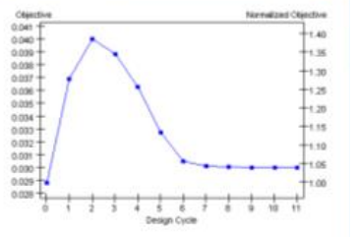

(Lake, 2023)
Above is a typical mass reduction graph (Lake, 2023) showing the mass increasing until the maximum deflection is met before the optimisation starts to reduce the mass.

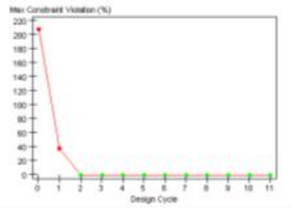
    - Constraint Violation

(Lake, 2023)
Above is a typical constraint violation graph (Lake, 2023) showing the cycle numbers it takes before the optimisation stops violating the constraints.

    - Variable Thickness
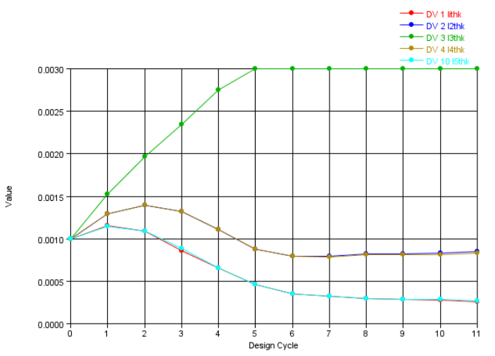

(Lake, 2023)
Above is a typical variable thickness graph (Lake,2023) depicting the the layer thickness per orientation throught the optimisation

