Evaluating Workplace Problem of Tesco Plc

Yana Taneva
2133822
Problem solving and decision making
(BMSW4004_LON)
Balendran Kandasamy

Table of Contents
1.0 Introduction 3
1.1 Importance of Problem Solving 3
1.2 Background of Organisation 3
2.0 Workplace Problem 3
2.1 Scope of the Problem 3
2.2 Actual and Potential Impact 4
3.0 Root Cause Analysis 4
4.0 Situational Analysis 6
5.0 Range of Alternative Solution 7
6.0 Evaluation of Alternative Solutions 8
7.0 Implementation Plan 9
8.0 Monitor and Review Techniques 12
9.0 Conclusion 13
10. References 14
11 Appendix 16

Task 2: Report

1.0 Introduction

1.1 Importance of Problem Solving
In the personal, intellectual, and professional spheres of life, problem-solving abilities are essential (Schwencke, 2023). They help people recognise, examine, and resolve complicated issues, as well as make wise judgments and adjust to changing circumstances (Atuahene-Gima and Wei, 2018). In the workplace, where employees are required to address a variety of issues and create practical, long-lasting solutions, problem-solving abilities are especially crucial.
Problem-solving abilities are becoming more and more crucial in today's quick-changing environment (Schwencke, 2023). They assist people in navigating challenging and unpredictable circumstances, adjusting to new technology and working conditions, and maintaining their competitiveness in the labour market. Strong problem-solving abilities are also in demand from employers because they are essential for success in practically every job function (Atuahene-Gima and Wei, 2018). The workplace problem analysis will focus on Tesco plc.

1.2 Background of Organisation
Tesco plc is a global retailer with headquarters in the UK. It was established in 1919 and has since expanded to become one of the largest retail chains worldwide, with more than 6,800 locations and 440,000 staff members working in 12 different countries (Forbes, 2023). Tesco has a broad selection of goods and services, such as food, clothes, appliances, financial services, and telephones. The business is renowned for its potent brand, devoted clientele, and cutting-edge advertising techniques (Guardian, 2019).

2.0 Workplace Problem

2.1 Scope of the Problem
Customer dissatisfaction is a complex problem that is affecting Tesco plc, a multinational retail company based in the United Kingdom (Marshall et al., 2022). The problem involves customers expressing dissatisfaction with various aspects of the company's products, services, and overall customer experience (McDonald, 2017). The scope of the problem is quite significant, with numerous customer complaints and negative reviews being reported across various channels, including social media, online forums, and customer service hotlines.

2.2 Actual and Potential Impact
The actual impact of customer dissatisfaction on Tesco plc is evident in various ways. It has led to a decline in customer loyalty and retention, with many customers switching to competitors who offer better products, services, and overall customer experience (McDonald, 2017). This has resulted in reduced revenue and profitability for the company. Besides, customer dissatisfaction has also impacted the company's reputation, with negative reviews and feedback spreading quickly online, potentially deterring new customers from trying Tesco's products and services (Ward, 2015). This can have a long-term impact on the company's ability to attract and retain customers, as well as its overall brand image and reputation.
The potential impact of customer dissatisfaction on Tesco plc is even more significant. The negative reviews and feedback can cause long-term damage to the company's reputation, making it difficult for Tesco to rebuild trust with its customers (Statista, 2017). This can also lead to increased scrutiny from regulators and other stakeholders, potentially resulting in legal and financial penalties.

3.0 Root Cause Analysis
A Fishbone diagram is a cause-and-effect analysis tool that can be used to identify the possible causes of a complex problem. In this case, the use of a Fishbone diagram to identify the possible causes of customer dissatisfaction at Tesco plc and to narrow down the root causes of the problem will be used.
The Fishbone diagram will have six main branches, including people, process, product, equipment, environment, and management. Each branch will have several sub-branches that relate to specific aspects of the problem. The possible causes will be listed under each sub-branch, and their interrelationships will be illustrated with arrows.
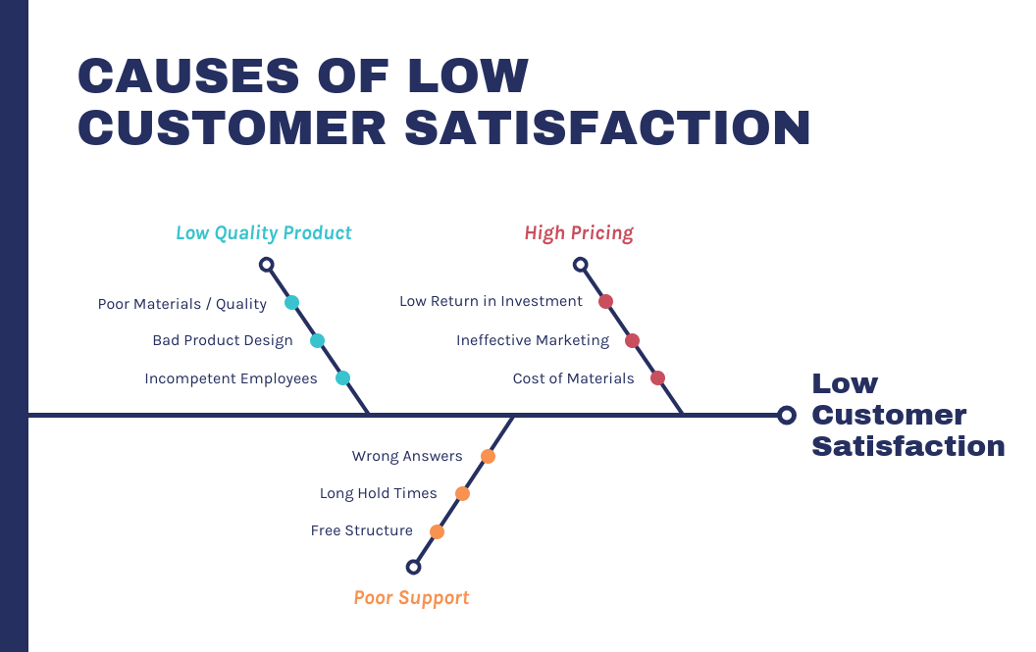
Figure 1: A fishbone diagram representing root causes of customer dissatisfaction
Possible causes for customer dissatisfaction at Tesco plc may include poor support resulting to inadequate customer service, poor quality products, poor store layout, confusing pricing strategies, and lack of variety in product offerings (McDonald, 2017). Some of these possible causes are listed under the appropriate sub-branches on the Fishbone diagram as shown above based on low quality products, high pricing, and poor support.
Various sources, including customer feedback, employee feedback, sales data, and industry research could be gathered to filter out the possible root causes and identify the actual root causes of customer dissatisfaction (Tesco, 2021). This information will help in understanding which possible causes are most likely to be the root causes of the problem.
For example, customer feedback may reveal that long queues at checkout are a major source of frustration and dissatisfaction for customers. Sales data may also show a decrease in revenue during peak shopping hours, indicating that long queues are impacting the customer experience and causing customers to shop elsewhere (Tesco, 2021). This information suggests that long queues at checkout may be a root cause of customer dissatisfaction at Tesco plc.

4.0 Situational Analysis
A SWOT analysis is a useful tool for conducting a situational analysis and identifying the strengths, weaknesses, opportunities, and threats facing an organisation. In the case of Tesco plc, a SWOT analysis can help to identify the internal and external factors that may be contributing to customer dissatisfaction and to suggest alternative solutions.
STRENGTHS  - Strong brand recognition and reputation in the UK retail market  - Wide range of products and services, including online shopping and home delivery  - Established supply chain and logistics infrastructure | Weaknesses:  - Inconsistent customer service quality and staff training  - Limited product differentiation from competitors  - Negative media coverage and customer perception of poor quality products
Opportunities:  - Growing demand for organic and locally sourced products  - Increasing demand for online shopping and home delivery  - Potential expansion into international markets | Threats:  - Intense competition from established rivals such as Sainsbury's and Asda, as well as discounters like Aldi and Lidl  - Changing consumer preferences and increasing concerns around sustainability and ethical sourcing  - Political and economic uncertainty, such as Brexit and changing trade agreements

Relevant data and information is necessary from various sources to conduct a comprehensive SWOT analysis. This may include customer feedback, employee surveys, sales data, market research reports, and industry trends.
For example, customer feedback may reveal specific areas of weakness in Tesco's customer service, such as long queues, inadequate staffing levels, or poor product quality. Employee surveys can provide insights into training needs and employee morale, which can impact customer service and overall customer experience (Varekamp and Van Dijk, 2019). Sales data and market research reports can provide insights into changing consumer preferences and trends, such as the growing demand for organic and locally sourced products.
Tesco can identify areas of strength and weakness and develop strategies to capitalise on opportunities and address threats by conducting a thorough SWOT analysis. For example, the company may invest in training programs for employees to improve customer service quality and reduce long queues (Spinoza, 2022). They may also introduce new products and services that cater to changing consumer preferences, such as more organic and locally sourced products.

5.0 Range of Alternative Solution
Based on the analysis above, several alternative solutions can be suggested for Tesco to address the issue of customer dissatisfaction. Here are three preferred solutions:
Range 1: Redesigning stores and improving checkout processes
One solution to address customer dissatisfaction is to redesign Tesco's stores and improve checkout processes to reduce long queues and waiting times. Tesco can redesign its stores to make them more customer-friendly by placing popular products at the front of the store, reducing clutter, and creating wider aisles (Spinoza, 2022). Tesco can also invest in self-checkout machines to reduce wait times during peak shopping hours. In addition, Tesco can train employees to provide efficient and friendly customer service, which can help reduce customer frustration and dissatisfaction.
Range 2: Simplifying pricing strategies and improving product quality control
Simplification of pricing strategies and improve product quality control is another solution to address customer dissatisfaction. Tesco can simplify its pricing strategies by offering clear and transparent pricing information to customers, avoiding hidden fees, and using simple pricing structures. Besides, Tesco can improve product quality control by implementing regular quality checks, reducing the number of out-of-stock items, and ensuring products are fresh and of good quality.
Range 3: Conducting regular customer research.
Conducting regular customer research is a third solution to address customer dissatisfaction (Spinoza, 2022). Tesco can use surveys, focus groups, and other research methods to gather feedback from customers and understand their needs and preferences. Tesco can identify the root causes of customer dissatisfaction and take corrective actions accordingly. For example, if customers are dissatisfied with the quality of Tesco's own brand products, Tesco can improve product quality control and introduce new products that better align with customer preferences.

6.0 Evaluation of Alternative Solutions
The evaluation of the alternative solutions will incorporate weighted decision-making matrix. It can be used to evaluate the alternative solutions to the complex problem of customer dissatisfaction affecting Tesco (Spinoza, 2022). This tool can help identify the most appropriate solution by considering factors such as cost, effectiveness, and ease of implementation. Here is an example of a weighted decision-making matrix that can be used to evaluate the three solutions proposed above:
Solution | Cost | Effectiveness | Ease of Implementation | Total Score
Redesigning stores and improving checkout processes | 3 | 4 | 3 | 10
Simplifying pricing strategies and improving product quality control | 4 | 3 | 4 | 11
Conducting regular customer research | 2 | 3 | 5 | 10
Table 1: weighted decision-making matrix
In this matrix, each alternative solution is evaluated on a scale of 1 to 5 for three criteria: cost, effectiveness, and ease of implementation. The scores for each criterion are then multiplied by a weighting factor, which reflects the relative importance of each criterion. For example, if cost is considered more important than effectiveness and ease of implementation, it may be assigned a weighting factor of 4, while the other two criteria are assigned a weighting factor of 3.
In this case, the weighting factors are as follows cost is 3, Effectiveness is 4, and ease of implementation is 3. The total score for each solution is calculated by summing the scores for each criterion multiplied by its weighting factor. The solution with the highest total score is deemed the most appropriate solution. In addition, based on the weighted decision-making matrix above, the solution with the highest total score is simplifying pricing strategies and improving product quality control with a total score of 11. This solution scored highest in the effectiveness criterion and had an above-average score in both cost and ease of implementation.

7.0 Implementation Plan
The ADKAR model is a change management framework that can help guide the implementation plan for the chosen solution to the complex problem of customer dissatisfaction affecting Tesco (Karambelkar and Bhattacharya, 2017). The model which focuses on awareness, desire, knowledge, ability, and reinforcement are the five stages that individuals need to go through to successfully adopt and implement a change. Here is an example of an implementation plan using the ADKAR model:
Awareness
Increase awareness of the need for the change among all employees and stakeholders by communicating the rationale for the change and the benefits it will bring (Karambelkar and Bhattacharya, 2017). This can be achieved through email updates, town hall meetings, and posters in stores.
Desire
Foster a desire to support the change among employees by involving them in the process and addressing their concerns. This can be achieved through focus groups, one-on-one meetings, and surveys to gather feedback and ideas from employees.
Knowledge
Provide employees with the necessary knowledge and skills to support the change by offering training programs and workshops on new pricing strategies, quality control procedures, and customer service skills. (Goyal and Patwardhan, 2018) This can be achieved through online training modules, workshops, and coaching sessions.
Ability
Enable employees to apply the new knowledge and skills to their work by providing them with the necessary tools and resources, such as new software and equipment, updated procedures manuals, and job aids (Goyal and Patwardhan, 2018). This can be achieved through pilot tests, shadowing programs, and job shadowing.
Reinforcement
Reinforce the change by recognising and rewarding employees who demonstrate the desired behaviours and outcomes. This can be achieved through recognition programs, performance reviews, and incentive schemes.
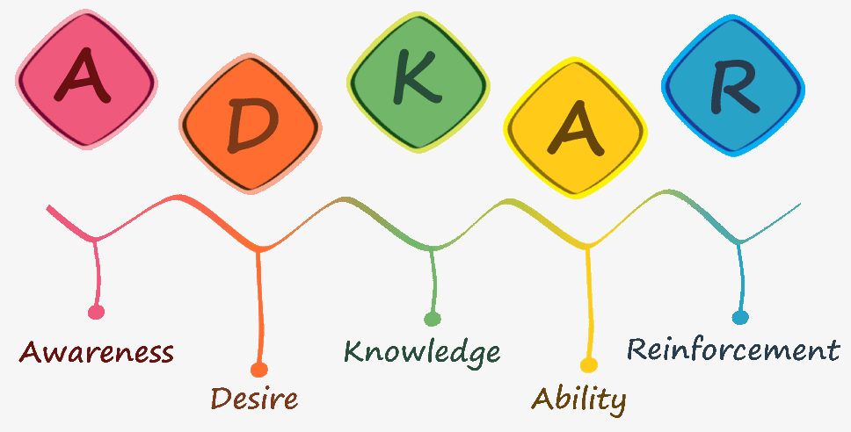
Figure 2: ADKAR model

Communication Plan with stakeholders
Stakeholder Identification:
- Customers
- Employees (store staff, customer service, management)
- Shareholders/investors
- Suppliers/vendors
- Government/regulatory bodies
- Local communities
- Media/journalists
- Competitors
Influence/Power and Interest Matrix
The Power/Interest Grid is a tool that can help categorise stakeholders based on their level of influence over the project and their level of interest in the project. This can help identify which stakeholders should be prioritised for communication and engagement efforts. Here is an example of a Power/Interest Grid for Tesco:

Stakeholder Communication Plan
Stakeholders | Power/Interest | Key Interest and Issues | Communication Vehicle | Frequency | Comment
Customers | High power/high interest | Quality products, competitive prices, | Advertising, social media, | Regular updates | Effective stakeholder communication
Investors | High power/high interest | Financial performance, growth, dividends, | Annual reports | Annual reports, quarterly | Effective stakeholder communication
Employees | High power/high interest | Fair pay, career development | Internal communications | annual performance reviews | Effective stakeholder communication
Suppliers | High power/high interest | timely payments, long-term partnerships | Supplier portal, | Regular updates | Effective stakeholder communication
Government | High power/high interest | Compliance with regulations, | Regulatory filings, | Regular updates on compliance and sustainability initiatives, | Effective stakeholder communication
Local communities | Low power/high interest | Support for local economy, environmental impact | Local events and sponsorships, | Regular updates on local events and sponsorship | Effective stakeholder communication
Table 2: Power/Interest Grid for Tesco

The stakeholders in the top left quadrant (high power, high interest) are the most critical and require the most attention. These stakeholders are likely to have a significant impact on the project and are therefore important to engage and communicate with frequently. The stakeholders in the top right quadrant (high power, low interest) may not be as interested in the project, but they still have a lot of influence and should be kept informed of progress and any changes. The stakeholders in the bottom left quadrant (low power, high interest) may not have much influence over the project, but they are still important to engage with as they are likely to be impacted by the project. Furthermore, the stakeholders in the bottom right quadrant (low power, low interest) are not a priority and may only need to be communicated with on a limited basis.

8.0 Monitor and Review Techniques
It is important to have a monitoring and review plan in place to ensure successful implementation of the chosen solution (Goyal and Patwardhan, 2018). This plan will allow Tesco to track progress, identify potential issues, and make adjustments as necessary to ensure that the solution is being implemented effectively. Here are some techniques that Tesco can use to monitor and review the implementation:
- Milestones: One effective way to monitor progress is by setting milestones for the implementation process (Wilkinson et al., 2017). These milestones can be used to track progress and ensure that the project is on track. Tesco can create a list of milestones and associated timelines, and regularly review progress against these milestones to ensure that the project is moving forward as planned.
- Regular Communication: Regular communication with stakeholders is essential to ensure that everyone is on the same page and to identify any potential issues (Khandelwal, 2022). Tesco can schedule regular check-ins with key stakeholders to provide updates on progress, discuss any challenges, and get feedback on the implementation process.
- Customer Feedback: Tesco should collect regular feedback from customers to monitor their satisfaction levels with the changes implemented (Varekamp and Van Dijk, 2019). This can be done through surveys, focus groups, or social media monitoring. The feedback should be used to identify any areas for improvement or further adjustment.
- Employee Feedback: Employee feedback is also essential to monitor the success of the implementation (Khandelwal, 2022). Tesco should conduct regular employee satisfaction surveys and feedback sessions to gauge their understanding and engagement with the new processes and procedures. This will also help identify any training needs or areas where employees need additional support.

9.0 Conclusion
In conclusion, the problem of customer dissatisfaction is a complex issue that requires a systematic approach to identify the root causes and develop appropriate solutions. The analysis has used various tools such as Fishbone diagrams, SWOT analysis, and a weighted decision matrix to identify possible causes and evaluate alternative solutions. Besides, the analysis has developed an implementation plan that includes communication strategies, training, and a monitoring and review process to ensure the successful implementation of the chosen solution.
As a result, Tesco can ensure that the implementation of its solution is successful and that its customers are satisfied with the changes made by involving all stakeholders and regularly monitoring progress. It is important for Tesco to maintain a customer-focused approach and continue to seek feedback to identify areas for improvement. With a well-planned and executed solution, Tesco can regain its position as a market leader and ensure its long-term success.

10. References
Atuahene-Gima, K. and Wei, Y.S. (2018) ‘The vital role of problem-solving competence in new product success*: the vital role of problem-solving competence in new product success’, Journal of Product Innovation Management, 28(1), pp. 81–98. Available at: https://doi.org/10.1111/j.1540-5885.2010.00782.x.
Forbes (2023) Tesco | company overview & news. Available at: https://www.forbes.com/companies/tesco/ (Accessed: 10 April 2023).
Guardian (2010) ‘Company profile for Tesco’, The Guardian, 11 October. Available at: https://www.theguardian.com/sustainable-business/profile-tesco (Accessed: 10 April 2023).
Karambelkar, M. and Bhattacharya, S. (2017) ‘Onboarding is a change: Applying change management model ADKAR to onboarding’, Human Resource Management International Digest, 25(7), pp. 5–8. Available at: https://doi.org/10.1108/HRMID-04-2017-0073.
Khandelwal, M. (2022) 9 shockingly common workplace challenges, OpenGrowth. Available at: https://www.opengrowth.com/resources/shockingly-common-workplace-challenges (Accessed: 10 April 2023).
Lewis, S. (2023) What is a fishbone diagram (Ishikawa cause and effect diagram)? WhatIs.com. Available at: https://www.techtarget.com/whatis/definition/fishbone-diagram (Accessed: 10 April 2023).
Marshall, L., Pugh, R. and Barker, S. (2022) Tesco face hundreds of complaints after customers unable to buy essentials, YorkshireLive. Available at: https://www.examinerlive.co.uk/whats-on/shopping/tesco-face-hundreds-complaints-after-24960192 (Accessed: 10 April 2023).
McDonald, C. (2017) Tesco customers miss out on deliveries due to tech fault | Computer Weekly, ComputerWeekly.com. Available at: https://www.computerweekly.com/news/450421076/Tesco-customers-miss-out-on-deliveries-due-to-tech-fault (Accessed: 10 April 2023).
Schwencke, B. (2023) Why problem solving is important in the workplace - testpartnership. Available at: https://www.testpartnership.com/blog/why-problem-solving-important.html#:~:text=Those%20with%20good%20problem%20solving,issue%20or%20indeed%20exasperate%20it. (Accessed: 10 April 2023).
Spinoza, J.D. (2022) ‘10 common workplace challenges and solutions - zoomshift’, 2 February. Available at: https://www.zoomshift.com/blog/workplace-challenges-and-solutions/, https://www.zoomshift.com/blog/workplace-challenges-and-solutions/ (Accessed: 10 April 2023).
Statista (2017) Customer satisfaction rates of leading supermarkets 2017. Available at: https://www.statista.com/statistics/661074/customer-satisfaction-loyalty-index-uk/ (Accessed: 10 April 2023).
Tesco (2021) ‘How analytics helped Tesco improve its customer satisfaction amid Covid: An Economic Times Coverage’. Available at: https://www.tescobengaluru.com/news/how-analytics-helped-tesco-improve-its-customer-satisfaction-amid-covid-an-economic-times-coverage/ (Accessed: 10 April 2023).
Ward, C. (2015) Tesco losses not indicative of customer satisfaction levels in supermarket sector, MyCustomer. Available at: https://www.mycustomer.com/service/management/tesco-losses-not-indicative-of-customer-satisfaction-levels-in-supermarket-sector (Accessed: 10 April 2023).
Wilkinson, K., Tomlinson, J. and Gardiner, J. (2017) ‘Exploring the work–life challenges and dilemmas faced by managers and professionals who live alone’, Work, Employment and Society, 31(4), pp. 640–656. Available at: https://doi.org/10.1177/0950017016677942.
Appendix 



