Implementation of CAE activities to gain confidence in design before launching mass production tooling from a build to print mentality.

Conducted by Kieran Cassidy.





This thesis is the result of the author’s original research. It has been composed by the author and has not been previously submitted for examination which has led to the award of a degree.
Signed: K. Cassidy Date: 23/04/2025

Contents
Table of Figures 3
1. Abstract 5
2. Introduction and background 5
3. Aim and Objectives 9
3.1.1. Aim.. 9
3.1.2. Objectives 9
3.3. Gantt Chart 10
3.4. Research/ literature Survey 11
3.4.1. Build to Print Manufacturing Approach 11
3.4.2. Role of Computer-Aided Engineering (CAE) in Design Validation 11
3.4.3. Limitations of CAE in Build-to-Print Contexts 12
3.4.4. Industrial Case Studies 12
3.4.5. Gaps in Literature and Research Opportunities 12
3.5. Customer Relationship 13
3.6. Other tooling launched on CAE activities. 13
3.7. Project Management Techniques. 15
4. Before Mass Production 16
4.1. CAE 16
4.1.1. CAE Preparation 18
4.1.2. CAE Results 20
4.2. Prototype Builds 21
4.2.1. 3D Prints 22
4.2.2. Design stage DC prototype build 24
4.2.3. Production site prototype build 26
5. Launching Mass Production tooling based on prior design activities 30
5.1. Injection moulding 32
5.1.1. Project management techniques used throughout project. 34
6. Future corrective actions 38
6.1. Future Work 39
7. Conclusion 39
8. Reference 41

Table of Figures
Figure 1 Wiring Harness 6
Figure 2 Department Infrastructure 6
Figure 3 Department Workload 7
Figure 4 Gantt chart showing overview of project. 10
Figure 5 Protector Design in CAE Condition 17
Figure 6 Protector Joint Check 17
Figure 7 Visual Representation of Harness Inside Vehicle (Skill-Lync, 2025). 18
Figure 8 CAE Preparation 19
Figure 9 CAE constraint locations. 20
Figure 10 CAE Vibration Test Results 21
Figure 11 Joint Check Sheet Title Page 22
Figure 12 Mechanical Properties of PA12 Material (3D Component) 23
Figure 13 Mechanical Properties of PP Material (Mass Production component) 23
Figure 14 Timing Plan Comparison 23
Figure 15 Image of Wiring Harness Fitment Check During Initial Trail 25
Figure 16 Component Photo 25
Figure 17 Workflow of Wiring Harness Manufacturing Process 26
Figure 18 Tape Workability Point Raised During Joint Check 27
Figure 19 Taping Concern Raised in Joint Check 27
Figure 20 Joint check sheet point 13. 28
Figure 21 Joint check sheet point 10. 28
Figure 22 Effected Area of Component - 90° Bend 29
Figure 23 Joint check sheet point 17. 29
Figure 24 CAD Image of clip mount and locator pin 31
Figure 25 Picture of 3D component 32
Figure 26 Diagram showing an injection moulding machine. 33
Figure 27 Injection moulding tool 33

Table of Tables
Table 1 CAE Test Parameters 12

Abstract
This project explores methods such as computer aided design and additive manufacturing used with failure mode and effects analysis and computer aided engineering techniques being used as tools to evaluate and create design confidence. The aim is to assess how said techniques can be implemented by SEWS-E to gain a higher confidence in the design, with the caveat of historically being a ‘build to print’ supplier. This study not only examines the technical feasibility but also how being an independent supplier with the capability of deign and development can instil more trust in customers and SEWS-E place within the automotive industry.

Introduction and background

The automotive industry is extremely competitive. Sumitomo Electric Wiring Systems Europe (SEWS-E) are renowned for quality instilling a history of trust throughout many customers. SEWS-E manufacture wiring harnesses for the automotive industry, part of this involves developing robust component designs. Historically, component design has been outsourced within the worldwide company structure, this is referred to as a ‘build to print project’ and involves implementing a developed and validated designs in Asia for a European market. While this method ensures traceability and compliance, it limits opportunity for design innovation and early risk mitigation. During a new project SEWS-E has assumed full design responsibility for a European specific wiring harness component, shifting towards localised design and development.
The transition involves a cultural shift within the company to introduce new and innovative processes. The need for methods to build confidence in the design prior to manufacturing mass production tooling is crucial. Nissan president and CEO Makoto Uchida actively describes Nissan’s Sunderland plant as Britain’s biggest ever car factory and the heart of their future vision EV36Zero (2023, GOV.UK) The vision supports Nissan’s carbon natural goal across the life cycle of all their products (2024, marketing). The Sunderland plant will be instrumental to the success of SEWS-E project, being the final production location of the wiring harness. The plant acts as an EV Hub supporting this vision and safeguarding the future of Britain’s largest car factory as people move away from petrol and diesel cars. This ideology supports government strategies, securing multi-million-pound electric vehicle technology and automotive transformation investment (2023, Government of UK).
Sumitomo Wiring Systems (SWS) are a tier one wire harness manufacture for automotive OEM’s, based in Japan. Sumitomo Electrical Systems Europe is a sub company to SWS, responsible for the European automotive market. The Associated Parts (AP) department is central engineering focussed, ensuring the development of mass-produced injection moulded components. The wiring harness is made up of copper wiring, connectors, sleaving, clips, grommets, protectors, and connector holders. SEWS-E act as an assembly plant assembling an array of components to crate the wiring harness as seen in figure 1.
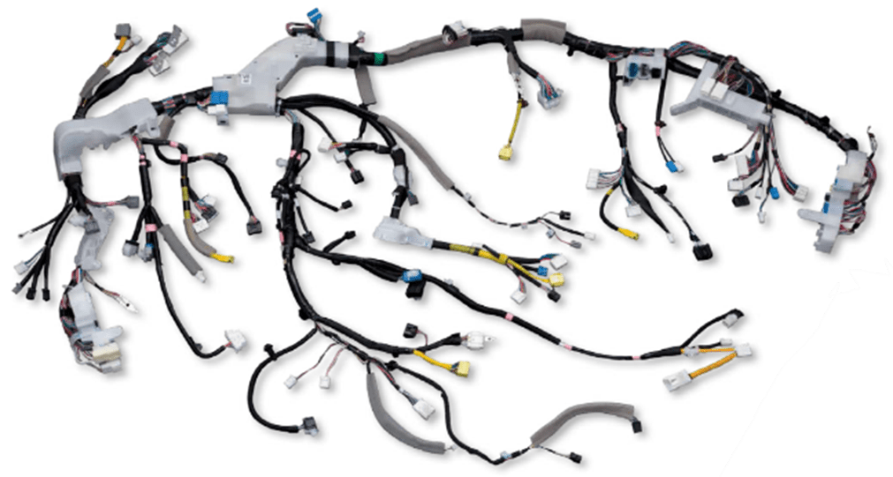
Figure 1 Wiring Harness

The associated parts department are central to SEWS-E, connecting departments and instigating actions to keep projects on track. The department are the ‘middlemen’ between the customer and the supplier for all technical information related to plastic and rubber components. Also, AP must liaise with the project team and purchasing during quotation and project milestones tying together information and solutions. The relationship between AP, the customer and the supplier can be seen in figure 2, this structure is present in both build to print and design and development projects.
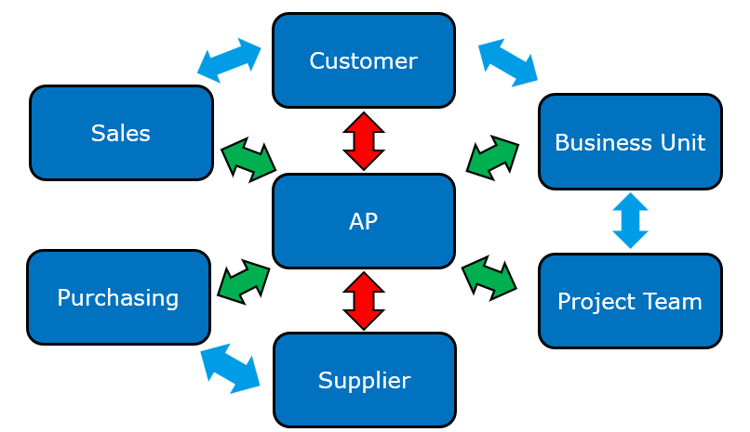
Figure 2 Department Infrastructure
Currently Sumitomo Electrical Systems Europe Japan associated parts team develop validated designs already in mass production, in Asia, for the European market. These designs are produced by SEWS-E mother company SWS, they are referred to as build to print. SWS compose 2D drawings and 3D CAD data that SEWS-E implement with a supplier to create mass production injection moulding tooling. The current project will be outside of normality for the SEWS-E Japan AP team as it will be a design and development project. This will mean the team will be design responsible for the first time, creating new challenges. As shown in figure 3, the main three tasks during a design and development project can be broken down with respect to department responsibility. Associated parts department hold the overall authority and responsibility to each task, however different departments play unique roles. For example, during the joint check study the project team at SEWS-E production site will work in conjunction with AP to carry out the trail. Both customer and supplier will be informed of problems or design related actions required to be corrected. Computer aided engineering will be carried out by AP and shared with the customer. Prototype parts will be manufactured by AP and used for design related activities, while in parallel sent to project team to manufacture assembly jigs.

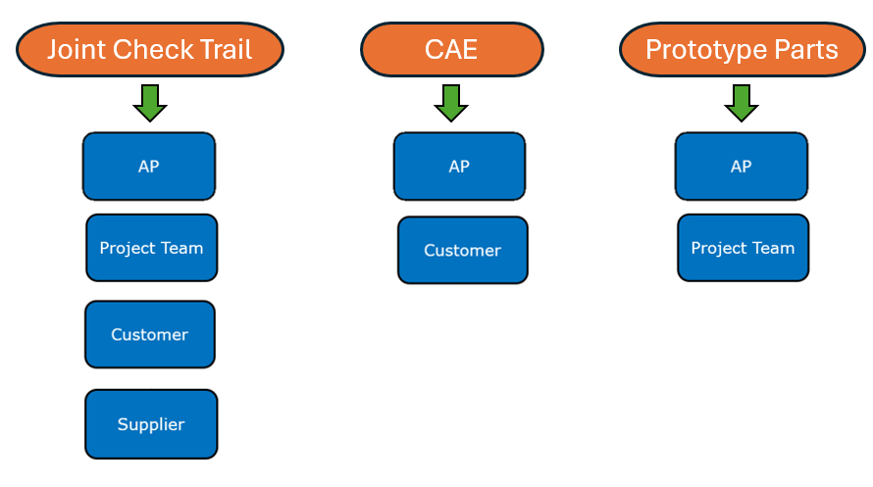
Figure 3 Department Workload

The shift of responsibility has been implemented to instil an improvement in working relationship with the customer. Nissan moving the design responsibility to the UK, allows SEWS-E (tier 1 supplier into Nissan) to communicate affectively between design teams and suppliers, eliminating the language barrier. This ability to implement a close working relationship also makes SEWS-E more competitive compared to other Japanese OEM automotive wire harness suppliers. It is shown that integration of design and manufacturing will enhance product quality and significantly streamline the process. Moving the design work closer to manufacturing not only promotes better efficiency but also reduces production issues later on in the project (Favi et al., 2021). Wang further describes the link between efficiency and designing closer to manufacturing as it facilitates effective communication among multidisciplinary teams (Wang et al., 2007). This is paramount to the fundamental reasoning behind SEWS-E moving design and development to Europe parallel to customer.
The main problem SEWS-E Japan AP team face during this project is gaining confidence in the design prior to launching mass production tooling. Previously in build to print projects, the design would’ve been fully validated to OEM standards and had gone through a full production part approval process (PPAP). This consists of a fitment and functionality report signed by the customer, dimensional report according to the drawing and testing completed to rigours standards. The decision was made to gain confidence through computer aided engineering (CAE) and 3D printed prototype builds, allowing the AP department to launch mass production tooling with confidence. The successfulness of the design will be assessed using customer feedback, testing results and previous projects. It is crucial AP monitor this process as it will be instrumental to the future of the department within the company.
CAE is used during the design stage of the project to identify potential design faults and not to a means of an end to all physical testing. This approach minimises the dependency on physical testing that takes time and physical components to achieve (Jan et al., 2021). CAE has revolutionised many engineering industry’s such as automotive, aerospace, construction and medical applications. It is used for a range of applications in the automotive industry, it can be implemented to simulate crash, aerodynamic and durability testing. During durability testing CAE is used to simulate fatigue and stress on vehicle components, the result will show the performance under different conditions. Historically testing components structural integrity prior to manufacturing mass production tooling would be inaccurate as 3D printed components wouldn’t have the same properties. CAE allows the designer to assess the structural integrity of the component for example stress points during a vibration analysis. The vibration test simulates the load a component will go through during its lifetime, identifying stress points showing the designer where to add strength and rigidity in the part to get rid of any fatigue points.

Aim and Objectives

Aim
The aim of this project is to analyse the effectiveness of CAE and design activities used to gain confidence in plastic injection moulded components before launching mass production tooling.

Objectives
The objectives of this project are the following:
- Analyse the CAE used, how It simulates vehicle environment and demonstrates confidence in the design of the component.
- Breakdown the milestones needed to gain confidence in the design before launching mass production tooling.
- Show findings and outcome of project using physical trail build to determine the success of the first design and development project.
- Compare the process to build to print projects from the past and determine how the shift to implement D&D projects in the future will affect launching mass production tooling of plastic injection moulded components.
- Distinguish capabilities of 3D printed parts and establish comparison to the convention build to print approach.

3.3. Gantt Chart
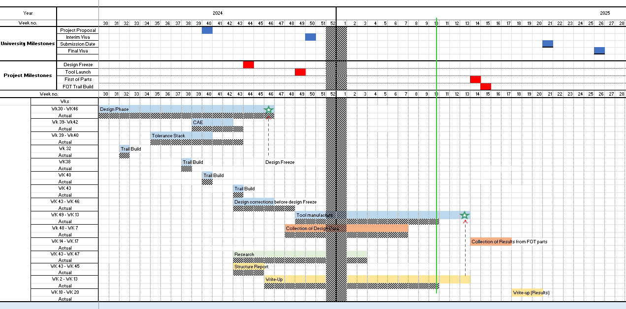
Figure 4 Gantt chart showing overview of project.
The above Gantt chart shown in figure 4 shows the main milestones from both a university and project perspective. The university milestones shows dates of the initial viva, submission and final viva allowing the project milestones and actions to be cross referenced. This ensures there will be sufficient time to correlate information and curate a discussion according to the outlined aims and objectives of the topic.

3.4. Research/ literature Survey
During automotive manufacturing it is crucial the component meets the performance specifications determined by the customer before committing to mass production tooling. This is more critical in a build to print approach as the manufacture follows a set design, already fully validated and functional. Build to print projects are efficient in replacing designs however still bring a risk of manufacturing an insufficiently tested component, posing issues to be raised during the lifetime of the part in a mass production scenario. Computer aided engineering (CAE) and finite element analysis tools have been implemented and heavily discussed to improve this design process. The below literature review explores the use of CAE techniques used to gain confidence before tooling in design and development projects while highlighting the limitations of the build to print approach.

3.4.1. Build to Print Manufacturing Approach
The build to print approach consists of replacing validated drawings and 3D data, provided by customer with little to no deviation or redesign. It is common practice throughout the automotive industry, where control and traceability is crucial. Control and traceability of design are paramount considerations that significantly influence product quality and enhance design reviews, leading to more reliable vehicles (Briand et al., 2014). This method is consistent and supports quality and compliance with customer specifications for components, however it doesn’t consider innovation and customer feedback. Furthermore, it works on the assumption that the design is production ready leaving little room for design improvement. The risk is also heightened when considering a design where mass production tooling has been launched before physical testing. The concept of "launch risk," defined by Steen as uncertainty and severity of consequences stemming from a failed launch is more likely to happen when mass production tooling is initiated prior to comprehensive testing (Steen, 2015).

3.4.2. Role of Computer-Aided Engineering (CAE) in Design Validation
CAE has become a major asset throughout engineering design, the ability to virtually test designs identifying weakness and simulating the performance under various operating conditions vastly improves components. The major advantages are that CAE helps shorten development time, reduce physical prototyping and increase the confidence in the design. CAE results can lead manufacturers to cut back on preproduction experiments, thus eliminating the need for rework and accelerating development timeline (Onodera et al., 2013). Studies by Zhang et al. (2019) and Singh & Patel (2020) demonstrate up to 30% cost savings and significant defect reductions when CAE is applied early in the product lifecycle.

3.4.3. Limitations of CAE in Build-to-Print Contexts
CAE is often mis-used and underutilized in build to print projects due to the manufacturer not owning or having the ability to influence the design. During build to print projects there is often limited access to boundary conditions, complete models and load cases, restricting the ability to implemented CAE practices. CAE relies heavily on comprehensive data, including boundary conditions and load cases, which are often unavailable or inadequately detailed in BTP scenarios Kalilayeva et al. (2024). Literature suggests that the build to print mentality, uses CAE as a post-tooling consideration rather than an asset to be embedded into the design of the component. It is essential that CAE serves as a support mechanism to the design rather than used as a liability based upon insignificant data validation Han et al. (2014).

3.4.4. Industrial Case Studies
When identifying examples of CAE being implemented pre-tooling throughout engineering industries, it was identified that there has been both successes and failures. For example, Boeing’s 787 Dreamliner project involved the use of multi-physics simulation early on, reducing testing cycles PANDIAN et al., (2020). Inadequate simulation assumptions in a build to print contract to be the root cause of tooling rework and design flaws within the component (Nieto and Moreno, 2021).
Both real world scenarios show the value of implementing CAE early to identify problematic barriers, while also highlighting the operational barriers such as data access and simulation ownership as a result of a build to print project.

3.4.5. Gaps in Literature and Research Opportunities
There are several gaps present in the literature concerning CAE being implemented into a design project to gain confidence in tooling from a historical build to print perspective, opening research opportunities that will be explored throughout this project. For example, from a build to print perspective, there is lack of framework for integrating CAE into fixed-design workflows. The frameworks integrating CAE capabilities into the design are hindered by the constraints of fixed-design workflows Elwert et al. (2019). Also, limited access to simulation-ready data for manufactures without design ownership. When discussing design projects there is a key gap in metrics and methods to quantify design confidence through CAE before tooling. Wisthoff et al. (2016); highlight that existing methods, mostly developed for later-stage design validation such as Life Cycle Assessments (LCA), do not adequately support early-stage decision making.
To summarise, the literature indicates that CAE can be implemented before tooling at a benefit to build to print and design projects. However, it can be flawed when used with too much confidence, potentially leading designers and OEMs to be naive as CAE should be used as a guide. There are no clear guidelines in place to determine what design confidence truly means, confidence in the design is key to a successful component. In practical terms, design confidence can be defined as a part with sufficient evidence obtained through analysis, simulation, or prototyping that indicates the design decisions are robust (Frimpong & Thiruvengadam, 2016).

3.5. Customer Relationship
The customer relationship is crucial to consistent business and establishing a strong grounding for potential future business. This project has shown the OEM that SEWS-E can be design responsible in Europe while developing a European specific wiring harness. This is a key milestone for SEWS-E and OEM as previously Europe has never been design responsible, leading to a unique scenario. Strong relationships can lead to repeat business, referrals and potentially increasing awarded business. Trust and open communication are foundational elements promoting commitment and ultimately leading to sustained business relationships (2021, Nwachukwu and Vu). Building trust and reliability between customer and supplier relies on consistent quality and delivering on time (2019,Martinelli). OEM’s performance expectations are instilled upon SEWS-E and will be a key goal throughout the project. Meeting customer requirements for SEWS-E will mean delivering components to customer specifications on time with zero delay, this can be challenging especially when design corrections limit the lead time between launching a mass production tool and producing first off samples to be fitted to wiring harnesses and shipped to customer.

3.6. Other tooling launched on CAE activities.
The biggest tension during the development of plastic injection moulded parts is balancing speed, risk and confidence in design prior to mass production tooling. Fundamentally, confidence is built up by layering validation, physical, digital and environmental testing. The mentioned techniques are implemented widely throughout a range of industries each offering guidance and essential information to minimise risk as much as possible.
During COVID-19 lead time was crucial to saving lives, implementing engineering design solutions into lifesaving medical devices became crucial. During the pandemic there was a shortage of ventilators, which patients facing severe respiratory failure are dependent upon. A potential solution was identified, with the implementation of a ventilator splitter one ventilator could be used to not only support one patient but multiple at any given time. The danger of implementing such device is the cross-contamination or unequal airflow both potentially life threating. Regional medical centres quickly identified the need for such a device and lead a team to tackle the manufacturing and production challenges. The challenge was to produce a reliable, adjustable and sterilizable device to split airflow and be able to be mass produced. In order to gain confidence in the design before launching mass production tooling, rapid 3D prototyping was implemented. Without the confidence in design there could be potential that the tooling would need to be scrapped or machined, costing time patients and hospitals didn’t have. Mike Dresher and his team developed nine iterations of prototypes in under 3 weeks using the HP Multi Jet Fusion 3D printing machine. This is the same machine used during the SEWS-E project when manufacturing 3D prototypes for trail builds. Mike used the protypes to change parameters such as flow control valves, port diameters and mechanical strength, assessing and validating each design iteration. To summarize the implementation of 3D prototypes minimised the risk of potential device failure, potentially delaying a crucial time sensitive project. (Ngoh, 2020)
Plastic injection moulded protectors used in the automotive sector to fixate and protect wiring harnesses from damage are not life critical components. However, the fundamental mentality to the project management and activities are very similar. Project management is crucial to injection moulding components efficient product development is responsible for success, especially where time and cost considerations heavily influence overall success Junk et al. (2023). Mike Dresher and his team implement 3D prototypes for the sole purpose of having a strong amount of confidence in the design prior to tooling Kick off. As shown from the outcome of the project, multiple prototype trails lead to minimizing the risk of product failure. One interesting point is the requirement for a substantial amount of confidence in the design prior to tool Kick off being instrumental to the time sensitive nature of the project. There is a clear link between low lead times and confidence in tooling prior to tool manufacturing Kiani et al. (2014). SEWS-E implement trail builds for the sole purpose of limiting risk of design errors on mass production components, potentially resulting in additional cost and extended lead times.

3.7. Project Management Techniques.
Project management techniques provide structure, visibility and control over complex processes helping to break down the multitude of tasks. Furthermore, the implemented techniques also mitigate risk, balancing performance, safety, reliability and cost requirements. It is clearly shown that implementing project techniques leads to improved efficiency and time management Khan & Haider (2017).
A Gantt chart is a tool used to layout the project milestones and actions, creating a visual representation of the timeline, showing actions that have been completed or are outstanding. Also referred to as timing plans, they are instrumental to achieving customer milestones and distributing the correct actions, while enhancing project control OCHIENG & TUMUTI (2023). Without said timing plan it would open the project to mismanagement, with no clear responsibility and poor outlook. Schedule and cost can be closely tied to detailed timing schedules, the project would be put at a major disadvantage without implementation of one (Zwikael & Sadeh, 2006). Critical Path Method (CPM) is a project scheduling technique used to outline the critical tasks, determining the minimum time required to complete a project. With the focus on any delay to the tasks directly effecting the timescale of the entire project. The purpose of this approach is to focus attention on tasks that can directly alter the schedule helping to mediate the risk, while optimizing project schedules Amalia et al. (2023).
Design failure mode and effects analysis (DFMEA) is a structured risk assessment method used by design teams to determine possible failures within the component’s lifespan. The method identifies the probability of a failure as well as how severe the impact would become, Leading to design improvements that enhance product performance Yacob et al. (2018). The purpose of DFMEA is to find and fix design related risks, ideally before the component reaches customer, to improve quality and reliability while also reducing lead times and cost (Belu et al., 2013). Process failure mode and effects analysis (PFMEA) is more specific from DFMEA in the sense it addresses the potential failures in the manufacturing process itself. The method takes action during each step of the production, identifying possible issues. For example, an assembling error is crucial to SEWS-E, implementing the correct fitment and function during the assembly process prior to design fix and launching mass production tooling leads to more capable and robust components in mass production.
Contingency plans are put in place to strategies over potential solutions to potential problems and prevent a problem failing the project. For example, if the delivery date of an essential component was close to a set milestone in the project, there could be a contingency plan to expedite shipping or assemble said component on the production line. The incorporation of contingency planning allows project managers to foresee uncertainties and implement strategies to ensure success (Zarghami, 2023). Contingency plans are mainly used for high-risk scenarios such as failed validation program, a tooling delay or supplier issues. The plans should usually be documented in FMEA tracking each potential root cause, significantly enhancing risk management efforts Garcia et al. (2020).
Design reviews rely on cross-functional teams reviewing the component and checking for issues, multiple perspectives can often result in a more robust review. Combining various viewpoints can lead to novel solutions by integrating diverse requirements and aspects into the design Austin et al. (2020). The process involves multiple teams identifying if the customer specification is met from a functional and quality perspective. Design reviews are used throughout the development phase, preliminary, critical and final checks. The purpose of the design review is to validate the design feasibility prior to tooling kick off, helping identify potential design related issues that need to be addressed. Product design reviews are crucial for discovering defects and errors, as well as predicting potential manufacturing problems before production begins An & Fan (2011).
Engineering tasks such as finite element analysis (FEA), computer aided engineering (CAE) and moldflow analysis work in conjunction to build a picture of the component’s overall functionality and workability. The purpose of the mentioned engineering tasks are to predict performance and manufacturability concerns prior to physical components existing. CAE simulations can effectively determine how the product will perform during its lifetime physical applications Liu et al. (2021). All of the above techniques discussed are implemented by SEWS-E throughout the design and development project.

Before Mass Production
Computer aided engineering (CAE) consists of software used to aid engineers prior to the manufacturing process. It allows engineers to optimise components, validating to customer specifications and requirements helping give an insight into how the design will perform. CAE is widely used throughout many industries including automotive, manufacturing and aerospace. During this project CAE is implemented to pre-empt design solutions and corrective implementations that could occur during the mass production phase, CAE will be conducted by SEWS-E AP engineers.

CAE
There are four main aspects to consider for the performance of the protector, assembly insertion and retention forces, impact strength and vibration simulation. The CAE conducted by SEWS-E will consider the vibration, helping SEWS-E understand how the protector will perform during its lifetime in the vehicle. The protector can be seen in figure 5, it is used on a wiring harness to protect joint connectors and wires.
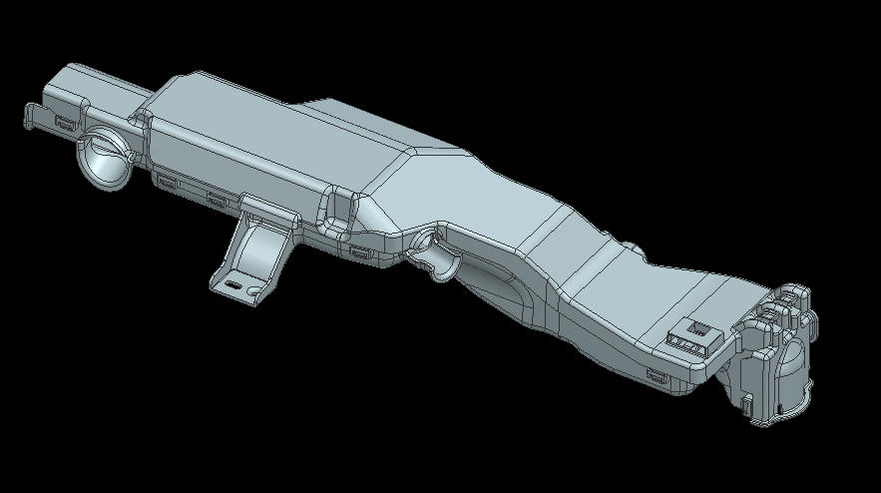
Figure 5 Protector Design in CAE Condition
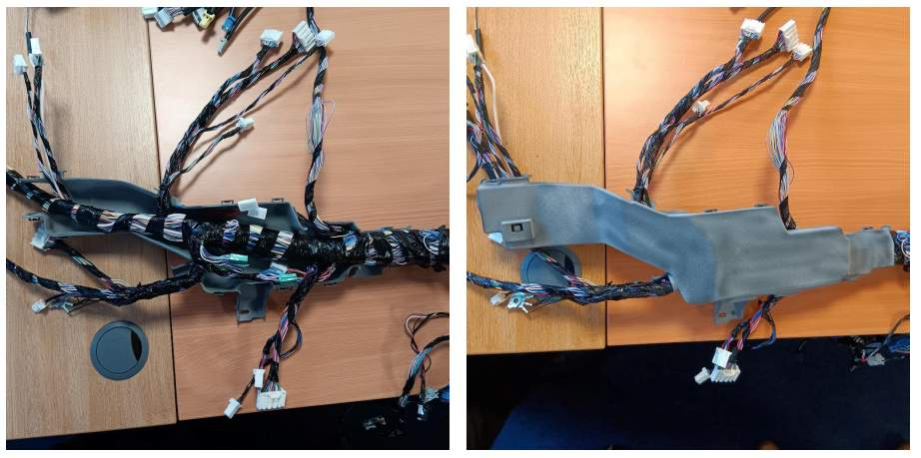
Figure 6 Protector Joint Check
The component is an injection moulded plastic wiring harness protector, made from poly propylene material, a 3D printed prototype can be seen in figure 6. This material was implemented due to its past performance in previous OEM projects. The material has passed all specifications referenced by OEM’s and has a proven past record. It secures the main harness of the vehicle into the correct position, incapsulating joint connectors and insuring wiring breakouts don’t roam loose throughout the body in white. There are many fixation points ensuring the protector is secure, customer specifications require vigorous validation requirements to ensure product life and mediate the risk of component failures.
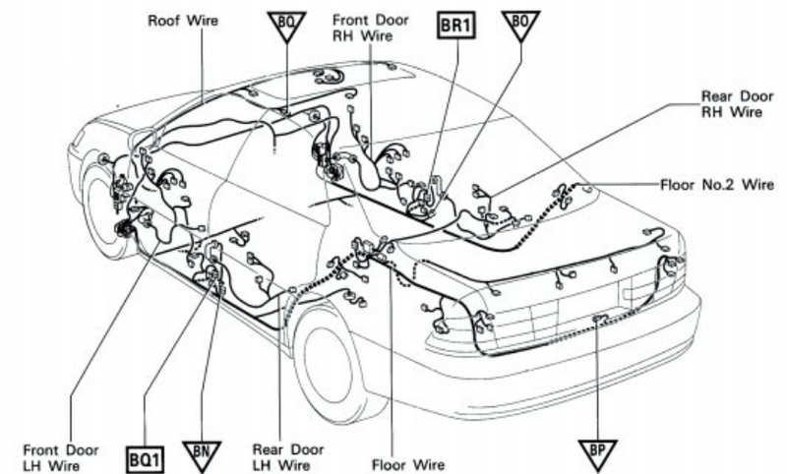
Figure 7 Visual Representation of Harness Inside Vehicle (Skill-Lync, 2025).
The example above in figure 7 shows an example of a main wiring harness situated inside a vehicle, the protector in development would be situated along the body in white of the vehicle supporting the wiring harness.

4.1.1. CAE Preparation
Table one below shows the customer specifications required to be met by SEWS-E, achieving these figures will ensure the component will withstand vehicle forces applied during the lifetime. The CAE will be conducted with ANSYS mechanical software , renowned for its comprehensive Multiphysics capabilities.
Preparation is the most crucial part of the CAE process, identifying the correct requirements, fixation points and data has a direct effect to the test result. The main limitation to CAE is the integration of simulations in the design process being bottlenecked by the inefficiencies of converting CAD models into computational simulations Boussuge et al., (2019). Figure 8 shows the identified fixed locations on the component, each fixation point will be determined in X, Y & Z locations representing where the part will be mated to the vehicle body. The vibration test will be conducted according to OEM specification, table 1 shows testing parameters.
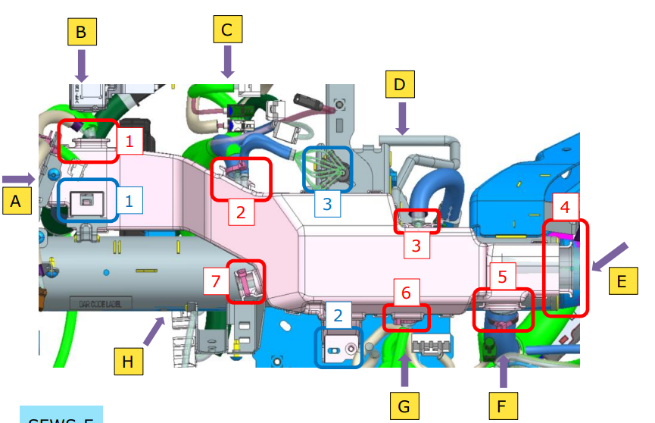
Figure 8 CAE Preparation

Testing Parameters | Figure
Number of Vibrations | 30~260Hz
Vibration Acceleration | 32m/$s^{2}$ (3.2G)
Time / Parameters | X dim 6hr, Y dim 3hr & Z 3hr
Table 1 Customer Specification

Table 1 represents a sweeping vibration test that simulates the vehicle environment during the lifespan of the component. The testing parameters are often more severe than what the component will go through during its lifetime. This gives confidence in the overall performance and capabilities, instilling a robust design to present to the OEM.
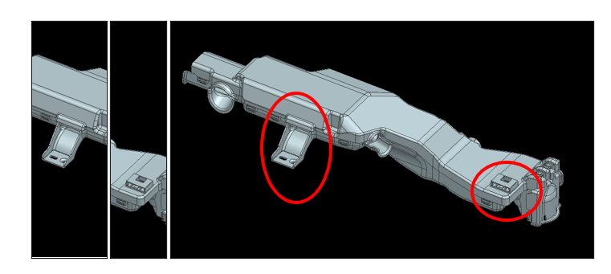
Figure 9 CAE constraint locations.
Figure 9 shows the constraint points used during the CAE analysis, these points are vehicle fixations. During vehicle fitment the fixation points are rigid throughout the lifetime of the component, therefore will not move. Each surface in X,Y and Z orientation has a load applied to it during the given time parameters set by the customer specification as seen in table 1. The material applied is poly propylene mechanical properties are as seen in figure 13 , this allows the CAE to have an accurate resemblance to mass production components.
The aim of the vibration testing is to identify potential stress points within the component, the CAE will show a 3D visualisation of the stress points throughout the component. The max stress points in each axis can be analysed and compared to the tensile and failure limit of the material. The CAE will identify any failures throughout the component, allowing design corrections to be implemented in the affected areas.

4.1.2. CAE Results
Figure 10 shows the regions of mass stress throughout the component, stress is the materials ability to resist deformation or failure under different conditions. The highest reported stress of 9 MPa is well within the materials tensile limit of 27 Mpa, showing that at each vehicle fixation point the component can withstand the applied load. The CAE analysis was conducted by SEWS-E AP engineer and external supplier during the design phase of the project, this allows design corrections to be implemented prior to the start of mass production tooling.

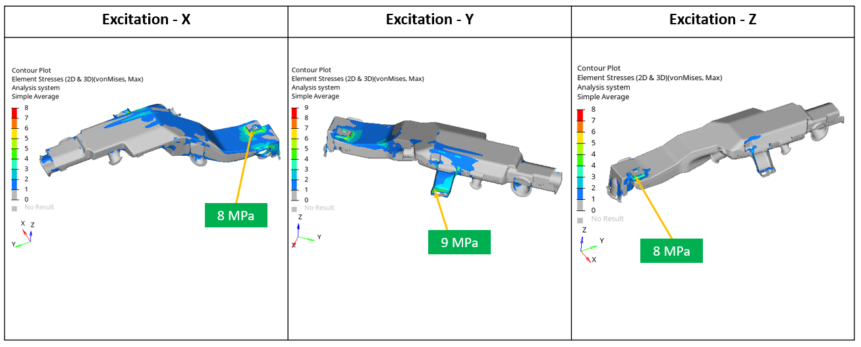
Figure 10 CAE Vibration Test Results

Prototype Builds
Risk assessment techniques are used in a variety of scenarios throughout the design and development project process. Failure mode and effects analysis (FMEA) is used during a project to identify what might go wrong, its effects and potential solutions. FMEA can be broad as it assesses multiple system functions, processes and individual components. The process ensures the component meets quality specifications leading to increased customer satisfaction (2018, Zadry et al), as a result SEWS-E implements FMEA processes into every design decision. Design failure mode and effects analysis (DFMEA) is used at the start of product development and specifically focusses on the product design stage. The purpose of DFMEA is to examine potential failure modes related to design features, this is done before the beginning of manufacturing. Some examples of potential failure modes would be material selection, dimensional tolerances, structural integrity and environmental conditions. DFMEA evaluates design requirements ensuring that design parameters are met according to specification, significantly mitigating design risks (2024, Shah et al), as a result SEWS-E implements DFMEA to ensure correct design evaluation. Process failure mode and effects analysis (PFMEA) is a method used to identify potential failure modes in manufacturing or assembly processes. This helps eliminate potential failures before they reach the customer as it will allow engineers to implement design corrections. Highlighting and managing defects through PFMEA activities in the early stage of manufacturing is crucial as it significantly decreases the cost associated by implementing a solution (2015, Liu et al), as a result SEWS-E implement PFMEA into trail builds.
All three FMEA, DFMEA and PFMEA are universal standardised processes used throughout engineering fields and projects, it is a creative source used to protect customers and suppliers (2012, Vinodh and Santhosh). These tools are put in place during a project to improve the design, manufacturing, assembly and production processes. Internally SEWS-E implement a Joint Check sheet during the development phase of the project, with the intent to capture manufacturing, assembly and production concerns. The complete Joint check sheet can be found in Appendix 2.
Figure 11 Joint Check Sheet Title Page
The Joint Check sheet is broken down by category and item which will have independent evaluation criteria for example check status, risk status, description of risk and defined actions or countermeasures. The action plan ensures a responsibility is assigned to individuals, requiring accountability for progression updates and remarks. The evaluation criteria allows a detailed explanation of each point to be checked on the part, such as part markings, assembly operations and drawing measurements. The risk factor status shows no risk, minor risk, major risk or not applicable. This is used to indicate the judgement of each item, creating a score on how it will affect the component. This sheet combines the standard DFMEA, FMEA and PFMEA approach used throughout engineering industries.

3D Prints
During the design phase of the project each component will be 3D printed, creating an opportunity for visualisation, assembly, manufacturing and production trails. 3D printed parts are a massive asset when implementing a component into a successful mass production scenario with a robust final design (Sackey, 2023).The 3D prints used in joint check activities will be printed via a multi jet fusion technique using the HP 4200 MJF machine. SEWS-E implement this machine because it manufactures high quality and accurate components comparable to mass production parts Nazir et al., (2021), This additive manufacturing process curates a component using PA12 material representing the PP material, as close as possible, that will be used on mass production components. The material properties of PP can be found in Figure 13, they show superior mechanical properties when compared to the PA12 material in Figure 12. The mechanical properties of 3D printed parts compared to those manufactured through mass production are profoundly significant often found to have lower mechanical strength Wang et al., (2021). This will be considered when implementing the DFMEA, FMEA and PFMEA joint check sheet.
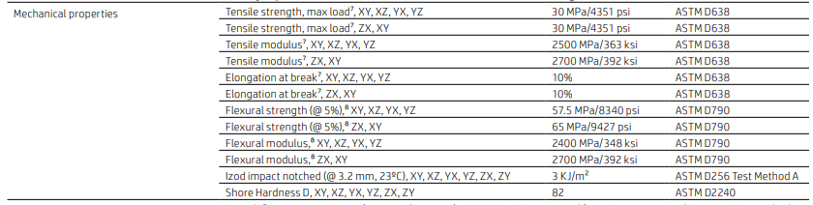

Figure 12 Mechanical Properties of PA12 Material (3D Component)

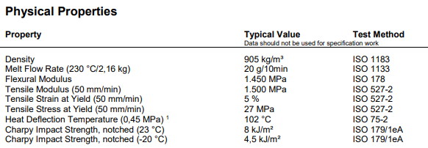
Figure 13 Mechanical Properties of PP Material (Mass Production component)
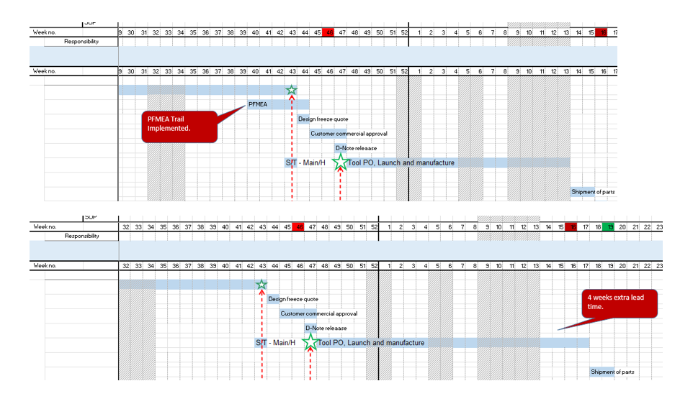
Many PFMEA considerations covered during the joint check activities will not rely solely on the physical properties of the 3D printed component as there will be many benefits from visualisation and assembly techniques. Design costs can be substantially lowered by gathering intel from multiple iterations of 3D component PFMEA trails and implementing them into the design (2023, Golubkov, Sergey S and Morozova). SEWS-E will be trailing the component in a mass production scenario using operators and jigs to determine design corrections that needs to be made. Implementing these changes in design phase will save costs and time during the mass production. Figure 14 shows a comparison between SEWS-E projects, one that implemented PFMEA trails and one that did not. The comparison clearly shows the changes saved time intern saving cost. Creating protype silicone injection moulding tools can be expensive and time consuming, 3D printing components offer a cost effective and adaptive approach (2022, Bagalkot et al).
Figure 14 Timing Plan Comparison
Injection moulding tools come with a huge cost and long lead time; it is a major benefit to make changes prior to manufacturing the tool. Also, some design modifications may not be possible after the tool is produced, resulting in the need to scrap the tool. This would cause a major delay to the customer and may result in SEWS-E being responsible for the cost of a new tool. Previously with build to print projects the customer has always been responsible for the cost of the tool; an inaccurate design would be of the result of SEWS-E supplier. In this case the supplier would take on responsibility of additional cost.

Design stage DC prototype build
The initial design stage joint check was implemented for the purpose of PFMEA activities, ensuring fitment of the harness and de-escalating capacity concerns raised from previous design iterations. Figure 15 shows the capacity check passed, the wiring harness fitted inside the protector, ensuring the success of lid and base fitment. The purpose of the protector is to house the additional wires and protect the joint connectors, stabilising them in a set location within the vehicle. Figure 16 shows a joint connector, they are crucial part of the wiring harness as they maintain reliable electrical connections while withstanding exposure to vibration, temperature fluctuations, and exposure to moisture. The joint connectors found in the protector are multi-pin connectors, used to connect multiple wires securely into one plug.
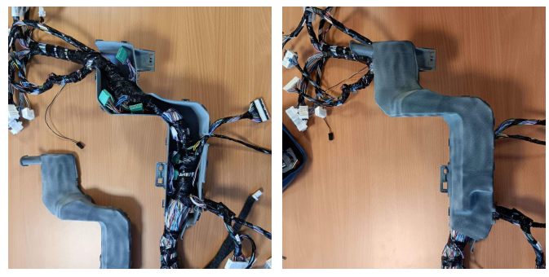
Figure 15 Image of Wiring Harness Fitment Check During Initial Trail
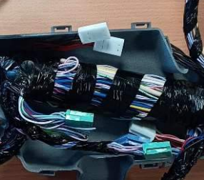

Figure 16 Component Photo
The initial concern was that the harness routing and joint connectors would not fit into the housing of the protector. The capacity trail shown in figure 15 showed the harness and connectors fitted into the protector with the lid and base connected. Completing this visual check using a mock up wiring harness and 3D printed component data alongside CAE created confidence in the design, which is fundamental to mass production tool launch. The key to a successful mass production component is the creation of designs that not only fulfil consumer requirements but can be produced reliably and cost-effectively (Zhou & Saitou, 2014). The purpose of the trail is to identify any failure in the design and instil a confidence, mitigating the risk of potential tool modifications. Further resulting in increased cost or the possibility of scraping the tool and manufacturing a new one, causing a major strain on resources and having a negative impact on the customer relationship.

Production site prototype build
The production prototype trail is held in mass production location with the aim to perform PFMEA activities to find potential design concerns prior to launching mass production tooling. The production process will be simulated from start to finish using mass production techniques, jigs and assembly processes. Figure 17 Shows a chronological workflow diagram depicting the process of manufacturing a wiring harness from start to finish. The prototype joint check build relies on a complete wiring harness, the protector will be fitted at the final clips and accessory stage.

Figure 17 Workflow of Wiring Harness Manufacturing Process

The aim of the joint check is to assess the component design in terms of assembly, workability, measurement tolerances, mounting position, protector capacity, tie wrap fixations, taping fixations and overall design condition. To determine each item a joint check sheet will be implemented, this can be found in appendix 2.
The process starts with generic checks such as correct component part numbers being stated on the drawing. It is crucial everything is considered during the joint check stage so it can be implemented into the project. When assessing the assembly and workability of the component it was found that applying tape during the assembly operation was not optimum and caused delay to the operation. After this risk had been identified the corrective action was put in place to apply during the assembly board. To ensure this point was not forgotten about it was communicated to guest engineers and implemented onto the 2D drawing. Figure 18 shows the risk highlighted, while figure 19 Shows the corrective action. PFMEA is crucial as it pre-emptively mitigates the risks of design failure by investigating potential failure modes associated with specific processes Lee et al. (2017).
Figure 18 Tape Workability Point Raised During Joint Check

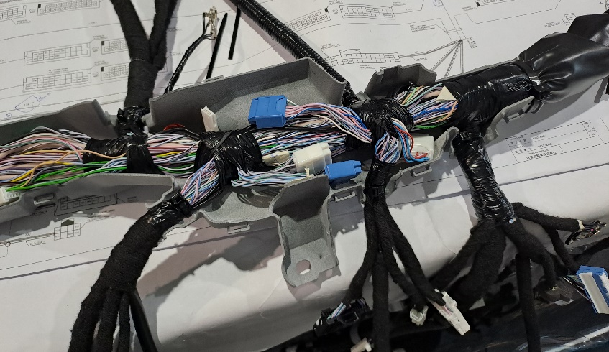
Figure 19 Taping Concern Raised in Joint Check

When assessing the protector bundle capacity, it was found that the joint connectors were lose and had the potential to rattle during operation. This was highlighted as a concern and as a countermeasure it was suggested that the joint connectors be tapped to the harness bundle. This will be implemented into the drawing and applied during the assembly board stage to coincide with previous raised concerns. Figure 16 also shows area where joint connectors were raised as a concern.

Figure 20 Joint check sheet point 13.

Although important, points thirteen and three from the joint check sheet had no direct effect to the protector’s design, this gave confidence in the capacity of the protector, previously raised as an issue in past component trails. It is crucial the final component meets both standards and customer expectations, building a foundation of trust between stakeholders (Wu et al., 2020). Point 10 concerning the protector/ wire cable routing and point 17 assessing tie-wrap fixations could both have the potential to change the design of the protector.
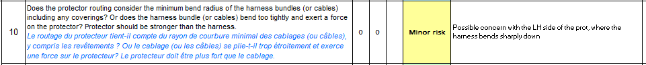
Figure 21 Joint check sheet point 10.
“Does the protector routing consider the minimum bend radius of the harness bundles (or cables) including any coverings? Or does the harness bundle (Or cables) bend too tightly and exert a force on the protector? Protector should be stronger than the harness.”
During the joint check it was raised that the harness is bending at a 90° angle, this could potentially put stress on the component and cause failure during the lifespan of the part. Figure 22 shows the affected area of the component, additional ribs will need to be added to increase the strength. Implementing this change during the design stage of the component will be a huge advantage, decreasing costs and having less of an effect on lead times.
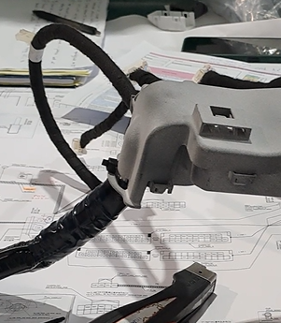
Figure 22 Effected Area of Component - 90° Bend

Figure 23 Joint check sheet point 17.
“Are operators able to access the tie-wrap heads with the tie-wrap gun in order to sufficiently tighten the tie-wraps? Is it possible on the assembly board?”
Point seventeen was raised many times during the joint check and it was a risk mentioned prior to the build. As a PFMEA check, cable tie assembly is a major process for the protector during mass production. It is a time-consuming task with operators required to fixate eight tie wraps to assemble the protector. The design was created with the tie wrap-gun in mind, ensuring there was ample space to perform the operation. However, CAD and reality don’t always coincide with that of reality, this rein stilled the need for physical checks. Physical components attributes such as dimensional accuracy and surface finish may not always meet expectations and a result of material behaviours and manufacturing processes (Singh et al., 2022). Physical checks are needed to identify complications in geometric and assembly checks before they escalate into larger quality control issues (Buswell et al., 2020). Figure 22 shows at risk breakouts found during the joint check, additional space will be implemented not to cause issue during a mass production scenario.

Launching Mass Production tooling based on prior design activities
Having complete confidence in the design of a plastic injection moulded component, implemented to protect the wiring harness and adhere to the functionality set by customer specifications, is impossible prior to launching a mass production tool and fully validating components to said specifications. Confidence in the design prior to tooling kick off comes from a variety of sources, each playing their part to build a complete picture, different perspectives correlate identifying as many concerns as possible. Studies have shown an interactive design process using CAE tools, enhances confidence in designers to apply theoretical concepts in practical settings Higbee & Miller (2021).
Currently at this stage in the project two methods have been used to identify the functionality of the component compared to its customer specification, CAE analysis and 3D printed protypes. CAE allows engineers to predict how a design will perform under operational stresses and conditions before any physical prototype is built Yamada et al. (2023) From the results of the CAE analysis, it is evident that the component can withstand the stress each fixation point will be subjected too during the course of the applications use. There are two vehicle fixation points attaching the component to the vehicle, Figure 24 shows a top clip mount and locator pin adjacent to a hole to feed a bolt through. Both vehicle fixation points are the most critical areas for stress related concerns, implementing CAE to show the affected areas can withstand the forces applied is a major asset from a design perspective. This will give confidence during the mass production validation stage that a late design change is not needed, affecting both timing and financial aspects of the project.
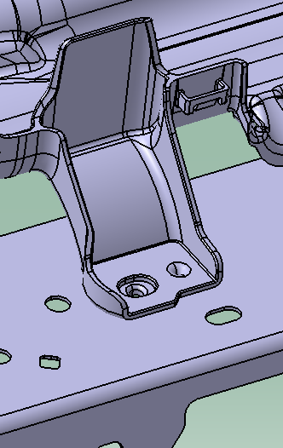
Figure 24 CAD Image of clip mount and locator pin
The use of additive manufacturing to curate accurate 3D printed components at a 1 to 1 ratio is also a huge aspect, helping to increase the confidence from a design, functionality and assembly perspective. From a design perspective 3D prototypes show how the component will sit in the vehicle, often the CAD environment can’t fully simulate the accurate positions of subcomponents, wiring harness and the body in white. Muto et al highlights the fact that measuring data between CAD and manufactured part after production phase demonstrate clear discrepancies Muto et al., (2012). Prototypes help identify clashes in the surrounding area, potentially resulting in further design changes to the component. From a functionality standpoint 3D protypes allow for the opportunity to assess features such as locator pins, vehicle fixations and most importantly base to cover clips as shown in figure 25. The base to cover clips are crucial to attaching the component together, keeping the wiring harness inside and protecting the harness from any potential damage. The failure of said clips could potentially mean a late design change to increase the capacity of the part or increase the strength of the clip features. Finally, the assembly operation can often lead to design changes, during mass production there will be a strict operating procedure manually adhered too. Each step could alter the design, for example the application of cable ties requiring a cable tie gun, potentially clashing with the part during its intended use.
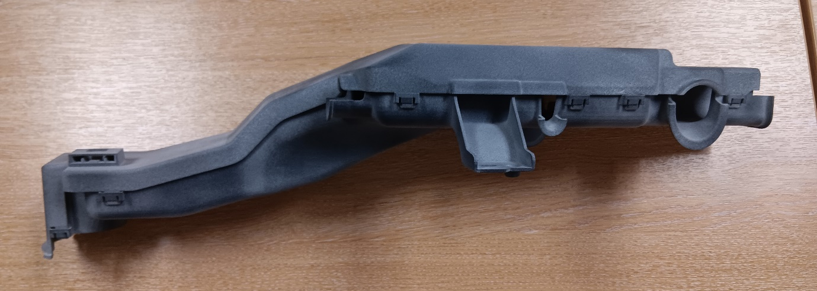
Figure 25 Picture of 3D component
In summary the design of the component had a significant amount of confidence prior to launching mass production tooling. Kulkarni et al. (2020) defines design confidence as an assurance built up by verification techniques such as inspection, testing, and analysis. Prior to mass produced components being available, it is clear that the component is functional, performing to customer specifications, assembling correctly, can house the correct capacity and fitment within the vehicle conditions. There are many benefits to gaining confidence in the design, not only pre-empting possible design errors, but mainly minimizing the risk of additional lead time and cost. For example, if a design change was requested as a result of an incomplete assembly operation or incorrect vehicle fixation from mass produced components, it would incur drastic counter measures. Such as modifying the tool, this would come at a substantial cost, while also affecting the lead time, delaying the testing program and the release of fully validated components.

5.1. Injection moulding
Injection moulding is widely used by SEWS-E to create the protector discussed above, the component will be mass produced. The process of injection moulding first starts by processing plastic resin pallets through the hopper. The hopper, using heat and pressure feeds the pallets into the barrel. Where the screw creates pressure and heat is provided by electric bands on the outside of the barrel. The ram builds up the pressure required so the screw can be pushed forward, when the resign is hot enough, the pellets are inserted into the mould. The nozzle between both injection moulding machine and mould is called an ejector gate, there are many different types. Each playing a significant role to the component in question, for example a submarine gate would show no physical ejection mark on the plastic component. Figure 26 shows the injection moulding machine as a diagram depicting individual sections.
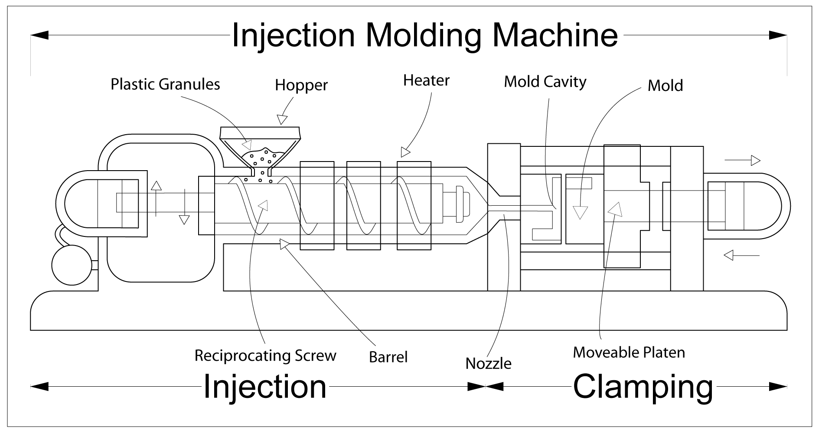
Figure 26 Diagram showing an injection moulding machine.
A mould, often in industry referred to as a tool, is made up of a cavity and core as shown in figure 27, pressed together to make up a complete mould. Both cavity and core are made from high density tooling steel, this is the main upfront cost of injection moulding. The tooling steel is not only expensive but takes a significant number of weeks to manufacture into a mass production injection moulding tool. Implementation of new evolving CAE and additive manufacturing techniques are crucial to gaining confidence in the design of the component before launching the manufacturing process of mass production injection moulding tooling. (Hussin et al., 2021).

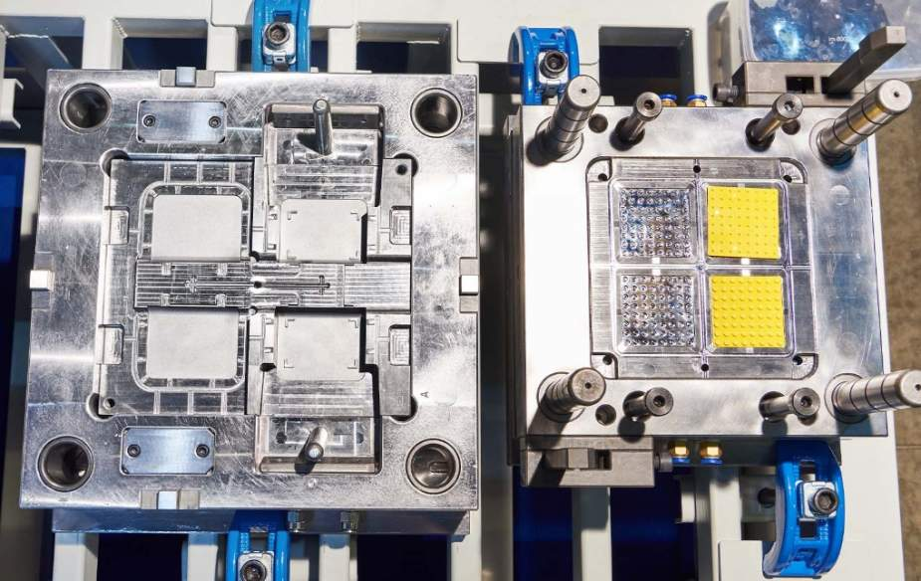
Figure 27 Injection moulding tool

There are a number of plastic materials available, each with their own representative mechanical properties. It is important to use the correct material, based on the application of the component. During this project polypropylene PP will be implemented, the mechanical properties can be found in figure 13. The design of the component considers specific injection moulding DFM techniques, for example draft angle, parting lines and mould flow.
After the plastic resign has solidified within the tool the part then needs to be ejected from said mould. To do this both cavity and core part from each other, leaving the component open to be ejected. Ejector pins are implemented into the mould for this purpose, however the process of ejecting the part cannot lie solely on the pins. Also, draft angle is added to the plastic component, this is added to all wall surfaces aiding the part when being extracted from the tool. The amount of degree of draft angle added is often a compromise between design, functionality and tooling requirements. Draft angle protects the tool, leading to a longer longevity, while also minimising risk of production errors to the component Zaki et al. (2024).
Mould flow represents how the material flows through the cavity and core to curate the part, tooling modifications can be implemented to correct a better flow path. Designers and toolmakers both monitor mould flow, to identify areas within the tool not filling successfully. The majority of the time areas with a poor filling rate can be fixed by modifying the injection moulding machine parameters. However, identifying this prior to tooling manufacture is crucial to reducing lead time and cost. This is one of the activities along with CAE and additive manufacturing, contributing to building confidence in the design of the component prior to kick off with the toolmaker. Chen et al., (2023) shows the use of Mold flow analysis reducing warpage during the injection Molding of plastic gear racks, helping streamline the design process. During build to print projects mould flow is carried out by SEWS-E suppliers on every project, helping to determine the correct material flow.

5.1.1. Project management techniques used throughout project.
SWOT analysis is a strategic approach to identify the strength, weakness, opportunities and threats of a given project. The strengths consist of possible advantages, in the term of using CAE and prototype tools to gain confidence in a component prior to manufacturing mass production tooling it could mean identifying unforeseen functionality and assembly concerns. A weakness would be explained as an internal limitation or challenge, for example budget or timing constraints. Opportunity are external factors that could be capitalized on such as previous project lesson learnt activities. A threat is an external factor that effects the project in a negative way, for example a supplier or logistic issue effecting the delivery of a subcomponent required for specific build. The range of these considerations help to build a complete outlook on the project as a whole, providing insights for decision-making (Keban et al., 2019).
The SWOT analysis below is based on the CAE and additive manufacturing techniques used to gain confidence in the design of the plastic injection moulded component prior to manufacturing a mass production intent injection moulded tool. With the perspective of achieving customer milestones and completing a successful project.
Strengths | Weaknesses
- Rapid prototyping enables early visualisation, fitment, and assembly checks. | - 3D printed parts (PA12) lack identical material properties to mass production PP components.
- CAE simulations identify design faults (stress points, vibration response) pre-emptively. | - CAE not a full substitute for physical validation — real-world variables may differ.
- Early issue detection saves tooling costs and prevents delays. | - Additional upfront resource/time required for iterative 3D printing and CAE testing.
- Supports close collaboration with Nissan, improving supplier-customer relationships. | - Risk of overconfidence in virtual/printed prototypes without final tooling validation.
Opportunities | Threats
- Strengthens SEWS-E’s capability as a European design-responsible supplier, enhancing competitiveness. | - Potential delays if 3D printed prototypes or CAE models miss unforeseen physical assembly or operational issues.
- Aligns with government-funded automotive transformation strategies (EV36Zero, green targets). | - Supply chain or technology constraints in additive manufacturing or CAE resources.
- Potential for broader adoption of localised design & development for other OEM projects. | - High financial risk if mass production tool adjustments are required after final CAE/3D print sign-off.
- Enhances internal technical skill development within SEWS-E Europe teams. | - Dependence on customer feedback timing for critical pre-launch milestones.

CAE and rapid prototyping offer many strengths when considering meeting customer expectation and implementing a successful project. For example, rapid prototyping plays a major part in identifying concerns through visualisation, fitment and assembly checks. SEWS-E implemented a joint check sheet, a process involving production site and design engineers using 3D printed prototype components in a production scenario. Assembling it to a wiring harness and identifying potential issues in the process from a design for assembly, fitment and functionality perspective. The process was a success and identified key design concerns before the kick off of mass production tooling. Standard DFMEA industry approach is not a one-time task; it should be reviewed and revised throughout the design and development process Ehigiato et al., (2023). CAE simulations, used by SEWS-E throughout the project, pre-emptily identify stress points and vibration response. Through the use of CAE SEWS-E gaining confidence in the design of the component as the results showed that it could clearly withstand the customer specification. This meant that there was a high level of confidence moving into the mass production validation program. Soboleva explores the advantages to imbedding development processes such as CAE to enhance design accuracy and improve the quality of the project’s outcome. Both of the mentioned approaches lead to early detection, which in tern saves on tooling cost and has a positive effect on lead times. From a project perspective a successful component strengthens Nissan and Sumitomo’s relationship in terms of a stronger trust in our ability to be design responsible in Europe, possibly leading to more business in the future.
During the process of gaining confidence in the design prior to manufacturing mass production tooling, compromises must be made. The technical information gathered from internal trails and CAE activities cannot and will not reflect that of mass production components. This can be seen as a weakness and the results gathered from mass production validation program could differ. For example, the 3D printed prototype components, used by SEWS-E throughout the joint check and trail builds, material properties differ between the polypropylene used in mass production and the PA12 used in the prototypes. Godec et al. highlight that there is limited research examining how the characteristics of prototype moulds impact the properties of moulded parts, leading to unexpected variations in product quality Godec et al. (2008). However, there are many component level testing that are design related and not necessarily dependent on mechanical properties of the material. For example, fitment, capacity and assembly checks rely mainly on the design of the component, meaning the mechanical properties have little to no effect on the result.
Also, the parameters of the CAE testing may differ to real-world variables. This was a crucial consideration for the SEWS-E design team during the set-up of CAE activities, the main goal being to simulate the vehicles environment while testing the component to customer specification. The results gathered were successful, however with the caveat of mass production validation results possibly being different. This is an interesting point, as there is not only a difference in CAE and physical validation testing but also physical testing and lifetime wear and tear of the component in its vehicle environment. The customer specification considers drastic and Sevier forces and loads the component may go through during its lifespan; however, it is impossible to fully simulate what every component could potentially be put through. Physical tests can reveal how materials react under stress and real-world environmental impacts that may not be able to be fully captured in CAE of FEA techniques Hopmann & Wipperfürth (2017).
Considering weaknesses of the project lead time and up front resources with respect to 3D printing and CAE testing stands out. SEWS-E have 3D printing capability, meaning full control over the manufacturing lead time and internal costs. Even though the physical manufacturing lead time of 3D printing is the same internally and externally, SEWS-E’s full control gives more insight and the possibility of multiple iterations being printed in parallel to trail builds. Multiple prototypes leads to innovation with a range of iterations allowing collaborative ideas and feedback to be investigated and trailed Dow et al. (2010). CAE was not completed internally and had to be sourced out to an external agency, this is a weakness in terms of lead time, loss of control and expense. Due to the external company having their own workload, it is often the approach that you are awarded a time slot to upload specification and design data. Missing this slot can lead to increased lead time compared to what was originally quoted. This all leads to lack of control from a project perspective for SEWS-E, also going external can potentially lead to time delay as a result of misidentified ior incorrect information (Netkachova et al., 2015). Also, the reliance on the prototype validation results can often be misconstrued into a false sense of security for the designer. CAE and prototype trail builds shouldn’t be considered as the final step in the validation program, it should be used to build confidence prior to final validation.
This project will Strengthen SEWS-E’s capability as a European design-responsible supplier, enhancing competitiveness, while also building a relationship of trust. There is massive value in having a strong relationship between customer and supplier, high levels of trust leading to increased loyalty and sustained partnerships (Cambra‐Fierro & Polo‐Redondo, 2011). A strong relationship between customer and supplier can lead to securing more future business as a proven track record shows SEWS-E is capable of being design responsible. Furthermore, the project aligns with government-funded automotive transformation strategies, showing the intent of future automotive production in the uk is strong. This strengthens SEWS-E possibility of being awarded future business, a huge opportunity to lead more design responsible projects from the UK. This also leaves the opportunity for further growth into leading design and development projects for other OEM’s. Ever expanding SEWS-E’s knowledge and capability into leading projects with a design responsibility from multiple OEM perspectives. Multiple perspectives leads to a diversified knowledge and expertise base, engineers can implement into a range of projects Adams et al. (2011). Furthermore, during this project there is a key opportunity to expand the technical knowledge and relationship internally with SEWS-E. As mentioned previously, SEWS-E is based all over Europe, leading a development project for the first time will strengthen the working relationship between manufacturing sites, design engineers and business teams. Unifying the need to learn and adapt together as each team processes the project for the first time.
There are some potential threats, that could jeopardise SEWS-E and the project, effecting the relationship with OEM and the possibility of being awarded future business. One threat would be the potential delay of 3D printed or CAE models miss unforeseen physical assembly or operational issues. The reliance of using techniques such as 3D printed protype trail builds and CAE testing is crucial to gain confidence in the tool prior to manufacturing, however it could also be a detrimental threat to the project as a whole. A delay in results could affect the timing of the project, for example it may lead to a ultimatum in kicking off tooling late with confidence in the designs capability while potentially delivering parts late to customer damaging our relationship and capability. Or kicking off tooling on time without confidence in the design, potentially leading to delivering parts to OEM with functionality concerns. The delay of said CAE and 3D additive manufacturing could be a result of resource and supply chain issues. Supply chain issues can be a threat and without the correct planning affect the timing of the project Khan et al. (2023). There is a high financial risk to manufacturing mass production tooling as SEWS-E will be responsible for the design, if the component doesn’t meet customer specifications, then the cost of tool modifications would be internal. Also, the dependence on customer feedback is crucial to keeping the project on time, this is why a strong relationship between SEWS-E, OEM and supplier is crucial.

Future corrective actions
To gain more confidence in the performance ability of the design prior to tooling manufacture, SEWS-E could’ve implemented a low volume injection moulding tool. The material properties between 3D printed PA12 and injection moulded PP, can lead to false confidence within the materials functionality. Low volume tooling produces consistent accurate components fit for validation and production scenarios whereas 3D components, although accurate and efficient, are not consistent and remain relatively high in cost Bagalkot et al., (2019). With the use of a low volume injection moulding tooling, prototype parts can be used in production scenarios assessing functionality and design criteria. The results of testing low volume components will be more true to mass production components and give more confidence in launching mass production tooling.
CAE techniques and 3D printed prototype trails are great methods of gaining confidence in a design of a component, to expand on this a ‘confidence matrix could be implemented’. While SEWS-E implement DFMEA during the development phase and PPAP techniques to sign off on components when moving into start of production. To contextualise the evidence gained to build confidence in a component design pre tooling a validation evidence matrix (VEM) could be implemented. Also, it would be beneficial for SEWS-E to create in house CAE capabilities, mediating the risk of using external companies, adding further confidence to maintaining deadlines and gathering valuable technical knowledge improving internal product development performance (Feng & Wang, 2013). Receiving technical results quicker allows design corrections to be made ahead of manufacturing mass production tooling.

6.1. Future Work
This project established a foundation for SEWS-E to take on design responsibility and launch mass production tooling with a high degree of design confidence, by implementing CAE and additive manufacturing. To build on this success and ensure continuous improvement there are actions that could be investigated and implemented. For example, the development of in-house CAE capability, reducing reliance on external providers and improving response time. Introducing design confidence framework, formalising the decision-making at key milestones. By consolidating data, it could lead to SEWS-E better identifying when a component is ready for tooling. Also, a higher degree of research into low volume tooling, may result in more accurate prototype results prior to tooling launch.

Conclusion
This project has demonstrated the value computer aided engineering and additive manufacturing used in conjunction with FMEA and PFMEA techniques has on gaining confidence in the design of an injection moulded component prior to mass production tooling launch. The research and technical data gathered has shown that deign confidence is a theoretical concept and techniques can be used to gain an insight, however physical testing and performance could still differ. Simulations and techniques implemented by SEWS-E identified crucial design changes, saving both time and cost, adding these design changes prior to mass production tooling launch will result in a more robust final component.
The findings reinforce that confidence in the design should not rely on a single method, but rather a conjunction of simulations, physical builds and interactive testing. Compared to the historic build to print approach adopted by SEWS-E, the proactive design and development CAE and additive manufacturing validation strategy supports a more agile, efficient and responsive development cycle. The findings has also highlighted limitations in the design and development approach with the need for improved internal CAE capacity, development a more robust design confidence matrix and considering low volume tooling for more representative prototype builds.
Ultimately this project confirms embedding CAE and prototyping early on in the devilment process enhances the design and ability to meet customer expectations, improve quality and maintain competitive advantages. By transitioning from a traditional build to print approach to a design and development project, SEWS-E has undertaken a crucial step into becoming a tier-one supplier for European OEM’s.

Reference
Adams, R., Evangelou, D., English, L.D., Figueiredo, Mousoulides, N., Pawley, A., Schiefellite, C., Stevens, R., Svinicki, Marilla D, Martin, J.P. and Wilson, D. (2011). Multiple Perspectives on Engaging Future Engineers. Journal of Engineering Education, 100(1), p.4888. doi:https://doi.org/10.1002/j.21689830.2011.tb00004.x.
An, J. and Fan, J.S. (2011). Application of AR Technology in Industrial Design Product Review. Applied Mechanics and Materials, 6668, p.10221026. doi:https://doi.org/10.4028/www.scientific.net/amm.6668.1022.
Austin, J., van, D.J. and Drossaert, C.H.C. (2020). When Theory Meets Users in CoDesign: Four Strategies Towards Synergy Between BottomUp and TopDown Input. doi:https://doi.org/10.21606/drs.2020.152.
Azemi, F., Šimunović, G., Lujić, R., Tokody, D. and Rajnai, Z. (2019). The Use of Advanced Manufacturing Technology to Reduce Product Cost. Acta Polytechnica Hungarica, 16. doi:https://doi.org/10.12700/APH.16.7.2019.7.7.
Bagalkot, A., Pons, D.J., Symons, D. and Clucas, D. (2019). Categorization of Failures in Polymer Rapid Tools Used for Injection Molding. Processes, 7(1), p.17. doi:https://doi.org/10.3390/pr7010017.
Bagalkot, A., Pons, D.J., Symons, D. and Clucas, D. (2022). The Effects of Cooling and Shrinkage on the Life of Polymer 3D Printed Injection Moulds. Polymers, 14(3), p.520. doi:https://doi.org/10.3390/polym14030520.
Belu, N., Anghel, D. and Rachieru, N. (2013). Failure Mode and Effects Analysis on Control Equipment Using Fuzzy Theory. Advanced Materials Research, 837, p.1621. doi:https://doi.org/10.4028/www.scientific.net/amr.837.16.
Boussuge, F., Tierney, C., Vilmart, H., Robinson, T., Armstrong, C., Nolan, D., Léon, J. and Ulliana, F. (2019). Capturing Simulation Intent in an Ontology: CAD and CAE Integration Application. Journal of Engineering Design, 30(1012), p.688725. doi:https://doi.org/10.1080/09544828.2019.1630806.
Briand, L., Falessi, D., Nejati, S., Sabetzadeh, M. and Yue, T. (2014). Traceability and SysML Design Slices to Support Safety Inspections. Acm Transactions on Software Engineering and Methodology, 23(1), p.143. doi:https://doi.org/10.1145/2559978.
Buswell, R., Kinnell, P., Xu, J., Hack, N., Kloft, H., Maboudi, M., Gerke, M., Massin, P., Grasser, G., Wolfs, R. and Bos, F. (2020). Inspection Methods for 3D Concrete Printing. p.790803. doi:https://doi.org/10.1007/9783030499167_78.
Cambra‐Fierro, J. and Polo‐Redondo, Y. (2011). Post‐satisfaction Factors Affecting the Long‐term Orientation of Supply Relationships. Journal of Business and Industrial Marketing, 26(6), p.395406. doi:https://doi.org/10.1108/08858621111156395.
Chen, D., Yang, R., Lu, S. and Guo, H. (2023). Application of Mold Flow Analysis to the Study of Plastic Gear Rack Injection Molding Warpage. Transactions of the Canadian Society for Mechanical Engineering, 47(1), p.1525. doi:https://doi.org/10.1139/tcsme20220048.
Chen, M., Tzeng, H., Chen, Y. and Chen, S. (2008). The Application of Fuzzy Theory for the Control of Weld Line Positions in InjectionMolded Part. Isa Transactions, 47(1), p.119126. doi:https://doi.org/10.1016/j.isatra.2007.07.001.
Dian, A.I., Sudjatmiko, E.T. and Bangkara, A. (2023). Construction Delays Analysis in the Kampung Akuarium Flats Project, PenjaringanJakarta. Presunive Civil Engineering Journal, 1(2), p.70. doi:https://doi.org/10.33021/pcej.v1i2.4756.
Dow, S.P., Glassco, A., Kass, J., Schwarz, M., Schwartz, D.L. and Klemmer, S.R. (2010). Parallel Prototyping Leads to Better Design Results, More Divergence, and Increased SelfEfficacy. Acm Transactions on ComputerHuman Interaction, 17(4), p.124. doi:https://doi.org/10.1145/1879831.1879836.
Ehigiato, I., Hainsworth, B. and Barner, P. (2023). Safety and Product Robustness in the Air Vehicle Design Process. p.18. doi:https://doi.org/10.4050/f0079202317996.
Favi, C., Garziera, R. and Campi, F. (2021). A RuleBased System to Promote Design for Manufacturing and Assembly in the Development of Welded Structure: Method and Tool Proposition. Applied Sciences, 11(5), p.2326. doi:https://doi.org/10.3390/app11052326.
Feng, T. and Wang, D. (2013). Supply Chain Involvement for Better Product Development Performance. Industrial Management & Data Systems, 113(2), p.190206. doi:https://doi.org/10.1108/02635571311303532.
Fernandez, G.P., PérezDomínguez, L., Luviano‐Cruz, D., Solano, J., Adán, E. and CallejasCuervo, M. (2020). PFDAFMEA. An Integrated Method Improving FMEA Assessment in Product Design. doi:https://doi.org/10.20944/preprints202012.0429.v1.
Frimpong, S. and Thiruvengadam, M. (2016). Multibody Dynamic Stress Simulation of RigidFlexible Shovel Crawler Shoes. Minerals, 6(3), p.61. doi:https://doi.org/10.3390/min6030061.
Godec, D., Šercer, M. and Rujnić‐Sokele, M. (2008). Influence of Hybrid Mould on Moulded Parts Properties. Rapid Prototyping Journal, 14(2), p.95101. doi:https://doi.org/10.1108/13552540810862055.
Golubkov, Sergey S and Morozova, S.M. (2023). Recent Progress of 3D Printing of Polymer Electrolyte MembraneBased Fuel Cells for Clean Energy Generation. Polymers, 15(23), p.4553. doi:https://doi.org/10.3390/polym15234553.
GOV.UK (2023). Nissan triples investment in electric vehicle production in the UK. [online] GOV.UK. Available at: https://www.gov.uk/government/news/nissan-triples-investment-in-electric-vehicle-production-in-the-uk.
Government of UK (2023). £89 million of funding to develop cutting edge new electric vehicle technology. [online] GOV.UK. Available at: https://www.gov.uk/government/news/89-million-of-funding-to-develop-cutting-edge-new-electric-vehicle-technology.
Guo, C., Shang, X., Lancaster, M.J. and Xu, J. (2015). A 3D Printed Lightweight XBand Waveguide Filter Based on Spherical Resonators. Ieee Microwave and Wireless Components Letters, 25(7), p.442444. doi:https://doi.org/10.1109/lmwc.2015.2427653.
Han, J., Lee, S. and Nyamsuren, P. (2014). An Integrated Engineering Change Management Process Model for a ProjectBased Manufacturing. International Journal of Computer Integrated Manufacturing, 28(7), p.745752. doi:https://doi.org/10.1080/0951192x.2014.924342.
Higbee, S. and Miller, S. (2021). Finite Element Analysis as an Iterative Design Tool for Students in an Introductory Biomechanics Course. Journal of Biomechanical Engineering, 143(12). doi:https://doi.org/10.1115/1.4051659.
Hopmann, C. and Wipperfürth, J. (2017). Ultrasound Tomography for Spatially Resolved Melt Temperature Measurements in Injection Moulding Processes. Journal of Applied Mechanical Engineering, 06(03). doi:https://doi.org/10.4172/21689873.1000264.
Hussin, R., Sharif, S., Nabiałek, M., Rahim, Mohd, K., Suhaimi, Mohd Azlan, Bakri, A., Mohd, H., Wysłocki, J.J. and Błoch, K. (2021). Hybrid Mold: Comparative Study of Rapid and Hard Tooling for Injection Molding Application Using Metal Epoxy Composite (MEC). Materials, 14(3), p.665. doi:https://doi.org/10.3390/ma14030665.
Jan, J., Swisher, S., Ali, M.Y. and Chandrakesan, S. (2021). An Integrated Virtual Engineering Methodology to Evaluate Manufacturing Residual Stress in Cylinder Blocks Through Casting and Quenching. doi:https://doi.org/10.31399/asm.cp.ht2021p0244.
Junk, S., Schrock, S. and Schmieder, N. (2023). Review and Development of Design Guidelines for Additive Tooling of Injection Molds Using PolyJet Modelling. p.3545. doi:https://doi.org/10.1007/9783031429835_3.
Kalilayeva, A., Zhumashev, D., Wei, D., Perveen, A. and Talamona, D. (2024). Investigation of Stereolithography Additively Manufactured Components for Deviations in Dimensional and Geometrical Features. Polymers, 16(23), p.3311. doi:https://doi.org/10.3390/polym16233311.
Keban, Y., Arifin, S. and Wahyono, R. (2019). SWOT Analysis and Its Implementation Strategies in Educational Management. doi:https://doi.org/10.7176/jep/101210.
Khan, M.R., Alam, M.J., Tabassum, N., Khan, N.A. and McKenzie, A.M. (2023). Supply Chain Challenges and Recommendations for International Development Agriculture Projects: An Application of the FGDfuzzy Delphi Approach. Humanities and Social Sciences Communications, 10(1). doi:https://doi.org/10.1057/s41599023020279.
Khan, U.A. and Haider, S.F. (2017). Impact of Quantitative Analysis Techniques in Enhancing Time Management. International Journal of Innovative Research in Engineering & Management, p.749752. doi:https://doi.org/10.21276/ijirem.2017.4.5.3.
Kiani, R., Corthell, L. and Shadlen, M.N. (2014). Choice Certainty Is Informed by Both Evidence and Decision Time. Neuron, 84(6), p.13291342. doi:https://doi.org/10.1016/j.neuron.2014.12.015.
Kulkarni, A.U., Salado, A., Xu, P. and Wernz, C. (2020). An Evaluation of the Optimality of Frequent Verification for Vertically Integrated Systems. Systems Engineering, 24(1), p.1733. doi:https://doi.org/10.1002/sys.21564.
Lee, H., Lee, H., Baik, J., Kim, H. and Kim, R.Y. (2017). Failure Mode and Effects Analysis Drastically Reduced Potential Risks in Clinical Trial Conduct. Drug Design Development and Therapy, Volume 11, p.30353043. doi:https://doi.org/10.2147/dddt.s145310.
Liu, H., You, J., Ding, X. and Su, Q. (2015). Improving Risk Evaluation in FMEA With a Hybrid Multiple Criteria Decision Making Method. International Journal of Quality & Reliability Management, 32(7), p.763782. doi:https://doi.org/10.1108/ijqrm1020130169.
Liu, Y., Sun, H., Wang, B., Dai, L. and Cao, J. (2021). Experimental Accuracy and Stability of Gas Outburst Experimental System. Geofluids, 2021, p.19. doi:https://doi.org/10.1155/2021/6678608.
M, S.S. (2023). Optimisation of Process Parameters on Compressive Strength of 3dPrinted Polylactic Acid Parts. African Journal of Applied Research, 9(2), p.1234. doi:https://doi.org/10.26437/ajar.v9i2.558.
marketing, C. (n.d.). EV36Zero: the future of Nissan. [online] Careers at nissan. Available at: https://careersatnissan.co.uk/life-at-nissan/manufacturing-hub/ev36zero-the-future-of-nissan/.
Martinelli, E. (2019). Building LongTerm SupplierRetailer Relationships in the Jewellery Sector: Antecedents of Customer Loyalty. Sinergie Italian Journal of Management, 37(2), p.7592. doi:https://doi.org/10.7433/s109.2019.05.
Muto, K., Fuke, K. and Nakamura, H. (2012). Study on Adopting Measuring Technology(CAT) for Producing Automotive Closure Parts. International Journal of Automotive Engineering, 3(1), p.4146. doi:https://doi.org/10.20485/jsaeijae.3.1_41.
Nazir, A., Arshad, A., Hsu, C. and Jeng, J. (2021). Effect of Fillets on Mechanical Properties of Lattice Structures Fabricated Using MultiJet Fusion Technology. Materials, 14(9), p.2194. doi:https://doi.org/10.3390/ma14092194.
Netkachova, K., Netkachov, O. and Bloomfield, R. (2015). Tool Support for Assurance Case Building Blocks. p.6271. doi:https://doi.org/10.1007/9783319242491_6.
Ngoh, S. (2020). Case Study: A Task Force Uses Rapid Prototyping to Evaluate an Emergency Medical Device | ManufacturingTomorrow. [online] Manufacturingtomorrow.com. Available at: https://www.manufacturingtomorrow.com/article/2021/01/case-study-a-task-force-uses-rapid-prototyping-to-evaluate-an-emergency-medical-device/16379/?utm_source=chatgpt.com [Accessed 3 May 2025].
Nieto, M. and Moreno, D. (2021). Design for Additive Manufacturing: Tool Review and a Case Study. Applied Sciences, 11, p.1571. doi:https://doi.org/10.3390/app11041571.
Nwachukwu, C. and Vu, H.M. (2021). Assessing SupplierCustomer Relationship Management Practice and Business Performance. doi:https://doi.org/10.4108/eai.762021.2308605.
OCHIENG, I.A. and TUMUTI, J. (2023). Project Planning Practices and Performance of Building Construction Projects in International Schools in Nairobi City County, Kenya. 10(4). doi:https://doi.org/10.61426/sjbcm.v10i4.2829.
Onodera, T., Kozaki, T. and Amasaka, K. (2013). Applying a Highly Precise CAE Technology Component Model Automotive BoltLoosening Mechanism. ChinaUsa Business Review, 12(06). doi:https://doi.org/10.17265/15371514/2013.06.007.
PANDIAN, G., Pecht, M., Zio, E. and Hodkiewicz, M. (2020). Datadriven reliability analysis of Boeing 787 Dreamliner. Chinese Journal of Aeronautics, 33, pp.1969–1979. doi:https://doi.org/10.1016/j.cja.2020.02.003.
Sadikin, M. (2023). Defect Reduction in The Manufacturing Industry: Systematic Literature Review. International Journal of Industrial Engineering and Engineering Management, 5, pp.73–83. doi:https://doi.org/10.24002/ijieem.v5i2.7495.
Shah, A., Shea, R. and Siskowski, B. (2024). Ensuring Zero Defects Through Effective Design Failure Modes and Effects Analysis Processes in the Aerospace Industry. doi:https://doi.org/10.4271/2024260410.
Singh, I., Singh, K. and Sethi, N. (2022). CAD/CAM – Historical Aspects, Processing and Various Systems: A Literature Review. Iar Journal of Medical Sciences, 3(01), p.16. doi:https://doi.org/10.47310/iarjms.2022.v03i01.001.
Skill-Lync (2025) Project 2 - Wiring harness routing on given car body. Available at: https://skill-lync.com/student-projects/project-2-13575 (Accessed: 16 May 2025).
Soboleva, E.V. (2018). Theoretical Justification for Development as an Institution for the Development of Investment and Construction. Matec Web of Conferences, 170, p.01117. doi:https://doi.org/10.1051/matecconf/201817001117.
Steen, R. (2015). A Risk Assessment Approach to Support the Launching of New Products, Services or Processes. International Journal of Business Continuity and Risk Management, 6(1), p.17. doi:https://doi.org/10.1504/ijbcrm.2015.070347.
Vinodh, S. and Santhosh, D. (2012). Application of FMEA to an Automotive Leaf Spring Manufacturing Organization. The TQM Journal, 24(3), p.260274. doi:https://doi.org/10.1108/17542731211226772.
Wang, J., Hu, S., Yang, B., Jin, G., Zhou, X., Lin, X., Wang, R., Lu, Y. and Zhang, L. (2021). Novel ThreeDimensionalPrinting Strategy Based on Dynamic Urea Bonds for Isotropy and Mechanical Robustness of LargeScale Printed Products. Acs Applied Materials & Interfaces, 14(1), p.19942005. doi:https://doi.org/10.1021/acsami.1c20659.
Wang, W., Hu, J., Yin, J. and Peng, Y. (2007). A KnowledgeBased Parameter Consistency Management System for Concurrent and Collaborative Design. Proceedings of the Institution of Mechanical Engineers Part B Journal of Engineering Manufacture, 221(1), p.97107. doi:https://doi.org/10.1243/09544054jem450.
Wisthoff, A., Ferrero, V., Huynh, T. and DuPont, B. (2016). Quantifying the Impact of Sustainable Product Design Decisions in the Early Design Phase Through Machine Learning. doi:https://doi.org/10.1115/detc201659586.
Wu, G., Li, Z. and Liu, P. (2020). RiskInformed Reliability Improvement Optimization for Verification and Validation Planning Based on Set Covering Modeling. Proceedings of the Institution of Mechanical Engineers Part O Journal of Risk and Reliability, 236(2), p.357370. doi:https://doi.org/10.1177/1748006x19898294.
Yacob, D.H., Sarip, S., Suhot, M.A., Hassan, M.Z., Aziz, S.A., Daud, Bani, N.A. and Muhtazaruddin, Mohd Nabil (2018). Critical Design Factors on Performance of Car Jack Lifting Operations. Indonesian Journal of Electrical Engineering and Computer Science, 12(2), p.521. doi:https://doi.org/10.11591/ijeecs.v12.i2.pp521526.
Yamada, T., Semba, K., Sano, H. and Suzuki, Y. (2023). Simulation Based Design, a Necessity for Advanced Design and Requirement for CAE Tools. Ieej Journal of Industry Applications, 12(1), p.111. doi:https://doi.org/10.1541/ieejjia.22005984.
Zadry, H.R., Adi, S.D., Budiman, T.A., Meilani, D. and Rahmayanti, D. (2018). Failure Modes and Effects Analysis (FMEA) for Evaluation of a Sugarcane Machine Failure. Matec Web of Conferences, 204, p.01012. doi:https://doi.org/10.1051/matecconf/201820401012.
Zaki, S., Zhang, N. and Gilchrist, M.D. (2024). Optimization of Forward Pulsed Currents for Combining the Precision Shaping and Polishing of Nickel Micro Mould Tools to Reduce Demoulding Defects. The International Journal of Advanced Manufacturing Technology, 131(78), p.36313649. doi:https://doi.org/10.1007/s00170024131630.
Zarghami, Seyed Ashkan (2023). Project Schedule Contingency Planning: Building on Von Bertalanffy’s Open Systems Theory and Critical Systems Practice. Systems Research and Behavioral Science, 41(2), p.247261. doi:https://doi.org/10.1002/sres.2965.
Zhou, Y. and Saitou, K. (2014). Identification of Manufacturability Constraints Through Process Simulation and Data Mining. doi:https://doi.org/10.1115/detc201434542.
Zwikael, O. and Sadeh, A. (2006). Planning Effort as an Effective Risk Management Tool. Journal of Operations Management, 25(4), p.755767. doi:https://doi.org/10.1016/j.jom.2006.12.001.

Appendix 1 – Flow chart of AP work

Appendix 2 – Joint check sheet
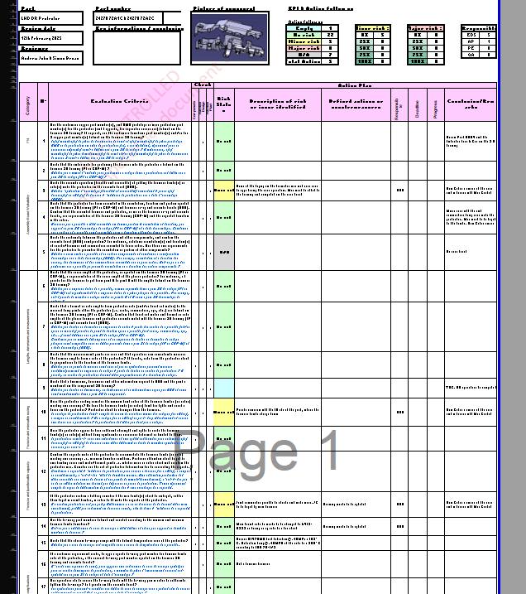

Appendix 3 – Non-Disclosure Act between SEWS-E and UWTSD




