


MSc Industry 4.0 Advanced Manufacturing

Financial Management and Planning
Module Code: ACPA7002

Assignment - Capital Project Appraisal

Lecturer: Howard Davies

Business Report:
UKWDG Capital Expenditure Investment Analysis – Air Compressors

28th May 2023
Student: Gareth Gooding (2125561)
E-mail: 2125561@student.uwtsd.ac.uk




Business Report
UKWDG Capital Expenditure Investment Analysis – Air Compressors

Contents

- Introduction 3

- Capital Project Overview 4

- Financial Analysis and Evaluation 7

- Funding Options 15

- Conclusion 15

- References 16

- Appendix 17

  - Calculations for Financial Modelling 17

    - Evolution Compressor Project 17

    - Treorchy Compressor Project 21

  - Present Value Table 25

Business Report:
UKWDG Capital Expenditure Investment Analysis – Air Compressors

- Introduction

Businesses need to analyse investment opportunities before committing expenditure. An investment is an exposure of cash that has the objective of producing cash flows in the future. An investment is measured by how much cash is expected to be generated compared with how much is required – return on investment.

The return on investment is analysed to evaluate whether an investment opportunity is worthwhile. Capital expenditure usually involves a major amount of money, hence financial risk, and investments must be chosen carefully. If numerous investments are required for a business, then prioritisation is essential, and financial analysis is key to highlight the risk, benefits, and which investment would give the best return on investment.

Methods to evaluate basic return on investment are:
- Payback Period – the only method used by UKWDG in recent years.
- Annual Rate of return (ARR)

Payback Period is the most common measure when evaluating an investment. It is useful for companies with tight cash flow situations as it is a measure of risk, rather than profitability. If a company has invested, it needs to know when it is having it back. The sooner cash is returned, the less risky the investment is.

To further evaluate investment opportunities Discounted Cash Flow (DCF) is used to estimate the value of investment based on its predictions of its future cashflow. This is based on the ‘time value of money.’ We value how much cash is generated, but concerned when it is received. The sooner the cashflow/return is received, the sooner it can be used or re-invested. £1 now is worth more than £1 in the future - £1 now can be invested to create a return, whereas £1 to be returned in the future does not have the same opportunity.

There are a number of ways to evaluate investment opportunities based on DCF.
- Net Present Value (NPV)
- Internal Rate of Return (IRR)
- Profitability Index (PI)

UKWDG should consider these other methods to ensure better accuracy of return on investment and profitability.

UK Windows and Doors Group

UK Windows and Doors Group is the largest Manufacturer of PVCu windows and doors in the UK, producing over 1200 units per day.

The company consists of six sites across the UK. The company’s financial performance has been impacted by a number of factors in recent years, resulting in a limited budget for investment, so selecting the correct investment is key to ensuring profitability.

This investment is based on Cost Saving by reducing Energy Usage. In the last 3 years Energy prices have inflated, particularly in 2021, due to disasters such as disrupted electricity supply from France, and the war in Ukraine disrupting Natural Gas supplies, which is used to generate electricity. This has directed UKWDG focus onto Energy Saving initiatives to reduce the financial impact on the company.

As per communications to all 950 staff at UKWDG, the energy price increase cost the company an extra £135k per month from December 2021.
The basis for this was the price per kWh raising from 18p per kWh in January 2021 to 34p per kWh in November 2021, increasing further into 2022. Electricity price increases mean projects that were deferred due to poor Payback Periods are now more attractive.

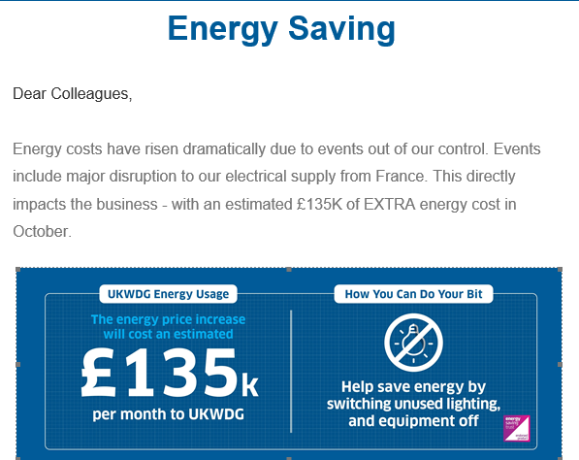

---------------------------------------------------------------------------------------------------------------------------------------------------------

- Capital Project Overview

For 2023 the available Cash to fund such investments is limited. £135k per month of extra energy costs in 2022 equals £1.62m, inhibiting available cash to pay out on Investment projects. Essential projects are prioritised that can reduce the cashflow out of the company, such as Energy Saving projects.

This report highlights two projects that would achieve Energy Savings - Air Compressors.

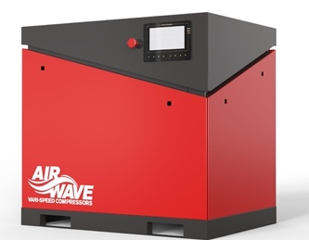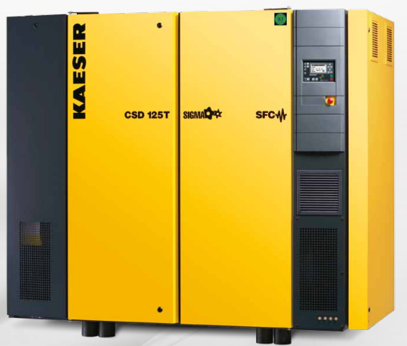

Air Compressors use a lot of electricity to generate compressed air for equipment functions across all UKWDG sites. Fixed speed compressors can only run at 0 or 100% percent power, where VSD (Variable Speed Drive) compressors can vary between 0 and 100% depending on demand.

Project 1 - Evolution Windows, Biggleswade

The Evolution Windows site has three fixed speed Air Compressors providing Compressed Air to the site. The Air demand is too great for just two of the Compressors to run, so the 3rd Compressor is required to run at 20% ensure Air demand is met. The proposal is to replace the fixed speed compressors with 1 Variable Speed Compressor, which will vary its speed to what is required. This will reduce electricity consumption of Compressed Air creation by 17,199kWh, a significant reduction in electricity usage, thus a Cost Saving.

Current Situation – 3 Fixed Speed Compressors
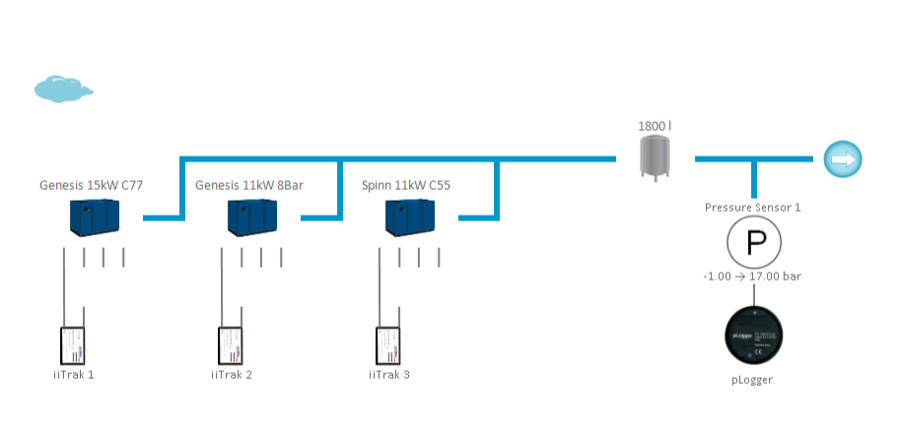
Future Situation – 1 Variable Speed Compressor
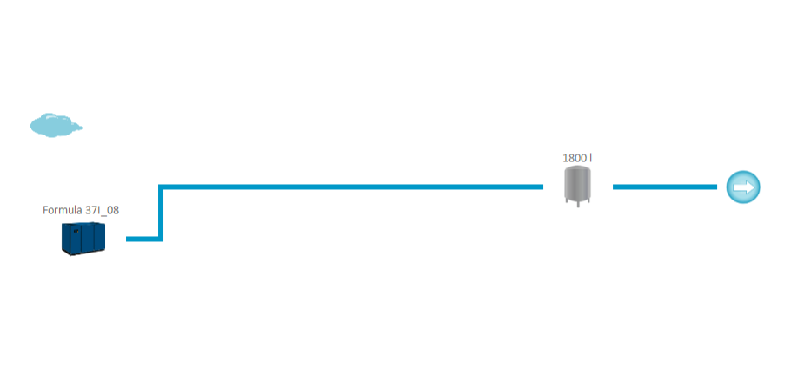
Energy Consumption calculated after a metered survey of site Compressed Air usage.
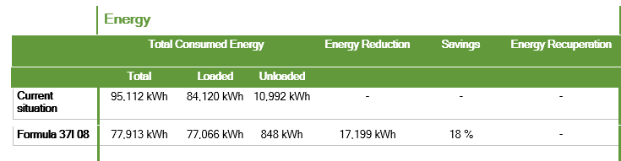
The new installation will deliver an energy reduction of 17199kWh per year.

Project details:
- Time for installation – 6 weeks from order.
- Equipment installed and commissioned by supplier.
- Installation timescale is 12hrs, with backup compressors to be used during installation, so zero disruption to Production schedule.
- Payment terms – 6 x Monthly instalments of £2536.
- Expected Lifespan – 10 years (based on 8000hrs per year)
- Based on current Electricity rates = 17199kWh at £0.42/kWh = £7223 Cost saving per year
(Based on UKWDG Invoice December 2022)

Project 2 - Griffin Windows, Treorchy

Treorchy has three fixed speed compressors. The Air demand is too great for just two of the compressors to run, so the third compressor is required to run at 40% ensure air demand is met. The proposal is to replace all 3 Compressors with 2 Fixed and 1 Variable speed compressor. The site demand will allow the fixed speed compressors to run continuously, with the Variable speed compressor kicking in and out on demand, when required. This will reduce electricity consumption of Compressed Air creation by 63,299kWh, which is a Cost Saving.

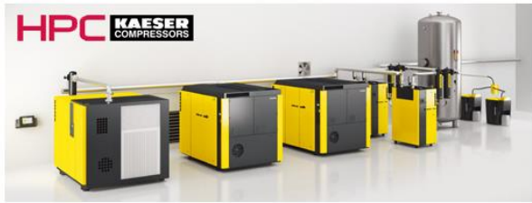

Energy Consumption calculated after a metered survey of site Compressed Air usage.

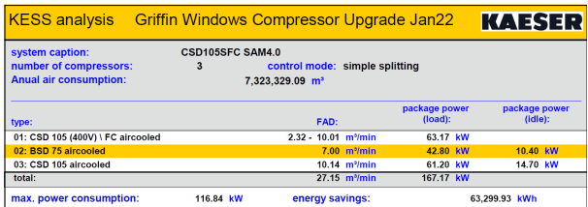

The new installation will deliver an energy reduction of 63,299kWh per year.

Project details
- Time for installation – 16 weeks from order.
- Equipment installed and commissioned by supplier.
- Installation timescale is 12hrs, with backup compressors to be used during installation, so zero disruption to Production schedule.
- Payment terms – 50% on order, 50% Upon completion.
- Expected Lifespan – 10 years (based on 8000hrs per year)
- Based on current Electricity rates = 63,299kWh at £0.42/kWh = £26,585 Cost saving per year
(Based on UKWDG Invoice December 2022)

- Financial Analysis and Evaluation

Project 1 - Evolution Windows, Biggleswade

Evolution Windows Financial Modelling (£0.42/kWh)
Weight Average Cost of Capital (WACC) | 10% (company advised)
Payback Period | 2.1 years
Net Present Value (NPV) | £12,169
Internal Rate of Return (IRR) | 38%
Profitability Index (P.I.) | 1.8
(Calculations in Figures 1a and 1c of Appendix)

Project 2 - Griffin Windows, Treorchy

Treorchy Windows Financial Modelling (£0.42/kWh)
Weight Average Cost of Capital (WACC) | 10% (company advised)
Payback Period | 2.9 years
Net Present Value (NPV) | £23,028
Internal Rate of Return (IRR) | 21%
Profitability Index (P.I.) | 1.3
(Calculations in Figures 2a and 2c of Appendix)

WACC - Weighted Average Cost of Capital

WACC is the average after-tax cost of capital from all sources. Some businesses are financed by equity and debt, so the Weighted Average Cost of Capital is the average rate at which a company is expected to pay for its finances. The more debt, the higher the WACC.
(Investopedia, 2023)

WACC is the discounted rate used to determine the Net Present Value of investments.

UKWDG is financed by a number of loans and has a variety of equity. These change on an annual basis, making it difficult to calculate the actual WACC of the company. For investment analysis a WACC value if 10% is used.

Payback Period

Payback Period is a measure of how soon the investment is returned to the business. With these two projects the cashflow improvement is predicted to be flat over 5 years, so the calculation below can be used:

Investment / Annual Cashflows = Payback period

Evolution Windows @ £0.42/kWh

£15212 / £7223 = 2.1 years

Treorchy Windows @ £0.42/kWh

£77,750 / £26,585 = 2.9 years

Both projects are under 3 years Payback Period, which is a pre-requisite for UKWDG project prioritization.
Payback Period is good for a very swift analysis for return on investment but does not focus on profitability. It also does not take the time value of money into account, the assumption that future values of money will be less than the present value. This evaluation method should only be used as a benchmark to ensure the company does recoup its investment in reasonable time.

Net Present Value (NPV)

Net Present Value is the difference between the present value of cash Inflows and the Investment. If positive, then the investment is deemed as profitable. The higher the NPV, the more profitable. NPV is used to calculate the time value of money. Future values of money are assumed to be less than the current value. The discount value of the company determines the future value of money.

Present Value of the Cash Inflows is the future value of the cash in from a project. This is determined by the WACC (Discount rate). The discount rate then calculates the value of the cash inflow for the period of the project.
(Fields, 2016)

Cost of capital may equal 10%, so the 10% discount value would be used to calculate the future value of money.

For example – Discount rate of 10% is used to determine the present value per year.

Year 1 = (1+10%)⁻¹ = 0.9091 – present value factor for Year 1
Year 2 = (1+10%)⁻² = 0.8264 – present value factor for Year 2
Year 3 = (1+10%)⁻³ = 0.7513 – present value factor for Year 3
Year 4 = (1+10%)⁻⁴ = 0.6830 – present value factor for Year 4
Year 5 = (1+10%)⁻⁵ = 0.6209 – present value factor for Year 5

These factors are used to calculate the future value of the Cash inflow, with the discount rate indicating the future value of that particular year. A Present Value Table is also used to quick reference these factors, as per Appendix 7.2.

Calculation:
NPV = Present Values of Cash Inflow – Present Value of Investment

Project 1 - Evolution Windows, Biggleswade

On the figure below the Cash Inflow future values have been calculated –totalling to £27,374.

NPV = Present Values of Cash Inflow – Present Value of Investment
NPV = £27,375 - £15212 = £12163

Project 2 - Griffin Windows, Treorchy

On the figure below the Cash Inflow future values have been calculated –totalling to £100,757.

NPV = Present Values of Cash Inflow – Present Value of Investment
NPV = £100,757 - £77,750 = £23,007

If the NPV is positive this indicates a good Investment, the larger the number the more benefit for the business. Producing more cash inflow than the investment

If the NPV is negative this indicates a bad investment and a drain on future cash.
(Gallo, 2014)

Internal rate of Return (IRR)

The Internal Rate of Return (IRR) is measured by finding the interest rate at which the present value of future cash Inflows equals the required capital investment. The threshold for profitability. If below the business’s Weighted Average Cost of Capital (WACC) Discount rate, then it would not be profitable as the cost of capital would exceed Cash Inflow.
(Fernando, 2023)

IRR uses the same formulas as NPV (Net Present Value), except it sets the NPV to zero (via an Excel formula below).

By considering the time value of money, and the threshold for profitability IRR is a good evaluation tool, capturing a more accurate forecast than Annual Rate of Return (ARR), which does not consider time value of money.

A disadvantage using IRR is that it does not consider the size of the project. A smaller project with lower investment but higher IRR would indicate a more profitable project, but a larger project with higher investment and lower IRR could provide more actual profit.
(Lanctot, 2019)

For the evaluation of these projects the below was used to determine the IRR – using the Excel formula method:

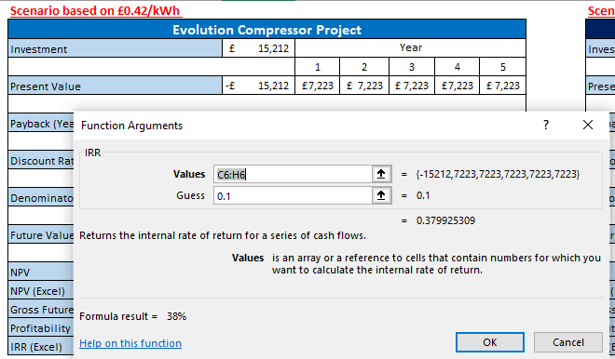
IRR Excel formula calculation

Figure 1a – Evolution Compressor IRR - £0.42/kWh

Figure 2a – Treorchy Compressor IRR - £0.42/kWh

IRR can be used to rank potential investments. For example, the Evolution Compressor project has a higher IRR than the Treorchy Compressor, so would be a more beneficial project to invest in due to its better measure of profitability.

Profitability Index (PI)

The Profitability Index (PI) is the comparison of the actual return on investment to the investment.
(Fields, 2016)

A PI greater than one indicates the return on investment exceeds the target. Lower means that the return on investment is lower. In simpler terms does the Cash Inflow exceed the Investment? – If so, the investment has been returned.

P.I. is useful to rank projects with the higher value considered to be the best use of capital, especially with limited budgets. It does consider the time value of money, so more accurate than Annual Rate of Return (ARR) or Payback period.

A disadvantage using PI is that it does not consider the size of the project. A smaller project with lower investment but higher IRR would indicate a more profitable project, but a larger project with higher investment and lower IRR could provide more actual profit.
(Chen, 2023)

Calculation:
Profitability Index = Present value of Cash Inflows / Investment

Project 1 - Evolution Windows, Biggleswade

Profitability Index = Present value of Cash Inflows / Investment
£27374 / £15212 = 1.8

This indicates the project will exceed its return on investment – making a profit of 80% over the project timeline.

Project 2 - Griffin Windows, Treorchy

Profitability Index = Present value of Cash Inflows / Investment
£100,757 / £77,750 = 1.3

This indicates the project will exceed its return on investment – making a profit of 30% over the project timeline.

Annual Rate of Return (ARR)

A formula that reflects the percentage rate of return expected on an investment or asset, compared to the initial investments’ cost.
(Murphy, 2022)

It is used as a base measure and a straightforward way to determine an investment’s profitability, without considering the Time Value of Money, which considers the Present value of money based on future values. If the ARR % is negative, or a low percentage, then it would be considered a poor investment, assuming the IRR (Net Present value based on future values of money) would always be lower.

The main advantage would be the quick initial profitability assessment to determine a project viability.

A disadvantage would be that it does not account for cash Inflow timings – it just averages the full project term.

ARR should be followed by an IRR assessment to capture the time value of money for more accurate forecasts of profitability.

Calculation
ARR = Average Net Income / ((Initial Investment + future residual value)/2)

Project 1 - Evolution Windows, Biggleswade

Project 2 - Griffin Windows, Treorchy

---------------------------------------------------------------------------------------------------------------------------------------------------------

- Funding Options

Proposition of this Capital Expenditure has been made with the assumption that the business would be using the Capital Expenditure budget. With regards to Cost Rationing UKWDG has limited funding, so Soft Rationing (company fund limits) has been the strategy for a number of years.

There are however Hard Rationing options for a Project with Environmental factors. Capital from external resources may be available, with options such as:

- Loans – secured, unsecured.
- Enhanced Capital Allowances – offering a 100% discount on profit related tax to the value of the asset.
- Government – Energy Funding
- Post BREXIT Capital Investment funding
- R&D Tax Credit
---------------------------------------------------------------------------------------------------------------------------------------------------------
- Conclusion

As per the financial analysis both projects are viable for investment. The Energy Cost Saving would reduce the Cash Outflow for the project period of 5 years, which enables the cash to be used elsewhere.

A short Payback Period, High ARR, Positive NPV, a high IRR, and good Profitability Index indicate that the investment will be returned within 3 years for both projects and further savings will be made once the investment is returned.

Financial Sustainability is not the only factor to consider when making decisions on these investments. There are Social and Environmental Sustainability reasons for progressing the project.

Socially, investment into the infrastructure of the business will give confidence to the workforce – investment usually indicates a longer future.

Environmental reasons include ethically lowering the business’s Carbon footprint by using less electricity. UKWDG is also ISO:14001 Environmental Management accredited, with projects such as this indicating the business is investing to improve the Environment and Carbon footprint.

Along with the Social and Environmental factors there is also an equipment risk. Both Evolution and Treorchy compressors are over 10 years old, so will require high costing refurbishments or replacements in the next 2-5 years.

Before progressing with the full investment other funding opportunities should be explored further to lower the investment costs.

Project Risk

Should the electricity tariff drop for UKWDG then the investment would not produce a good Payback period, a negative NPV, negative IRR and low Profitability Index (As per Appendix figure 1b, 1d 1f, 2b and 2d,2f). An example tariff of £0.16/kWh has been used to evaluate the financial measures.

For a 5-year project this is a high risk with energy markets fluctuating regularly, although the tariff could also increase, which would bring a larger Cost Saving.

- References

References
- ACCA Global, n.d. Present table value. [Online]
Available at: https://www.accaglobal.com/content/dam/acca/global/pdf/p5_formulae.pdf
[Accessed 2023].
- Chen, J., 2023. Profitability Index (PI): Definition, Components, and Formula. [Online]
Available at: https://www.investopedia.com/terms/p/profitability.asp#:~:text=The%20profitability%20index%20(PI)%20is%20a%20measure%20of%20the%20attractiveness,investment%20amount%20in%20the%20project.
- Fernando, J., 2023. Internal Rate of Return (IRR) Rule: Definition and Example. [Online]
Available at: https://www.investopedia.com/terms/i/irr.asp#:~:text=The%20internal%20rate%20of%20return,same%20formula%20as%20NPV%20does.
[Accessed 2023].
- Fields, E., 2016. The Essentials of Finance and Accounting for Nonfinancial Managers. 3rd ed. USA: AMACOM.
- Gallo, A., 2014. A Refresher on Net Present Value. [Online]
Available at: https://hbr.org/2014/11/a-refresher-on-net-present-value
[Accessed 2023].
- Investopedia, 2023. Weighted Average Cost of Capital (WACC) Explained with Formula and Example. [Online]
Available at: https://www.investopedia.com/terms/w/wacc.asp
[Accessed 2023].
- Lanctot, P., 2019. The Advantages and Disadvantages of the Internal Rate of Return Method. [Online]
Available at: https://smallbusiness.chron.com/advantages-disadvantages-internal-rate-return-method-60935.html
[Accessed 2023].
- Murphy, C., 2022. Accounting Rate of Return (ARR): Definition, How to Calculate, and Example. [Online]
Available at: https://www.investopedia.com/terms/a/arr.asp
[Accessed 2023].

- Appendix

  - Calculations for Financial Modelling

    - Evolution Compressor Project

Figure 1a – Evolution Compressor IRR - £0.42/kWh

Figure 1b – Evolution Compressor IRR - £0.16/kWh

Figure 1c – Evolution Compressor Financial Modelling - £0.42/kWh

Figure 1d – Evolution Compressor Financial Modelling - £0.16/kWh

Figure 1e – Evolution Compressor ARR - £0.42/kWh

Figure 1f – Evolution Compressor ARR - £0.16/kWh

    - Treorchy Compressor Project

Figure 2a – Treorchy Compressor IRR - £0.42/kWh

Figure 2b – Treorchy Compressor IRR - £0.16/kWh

Figure 2c – Treorchy Compressor Financial Modelling - £0.42/kWh

Figure 2d – Treorchy Compressor Financial Modelling - £0.16/kWh

Figure 2e – Evolution Compressor ARR - £0.42/kWh

Figure 2f – Evolution Compressor ARR - £0.16/kWh
  - Present Value Table

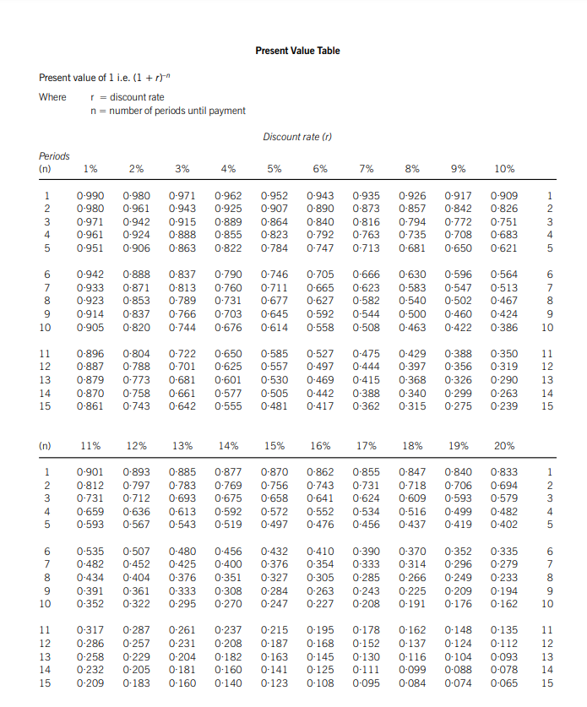
Figure 3. Present Value Table
(ACCA Global, n.d.)

