

MODULE CODE: Digital Skills for Personal Development and Business Growth BMSW4008

ASSESSMENT COMPONENT: PORTFOLIO

STUDENT NAME: Finn Dixon

STUDENT NUMBER: 2511455

LECTURER: Philippa Fitzgerald

DATE:
Contents
Task 1 3
Assessment of Digital Skills 3
References 3
Task 2 4
LinkedIn Learning Certificates for Office365 4
Task 3 5
Essay on Relevance of Excel in professional and personal life. 5
References 5
Task 4 6
7 Minute Reflective Presentation 6
References 6

I confirm that I have not presented any AI generated materials as my own work.
I confirm that I have copies of my drafts, notes, and other resources I used, which I may be asked to provide in evidence.
Task 1
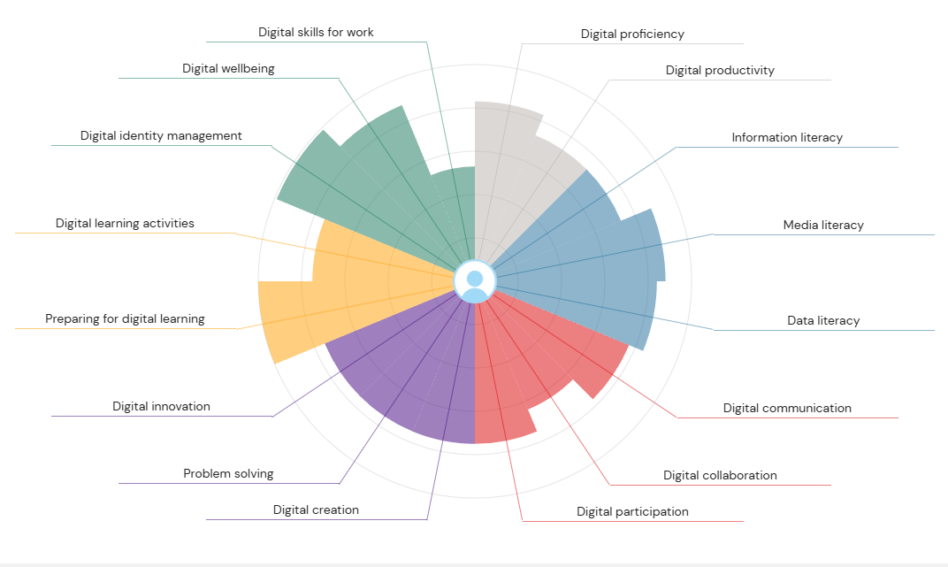
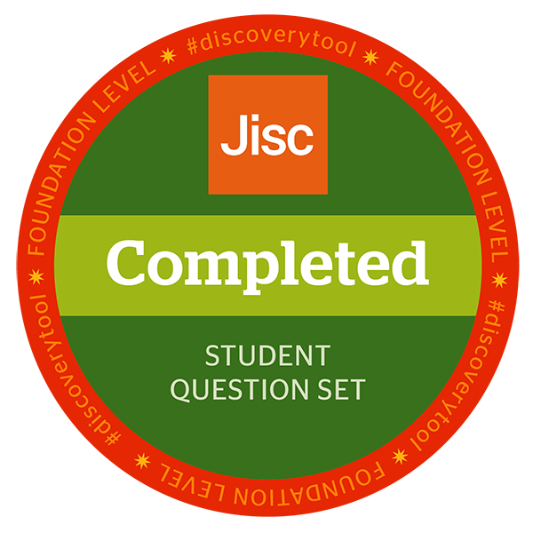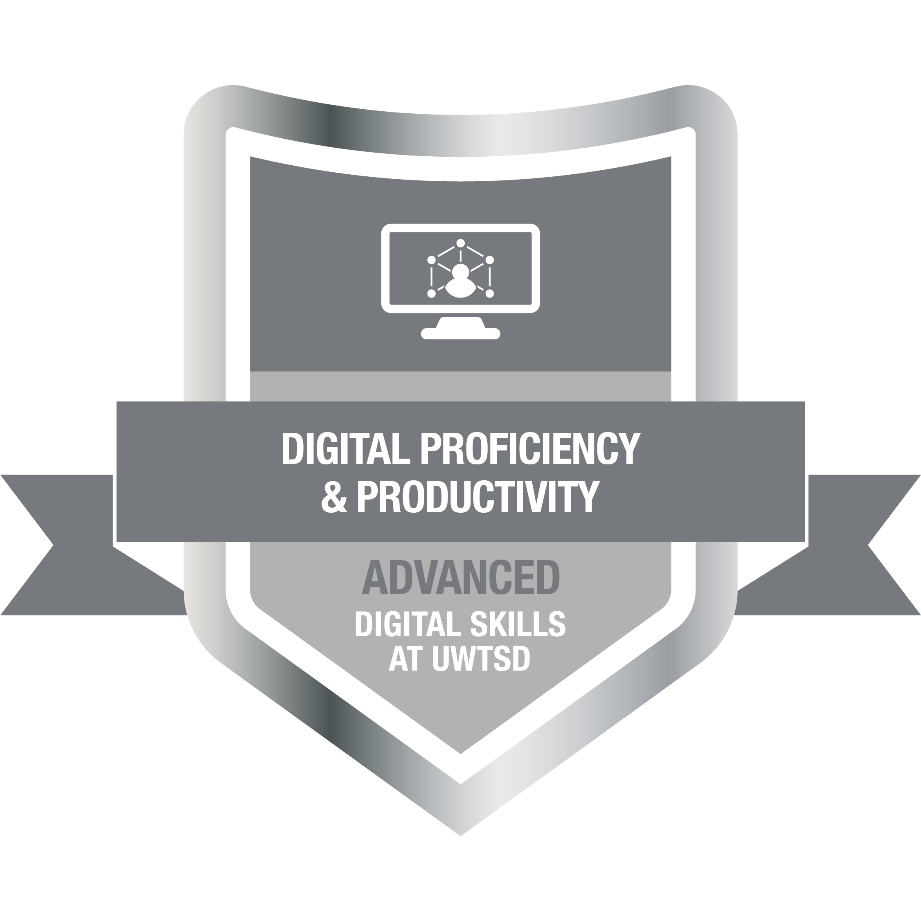
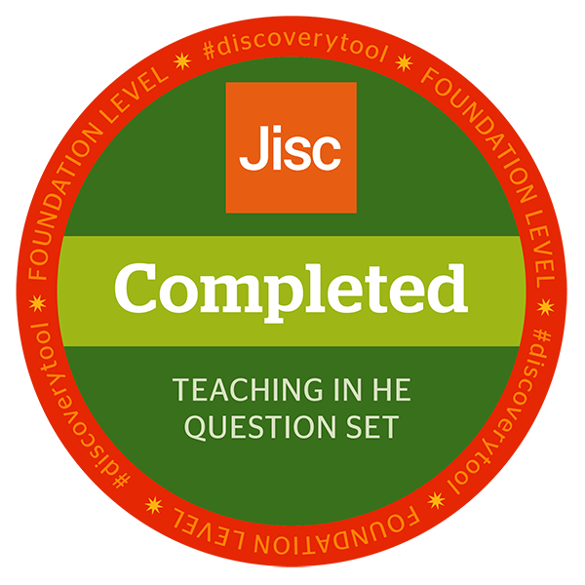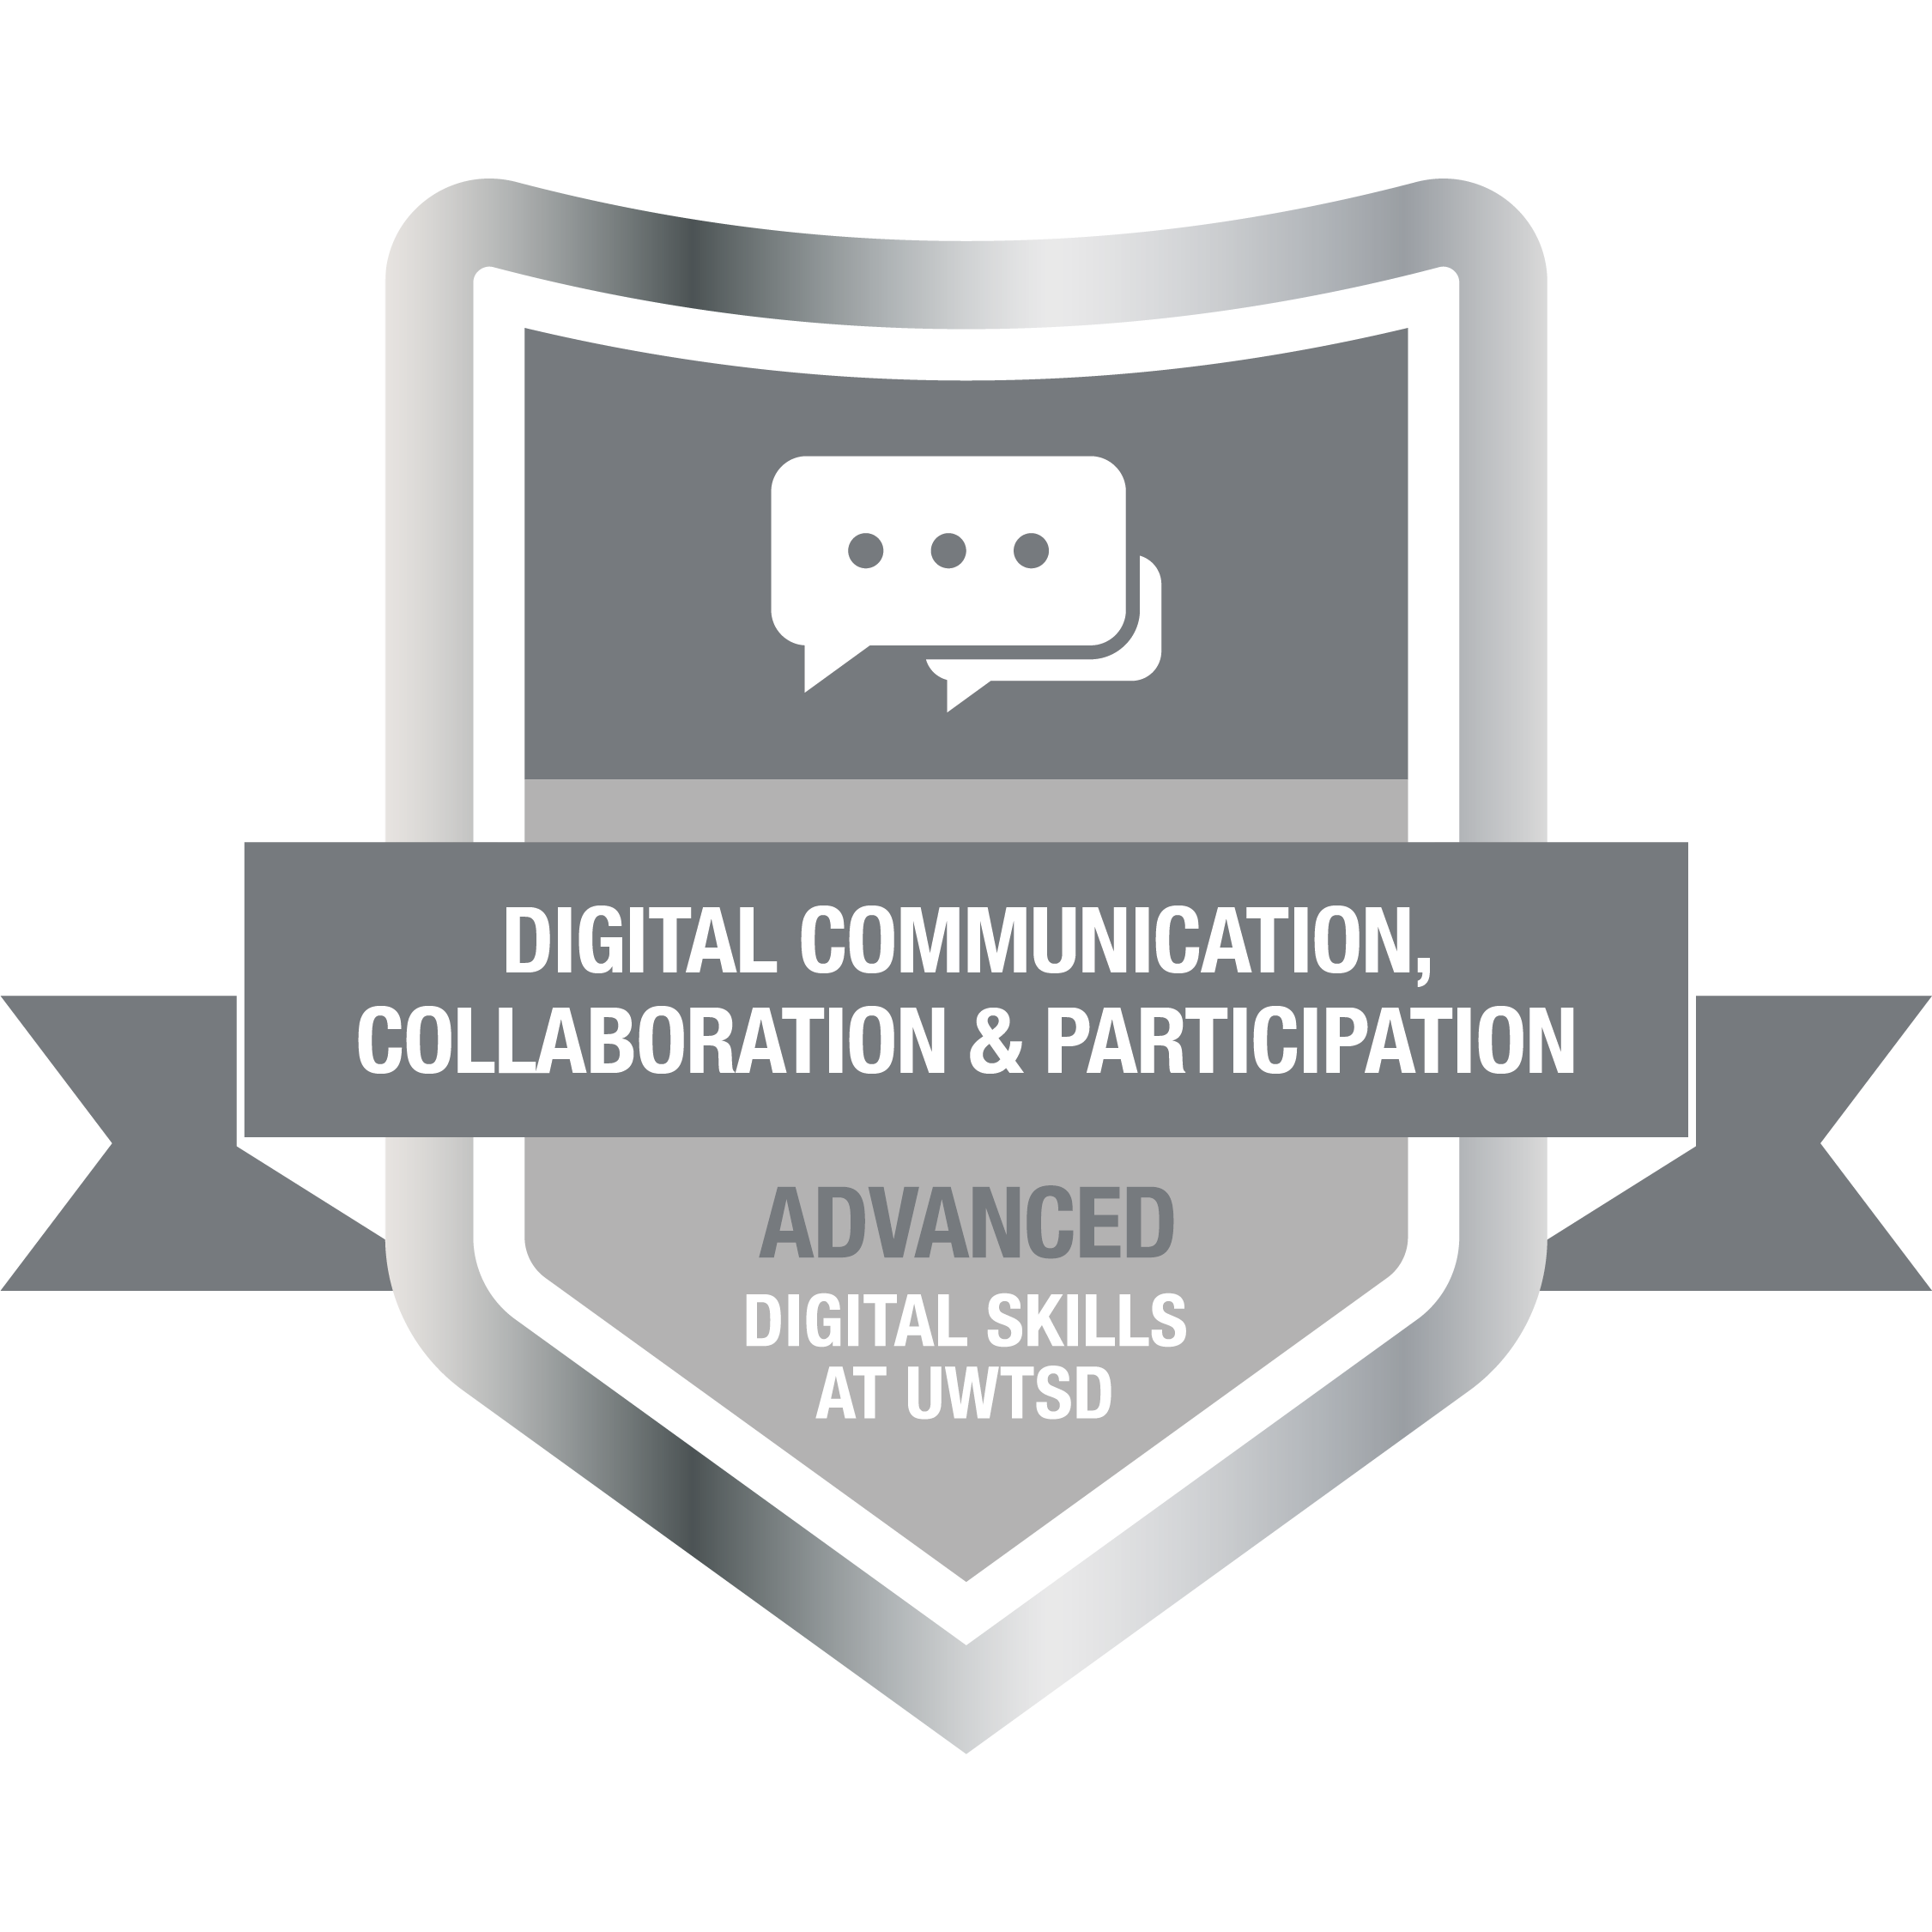
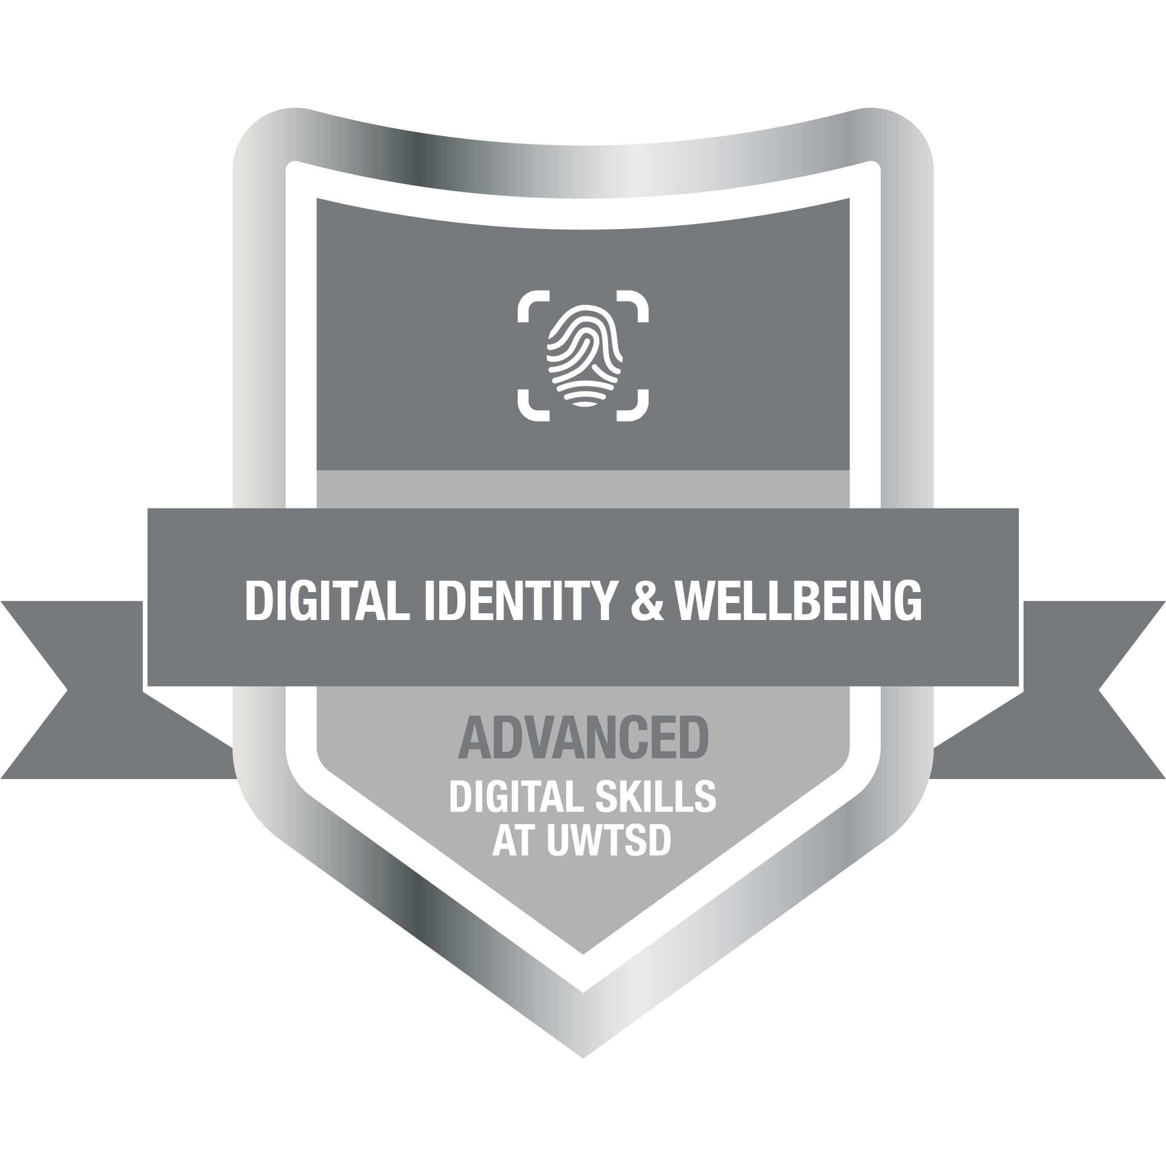
Having strong digital skills is so important in the digital era, they are so valued in the modern world, and many careers require strong digital skills for businesses and organisations to be successful. People who have a good knowledge of digital skills are often more productive, successful and end up with better career prospects. Many businesses and organisations must overcome and adapt to the new digital tools available to them.
My JISC report gave me an insight into my overall level of digital skills at the start of the term. In some areas the report shows that I am confident in using certain digital skills, but it also highlights the key weaknesses I have when using digital skills. The report has helped me to understand what I need to improve and how I can achieve this moving forward.
After completing my JISC report, I was able to evaluate my strengths and weaknesses. A digital skill I performed best in was digital identity management, in simplified terms this meant that I am confident in my ability to keep my identity safe online and know about the risks of sharing personal information online. For example, knowing that people can access personal information like bank details if I were to share them or had them stolen online is a sign of how important it is to have a strong knowledge of my digital identity. Ensuring you take practical steps online to protect your personal information will reduce the risk of fraud and identity theft (Waugh, 2025). My other biggest strength was preparing for digital learning, in short having a strong knowledge of this meant that I could understand the key skills, tools and mindset that are needed to learn well online and be able to use technology confidently. According to the Bancroft, Challen and Pearce, (2024), being able to use digital tools competently is vital when browsing online information and highlights the importance of digital confidence.
The JISC report has also highlighted my key weaknesses, which include digital skills for work and digital collaboration. An area like digital skills for work is an area that I haven’t had as much time using so far in my career. This is most likely due to previous jobs not involving the use of certain digital skills; to improve this skill I completed an online course which included the use of digital skills in the workplace. I gained a badge after which would have me develop this skill. The European Commission (2022), found that digital skills are key when it comes to the workplace, communicating online, managing data and collaborating all require the use of digital skills. Another weakness the report found was in digital collaboration, this could be due to my lack of experience when it comes to collaborating online. I completed a badge in Digital Communication, Collaboration and Participation, this has helped me to understand why digital collaboration is so important in the digital world. According to JISC (2024), collaboration in digital areas, in data and technology can help organisations and individuals work more effectively together.
For future development I will create an action plan and set SMART goals, which will give me clear and achievable goals. In the next term I would like to develop my weaknesses in a way that is achievable and can be completed in a certain timeframe. SMART goals can improve productivity and can help development (Day, 2024).
Smart Action Plan
Specific- I will spend more time using collaborative tools, this will include using Microsoft Teams. I will use certain functions like using the chat functions, video calling with peers and collaborate more for tasks. I will aim to use the Teams 2-3 times a week
Measurable- I will track my progress by recording a log of how long I use the tool each time, I will aim for 30 minutes a time.
Achievable- I will only use it 30 minutes at a time, which gives me plenty of opportunity to complete during the week.
Relevant- It will improve my collaborative skills and will grow my confidence in collaborating digitally.
Time-bound- I will aim to achieve this by the end of next term; I will then review my progress and see how I have developed this skill.
To conclude, I have gained lots of valuable knowledge from my JISC report, this will be massively beneficial as year progresses. It has helped me identify what I need to focus on for next term. Thanks to the report I have now been able to set out some smart goals which will help me overcome my weaknesses.

References
Bancroft, R., Challen, R. and Pearce, R. (2024) ‘Searching for a shared understanding of digital confidence in a tertiary context: a scoping review’, Journal of Learning Development in Higher Education (Preprint), (30). Available at: https://doi.org/10.47408/jldhe.vi30.1061
Day, B (2025) The Ultimate Guide to SMART Goals. Available at: https://www.forbes.com/uk/advisor/business/smart-goals/ (Accessed 7th of December 2025)

European Commission. (2022) Digital Economy and Society Index (DESI), European Union, Available at: https://digital-strategy.ec.europa.eu/en/library/digital-economy-and-society-index-desi-2022
(Accessed 7th of December 2025)
JISC. (2024) Deeper collaboration key to securing the future of UK higher education. Available at: https://www.jisc.ac.uk/news/all/deeper-collaboration-key-to-securing-the-future-of-uk-higher-education (Accessed 7th of December)
Waugh, E (2025) How to protect your personal information online. Available at:
https://www.experian.com/blogs/ask-experian/how-do-you-protect-your-personal-information-online/ (Accessed 7th of December 2025)

Task 2
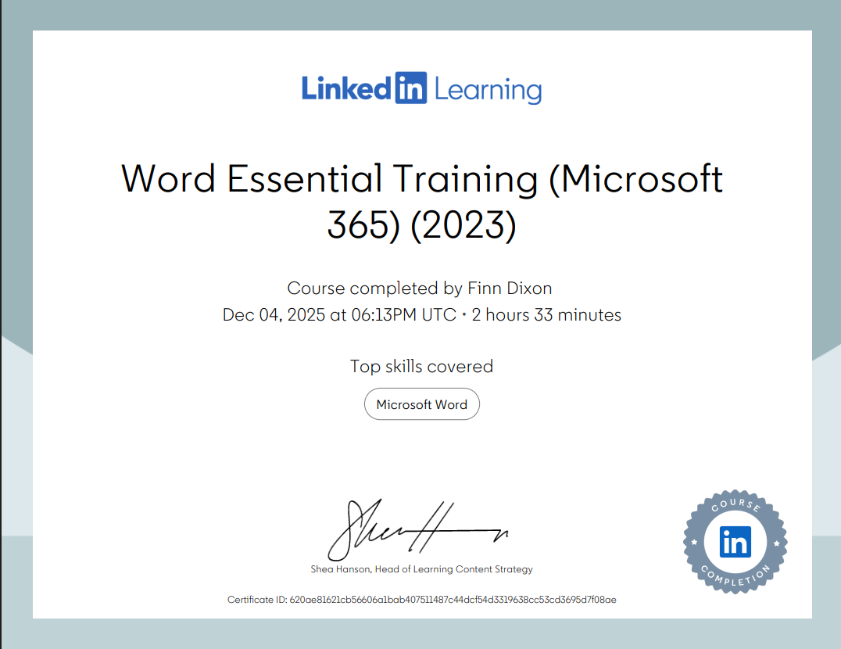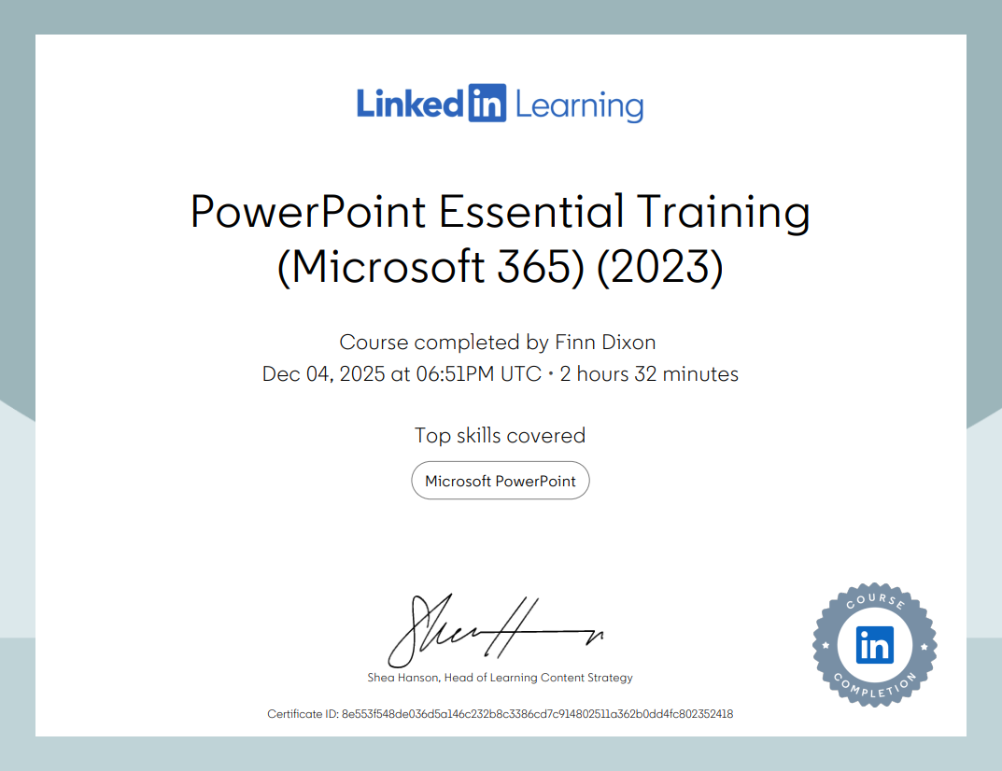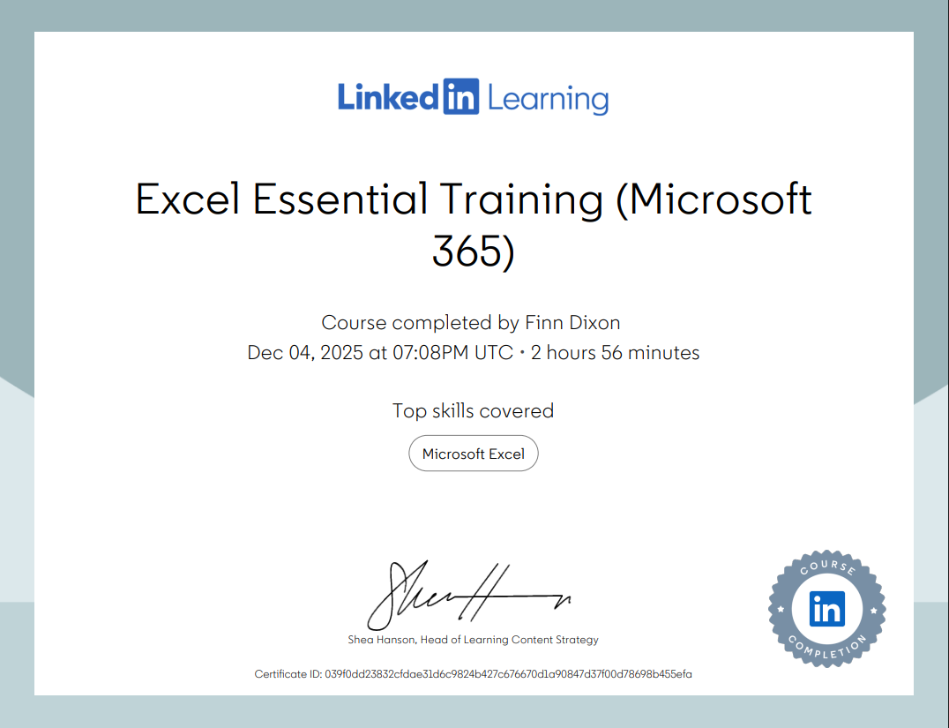

Task 3
Microsoft Excel is an online tool that is used by many and has many different uses in professional and personal life. Excel’s main uses include financial planning, storing and organising data, analysing information and many more. In the digital era Excel is used in many different places of work, educational settings and many people's personal lives. Excel’s widespread use shows how flexible and useful it is and its use by businesses and individuals shows this. Understanding this tool and how it is so relevant to professionals and personal users reflects its importance as a vital tool to have in the 21st century.
Microsoft Excel can play a vital role in sorting and managing data. Excel is used in many different professional environments. For example, many businesses use Excel to handle important information such as details of their employees, inventory records and financial information. According to Charlesworth (2024), Excel can be used by professionals to analyse certain financial information and can be used to keep track of inventory. Another way Excel is used in a professional environment is to track certain performance data such as employees' performances, attendance, total sales and sales forecasts. This analytical data can help businesses make better decisions and allows them to spot certain trends in their performance, which can help them to become more successful and more aware of the problems that could lie ahead. Using Excel businesses can monitor their overall performance, the performance of their staff and performances of certain teams within their business (GeeksforGeeks, 2025). Excel also has many formulas that can be used which allows professionals to complete basic calculations and more advanced calculations like financial modelling. Tools such as charts, PivotTables and forecasting functions can help users spot trends, review performance and predict their future performance.
The use of Excel can massively improve productivity in a working environment. Excel can complete repetitive work autonomously, which saves time and means there is less chance of an error in the data due to the data being incorrectly entered. Automation can also keep costs down. Users can benefit from features like macros, data validation and templates, these features can help to keep information organised and accurate. Smith (2025) says that using a feature like automation to collect data can save time, money and improves productivity. Another way Excel can boost productivity is the use of features like drop-down menus and built-in templates, this can make everyday tasks such as the creation of invoices, organising events and collecting financial information for users easier than ever to complete. Excel’s use of automation and formulas can help reduce inaccuracies in data (Reisfield, 2023).
Excel is a key skill to possess in the digital era; many employers consider Excel an essential skill to have in the digital world. The use of Excel in certain jobs such as administrative roles, financial management, analytical roles and project management is considered a digital skill that applicants must have. Almost all jobs require some basic knowledge on how Excel works and employees are expected to be able to use the key tools and features available to them. Many industries rely on Excel for daily operation, this includes healthcare, marketing, education and engineering. An article by the BBC (2022) shows that being able to use a digital tool like Excel is considered a vital skill that employers believe their staff should have. Workers with good excel skills are more likely to go further in their field of work and will become more valuable to their employer.
Excel’s versatility allows it to not just be relevant to professionals but also can be used for more personal tasks. Excel particularly helps with organising, planning and managing daily tasks. One of Excel’s best uses is for managing personal financial information, this includes tracking monthly expenses, savings and making budgets. With Excel, you can get it to calculate sums of money, averages of your data and it can calculate differences in data, which can help you spot certain trends in your data. Excel’s ability to calculate certain figures using features like SUM, AVERAGE and MAX are hugely beneficial when trying to input data into a spreadsheet (Formulas HQ, 2024).
Excel can also be used to organise personal activities, it can be used to create shopping lists, create itineraries and schedule events. Excel can help families create plans for birthdays, develop lists for chores and can help manage inventories for the household. According to Washburn (2023), Excel can help personal users keep their schedules organised and can also help with tracking important life goals like tracking their health.
Another way Excel can be used in personal life is by using it to track goals, which can help individuals improve their lives. Excel is used by many people to keep records of fitness schedules and monitor them, plan a study schedule and help them keep track of long-term goals. Excel also can also provide users with helpful and easy to understand feedback, this can be done through graphs and charts, this gives the user a clear understanding of what they need to change. This can help them to reflect better on their goals and can help motivate them further. Excel’s versatility and flexibility allow you to easily to track events in daily life, this can help individuals monitor certain aspects of their life and leads to better personal growth. (Biziouras, 2024). Understanding that Excel can be used in so many ways allows you to create a spreadsheet on virtually any topic imaginable, making it so relevant in professional and personal situations.
In conclusion, Excel is digital tool that can be used for almost everything and when discussing the relevance of Microsoft Excel in professional and personal life, the vast number of different applications it can be used for, showing how useful and relevant it is. All of excels’ helpful formulas and different tools like automation also mean users can create data that is more accurate and allows users to concentrate on more important tasks.

References
Biziouras, T (2025) Excel as a Tool for Self-Discovery: Unlocking Personal Growth Through Data. Available at:https://medium.com/illumination/excel-as-a-tool-for-self-discovery-unlocking-personal-growth-through-data-480f25e00beb (Accessed 6th of December 2025)
Charlesworth, L (2024) What is Microsoft Excel used for and is it still relevant? Available at:https://kaplan.co.uk/blog/features/is-microsoft-excel-still-relevant (Accessed 8th of December)
Christian, A (2022) Why ‘digital literacy’ is now a workplace non-negotiable. Available at: https://www.bbc.co.uk/worklife/article/20220923-why-digital-literacy-is-now-a-workplace-non-negotiable (Accessed 7th of December 2025)
FormulasHQ (2024) Mastering Personal Finance with Excel: A Comprehensive guide. Available at:https://formulashq.com/mastering-personal-finance-with-excel-a-comprehensive-guide/ (Accessed 8th of December 2025)
GeeksforGeeks (2025) Importance of Microsoft Excel in the Workplace (with real-world examples). Available at:https://www.geeksforgeeks.org/excel/importance-of-microsoft-excel-in-workplace/ (Accessed 8th of December 2025)

Reisfield, A (2025) Excel Automation: 9 Essential Methods to Save Time, Reduce Errors, and Streamline Your Workflows. Available at: https://parabola.io/blog/how-to-automate-excel#:~:text=Improved%20accuracy,and%20eliminate%20duplicates%20and%20mismatches. (Accessed 7th of December 2025)

Smith, S (2025) Spreadsheet improvements 1/9: Purpose. Available at:
https://infosmith.co.uk/blog/spreadsheet-improvements-1-9-purpose (Accessed 8th of December)
Washburn, E (2023) 5 Ways to Get Started Using Microsoft Excel. Available at: https://www.forbes.com/sites/emilywashburn/2023/04/05/5-ways-to-get-started-using-microsoft-excel/ (Accessed 7th of December 2025)

Task 4

7 Minute Reflective Presentation
Create a PowerPoint presentation using techniques learned in class, reflecting on the module and what you have learned.
Maximum of 15 slides Minimum 7
You will reference your work where appropriate.
Embed PowerPoint here
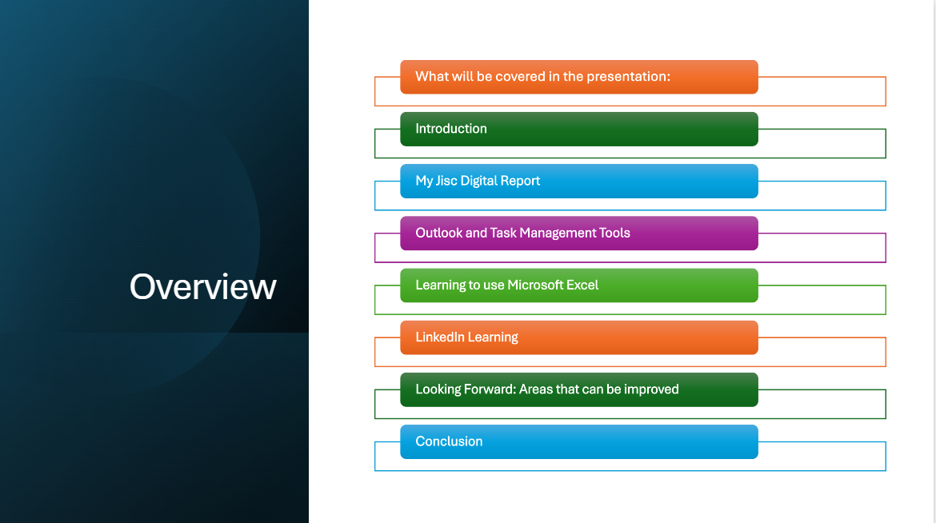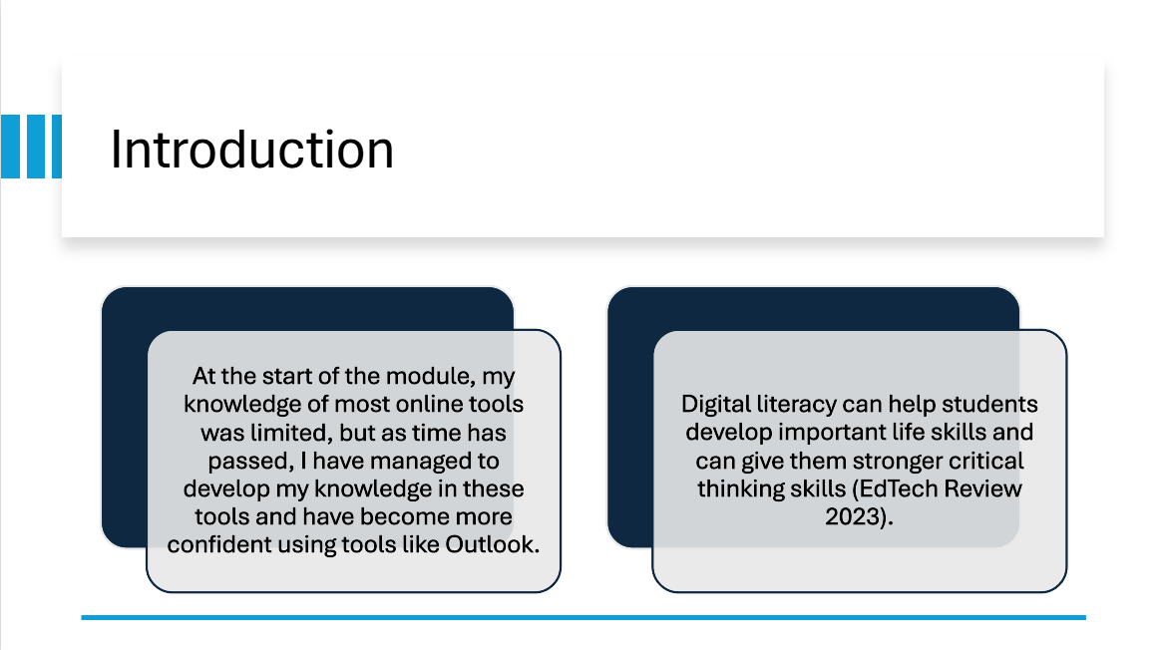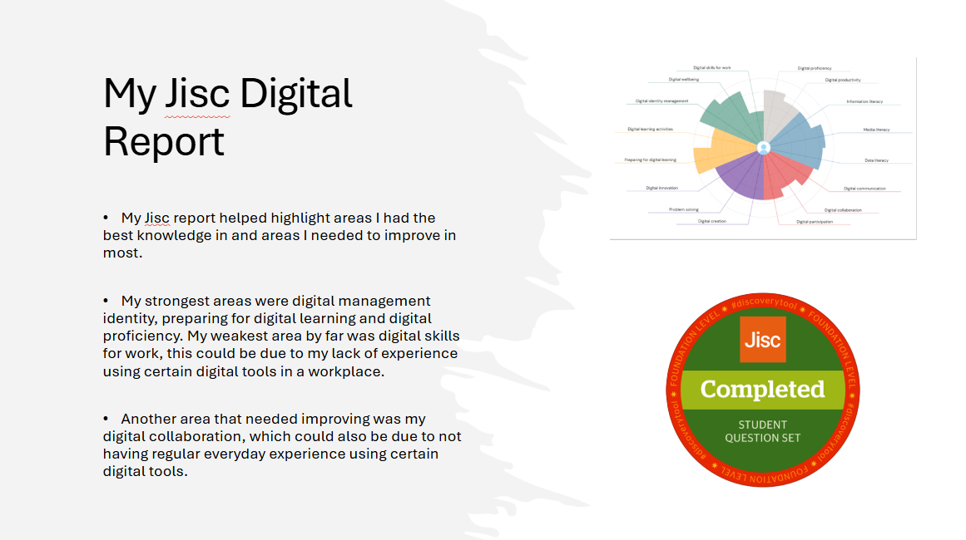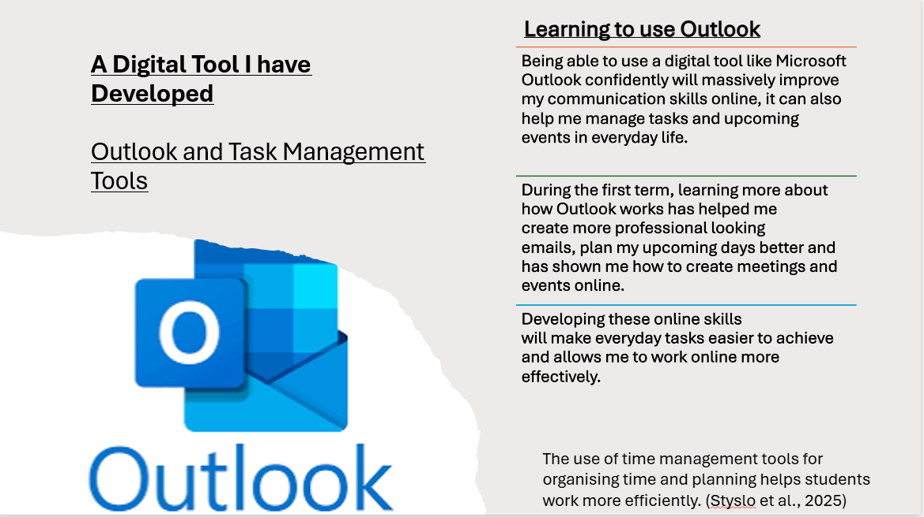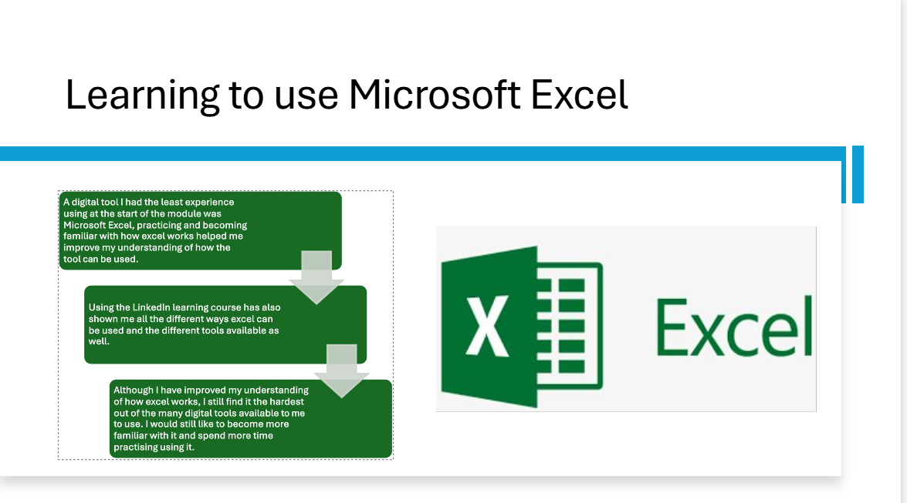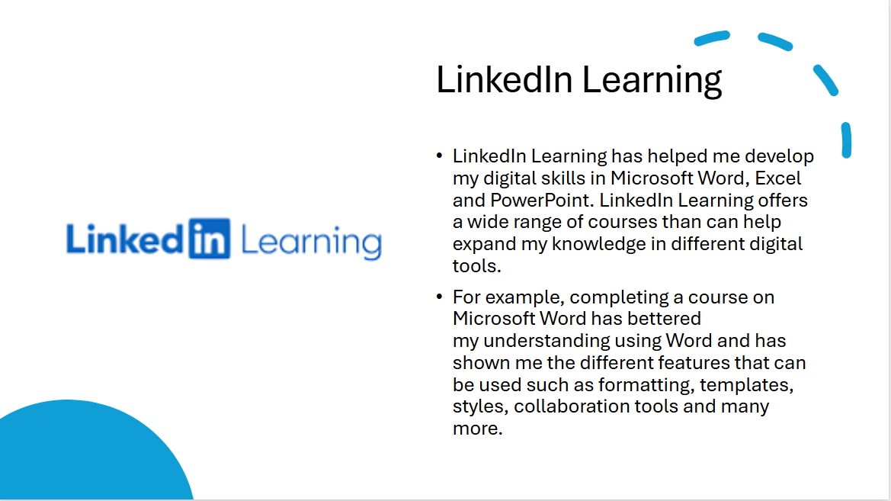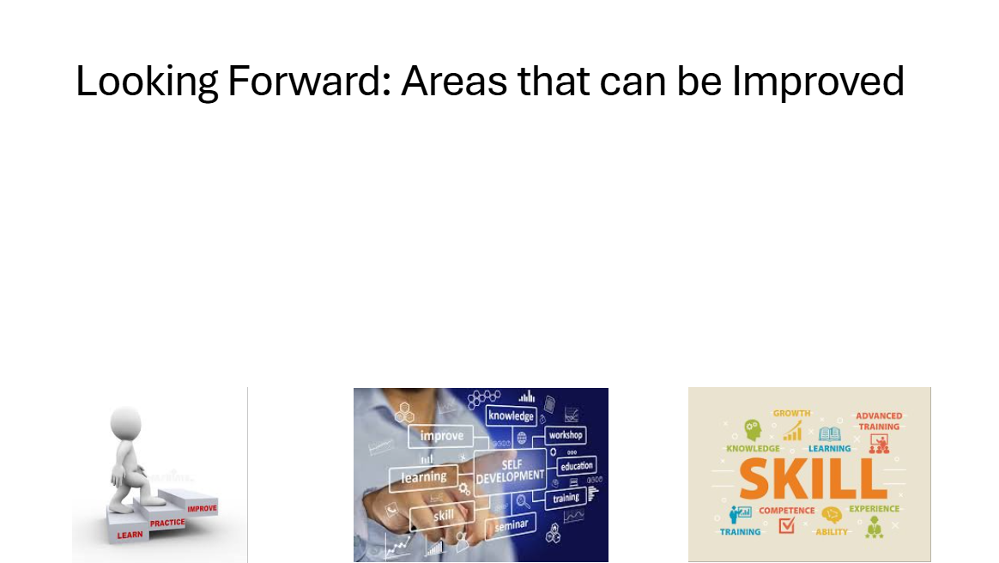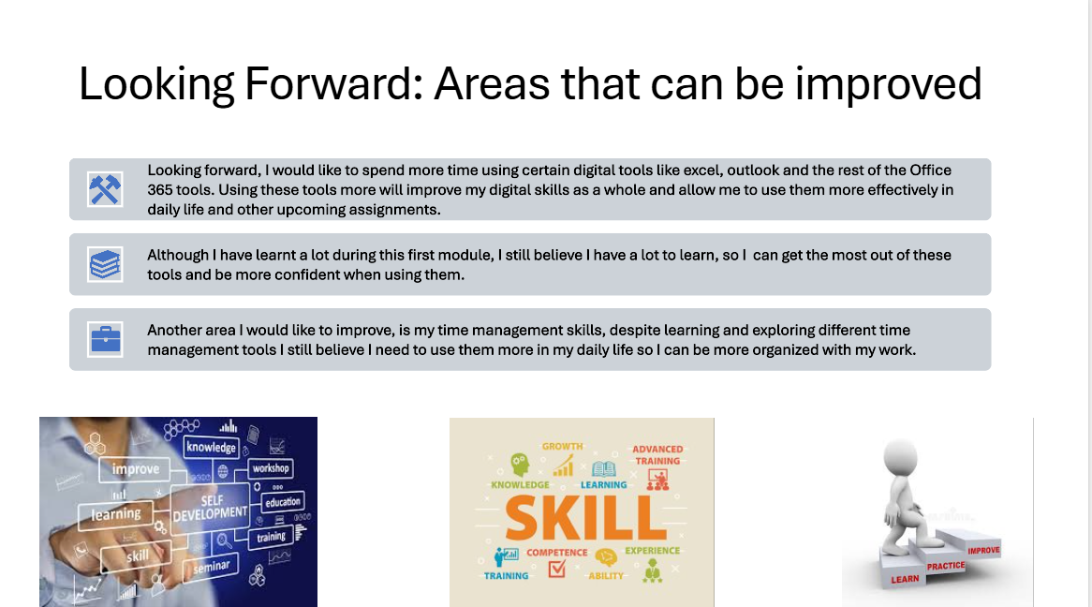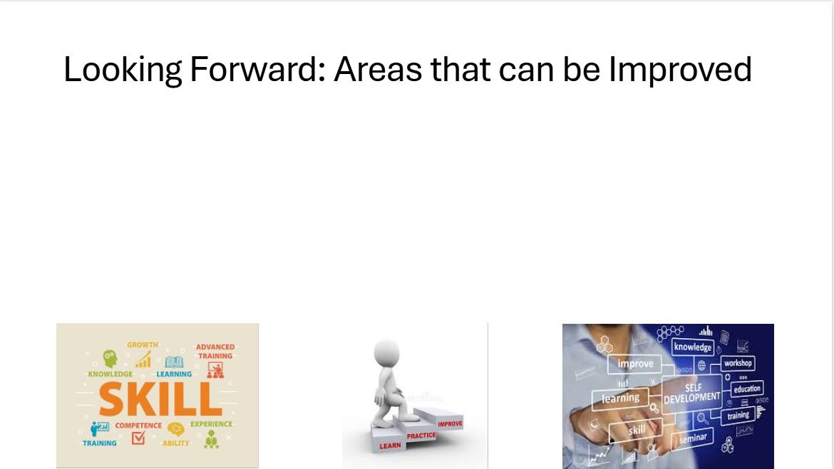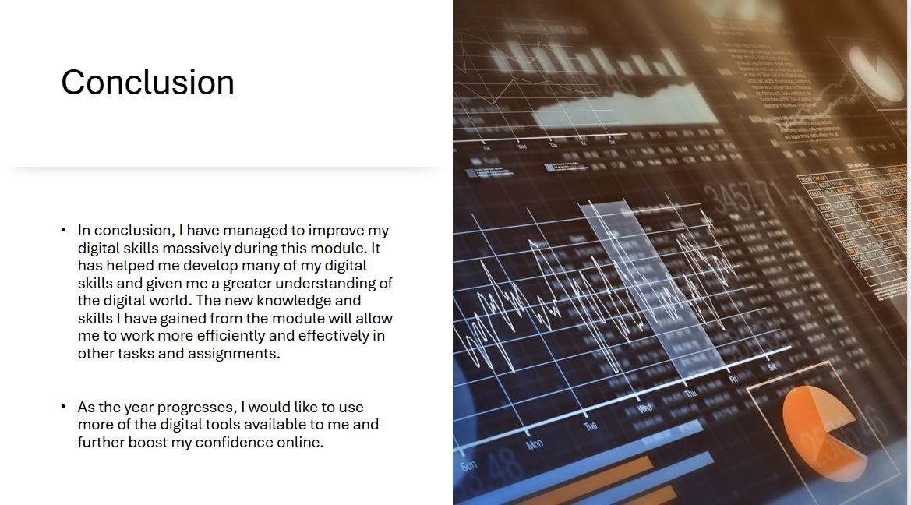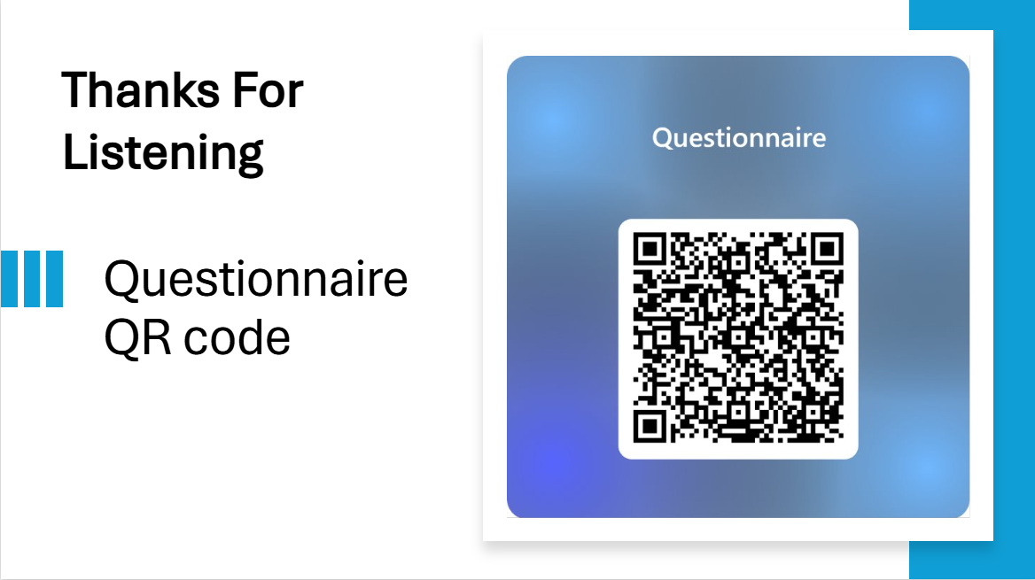

References
- EdTechReview Editorial Team (2023) What is Digital Literacy, Its importance, and challenges? Available at https://www.edtechreview.in/trends-insights/insights/what-is-digital-literacy-its-importance-and-challenges/ (Accessed 30th of November 2025)

- Styslo, T., Humeniuk, N., Ivanov, O., Varvaruk, I. (2025) 'The impact of digital tools on the development of students' time management skills', Revista EDaPECI, 25 (2), pp. 201-217.
DOI:10.29276/redapeci.2025.25.222264.201-217

