The importance of academic skills
To higher education students.

Name: Rox-Ann Richmond
Student number:1714480
Tutor:

TABLE OF CONTENTS

INTRODUCTION……………………………………………………3
The intention………………………………………………..3
Aims………………………………………………………….3
Time management…………………………4
Frequent issues………………………………………………4
How it impacts me and other students………….4
Recommendations……………………5
Note taking…………………………………….6
Methods of note taking………………………………6
How does this link to CRAAP? …………………..6
Recommendations……………………7
Critical thinking………………………………….8
Why is it important……………………………………………….8 Case studies?………………………………………………………8
Recommendations…………………………………..9
CONCLUSION………………………………………………….10
Final thoughts………………………………………………….10
Is online learning helpful? …………………………………..10
REFERENCES…………………………………………………11
Bibliography………………………………………………12
APPENDICES…………………………………………………13

Introduction
This report intends to show the importance of academic skills on students Growth throughout higher education. Throughout this report, Different skills will be discussed and The meaning importance will be highlighted And relevant examples will be made on how they are used by students. academic skills allow students to Make a set routine of study And infer and deduce relevant information. The primary aim of this report is to show readers the impact academic skills can have on a student’s growth. this will be achieved using different scholar's ranging from psychologist researchers and even teachers. this will allow the report to have a good analytical approach to the usefulness of academic skills.



Time management

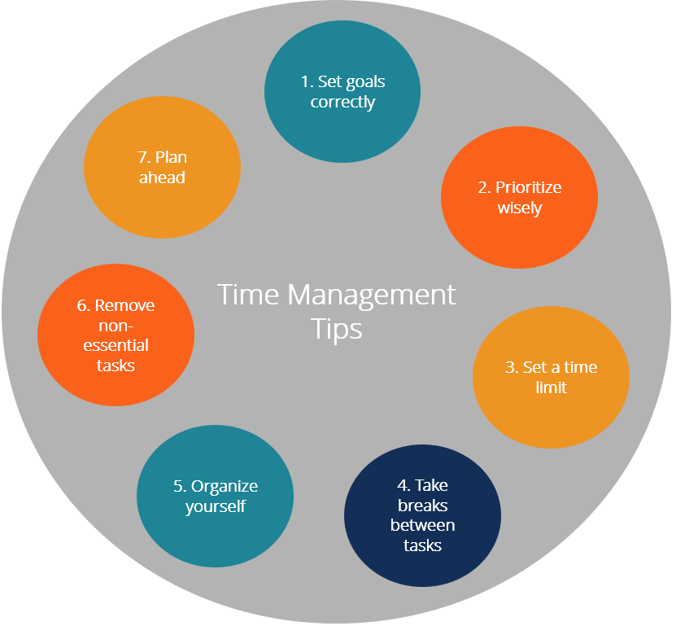
Time management is a skill that is detrimental for all students in the UK. It allows them to be able to complete their work suitably. Without this skill, the student may face immense difficulty when completing work and handing in submissions. Collins Dictionary (2020) time management is “the examination of how time is used and the ability to rank the important assignments to be efficient in the work”. Time management is a universal skill that is not only used in the adolescent years but the adult stages of life, Concerning education time management enables a student to have academic freedom when completing work I'm doing day to day tasks and activities. As Claessens, Eerde and Rutte, (2005) state "time management is conceivable just through self-motivation and planning” implying that to have the option to accomplish the proposed purposes, an understudy should make a rundown of the significant things and exercises and set up a 'daily agenda' with a game plan considering the time stealers like online media, work, sentiment, work and companions that can ease back the best approach to progress.

Frequent issues

If there is no time management it can calls an immense strain on the individual as it becomes more of a tedious task to make time for academic work. It could result in the individual leaving things to the last minute and rushing To form a piece of work. in most cases the quality of work is dramatically lowered as a sufficient amount of time was not put in place for it to be of standard. In relation to education the most common lack of skill when it comes to time management would be note taking. Note taking requires a specific amount of time to create efficient notes. note taking allows information from the short term memory to migrate to the long term memory. many successful students have a copious amount of notes that they use during their academic career.

How time management is significant to me and other peers?

This skill is very beneficial to me and many other people, because it Allows me to organise and complete work efficiently. It gives me the opportunity to use my thinking skills as I am able to pick and choose which topics I should prioritise. This is a prime example of delegating primary and secondary tasks. It also helps me mentally as I am able To stay motivated and focused on the Work. Time management was definitely made easier due to the 4D strategy. This is a common strategy used by most students as it allows them to question whether they should do dump delegate or delay certain tasks. this way of thinking train students to pick and choose wisely which things they should prioritise.

Recommendations

- Focus carefully

Focus on errands dependent on significance and earnestness. For instance, take a gander at your day by day assignments and figure out which are:

- Making time

Setting time requirements for doing jobs assists you with being more engaged and productive. Putting forth the little additional attempt to settle on how long you need to dispense for each undertaking can likewise assist you with perceiving expected issues before they emerge. That way you can make arrangements for managing them.

Note taking

Note taking is one of the most detrimental skills a student must learn. It is seen as a compulsory factor too academic growth, it can also be used for day to day tasks. It allows them to recall important information and decide which information is most important to learn. Without note taking it would be hard for the student to remember key points from there learning. it is almost impossible to remember all that information taught so note taking allows us To remember the necessary points.

As Macdonald (2014), wrote that "scholars write less than one word per second while lecturers usually deliver two or three times faster". This essentially means that it is nearly impossible for a student to keep up with the speech from a teacher so it is Important thought they take notes as a teacher speaking so they can recall information at a later stage. However not all note taking is efficient. Individuals now use methods such as: index cards, Cornell notes and mind maps.

Methods of note taking

As discussed before different note taking methods allow students to understand which method works for them. As some methods may not work for some students. The most popular methods would be index cards Cornell notes and mind maps.

Index card is made from a card sort Used for storing small and discrete If a collection is formed it can be used to recall copious amounts of information as often the cards have very straight to the point information. this system was invented by Carl Linnaeus, around 1760.

Link to CRAAP
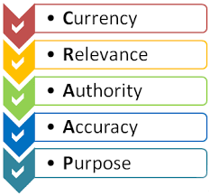
The CRAAP test is a test to check the objective reliability of information sources across academic disciplines. CRAAP is an acronym for Currency, Relevance, Authority, Accuracy, and Purpose. Due to a vast number of sources existing online, it can be difficult to tell whether these sources are trustworthy to use as tools for research. The CRAAP test aims to make it easier for educators and students to determine if their sources can be trusted. By employing the test while evaluating sources, a researcher can reduce the likelihood of using unreliable information.

The importance that note taking has to me and other scholars:

Note taking is a very helpful skill to and to others as it shows individuals how to gather information and prioritize important parts.It allows information gained from lectures to be made into a plan of study. This also helps decrease any stress as this skill can be applied out of class. A tool that helped me with the process of taking note during the lessons was the flash cards because I was able to listen and in the same time grab, writing on my cards, and all the important information of the lesson I was attending.

Recommendations

• Reorganise your notes outwardly (make blueprints, outlines or diagrams)

• Use distinctive pen tones or highlighters for various kinds of material

• Try composing brief outlines of the data in the most natural sounding way for you

• Review your notes consistently to work on comprehension.

Critical thinking

Critical thinking with students allows them to analyse Deduce conclusions, and form intricate arguments to defend their point. It also allows them to reflect on their work and approach problems in a systematic way. Away critical thinking could be used would be a teacher giving a student raw data such as a case study And allow them to create An analysis or an argument for the data. It also allows the student to look at the information from different standpoints so they can Explore different sides of the information given and Under explore “what if” situations.This can be shown in “research in higher education” terenzini (1995), Which explores Relative and unique facts of critical thinking with students. In this study researchers explored how; extracurricular, inner school and formal class experiences impact a student’s critical thinking. Theoreticians Have concluded that all of these experiences can influence a students critical thinking. This can further be supported by psychologist rimiene (2002) who assessed The importance of critical thinking on a students holistic education.

Frequent issues

For some people critical thinking can be seen as quite difficult as it requires a certain amount of knowledge to develop a sufficient argument. for example these could possibly be barriers for critical thinking.

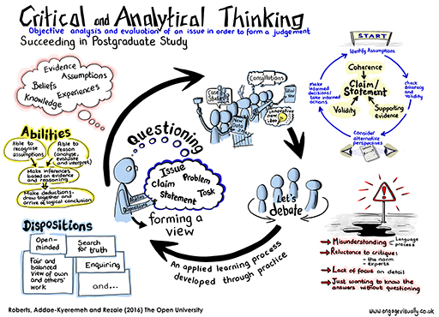
- Misconception. This can emerge because of language or social contrasts, an absence of consciousness of the 'measures' in question, or a misconception that basic reasoning method offering 'negative' remarks.
- Hesitance to study the 'standard' or specialists in a field and think about elective perspectives (feeling out of your 'usual range of familiarity' or unfortunate of being off-base).
- Absence of itemised information. Shallow information (not having perused profoundly enough around the subject).
- Needing to know the appropriate responses without posing inquiries.

Why is it significant for students?
Critical thinking is a center scholastic expertise that help students address or think about their own insight and data introduced to them. This ability is fundamental for understudies chipping away at tasks and performing research. It's additionally an important ability in numerous work environment situations.

Recommendations

• Become more mindful

Turning out to be more mindful means thinking about your point of view, values, ethics, morals and different convictions. What do you put stock in? How do your contemplations mirror these qualities? Contemplate your preferences. Knowing what your own inclinations, qualities/shortcomings and predispositions are can assist you with bettering why you approach explicit circumstances according to a specific viewpoint.

• Understand your psychological cycle

Distinguish and assess how you get and measure data. Seeing how you tune in, then, at that point decipher, lastly respond to data is crucial to turning out to be all the more intellectually effective in the working environment.

Conclusion
Throughout the process of investigating and announcing about using time management , note taking and critical thinking, three of the fundamental scholarly abilities, it very well may be inferred that every one of them are identified with each: having the option to take notes during an exercise will decrease the time spent on perusing and attempting to see alone what the significant data are required for a scholarly composition and scholastic composing becomes simpler if note taking is a created ability.Merriam-Webster (n.d.), defines skills as “the capability to practise the owned knowledges in practice”. As discussed before, academic skills allow students to understand the necessary steps needed to be successful in higher education. Some of them can be used for the rest of their lives and can often have a rewarding outcome.

References

Collinsdictionary.com. (2020). Time management definition and meaning | Collins English Dictionary. [online] Available at: https://www.collinsdictionary.com/dictionary/english/time-management

Claessens, B.J., Van Eerde, W., Rutte, C.G. and Roe, R.A., 2007. A review of the time management literature. Personnel review.

Macdonald, V., 2014. Note Taking Skills For Everyone: Learn the strategies of effective note taking in order to earn maximum grades today! (Vol. 1). Martin Knowles.

Einstein, G.O., Morris, J. and Smith, S., 1985. Note-taking, individual differences, and memory for lecture information. Journal of Educational psychology, 77(5), p.522.

Ali, D.B., Dehham, S.H. and Nayif Hasan, A.A., 2019. The Effect of Using Index Cards Games Technique on Iraqi EFL Intermediate Students’ Performance on Writing Skill. Indian Journal of Public Health Research & Development, 10(1).

Terenzini, P.T., Springer, L., Pascarella, E.T. and Nora, A., 1995. Influences affecting the development of students' critical thinking skills. Research in higher education, 36(1), pp.23-39.

Rimiene, V., 2002. Assessing and developing students' critical thinking. Psychology Learning & Teaching, 2(1), pp.17-22.

Merriam-webster (n.d.). Definition of SKILL. [online] Available at: https://www.merriam-webster.com/dictionary/skill [Accessed 18 Feb. 2020].

Bibliography

https://www.pinclipart.com/maxpin/JJRhwR/

https://www.google.co.uk/url?sa=i&source=web&cd=&ved=2ahUKEwj_4LPg9fPxAhVDQEEAHdiSAv8Qjhx6BAgBEAI&url=https%3A%2F%2Fcorporatefinanceinstitute.com%2Fresources%2Fcareers%2Fsoft-skills%2Ftime-management-list-tips%2F&psig=AOvVaw30xxAblPlg2d8SH4wDm5OV&ust=1626948539267483

https://blog.lulu.com/take-note-4-note-taking-skills-you-need/?amp
https://blog.lulu.com/take-note-4-note-taking-skills-you-need/?amp

https://library.raritanval.edu/craap/test

https://www.open.edu/openlearn/ocw/mod/oucontent/view.php?id=64740&section=1

Appendices

