Entrepreneurship – Assignment 2

15th JANUARY 2019
MODULE NAME: ENTREPRENEURSHIP
ENTREPRENEUR: ELON MUSK
NAME: JAMES DE KERCKHOVE
STUDENT NUMBER: 1707439

CONTENTS

TABLE OF CONTENTS:

TABLE OF CONTENTS……………………………………………………………………………………………….………….…2
LIST OF FIGURES…………………………………………………………………………………………………….……….….….2
- INTRODUCTION……………………………………………………………………………………………………....…3
- ENTREPRENEURHSIP………………………………………………………………………………………………..…3
- ELON MUSK………………………………………………………………………………………………………………..4
- MOTIVATION………………………………………………………………………………………………………………5
- ENTREPRENEURSHIP THEORIES………………………………………………………………………………….6
  - ECONOMIC…………………………………………………………………………………………………….…….6
  - PSYCHOLOGICAL……………………………………………………………………………………………..……7
  - SOCIO-CULTURAL……………………………………………………………………………………………..….9
- CONCLUSION……………………………………..………………………………..………………………………..…10
- BIBLIOGRAPHY……………………………………………………………………………………………………….…11

LIST OF FIGURES

- MODEL OF ENTREPRENEURIAL PROCESS (Shane, 2003)

INTRODUCTION

This report will analyse entrepreneurship and will discuss Elon Musk, how he conforms to the current entrepreneurship theories and his entrepreneurial motivation.

Entrepreneurship can be defined in many ways. The Global Entrepreneurship Monitor (GEM) defines entrepreneurship as “Any attempt at new business or new venture creation, such as self-employment, a new business organisation, or the expansion of an existing business, by an individual, a team of individuals, or an established business” (Reynolds, et al., 2005 :223). The Harvard business school uses a definition by Howard Stevenson (1983 :3) “the pursuit of opportunity without regard to resources currently controlled”.

This report will analyse Elon Musk’s activities and how he can be interpreted as an entrepreneur from current academic definitions and theories. These theories are from an economic, psychological and socio-cultural view.

Entrepreneurship needs the right environment to be successful. Currently, according to GEM (Kelley, 2016), America is an innovation driven economy. Therefore, ideal for innovative characters such as Elon Musk.

ENTREPRENEURSHIP

The definition by GEM implies that anyone who starts up their own company or expands on an existing company through being an individual or team, can be defined as an entrepreneur.

The Harvard business school uses a definition developed by professor Howard Stevenson, which essentially states that anyone who embarks on a project, without currently having the resources they need to start, should be defined as an entrepreneur.

These definitions, although not the same, provide an overall view of entrepreneurship. However, there is no one agreed definition (Venkataraman, 1997).

ELON MUSK

Elon musk is, by any definition, an entrepreneur. He started his own businesses with his own creations and achieved them despite the lack of resources initially. As discussed by
Mair (2016) Elon Musk started young by coding and creating a game to sell. In his twenties he started up companies such as PayPal, Space X and Tesla motors. Overtime Elon musk has had more involvement with other companies and inventions too. An example is The Boring Company, which sells merchandise such as a “not a flamethrower” flamethrower to raise money for the business. He attended university to study business and physics in order to help his career ideas.

Elon Musk’s motivation appears to extend from a drive to improve humanity, in terms of extending life to other planets and improving renewable sources of energy such as electric cars. He stated in an interview that money was not a motivational factor as he had a genuine interest in inventing as well as furthering humanity (Easto, 2017).

Elon Musk qualifies as an entrepreneur. From the GEM definition, he fits the criteria as he has started up his own business with success selling new, innovative products between companies he developed himself or as part of his team of employees. With regards to Stevenson’s definition, there is also a link to Elon Musk as he pursued opportunities beyond the resources he had control over. He used the money he had from a previous business he had sold to develop his SpaceX firm. He had no resources already, but he pursued the opportunity to enter the world of space travel. He hired expert staff and started building his own rockets as it was considerably cheaper (Seedhouse, 2013).

MOTIVATION

Figure 1. Model of Entrepreneurial Process
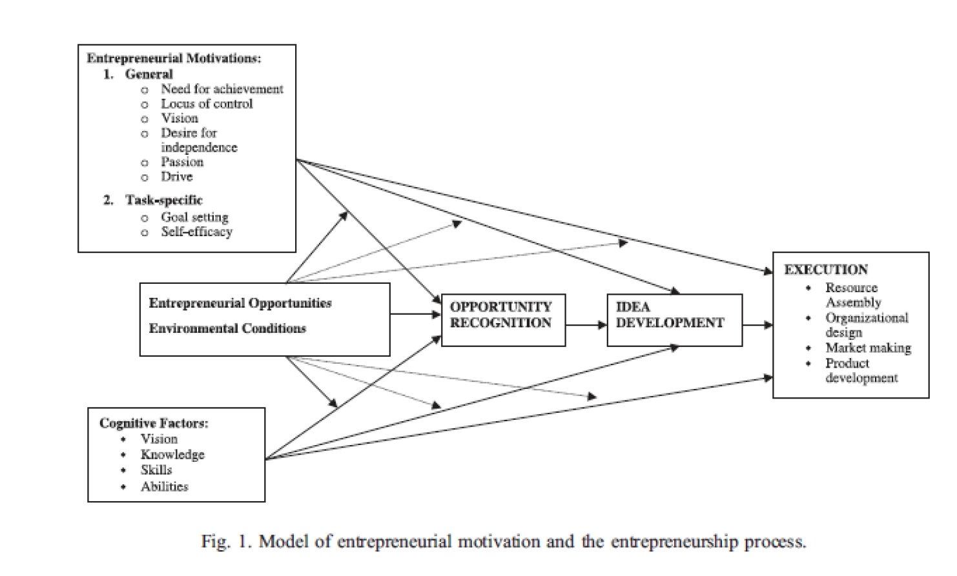
(Shane, 2003)

This diagram shows an entrepreneurial model starting with motivation for the entrepreneur, which can be developed by different characteristics such as vision or passion. Also, a need for certain skills and knowledge in order to succeed. The first step is having the right conditions and opportunities for an entrepreneurial project. The entrepreneur then has to recognise the opportunity in order to start their ambition. This follows onto idea development and finally execution of the project.

ENTREPRENEURSHIP THEORIES

Entrepreneurial theories can be Psychological, Economic and Socio-cultural:

ECONOMIC

Economic views of entrepreneurship differ. Mark Casson (1982) a professor in economics, states that there is no one economic theory of entrepreneurship that encases all the differing viewpoints, as the neoclassical economic theories contradict entrepreneurship.

Cantillon (2010) explains that an entrepreneur’s business involves risks through uncertain decisions. This would involve people investing in a business with an uncertainty to the profit that will be made. For example, when growing crops the yield is uncertain. Elon Musk created Tesla, a business making electronic cars. This involved Cantillon’s theory as he created the cars and then relied on a variable market to sell these vehicles. It was undetermined how successful this project would be, given the varying nature of car drivers views on electric vs petrol/diesel. Another example would be his use of online banking at a time when the internet was in its infancy.

Frank Knight (2012) states that the risk taking nature and uncertainty bearing characteristics of a person, allow for a more entrepreneurial character. Elon Musk’s personality is not averse to risk or uncertainty. For example, his recent work with the company he created called ‘ The Boring Company’ attempts to relieve traffic in Los Angeles through creating underground tunnels for cars to use. He has stated that this undertaking may well fail but he is attempting it anyway. He also failed with his rocket launch for SpaceX three times before succeeding (Liao, 2016). This logic derives from the principle of uncertainty and risk taking as his company could be embarking on a futile project, however he, as an entrepreneur does not fixate on the negative but will try if he believes there is a chance of success.

Schumpeter (2000) states that entrepreneurs are innovators; an innovator can introduce new ideas on previous inventions. Elon Musk relates to this theory as an innovator in many of his businesses, such as PayPal, SpaceX, Tesla and SolarCity. He clearly appears to be more innovative than inventive as his ideas are based on other inventions.

Barney’s (1991) theory of resourced based management explains ways of achieving sustained competitive advantage. This is established through having resources which are valuable, rare, and cannot be copied or substituted. Entrepreneurs are able to spot these unique resources. Elon Musk capitalised on this advantage when he set up SpaceX, by employing experienced and skilful staff who gave his business competitive advantage.

PSYCHOLOGICAL

Psychological theories of entrepreneurship analyse an entrepreneur’s psychological attitude. For example, someone’s ability to recognise opportunities or tolerance for ambiguity. (Baum, et al., 2014)

There are many traits that entrepreneurs display. Elon musk, for example, shows ambiguity tolerance (Schere, 1982) , opportunity recognition (Baron, 2006) and locus of control (Brockhaus, 1982).

The theory of ambiguity tolerance was created by Brunswik (Furnham & Marks, 2013). This theory considers the better the ambiguity tolerance there is, the more suited the individual is to entrepreneurship. Elon Musk exhibits this trait as he has a good tolerance for the unknown. For example, The Boring Company’s creation of an underground traffic system is completely unpredictable. Also, his creation of SpaceX sending rockets into space had no guarantees and Elon musk originally lost a lot of money. Despite these variables he proceeded anyway showing a tolerance for ambiguity.

Opportunity recognition, as discussed by Baron (2006), shows it to be a key resource in entrepreneurial activity. Similarly, Kirzner (2015) believes there needs to be an alertness to opportunities by entrepreneurs for them to see the gap in the market. Elon Musk exhibits this trait with his unique projects, such as electric cars, online banking/payment system, underground roads and having the first privatised space travel company.

Locus of control was first introduced by Julian Rotter (Phares ,1976). This theory explains how people either have an internal or external locus of control. Having an extreme internal locus of control means to believe completely in yourself and how your actions determine the outcome, rather than being influenced by external factors. Elon Musk demonstrates this behaviour as his main vision from his work is not to make money but to create sustainability. Whether this is life on another planet from his space company or the transition to electric cars to provide a more sustainable energy option. These visions do not appear to be inhibited by a belief of external control.

Passion theory examines the possible link between entrepreneurship success and passion for the field. There are many studies to show the correlation between being passionate about your work and success (Kuratko, 2016). Elon Musk shows passion in his ventures whether it is built on practicality or desire. His space company seeks to make the human race a multi-planetary species (Musk, 2017) which is a dream he is passionate about. However, The Boring Company seeks to relieve traffic (Pierce, A., 2017.) which is more of a practical passion as he travels in this. Elon Musk’s passion about tesla is a combination of both these passions. It would be desirable for the world to be using sustainable electric cars instead of gasoline, however, it is also practical as electric cars are cheaper to run (Bilbeisi & Kesse, 2017). This level of passion for work can motivate entrepreneurs.

Vroom’s Expectancy theory (1964, Cited by Van Eerde & Thierry, 1996) examines valence, instrumentality and expectancy in relation to work motivation. Valence is the value the person will receive from their effort. Instrumentality is hope that if they perform well they get the reward. Lastly, expectancy is the assumption that effort will bring the outcome they wanted. This analyses the potential for an entrepreneur to create a business (Renko, et al., 2012). Elon Musk does exhibit characteristics of the expectancy theory as there is a link in how he expects his projects to succeed and his level of success. For example, the rockets used in SpaceX failed three times before a successful launch (Liao, 2016), therefore he obviously had a belief that this project could work.

McClelland’s theory of achievement motivation (1961, Cited by Elizur, 1979) explains that motivation is accomplished through achievement and discusses the link between achievement theory and entrepreneurship (McClelland, 1965). Elon Musk has run five successful companies showing a need for achievement. For example, The Boring Company has a goal of relieving traffic; Tesla has a goal of moving the market to sustainable energy use cars; SpaceX’s aim is to make space transportation cheaper and to make mars inhabitable.

SOCIO-CULTURAL

Max weber’s theory explained that the entrepreneurial activity of a society was reliant on the cultural values of the population. This theory implies that differing cultural values, such as religion in society, affect entrepreneurship activity (Weber, 2013). Weber’s view was that the religion of a population determined the economy. Weber’s theory took the view that the protestants’ beliefs of working hard but not indulging on spending was the moral way to be, therefore encouraging an entrepreneurial mindset within the religion (Begley & Tan, 2001).

The theory of nature versus nurture was originally used by Galton according to Østergaard et al., (2018). This theory describes the way in which a person can develop through their nature, which would be genetics, or nurture, such as a person’s upbringing. Barnea et al., (2010) discusses the choice to be self-employed in relation to the theory of nature versus nurture. With relation to entrepreneurship this theory asks whether an entrepreneur is born or raised. Elon Musk’s parents were not entrepreneurs as his mother, Maye, was a model/dietician and his father, Errol, was an engineer. Therefore, his genetics would not suggest he was born an entrepreneur. However, Elon and his siblings all became entrepreneurs, his sister founding a film site and his brother founding a healthy eating business (CNBC, 2018). This suggests that nurture is the key behind their entrepreneurial characteristics.

CONCLUSION

Elon Musk is a icon within the entrepreneurship world, with his escape from failure and his continued success (Roach, 2017). Elon Musk has an undeniable entrepreneurial spirit. Within all of the aforementioned theories each can be applied to him. Additionally, he conforms to both definitions of entrepreneurship. Each of these theories can be related to Elon Musk’s projects, although there is no one theory that is able to summarise all elements of entrepreneurship. Elon Musk constantly displays entrepreneurial characteristics and must be considered one of the most accomplished and innovative entrepreneurs in his field.

BIBLIOGRAPHY

Barnea, A., Cronqvist, H. and Siegel, S., 2010. Nature or nurture: What determines investor behavior?. Journal of Financial Economics, 98(3), pp.583-604.

Barney, J., 1991. Firm resources and sustained competitive advantage. Journal of management, 17(1), pp.99-120.

Baron, R.A., 2006. Opportunity recognition as pattern recognition: How entrepreneurs “connect the dots” to identify new business opportunities. Academy of management perspectives, 20(1), pp.104-119.

Baum, J.R., Frese, M. and Baron, R.A. eds., 2014. The psychology of entrepreneurship. Psychology Press.

Begley, T.M. and Tan, W.L., 2001. The socio-cultural environment for entrepreneurship: A comparison between East Asian and Anglo-Saxon countries. Journal of international business studies, 32(3), pp.537-553.

Bilbeisi, K.M. and Kesse, M., 2017. Tesla: A Successful Entrepreneurship Strategy. B> Quest.

Brockhaus, R.H., 1982. The psychology of the entrepreneur.

Cantillon, R., 2010. Essay on Economic Theory, An. Ludwig von Mises Institute.

Casson, M., 1982. The entrepreneur: An economic theory. Rowman & Littlefield.

CNBC, 2018. Elon Musk comes from a family of entrepreneurs – here’s who they are. [online] Available at: < https://www.cnbc.com/2018/08/12/elon-musk-family-tree-tosca-kimbal-maye-entrepreneurs-spacex-tesla.html> [Accessed 14th January 2019].

Easto, J. ed., 2017. Rocket man: Elon Musk in his own words. Agate Publishing.

Elizur, D., 1979. Assessing achievement motive of American and Israeli managers: Design and application of a three-facet measure. Applied Psychological Measurement, 3(2), pp.201-212.

Furnham, A. and Marks, J., 2013. Tolerance of ambiguity: A review of the recent literature. Psychology, 4(09), p.717.
Kelley, J., Ali, A., Brush, C., Corbett, A., Kim, P., Majbouri, M., 2016. 2016 United States Report. Global Entrepreneurship Monitor. [pdf] United States: Babson College. Available at:< https://www.gemconsortium.org/country-profile/122> [Accessed 8th January].
Kirzner, I.M., 2015. Competition and entrepreneurship. University of Chicago press.

Knight, F.H., 2012. Risk, uncertainty and profit. Courier Corporation.

Kuratko, D.F., 2016. Entrepreneurship: Theory, process, and practice. Cengage Learning.

Liao, J.J., 2016. SPACE EXPLORATION TECHNOLOGIES & ELON MUSK: founding, failures and successes, funding, and future.

Mair, M., 2016. Enlightened entrepreneurship: the success of Elon Musk.

McClelland, D.C., 1965. N achievement and entrepreneurship: A longitudinal study. Journal of personality and Social Psychology, 1(4), p.389.

Musk, E., 2017. Making humans a multi-planetary species. New Space, 5(2), pp.46-61.

Østergaard, A., Santos, S.C. and Costa, S.F., 2018. Psychological perspective on entrepreneurship. In The Palgrave Handbook of Multidisciplinary Perspectives on Entrepreneurship (pp. 17-41). Palgrave Macmillan, Cham.

Phares, E.J., 1976. Locus of control in personality (Vol. 174). Morristown, NJ: General Learning Press.

Pierce, A., 2017. Elon Musk’s Boring Company. Tech Directions, 77(1), p.8.

Renko, M., Kroeck, K.G. and Bullough, A., 2012. Expectancy theory and nascent entrepreneurship. Small Business Economics, 39(3), pp.667-684.

Reynolds, P., Bosma, N., Autio, E., Hunt, S., De Bono, N., Servais, I., Lopez-Garcia, P. and Chin, N., 2005. Global entrepreneurship monitor: Data collection design and implementation 1998–2003. Small business economics, 24(3), pp.205-231.

Roach, C.R., 2017. Simply Electrifying: The Technology that Transformed the World, from Benjamin Franklin to Elon Musk. Benbella Books.

Schere, J.L., 1982, August. Tolerance of Ambiguity as a Discriminating Variable Between Entrepreneurs and Managers. In Academy of management proceedings (Vol. 1982, No. 1, pp. 404-408). Briarcliff Manor, NY 10510: Academy of Management.

Schumpeter, J.A., 2000. Entrepreneurship as innovation.

Seedhouse, E., 2013. SpaceX: making commercial spaceflight a reality. Springer Science & Business Media.

Shane, S.A., 2003. A general theory of entrepreneurship: The individual-opportunity nexus. Edward Elgar Publishing.

Stevenson, H.H., 1983. A perspective on entrepreneurship(Vol. 13). Cambridge, MA: Harvard Business School.

Van Eerde, W. and Thierry, H., 1996. Vroom's expectancy models and work-related criteria: A meta-analysis. Journal of applied psychology, 81(5), p.575.

Venkataraman, S., 1997. The distinctive domain of entrepreneurship research. Advances in entrepreneurship, firm emergence and growth, 3(1), pp.119-138.

Weber, M., 2013. The Protestant ethic and the spirit of capitalism. Routledge.

