Qualification: CIPD Diploma in Applied Human Resources

Module Name: Developing Professional Practice in Human Resources

Title: Activities 2 and 4

Word Count: 2245
Student Name: Maria Mellen Jimenez
Student Number: 2005457
CIPD Membership Number: 57501591

By signing below, I confirm that the work/evidence presented is my own, unaided work. I understand the regulations pertaining to candidate malpractice and the action that may be taken as a result.

Signed: Maria Mellen Jimenez
Date: 03/01/2021

ACTIVITY 2: THE CIPD HRP MAP

  - Introduction

The aim of this report is to describe the CIPD HR Profession Map, explaining the different bands, areas and behaviours which HR professionals will need in the future, focusing on the reasons why each behavior is considered crucial in Human Resources Practice. But, in order to do that, we need to define what HR Professionalism means.

  - HR Professionalism

According to Lester (2010), a professional is someone who has an expert or specialist skills or education, implements their own beliefs and conclusions and devotes to a series of values. This person does not have to be a part of a professional association.

The main aspects that differentiate the profession from occupation are:

- It is based on a form of knowledge that can be studied.
- The professionals apply their expertise, judgement and knowledge.
- It is supported by ethic principles.

In the United Kingdom and Ireland, we have a governing body for the HR profession, the CIPD, with its own code of ethics, but it is not compulsory for the HR professionals to become members in order to practice.

There is another approach to the definition of being professional, which is performing a job to a high standard. This takes us to the Four concentric circles of HR professionalism:

- Self-managing
- Managing in teams
- Upwards management
- Managing across the organisation

  - The CIPD’s HR profession map

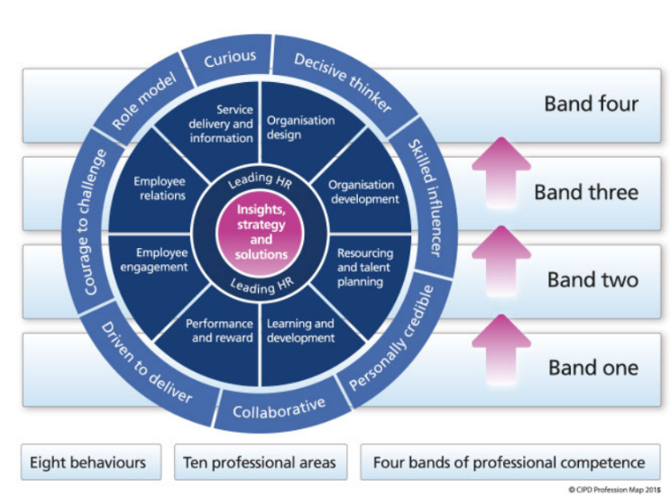

The CIPD’s HR profession map I will be referring to in this report is the one from 2013, although the CIPD has developed a new one since then, which we can find on the CIPD website, https://peopleprofession.cipd.org/profession-map.

This map outlines the skills needed to become a HR professional. They are divided in Professional areas, Bands of professional competence and Behaviours.

    - Professional Areas and Bands of Professional Competence

The CIPD Profession Map (2013) includes ten different areas, two core and eight functional, with the activities that the professional needs to do and the knowledge required for each band of professional competence.

The core areas are aimed at all the HR practitioners, regardless of their experience or field. The first core area we find is insights, strategy and solutions, and the second core area is Leading HR.

Along with these core areas, there are eight functional professional areas, whose importance depends on the role HR practitioners have in the business. These are:

- Organisation design
- Organisation development
- Resourcing and talent planning
- Learning and talent development
- Performance and reward
- Service delivery and information
- Employee engagement
- Employee relations

From this list we can understand the HR profession’s variety. As one point of view, the professional’s task may be resourcing and talent planning, or it could be advising on any employee issues, but they all should be focused on both change and business.

Together with the professional areas, we find four levels of competence on the CIPD Map (2013), which correspond to the different levels of development from lower skilled to expert. These bands are classed from one to four, being one the professionals who concentrate on the current needs of the customer, and four, the ones who lead and develop the strategy.

    - Behaviours

The CIPD Map (2013) identifies eight behaviours which are fundamental to all HR professionals. Depending on the band the professional is at, the CIPD describes the activities they have to carry out to contribute to the success in the organisation. We can also find the indicators that show negative signs of each behaviour.

- Decisive thinker: The professional should be able to analyse and understand information and data in a quick way to distinguish the different options and make a strong and effective decision. An example could be when an issue occurs in an organisation and we have to proceed with an investigation, the professional chairing it should gather witness statements or proceeding with an investigation meeting. After that, the professional will decide the outcome, and this decision usually has to be made within hours of the meeting taking place.

- Skilled influencer: This person is capable of gaining the support and dedication from the stakeholders to seek the organisation’s principles. At the same time, they have to tailor their way of communicating to the different members of the company. An example could be when a line manager shares any procedures or new information to the staff with a different choice of words to make sure the staff understands properly. But when the manager attends a meeting with their superiors, the language used will be more professional.

- Curious: This is one of the key behaviours as businesses always are looking of new ways of improving, so HR professionals have to be open-minded and keen on looking for new alternatives for the future.

- Personally credible: It consists on building and delivering professionalism through the commercial and HR’s own experience to bring a significant meaning to the business. One example is when managers or HR specialists give feedback or advice on their staff performance or actions.

- Collaborative: In this case, a recent example of being collaborative has been developed with the Covid pandemic, as HR professionals have been working with people outside their organisations, such Health and Safety representatives from different councils, to create new policies to be implemented in the workplace, but also working with the managers in the workplace to ensure the measures are being followed and to provide support.

- Driven to deliver: This behaviour could be related to the one above, as HR specialists focused on delivering a series of new initiatives in the workplace.

- Courage to challenge: HR professionals have been confronted with unfamiliar circumstances due to Covid-19, such staff working from home, or having to adapt tasks for vulnerable staff.

- Role model: This would be one of the most important behaviours as the HR professional has to react impartially to any issues within the organisation, taking into consideration individual, business and legal factors.

  - Conclusion

The main aim of this report was to explain the meaning of professionalism and to look in depth at the CIPD Profession Map from 2013. The main aspect about HR professionals is that they must have a set of skills that they have to develop along with their knowledge and expertise, and they are supported by a code of ethics from the CIPD, which acts as a governing body.

After analysing the CIPD Profession Map (2013) we can establish that the Core Professional Areas and the Behaviours are essential to become a HR professional, whereas the Functional Professional Areas will depend on the professional’s speciality.

ACTIVITY 4: TEAM DYNAMICS AND POLITICAL BEHAVIOUR

4.1. Introduction

In this activity I will be explaining the importance of working in teams, their dynamics and the different theories by Belbin and Tuckman. It is also important to mention how political behaviour may impact on the organisations and what the best approach is.

4.2. HR Professionals and Teamwork

The HR Professionals must develop skills related to the Collaborative behaviour from the CIPD Map (2013), which means to be able to work with fellow HR colleagues but also with groups and individuals from different backgrounds. They should also have the knowledge to resolve conflicts within the organisation.

It is important that the teamworking is effective as it will bring profits in the productivity of the organisation and individual motivation. As groups are formed by individuals with different needs, this might cause conflicts. It is when the HR professional must collect information from each participant and highlight the problem, before they suggest possible solutions. They will have to discuss a successful solution which might require a commitment from both sides.

4.3. Group / Team Dynamics

According to Watson (2016), a group is formed by individuals who work towards a common goal, with different factors like age, gender, culture, background, knowledge, skills and agendas. They are also influenced by diverse dynamics, such as power, leadership, structure and communication.

As Kurt Lewin defined in the early 1940s, the group dynamics describes the consequences that the positions and actions adopted by its members have on the other individuals belonging to the same group and on the group as an entity.
There are two theories to be familiar with: “Theory of team development”, by Tuckman, and the “Theory of team roles”, by Belbin.

4.4. Belbin’s theory of the 9 Team Roles

Belvin and his team (1981, 2007) discovered that the high performing teams must have the 9 Team Role behaviours, all of them equally important but with different strengths and weaknesses. Each team member can acquire more than one team role. The different team roles behaviours are:

- The Coordinator
- The Resource Investigator
- The Teamworker
- The Plant
- The Monitor Evaluator
- The Specialist
- The Implementer
- The Shaper
- The Completer Finisher

The first step in a group formation is to complete a Belbin questionnaire (Self-Perception Inventory) and request feedback from managers and colleagues. See EV19 for my own Belbin questionnaire.

4.5. Tuckman’s theory of Team Development

Current and future managers must gain the skills to enable building groups and teams to reach their potential. Tuckman (1965) described the path that the teams must follow to become high performing. I recently took part in a project in my workplace where we went through these stages:

- Forming: The team was formed by two managers and two sales assistants. We were called back to work in May 2020 to participate in a project to process online orders while the store was closed to the public. Our Head Office established the goal (complete pending online orders) and we analysed our strengths and weaknesses.

- Storming: After that, I was appointed as the leader as I was the most experienced manager, while having the support of the other manager on my days off. We listed the tasks that were to be completed daily, shared them with the other members of the team, and communicated daily with our regional team if any problem arose.

- Norming: As we all had common but also individual skills, we split the tasks according to them, explaining the importance of each one of us as essential part of the team to achieve results.

- Performing: Two days into the project we were fully functional, committed to the goal of increasing units of orders completed daily, where we all shared the responsibility.

- Mourning/adjourning: Just over one month later, we achieved the original goal. We will then start getting the store ready for reopening again, where we went back to the first stage of the group development, having more members of staff joining us.

4.6. Political behaviour and its impact

Horn (2009) defines political behaviour as “Taking a particular view or position with the intention of personally gaining from that position”.

A political approach is valid provided that the ends can be justified from the organisation’s point of view. Politics could be as useful way of getting things done, but it could have a negative impact on staff morale, employee commitment and working environment. The best option regarding political behaviour in an organisation is to run the operations as clear as possible. There should be an open communication to solve any issues with honesty from all parts involved.

Michael Jarret explains on his article The 4 Types of Organizational Politics (Harvard Business Review, 2017) that organisational politics stands for the diversity of activities performed by individuals where they make use of influence methods in order to improve organisational and personal interests. Those with political abilities are more likely to acquire more personal power, achieve job demands and manage stress, and their impact on the organisational results is superior. But executives tend to stay away from those activities as they might find hard to understand that they can be for the benefit of the company.

To deal with these challenges, it is key to know the political terrain and its four metaphorical areas, based on where the political activity takes place and its source of power.

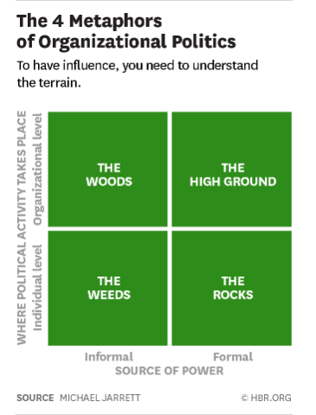

- The Weeds: Personal influence and informal networks. The key is to understand the networks by identifying the key brokers and the gaps, that can be filled by the executives, or join with the brokers to increase the influence. If the brokers actions are harmful, the executive may try to isolate them.

- The Rocks: Individual interactions and formal source of power. Instead of resisting the formal sources of power we should make use of them by attracting their interests.

- The High Ground: Organisational level and formal power. The rules and guidelines to that ensure that the company meets the legal requirements, but this can result to the company becoming inflexible. In that case, an external group may be brought in to analyse the issue which provide a different source of power and might even stimulate change and innovation.

- The Woods: Informal source of power and organisational level. As well as their guidelines and rules, companies also have implied standards or routines, that can provide security for the staff, bit may also be a confusing place where necessary changes get missed. The key here is to get the information from surveys or experts and get the team to analyse if they are benefiting or obstructing it.

4.7. Conclusion

In terms of team working, every individual has an equal value, as they are all essential to the accomplishment of the goal, but they all have different roles according to their skills.

Regarding political behaviour in organisations, the best approach is to have an open communication and to run the operations as transparent as possible.

