Module Name: Digital Skills for Personal and Professional Growth (BMSW4008)
Sophia Sammut
2440444
2025-2026 Level 4

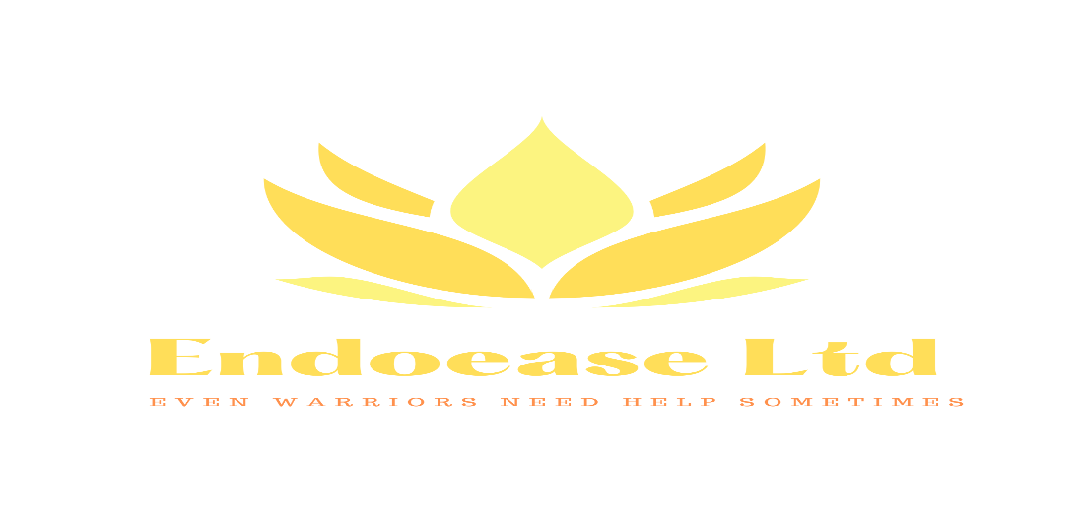
Image of business card created with Canva

Introduction
Endoease Ltd – Who are we? what we are all about?

EndoEase Ltd is a small business concept designed to support individuals experiencing chronic menstrual health conditions, particularly endometriosis. Endometriosis affects approximately one in ten women in the UK and can cause severe pelvic pain, fatigue and other debilitating symptoms (Endometriosis UK, 2024). Although it is common, many individuals experience sudden flare-ups in public spaces where immediate support products are not easily accessible. (NHS (2023) Endometriosis overview)

The EndoVend machine is an innovative vending solution created to provide emergency relief products such as heat patches, pain relief, sanitary products and mini TENS machines. These machines would be strategically placed in universities, transport hubs and shopping centres to ensure accessibility. The aim of EndoEase Ltd is not only to provide practical support but also to raise awareness of chronic menstrual health conditions while improving comfort and availability for those affected.

Endometriosis affects approximately one in ten women in the UK today (Endometriosis UK, 2024)

Market Research Methodology

To understand the potential demand for the EndoVend machines, primary research was carried out using an online questionnaire created through Microsoft Forms. The survey consisted of ten questions intended to collect knowledge of awareness of endometriosis, experiences of menstrual pain in public spaces and attitudes toward affordable support products.

We shared the questionnaire with twenty women aged 16 to 50. This age group was chosen because they are most likely to experience menstrual health conditions and are the main target audience for the service.

We analysed the responses to find patterns in awareness, product demand, and preferred locations for the vending machines. These results helped shape the website design, marketing materials, and the overall business idea. (Kotler, P. and Keller, K. (2016)

Below are the questions we asked 20 members of the public and an example of four members answers:

Question | Name | Name | Name | Name
 | Leah Qassim | Lucy Kassi | Jade Ward | Cait Cole
What age group are you in? | 35 | 37 | 41 | 24
Have you heard of endometriosis before? | Yes | Yes | Yes | Yes
Do you know someone who suffers from endometriosis? | My sister | Myself | Myself | My aunt
Have you ever experienced severe menstrual or pelvic pain in public? | Yes | Yes | Yes | Yes
How comfortable are you managing this pain in public spaces? | 50/50 | Not at all | Not at all | Ok with it
Would you use a vending machine providing emergency relief products for menstrual pain? | Yes | Yes | Yes | Yes
Which products would you most likely purchase? (heat patches, pain relief, sanitary products, TENS machine, single pack underwear, emergency kit) | Emergency kit, pads & pain relief | All of them | All of them | Pads, pain relief and heat patches
Where would you like to see an Endovend machine installed? | Everywhere | Everywhere | Everywhere | Everywhere
How important do you think access to menstrual and endometriosis support products is in public spaces? | Very important | Highly | Highly | Very important
Would a service like Endovend improve comfort and accessibility for you when out in public? | Yes | Yes | Yes | Yes

Key findings from research

The results showed that most participants were aware of menstrual health conditions and knew about endometriosis. Many also said they had experienced severe menstrual pain in public, which shows there is a real need for affordable support.

The main finding was that many participants were interested in using a vending machine for emergency relief products. They also said that universities, transport hubs, and shopping centres would be the best places for these machines.

Audience Segmentation
EndoEase Ltd’s main audience is people with chronic menstrual health conditions like endometriosis, adenomyosis, and severe dysmenorrhea. These conditions can seriously affect daily life, especially when symptoms happen suddenly in public.

The secondary audience includes individuals who experience general menstrual discomfort and may require access to emergency products such as sanitary items or pain relief. By targeting a wider audience while keeping a focus on endometriosis awareness, EndoEase Ltd aims to develop a supportive and inclusive service.

Demographically, the key users are individuals aged 16 to 50 who are active in educational institutions, workplaces, and public transport systems.

Website Design & SEO Strategy
Digital platforms allow small businesses to connect directly with consumers and improve accessibility (Chaffey and Ellis-Chadwick, 2019)
The EndoEase Ltd website endoeaseltd.co.uk uses a clean, easy-to-use layout so users can browse without trouble. The soft yellow colour matches the official awareness colour for endometriosis and helps create a warm, caring look. The EndoEase logo and pictures of the EndoVend machine help build brand recognition.

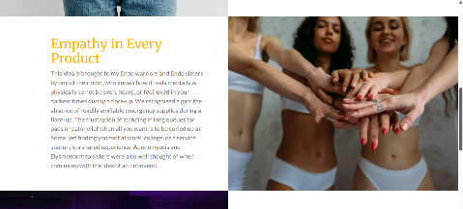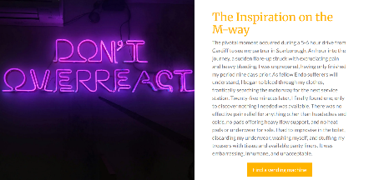
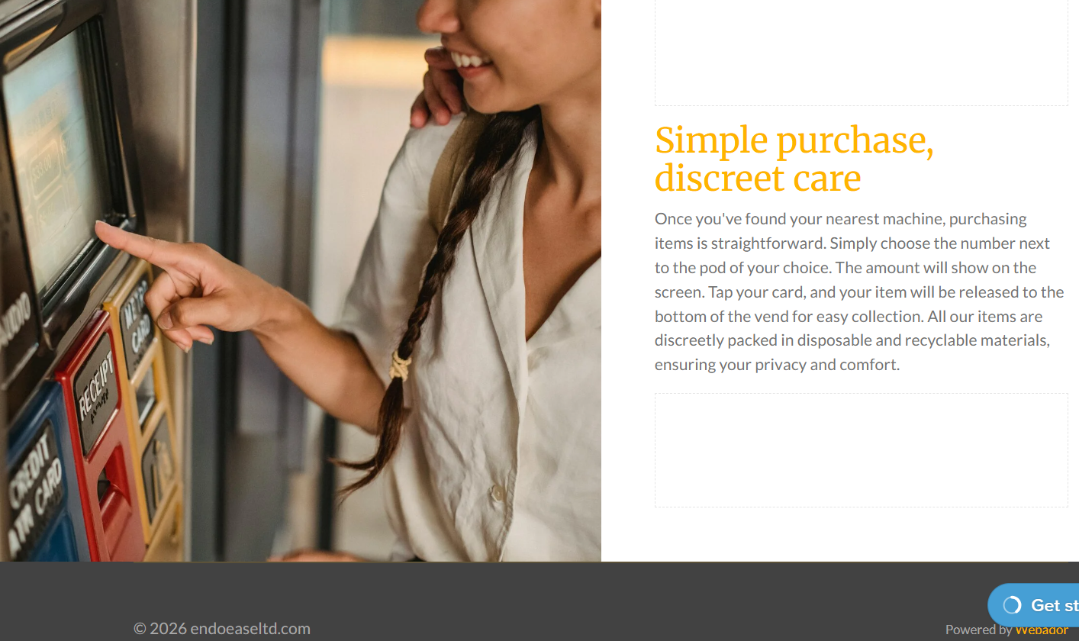
The homepage displays the statement “From personal pain to purpose,” which supports the company’s mission to help people living with chronic menstrual health conditions.

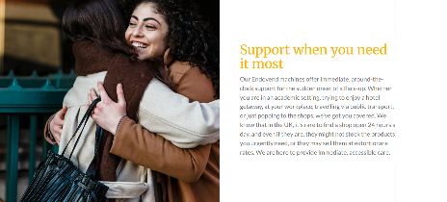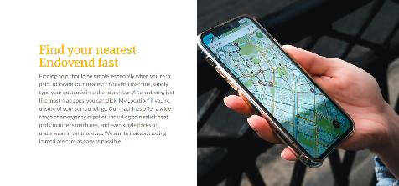

Key features of the website include a location tool that lets users find their nearest EndoVend machine, as well as a direct link to a free mental health helpline and a 24-hour webchat with trained support workers. This reflects the understanding that menstrual health conditions may also affect emotional well-being. (Statista (2024)

We also considered search engine optimisation (SEO) by using keywords like “endometriosis support,” “menstrual pain relief,” and “emergency menstrual products.” (Johnson, L. (2021)

This is proven as individuals living with chronic conditions often experience psychological stress alongside their physical symptoms (World Health Organisation, 2022).

Below are some of our Instagram and Facebook flyers to attract not only Endometriosis sufferers themselves, but their families and friends who may see it and word of mouth guides them to our page. (Ryan, D. (2016)
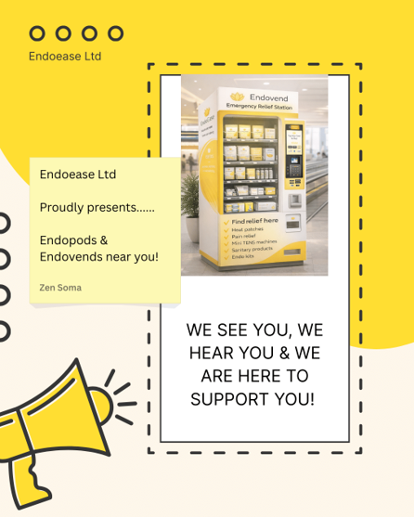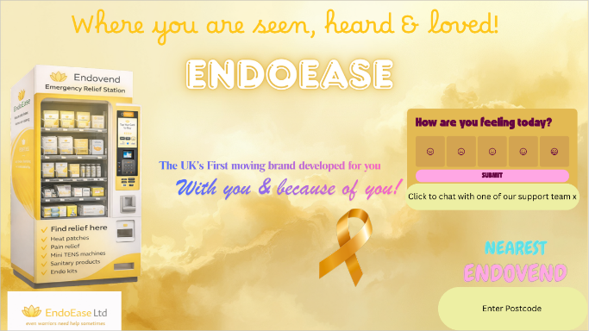 Images created with Canva.
This Photo by Unknown Author is licensed under CC BY-ND

Improvements in underlying information technologies and continuing entrepreneurial innovation in business and marketing promise as much change in the next decade as was seen in the previous two decades. (Laudon, K. and Traver, C. (2021)

As of 12/03/2026, endoeaseltd.co.uk is now a registered domain, and we hope to fulfil our dream of producing Endovends across the UK in the near future.
(Smith, J. and Anderson, M. (2020)

Our mission is not just to make Endometriosis sufferers feel seen and heard, but all women across the UK.

Reference list:

Endometriosis UK (2024) What is Endometriosis? Available at: https://www.endometriosis-uk.org (Accessed: 12 March 2026).

World Health Organization (2022) Mental health and chronic illness. Available at: https://www.who.int (Accessed: 12 March 2026).

Kotler, P. and Keller, K. (2016) Marketing Management. 15th edn. Harlow: Pearson Education.

Chaffey, D. and Ellis-Chadwick, F. (2019) Digital Marketing. 7th edn. Harlow: Pearson.

Laudon, K. and Traver, C. (2021) E-commerce: Business, Technology and Society. 16th edn. Harlow: Pearson.

Ryan, D. (2016) Understanding Digital Marketing. 4th edn. London: Kogan Page.

Statista (2024) Digital consumer behaviour statistics. Available at: https://www.statista.com

NHS (2023) Endometriosis overview. Available at: https://www.nhs.uk

Smith, J. and Anderson, M. (2020) Online consumer behaviour and digital engagement. Journal of Digital Marketing, 12(3), pp. 45-58.

Johnson, L. (2021) The role of digital platforms in small business development. Journal of Business Innovation, 8(2), pp. 77-89.

AI Statement

I confirm that I have not presented any AI-generated materials as my own work.
I confirm that I have copies of my drafts, notes, and other resources I used, which I may be asked to provide in evidence.

