Job advert

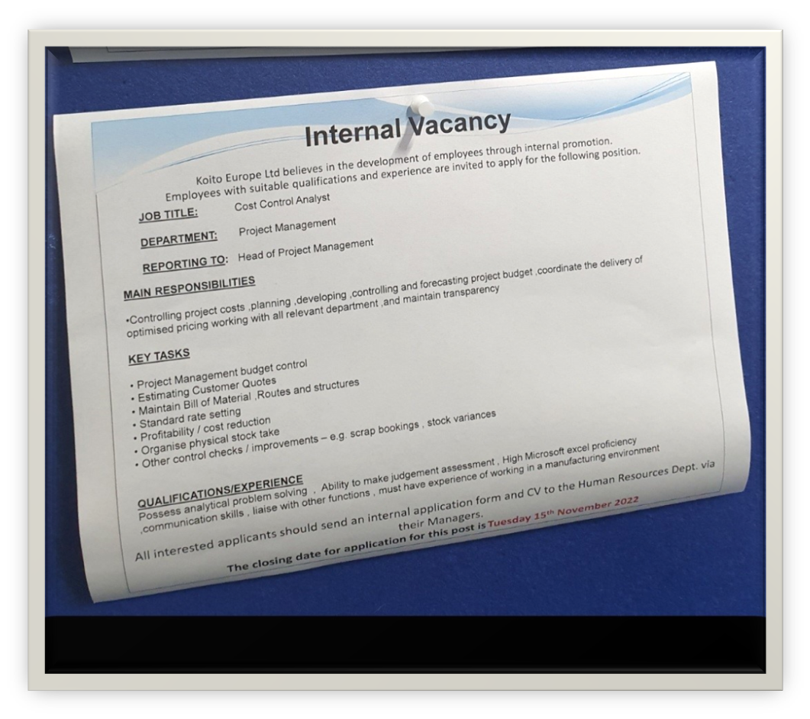
PERSONAL INFORMATION | Valentina Vasilica Dinca
 | Worcester WR1 1RB
 | 07459408007
 | Zlate.valentina@yahoo.com

JOB APPLIED FOR  POSITION  PREFERRED JOB  STUDIES APPLIED FOR | Cost control analyst

WORK EXPERIENCE

20.08.2018 – Present Operator
Hampton Lovett Ind Est, Droitwich Spa WR9 0QH
- Assembling automotive components
- Working at a fast pace to set standards
- Completing quality checks on products
- Follow detailed instructions, focus on detailed

9.04.2018 – 16.08.2018 Barista
Costa Cofee, 31 High Street, Worcester WR1 2QL
- Preparing and serving hot and cold drinks
- Cleaning work areas and tables
- Taking orders and serving clients
- Receiving customer payments

06.02.2018 – 13.08.2018 Picker/Packer
Vandemoortele Worcester, Martley Rd, Lower Broadheath, Worcester WR2 6RF
- Packing frozen cakes
- Working in a team
- Cleaning the working area
- Working under pressure

12.11.2015 – 15.11.2015 Internship at Romania’s Tourism Fair
25.02.2016 – 28.02.2016 Bucharest, Marasesti 65-67, 011465
- Providing information for all fair participants
- Making badges and offering catalogs
- Applying surveys for all exhibitors

4.01.2016 – 20.12.2017 Sales consultant
Brico Depot, Calarasi, 910023 Romania
- Providing consultancy to clients (advice, help in the purchases they make)
- Promoting products and services in the store
- Supplying the shelves with products
- Arranging the district according to the store’s important events (catalog, promotions)

EDUCATION AND TRAINING

May 2022 – Present  2010 – 2014 | Certificate of Higher Education Skills for the Workplace
May 2022 – Present  2010 – 2014 | Quay Place Campus, Birmingham B1 2RA
May 2022 – Present  2010 – 2014 | - Effective Team Working and Communication  - Problem-solving and Decision Making  Technician in economic activities  Economic College Calarasi, 910010  Accounting, business negotiation, business financing, economic contracts, quality management
PERSONAL SKILLS

Mother tongue(s) | Romanian
Other language(s) | UNDERSTANDING |  | SPEAKING |  | WRITING
Other language(s) | Listening | Reading | Spoken interaction | Spoken production
English | B1 | B1 | B1 | B1 | B1
Spanish | A2 | B1 | A2 | A2 | A2

Communication skills | - Good communication skills acquired during my work, and study experience and by participating in a internship at Romania’s Tourism Fair.  - Participate in project “Oratorica”, public speaking project, speaking in a front of an audience.

Organizational/managerial skills | - Solving tasks on time  - Working in a team at work and university  - Working in a stressful condition  - Multi-tasking, able to do more tasks at the same time  - Problem-solving and decision making

Computer skills | - Good knowledge and use of Microsoft Office, Microsoft Publisher

Other skills | - Understanding tasks all the time  - Quick adapt to the environment I belong  - Flexible person

Driving license | - B category

Valentina Vasilica Dinca
Worcester, United Kingdom
07459408007
2131463@student.uwtsd.ac
14.11.2022
John Steward
Koito Europe Ltd
Hampton Lovett Ind Est, Kingswood Rd
Droitwich Spa
WR9 0QH

Dear Mr. John,
Re: Cost control analyst

I am delighted to apply for the cost control analyst position at your company.
After working as an operator in the assembly department, I believe that I have accumulated theoretical and practical knowledge enough so that I can face the challenges and support the manager in the general plan that he holds.
I am a person who can work both in a team and individually, a fact demonstrated in my previous work as a barista, picker, and sales assistant.
Also, the theoretical knowledge gained during the academic year is an advantage to apply for this job.
The subjects studied, such as problem-solving, digital skills, and the module on effective communication, formed my analytical thinking, and at the same time, I gained experience in using the Office package, especially for using Excel, Word, and Powerpoint.
Punctuality, flexibility, and timely task resolution are also skills that we have gained from previous jobs but also from the university, through project achievements at the initial set date.

Thanks for your time,
Sincerely,
Valentina Vasilica Dinca

