
& Solutions Ltd
Manta Ray
Surveying
No. 624 (2023) Period Cottage in Parkmill
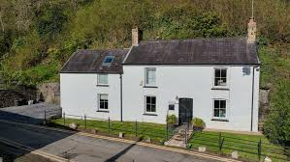

EnerPHit RETROFITTING SURVEY REPORT
Underwood, Parkmill, Gower, SA3 2EH
Property Address:

Ian Brown
Client:
Manta Ray Surveying & Solutions Ltd
Prepared By:
5TH May 2026
Date:

Contents
1.0 Introduction 3
2.0 Baseline Building Assessment 3
2.1 Existing building fabric 3
2.1.1 Passive haus requirements 4
2.1.2 Existing annual heat balance 4
2.2 Existing Stone Wall detail 5
2.2.1 Existing water content (stone wall) 5
2.3 Existing Solid Floor Detail 6
2.4 M&E domestic services and their existing issues 6
3.0 Proposed EnerPHit Interventions 9
3.1 External Wall Insulation 9
3.2 Vacuum Insulated Board – Solid Floor Detail 9
3.2.1 explanation of DPM upstand / tie into EWI 10
3.3 Justification for EWI & Material choice 11
3.3.1 Issues with EWI for Underwood 12
3.3.2 Potential water content with wood fibre EWI on the stone walls 12
3.3.3 EWI proposal dwg. 13
3.4 Justification for windows material choice 14
3.5 Carbon / Energy usage required for heating / MVHR 14
3.5.1 Proposed Annual heating load 16
3.6 Low Embodied Carbon – (Materials) 16
3.7 Space Optimization 17
4.0 PHPP Model (summarized) & Conclusion 17
5.0 References 17

1.0 Introduction
Underwood is a detached stone cottage built in the 15th century. This report identifies the existing building fabric and its construction detail. With proposals to meet EnerPHit standards with the main goal to achieve significant energy reductions. This will be done by modelling the existing building in the passive house planning package (PHPP) and then proposing changes to the potential insulation, building services, air tightness and the fabric as a whole.

2.0 Baseline Building Assessment

2.1 Existing building fabric
The current building details lack the modern requirements to achieve anywhere near passive house or EnerPHit standards. The windows and doors are very likely massive thermal bridges with considerable amount of air leakage pathways. The solid floor which is uninsulated also allows for majority of any heat created within the property to go into the earth below, heating the ground instead of the property.

2.1.1 Passive haus requirements
What is Passivhaus? (no date).

2.1.2 Existing annual heat balance
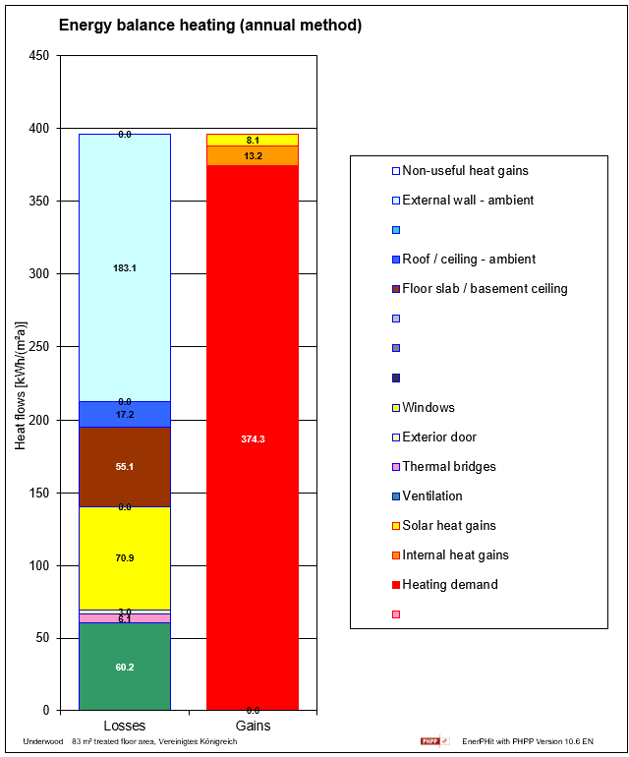

2.2 Existing Stone Wall detail

2.2.1 Existing water content (stone wall)
The existing wall make up is of gypsum and/or lime plaster. As mentioned, the stone wall is 600mm thick. The diagram provided by the homeowner shows that over time, the walls are getting considerably ‘wetter’. The existing heating (gas and fireplace) will be keeping the internal leaf dry but just pushing the moisture back into the wall and not stopping the walls from getting wet in the first place which can be very detrimental to the make up itself.
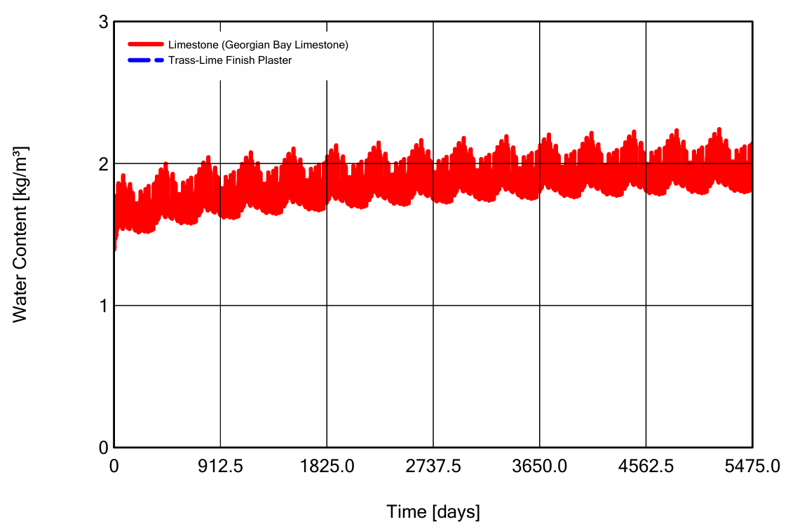

2.3 Existing Solid Floor Detail
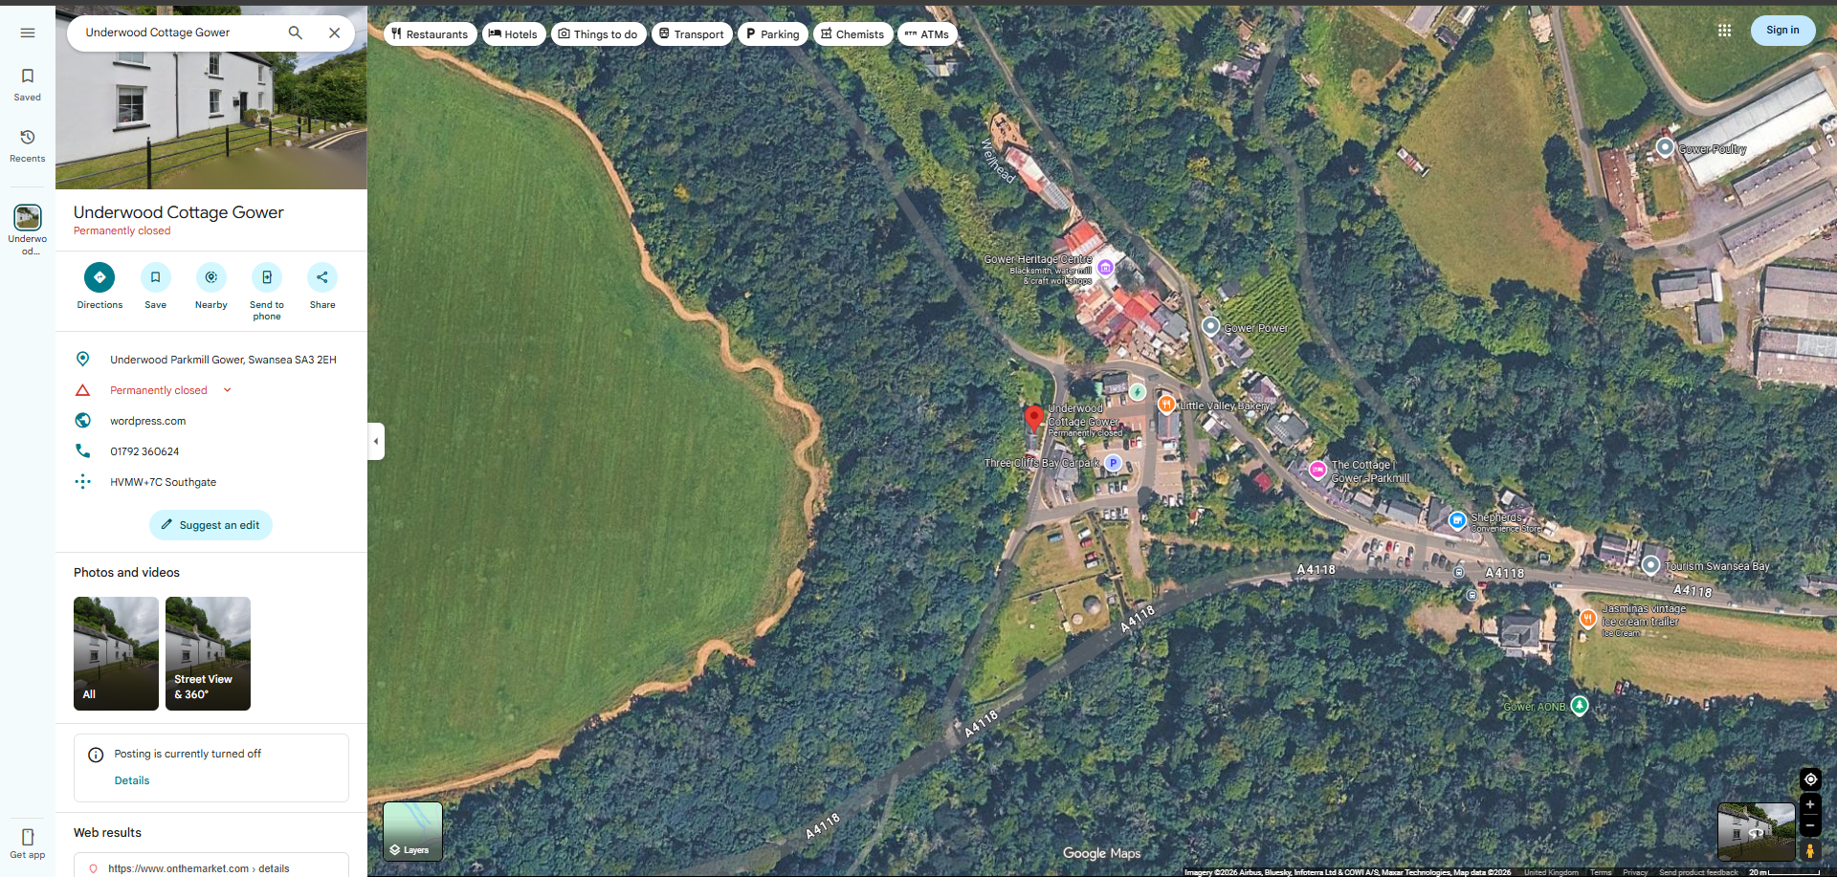

2.4 M&E domestic services and their existing issues
As far as mechanical and electrical services are concerned, there aren’t many. The property currently heats itself from an LPG fired conventional ‘Worcester Bosch Greenstar’ boiler. According to online reviews this boiler is generally considered an excellent and reliable system. They are praised for longevity and aftercare support as would be expected from such a premium brand. However, as will be discussed further on in this report, this boiler is not a great fit for EnerPHit due to the carbon emissions of using liquid propane gas and the poor efficiency at lower loads.
The existing ventilation consists of opening the windows, trickle vents and the unintentional infiltration through the building envelope. Completely wasting any built-up heated air, even worse, as the walls are uninsulated, the air that leaks through the gaps will carry moisture. When that warm air hits any cold spot on the stone walls, it will hit its dew point and turn into water. This is called interstitial condensation (Damp), which can rot away any timber joists and cause significant structural and tenant health damage.
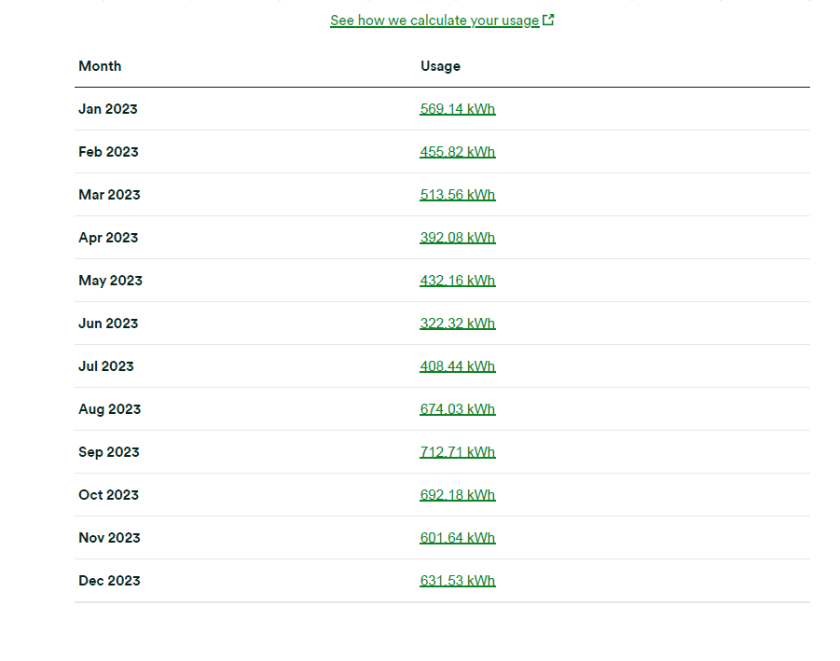
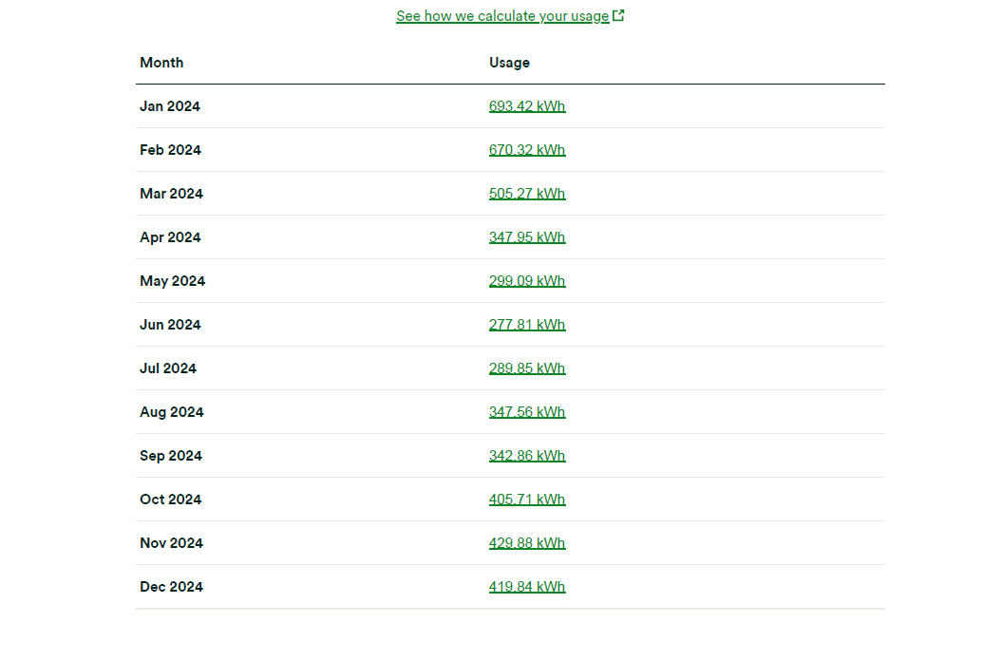
The energy usage taken from the data provided by the homeowner shows that the 2023-2024 consumption patterns fluctuate the same of a typical poorly insulated building with very high peak heating requirements.

3.0 Proposed EnerPHit Interventions

3.1 External Wall Insulation
Natural suggestions for any retrofit aiming to reduce heating costs would be to fit IWI (internal wall insulation) to all external walls. As this is a fully detached cottage, on paper this would be an ideal subject. However, due to the limited size of the existing properties dimensions, fitting at minimum an extra 65mm on all external walls internal leaf’s would reduce the room sizes too much to be adequate for a generic family of 4. This property also benefits from a well designed and fitted kitchen. Ideally this can be removed and refitted once refurbishments have taken place.
Due to these issues – the next obvious choice is to retrofit EWI (external wall insulation). The fact that this is a detached cottage also helps with this proposal as it allows for all external walls to be covered entirely with an EWI solution.

3.2 Vacuum Insulated Board – Solid Floor Detail
To achieve the EnerPHit requirements while keeping the existing slab due to structural concerns. These being that there is evidence that this building is sat on nothing but the ground itself and to disturb a building as old as this one is not wise as underpinning would only disrupt it even more. To keep the existing slab, I have modelled in the PHPP to retrofit a floating floor detail. This starts with a liquid bitumen DPM (Damp Proof Membrane) , applied to a cleaned and ‘scabbed’ concrete floor, the dpm will have an upstand of 150mm and will be tied into the EWI as per EnerPHit ‘laws’ to create a seamless air and moisture seal. Above this will be 50mm Kingspan OPTIM-R VIP’s (Vacuum Insulation Panels). These provide an exceptional 0.14 W/m2k especially for the depth provided. These are to be fitted according to a bespoke uk-designed layout with PIR infill strips on the perimeter walls. To protect this insulation, a foil backed vapour control layer will be installed with taped joints to meet air tightness targets of 1.0 h-1. This is then topped with 18mm weyroc moisture resistant tongue and groove boards with a timber tongue and groove polished floor finish. This brings the overall building up of the floor to roughly 80mm, therefore maintaining the heritage registered cottages original build type and avoiding the need to be adjusting door/window heights.
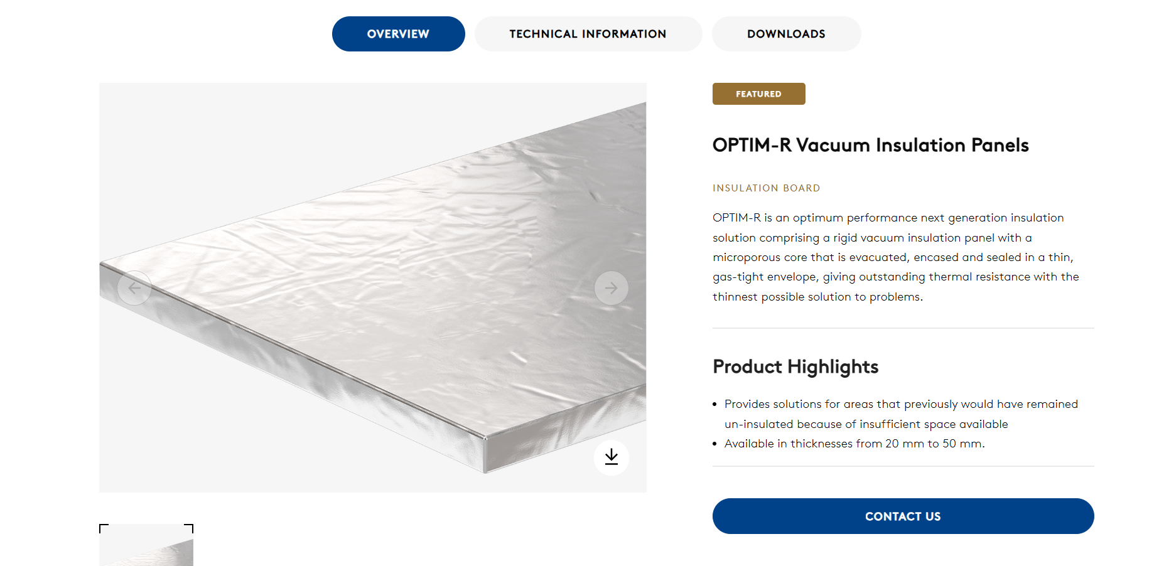
Kingspan OPTIM-R vacuum insulation Panels (no date).

3.2.1 explanation of DPM upstand / tie into EWI
The DPM will have an upstand of 150mm and be lapped and tie into the EWI to provide a continuous moisture and air tightness seal. Traditionally, lapping an upstand would be used to create a bathtub like barrier that stops any rising damp from breaching the walls and begin to dampen the wood fibre boards due to capillary action. Additionally, as mentioned before, we are going with perimeter insulation strips, the DPM will provide an additional protective backing which will ensure a robust thermal break between the stone wall and the new floor detail. Most importantly, the tie will ensure a seamless bond which will eliminate air leaking at the floor/wall junction which will secure the air tightness EnerPHit target of 1.0 ACH @ 50pa.

3.3 Justification for EWI & Material choice
For Underwood, a traditional stone walled cottage. EWI will be far superior in comparison to IWI for tenants’ health. This is because it will keep the stone walls warm and dry, limiting the chance that any mould will be created from interstitial condensation. Stone walls act as a sort of heat store, with EWI, they would soak up the heat as usual and then reflect that back into the building. This on its own will drastically reduce the energy costs. Compared to IWI, cold spots will be few and far between with EWI, this is due to not needing to fit insulation between timber battens and junctions between gf/ff. these cold spots create mould and air leaks. EWI will likely eliminate a majority of these from starting.
High density wood fibre insulation as the EWI system, this has been chosen due to its breathability which allows moisture to transfer safely through the stone walls – preventing interstitial condensation and typical damp issues.
Wood fibre is an environmentally friendly material choice as it acts as a natural carbon store, this means that it essentially traps more CO2 than was released during its creation which has been proven to be far better for the planet than the standard plastic insulation boards such as Celotex. Woodfibre provides the ‘super insulation’ needed for the EnerPHit certification all the while allowing the stone walls to breathe ensuring the cottage stays dry and mould free.
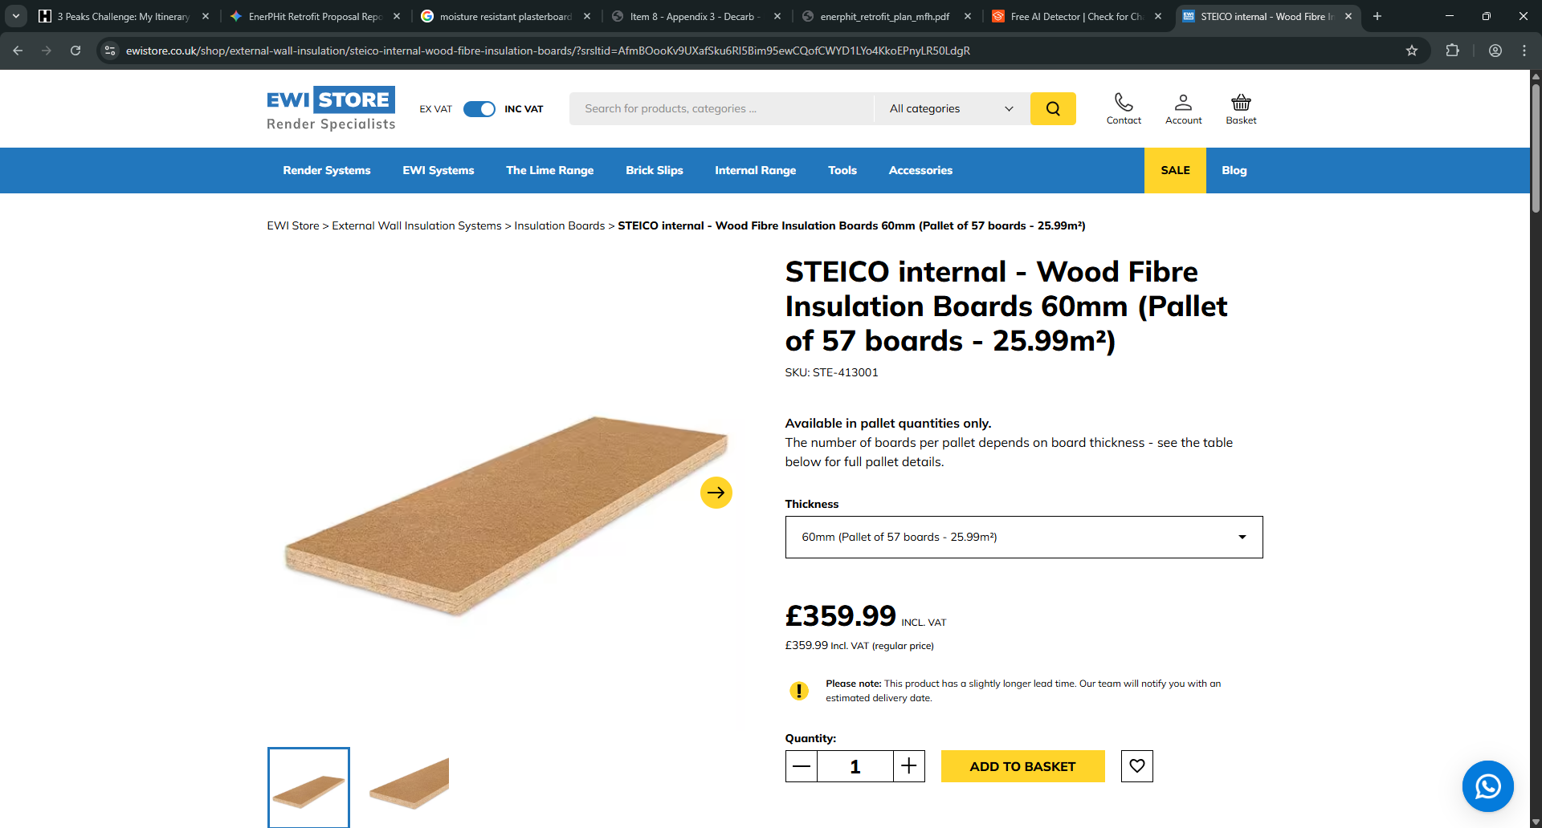
STEICO internal - Wood Fibre Insulation Boards (no date)

3.3.1 Issues with EWI for Underwood
To resolve the thermal bridging issue and lack of space for the EWI proposal at the rear of the property, we propose excavating the abutting hill/mountain side creating a physical separation from the building. The excavated hill side will be held back with a structural engineered heel and toe in-situ concrete retaining wall with a wrapped French drain on the hill side to drain away any water build up. This collected water will be transported away from the building and into the stream opposite the road. To ensure a continuous thermal and moisture resistant barrier, there will be a waterproof seal upstand that ties into the EWI. This will eliminate the ‘heat sink’ effect protecting the cottage from any hydrostatic damp and will secure the airtightness goals of an EnerPHit retrofit.

3.3.2 Potential water content with wood fibre EWI on the stone walls
This graph provided again by the homeowner shows the projected water content in the stone walls over a 15-year period. The wood fibre EWI helps the old stone walls dry out and stay in good condition.
The blue graph line shows that at the beginning of the survey – the walls are considered ‘damp’. However, because the wood fibre is breathable, it lets the trapped moisture escape. Over the first few years you can see the water content level dropping to a much safer and dryer point.

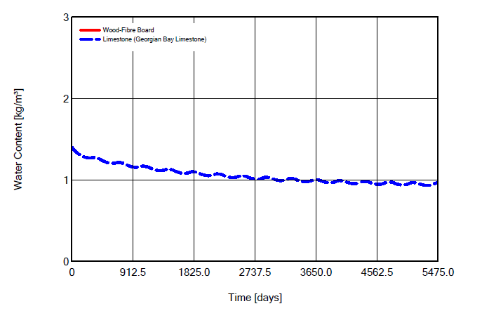

3.3.3 EWI proposal dwg.

3.4 Justification for windows material choice
To finalise mitigating the thermal bridging and ensuring the buildings airtightness’ is suited for an EnerPHit certification, the installation of ‘Harbin Sayyas PAZEN 120’ windows throughout the project. These windows are Passivhaus certified and will feature triple low-E glazing with 18mm Argon gas cavity. These will deliver a u-value which will meet the space heating demand of 22kWh/(m2a). By integrating these windows with the EWI system creates a continuous thermal wrap that will eliminate the chance for any cold spots. These windows also provide superior acoustic insulation and long-term protection against weather conditions.

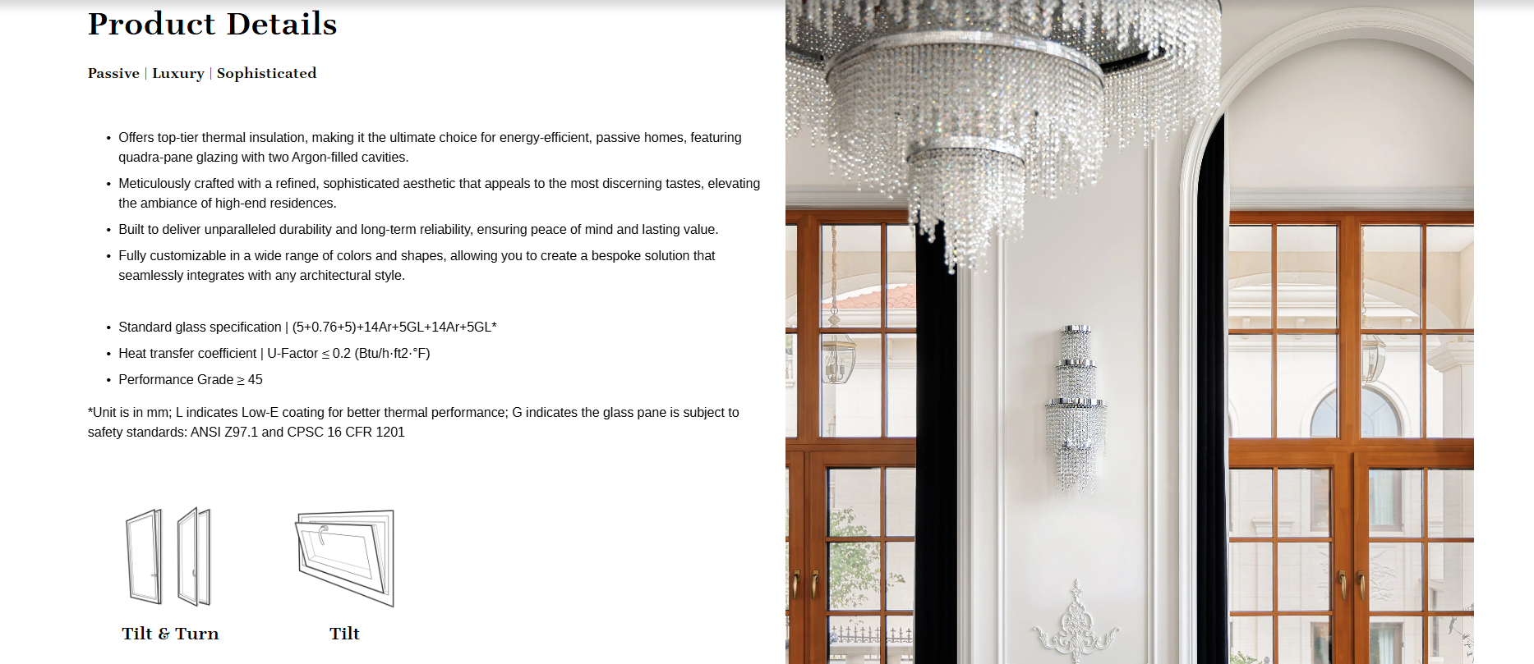
SAYYAS P120 Windows — The Gaze
Triple pane glazing unit (no date).

3.5 Carbon / Energy usage required for heating / MVHR
To meet EnerPHit’s target of 22kWh/(m2a), an ASHP (Air Source Heat Pump) is the justifiable choice. Replacing the existing LPG boiler will result in a 90% reduction of heating demand. Due to the proposed upgrades of EWI, triple glazed windows and new insulated floor – the old LPG boiler will be essentially ‘oversized’ and has the potential to ‘short-cycle’ causing it to be extremely less efficient. An ASHP would be perfect for this environment as it can operate at its most effectiveness running steady with a low temperature. Will comfortably be able to maintain a consistent 20°C internally with minimal energy input. Additionally, making this change will lower the buildings carbon footprint, moving away from the traditional fossil fuels and utilizing the national electricity grid. When paired with an MVHR system, which will recycle almost 85% of any existing heat, meaning when in full swing the system will only need to provide a small ‘top up’ to keep the temperature level. The current economical crisis means that oils and gas are going to keep rising due to logistical issues, swapping to an ASHP eliminates the worry about ever changing fuel prices.
The Zehnder ComfoAir Q350 MVHR system is a good suggestion. It will act as the lungs for the retrofitted cottage. A good place for the ducts to go is through the gf/ff floor voids and the now disuse chimney stack.
Along with the already proposed retro fit solutions, the chimney stack will have to be dropped below roof line to be encompassed within the building’s envelope. This leaves a substantial space where the main modules of the MVHR unit can sit and distribute mechanical forced air throughout the property.
Thermal Earth Ltd (no date) Air Source Heat Pumps UK

3.5.1 Proposed Annual heating load
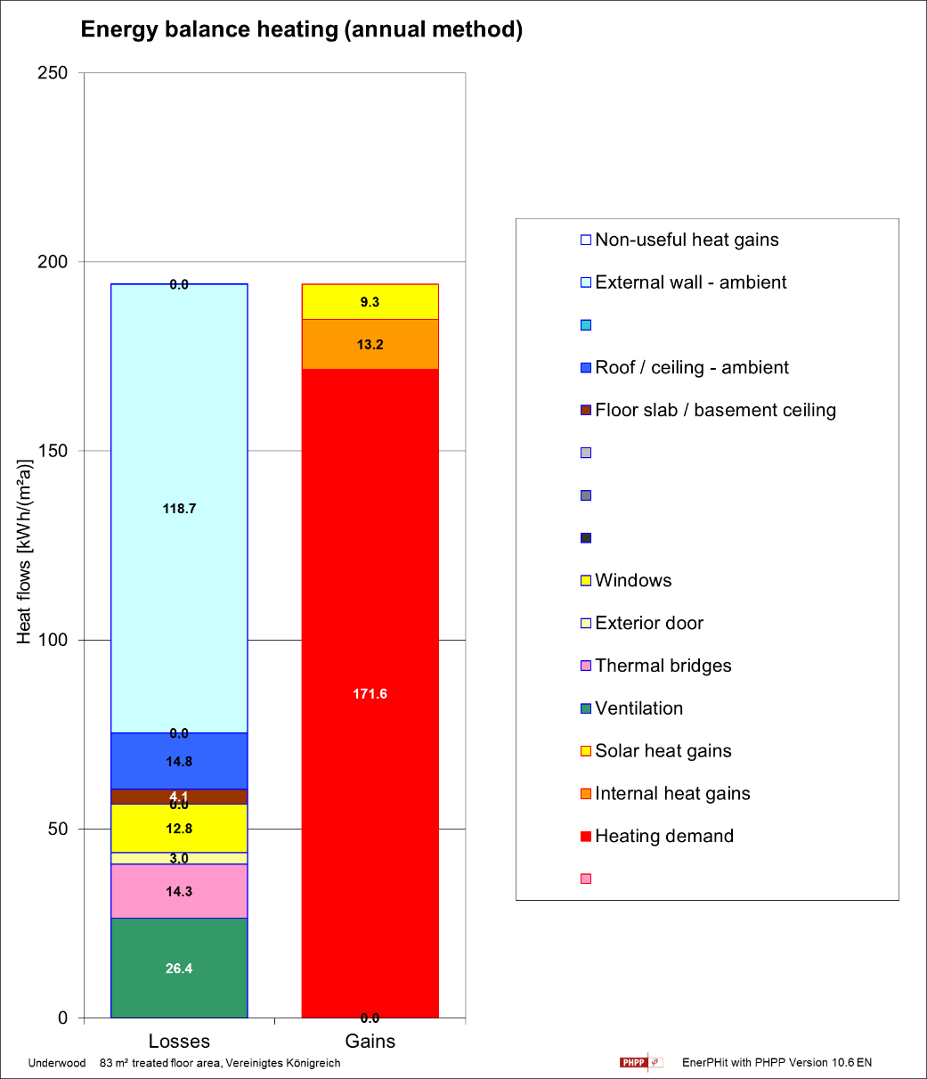

3.6 Low Embodied Carbon – (Materials)
To reduce the upfront carbon footprint of this proposed project, a bio-based insulation strategy will need to be adapted. Using high density wood fibre boards for the EWI and blown cellulose to insulate the roof. Due to wood fibre being created from natural elements (trees), it acts as a carbon store. Locking away the CO2 that the trees absorbed while growing – instead of releasing it into the atmosphere.
Additionally, using blown cellulose (made from recycled paper) offers a low embodied carbon solution in comparison to more traditional materials for the roof void.

3.7 Space Optimization
By choosing EWI and keeping the insulated floor detail to a minimum thickness, we preserve 100% of the existing floor space internally. This is essential as the property is not considered ‘large’ to begin with. This will keep the value of the property as high as possible.

4.0 PHPP Model (summarized) & Conclusion
This proposal uses the PHPP model to transform the traditional wet/leaky stone cottage into a high performing home with a 90% reduction in the heating demand. All of the upgrades from the EWI, triple glazed windows, VIP board insulated floor, liquid DPM with upstand to reach the airtightness goal. Finally, replacing the LPG boiler with the ASHP ensure the building will sip electricity rather than wasting any gas resulting in a cost effective, dry and warm home.

5.0 References
No. 624 (2023) Period Cottage in Parkmill, Gower, SA3 2EH. No. 14. https://alto2-live.s3.amazonaws.com/N1_WCcmWLM4K1syqq9gDYuzSsH8/_CN9iVngM1UBC7hcw9xGpG_zERA/Brochure/[0]/wwnkZW9L1UiJo_ufNanVlw.pdf. Accessed on 05/05/2026
Kingspan OPTIM-R vacuum insulation Panels (no date). https://www.kingspan.com/us/en/products/rigid-insulation/insulation-board/optim-r-panels/. Accessed on 05/05/2026
SAYYAS P120 Windows — The Gaze | Premium aluminum-clad wood windows and doors (no date). https://www.thegaze.us/sayyas-p120-windows. Accessed on 05/05/2026
Triple pane glazing unit (no date). https://ekookna.co.uk/ekoen/products/triple-pane-glazing-unit. Accessed on 06/05/2026
STEICO internal - Wood Fibre Insulation Boards (no date) EWIStore. https://ewistore.co.uk/shop/external-wall-insulation/steico-internal-wood-fibre-insulation-boards/?srsltid=AfmBOooKv9UXafSku6RI5Bim95ewCQofCWYD1LYo4KkoEPnyLR50LdgR. Accessed on 06/05/2026
Passivhaus Retrofit (no date). https://www.passivhaustrust.org.uk/competitions_and_campaigns/passivhaus-retrofit/. Accessed on 07/05/2026
Sustainable drainage suds products, solutions and services (no date). https://www.google.com/aclk?sa=L&pf=1&ai=DChsSEwioiZ717KmUAxWvklAGHYT-DI8YACICCAEQABoCZGc&co=1&ase=2&gclid=Cj0KCQjwk_bPBhDXARIsACiq8R0Tf39t6XBvcJQodd5lPLG9iQ4C3b6p5iP6mLhl2Yim65_OMtg6BesaApXnEALw_wcB&cce=2&category=acrcp_v1_32&sig=AOD64_3lRLxIpaT3ThgwYG1Ucyqh8D_UNQ&q&nis=4&adurl=https://selsource.co.uk/?gad_source%3D1%26gad_campaignid%3D21513633971%26gbraid%3D0AAAAADcQ4wi-vZ8rmHA7nt98kg9CAWWIF%26gclid%3DCj0KCQjwk_bPBhDXARIsACiq8R0Tf39t6XBvcJQodd5lPLG9iQ4C3b6p5iP6mLhl2Yim65_OMtg6BesaApXnEALw_wcB&ved=2ahUKEwjXxZX17KmUAxWRWkEAHTROL-UQ0Qx6BAgXEAE. Accessed on 07/05/2026
Thermal Earth Ltd (no date) Air Source Heat Pumps UK | £7,500 grant | Thermal Earth. https://www.google.com/aclk?sa=L&pf=1&ai=DChsSEwjvmMiE7amUAxWjkFAGHch8E50YACICCAEQAxoCZGc&co=1&ase=2&gclid=Cj0KCQjwk_bPBhDXARIsACiq8R22czU2NN90RQC3pNCxmuQ2cTRUKue82_j_t9BMRP5eb-mMBr2gpnoaAq8CEALw_wcB&cce=2&category=acrcp_v1_32&sig=AOD64_1nhOQG0y2g1-KMsvA9Wk67d_s3Lw&q&nis=4&adurl=https://www.thermalearth.co.uk/air-source-heat-pumps?https://www.thermalearth.co.uk/residential-online-estimator?utm_source%3Dgoogle%26utm_medium%3Dpcp%26utm_campaign%3Drising_oil_proces_08.04.26%26utm_content%3D2026_residential_landing_page%26gad_source%3D1%26gad_campaignid%3D23735761913%26gbraid%3D0AAAAABzFji9XmyoJi2EhNSlWYg2ypyq3Y%26gclid%3DCj0KCQjwk_bPBhDXARIsACiq8R22czU2NN90RQC3pNCxmuQ2cTRUKue82_j_t9BMRP5eb-mMBr2gpnoaAq8CEALw_wcB&ved=2ahUKEwij-L-E7amUAxXEUEEAHX7YMC4Q0Qx6BAg0EAE. Accessed on 08/05/2026
Stirling, C. (2011) Building pathology: moisture conditions within external masonry walls. https://www.thenbs.com/knowledge/building-pathology-moisture-conditions-within-external-masonry-walls. Accessed on 08/05/2026
Inca-Js (2022) - The benefits of external wall insulation. https://www.inca-ltd.org.uk/external-wall-insulation/the-benefits-of-external-wall-insulation/. Accessed on 08/05/2026
Ian Brown (2026) – Provision of Underwood sources. TEAMS. Accessed on 05/05/2026
Admin (2025) Average CO2 emissions per household. https://www.lifetimesavings.co.uk/average-co2-emissions-per-household/. Accessed on 07/05/2026
What is Passivhaus? (no date). https://www.passivhaustrust.org.uk/what_is_passivhaus.php. Accessed on 04/05/2026
Administrator (2025) 'Why stone wall insulation fails most homes – and how breathable solutions protect heritage,' Insitu SCP, 30 July. https://www.insituscp.co.uk/why-stone-wall-insulation-fails-most-homes-and-how-breathable-solutions-protect-heritage/. Accessed on 08/05/2026
ClimateWorks - What Architects should know about MVHR for listed and heritage buildings (no date). https://climateworks.co.uk/post/what-architects-should-know-about-mvhr-for-listed-and-heritage-buildings. Accessed on 08/05/2026

