Student name: Abdulai Kamara

Student ID: 2328050

Module name: Empowering the older people

Module code: BHP6027

Lecturer’s name: Dr Laila Sarani

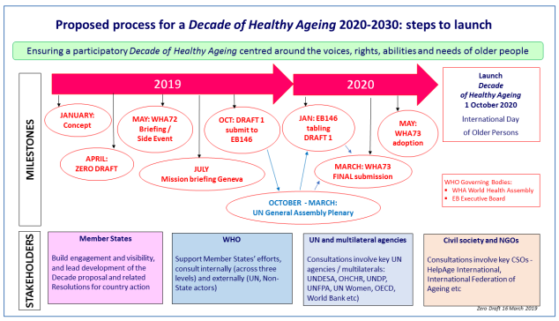 |  | Critically Evaluating the care, empowerment and support needs of older people  - Elderly people have distinct empowerment, care and support needs which go beyond the medicinal treatment to involve emotional, mental, physiological and social wellbeing.  - WHO suggests functional ability is shaped by both the supportive environments, and intrinsic capacity, outlining that successful ageing is based on transport, housing, health services, and social participation, instead of just healthcare (Who.int, 2020).  - As per sources, 66 percent of adults over 65 did not require help with IADLs or ADL while 24 percent had some unmet need for help with ADLs (NHS England, 2026).  - The person-centred care approach underpins collaborative decision-making by understanding the values, experiences, and preferences of individuals (Jobe, 2022).  - As per Hayes et al. (2024) integrated services of health and social care enhance outcomes by encouraging community living, minimising hospital admission, and multidisciplinary support. |  | 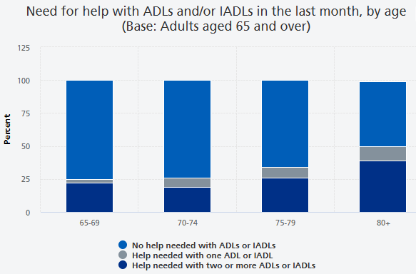
Introduction  - The focus will be on presenting a critical evaluation of care, support, and empowerment needs of older adults.  - million individuals are aged more than 65 in England which enhances pressure on the services of health and social care (Fleck, 2022).  - Intervention's effectiveness and benefits, challenges faced, and recommendations will be further outlined.  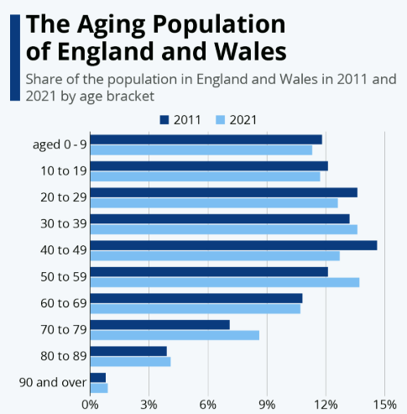 |  |  |  | Challenges faced by older people to maintain their functional ability and independence  - The physical changes that may enhance the need for health challenges to participation are not only the health issues themselves, but rather the societal barriers that emerge as per the Social Model of Disability (Zaks, 2024).  - The demands for coordinated support services, accessible environments, inclusive policies and community engagement assists elderly individuals maintain their dignity, exercise their choice and proactively (Siegler et al., 2026).  - The physical changes may enhance need for health services, dependence on carer, declining confidence and personal autonomy (Meredith et al., 2023).  - Private care services, home adaptations and healthy food may be restricted by economic challenges such as rising cost of living (£2,888.2 for a family of 4 per month) (Numbeo.com, 2026).  Recommendations and Conclusion  Recommendations  - Providing a person-centred and seamless support that is tailored to elderly adults' needs is required to be the focus on developing integrated health and social care (Murphy et al., 2025).  - Support for elderly people in guaranteeing their independence for a longer period can also involve increased funding of community-based rehabilitation services, preventive care services, and home adaptation initiatives.  - The digital tools and resources like internet access, technology training, and others must also be embedded for expanding the telehealth services (Alhussein et al., 2023).  - Workforce development via continuous training along with improved collaboration with voluntary organisations and carers can further support wellbeing and decrease social isolation.  Conclusion  - It reveals elderly people need person-centred and holistic care which promotes independence, dignity and functional abilities.  - Even with the robust policy framework in place in the UK, there are distinct challenges faced by elderly people when it comes to accessibility and delivery.  - Better capacity of staff, service integration and community support will improve outcomes and help elderly people experience better quality of life, wellbeing, and choice.
A critical evaluation of the effectiveness and benefit of approaches and interventions, including current provisions in the UK
- Initially, independence, wellbeing, and personalised support are promoted by Care Act 2014 and the integrated community-based services are encouraged through “The NHS Long Term Plan” (Briggs et al., 2020).
- The reablement programmes give positive outcomes by assisting elderly individuals re-obtain day-to-day living skills and confidence through hospital discharge or illness, minimising prolonged reliance on formal care services (Clotworthy et al., 2021).
- The empowerment theory, in elderly adult care, underpins self-management, shared decision-making, and active engagement in care planning (Kminiak et al., 2024).
- Despite the systems of integrated care enhancing collaboration between health and social care personnel, the consistent implementation is challenged by financial constraints, delayed assessments, and persistent workforce shortages (Thomson and Chatterjee, 2024).
- Mobility services, remote monitoring, and telecare as assistive technologies support independent living and safety, still the unequal access and digital literacy barriers minimize their effectiveness (‌Zager Kocjan et al., 2023).



References
Alhussein, M., Patel, B. and Liu, X., (2023). Closing the gap: technology access and telehealth use among older adults in the US Medicare beneficiaries. Telematics and Informatics Reports, 12, p.100103.
Briggs, A.D.M., Göpfert, A., Thorlby, R., Allwood, D. and Alderwick, H. (2020). Integrated health and care systems in England: can they help prevent disease? Integrated Healthcare Journal, [online] 2(1), p.e000013. doi:10.1136/ihj-2019-000013.
Clotworthy, A., Kusumastuti, S., and Westendorp, R.G.J. (2021). Reablement through time and space: a scoping review of how the concept of ‘reablement’ for older people has been defined and operationalised. BMC Geriatrics, [online] 21, p.61. doi:10.1186/s12877-020-01958-1.
Fleck, A. (2022). The Aging Population of England and Wales. [online] Statista Daily Data. Available at: https://www.statista.com/chart/27697/census-shows-population-of-england-and-wales/?srsltid=AfmBOorVfEOImMgTZLbV1ZjbBI_EEc0CG1mmRqPGYiab0eh2jLrbAu0c [Accessed 15 July 2026].
Hayes, C., Manning, M., Fitzgerald, C., Condon, B., Griffin, A., O’Connor, M., Glynn, L., Robinson, K. and Galvin, R., (2024). Effectiveness of Community‐Based Multidisciplinary Integrated Care for Older Adults with General Practitioner Involvement: A Systematic Review and Meta‐Analysis. Health & Social Care in the Community, 2024(1), p.6437930.
Jobe, I., (2022). Reflections of the collaborative care planning as a person‐centred practice. Nursing Philosophy, 23(3), p.e12389.
Kminiak, Ľ., Senáriková, Z., Candrák, M. and Kozubík, M., (2024). Empowerment–Theory, History and Current Situation in Social Work: Literature Review. Pomáhajúce profesie, 7(1), pp.5-15.
Meredith, S.J., Cox, N.J., Ibrahim, K., Higson, J., McNiff, J., Mitchell, S., Rutherford, M., Wijayendran, A., Shenkin, S.D., Kilgour, A.H. and Lim, S.E., (2023). Factors that influence older adults’ participation in physical activity: a systematic review of qualitative studies. Age and ageing, 52(8), p.afad145.
Murphy, S., McCance, T. and White, P.J., (2025). How Do Older People Experience Person-Centred Integrated Care? An Integrative Review of the Evidence. International journal of integrated care, 25(4), p.21.
NHS England. (2026). Health Survey for England, 2024. [online] Available at: https://digital.nhs.uk/data-and-information/publications/statistical/health-survey-for-england/2024/loneliness-and-wellbeing [Accessed 8 July 2026].
Numbeo.com. (2026). Cost of Living in United Kingdom. Prices in United Kingdom. Updated Jul 2026. [online] Available at: https://www.numbeo.com/cost-of-living/country_result.jsp?country=United+Kingdom [Accessed 8 July 2026].
Siegler, E.L., Lama, S. D, Knight, M.G., Laureano, E. and Carrington Reid, M. (2026). Community-Based Supports and Services for Older Adults: A Primer for Clinicians. Journal of geriatrics, [online] 2015, p.678625. doi:10.1155/2015/678625.
Thomson, L.J.M. and Chatterjee, H.J. (2024). Barriers and enablers of integrated care in the UK: a rapid evidence review of review articles and grey literature 2018–2022. Frontiers in Public Health, [online] 11, p.1286479. doi:10.3389/fpubh.2023.1286479.
Who.int. (2020). item. [online] Available at: https://www.who.int/news-room/questions-and-answers/item/healthy-ageing-and-functional-ability [Accessed 8 July 2026].
‌Zager Kocjan, G., Špes, T., Svetina, M., Plohl, N., Smrke, U., Mlakar, I. and Musil, B., (2023). Assistive digital technology to promote quality of life and independent living for older adults through improved self-regulation: a scoping review. Behaviour & information technology, 42(16), pp.2832-2851.
Zaks, Z., (2024). Changing the medical model of disability to the normalization model of disability: Clarifying the past to create a new future direction. Disability & Society, 39(12), pp.3233-3260.

