
Name:

Physical Landscapes and the Geosphere (ACNA 4007)
The Rock Cycle

Activity Outline:
Most environmental applications involve geology either directly or indirectly. Understanding basic geology will help you apply geological knowledge to the investigation of processes occurring at or near Earth's surface. Today you will be building on your skills of rock identification as we explore different rocks and their characteristics. You will be using simple classification sheets to help you identify samples in the lab.

Background
Rock identification and understanding lithology is a very useful skill. You may have some familiarity with the rock cycle (Figure 1). The rock cycle is a describes the processes in which rocks are continuously transformed between the three rock types igneous, sedimentary, and metamorphic.
Rocks are classified based on their origin and their physical properties such as mineralogical composition, grain size, and texture. Observing and, in some cases, measuring these physical properties is the first and most important step towards identifying rocks. When people think about rocks with grains they usually think about Sedimentary Rocks. Clastic sedimentary rocks will often have visible grains of varying sizes, but in some rocks like shales and mudstones the grains are too small to see with the naked eye. You may need a magnifying glass or microscope in order to see very fine grains. Most chemical and evaporate sedimentary rocks will not have visible grains.
Igneous Rocks are subdivided into two categories that are expressed by grain size. Intrusive igneous rocks generally have large, visible crystals because they cooled underground, and the crystals had time to organize and grow. Extrusive igneous rocks cooled more rapidly on the surface, and therefore they won’t have any visible grains.
For Metamorphic Rocks, the presence and size of grains is mostly determined by the protolith (the original, unaltered rock) and the degree of metamorphism. Sometimes when grains are present in a metamorphic rock, they are the same crystals as were present in the protolith, but other times they are completely new crystals with different mineralogies, sizes, and orientations.

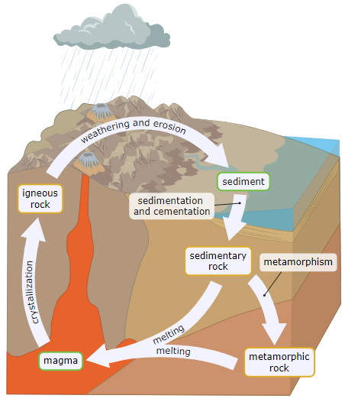
Figure 1. Diagram of the rock cycle

Exercise 1: Rock Identification
In your groups you have been given a series of 15 rock samples.
- You are tasked with working out what sort of rock type these samples are. In your group, you need to classify your rocks based on observations of mineralogy and other characteristics. You should be able to determine if the rock is Sedimentary, Metamorphic or Igneous. Place them into these three categories.
- Next, using the tables provided, identify your rocks. You can complete the table columns for each of your samples. Note: You should be able to fill out answers in all three tables. You have been provided instructions on how to use a microscope to examine your rock in further detail.

Exercise 2: Geological Provenance: where did my rock come from?
Select a rock sample from those you have examined so far. Using the geological maps provided or the BGS Geology Viewer (BETA), complete the following:
- Highlight areas of the UK that this specific rock is found.
- Draw a brief sketch of their locale or environmental setting within the UK. Some of the rocks will be fairly ubiquitous, but others will be trickier to locate.
- Have a go at describing the age or depositional/formational setting of the rock. You can consider the geologic period, formational processes, setting, specific environment. (hint: try to link this back to the texture, composition or identifiable features you have observed in the lab today). Add that information in your sketch. Well done!
Sketch your location here:

