Data Mining Based on Traffic Datasets
Research Proposal
Chen Tao

Contents

Contents 2
Figures 3
1. Introduction 5
2. Background to the Proposed Research 6
2.1 Research on Safety Issues of Traffic Accidents 6
2.1.1 Analysis of Causes of Traffic Accidents 7
2.1.2Forecast of the severity of traffic accidents 9
2.2 Research on Early Warning Methods of Vehicle Accidents 10
3. Aims & Objectives 11
4. Research Methods 11
4.1 Philosophy 12
4.2 Strategy 12
4.3 Approaches 12
4.3.1Analysis of Causes of Traffic Accidents 12
4.3.2Forecast of the severity of traffic accidents 12
4.3.3Research on Early Warning Methods of Vehicle Accidents 13
4.4 Data Collection & Evaluation 13
4.5 Ethical Issues, Risks & Limitations 13
4.6 Reliability, Validity & Generalisability 14
5. Development Methods 14
6. Resources & Planning 15
6.1 Resources Required 15
6.2 Project Plan 15
7. Reference List 16

Figures
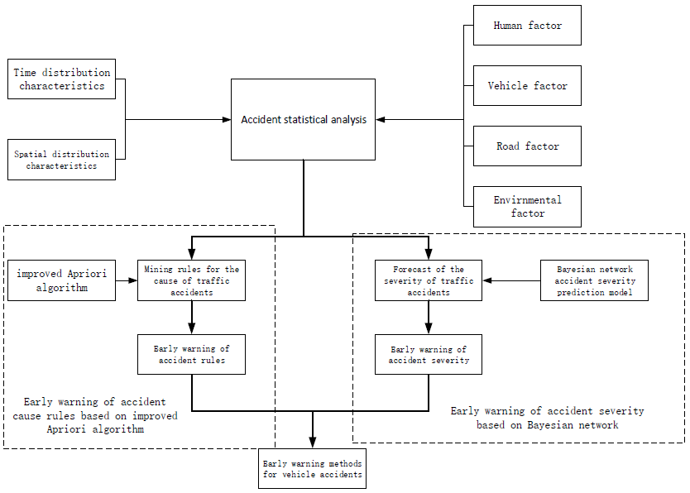

Figure 1 Technical route

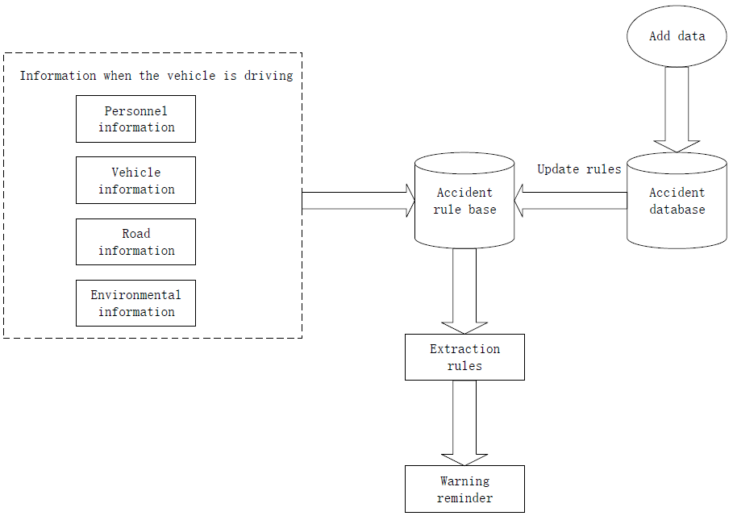
Figure 2 Accident rule early warning workflow

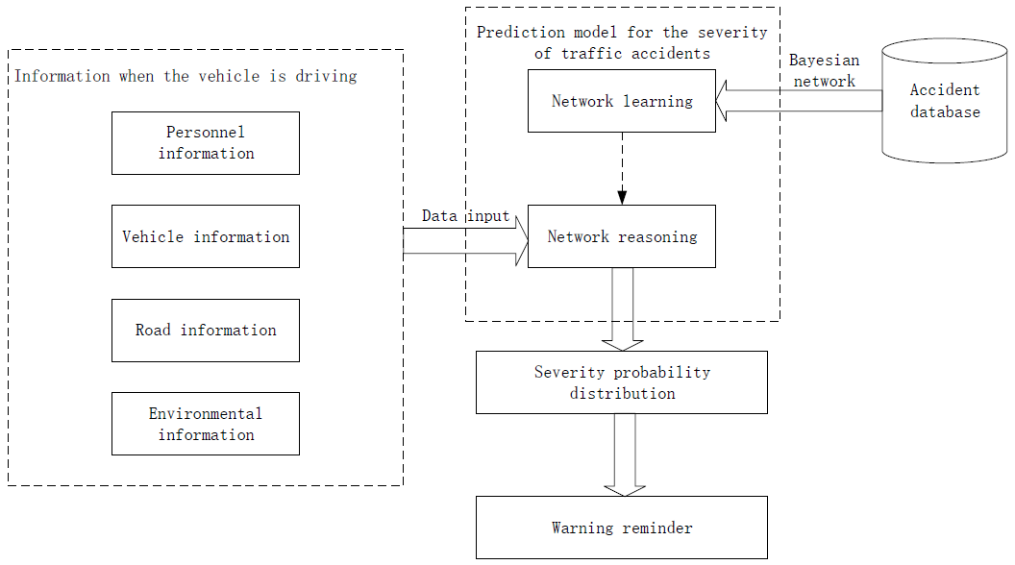
Figure 3 Traffic accident severity warning workflow

1. Introduction
Traffic accidents have brought an incalculable economic and emotional burden to society and individuals. Automobile manufacturers and road transport agencies have been committed to reducing the frequency of traffic accidents and the injuries suffered by people during accidents by improving vehicle performance and improving road management [1].
For many years, researchers in the field of road safety have tried to use a large amount of data to evaluate the causes of accidents and seek ways to reduce the accident rate. Data mining is an emerging technology in the field of computer science, which can automatically improve algorithms through experience and is very effective in the classification, clustering, and feature selection of high-dimensional data [3]. Data mining has broad application prospects in the field of road safety, and this technology can better help analyze the relationship between traffic accidents and various variables [4]. Especially in terms of explaining and predicting the effects of relevant factors of road users on injury risks, and analyzing the impact of multiple factors on the severity of accidents, data mining techniques have shown ideal results [5].
Traffic accident data contains a large amount of information at the time of the accident. Through the mining of historical accident data, it is of great significance to reduce the number of accidents and reduce the harm of accidents. Based on British urban road traffic accident data, this paper conducts research from two aspects of vehicle accident cause rule mining and severity prediction. By mining the potential rules of the accident cause and predicting the severity of the accident, corresponding early warning strategies are formulated for drivers and traffic management. Department provides accident warning information and suggestions.

2. Background to the Proposed Research
The research on the early warning of vehicle accidents has always been a hotspot and focus in the field of road traffic and vehicle safety. Early warning of vehicle accidents on urban roads refers to the use of statistical reasoning and data mining methods to study the rules governing the impact of various factors such as people, vehicles, roads, and the environment on vehicle traffic accidents, and then to grasp the rules of the occurrence and development of traffic accidents, through identification The safety status of the current operating environment of the vehicle, and the prediction of whether the vehicle will have an accident in the future, so as to provide the driver with early warning information through a certain early warning method before the accident, and minimize the risk of the accident, or the shortest after the accident Reduce accident injuries within time [6]. It can be seen that the study of historical traffic accidents is an effective means to dig out the potential information of accidents. At present, the research on traffic accidents in various countries around the world mostly focuses on the analysis of the cause of the accident and the accident prediction. In the accident prediction, the main research content is to predict the severity of the accident. Therefore, this article will conduct research from two aspects: research on traffic accident related issues and accident early warning methods. Among them, traffic accident related issues mainly include accident cause analysis and accident severity prediction.

2.1 Research on Safety Issues of Traffic Accidents
In order to solve the problem of traffic safety, countries all over the world have set up research institutions to conduct in-depth analysis and research on traffic safety problems. The Center for Urban Transportation Research (CUTR) of the United States combined with existing traffic databases, combined with multiple departments to conduct detailed statistics on national traffic vehicle safety accidents, and conduct information mining on accidents, and proposed 22 special research projects and countermeasures [7]. The Hokkaido Branch of the Engineering Research Association of Japan (CERI) established a traffic accident analysis system on the basis of electronic maps to analyze road traffic accidents in the Hokkaido region [8]. Tongji University in China, in conjunction with the Shanghai Public Security Traffic Police Corps and Volkswagen in Germany, carried out a research project on road traffic accidents in China, conducted analysis and mining of accidents across the country, and put forward specific recommendations for accident prevention and harm reduction [9]. The research on traffic accident-related issues in various countries mainly focuses on the analysis of the causes of traffic accidents and accident prediction.

2.1.1 Analysis of Causes of Traffic Accidents
Scholars from all over the world have carried out research on the analysis methods of accident causes for many years, and experienced three different theoretical footholds: single factor theory, multiple factor theory and system cause theory [10].
Single factor theory focuses on the impact of a certain aspect on traffic accidents. Rolison J et al. researched the relationship between driver’s age and traffic accidents and found that young people have relatively little driving experience, and accidents often occur due to risky driving. Young people who are speeding, taking drugs and driving under the influence account for a certain percentage; With age, more accidents are related to the driver’s vision and mental decline due to medication [11]. Nitsche P et al. used k-medoid clustering algorithm to cluster 1056 UK traffic accident data into different types for road intersections, established 13 T-junction collision scenes and 6 intersection collision scenes, and found that the vehicle did not give way. Traffic is the main cause of intersection collision [12]. Mohamed A et al. used a negative binomial model to model and analyze the traffic accident data of a major road in the United States. The results show that the lane width is narrow, the number of lanes is large, the urban road section is narrow, the shoulder width is narrow, and the width of the intermediate separation zone is reduced. Factors can increase the risk of accidents [13]. Based on environmental factors, Andersson A et al. studied the relationship between temperature, weather and other indicators and traffic accidents. They used the time simulation method and the UKCIP climate change scenario to process the UK accident data. They found that extreme weather such as snow and freezing had a negative effect. The impact of traffic accidents is greater [14].
It can be seen that starting from factors such as people, vehicles, roads, and the environment, studying the causes of accidents is the mainstream research direction. However, the focus of the above-mentioned research is single factor. Although it can be compared vertically within the same factor, it is still too one-sided and lacks the horizontal correlation between different influencing factors. The causes of traffic accidents are often a combination of multiple factors and influence each other. It is difficult to find the cause of the accident from the numerous complicated traffic characteristics. With the advancement of data mining and machine learning technology, analysis methods represented by association rules have increasingly entered the field of traffic safety research.
Yu et al. used the Apriori algorithm to dig out the important association rules between the authenticity of the accident and the influencing factors [15]. Compared with previous studies, the accident variables are included more comprehensively, including environment, management level, and driver and vehicle status. Faisal et al. used the Apriori algorithm and the EM clustering algorithm to mine the potential causes of accidents in KSA’s Alghat-Provence traffic accident data. Since the EM clustering algorithm requires an unquantified number of iterations to get an optimal solution, the Apriori algorithm can find All frequent itemsets outperform the EM algorithm in terms of time and results [16]. Fatima et al. used the Apriori algorithm to analyze the French traffic accident data, and sorted the obtained association rules through the ELECTRE method, revealing the conclusion that there is a narrow correlation between the driver and the pedestrian, the normal road surface and the normal atmospheric conditions, and the road surface and the pedestrian. , And choose the higher ranking accident rule as the criterion of accident prevention [17]. Olutayo et al. used artificial neural networks and decision trees to analyze the determinants of serious accidents. The results show that the performance of decision trees is better than neural networks, and the three factors most relevant to serious accidents are the alcohol content in the driver’s body, road light and whether Use seat belts [18].
There are also many scholars in China using a variety of methods to study the causes of traffic accidents. Hu Zhenbo combined the idea of ​​weighting with association rules and applied it to traffic accident data. The information entropy theory calculates the weights of the factors that may affect the accident, and proposes a dynamic FP-Growth algorithm, adding weighted support and confidence vectors. Describe the relationship between association rules and time changes, find the most applicable association rules for each time period, and analyze the impact of various factors on traffic accidents [19]. In view of the characteristics of tunnel traffic accident data, Liu Yunxiang and others also improved the FP-Growth algorithm, assigning different weights to each attribute, and obtaining potential association rules more efficiently, making the results meaningful, and using the improved WFP-Growth algorithm to establish The mining model, by digging the tunnel traffic accident data, finds out the combination of frequent factors that cause tunnel traffic accidents, and finds the potential relationship between the factors that cause tunnel traffic accidents [20]. Chen Jingxi started from single factor, multiple factor and multiple classification of accidents, selected PCA feature extraction algorithm, Apriori algorithm and K-Means clustering algorithm for different analysis levels to establish a comprehensive analysis model, and statically sampled the data to improve mining efficiency [21]. Deng Xiaoheng et al. used analytic hierarchy process to reduce accident attributes, combined association rules and genetic algorithms, optimized the efficiency of association rule mining, and obtained more effective accident rules [22]. Aiming at highway traffic accidents under non-extreme severe weather conditions, Jing Liantian used association rules and decision trees to explore the relationship between accident factors [23].

2.1.2Forecast of the severity of traffic accidents
For the related research on traffic accident prediction, it is not only to predict whether the accident will occur, but more importantly, to predict the severity of the accident. Therefore, the predictive modeling and analysis of the severity of the accident has attracted great attention from scholars all over the world.
Early research methods for the severity of traffic accidents were mainly based on binary regression, including Logit and Probit models, focusing on the analysis of the impact of accident factors on the fatality rate. Kim et al. used the Logit regression model to analyze the traffic accident data in North Carolina, USA, and studied the related factors of four different degrees of traffic accidents through control variables. The results showed that under severe weather and poor light conditions, alcohol Rear driving, speeding and frontal collisions can increase the probability of death after an accident by more than two times. Speeding is the most serious. If the vehicle speed exceeds 80.5km/h, the probability of death increases by more than 16 times [24]. Hu Ji and others used the Logit model and the Probit model to study the coupling relationship between the driver, vehicle, environment, management factors and the severity of the accident, and made effective predictions on the fatal accidents caused by rollovers [25]. Liu Haizhu divided the traffic accidents in Changchun City into 3 severity levels, introduced direct economic property loss factors, and established a road traffic severity prediction model through the cumulative Logistic regression model. The results showed that the model has good predictive ability [26].
With the deepening of theoretical research on traffic safety, the analysis of accident fatality rate alone cannot meet the safety requirements. In order to avoid the limitations of the accident severity classification model, the multiple regression model has gradually become a research tool favored by scholars, including the MNL model, OL model and ordered corresponding model, etc. Zhao et al. compared the MNL model with other regression models and found that for vehicle collision traffic accidents, the MNL model has a better fit, but requires that each category of accident severity is independent of each other, and accidents are based on property loss and the classification of the degree of casualties is difficult to achieve this [27]. Celika and Oktay used the MNL model to analyze traffic accidents in Turkey and found that the driver’s age, education level, road conditions and weather conditions are the main factors affecting the severity of the accident, and based on this conclusion, they made a more accurate assessment of the severity. Forecast [28]. Kockelman et al. analyzed the factors influencing the severity of various types of collisions and found that compared to cars, pickup trucks or SUVs, they are more likely to cause serious traffic accidents, and the driver's injury degree is generally lower than that of the passengers. In addition, factors such as the driver's gender and age also have a significant impact on the severity of the accident [29].
In addition, with the development of data mining technology, machine learning has become one of the effective methods for analyzing the severity of traffic accidents by virtue of its powerful learning and predictive capabilities. It is increasingly used to study traffic accidents such as people, vehicles, roads, and the environment. A complex pattern of influence between factors and the severity of the accident. Delen et al. used artificial neural networks to simulate the potential nonlinear relationship between the severity of the accident and collision-related factors, and conducted a sensitivity analysis of the established neural network model. The results showed the driver’s gender, age, vehicle use, and whether or not to drink and drive. Significantly related to the severity of the accident [30]. Sohn et al. used the decision tree model, the Logit model and the neural network model to build the prediction model of the severity of the accident, and found that the prediction accuracy of different models is not much different, and the severity of the accident can be greatly reduced by wearing safety belts and other protective devices [31]. W Budiawan et al. studied 501 traffic accidents on toll roads in Indonesia. Based on the number of days, road type, weather, road conditions, accident time, driver gender, vehicle type and other factors, they used the naive Bayes method to establish the severity of the accident. Model, but due to the small number of data samples and the large gap in the number of different types of accidents, the accuracy of the model for predicting the severity of accidents and the probability of accidents is only 39.49% [32]. Sun Yixuan uses mining methods such as classification, regression, cluster analysis, and association rule mining to analyze the severity of accidents, and builds two-class and multi-class TPMSVM classification prediction models to classify and analyze the severity of accidents, and apply feature selection to the severity of accidents. Analysis of influencing factors, screening out the core characteristic variables [33]. Wang Lei and others used Bayesian network, random forest model, BP neural network model and support vector machine model to predict the severity of road tunnel accidents. The results show that the Bayesian model is the most reliable for predicting the severity of accidents, and the accuracy rate is as high as 78%[34]. Shi Xuehuai et al. proposed a traffic accident severity prediction method that combines CNN neural network and Xgboost ensemble algorithm, and considers the approaching road conditions of the accident. Experimental results show that this model has a prediction accuracy of 91.51% on the test set, which is better than a single model. Good prediction effect [35].

2.2 Research on Early Warning Methods of Vehicle Accidents
The early warning mode refers to how the early warning information is transmitted to the driver after it is generated. It is mainly divided into visual, auditory, tactile and olfactory senses. Sepulcre et al. combined voice and image to provide early warning information for the driver [36]. When Ruscio et al. studied the reaction time of the driver before the accident, they used a visual way to transmit early warning information, and set up red, yellow, and green LED lights above the steering wheel of the vehicle to represent the degree of danger of the accident [37]. However, although the visual transmission of early warning information is clear and intuitive, it may sometimes have the side effect of distracting the driver's attention, and the transmission of information through hearing can make up for this deficiency. When Claudia et al. studied the vehicle anti-collision early warning system, they used a combination of audio-visual early warning [38]. Among them, the visual warning is composed of the indicator light above the speedometer and the LED lights outside the speedometer; the audible warning is composed of two sounds with peaks of 2465Hz and 2620Hz. Before an accident occurs, the visual system and the auditory system give early warning at the same time. Zhang Junyi et al. combined different types of visual and auditory warnings, and compared the effects of each method [39]. The results show that the dynamic information display of information has a better effect than the static display; in the static display, the audio-visual comprehensive warning is better than the audio-only warning.

3. Aims & Objectives
Generally an MSc project will have an aim (what you’re planning to do) and 4-5 objectives (the things you need to do to meet your aim). You should also define any deliverables that the project will generate, e.g. software, an evaluation framework or a set of recommendations.
Aim
Propose a vehicle early warning method that includes the rules of the cause of the accident and the severity of the accident.
Objectives
- Conduct a literature review relating to data mining for traffic accident
- Study relevant algorithm applied to solve this project
- Build some specific models to address this problem
- Evaluate the model for usability and generalisability

4. Research Methods

4.1 Philosophy
Choosing Positivism as research philosophy can be better
Positivism is that Knowledge is based on the observation or experience of real phenomena in an objective and real world, and objective experiments are performed to observe these phenomena
Techniques of data mining definitely take some experiment in order to find which algorithm is suitable for our aim.

Strategy
- Statistical analysis of traffic accidents in the UK. Discussed from the four factors of human, vehicle, road and environment, expounded the impact of each factor on the accident in detail, and provided a basis for the selection and classification of accident attribute factors in the early warning of accident rules and the early warning of accident severity.
- Use the improved Apriori algorithm to formulate the early warning strategy of accident rules
- Predict the severity of accidents through Bayesian networks and formulate early warning strategies for the severity of accidents
- Combining the early warning of accident rules and the early warning of the severity of the accident, a vehicle accident early warning method based on urban traffic accident data is proposed

4.3 Approaches
the literature review can be used to justify chosen research approaches

4.3.1Analysis of Causes of Traffic Accidents
From the literature review, it can be seen that searching for potential rules hidden among the influencing factors of traffic accidents through association rules is one of the common methods to solve the cause analysis of accidents. However, the results obtained by classic association rule algorithms often contain many redundancies. Information and a large amount of repetitive content lead to the ineffectiveness of association rules, and it is difficult to use them in actual accident prevention. Therefore, the application of association rules in the cause analysis of traffic accidents is still being explored.

4.3.2Forecast of the severity of traffic accidents
Machine learning algorithms such as support vector machines, random forests, neural networks, and Bayesian theory are often used to predict the severity of traffic accidents. Among them, the support vector machine has the characteristics of simple structure and good adaptability, but different kernel functions will have different effects on the accuracy of the results; integrated algorithms such as random forest have high accuracy in predicting the severity of accidents, but they are prone to over-simulation. Synergistic phenomenon; neural network has certain limitations in the prediction of severity, local search makes it more accurate in predicting the severity of some traffic accidents, but sometimes the optimal solution cannot be obtained; Bayesian network can obtain each type of accident The distribution probability of severity, and the ability of reverse reasoning, can accurately grasp the relationship between different influencing factors, but the accuracy of prediction is often not ideal due to the large difference in accident types. It can be solved by data balancing.

4.3.3Research on Early Warning Methods of Vehicle Accidents
The use of comprehensive audio-visual early warning methods can more attract the attention of drivers, improve their driving vigilance, and avoid accidents

4.4 Data Collection & Evaluation
What data will you collect? How will you collect it? How will you analyse it once you’ve got it?
The data come from the Open Data website of the UK government, where they have been published by the Department of Transport.
The dataset comprises of two csv files:
- AccidentInformation.csv: every line in the file represents a unique traffic accident (identified by the AccidentIndex column), featuring various properties related to the accident as columns. Date range: 2005-2017
- Vehicle_Information.csv: every line in the file represents the involvement of a unique vehicle in a unique traffic accident, featuring various vehicle and passenger properties as columns. Date range: 2004-2016
The two above-mentioned files/datasets can be linked through the unique traffic accident identifier (Accident_Index column)^{[2]}.
Once we have got this dataset, we can statistically process this data and do some predictions by data mining algorithm after preprocessing there data.

4.5 Ethical Issues, Risks & Limitations
This project does not raise any ethical issues, because this is an open source dataset offered by UK government. There are no any risks that might cause this project to fail at present.
What are the limitations/scope of your project?
If there are traffic data sets from all over the world, then this model has more generalization ability, that is, it can be applied in the transportation field of other countries

4.6 Reliability, Validity & Generalisability
- Reliability
The research gives the same result if run a second time or by a different researcher
- Validity
This is an appropriate way to research this topic, which will use common algorithms for data mining, such as apriori and Bayes.
- Generalisability
Since the UK data set is used to build the model, it may be better applied to the traffic in the UK.
But, we can believe that it can have super generalization ability with enough data.

5. Development Methods
CRISP-DM breaks the process of data mining into six major phases:[1]
- Business Understanding
By digging out the underlying rules of the cause of the accident and predicting the severity of the accident, the corresponding early warning strategies are formulated to provide drivers and traffic management departments with accident early warning information and suggestions
- Data Understanding
The data come from the Open Data website of the UK government, where they have been published by the Department of Transport. Therefore, we do not need to collect data by ourselves.
- Data Preparation
We can proprecess our data before use.
- Modeling
Algorithm ：improved apriori ; Bayesian networks
Tools: Weka; python/R Language; Tableau
- Evaluation
We need to evaluate the results of models
- Deployment
Apply the model to traffic problems

6. Resources & Planning

6.1 Resources Required
Windows10
Tableau
Weka
Python /R Language

6.2 Project Plan
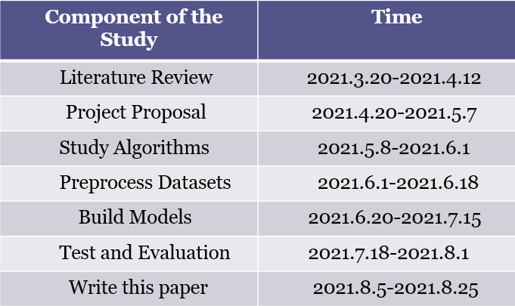

7. Reference List
[1] Savolainen P T,M annering F L,Lord D,et al.The statis- tical analysis of highway crash injury severities: are- view and assessment of methodological alternatives［J］,Accident Analysis & Prevention,2011,43 (5): 1665 -1667.
[2] Abegaz T,Berhane Y,Worku A,et al.Effectiveness of an improved road safety policy in Ethiopia: an interrupted time series study［J］.BMC Public Health,2014,14(1): 539.
[3] He Qing, Li Ning, Luo Wenjuan, etc. Overview of machine learning algorithms under big data［J］.Pattern recognition and artificial intelligence, 2014,27( 4) : 327-336．

[4] Nayak R N, Piyatrapoomi N, Weligamage J. Application of text mining in analysing road crashes for road asset management［C］.Proceedings of the 4th World Congress on Engineering Asset Management.London: Springer,2009: 45-58.

[5] Beshah T, Ejigu D, Abraham A,et al. Knowledge discovery from road traffic accident data in ethiopia: data quality, ensembling and trend analysis for improving road safety［J］.Neural Network World,2012,22 (3) :215-244．

[6] Yang Yanfang. Urban road network traffic flow analysis and prediction and accident early warning methods [D]. Beijing: Beijing Jiaotong University, 2017.

[7] Foreman C, Rey J R, DeAnnuntis C. National transit bus accident data collection and analysis. South Florida University[J]. National Center for Transit Research, Tampa, 2002.

[8] Sun Xiaoliang. Urban road traffic state evaluation and prediction method and application research [D]. Beijing: Beijing Jiaotong University, 2013.

[9] Wang Hongyan, Wang Yong. Multidisciplinary and diversified research on road traffic accidents [C]. 2007 China Automotive Safety Technology International Conference and China Automotive Engineering Society Automotive Safety Technology Annual Meeting, Beijing, China, 2007: 93-97.

[10] Jiao Chengwu. Research on Highway Traffic Safety Systematic Analysis and Evaluation Methods and Improvement Strategies [D]. Changchun: Jilin University, 2007.

[11] Rolison J J, Regev S, Moutari S, et al. What are the factors that contribute to road accidents?An assessment of law enforcement views, ordinary drivers' opinions, and road accident records[J]. 2018, 11(6):11-24.

[12] Nitsche P, Thomas P, Stuetz R, et al. Pre-crash scenarios at road junctions: A clustering method for car crash data[J]. Accident Analysis & Prevention, 2017, 17(1):137-151.

[13] Abdel-Aty M A, Radwan A E. Modeling traffic accident occurrence and involvement[J]. Accident Analysis & Prevention, 2000, 32(5):633-642.

[14] Andersson A K, Chapman L. The impact of climate change on winter road maintenance and traffic accidents in West Midlands, UK[J]. Accident Analysis & Prevention, 2011, 43(1):284-289.

[15] Yu S, Jia Y, Sun D. Identifying Factors that Influence the Patterns of Road Crashes Using Association Rules: A case Study from Wisconsin, United States[J]. Sustainability, 2019, 11(7):19-25.
[16] Nafie A F, Mohamed H A. Usage Apriori and clustering algorithms in WEKA tools to mining dataset of traffic accidents[J]. Journal of Information & Telecommunication, 2018:1-15.

[17] Mazouri F Z, Abounaima M C, Zenkouar K. Data mining combined to the multicriteria decision analysis for the improvement of road safety: case of France[J]. Journal of Big Data, 2019, 6(1):1-30.

[18] Chong M M, Abraham A , Paprzycki M . Traffic Accident Analysis Using Decision Trees and Neural Networks[J]. 2004, 12(2):22-28.

[19] Hu Zhenbo. Data mining of traffic accidents based on association rules [D]. Tianjin: Tianjin University, 2017.

[20] Liu Yunxiang, Han Bei. Correlation analysis of tunnel traffic accidents based on improved FP algorithm[J]. Modern Electronic Technology, 2018,41(7):141-144.

[21] Chen Jingxi. Analysis of traffic accidents based on K-Means [D]. Xi'an: Chang'an University, 2018.

[22] Deng Xiaoheng, Zeng Detian. The cause analysis model of traffic accidents based on AHP and hybrid Apriori-Genetic algorithm[J]. Application Research of Computers, 2019, 36(6):1633-1637.

[23] Jing Liantian. Research on the relationship between non-extreme severe weather conditions and highway traffic accidents[J]. Highway, 2015(1): 114-119.

[24] Kim J J, Kim S K, Ulfarsson G F, et al. Bicyclist injury severities in bicycle-motor vehicle accidents[J]. Accident Analysis and Prevention, 2007, 12(3):238-251.

[25] Hu Ji, Yan Zhangcun, Lu Xiaozhao, et al. Analysis of factors affecting the severity of traffic accidents based on ordered Logit and Probit models[J]. Journal of Safety and Environment, 2018, 18(3):836-843.

[26] Liu Haizhu. Analysis of factors affecting the severity of road traffic accidents and establishment of prediction models [D]. Changchun: Jilin University, 2014.

[27] Zhao S, Khattak A, Wali B, et al. Motor vehicle drivers' injuries in train-motor vehicle crashes [J]. Accident Analysis and Prevention, 2015, 32(5):162-168.

[28] Celik, Ali Kemal, Oktay E . A multinomial logit analysis of risk factors influencing road traffic injury severities in the Erzurum and Kars Provinces of Turkey[J]. Accident Analysis & Prevention, 2014, 25(7):66-77.

[29] Kockelman K, Kweon Y. Driver injury severity: an application of ordered probit models[J]. Accident Analysis & Prevention, 2002, 34(3):313-321.

[30] Delen D, Sharda R, Bessonov M, et al. Identifying significant predictors of injury severity in traffic accidents using a series of artificial neural networks[J]. Accident Analysis and Prevention, 2006(No.3):434-444.

[31] Sohn S Y, Shin H. Pattern recognition for road traffic accident severity in Korea[J]. Ergonomics, 2001(No.1):107-117.

[32] Budiawan W, Saptadi S, Sriyanto, et al. Traffic Accident Severity Prediction Using Naive Bayes Algorithm - A Case Study of Semarang Toll Road[J]. IOP Conference Series: Materials Science and Engineering, 2019(No.3):598-620.

[33] Sun Yixuan. Road traffic accident analysis based on data mining [D]. Beijing: Beijing Jiaotong University, 2014.

[34] Wang Lei, Qiu Feng, Xia Yongxu, et al. Road tunnel traffic accident prediction based on road environmental factors[J]. Tunnel Construction, 2019, 39(8):1301-1307.
[35] Shi Xuehuai, Qi Yong, Zhang Weibin, et al. Traffic accident severity prediction method based on combined model[J]. Application Research of Computers, 2019, 36(8):2395-2399.
[36] Sepulcre M , Gozalvez J , Hernandez J . Cooperative vehicle-to-vehicle active safety testing under challenging conditions[J]. Transportation Research Part C: Emerging Technologies, 2013, 26(3):233-255.
[37] Ruscio D, Ciceri M R, Biassoni F. How does a collision warning system shape driver's brake response time: The influence of expectancy and automation complacency on real-life emergency braking[J]. Accident Analysis & Prevention, 2015, 77c:72-81.
[38] Claudia, Wege, Sebastian, et al. Eye movement and brake reactions to real world brake-capacity forward collision warnings: A naturalistic driving study[J]. Accident Analysis & Prevention, 2013, 58(3):259-270.
[39] Zhang J , Suto K , Fujiwara A . Effects of in-vehicle warning information on drivers' decelerating and accelerating behaviors near an arch-shaped intersection[J]. Accident Analysis and Prevention, 2009, 41(5):948-958.

