Micros Peripherals and Interfaces: Assignment

Contents

Profound impact on
Introduction:
Microcontrollers have had a profound impact on the development of science, technology and engineering and their importance in the modern day cannot be overstated. Used in countless industries for almost any task that one could conceive of, electrical control units for cars, sensors, in factory equipment or even white goods and smartphones. Every modern electronic device has some form of ‘microchip’. ^{[1]} In this paper we will outline simulations end experiments using the PIC16F84A, which is 8 bit, 18 pin, reduced instruction set (RISC) microcontroller having 35 single word instructions.^{[2]}
Section 1:
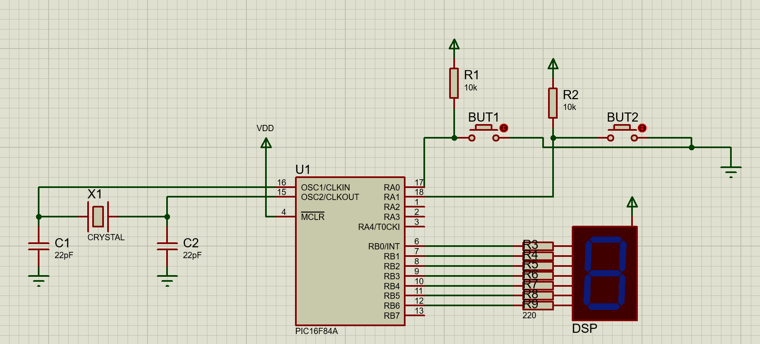
Figure 1: circuit diagram of system to be used, created using proteus, at a high level it's simply two buttons a reference clock a seven-segment display all connected to the PIC microcontroller.
Label | Component Type | Description
X1 | Crystal Oscillator | This delivers a clock signal of DC - 20 MHz clock input to microcontroller.
C1 & C2 | Capacitor | Both 22pF, deliver frequency stabilisation and noise reduction to the clock signal.
U1 | Microcontroller | PIC16F84A, functions as the nerve centre of the circuit, processing code/instructions and logic. The RAx and RBx ports are bi-directional I/O ports. In this case input logic through RA0 and RA1 and output logic RB0-RB6. OSC1/CLKIN is the input pin for the crystal oscillator and OSC2/CLKOUT the output to the oscillator.
R1 & R2 | Resistor | Both 10kΩ resistors, prevent change to logic of inputs.
BUT1 &  BUT2 | Button | Provide the change in input logic to get the microcontroller to do a function.
R3 – R9 | Resistor | All resistors 220Ω, act as a barrier limiting the current between the outputs from RB0 – RB7 and the input pins of the 7-segment display.
DSP | Display | Each of the segment of the display are connected to the output ports RB0 to RB7. Can control output from PIC individually or as a unit via software, to only activate certain segments or display a specific character.

What is a microchip.
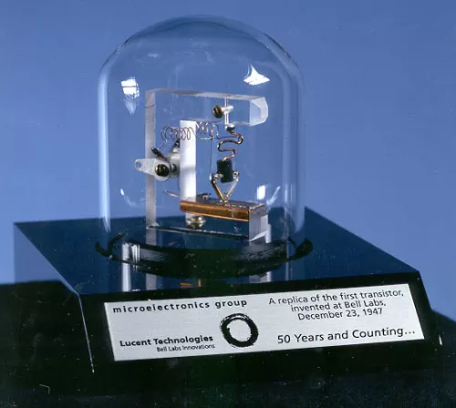
Before the advent of silicon integrated circuits electronics were dependent on large vacuum tubes for logic, whilst functionally the same and easy to handle there is a fundamental limit on available computing power simply due to the size of these compared to silicon transistors.^{[3]}
Figure 2: Replica of the world's first semiconductor transistor, invented at bell labs by physicists William Shockley, Walter Brattain and John Bardeen 1947.[3]
Whilst mostly superseded by more advanced silicon processes the vacuum tube does live on in specific industrial or scientific applications. Featuring prominently in the music world with many musicians swearing off silicon-based amplification for valve/tube amplifiers often at a financial premium, and less functionality but alleged better sound quality than solid-state amplifiers.
A microchip or more generally an integrated circuit (IC) Is an assembly of what would previously be discrete components packed into a single monolithic device.^{[4]} In modern ICs there are billions of transistors, diodes, resistors and capacitors connected in a bewilderingly complex web but the process is still driven by logic gates, it is the further reduction in size and thereby increase in computational density allowing more compute per square millimetre of silicon overtime.

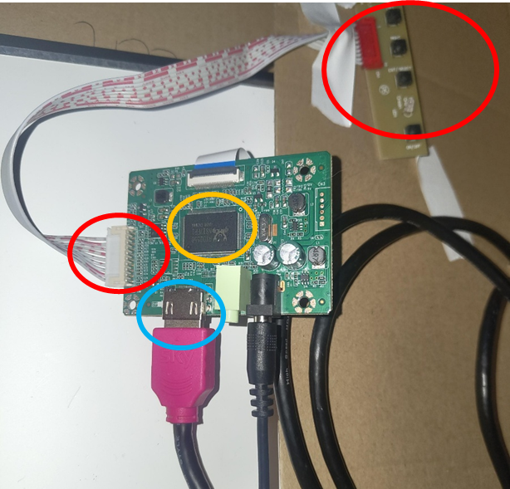
A PIC microchip is a specific family of IC developed by the microchip technology company for use in embedded systems, with the acronym PIC being an elusive term to define. It appeared to evolve over time from peripheral interface controller, programmable interface controller to programmable intelligent computer.^{[5]} The PIC acts as an interface between incoming and outgoing signals for example wanting to display characters on an LED display as in figure 1, the display cannot process the code required on its own and so the microchip or microprocessor process is the instructions that are given outputting the defined signal which can then be understood by the display. This holds true even for modern displays although more complex than a humble 7 segment LED the principle is the same, a modern display still requires an input signal often in the form of display port or HDMI and the input signal needs to be processed by a microchip of some description to be displayed an example in figure 3 below.
Figure 3: An example from the wild, this is the circuit board and microchip (yellow circle), for a NTI56FHM-N41 salvaged laptop LCD. Just like the PIC16F84A and the circuit in figure 1 there are various I/O ports with the logic handled by the central processor. In blue is the input signal for HDMI, in purple is the output to the LCD display being an (eDP) embedded display port cable, in red are the buttons for power and the like analogous to the RA0 and RA1 pins in the PIC.

Keeping Time
Processing hundreds, thousands or even billions of instructions a second, with modern processors well into the GHz^{[6]}, comes with chronological challenges. Requiring the precise and accurate keeping of time or at least accurate within the inertial reference frame of the microchip as moving at relativistic speeds subject to time dilation will play havoc with communications when humanity eventually reaches the stars. ^{[7]} Relativity aside the challenge of having a sensible accurate and reliable reference for microchips comes in the form of piezo electric crystal oscillators. The piezoelectric effect being discovered by the physicists Jacques and Pierre Curie in 1880, is broadly that when a piezo electric material is subject to mechanical stimuli, stress, pressure, compression, or similar there is build-up of an electrical charge and potential difference within the material. It is not one singular field but a build-up of charge because of the displacement of ions through the lattice structure of suitable crystals with the individual unit adding up to form a macroscopic voltage across the crystal lattice.
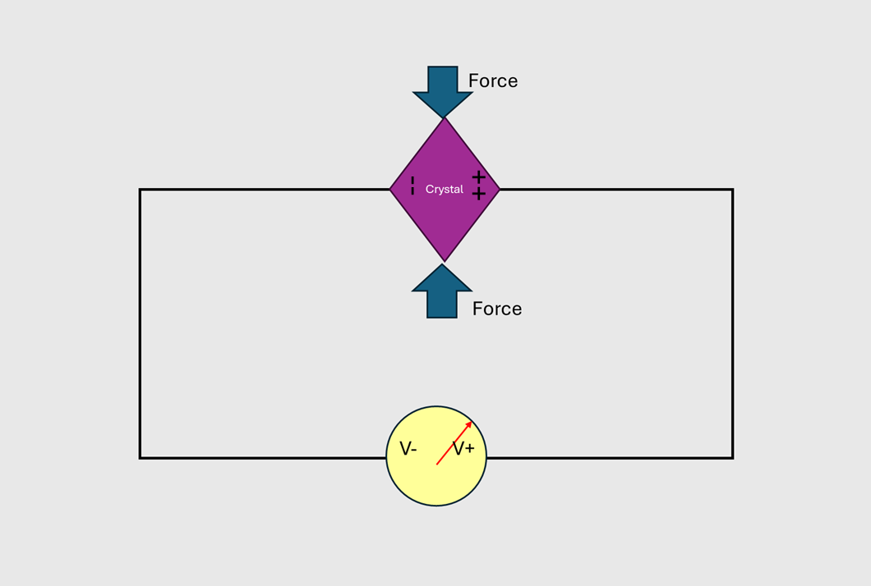
Figure 4: A simplified diagram of the piezo electric effect, the crystal turning mechanical energy exerted on the crystal into electrical energy
Likewise, it follows that one can apply an electric field across said piezo electric material it will deform in a regular and repeatable manner as the individual unit cells that make up the macroscopic crystal are displaced by the movement of ions because of the electric field.^{[8,9]} leveraging this picking a suitable material applying an alternating voltage across it and counting how many times it moves within a given time frame allows the microchip to accurately keep time. Quartz crystals are typically used for this purpose and microchip define the practical frequency range of fundamental mode crystals to be 600kHz to 30MHz.^{[10]}
The 7-Segment Display
The seven segment display is a series of light emitting diodes arranged in a figure of eight allowing for the display of characters by choosing to selectively activate certain parts of the LED array. These are controlled by the RB0-RB7 ports coming from the PIC16F84A. When current flows and I particular voltage is reached the LED will be activated. Seen below in figure 5 and used within the circuit in Figure 1 is a blue common anode display.

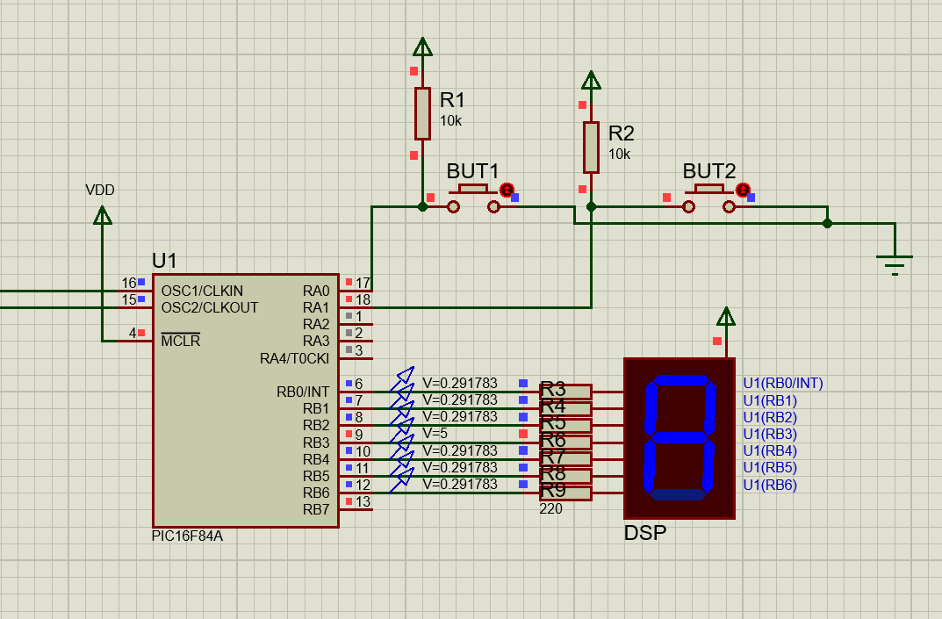
Figure 5: zooming of the circuit showing the display along with the operating voltage of each pin when A is displayed.

From the voltages probed the activated part of the display are responding to an input voltage of approximately 0.3V. Whilst this would seem counter intuitive it is because it is a common anode display, the power is coming in on the pin on top of the display going to the LED segments, the 0.3V is the voltage of the PIC output drawing current to activate the display. This means that the HIGH level logic at 5 Volts deactivates a segment of the display and low level logic voltage activates it. The common anode means that all the seven segments LEDs share is the power terminal on top of the display and the individual cathodes are connected to the resistors.^{[11]} With these seven segments each of which having two distinct states it can be worked out how many individual characters can be displayed.
$$Number of distinct Characters= {Number of segments}^{number of states} \\ Characters=7^{2}=128 \{1\}$$
There are a total of 128 discrete characters that can be displayed.
PIC architecture?
PICs generally and specifically for the PIC16F84A are built on the Harvard architecture.

Fabrication of microchips and gate making silicon process

Section 2:
Explain how to get the circuit to display the hexadecimal characters 0-F on the 7-segment display

Before initialising anything, it is appropriate to reset the system using the reset vector RST following this, the bank selection bit in the status registry RP0 RP1 will also need to be cleared. The next step is to initialise and set the appropriate data direction for the I/O ports, as the output ports to the 7-segment display is connected through the RBx ports we load the W register with zeros then load this into the Trisb register. For TRISB value of 0 tell the PIC that it will be outputting data and a value of 1 that it will be inputting data. If the buttons were to be used to tell the microcontroller when to start, set these as inputs and so TRISA is set to 1 In the same manner.
To stop all the hexadecimal characters trying to be displayed too quickly a delay subroutine needs to be defined needs to be defined. 1st we need to work out the instruction clock speed or the CPU cycle speed which is the frequency of the incoming clock signal divided by 4, as one instruction is run per 4 oscillator cycles in this case 5MHz.
$$Processor Instruction Speed= \frac{Oscilator Frequency}{4}=\frac{20MHz}{4}=5MHz \{2.0\}$$
$$Time Period= \frac{1}{5MHz}=0.2μs \{2.1\}$$
So every instruction cycle takes 0.2us to complete providing the given instruction only requires 1 cycle. This means that a delay can be programmed by making it count down several instruction cycles.
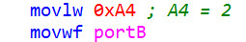
Next the most straightforward way to get the pic to display the hexadecimal alphabet is to create a main loop in which the hex value of the desired character is moved to the working w register and then to port B. For example, the hex value of the number 2 is A4, thereby with the two lines of code:
The PIC will then send the required low/high voltage logic to the appropriate segments:
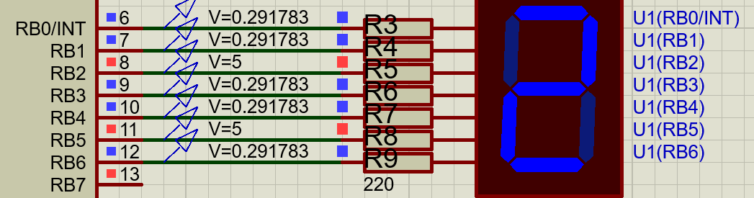
Thus, displaying the character 2, in order to cycle through the hexadecimal alphabet that needs to be the aforementioned call pause after the given code above to stop all characters trying to be displayed at once. Then simply write the next character in the same manner for 3 this would be B0. This process is repeated for all the required characters in this case the number one through to letter F.
Section 3:
Complete tasks 1-6 on assignment {think 1-3 is done} producing flowchart/pseudocode for each one.

Task 1: Display Hexadecimal Alphabet
goto Start
Reset & Start
-Initialisation
- Clear Bank & Ports Set
- Output Port, Port B
Main Loop
- Display Count
- Delay (increment count)
Pause Subroutine
Display Next Character
7-Segment.
Complete?
Pause in-between displays
Yes
No
Repeat Forever
Repeat Main

Task 2: Buttons Display L and r

goto Start
Reset & Start
-Initialisation
- Clear Bank & Ports
- Set Output Port, Port B
Button 1 pressed
0xC7 to Port B
L is displayed
Return to Main Loop
Main Loop
Check Buttons
RA0 = Low
RA1 = Low

Button 2 pressed
0xCE to Port B
r is displayed
Repeat
Forever

Task 3: Buttons Display all or None

goto Start
Reset & Start
-Initialisation
- Clear Bank & Ports
- Set Output Port, Port B
Button 1 pressed
0x00 to Port B
Nothing is displayed
Return to Main Loop
Main Loop
Check Buttons
RA0 = Low
RA1 = Low

Button 2 pressed
0xFF to Port B
All LEDs light up
Repeat
Forever

Task 4: Buttons count up and down:

Bibliography

