

Name: Azhda Ali
Student ID: 2436859
Module Code: LCHS4009
Module: Professional Development within Health and Social Care
Assignment Title: Personal Development
Lecturer: Dr Aishat Bakre

Submitted on: 27/03/2026

Task 1
Job Advertisement – General Practitioner

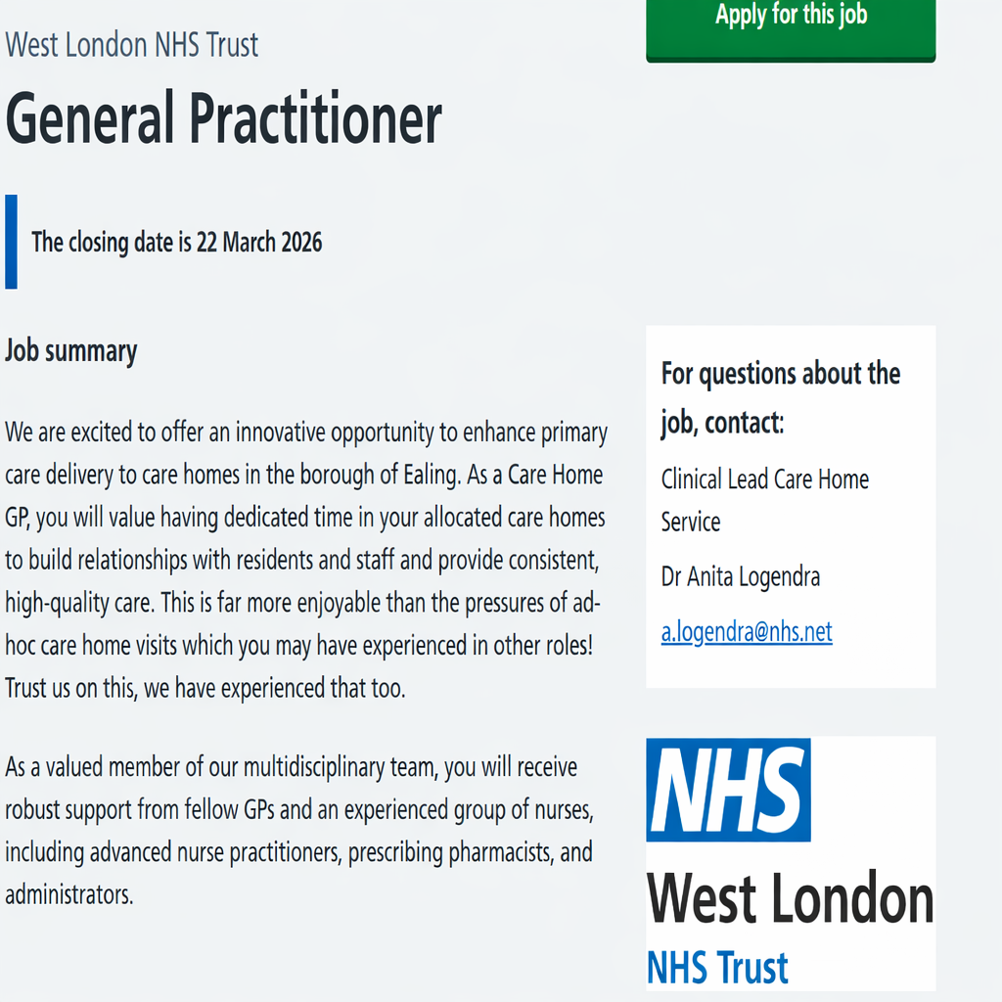
Figure 1: General Practitioner (West London NHS Trust) NHS Jobs (2026).

AZHDA ALI
7 Shakespeare Road, Stafford, ST17 9TY
07455639126 | azhda.ali@hotmail.com
PROFILE
I am a motivated and adaptable individual with effective communication skills and extensive customer-facing experience. I collaborate confidently with people from diverse backgrounds and manage responsibilities effectively in fast-paced environments. I am reliable, organised and able to work independently or as part of a team. I am currently completing a Higher Education in Health and Social Care qualification, with a long-term goal of progressing into nursing.
EDUCATION AND QUALIFICATIONS
University of Wales Trinity Saint David
Certificate of Higher Education
Skills for the Workplace (Health & Social Care)
2025–2026
VFU Chernorizets Hrabar, Varna
Bachelor’s Degree
Public Administration
2007–2012
SOU “Vasil Levski”, Dulovo
High School Diploma (General Education)
1996–2007
WORK EXPERIENCE
Warehouse Operative | Oct 2021 to Present
Wincanton – Screwfix Distribution Centre, Stafford
- Preparing and organising online customer orders with accuracy and efficiency
- Issuing and troubleshooting handheld scanners for staff
- Supporting colleagues with equipment queries and digital processes
- Meeting fulfilment targets in a fast-paced environment
Assistant Manager | Aug 2020 to Sep 2021
Uniqlo Co, Manchester
International retail clothing company known for high-volume operations and customer-focused service.
- Managing daily store operations and supervising staff
- Planning rotas and ensuring compliance with health and safety procedures
- Meeting sales targets and store KPIs
- Overseeing stock control, deliveries and returns
- Training and developing sales advisors
- Handling customer queries, complaints and refunds
- Completing daily paperwork and audits
- Improved team performance through effective training and daily briefings
- Strengthened customer satisfaction by resolving complex queries
Supervisor | Aug 2016 to Aug 2020
Uniqlo Co, London and Manchester
- Training inexperienced staff using structured training materials
- Leading shifts and running the store in the manager’s absence
- Delivering briefings and motivating teams
- Creating rotas and action plans
- Maintaining store standards and monitoring performance
Customer Service Advisor | Dec 2015 to Aug 2016
Uniqlo, London
- Providing excellent customer service and product knowledge
- Training inexperienced staff on fabrics, alterations, and styling
- Supporting visual merchandising and achieving sales targets
COMMUNITY EXPERIENCE / VOLUNTARY
Informal community interpreter and elderly care support (Voluntary)
Independent / Community-based | 2015 – Present
Providing voluntary interpreting support and person-centred elderly care, including help with letters, forms, health information, daily activities and appointments, delivered with confidentiality, cultural sensitivity, empathy and respect.
SKILLS
Adaptability, Communication and Listening, Customer Service, Empathy, Time Management and Organisation, Problem Solving, Teamwork, Leadership, Professionalism, Microsoft Office, General Computer Literacy
TRAINING
First Aid (2020), Fire Marshal (2020), Scissor Lift (2020)
LANGUAGES
English, Bulgarian and Turkish (Fluent)
INTERESTS
Reading about health and wellbeing, walking and outdoor activities, learning languages, cooking, personal development and driving.
OTHER: Full UK Driving Licence
REFERENCES: Available upon request
Task 2
PERSONAL STATEMENT

I am applying for this role because my long-term career aim is to progress into nursing and eventually work as a General Practice Nurse within primary care. I am motivated by the opportunity to support individuals across various stages of life, promote health and wellbeing, and contribute to high-quality, person-centred care. Through my current studies in Health and Social Care, I am developing the foundational knowledge, self-awareness and professional behaviours needed for this pathway. Self-awareness enables practitioners to understand their strengths, limitations and the impact of their behaviour on others (Eurich, 2018), which has helped me reflect on my qualities and identify areas for development.
My educational background includes a Bachelor’s degree in Public Administration and my current Certificate of Higher Education in Skills for the Workplace (Health and Social Care). Studying at Level 4 has strengthened my academic writing, communication and reflective skills, all of which are essential for professional practice. Emotional intelligence is also important in health and social care, as it supports empathy, relationship building and effective communication with service users (Goleman, 2020). Through class activities and assessments, I have developed a clearer understanding of how these skills contribute to safe and compassionate care.
My work experience has provided me with transferable skills relevant to the role of a General Practice Nurse. Working in fast-paced environments such as Wincanton and Uniqlo has strengthened my organisation, teamwork and problem-solving abilities. These roles have also developed my ability to work accurately, manage responsibilities and maintain professionalism, skills that are applicable to healthcare settings. I have further enhanced my communication skills through supporting colleagues, resolving queries and managing daily operational tasks. Effective communication is a core requirement in health and social care, as it supports trust and positive relationships with service users (Northouse, 2019).
Alongside my employment, I have gained informal experience through voluntary interpreting and providing support to an older adult within the community across London, Manchester and Stafford. These experiences have helped me develop empathy, patience and cultural sensitivity, as well as an understanding of the challenges faced by individuals with communication barriers or health needs. This aligns with the values of dignity and respect, which are central to professional practice in the NHS (NMC, 2018).
I am committed to lifelong learning and continuing professional development, which are essential for anyone pursuing a career in nursing (Health Education England, 2021). My current studies have encouraged me to set clear goals for my future development, including improving my academic writing, gaining more knowledge of clinical practice and building confidence in presenting information.
Overall, my motivation, communication skills and experience supporting others provide a solid foundation for progressing into the General Practice Nurse pathway. I am confident that my values, commitment to person-centred care and willingness to learn align well with the expectations of this role. If given the opportunity, I believe I would be a capable and resolute candidate who would contribute positively to primary care while continuing to develop the knowledge and skills required for a future nursing career.

Task 3
SWOT ANALYSIS
A SWOT analysis helps identify personal strengths, weaknesses, opportunities and threats, supporting reflection and guiding development planning (Gürel and Tat, 2017). In health and social care, it is commonly used to assess readiness for future professional roles (NMC, 2018). The following SWOT relates to my progression towards a General Practice Nurse pathway.
Strengths
One of my key strengths is effective communication, developed through customer-facing roles and voluntary interpreting across London, Manchester and Stafford. Effective communication supports trust, clarity and person-centred interactions (Northouse, 2019). I have also developed digital skills through administrative tasks and online learning, and I am empathetic, patient and adaptable when supporting others. My multilingual ability (English, Bulgarian and Turkish) enables me to assist individuals with language barriers. In addition, my Public Administration degree has strengthened my organisational awareness and provided transferable skills relevant to GP and NHS administrative settings.
Weaknesses
My main weakness is limited formal experience in healthcare environments. Although I have effective communication and developing digital skills, I need to build confidence in using healthcare systems and understanding clinical terminology. Self-awareness helps individuals recognise their limitations (Eurich, 2018), and this has highlighted the need to gain practical experience in primary care and continue improving my academic writing.
Opportunities
There are several opportunities to support my development. My Public Administration degree provides a route into GP or NHS administrative roles, which can help me gain experience while progressing through Level 5 and Level 6 studies. I am also exploring short courses such as phlebotomy, venepuncture and IT training to strengthen my employability. Continuing Professional Development (CPD) through organisations such as the Royal College of Nursing (RCN, 2021) can further support my progression towards the General Practice Nurse role.
Threats
Potential threats include competition for NHS roles and balancing work, study and personal responsibilities. External factors such as financial pressures or changes in recruitment requirements may also affect my progression. Recognising these challenges allows me to plan ahead and remain focused on my long-term aim.
PERSONAL DEVELOPMENT PLAN (PDP)

A Personal Development Plan is a structured process that helps individuals reflect on their skills, set goals and plan their development effectively (Cottrell, 2015). Based on my SWOT analysis, I have identified three key goals for the next year. Personal Development Plans support this process by helping individuals set structured goals and plan their development effectively (Cottrell, 2015).
Build confidence in patient communication and primary care systems
To achieve this, I will apply for administrative or receptionist roles within GP practices or the NHS to gain experience with patient communication and primary care processes. I will use NHS Jobs, GP practice websites, university careers advice and voluntary opportunities to support my development and strengthen my applications. I aim to begin submitting applications in June 2026, and I will review my progress in October 2026.
Complete clinical-related courses such as phlebotomy and venepuncture
To achieve this goal, I will complete accredited short courses in phlebotomy and venepuncture to build foundational clinical knowledge and improve my employability in primary care settings. I will use CPD opportunities, accredited training providers, volunteering and RCN professional development resources to support my progress, as Continuing Professional Development is essential for developing skills for future professional roles (RCN, 2021). I aim to complete at least one accredited course within the next six months and will review my learning after each course using structured reflective models.
Strengthen digital skills for healthcare settings
To achieve this goal, I will complete an IT skills course to improve my digital literacy, including data entry, record keeping and the use of healthcare-related systems. I will use online IT training platforms, university digital skills support and access to healthcare system simulations to develop these skills, as personal development planning helps individuals identify skill gaps and set structured goals for improvement (Cottrell, 2015). I aim to complete the IT skills course within the next six months and will review my digital progress every two months by reflecting on improvements in speed, accuracy and confidence.

Task 4
GIBBS MODEL REFLECTION

Description
Using Gibbs’ Reflective Cycle (1988), I reflected on my recent presentation for this module. The task required me to deliver a presentation explaining a key professional skill, its importance, a relevant model and real-world examples. My lecturer observed the presentation and later provided written feedback, which included marks for engagement with literature, knowledge and understanding, cognitive skills, practical skills and transferable skills. The feedback highlighted strong use of credible literature, clear explanation of concepts, accurate model application and well-designed slides, as well as areas for improvement such as proofreading, expanding acronyms and developing greater confidence during delivery.
Feelings
Before the presentation, I felt relieved to have arrived on time but still internally rushed because of the travel disruption. During the presentation, I noticed that I was speaking slightly faster than usual, which made me unsure whether I had explained all points clearly. After receiving the feedback, I felt pleased with the positive comments, especially regarding my literature use, model application and slide quality. At the same time, I recognised that my nerves and minor academic errors had affected my overall performance.
Evaluation
There were several positive aspects. My lecturer stated that I demonstrated “impressive understanding of the assessment” and used “an excellent range of relevant and credible literature,” which confirmed that my preparation was strong. She also noted that I addressed all parts of the brief, applied the model well and provided practical examples. My slides were described as “excellent,” and I maintained professionalism throughout.
However, there were also areas that did not go as well. My lecturer advised me to practise more to improve my confidence, as this would help me present to an outstanding level. She also highlighted the need to proofread carefully and expand acronyms on academic writing. These comments showed that while my content was strong, my delivery and accuracy needed improvement.
Analysis
Reflecting on the experience, I recognise that my nervousness was influenced by the stressful journey and my fear of being late. Emotional responses can affect performance and developing self-awareness helps individuals understand how their feelings influence their actions (Eurich, 2018). The lecturer’s feedback confirmed that my academic preparation was strong, but my delivery was affected by nerves. The issues with proofreading and acronyms also showed the importance of mindfulness in academic work. Research suggests that anxiety can reduce clarity of speech and affect the ability to process information during presentations, which helps explain why I spoke faster than planned (Moon, 2020). Effective communication requires confidence, clarity and appropriate pacing, and this experience showed how emotional pressure can impact these skills (Northouse, 2019). I also realised that although my content was well prepared, I had not rehearsed enough to manage my nerves, which limited my ability to deliver the presentation as confidently as I intended.
Conclusion
Overall, I learned that strong content must be supported by confident delivery and accurate academic writing. I also realised the importance of preparing myself calmly before presenting to avoid rushing or speaking too quickly. The feedback confirmed that I met the assessment requirements well but highlighted clear areas for improvement.
Action Plan
To improve, I will practise presentations in advance, arrive earlier to reduce stress and speaking at a steady pace. I will also review citation and referencing guidelines, expand all acronyms and proofread my work more carefully. Reflection supports ongoing learning and professional development (Moon, 2020), so I will continue using this model to strengthen future presentations.

REFERENCE LIST
Cottrell, S. (2015) Skills for success: Personal development and employability. 3rd edn. London: Palgrave Macmillan.
Eurich, T. (2018) Insight: The surprising truth about how others see us, how we see ourselves, and why the answers matter more than we think. London: Macmillan.
Gibbs, G. (1988) Learning by doing: A guide to teaching and learning methods. Oxford: Oxford Polytechnic.
Goleman, D. (2020) Emotional intelligence: Why it can matter more than IQ. 25th anniversary edn. London: Bloomsbury.
Gürel, E. and Tat, M. (2017) ‘SWOT analysis: A theoretical review’, Journal of International Social Research, 10(51), pp. 994–1006.
Health Education England (2021) Lifelong learning and professional development in healthcare. Available at: https://www.hee.nhs.uk/ (Accessed: 15 March).
Moon, J. (2020) Reflection and employability: Reflection on learning and reflective practices. London: Routledge.
NHS Jobs (2026) General Practitioner – West London NHS Trust. Available at: https://www.jobs.nhs.uk/candidate/jobadvert/C9222-26-0180 (Accessed: 15 March).
Nursing and Midwifery Council (2018) The Code: Professional standards of practice and behaviour for nurses, midwives and nursing associates. London: NMC.
Northouse, P. (2019) Leadership: Theory and practice. 8th edn. London: Sage.
Royal College of Nursing (2021) Professional development resources. Available at: https://www.rcn.org.uk/ (Accessed: 15 March).

