Student Name: Yasmeen Begum
Student Number: 2119725
Lecturer Name: Besty Jose
BMSW4004_BIRM
Problem-solving and Decision making

Table of Contents

Introduction 3
Nature and impact of the complex problem on employees and their organizations 4
A research-informed discussion on the nature and impact of the complex problem on employees and their organizations 5
SWOT Analysis 6
PESTLE Analysis 7-9
A research-informed cause-and-effect analysis, using Fishbone Diagram, of the complex problem. 10
Fishbone diagram 11
An evaluation of alternative solutions to absenteeism with an aim of choosing the most appropriate solution among these alternatives 12
Implementation of decision making 13

Measurement of the effectiveness of decision-making 14

Conclusion 15
References 16

INTRODUCTION
In this report, we will be looking at the staff shortages at an organization called proper care UK. We will be looking at the scope of the problem. what are the main impacts and the challenges? Will be looking at the main 4 key factors which include the Pestel analysis and at fishbone diagram. We will also be seeing what implementation and measures can be implemented. Also seeing what strengths and opportunities and weaknesses the organization has. The healthcare problem is increasing in the UK day by day, and the impact of those problems is too high to manage for Proper Care in the UK. The NHS hospitals, community, and mental health care workers are concerned that the shortage of FTE staff is the biggest issue in Proper Care. However, nursing challenges, staffing issues, and medical problems are the biggest problems that have been increasing day by day. Those kinds of workforce challenges are facing the biggest threats in the UK.
.

Nature and impact of the complex problem on employees and their organizations

Scope of the problems is mainly Staff shortages. Unfortunately, staff shortages are issues everywhere. Not in just care homes but also in any industries but is staff shortage just based in the UK or worldwide? according to (Roth et al., 2022) Nursing shortages are becoming more common around the world, highlighting the need to create more efficient strategies to recruit and retain nurses. The goal of this study was to learn about the variables that maintain German nurses in the profession and to learn about their perspectives on the reasons that cause nurses to leave or stay in the profession.
When there are staff shortages, we also have to see who it affects as part of the care home. it affects the whole company because it then affects the patients and put them at risk by not getting the full accurate care and service that should be provided at this care home. The main function of the Proper Care organization is based on the providence of adult care to the population in the UK. According to (Sun et al. 2020). Therefore, the several workforce challenges affect both staff and the patient in the organization. Therefore, the issue of the shortage of nurses will influence the quality of the care and the overall sustainability of the service.
The workforce challenges like nursing challenges, staff shortage issues, and shortage of FTE staff issues are the most threatening issues, which have been faced by Proper Care mainly in the Covid-19 pandemic situation.: which has been a big impact on staff shortages, according to (Xu, Intrator and Bowblis, 2020) During the coronavirus pandemic, these staff shortages issues have only gotten worse for NHS. Because their profession involves constant interaction with locals, the workers did not have

A research-informed discussion on the nature and impact of the complex problem on employees and their organizations
staff shortage is not just an issue in the United Kingdom. as researched it is worldwide. Due to many factors. Long-time factors could be less pay. And benefits. motivation. and now the latest one which is covid 19. which had a big impact everywhere worldwide as well. as the impact also affects the family. Who might cant come and visit due to staff shortages which then the service to clients can be affected .according to (Nyashanu, Pfende, and Ekpenyong, 2020) A shortage of employees in an organization is obvious to increase the burden on the existing employees? A low workforce means more work pressure because the work is not able to get divided into the number of parts it requires. Eventually, this will have an effect on the performances of the employees who would otherwise work effectively.

Impact on care quality
As the finds in the case scenario suggested, the Proper Care organization in the UK is facing Staff issues at a tremendous level. Therefore, it was significantly affecting the quality of care of the patient. Due to the lack of nursing staff, the time of the adult acre was shortened. On the other hand, few patients are returned due to a lack of nursing staff.
Workforce challenges
The Proper Care UK set a plan for improving healthcare for a long time. The shortage of FTE staff nurses influences their long-term ambition. Due to that reason, the employees within this organization have faced risk factors.
Mainly the pressure in work, is an uphill struggle Due to these staffing issues, mainly the GPs have fallen down.

A SWOT framework can also identify internal and external factors.SWOT ket facts are strengths, weakness, opportunities, and threat. strengths and opportunities are positive factors where weakness and threat are negative factors. strengths and weakness are internal factors and opportunities and threats are external.
1.strengths key points,opportunity,locations.resoures,clients satifactions.well trained staff.
2.weakness key point,staff shortage,high turnover.poor service.management weakness.
3.opportunities key points,progress.technology chage.staff training.
4.threats key point,reduce funding.government policy.competitors competition.

A pestle analysis of the macro-environmental factors contributing to the complex problem.
From the above analysis, it can be noticed that the main issue that has been encountered by Proper Care and other mental and community groups in the UK is the staff shortages and “Workforce challenges.” Several kinds of factors are responsible for increasing these issues. All of those factors have been evaluated here by describing the PESTLE analysis.
A Pestel analysis is a breakdown of key external factors of a organization, which has six main bullet points
1 Political.
. according to (marketingtutor.net, 2022). The broader “migration policies'' of BREXIT have made a great impact on the recruitment of staff. However, medical equipment and medicine equipment has come to the UK from different parts of the EU. For this BREXIT issue, the disruption has been made for dealing with the lack of medicine. That can affect the UK organization. Following the BREXIT issue, the workforce has faced staff scarcity for the lack of skilled workers

2 Economic :
According to (Drennan and Ross, 2019), it can be stated that during the COVID-19 pandemic situation, for the economical lack, the shortage of nurses has been located in the organizations in the UK. The economic factors are too much in raising these issues. For the economical crash of 2008 in the UK, the organizations and their management have faced several kinds of difficulties. The economic fallout can influence maintaining the organizational standard. For the lack of resources and several kinds of economic regulations, the organization is under pressure to reduce its salaries. Due to that reason, the shortage of skilled staff retention and the resignation of staff within the organizations have increased.

3 Social
According to( Johnson et al. 2018), it can be stated that different types of causes, tends, well-being staff, and burnout in the healthcare workforce can be the main reason for the shortage of staff in the organizations in the UK. However, added pressure mainly in the organization and the current state make it a great difficulty to provide quality treatment that can influence the staff shortage. However, the socio-cultural impact also influences healthcare organizations by giving low-quality services. Following this shortage of staff in the healthcare system, the service provider has been hampered.

4 Technological
According (marketingtutor.net, 2022). Technological factors only can improve staff retention by providing a “medical education system”. The NHS healthcare system can achieve many benefits by operating well-skilled staff. Due to that reason, the healthcare sector can easily deal with this problem. The organizations can easily give the training for improving skills and pieces of knowledge from being a well-being staff through this system that can make a positive impact on reducing these stuffing issues.

5 Environmental: ARE WEATHER CHANGE.THE ENIVIRMOMENT CHANGE.AS PLANNING IS IMPORTANT IN THIS FACTORS.A LOT OF STAFF SHORTAGES.
According to(marketingtutor.net, 2022).
The toxic environment within the UK organization has put huge pressure on all of the medical organizations in the UK. Along with this, the cause of waste disposal through the global crisis causes some diseases in the healthcare organization. Due to that reason, the resignation among staff has increased, affecting the shortage of staff.

6 Legal : WHICH IS LEGAL DOCUMENTS,SUCH AS DBS(DISCLOSURE AND BARRING SERVICE..SATFF AS NEED RISK ASSESMENTS ALSO DATA PROTECTION
Different kinds of legislation cases highly affect the shortage of staff in the organizations.

PESTAL ANALYSIS (PROPER CARE UK)
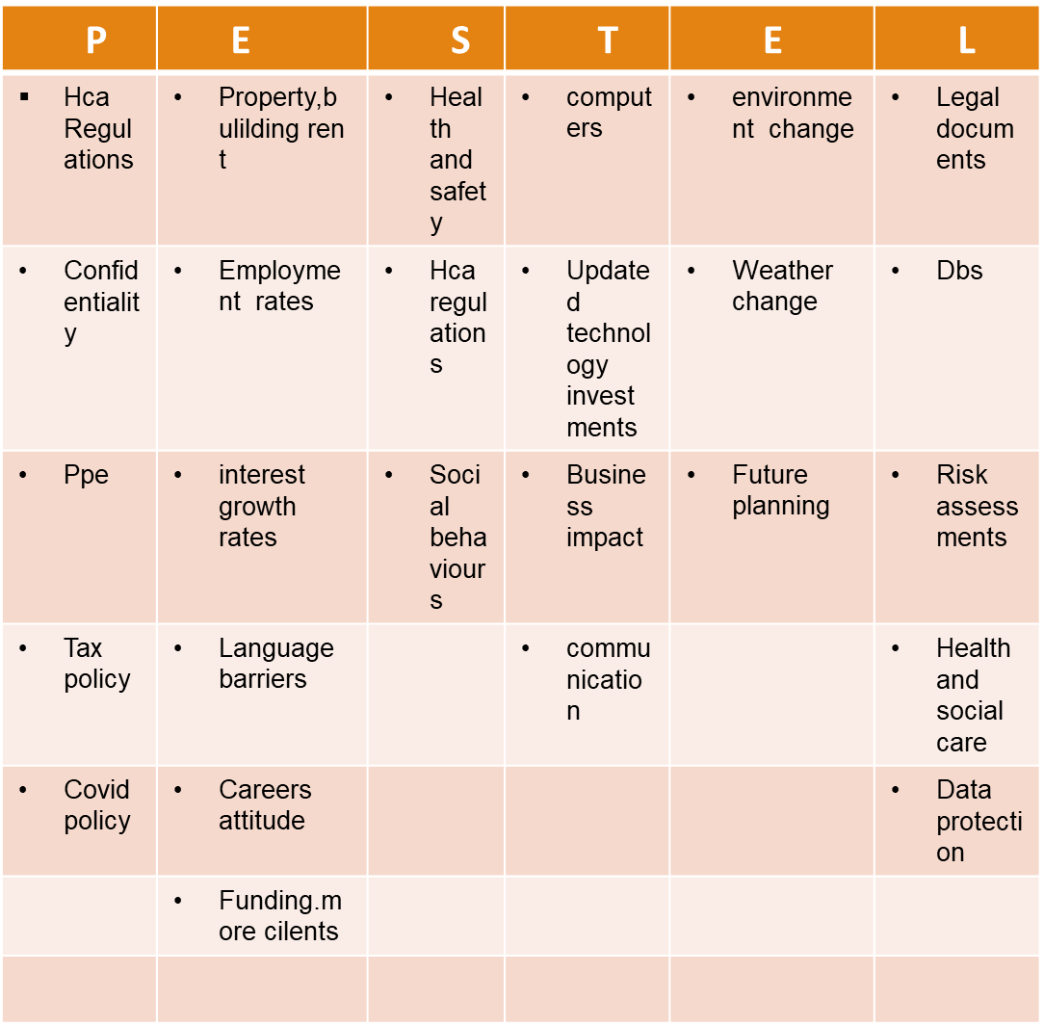

A research-informed cause-and-effect analysis, using Fishbone Diagram, of the complex problem.
From the FISHBONE analysis, mainly the cause and effects of the main problem can be demonstrated. In this report, the FISHBONE analysis has stated the cause and the effects of the staffing issues at proper care UK. it can be stated that the main cause of the staffing issues for the Proper Care organizations is recruiting problems, staff resignation, and huge working burnout and workforce issue. Based on the case study analysis, it can be stated that the lack of proper recruitment can be the main factor that influences staffing shortage. According to (wade,2020)From the analysis of the case study, it can be stated that the economic downfall can make a great impact on the requirements of staff in the healthcare sector. According to (Reicher and Drury, 2021) However, during the COVID-19 pandemic situation, the proper training cannot be given and based on the protocol maintenance a shortage of employees has been seen. The huge working pressure causes many problems that can affect the resignation of staff this kind of impact can affect giving proper care quality.

FISHBONE DIAGRAME
Poor quality of
Treatment
Less amount of involvement of management within the process
Lack of future sustainability of services
Lack of nursing staff
Overall management issue

Workforce challenges
Staff shortages at proper care
Less motivation at work and poor infrastructure
Lack of knowledge, training, and skills
Lack of discipline
Heavy workload
Poor attitude, demotivated staff
Monotonous activities
Unhappy patients
Outdated processes
No environmental surveillance in the workplace
Poor quality offices
Resignation of staffs
Lack of well-being staff
Problems in recruiting staff

Excessive work pressure

Low vacancy rate
BREXIT lowering the net inflow
Deterioration in the care provision

(DRENNEN-ROSS
2019)
(Ismainar and Mishbahuddin, 2021)

(Ma et al., 2021)

An evaluation of alternative solutions to absenteeism with an aim of choosing the most appropriate solution among these alternatives

From the overhead evaluation, it can be noted that the Proper Care organizations and other community and medical services have encountered mainly staffing issues. For reducing the staffing issues, mainly some of the major steps need to be taken for making a solution to absenteeism of these issues.
Giving proper training
Proper Care needs to give proper training to its staff for improving the care quality. The improvement of care quality can potentially influence implementation service sustainability in the future.
Improving requirement
Apart from this, they need to improve the requirement process. The proper recruitment helps in reducing the issues in Proper Care . As the vacancies are rising to 110000, so they need to implement proper staff for vacancies of FTE jobs. However, by increasing the number of staff and well-skilled healthcare professionals,
Implementation of “best place to work”
The implementation of this rule can reduce the staff minority from some types of ethnic groups. However, proper requirements with the right skills can help in improving the workforce strategy

PMI SOLUTION TRAINING
plus | minus | intrested
Staff would gain more knowledge +8 | Funding -4 | Progress in a higher position +6
Staff would perform better +6 | Staff shortages -8 | Confidence +6
Builds up skills and confidence +8 | Stressful -3 | Team work + 6
Updated rules and regulations +8 | Time consuming -5
Progress in career +6
Total + 36 | Total - 20 | Total + 18

Implementation of decision making
The implementation of this decision needs to be taken by the Proper Care organizations in the UK that can reduce the issues. Some of the major implementation ways need to be taken that help in achieving the ambition.
Prioritization
For reducing the impact, mainly the scale of challenges needs to be measured, and implementing multiple types of training opportunities can reduce the challenges. According to (Buchan et al. 2019). staff retention is proper and training routes need to be prioritized. If all of those can be implemented, then the flexible working progress and the career opportunities can be improved which can reduce the staffing issues.
Implementing the proper way of recruiting
The proper requirement is one of the main issues, which have been faced by the healthcare sectors in the UK. They need to hire proper staff in the proper workplace. If this implementation has been done, then helps in increasing job satisfaction. the proper relationship between healthcare staff and the workforce can then be done,
Proper training
According to (Iyengar et al. 2020). The implementation of proper training helps in improving the professional activities of medical staff that help in improving the care quality. The proper learning and planning theories help in reducing the staff shortage. the proper training can be given to the medical staff by proper recruiting.

Measurement of the effectiveness of decision-making

For measuring the effective decision after proper decision-making, mainly the proper outcomes need to be measured. The lack of proper training can be reduced by giving proper training that is improving medical education. Due to that reason, the proper recruitment of staff can be improved. According to (Nyashanu et al. 2020). for reducing the workforce challenges, prioritization needs to be implemented that helps in focusing on the long-term ambition that helps in improving the recruitment process. the right implementation of staff in the right place helps in improving job satisfaction that helps in reducing staff shortages.

CONCLUSION
From the above analysis, it can be conclusively stated that the main problem that has been faced by the Proper Care organization. and another community and mental health sector is based on staffing issues. That can make a significant impact on their economical and service provision downfall. The proper requirement is the biggest problem for those organizations. Mainly the economical and BREXIT issue is the biggest factor that affects most on this issue. For reducing these issues, proper implementation of medical staff and proper training can help in reducing all those issues
References
healthcare staff well‐being and burnout: A narrative review of trends, causes, implications, and recommendations for future interventions.International journal of mental health nursing, 27(1), pp.20-32. Bowblis, J.R. (2020). Shortages of Staff in Nursing Homes During COVID-19 Pandemic: What Are the Driving Factors? Journal of the American Medical Directors Association, 21(10). doi:10.1016/j.jamda.2020.08.002.
Buchan, J., Charlesworth, A., Gershlick, B., and Seccombe, I., 2019. A critical moment: NHS staffing trends, retention, and attrition.London: The Health Foundation.
Drennan, V.M. and Ross, F., 2019. Global nurse shortages: The facts, the impact and action for change. British medical bulletin, 130(1), pp.25-37
Hu, X., Yan, H., Casey, T. and Wu, C.H., 2021.Creating a safe haven during the crisis: How organisations can achieve deep compliance with COVID-19 safety measures in the hospitality industry.International Journal of Hospitality Management, 92, p.102662.
Iyengar, K.P., Jain, V.K., Vaish, A., Vaishya, R., Maini, L. and Lal, H., 2020. Post COVID-19: Planning strategies to resume orthopaedic surgery–challenges and considerations. Journal of Clinical Orthopaedics and Trauma, 11, pp.S291-S295
. Ismainar, H. and Mishbahuddin, M. (2021). Family Planning Unmet Need; Determinant Factors and Strategy Design through Health Management Approach and Fishbone Analysis in Riau Province, Indonesia. Technium Social Sciences Journal, 26, pp.749–760. doi:10.47577/tssj.v26i1.5231.
Johnson, J., Hall, L.H., Berzins, K., Baker, J., Melling, K. and Thompson, C., 2018. Mental
Ma, E., Kritsimali, A., Olby-Clements, B., Boyd, K. and Demirbasa, B. (2021). Innovative Staffing Solutions to Nursing Shortages in Acute Mental Health Inpatient Wards. Issues in Mental Health Nursing, pp.1–8. doi:10.1080/01612840.2021.1961331.

Nyashanu, M., Pfende, F. and Ekpenyong, M., 2020. Exploring the challenges faced by frontline workers in health and social care amid the COVID-19 pandemic: experiences of frontline workers in the English Midlands region, UK. Journal of Interprofessional Care, 34(5), pp.655-661.

Reicher, S. and Drury, J., 2021.Pandemic fatigue? How adherence to covid-19 regulations has been misrepresented and why it matters. BMJ, 372.
Roth, C., Wensing, M., Breckner, A., Mahler, C., Krug, K. and Berger, S. (2022). Keeping nurses in nursing: a qualitative study of German nurses’ perceptions of push and pull factors to leave or stay in the profession. BMC Nursing, 21(1). doi:10.1186/s12912-022-00822-4.

Sun, J.J., Perera, B., Henley, W., Ashby, S. and Shankar, R., 2020.Seizure and Sudden Unexpected Death in Epilepsy (SUDEP) characteristics in an urban UK intellectual disability service.Seizure, 80, pp.18-23.

Wade, D.T., 2020. Rehabilitation after COVID-19: an evidence-based approach.Clinical medicine, 20(4), p.359.

. websites
marketingtutor.net, 2022, PESTLE Analysis of the NHS,available at: https://www.marketingtutor.net/pestle-analysis-of-the-nhs/[Accessed on: 27.06.2022]

