
Constantin Polgar 2116259

Changemakers: Creativity and Value Creation

Content Page
Task 1 – Research Question…………………………………………. Pg.1-2
Task 2 – Research Techniques………………………………………Pg.3
Task 3 – Presentation of Idea………………………………………. Pg. 3
Task 4 – Data Analysis…………………………………………………. Pg. 4
References

Research Question: Why do Leaders eat last?
Intrigued by the title of the book “Leaders eat last” by Simon Sinek along with somewhat slow progress in the transition process from management to leadership within organizations, I decided to dive deeper, conduct research, and answer the question: Why do Leaders eat last? what he means by that, and at the same time demonstrate the need of this transition.
This intends to highlight the value of a leader in an organization as opposed to a manager.
Sinek (2011) said, ‘‘A way of thinking, acting, and communicating that gives some leaders the ability to inspire those around them’’. Also, he gives Bill Gates as an example, Bill Gates is not the most energic speaker as he is shy, and he doesn’t rally a room when he speaks, he inspires it, and people hold their breath while he speaks.
According to the World Health Organization (2022), twelve billion working days are being lost globally each year, due to depression or anxiety and a massive loss in productivity.
A healthy work culture based on inclusion, respect, empathy, collaboration, and communication could make a better world and most definitely a pleasant workplace.
Sinek (2017), said that every single employee is someone’s daughter or someone’s son also, ‘Employees are people too’ and companies are responsible for their precious lives, this statement can make full sense under strong cultures, not under control.
According to Morgan (2015), managers focus on control, delegation, process, or efficiency while leaders focus on vision, empowerment, and innovation.
According to Sinek (2017), ‘’Our confidence to do what’s right is determined by how trusted we feel by our leaders’’.
I will be using for this a deductive research approach, as I would like to bring clarity and understanding to the question. I consider this to be more appropriate than an inductive method, as I emphasize this idea and I just want to bring more clarity and value to it rather than creating a new theory.
As stated by Warwick (2016), ‘‘The deductive method seeks to draw valid conclusions from initial premises’’.
This study will be based on a Quantitative approach using closed questions around the idea of transitioning from management to leadership in organizations so, I can clearly conclude if employees agree/sustain the idea or, not.
For this, a primary research method will be used, in the form of a quantitative online survey; the sample size will be 15 and it will be sent out to my colleagues.
I consider this research method more appropriate and capable to provide sufficient information to answer the question and to bring clarity to the research, as opposed to an inductive method which I believe to be a bit too complicated for this, and words would not make a difference or bring so much clarity as opposed to figures therefore on a small scale as this research, clear figures and percentages would show clearly what people think rather than having a sum of different statements leading each in a different direction.
Resistance to change can be challenging and implementation can take time but if an organization accelerate the learning process, it can help leader thrive and bring many other benefits such as strong culture, a strong brand, retaining talent, and speed up the time to perform, (Watkins, 2014).
As seen within the last few years, including during Covid 19 Pandemic, mental health at the workplace is crucial, true leaders inspire, create shared visions, and drive them in a way that becomes a shared vision, they have the power to motivate, include, stand up and maintain employee’s loyalty and a successful shift from management to leadership is essential. (Castrillon, 2021).
As we can observe that the need is there and is beneficial for organizations and employees at the same time, the transition unfortunately is making slow progress. A study from 2021 shows that seventy-seven per cent of organizations report leadership gaps, seventy-nine per cent of people quit, due to lack of appreciation and just over fifty per cent of managers received appropriate training. Also, a shocking twenty per cent or less of the organizations have a bench of leaders ready to fill important roles, (Johnson, 2021).

Task 2 – Research Techniques

PRIMARY RESEARCH
The Problem identified is the transition from management to leadership in organizations is rather slow in accordance with its importance. Could it be that organizations aren’t providing enough support and training or just simply are not interested due to costs or, perhaps managers have a strong resistance to change?
For this matter, the primary research method chosen is deductive as it will provide good answers to concerns on the need for this transition.
Please find below the link to access the survey for an in-depth analysis.
https://forms.office.com/pages/designpagev2.aspx?lang=en-GB&origin=OfficeDotCom&route=MyContent&sessionid=35f762a5-a7a4-47aa-a7f3-b580f271271c&subpage=design&id=-REPTm4EBUWcuNshUjEeIfBd9NfVsHBBmUoksd0oyKJURTJLUFkzMEVSSERRRTA5T0ZOR1ZCQVdFUS4u&analysis=true

SECONDARY RESEARCH
A publication revealed four things to do in the transition from Manager to Leader.
1 Take a step back.
Leaders want to see the big picture; they want to look at the employees and at the same time consider the health of the business. Leaders aren’t concerned with tasks, they create a vision, inspire, and take on challenges focused on long-term growth.
2 Shift your focus outward.
A Leader will not focus on his own performance but on his team, his mindset is to prioritize success and nurture the growth potential of all employees and be responsible for the health of the organization at the same time.
3 Don’t just instruct but inspire.
Leaders effectively communicate the culture of the organization, motivate, appreciate new ideas, and give credit also, this is the way to create loyalty.
4 Communicate big Ideas.
Leaders create wide strategies, and cultures and make sure they communicate effectively and efficiently those ideas to everyone in the company not just management.
They deliver clear, consistent, and transparent messages for the best of the employees. They prioritize goals, missions and visions and make sure that they become shared goals. (B10Space, 2018).
Oxytocin is a chemical for survival and is obtained from the feeling of being loved and trusted or by having a friendship feeling including at work. When we feel trusted and appreciated, we become more social, productive, or more generous (Sinek, 2017).

Task 3 – Presentation on Ideas
Please find below the link for the elevator pitch:

https://uowtsd-my.sharepoint.com/:v:/r/personal/2116259_student_uwtsd_ac_uk/Documents/Recordings/Meeting%20with%20Constantin%20Polgar%20(2116259)-20230615_211644-Meeting%20Recording.mp4?csf=1&web=1&e=J9ziUc

Task 4 – Data Analysis

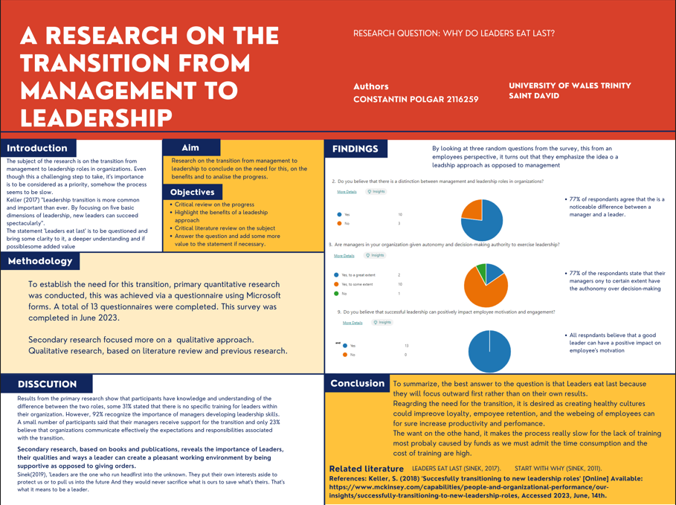

References

B10Space, (2018) ‘4Things to Do When You Transition From Manager to Leader’ [online] Available: https://www.biospace.com/article/4-things-to-do-if-you-want-to-transition-from-a-manager-to-a-leader-/, Accessed 2023, June, 14th.
Castrillon, C. (2021) ‘This Is How To Transition from Manager To Leader’ [Online] Available: https://www.forbes.com/sites/carolinecastrillon/2021/07/18/this-is-how-to-transition-from-manager-to-leader/, Accessed 2023, June, 12th.
Johnson, K. (2021) ‘Recent Leadership Data and Statistics That You Should Know’ [Online] Available: https://www.linkedin.com/pulse/recent-leadership-data-statistics-you-should-know-johnson, Accessed 2023, June, 12th.
Morgan, J. (2015) ‘Why All Managers Must Be Leaders’ [Online] Available: https://www.forbes.com/sites/jacobmorgan/2015/01/21/why-all-managers-must-be-leaders/, Accessed 2023, June, 5^{th.}
Sinek, S. (2017), ‘Leaders eat last’, United Kingdom: Penguin.
Sinek, S. (2011), ‘Start with Why’, United Kingdom: Penguin.
Warwick, (2016) ‘Inductive or deductive approaches’ [Online] Available: https://warwick.ac.uk/fac/soc/ces/research/current/socialtheory/maps/when/, Accessed 2023, June, 7th.
Watkins, M. (2014) ‘Hit the ground running: Transitioning to new leadership roles’ [Online] Available: https://www.imd.org/research-knowledge/organizational-behavior/articles/hit-the-ground-running-transitioning-to-new-leadership-roles/, Accessed 2023, June, 12th.
Word Health Organization, (2022) ‘Mental health at work’ [Online] Available: https://www.who.int/news-room/fact-sheets/detail/mental-health-at-work, Accessed 2023, June, 7^{th.}

