Professional Career Development
Reflective report

Student name | Alexandra Plumb
Student ID | 2007923
Lecturer name | Sylvia Hoffmann
Module name and code | Professional Career Development  BMSW4005
University Name | University of Wales Trinity Saint David

Table of Contents

INTRODUCTION 3
Lifeline 3
Career plans 4
Self-motivation 4
Learning style 5
Personal development 5
SWOT Analysis 6
Personal development plan (PDP) 6
Recruitment and Selection 7
CONCLUSION 7
Reference list 8
Appendix 1 9
Appendix 2 10

INTRODUCTION
Planning your future represents an essential part of your career, which will help you discover your passion, skills and interests. A career plan includes different steps that will lead to a better job and fulfil your life (Rolfe, 2021).
The report will present the most valuable parts that will help me in my desired future career; it will include a personal development plan for finding the skills that will support me, my learning style, my self-motivation, and a quick action plan for the future. I will outline my career path and look for the needed skills to achieve my goal represented by the Receptionist job.
The report will end with a Reflection exercise about a role play where I was an interviewer and an interviewee.

Lifeline
The lifeline exercise learned at school helped me reflect on my past and present and define my future. In figure 1, I pointed the main events that happened in my life, giving them a high or a low score depending on what impact had positive or negative. The pandemic represents the lowest point in my lifeline, started in 2020. During that time, I have lost my job. It was a situation full of uncertainty. The highest points are when I have started or finished school because I consider that this helped prepare me for life.
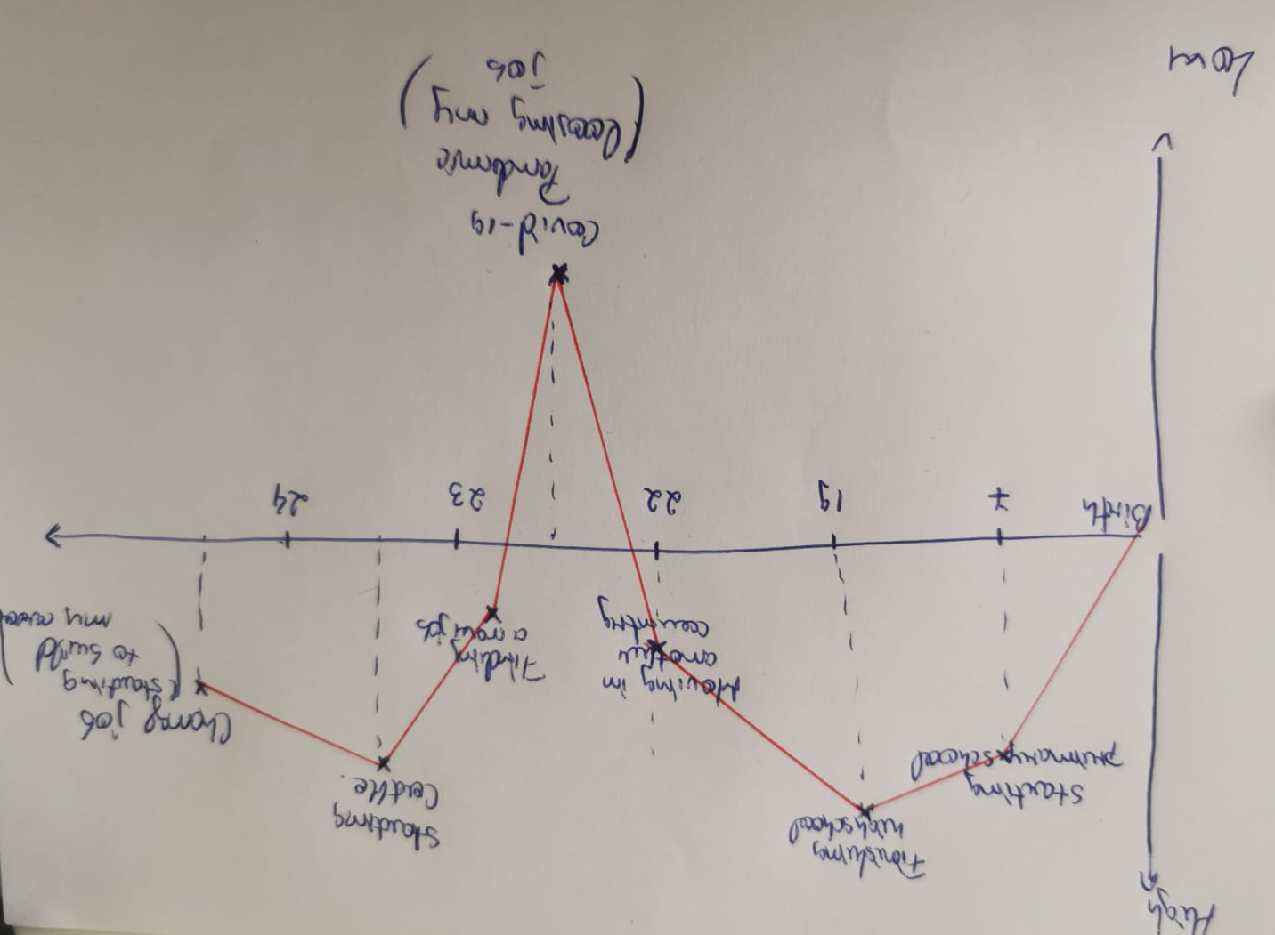
Fig.1: Lifeline diagram (Original)

Career plans
Changing what you do requires a lot of courage and time to think. As we know, a career means more than your profession. A career is related to your daily occupation, what you do during your life (Indeed Editorial Team, 2020).
I have started to wonder what I want to do in my future, to discover what my career looks like. It is challenging and involves a lot of emotion when you decide that what you do is not what you want and to change that. Realising that I wish to have a different career begins with my current job, where I have learned a lot, but I understood that I want more in my life. I started to think about what I should do, what things I like and do not like in my current position and start picturing myself in time.
In five years, I picture myself working in a company as a reception supervisor, coordinating other people, and having at least two years of experience in the job. I picture myself living in a geographical town with a lot of history, allowing me to be close to my friends and family by reducing the travelling time. I consider myself a practical, thoughtful, and kind person, which I believe will help me work better in a team. Kindness represents a strength that helps people build strong connections made by trust (Urban, 2018). My career plans also include the academic part, which will help me grow and reach a better position. After years of working and improving myself, studying at university will lead me to a better job and the desired career.

Self-motivation
Reaching your goals requires all the motivation you can get, but the most important is represented by your self-motivation, which can lead you to the greatest things in life. I am a person who is willing to do lots of things, but some of them remain just dreams because of my level of motivation. The MindTools (n/d) questionnaire about self-motivation said my level is somewhere in between, which requires more effort to improve motivation factors such as positiveness, self-confidence and making strong goals. The questionnaire confirmed that my motivation is low when I need to go to the gym or exercise, making me feel anxious because I know this will improve my health. My low motivation happens more in my personal life because I am a self-motivated person at work; I like to initiate and organise different things to improve my work.
I learned that making strong goals can help you finish a deadline in time or start working in advance. Working on my self-confidence represents the most challenging part that I want to achieve for a better future.

Learning style
Accumulating new knowledge represents learning, which can be done in different ways, specific for every individual in this world. Different categories can define the learning style, and some questionnaires can help you discover every individual type. For example, Honey and Munford’s learning model is based on a questionnaire that makes people discover their learning style with the aid of their perspective of capturing and transforming the information (Dantas and Cunha, 2020). The results of the questionnaire labelled learners as Activist, Reflector, Theorist or Pragmatic.
For discovering my learning model, I have applied two different types of questionnaires. The first one (VAK) shows my best way of learning by seeing things (visual), hearing (auditive) or touching (kinaesthetic), while the second one reveals my method of capturing and transforming the information.
The VAK questionnaire showed that I am a visual learner, and I agree with because I have noticed that I can easily remember a diagram or a picture rather than a written paragraph when I am learning. Also, I have observed that I have elements from the kinaesthetic style, and I believe that I am a combination of the two. For example, I have a passion for origami and this work requires a good visual memory, but to finish the model you need to practice, try by yourself, not just to see how it is done.
Honey and Munford’s questionnaire indicated that I am a reflector who likes to observe things, which became true after I realised that I am not always the one who replies first to the questions at school. I like to observe things first and after that to express my opinions.
I consider that my learning styles could help me in my chosen career; being a receptionist means being aware of what other people need and learning fast; having kinaesthetic memory can help me remember where every paper is, which will help me being an organised person, one of the essential parts in being a receptionist.

Personal development
Planning your future involves developing your knowledges and skills along with your experience. This helps to have a happier life, personal and professional. Thinking about your soft skills and trying to improve them, and developing new hard skills gives you a purpose and a higher dose of confidence (Putter, 2021).
To plan my future, I started with a personal development plan (PDP), and I realised that I need first to see what weaknesses and strengths I have and how they improve or affect my future. I was able to do all of this with a useful tool names SWOT Analysis, which makes you think about what choices you have in life.

SWOT Analysis
In figure 2, I highlighted my main strengths, which lead me to the opportunities and weaknesses connected with my life threats.

Fig.2: SWOT analysis

Personal development plan (PDP)
When I started doing my PDP (Appendix 1), I looked into my future, focusing on my main goal, becoming a receptionist. After setting the goal, I thought about what skills I need, how I will get them, what resources and what obstacles I have, and how long it will take.
The skills that I need are represented by communication skills (writing and verbal), which I will be able to improve by attending the Certificate of Higher Education in skills for the Workplace for one year. Working at the same time to pay my expenses represents the obstacles in achieving my goal. Organisational skills and multitasking will need a lot of practice and to-do list, and I will need resources like more responsibility at work to push me to do more tasks at the same time. The obstacles can be the stress involved and the changes in my schedule that are coming from the exterior for the organisational skills. Both require indefinite time because it involves a lot of practice.
Knowing more about Microsoft Office involves attending a three-month course, with resources like a computer and a Microsoft license. Technical issues and money represent an obstacle.
Customer service has a crucial role in achieving my goal, which I will be able to improve by working in an industry close to people for at least two years.

Recruitment and Selection
Reflecting on what happened during the interview exercise, I will use the Reflective Cycle made by Gibbs, which includes six stages: Description, Feelings, Evaluation, Analysis, Conclusion and Action Plan (Reflection Toolkit, 2020).
Description
In a practical exercise, which was part of our assignment, my colleague and I, took the interviewer and interviewee role. When we first practised, we identified some problems in terms of speaking free on a certain topic. Another issue was the short time to meet before the real presentation.
Feelings
I felt discouraged when we first tried to do the task, and during the presentation, I felt nervous, like I was in a real interview. When I played the interviewer, I liked it most, I tried to make my colleague feel more relaxed, and I started with a small talk about usual things. The hard part when I felt like I need more practice was when I played the interviewee part because I consider that I do not know how to present myself, and I thought that I would fail this piece, as it happens before. It felt like an actual interview.
Evaluation
I believe that both parts of the interviews, when I was an interviewee and an interviewer, went well because we tried to meet before and practised a couple of times. We learn in school that practice can help you, and in my case, I think it helped by making me more confident and relaxed.

Analysis
As Long, J. (2016) says, learning requires practice which is essential for every individual. Reading a new technique does not guarantee that you know the method; first, you need to practice.
I believe that the interview went well for both of us because first, we listened to what our teacher said and showed that there are many valuable tools on the internet to prepare for an interview. Even if we did not practice as many times as we wanted, the presentation went well, and I think we will do well on an actual interview with more practice.
Action plan
In the future, I intend to learn more for a project and to practice more. My self-motivation sometimes is not in the right place and practising more requires time and motivation, which I will try to work on more. You never know what could happen to a real interview, but as we proved with practice, you can know what to say or how to behave in a certain situation.
Conclusion
I learned that practising represents the best method to be good at something, and the hard part when working in a team is finding time to meet and discuss. There is always a chance to succeed with a bit of confidence and desire to succeed from both parts.

CONCLUSION
Having a balance between work and personal life makes things easier for me, and I believe that reaching my main goal, which is represented by becoming a receptionist in my professional life, could make me happier and more relaxed.
Achieving my goal will take time, but I believe that working hard and improving my skills and finding a job in this field of work will help me get there when I have set on my personal development plan. Two years seems a long time, but since I do not have the necessary experience, it will help me develop and learn everything.
In conclusion, planning the future is more complicated than accomplishing the goals, and now after I have learned what I want and set my priorities, I can start working on my weaknesses and improve my skills.

Reference list
Dantas, L.A., Cunha, A. (2020) An integrative debate on learning styles and the learning process, Vol 1, 1. Social Sciences & Humanities Open, https://doi.org/10.1016/j.ssaho.2020.100017.
Indeed Editorial Team (2020) What is a Career? Definition, Paths and Examples. Available at: https://www.indeed.com/career-advice/career-development/what-is-a-career Accessed:29/07/21
Long, J. (2016) The Importance Of Practice – And Our Reluctance To Do It. Available at: https://www.harvardbusiness.org/the-importance-of-practice-and-our-reluctance-to-do-it/ Accessed:01/09/21
MindTools (n/d) How Self-Motivated Are You? Available at: https://www.mindtools.com/pages/article/newLDR_57.htm Accessed: 01/08/21
Putter, M. (2021) What is a personal development plan? Available at: https://cpdonline.co.uk/knowledge-base/business/what-are-personal-development-plans/ Accessed: 02/08/21
Reflection Toolkit (2020) Gibbs' Reflective Cycle. Available at: https://www.ed.ac.uk/reflection/reflectors-toolkit/reflecting-on-experience/gibbs-reflective-cycle Accessed:01/09/21
Rolfe, A. (2021) How to: Make a career plan. Available at: https://www.reed.co.uk/career-advice/how-to-make-a-career-plan/ Accessed: 26/08/21
Urban, E. (2018) The Remarkable Benefits of Kindness at Work. Available at: https://www.linkedin.com/pulse/remarkable-benefits-kindness-work-erin-urban Accessed:07/08/21

Appendix 1
PERSONAL DEVELOPMENT PLAN

NAME | ALEXANDRA PLUMB | Target Job/career  Example: Teacher, Manager, Business Person | Receptionist

TIME PERIOD | From:07/2020 | To:07/2023

What Skills do I need to achieve my goal?
SKILLS | How Will I get them | What resources or support will I need? | What can prevent me from achieving my goals: (unemployment, illness | How long should it take
COMMUNICATION  -writing and verbal  Organisation skills  Multitasking  Microsoft Office knowledge  Customer service | Learning in school (CerHe in Skills for the Workplace)  -building to-do lists  -making plans for the next day  -practising  -learning at school (webinar/online course)  -employment (sales/supervisor store/restaurant) | -resource needed: free time to learn 6  -notebooks or a notepad  -taking more responsibility at work which will place me in a situation where I need to resolve more than one thing at the same time  -computer, Microsoft office license  -a job which placed me in contact with people | -working at the same time to pay bills and rent  -my manager changing the rota  -friends cancelling our plans  -stress  -technical issues  -not enough money for paying the course  - unemployment  -pandemic | -1 year  -indefinite time  -indefinite time, requires practice  -3 months  -2 years

Appendix 2

Interview questions:
Tell me about yourself.
How Did You Hear About This Position?
Why Do You Want This Job?
Why Should We Hire You?
What are your greatest strengths and weaknesses?
Where do you see yourself in 5 years?
How do you handle stress?
Describe yourself in 3 words
What motivates you at work?
What makes you unique?
Why Are You Leaving Your Current Job?

Appendix 3
Application for Employment
Private & Confidential

To ensure that you are able to complete the application form in full, please refer to the short-listing criteria on the job description.
Position Applied For | Receptionist

1. Personal Details
Title | Miss
Surname | Plumb
Forenames | Alexandra

1a. Additional Information
Do you hold a full, clean driving license valid in the UK? |  |  |  | Yes |  |  | No | x
Do you have the right to work in the UK without restriction?  (Proof of right to work in the UK ID will be required) |  |  |  | Yes | x |  | No

2. Employment History
The last 5 years employment should be detailed, including any gaps in employment.
Please continue on a separate sheet if required.

y
Current or Most Recent Employment |  |  |  |  | Y
Employers Name | Raoul’s Deli
Job Title | Delicatessen Assistant
Dates of Employment |  |  | 07/2020 |  |  | present
Reason for leaving | Change of industry
Brief outline of main responsibilities and key duties | Assisting customers to find the goods and products they are looking for  Preparing hot and cold beverages  Being responsible for displaying the products to attract customers  Answering queries from customers  Being responsible for processing card and cash payments  Receiving and storing the delivery of a large amount of stock  Keeping up to date the promotions and advertising new products

3. Formal Qualifications and Training & Development
Continue on a separate piece of paper if required. You will be required to provide original qualification certificates if successful.

Name of Qualification | Date Gained | Level | Grade | Awarding Body
CERTHE  SKILLS FOR THE WORKPLACE | OCT 2021 | 4 | - | -

4. Interests and hobbies

Please provide details of your hobbies / leisure activities / voluntary work
I am interested in reading and long walks in nature. I like to spend time with my friends and discover new places where I can learn new things.
One of my hobbies is origami, and I like to spend my free time relaxing with a piece o paper or a puzzle.

5. Reason for applying

llll

Please detail below reasons for applying for the position including your skills, experience and attributes.
I am applying to the receptionist job in Grosvenor House Suits because:
-I want to work in a company with higher standards
-I believe this company will improve my skills and help me grow professional
-I want to put into practice my organisational and multitasking skills
I have experience in customer services, which I believe will help me work as a receptionist, being all the time in contact with the quests.

Please specify how you meet the criteria for this role.
In my opinion, I meet all the essential requirements. I am friendly, approachable and professional in what I do. I have a good level of English. I also have some basic knowledge of using the Opera system, which is one of the desirable requirements.

