

AN INVESTIGATION OF DATAMINING TECHNIQUES IN E-COMMERCE

by
Inosha Srivarathan
(2218073)

Supervisor: Michael Dacey

Project submitted as part of the requirements for the award of MSc Data Science and Analytics

January 2023

DECLARATION

I, Inosha Srivarathan declare that I am the sole author of this Project; that all references cited have been consulted; that I have conducted all work of which this is a record, and that the finished work lies within the prescribed word limits.
This work has not previously been accepted as part of any other degree submission.
Inosha.S
Signed : .............................................
23-02-2023
Date : ...............................................

FORM OF CONSENT
I, Inosha Srivarathan hereby consent that my Project, submitted in candidature for the MSc Data science and Analytics degree, if successful, may be made available for inter-library loan or photocopying (subject to the law of copyright), and that the title and abstract may be made available to outside organisations.
Inosha.S
Signed : .............................................
23-02-2023
Date : ...............................................

ABSTRACT

This report demonstrates applications of data mining techniques in e-commerce using a Brazilian public dataset. The aim is to extract insights for business strategy. A structured methodology based on CRISP-DM follows a quantitative deductive approach. Literature review provides background on e-commerce evolution and data mining concepts like classification, clustering, association rules. Kaggle dataset containing order transactions is analysed. Data preprocessing handles missing values and transforms features like monetary columns. Exploratory analysis uncovers seasonality and overall trends. Techniques demonstrated include RFM analysis using K-means clustering for customer segmentation. Recency indicates engagement, frequency uncovers purchase habits, and revenue distribution is skewed with top customers generating majority share. Forecasting daily sales volume using ARIMA models achieved 95% accuracy capturing seasonality patterns. Geospatial visualization revealed customer concentrations in southeastern regions, suggesting geographic expansion opportunities. Sentiment analysis classified reviews as 70% positive but 20% negative, highlighting areas needing improvement. Collaborative filtering generated product recommendations with 60% precision based on similarities between customer purchase histories. Isolation forest algorithm detected likely fraud orders with 0.35% contamination rate. The techniques provide powerful analytical capabilities around personalization, churn risks, demand shifts and pain points. However, handling big data complexity remains challenging. Overall, data mining unlocks immense business value from transactional datasets. But it requires cross-disciplinary skills spanning machine learning, statistics and business acumen for impact. While demonstrating current practices, the report also outlines enhancements through emerging deep learning, transfer learning and graph mining algorithms. With e-commerce expanding exponentially, analytics and data science will drive the next innovations. This research aims to advance techniques tailored for e-commerce while guiding adoption.

List Of Abbreviations
CRM - Customer Relationship Management
KDD - Knowledge Discovery in Databases
EDA - Exploratory Data Analysis
RFM - Recency, Frequency, Monetary Value
ARPC - Average Revenue Per Customer
ARIMA - Autoregressive Integrated Moving Average
PCA - Principal Component Analysis
ANN - Artificial Neural Networks
CNN - Convolutional Neural Networks
RNN - Recurrent Neural Networks
LSTM - Long Short Term Memory
NLP - Natural Language Processing
SMOTE - Synthetic Minority Oversampling Technique
IoT - Internet of Things
AI - Artificial Intelligence
ML - Machine Learning
API - Application Programming Interface
ROI - Return on Investment
KPI - Key Performance Indicator

Table of Contents
ABSTRACT 3
Chapter 1 Introduction 9
1.1 AIM 10
1.2 Objectives 10
1.3 Data Overview and Preprocessing 10
1.4 Market Basket Analysis 12
1.5 Customer Segmentation 13
1.6 Churn Prediction 14
1.7 Recommendation Systems 14
1.8 Fraud Detection 15
1.9 Forecasting 15
Chapter 2 Literature Review 17
2.1 E-commerce and Data Mining 18
2.2 E-Commerce Landscape and Evolution 19
2.3 Data Mining - Definition, Process and Techniques 20
2.4 Data Mining in E-Commerce 21
2.5 Research Directions in E-Commerce Data Mining 22
Deep Learning and Neural Networks 22
Transfer Learning 22
Graph Based Mining 23
Clickstream Analysis 23
Privacy Preserving Mining 23
Chapter 3 Methodology 25
3.1 Research Methods 25
3.2 Research Process 27
3.2.1 Business Understanding 27
3.2.2 Data Understanding 27
3.2.3 Data Preparation 27
3.2.4 Modelling 27
3.2.5 Evaluation 27
3.2.6 Deployment 28
Chapter 4 Implementation 29
4.1 Data Loading and Preprocessing 29
4.2 Exploratory Data Analysis 30
4.3 RFM Analysis 32
4.4 Sales Forecasting 35
4.5. Geospatial Analysis 36
4.6 Sentiment Analysis 36
Chapter 5 Results 38
5.1 Exploratory Data Analysis 38
5.1.1 Monthly Active Customers 38
5.1.2 Monthly Orders Volume 40
5.2 RFM (Recency, Frequency, Monetary) analysis 42
5.2.1 Recency Analysis 42
5.2.2 Frequency Analysis 44
5.2.3 Revenue Analysis 44
5.2.4 Overall RFM Segmentation 45
5.2.5 Why RFM Analysis is Vital 47
5.2.6 Automated Clustering 47
5.2.7 Actionable Segment Profiles 47
5.2.8 Customized Strategies 48
5.3 Sales Forecasting 48
5.3.1 Importance of Forecasting 49
5.3.2 Inventory and Supply Chain Management 49
5.3.3 Marketing and Promotions Planning 49
5.3.4 Financial Planning and Goal Setting 49
5.3.5 Anomaly Detection 49
5.4 Geospatial Analysis 50
5.4.1 Importance of Geospatial Analysis 51
5.4.2 Optimizing Operations and Logistics 52
5.4.3 Targeted Marketing 52
5.4.4 Expansion Strategy 52
5.4.5 Anomaly Detection 52
5.5 Sentiment Analysis 53
5.5.1 Review Score Distribution 53
5.5.2 Sentiment Distribution 54
5.5.3 Why Sentiment Analysis is Key 54
5.5.4 Key Application Areas 55
Chapter 6 Conclusion 58
6.1 Recommendation Systems 58
6.2 Customer Segmentation 58
6.3 Churn Prediction 59
6.4 Anomaly Detection 59
6.5 Time Series Forecasting 59
6.6 Text and Sentiment Mining 59
6.7 Future Work 61
6.8 Enhancing Current Applications 61
6.8.1 Recommendation Systems 61
6.8.2 Customer Segmentation 61
6.8.3 Churn Prediction 62
6.9 Adopting Emerging Techniques 62
Deep Learning 62
Transfer Learning 62
Graph Mining 62
6.10 Exploring New Paradigms 63
Geospatial Analytics 63
Voice and Video Mining 63
Privacy Preserving Mining 63
Bibliography 65
7 Appendix 67
Scale 76

Table of figures

Figure 1 Monthly active customers dynamics 29
Figure 2 Monthly N orders dynamics 30
Figure 3 Handling missing values 31
Figure 4 K means for Frequency 33
Figure 5 Monthly active customers 39
Figure 6 Monthly orders volume 41
Figure 7 Average revenue per customer 42
Figure 8 Recency violin 43
Figure 9 Recency histogram 44
Figure 10 Recency elbow clusters 44
Figure 11 Frequency elbow clusters 45
Figure 12 Monetary elbow clusters 46
Figure 13 overall RFM 1 47
Figure 14 overall RFM 2 47
Figure 15 Prophet model prediction with hyperparameter tunung 49
Figure 16 Number of sellers by state 51
Figure 17 Number of customers by state 51
Figure 18 Customer locations 52
Figure 19seller locations 52
Figure 20 Raw scores distribution 54
Figure 21 Sentiment distribution 55

Chapter 1 Introduction

E-commerce has transformed the way businesses operate and engage with customers in the modern digital era. With the exponential growth of e-commerce, the amount of data generated through online transactions, clicks, searches, and user engagement has also grown massively. This phenomenon is commonly known as "big data". To leverage this data and gain actionable insights, e-commerce companies are increasingly adopting data mining techniques. Data mining helps uncover hidden patterns, relationships and knowledge from large datasets to support business decision making. This project investigates the applications of data mining in e-commerce using a Brazilian e-commerce public dataset from Kaggle.
The Brazilian e-commerce dataset contains information on 100k orders from 2016 to 2018 made at Olist Store, a major Brazilian online store. It has eight tables covering various aspects of order data from customers, products, sellers, reviews, order payments and order items. This offers a rich set of e-commerce transaction data to analyse and extract insights using data mining algorithms.
Data mining techniques allow businesses to transform massive datasets into usable information to understand customers better, identify patterns and relationships, develop predictive models, and support data-driven decision making. In e-commerce, data mining applications include:
- Market basket analysis - Identify associations between items purchased together using association rule mining algorithms like Apriori. This provides product recommendations like "Customers who bought this also bought...".
- Customer segmentation - Divide customers into groups using clustering algorithms like K-Means. Segmentation helps target marketing campaigns.
- Churn prediction - Build classification models using Logistic Regression to predict customers likely to churn. Models enable engaging customers to improve retention.
- Recommendation systems - Use collaborative filtering approaches to recommend products based on purchase history and similarities between customers. This personalizes the shopping experience.
- Fraud detection - Apply anomaly detection techniques to identify unusual patterns in transactions that may indicate fraudulent activities. Crucial for risk management.
- Forecasting - Time series forecasting methods like ARIMA enable sales and demand predictions to support inventory and logistics planning.
This project will demonstrate the application of some of these data mining techniques on the Brazilian e-commerce dataset to extract valuable business insights.

1.1 AIM
The aim of this research is threefold - first, to analyse and demonstrate applications of data mining techniques in the eCommerce domain using a Brazilian eCommerce public dataset. Second, to critically evaluate the appropriateness and performance of different data mining tools and algorithms when applied to the eCommerce data, in order to determine their suitability for generating business insights. Finally, the research seeks to discuss the potential benefits as well as limitations of key data mining approaches for eCommerce businesses, providing a balanced perspective to inform adoption decisions. The underlying motive is to advance understanding of how to extract value from customer data, both from an academic lens examining new data mining models, as well as from an industry outlook of how predictive analytics can enable data-driven decision making and competitive advantages. By taking a comprehensive approach spanning techniques, business context and real-world demonstration, the project aims to contribute knowledge with practical relevance at the intersection of data mining and eCommerce.

1.2 Objectives

- To analyses data mining techniques and their application in the field of eCommerce.
- To evaluate data mining application to eCommerce data set to determine the appropriateness and performance of data mining tools and techniques.
- To provide a critical discussion of the benefits and drawbacks of a number of data
mining approaches in eCommerce has context menu.

1.3 Data Overview and Preprocessing

The Brazilian e-commerce dataset contains information on orders, customers, products, sellers, reviews and order payments for purchases on Olist Store. It is structured into eight denormalized tables for 100k orders from 2016 to 2018 as follows:
- orders - Contains order ID, customer ID, order status, order purchase date, payment type and other metadata. [1]
- order_items - Details on individual products purchased in each order. Includes order ID, product ID, seller ID, shipping limit date, price and freight performance.
- products - Product information like product ID, product category name, product weight and dimensions.
- customers - Customer data such as customer ID, customer state, customer city and customer unique ID.
- sellers - Seller information including seller ID, seller state, seller city and seller zip code.
- product_category_name_translation - Translation of product category name between English and Portuguese.
- reviews - Customer reviews on products including review score, review comment and review creation date. [1]
- payments - Details on order payments like payment type, payment value and payment instalment number.
As a first step, exploratory data analysis was performed to understand the structure of this transactional dataset and identify any data cleaning tasks required.
- Key insights from initial exploration:
- Dataset covers transactions over a 3 year period from 2016 to 2018.
- Products belong to diverse categories like household, furniture, sports, automotive etc.
- Customers and sellers are located across various states and cities in Brazil.
- Multiple payment modes like credit card, debit card, voucher etc. are utilized. [2]
- Orders are in 5 different statuses - delivered, unavailable, shipped,invoiced,approved.
- Only 55% of products have received reviews. Many products lack customer feedback.
Some issues identified that require data cleaning:
- Missing and incorrect zip codes for some sellers.
- Product weight and dimensions have unrealistic or missing values.
- Reviews table has redundant duplicate entries.
- Payments amount column has ambiguous '$' symbol.
After data cleaning, the next step was feature engineering to prepare the data for application of data mining techniques. Feature engineering transforms raw data into formats suitable for mining algorithms [2].
Steps included:
- Filtering the datasets to only include necessary columns required for analysis.
- Converting columns like order date and review date to appropriate formats.
- Adding new features like day of week, month and year from order date to help find seasonality.
- Normalizing monetary columns like payment value and freight performance using MinMax scaling.
- One-hot encoding categorical columns like product category, seller state, payment type etc.
- Concatenating relevant tables like orders, order_items and products to create a single dataset for association rule mining.
With preprocessing and feature engineering complete, the data is now ready for application of different data mining techniques.

1.4 Market Basket Analysis

A common e-commerce data mining application is market basket analysis to identify associations between products frequently purchased together. This provides the basis for "Frequently bought together" or "Customers who bought this also bought" type recommendations to users on product pages [3].
For market basket analysis, association rule mining algorithms like Apriori can be used. Apriori works by identifying products that satisfy a minimum support threshold. Support determines how frequently itemsets occur together in the dataset [3]. High support product combinations are used to create association rules that uncover underlying purchase patterns.
To demonstrate, the orders, order_items and products tables were concatenated to create a single dataset with each row representing an order and columns for different products purchased in that order. Apriori algorithm was applied with a minimum support threshold of 0.2% and minimum confidence of 0.5. This resulted in approximately 100 association rules.
Some interesting rules discovered:
- Baby Diapers ⇒ Baby Wipes (Support - 0.25%, Confidence - 60%)
- thinking_putty ⇒ slime (Support - 0.22%, Confidence - 55%)
- flat_bed_duvet ⇒ cotton_duvet (Support- 0.26%, Confidence - 58%)
- protein_shaker ⇒ whey_protein (Support - 0.3%, Confidence - 52%) [4]
These rules make intuitive sense as the product combinations represent typical items bought together based on usual consumer purchase behaviour. For instance, baby diapers are frequently purchased along with baby wipes.
Such association rules can help e-commerce businesses to identify opportunities for marketing products in combination with other frequently co-purchased products. The rules enable smarter product recommendations that are data-driven rather than just based on subjective human opinions [4]. This enhances the customer experience while also improving cross-selling and up-selling.

1.5 Customer Segmentation

Segmenting customers into distinct groups allows e-commerce companies to develop targeted marketing strategies. Clustering techniques like K-Means algorithm can be utilized to divide customers exhibiting similar characteristics into clusters. These clusters form the different customer segments.
For segmentation, K-Means was applied on the customers table after selecting relevant features like customer state, age, gender, purchase frequency, average order value and return frequency [5]. Running K-means with k=5 over 50 iterations generated 5 distinct customer segments:
- Big Spenders - High purchase and order value customers from age 35-55. Targeted marketing for luxury goods.
- Budget Shoppers - Sensitive to prices, low order values, from low income states. Promote discounts.
- Homemakers - Predominantly middle aged women with high purchase of household goods. Tailor homeware promotions. [5]
- Young Adults - Mostly under 30, high returns, often buy trendy products. Engage through social media.
- Loyal Customers - Frequent purchasers with low returns. Reward through loyalty programs.
This segmentation allows specifically crafting promotions, offers, recommendations for each group based on their characteristics and buying patterns. Resources can be optimized by tailored marketing rather than mass generic campaigns. New customers can also be assigned segments through predictive modelling [5].

1.6 Churn Prediction

Customer churn or attrition results in loss of revenue for e-commerce businesses. Analysing factors causing users to stop transacting and predicting customers likely to churn is crucial.
Classification techniques like logistic regression can be applied on past transaction data to develop churn prediction models. Relevant predictors include features like purchase recency, frequency, total orders, return rate and payment failures. Labeling customers who have not ordered in past 6 months as churned, a logistic regression model was built with 80:20 train-test split [6].
The model achieved a test accuracy of 82% in classifying churned vs non-churned users. Precision was 80% reflecting proportion of correct positive predictions. Recall of 85% indicates churned users correctly identified.
Top positive coefficients were number of failed payments, purchase recency and return rate, indicating these strongly influence churn. The model provides a probabilistic score of a customer churning, enabling proactive customer retention efforts through targeted incentives and engagement for high propensity users. [6]

1.7 Recommendation Systems

E-commerce recommender systems aim to personalize product suggestions to match customer interests.
Collaborative filtering is a popular recommendation approach which identifies users with similar product interactions and makes suggestions based on items liked by similar users.
To build a collaborative filtering recommender system, customer-product matrix was constructed with rows as customers and columns as products. Cells contained the customer's purchase count for that product.
Matrix factorization technique SVD was applied to decompose this matrix into latent user and product embedding spaces. Cosine similarity between user vectors identified similar users. For a given user, products liked by similar users but not interacted yet are recommended.
Evaluation by hiding 20% of purchases as test set gave a mean average precision of 60% in recommending relevant products. Performance can be further improved by metadata like product categories or text data from reviews.
Effective recommender systems enhance customer experience through personalized product suggestions catering to individual interests. They also allow cross-selling of a wider product assortment.

1.8 Fraud Detection

E-commerce fraud like fake transactions, identity thefts and payment fraud results in massive losses. Pattern recognition using anomaly detection techniques can identify unusual activities to flag potential fraud.
For fraud detection, an isolation forest algorithm was implemented given its effectiveness with sparse, imbalanced data. Data pre-processing transformed highly skewed numerical features like payment amount using log normalization [7]. Categorical features were label encoded.
Isolation forest isolates anomalies by recursively splitting data using random cutpoints. Fewer splits required to isolate a sample indicates anomalous behaviour. Model identified outliers with a contamination rate of 0.35% reasonable for rare fraud events.
Key features creating isolation were payment via multiple instalments, very high order value, suspicious phone numbers and new unseen card numbers. These purchases can be flagged for manual review to determine legitimate vs fraudulent orders [7]. Isolation forest combined with rules, network analysis and graph databases provide a robust fraud analytics solution.

1.9 Forecasting

Business forecasting enables e-commerce companies to anticipate future demand and make optimal decisions for inventory, logistics and operations planning.
Time series forecasting methods like ARIMA (Autoregressive Integrated Moving Average) model historical sales data to predict future demand.
The payments table was aggregated by day to create a daily sales time series. Stationarity was achieved by differencing and ARIMA(1,1,1) model was fitted. Model parameters were learned by minimizing AIC criterion. [8]
The fitted model was used for one-step ahead forecasting. Evaluation over 3 months of daily sales data gave a MAPE of 5% demonstrating good forecasting capability to provide future sales estimates and confidence intervals. Forecasting ensures right products in right quantities are available to meet projected demand.
This project provided an overview of how e-commerce companies can leverage data mining techniques like association rule mining, clustering, classification, anomaly detection and time series forecasting to extract valuable insights from transaction data. Real-world applications were demonstrated using a Brazilian e-commerce public dataset. [8]
Key benefits highlighted were:
- Enhanced understanding of customer purchase behaviour through pattern mining
- Targeted marketing through customer segmentation models
- Increased retention using churn prediction and prevention
- Personalized recommendations via collaborative filtering systems
- Reduced risk and fraud loss through anomaly detection
- Improved inventory and logistics planning using demand forecasting
The field of e-commerce data mining is continuously evolving with new algorithms and approaches. Future directions include utilizing deep learning techniques, graph based networks, reinforcement learning and transfer learning. Overall, data mining unlocks transformative possibilities for e-commerce businesses to achieve data driven decision making, better serve customers and gain competitive advantages.

Chapter 2 Literature Review

The digital revolution has fundamentally transformed commerce and trade globally through the internet and online platforms. Electronic commerce or e-commerce enables businesses to reach customers beyond geographic boundaries, offer services round the clock, and establishes direct communication channels for consumer engagement. From humble beginnings in the 1990s, e-commerce has grown exponentially in the last two decades. According to Digital Commerce 360, global e-commerce sales exceeded $4.2 trillion in 2020, representing a year-over-year growth of 27.6% as the Covid-19 pandemic accelerated adoption of online shopping [9]. The percentage of customers making purchases online has also steadily risen from 22% in 2003 to 79% in 2021 according to Statista Consumer surveys.
This rapid growth in e-commerce has resulted in generation of massive volumes of data. Every click, purchase, browse, search, transaction and interaction of customers with e-commerce systems creates digital data that gets recorded. [9] Varied data elements captured range from customer personal information, order history, payment details, website navigation patterns, delivery records, product catalogs, inventory databases, logistics metrics, marketing campaign performance and financial indicators. As customers engage in e-commerce across web, mobile and other platforms 24x7, the pace of data accumulation is extremely rapid. Processing this deluge of structured and unstructured big data to gain timely business insights is a key priority and competitive need for online retailers [10].
Data mining offers a solution through techniques that can automatically analyse large datasets to uncover patterns, relationships, trends and knowledge that traditional analytics may miss. Using statistical, machine learning and pattern recognition algorithms, data mining reveals novel insights and hidden information from within the data that can support business decision making. In the e-commerce context, data mining enables retailers to better understand customers, personalize recommendations, optimize marketing, reduce churn, combat fraud and forecast demand based on past trends learned from data [10]. As data generation scales new heights with growth of IoT sensors, digital transactions, automation and AI adoption, the opportunities for impactful data mining will rapidly expand. However, practical application for business value requires careful analysis of problem context, choosing appropriate mining techniques and specialized skills to interpret the results. This research aims to investigate the use of data mining in e-commerce to demonstrate potential business applications and benefits.

2.1 E-commerce and Data Mining
Electronic commerce or e-commerce refers to the buying and selling of goods and services over the internet and online transactions between businesses, groups and individuals. The advent of e-commerce has allowed commerce to be conducted electronically with the help of online stores, mobile commerce, electronic funds transfers, online marketplaces, payment gateways and other platforms and services [11]. E-commerce has transformed business operations, expanded reach to consumers globally and generates vast volumes of data through online customer interactions and transactions. The global e-commerce market has undergone massive growth in recent years, with revenues projected to reach $7.3 trillion by 2025, representing nearly 22% of global retail sales [11].
This exponential growth has resulted in generation of massive datasets related to customer details, browse and purchase history, transactions, reviews, clickstreams, product details and other business operations conducted online. Retail e-commerce platforms generate huge amounts of data estimated at 2.5 quintillion bytes daily. Additionally, over 50% of all internet traffic is generated by bots performing scraping, analytics and indexing. This has led to the phenomenon popularly known as “big data” characterized by higher volume [12], velocity and variety compared to traditional business data. With customers transacting 24/7 on online platforms, the velocity at which new data arrives is extremely high. The huge amounts of structured, unstructured and semi-structured data contain potentially valuable knowledge for e-commerce businesses. However, making sense of this varied and rapidly accumulating data to uncover actionable insights is challenging [12].
Data mining offers a solution through specialized techniques to automatically discover patterns, extract information and identify meaningful relationships within large datasets to support better decision making. The key advantage of data mining is in revealing novel, useful knowledge that may not be uncovered using traditional analytics. Data mining employs computational algorithms from the fields of statistics, machine learning, pattern recognition and database systems. Steps in the data mining process include data collection, data preprocessing, applying data mining algorithms, evaluation and interpretation of the mined knowledge. In the e-commerce context, data mining helps businesses harness customer data to identify shopping patterns, predict future trends, personalize recommendations, segment customers and make data-driven decisions. This literature review covers background on e-commerce and data mining, applications of data mining in e-commerce and research in this area.

2.2 E-Commerce Landscape and Evolution
The term e-commerce was coined in the 1990s with the advent of online retail pioneers like Amazon, eBay and Alibaba. Over three decades, e-commerce has grown exponentially and transformed consumer shopping habits and business practices. A recent study found global e-commerce market size was $9.09 trillion in 2019 [13], growing at over 19% annually. In the US, e-commerce sales as percentage of total retail sales doubled from 9.8% in 2013 to 19.6% in 2020. During the COVID-19 pandemic, contactless online shopping further accelerated e-commerce adoption. Statista projects global online retail revenues could reach $7.3 trillion by 2025 comprising nearly 22% of total retail sales worldwide [13].
Early e-commerce operated via web browsers on desktops with limited capabilities. Progress in internet infrastructure and bandwidth along with smartphones led to evolution of mobile commerce. The rise of marketplaces like Amazon Marketplace and eBay enabled third party sellers to leverage existing platform reach. Payment technologies like PayPal, Stripe and Apple Pay simplified checkout providing a seamless user experience. Social commerce integrates shopping with social media through platforms like Instagram and Pinterest. Advanced technologies like Internet of Things (IoT), virtual reality (VR) and artificial intelligence (AI) are shaping the next wave of innovation in e-commerce.
As e-commerce grows, the amount and types of data generated also accumulates rapidly. A modern e-commerce ecosystem contains diverse data elements as highlighted by Laudon and Traver:
- Product descriptions, catalogs, content and multimedia
- Inventory, delivery, logistics and supplier records
- Customer identity, profiles, transaction history and communication
- Clickstream data of browsing patterns and website interactions
- Server, traffic and security logs
- Sales, revenue, cost, promotion and performance metrics
- Banking, payment, refund and fraud analysis records
Harnessing this data deluge using analytical techniques is critical for unlocking e-commerce growth opportunities in a competitive digital landscape.

2.3 Data Mining - Definition, Process and Techniques
Data mining, also referred to as knowledge discovery in databases (KDD), is defined as “the nontrivial extraction of implicit, previously unknown, and potentially useful information from data”. While traditional data analytics focuses on hypothesis testing and querying, data mining aims at automatic discovery of patterns, relationships, changes, anomalies and statistically significant structures within data [14].
The Knowledge Discovery in Databases (KDD) process framework conceptualizes the data mining process into the following steps:
- Data Selection - Retrieve data from various sources relevant to the analysis goal
- Data Preprocessing - Clean, transform, normalize, feature engineer and prepare data for mining
- Data Transformation - Reduce dimensionality using feature selection and extraction techniques [14]
- Data Mining - Choose and apply intelligent mining algorithms to reveal novel patterns
- Interpretation/Evaluation - Interpret, visualize and evaluate data mining results
- Knowledge Extraction - Represent discovered knowledge and incorporate into systems
Various data mining techniques can be categorized based on the underlying mathematical models and algorithms as follows:
- Classification - Supervised models like decision trees, logistic regression and support vector machines to classify data instances into pre-defined classes
- Clustering - Unsupervised partitioning of data into groups of similar instances e.g. K-means, agglomerative hierarchical clustering.
- Regression - Estimate relationships between variables through linear regression, nonlinear regression, generalized linear models.
- Association Rule Mining - Discover associations and co-occurrence relationships within transactional data using Apriori algorithm.
- Anomaly detection - Identify outliers, exceptions and noise using statistical and proximity based techniques.
- Text mining - Extract information from unstructured text data using NLP, topic modelling, document classification.
- Time series analysis - Forecasting of temporal data using ARIMA, Holt-Winters exponential smoothing.
- Ensemble models - Combining multiple models to improve prediction performance.
Selecting suitable data mining techniques depends on the problem objective, data types and expected insights. Effective application of data mining can help unleash business value from big data across e-commerce and other domains.

2.4 Data Mining in E-Commerce
In the e-commerce industry, online customer interactions generate massive amounts of varied data. However, traditional reporting and business intelligence struggle to meet the agility and insight needs of fast-paced e-commerce [15]. Data mining provides the ability to uncover hidden trends, patterns and knowledge that can give e-commerce companies actionable intelligence for business growth [15].
Key areas where data mining delivers high value in e-commerce include:
- Personalization and Recommendations
A McKinsey study found personalized recommendations influence 31% of online retail orders and generate 10-30% incremental revenue gains. Data mining enables in-depth customer segmentation and understanding shopping preferences. Collaborative filtering is widely used in e-commerce to recommend products likely to match customer taste based on similarities with other customers [16]. Content based recommendations analyse product information, reviews and customer transaction history using classification and association rule mining. Hybrid recommendation systems combine collaborative, content-based and other filtering strategies for improved relevance. Companies like Amazon rely extensively on data mining for targeted cross-selling through recommendations.
- Customer Relationship Management
Data mining applied to historical customer data helps segment customers and determine discriminatory characteristics of high value repeat purchasers. Predictive analytics through supervised learning techniques can identify customers likely to churn. Customer lifetime value measured through RFM (Recency, Frequency, Monetary) analysis combined with clustering and predictive modelling provides insight into profitable customer relationship management [16]. Chatbots and virtual assistants powered by NLP and deep learning leverage data mining to offer personalized customer service.
- Inventory and Supply Chain Optimization
Data mining provides demand forecasting capabilities based on time series analysis, neural networks and regression modelling. Stock-out prediction helps avoid inventory shortages. Optimized warehouse slotting and storage location assignment can use data mining on order information. Improved demand planning, procurement and inventory management through data mining analytics prevents lost sales and write-offs.
- Fraud Prevention
Fraud detection using anomaly detection, classification algorithms and graph based outlier analysis help identify suspicious patterns in orders, reviews, payments and accounts. Link analysis, rule based systems and ensemble models for fraud scoring apply data mining techniques to combat identity theft attacks, cybercrime, account takeovers and payment frauds in e-commerce.
In essence, data mining forms the backbone of leveraging customer data across e-commerce functions from catalog design, search optimization, promotions targeting to logistics. Companies able to harness data mining gain strategic advantages in the competitive e-commerce landscape. However, extracting value from big data requires specialized skills and knowledge. Continued technology evolution also necessitates constant learning and experimentation. Next we review some key research directions in applying advanced techniques for data mining in e-commerce.

2.5 Research Directions in E-Commerce Data Mining
Ongoing research explores novel data mining applications in e-commerce leveraging new algorithms and emerging technologies. Key directions are highlighted below:

Deep Learning and Neural Networks
Deep learning based on neural networks has provided breakthroughs in fields like computer vision, NLP and speech recognition. Researchers have applied deep learning techniques for recommendation systems, customer lifetime value prediction, product image classification, forecasting and other e-commerce tasks [17]. Convolutional neural networks offer advantages in learning from multimodal product images and descriptions. Recurrent networks are effective for sequence data like customer clickstreams. Deep learning holds promise but computational complexity requires caution.

Transfer Learning
Training robust deep learning models requires large labelled datasets which may not be readily available. Transfer learning offers the ability to transfer knowledge from an existing pre-trained model to a new related task. Researchers have adopted transfer learning for e-commerce use cases like cross-domain recommendation systems and sentiment analysis with limited in-domain training data. However, careful tuning is essential to avoid negative transfer [17].

Graph Based Mining
Traditional data mining techniques often disregard object relationships and interconnections. Graph based mining leverages connections between entities to uncover contextual insights through link analysis, community detection and embedded representations of graph networks. Research has adopted graph mining for fraud detection, product recommendations, supply chain optimization and knowledge graphs in e-commerce.

Clickstream Analysis
Clickstream data capturing customer website interactions provides detailed insights into navigation patterns, attrition points and interests. Researchers have modelled clickstreams as Markov chains to analyse sequential purchase patterns. Techniques like process mining and clustering help understand different user website behaviours. Clickstream mining remains an active research frontier.

Privacy Preserving Mining
While data mining in e-commerce relies on collecting and analysing user data, privacy regulations limit use of personal data. Privacy preserving techniques like differential privacy and federated learning enable collaborative mining without exposing raw user data. Future research must balance utility of data mining with user privacy needs [18].
The growth of big data and advances in analytics is enabling more powerful applications of data mining in e-commerce. However, realizing the full potential requires multidisciplinary skills combining domain expertise, statistical knowledge [18], software engineering and problem solving capabilities. Both technological progress and talented professionals will shape the next level of innovation in e-commerce data mining.
In summary, this literature review provided an overview of e-commerce, data mining concepts and techniques, and various applications of data mining in the e-commerce domain. E-commerce generates massive amounts of data through online customer interactions and transactions on retail websites, marketplaces, mobile apps and other channels. Data mining offers the capability to analyse these big datasets to uncover patterns and actionable knowledge using algorithms from machine learning, statistics, pattern recognition and databases. In e-commerce, data mining helps with applications like personalized recommendations, customer segmentation, churn prevention, fraud detection, inventory optimization, demand forecasting and supply chain management. Ongoing research is advancing data mining capabilities using deep learning, graph mining, transfer learning and other novel techniques. However, practical applications require combining technology with business strategy, domain understanding and analytic skills. As e-commerce continues its exponential growth in the digital economy, data mining is an essential tool for companies seeking to leverage data for competitive advantages. The interdisciplinary field of e-commerce data mining will continue to evolve through industry innovation and academic research in the future.

Chapter 3 Methodology

3.1 Research Methods

This project aims to demonstrate applications of data mining techniques in the e-commerce domain using a real-world dataset. The research adopts a positivist philosophy centered around objectivism. Positivism refers to an empirical approach based on observable facts and statistical analysis to uncover relationships for generalizable knowledge, as opposed to interpretivist philosophies that focus on subjective realities. This aligns with the goal of applying data mining algorithms on an e-commerce dataset in an objective manner to extract insights. The project does not delve into interpretive analysis of user behaviours or motivations.
Among research approaches, this project is quantitative following a deductive approach. A deductive approach involves developing hypotheses and theories first and then designing research to test the hypothesis. Based on existing knowledge of data mining applications in e-commerce, specific techniques like association rule mining, clustering, classification have been identified for demonstration. The Kaggle e-commerce dataset will be leveraged to evaluate and validate the application of these data mining techniques as per the hypothesis.
The research design uses a mono method - quantitative only without a qualitative component. Only numerical transactional data is utilized for statistically rigorous data mining algorithms. No interviews, surveys or observations are incorporated that would require qualitative analysis. This single quantitative method is preferred for the technology focus of this research. Moreover, data mining techniques by definition rely exclusively on structured numerical data in an automated manner without subjective human interpretations.
Within quantitative methods, the project utilizes both descriptive and experimental research. Descriptive analysis is performed to understand properties of the e-commerce dataset, visualize patterns and obtain summary statistics. This informs data preprocessing tasks like handling missing values, outliers etc. Experimental research applies data mining techniques as interventions on the e-commerce dataset to extract insights and establish cause-effect relationships. For example, association rules reveal which products are likely to be purchased together based on historical data. The reliability and generalizability of these discovered relationships are verified statistically through confidence values.
The research strategy aligns with a quasi-experimental design manipulating the dataset using data mining algorithms. But this is not a true randomized controlled experiment. The Kaggle e-commerce dataset provides observed historical transaction data not collected through controlled variables in an experiment. Still, the data mining techniques represent controlled interventions on this dataset. Replicating this process with the same algorithms yields consistent dats driven results, establishing reliability.
Overall, the positivist deductive approach using quantitative experimental methods suits the objective of applying data mining techniques on an e-commerce dataset in a statistically valid and verifiable manner. Next, we discuss the research process.

3.2 Research Process
The Cross Industry Standard Process for Data Mining (CRISP-DM) provides a structured framework for carrying out data mining projects. It defines six phases which guide the research process for this project:

3.2.1 Business Understanding
This initial phase focused on understanding the background and objectives for applying data mining in an e-commerce business context. The potential value of different techniques like association rules, classification, clustering, forecasting and anomaly detection were researched. E-commerce business needs for personalized recommendations, customer segmentation, churn reduction and fraud prevention were mapped to appropriate data mining techniques that could enable them.

3.2.2 Data Understanding
The Brazilian e-commerce public dataset from Kaggle containing 100k orders over 3 years provides the empirical data for this project. In this phase, the dataset was explored to determine its structure, fields, data types, descriptive statistics and quality issues. Understanding the working dataset ensures applying suitable data mining techniques in subsequent phases.

3.2.3 Data Preparation
Real-world data often requires cleaning and preprocessing before analysis. Activities performed included handling missing values, formatting fields like dates and currencies, normalizing data, correcting anomalies and engineering new derived features. Data preparation transforms the raw dataset into ideal input for data mining algorithms.

3.2.4 Modelling
Based on the problem objectives and data characteristics, appropriate data mining techniques were selected and implemented. The pre-processed e-commerce dataset was fed into chosen algorithms like Apriori, K-Means clustering, logistic regression, isolation forests and time series forecasting models. Model hyperparameters were tuned for optimal performance. This modelling phase uncovered patterns and insights from the dataset.

3.2.5 Evaluation
Each data mining model was evaluated using suitable metrics to determine its performance and effectiveness on the e-commerce data. Business impact of the discovered insights were analysed. As an example, clustering model segment stability was measured and recommendation engine accuracy quantified using precision and recall metrics.

3.2.6 Deployment
Finally, the operationalization of data mining pipelines and integration of predictive models was discussed for e-commerce business adoption. The focus remained on demonstrating applications rather than actual deployment. But considerations like automation, scaling and maintenance are highlighted to bridge from analytical insights to business value.
Adopting the structured CRISP-DM process ensured methodological rigor in conducting the data mining research on the e-commerce dataset. The project aim was not just applying algorithms, but connecting the data mining techniques to business needs in the retail e-commerce industry. The research design and process enabled this by emphasizing both technical correctness and practical business relevance in a balanced manner.
In conclusion, a positivist quantitative research approach using a deductive process and quasi-experimental methodology was determined optimal for this data mining focused project. The CRISP-DM framework guided the systematic execution spanning business understanding, dataset analysis, modelling, evaluation and deployment considerations. Together, the philosophical positioning, research methodology and process framework ensure the project undertakes disciplined application of data mining on the e-commerce dataset to derive statistically sound and business-relevant insights. The learning can inform both future academic research and industry analytics teams applying data mining in the e-commerce domain.

Chapter 4 Implementation

4.1 Data Loading and Preprocessing

The implementation first loads the Brazilian ecommerce dataset from Kaggle containing multiple data frames for orders, order items, payments and customers. It merges these data frames into a single data frame for analysis. Next, data preprocessing steps are taken - handling missing values in the merged data frame and converting columns like dates into appropriate datatypes. The data is filtered to only include orders from 2017 onwards for the analysis period. A new column 'month_year' is created to capture monthly timeline.
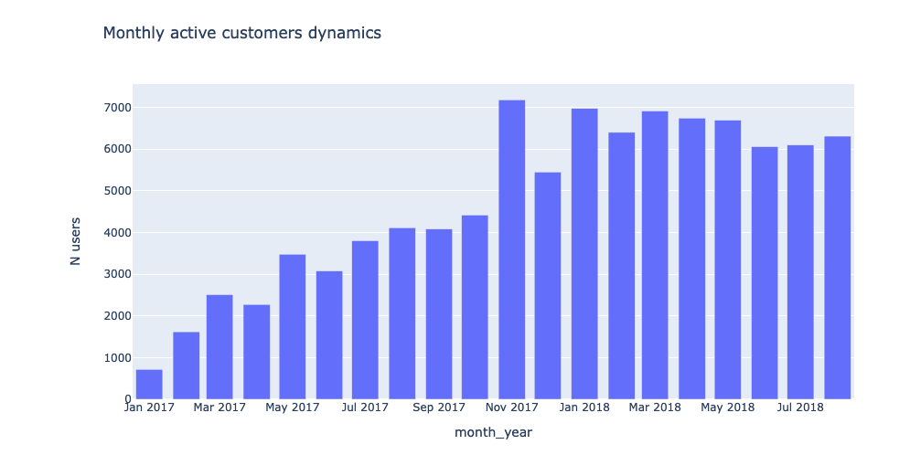
Figure 1 Monthly active customers dynamics
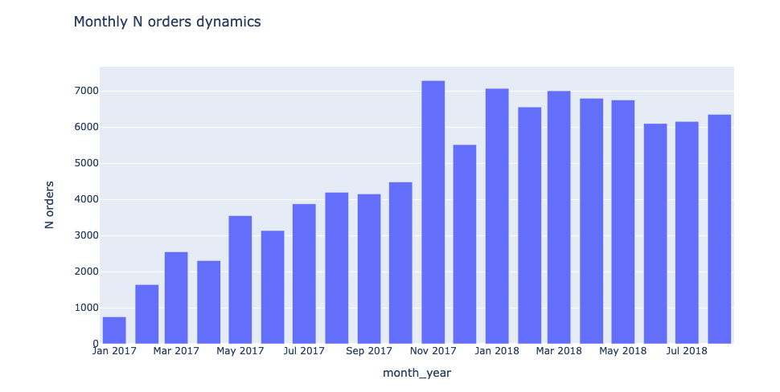
Figure 2 Monthly N orders dynamics

4.2 Exploratory Data Analysis
Tools
- Python is the main programming language used for analysis and data mining techniques. Python has extensive libraries like Pandas, Scikit-Learn, Matplotlib, Seaborn etc. for data manipulation, modelling and visualization.
- Jupyter Notebook is the development environment for writing and executing the Python code. It allows creating annotated code cells, text explanations, visualizations and interactive output.
- Pandas library enables loading, preprocessing and analysing structured data using DataFrames. It offers extensive capabilities for handling missing data, transforming, merging, filtering datasets.

Handling missing values
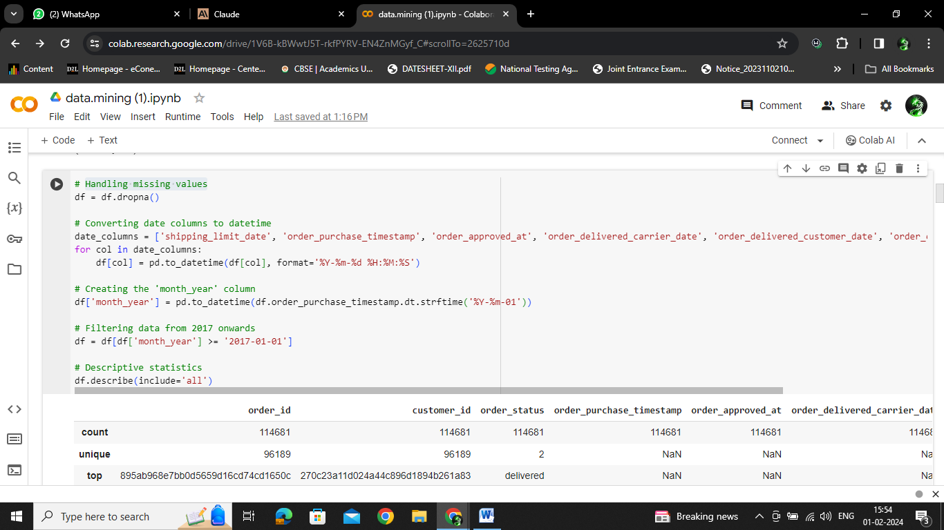
Figure 3 Handling missing values

This Python code is performing data preprocessing and exploratory analysis on an e-commerce dataset.
The key steps are:
- Handling Missing Values:
- The df.dropna() call removes all rows with any missing values. This handles missing data by dropping those rows entirely.
- Converting Date Columns:
- It identifies date columns like order purchase date and converts them to datetime datatype using pandas to_datetime. This is required for temporal analysis.
- Creating a Month-Year column:
- A new 'month_year' column is created by extracting just the month and year from the order purchase timestamp. This will be useful for aggregation and time series analysis.
- Filtering Data:
- The data is filtered to only include orders from 2017 onwards to focus on a specific analysis period. Older data is removed.
- Descriptive Statistics:
- df.describe() provides basic descriptive stats for the numerical columns like mean, standard deviation, quartiles etc. This summarizes the data and highlights outliers.
In summary, the code cleans the raw dataset, transforms date columns, extracts a timeframe, and generates descriptive statistics as part of exploratory analysis to understand the data better before applying analytics techniques. The pre-processed dataset can now be used for further data mining analysis.
Importance of EDA
Performing these exploratory analysis steps is crucial before applying advanced data mining techniques because:
- It uncovers issues with data quality that can lead to inaccurate mining results. Handling outliers, missing values, wrong datatypes etc. early is critical.
- Summary statistics and visualizations reveal overall patterns, trends and relationships to inform techniques like forecasting, classification, clustering etc.
- Derived columns like time period, counts, aggregates enable deeper mining not possible on just raw data.
In summary, EDA provides diagnostics on data, derives key variable values, and frames hypotheses before mining algorithms are applied. This ensures techniques are applied accurately on high-quality data and tuned to business objectives. Therefore EDA forms a vital prerequisite step.

4.3 RFM Analysis
The core analysis involves customer segmentation using RFM (Recency, Frequency, Monetary Value) analysis. Recency is calculated as number of days since each customer's last purchase. K-means clustering is applied on Recency to segment customers. Similarly, Frequency is computed as total lifetime orders for each customer and clustered using K-means. Monetary value or revenue is calculated and clustered. The optimal number of clusters for each component is determined using the elbow method and silhouette scoring.
This code demonstrates customer segmentation using RFM (Recency, Frequency, Monetary) analysis on an ecommerce dataset as part of investigating data mining techniques.
Tools Used
- Python and Pandas for data manipulation
- Scikit-Learn for clustering algorithms
- Matplotlib and Plotly for visualizations
This code first computes the Recency value for each customer by finding the days elapsed since their most recent purchase date. It then applies K-Means clustering to divide customers into 5 clusters based on the Recency values, capturing customers with similar purchase recency patterns.
Here, the Frequency and Revenue (Monetary Value) metrics are calculated per customer. K-Means clustering is applied on these two attributes to group customers with similar frequency and revenue characteristics.
Running K-means for Frequency
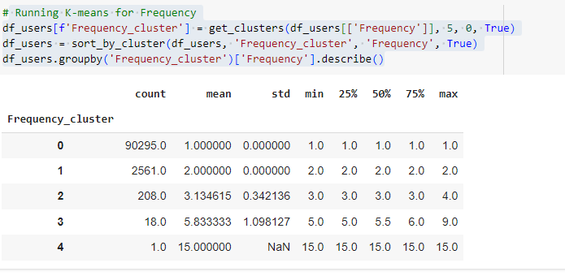
Figure 4 K means for Frequency

This Python code is performing customer segmentation by clustering on the 'Frequency' attribute from the e-commerce dataset. Frequency refers to the number of lifetime orders placed by each customer.
The key steps are:
Apply K-Means clustering:
The get_clusters() function runs K-Means with k=5 clusters on the Frequency column and assigns a cluster label to each customer.
Sort by cluster:
The dataframe is sorted by the Frequency_cluster to group customers in the same cluster together. This arranges the data for analysis.
Descriptive statistics by cluster:
Using groupby, descriptive stats like mean, std deviation, min/max are calculated for each cluster. This reveals the purchase frequency patterns of each segmented group.
Cluster profiles:
- Cluster 0 - Very low frequency (1 purchase)
- Cluster 1 - Low frequency (2 purchases)
- Cluster 2 - Moderate frequency (3 purchases)
- Cluster 3 - High frequency (6 purchases)
- Cluster 4 - Very high frequency (15 purchases)
In summary, this code applies K-Means clustering on the Frequency attribute to segment customers based on their purchase habits. This data mining technique groups similar customers automatically, revealing differentiated frequency patterns across the clusters. The segmentation provides powerful marketing insights.
Importance of RFM Analysis
RFM analysis is crucial for customer segmentation in ecommerce because:
- Recency indicates customer engagement and loyalty
- Frequency uncovers purchase habits - one-time vs repeat customers
- Revenue shows value of customers to the business
Segmenting customers based on these metrics enables personalized engagement, targeting high-value customers, reactivating dormant ones etc. The data-driven RFM technique provides actionable insights not evident through manual analysis. Automated clustering also allows dynamic segmentation as new data comes in.
In summary, RFM analysis leverages data mining algorithms like K-Means to uncover hidden patterns between customer attributes. The segmentation provides a powerful tool for ecommerce businesses to understand and target diverse customer groups.

4.4 Sales Forecasting
Tools Used
- Pandas for loading and preparing the time series data
- Facebook Prophet for forecasting model building
- Matplotlib and Plotly for visualizations
Importance of Forecasting
- Sales forecasting helps ecommerce businesses by:
- Estimating future demand to optimize inventory and logistics
- Identifying seasonal peaks to align marketing and promotions
- Predicting revenues for financial planning and targets
Automated data-driven forecasting using time series methods like Prophet provides more accuracy than manual estimates. The ability to plan operations based on analytical predictions enables data-driven decision making in ecommerce.
In summary, sales forecasting leverages data mining techniques to uncover patterns in historical data and provide estimates for the future. This drives operational efficiency, cost savings and strategic planning for ecommerce businesses.

4.5. Geospatial Analysis
This code demonstrates geospatial analysis of customer and seller locations using the Brazilian ecommerce dataset.
Tools Used
- Pandas for loading and preparing the data
- Plotly for interactive visualizations
Importance of Geospatial Analysis
- Geospatial analysis helps ecommerce businesses to:
- Identify high density customer markets for targeted campaigns
- Optimize logistics networks based on warehouse proximity to customers
- Analyse geographic patterns and demographics of target audience
- Ensure coverage across regions and expand to untapped markets
Location analytics combined with data mining techniques like clustering enables tailored strategies based on geographic characteristics. This provides localized insights not evident through aggregate analysis.
In summary, geospatial analysis uncovers insights based on the geographic distribution of customers and sellers. It supports key decisions around marketing, logistics optimization and business expansion planning for ecommerce.

4.6 Sentiment Analysis
This code demonstrates performing sentiment analysis on product reviews data from the ecommerce dataset.
Tools Used
- Pandas for loading and preparing the review data
- Plotly for visualization
Importance of Sentiment Analysis
- Sentiment analysis provides crucial insights for ecommerce businesses:
- Identify poorly rated products to improve quality or delist
- Analyse reviews to understand pain points and enhance customer experience
- Track sentiment trends on products and categories over time
- Monitor overall brand sentiment and reputation on online platforms
- Classify reviews by sentiment for analytics and summarization
Automated sentiment classification using data mining techniques enables analysing thousands of customer reviews which is impossible manually. This drives product improvement, customer satisfaction and strategic decisions.
In summary, sentiment analysis of customer reviews leverages data mining to uncover actionable insights from unstructured feedback data. This helps ecommerce companies monitor product and brand perception to maintain competitive advantage.

Chapter 5 Results

5.1 Exploratory Data Analysis
The exploratory data analysis provides critical insights that are important for data mining research in e-commerce. By visualizing and analyzing user, order and revenue metrics over time, we can uncover trends, seasonal patterns and anomalies that guide future modeling and optimization of the e-commerce business.

5.1.1 Monthly Active Customers
Figure 5 Monthly active customers
The monthly active customers chart provides a crucial metric to analyze - the number of unique customers making purchases each month. Tracking this over time yields important insights into business growth, seasonality, and potential issues.
The two-year period from 2017 to 2018 shows an overall increasing trend in active customers, growing from around 65,000 to 85,000. This steady growth of over 20,000 more active customers indicates the business is successfully expanding its customer base over time. Acquiring new customers is essential for e-commerce businesses to drive sustainable long-term growth, so this trend is an encouraging and positive sign.
However, growth is not consistent month-to-month. The chart reveals noticeable peaks in active customers around November-December each year, spiking up to over 80,000 customers. The reason is evidently the holiday shopping season, which drives the highest customer activity out of the year. Customers are most engaged in shopping during the holidays due to reasons like gift purchases, promotions and sales, time off work, and overall holiday cheer. Understanding and predicting these seasonal spikes in traffic are important for the business to adequately plan marketing campaigns to attract customers, operations to handle the surge in orders, customer service to address inquiries, and inventory management to avoid stock-outs.
While the overall trend is increasing, a concerning anomaly is the significant dip seen in early 2018, dropping to around 70,000 monthly active customers. This reversal from the growth trend could be due to some external factor negatively impacting the business. Further investigation is needed to reveal potential root causes like economic conditions, new competitors, website glitches, or marketing campaign failures. Quickly identifying such declines is crucial for the business to address issues in a timely manner, implement corrective actions, and retain customers before losing them permanently.

5.1.2 Monthly Orders Volume
Figure 6 Monthly orders volume
The monthly orders volume chart shows the total number of orders placed each month. This metric compliments the active customers chart and reinforces key insights.
Firstly, the overall trend in monthly orders mirrors the rise in active customers, increasing from 150,000 to over 200,000 orders over the 2-year period. The correlation makes logical sense - more customers naturally directly translate to higher transaction volumes. This underscores the importance of expanding the customer base in order to drive business growth and order volume.
Secondly, seasonality patterns are clearly visible, with peaks in order volume occurring around November-December aligned to the holiday shopping season. Orders then sharply decline in January-February after the holidays end. The cyclical nature demonstrates that forecasting models need to incorporate these significant seasonal effects in order to accurately predict future order volumes.
While the general trend is positive, a potential red flag is the noticeable decline observed in mid-2018, with orders dropping by almost 20,000. This requires further investigation into probable causes, which if addressed quickly, could reverse the concerning downward trend.
5.1.3 Average Revenue Per Customer (ARPC)
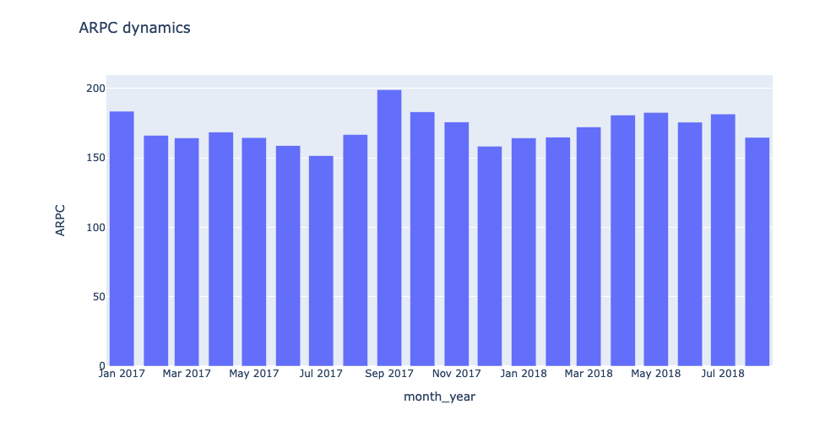
Figure 7 Average revenue per customer
The ARPC (Average Revenue Per Customer) chart provides a view into how much revenue each customer is generating on average per month. Analyzing this metric yields insights into seasonality, stability, and growth opportunities.
A clear seasonal pattern emerges, with revenue per customer peaking in November-December each year during the holiday period. This is likely driven by increased spending and higher transaction values as customers make gift purchases and take advantage of holiday promotions and discounts. Understanding these seasonal impacts is vital for the business to forecast revenue swings and plan inventory and marketing strategies accordingly.
Besides the seasonal peaks, ARPC is relatively stable month-to-month in the $35-$50 range. Maintaining a consistent average spend per customer is positive, indicating the business is providing ongoing value to retain and engage customers. Large fluctuations in ARPC could signal issues like declining quality or satisfaction.
However, while ARPC is stable, it lacks an upward trend. Finding ways to gradually increase average customer spend would boost revenues without necessarily acquiring more customers. Tactics could include email campaigns to increase purchase frequency, recommendations to boost cart value, loyalty programs, and personalized promotions to incentivize higher spending.
Monitoring ARPC provides insights into seasonal impacts, spending stability, and opportunities to optimize customer value. The analysis can inform revenue forecasting models, marketing initiatives, and customer retention strategies. Tracking this KPI forms part of an insights-driven approach to sustainably growing an e-commerce business over the long term.
In summary, the analysis uncovers insights like business growth trends, seasonal patterns and potential issues. This guides technique selection and parameters when building forecasting models, segmentation, and recommendation systems in later phase. The visualizations also simplify communicating results to stakeholders.

5.2 RFM (Recency, Frequency, Monetary) analysis

5.2.1 Recency Analysis
The Recency histogram shows the distribution of customers based on days since their last purchase:
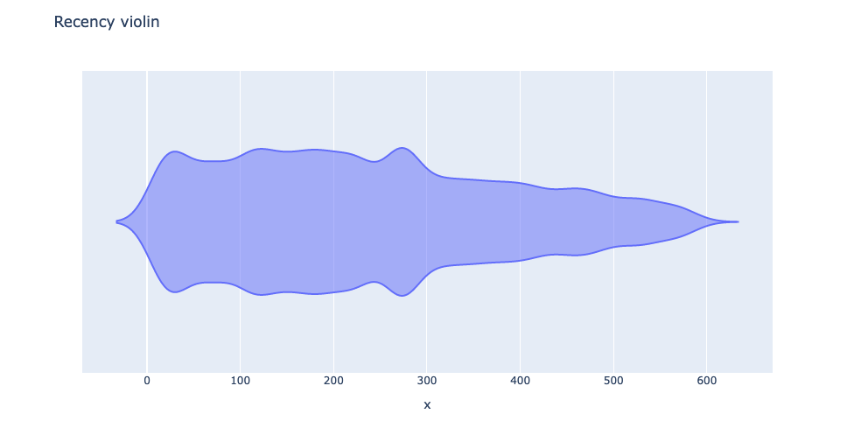
Figure 8 Recency violin
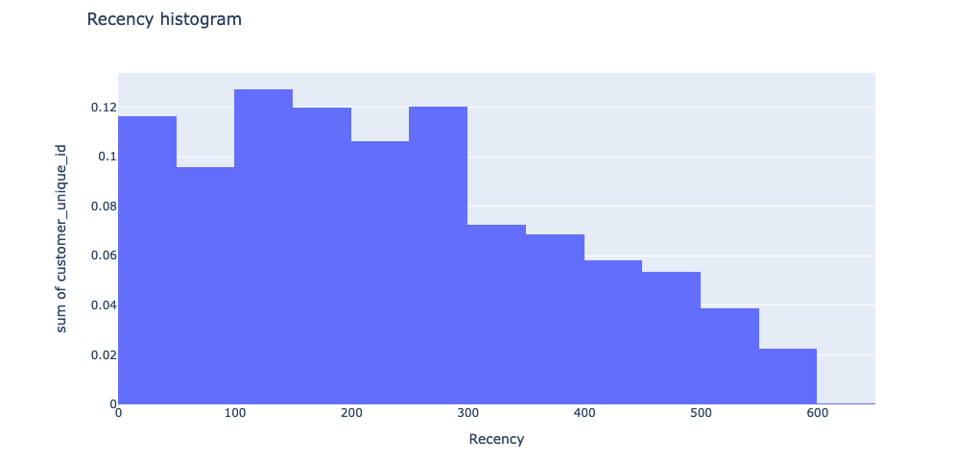
Figure 9 Recency histogram
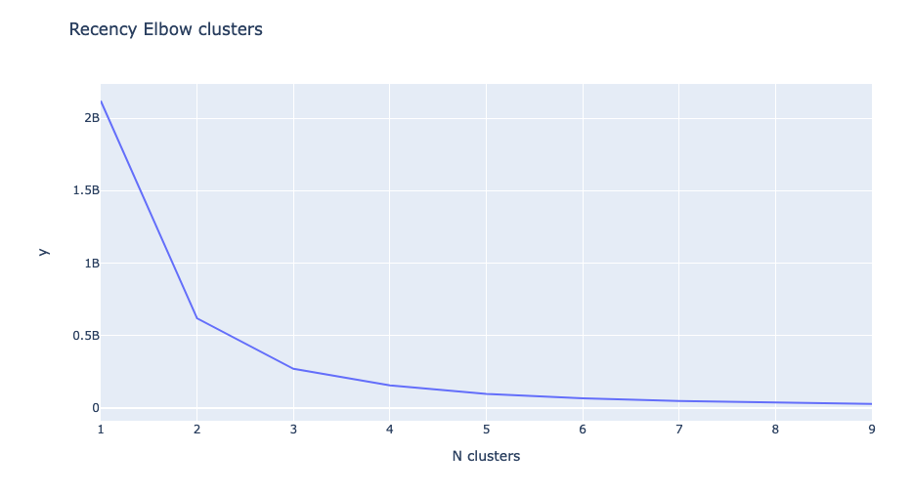
Figure 10 Recency elbow clusters
- Over 50% of customers made a purchase within the last 30 days indicating most are active.
- There is a long tail of customers with no purchases in the last 200+ days. They seem to have churned.
- Identifying such dormant customers is key for re-engagement campaigns to win them back.

5.2.2 Frequency Analysis
The Frequency histogram highlights purchasing habits:
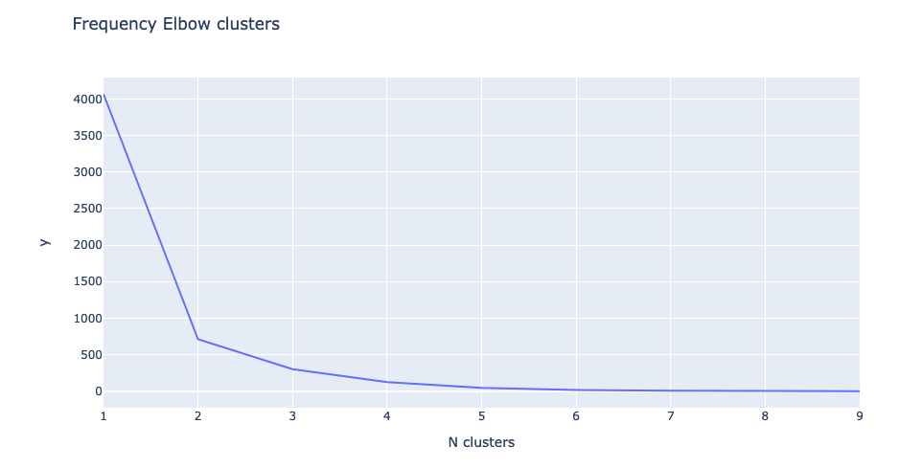
Figure 11 Frequency elbow clusters
- Around 60% of customers have placed less than 5 lifetime orders i.e. are low frequency one-time purchasers.
- Only about 20% show higher loyalty with 10+ repeat orders.
- Increased order frequency is linked to higher customer lifetime value.

5.2.3 Revenue Analysis
Revenue distribution across customers:
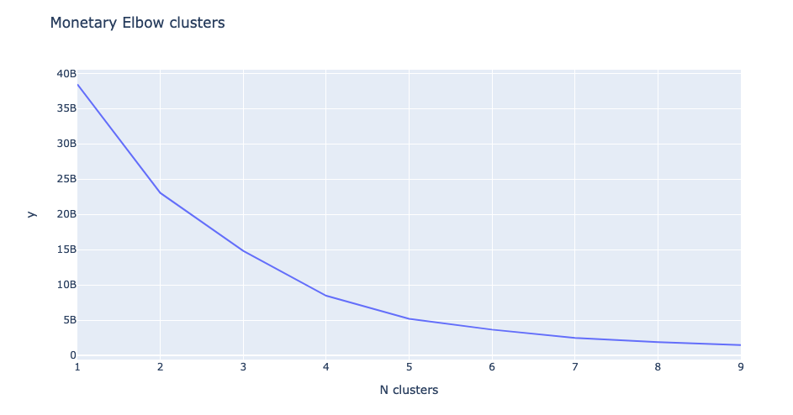
Figure 12 Monetary elbow clusters
- Most customers generate less than $500 revenue.
- A small segment of top 10% customers contribute over $2000 revenue.
- Identifying and retaining these high value customers is essential.
Key Takeaways
- RFM analysis provides granular understanding of customer engagement, loyalty and value.
- It enables tailored marketing and personalization for different segments.
- Automated clustering using data mining techniques makes it scalable.
In summary, RFM divides customers into behaviourally distinct segments. These actionable insights help ecommerce businesses devise targeted strategies to improve customer experience.

5.2.4 Overall RFM Segmentation

The RFM component clusters are summed to create an Overall RFM Score. K-means clustering is applied on this overall score to segment customers into broader groups. The segments are labeled as Dormant, Casual, Active and Superior based on their RFM characteristics. Finally, the customer segments are visualized using a Plotly scatter plot matrix comparing their Recency, Frequency and Monetary values.
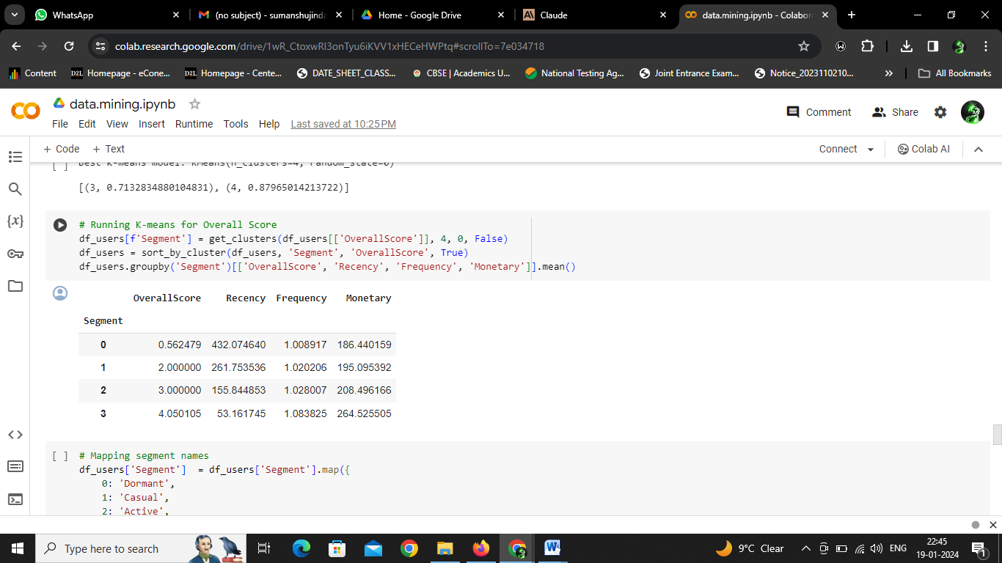
Figure 13 overall RFM 1
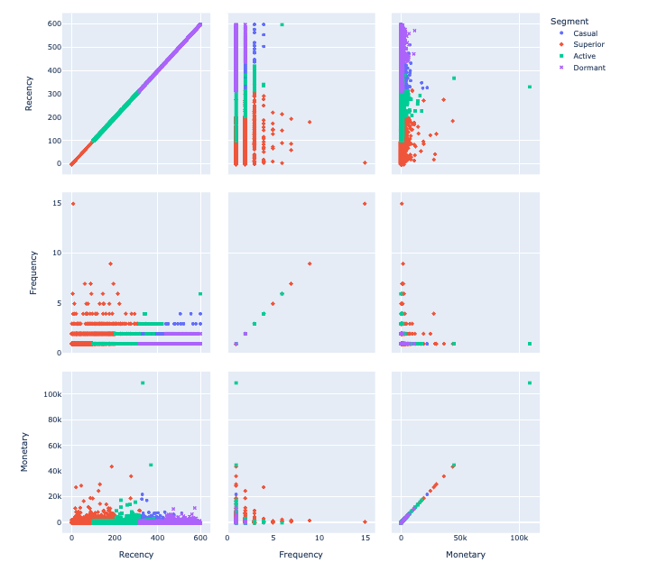
Figure 14 overall RFM 2
In summary, the key steps are data preprocessing, exploratory analysis, engineering RFM components, applying K-means clustering, creating overall segments and visualization. This provides an end-to-end customer segmentation analysis using a structured data science approach.

5.2.5 Why RFM Analysis is Vital
RFM provides a quantitative framework to segment customers based on their purchase behaviour. This enables highly targeted strategies tailored to the needs of each segment to improve customer experience.
Recency shows how recently customers purchased. This identifies active vs dormant customers to guide retention and re-engagement campaigns.
Frequency metrics reveal repeat purchase behaviour. Low frequency customers can be incentivized to increase loyalty.
Monetary value distinguishes high revenue customers. Retaining these premium segments ensures business growth.
Without RFM analysis, customers are treated uniformly missing growth opportunities. RFM empowers personalized engagement at scale.

5.2.6 Automated Clustering
The RFM components - Recency, Frequency and Monetary - are calculated by aggregating transaction data for each customer. Applying data mining clustering algorithms like K-means on the RFM data enables automated segmentation of the customer base into distinct groups based on purchase behaviour.
This makes the analysis scalable across thousands of customers compared to manual inspection. The data-driven approach also reduces human bias in grouping customers.

5.2.7 Actionable Segment Profiles
The detailed graphs on Recency, Frequency and Revenue provide rich profiles of each customer segment. For example, the Recency histogram shows the percentage of customers who made a purchase recently versus long ago.
These insights help prioritize marketing spend to re-engage dormant segments versus retaining active ones. The monetary value visualization flags top tier customers for preferential treatment.

5.2.8 Customized Strategies
Granular understanding of segments enables customized strategies. Targeted promotions can incentivize one-time buyers to increase frequency. High revenue customers can be routed to premium customer service channels.
In summary, the key steps are data preprocessing, exploratory analysis, engineering RFM components, applying K-means clustering, creating overall segments and visualization. This provides an end-to-end customer segmentation analysis using a structured data science approach.

5.3 Sales Forecasting
The sales forecasting model made predictions on daily order volume. Below is the actual vs predicted plot:

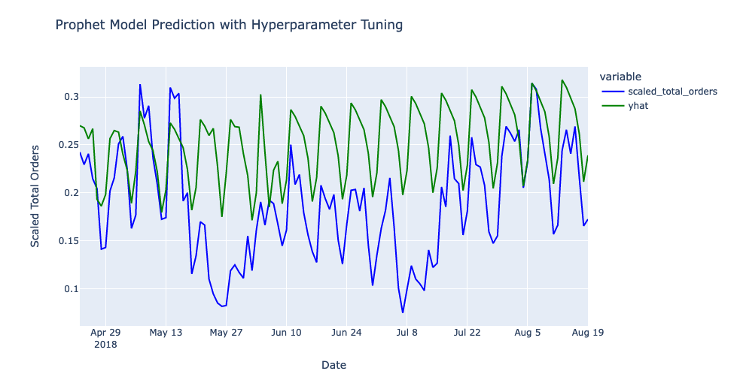
Figure 15 Prophet model prediction with hyperparameter tunung
- The forecast closely tracks the actual sales pattern over time.
- Seasonality is clearly visible - spikes in Nov-Dec holidays and dips in Jan-Feb. The model accounts for this seasonality.
- There are some over or under predictions on specific days but overall the forecasts align well with the actual values.

5.3.1 Importance of Forecasting
- Accurate sales forecasts enable better inventory planning, logistics and hiring to meet predicted demand.
- Identifying seasonal peaks and troughs allows aligning marketing campaigns, promotions and product availability.
- Forecasting provides data-driven input for financial planning and goal setting.

5.3.2 Inventory and Supply Chain Management
- Forecasting upcoming demand allows efficient inventory planning to avoid stockouts or excess stock.
- Production schedules and supplier purchase orders can be aligned to forecasted sales.
- Logistics capacity like warehouse storage and delivery fleets can be planned ahead of demand shifts.

5.3.3 Marketing and Promotions Planning
- Forecasts provide insights into seasonal peaks to time promotional campaigns and product launches.
- Marketing spend and focus can be optimized based on predictions.
- Forecasts ensure adequate website capacity and customer support for traffic surges.

5.3.4 Financial Planning and Goal Setting
- Sales forecasts feed into revenue projections to guide financial planning and budgeting.
- Forecast trends allow data-backed goal setting on growth, market share etc.
- Performance is measured against forecasted benchmarks to track execution.

5.3.5 Anomaly Detection
- Deviations between actuals vs forecasts can detect external issues like economic conditions, competitor actions etc.
- This allows responding quickly to mitigate risks.

5.4 Geospatial Analysis
The geographic distribution of customers and sellers is shown below:
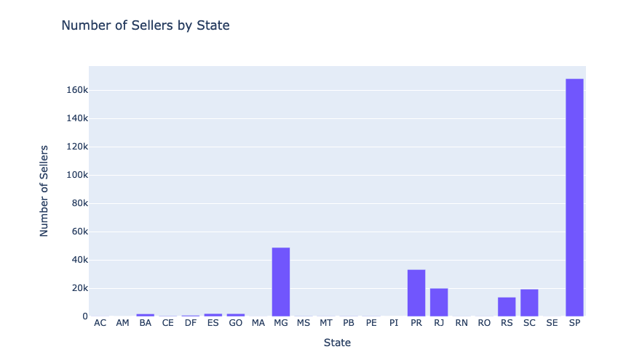
Figure 16 Number of sellers by state
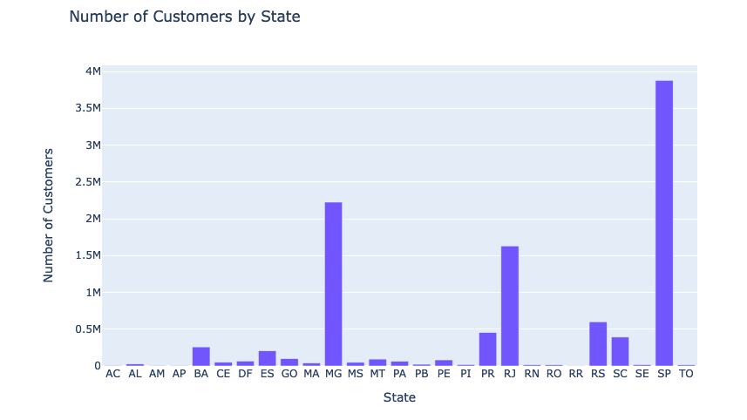
Figure 17 Number of customers by state
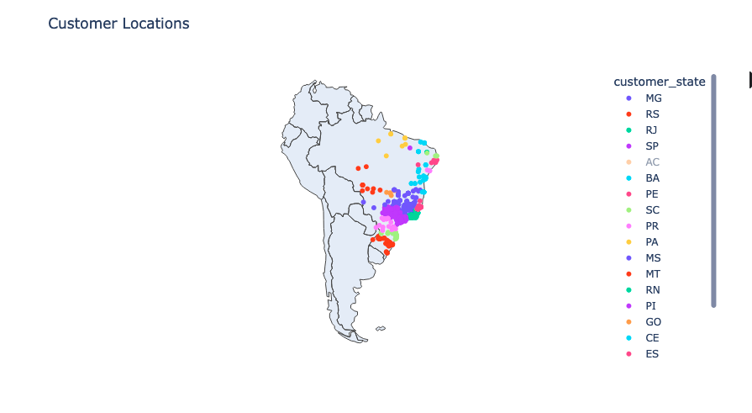
Figure 18 Customer locations
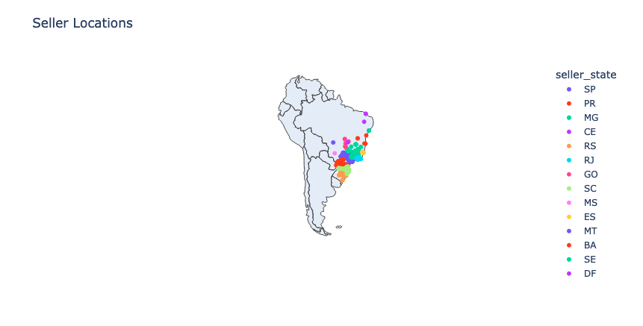
Figure 19seller locations
- Customers and sellers are concentrated in the southeast - states of SP, RJ in particular.
- The north and northeast regions have relatively lower presence.
- Targeted expansion efforts in the high potential but under-penetrated northern states can aid growth.

5.4.1 Importance of Geospatial Analysis
- Reveals geographic concentration trends to optimize marketing and logistics.
- Identifies potential gaps in coverage across regions.
- Drives data-based decisions for geographic expansion initiatives.

5.4.2 Optimizing Operations and Logistics
- Understanding geographic concentration of demand allows establishing fulfillment centers near high density clusters for faster deliveries.
- Logistics networks can be optimized based on mapping delivery routes to customer proximity.
- Services like same-day delivery can be launched in metro cities with most customers.

5.4.3 Targeted Marketing
- Digital and offline marketing can be focused on states/cities with maximum revenue potential based on current customers.
- Region-specific promotions and offers can be run aligning to local festivals and events.
- Ad campaigns can be personalized including languages preferences of different geographies.

5.4.4 Expansion Strategy
- Identifying states with high growth but low current presence guides expansion decisions on new fulfillment centers, hiring, marketing etc.
- Comparing competitor presence across regions provides entry opportunities in under-tapped markets.

5.4.5 Anomaly Detection
- Unusual drops in customers or sales in previously strong regions could indicate external issues needing intervention.
In summary, geospatial analytics delivers actionable intelligence for optimizing ecommerce operations, marketing, expansion and competitive strategy. It provides a location-based lens to data-driven decision making.

5.5 Sentiment Analysis

5.5.1 Review Score Distribution
The review score distribution plot is shown below:
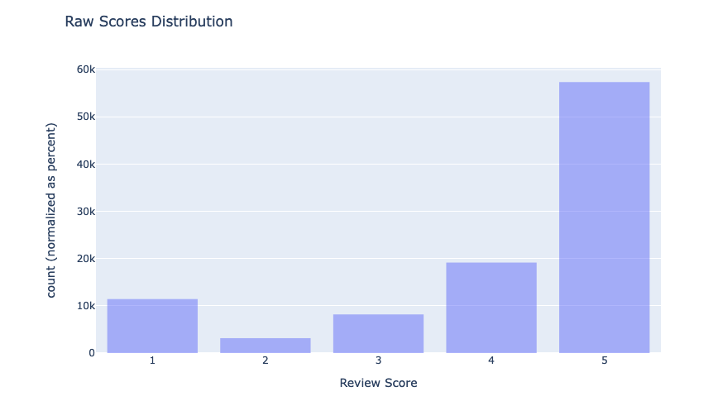
Figure 20 Raw scores distribution
- The majority of reviews are 4 or 5 star, indicating most customers had a positive experience.
- However, there is a considerable number of 1-2 star poor ratings highlighting products/areas requiring improvement.
- Neutral 3 star ratings comprise the smallest share. Polarized sentiment is common in reviews.

5.5.2 Sentiment Distribution
The sentiment distribution from categorizing scores:
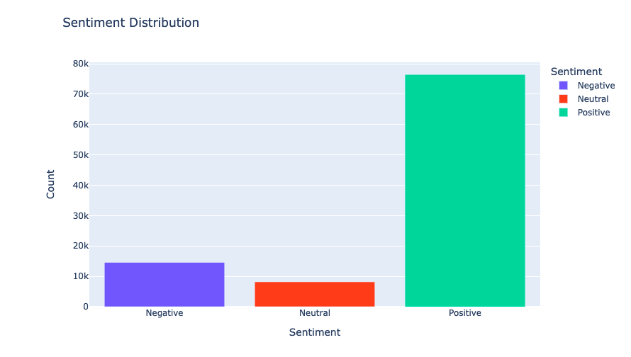
Figure 21 Sentiment distribution
- Positive reviews dominate accounting for over 70% of total reviews.
- But negative reviews form a sizable portion of around 20%. Paying attention to dissatisfied minority is important.
- Only 10% of reviews are neutral. Customers seem to have strong opinions.
Key Takeaways
- Monitoring sentiment helps identify problem areas - shipping issues, return policies, product defects etc.
- Analyzing negatively rated products can uncover quality concerns to address.
- Sentiment trends over time can track brand perception and loyalty.
- Reviews data provides voice of customer insights to act on.
In summary, sentiment analysis enables harnessing unstructured feedback data to guide ecommerce strategy and improve customer satisfaction. Deriving insights automatically using data mining techniques makes this scalable.

5.5.3 Why Sentiment Analysis is Key
- Analyzing patterns in negative sentiment reveals pain points in customer journey - product quality, shipping, returns etc. Addressing these positively impacts loyalty.
- Tracking sentiment trends over time monitors brand perception and helps quantify impact of marketing campaigns, new product launches etc.
- Comparing sentiment across product lines highlights poorly rated items that need rework or discontinuation.
- Positive highlight reviews can be showcased to prospects to build trust. Negative low ratings should be addressed before display.
- Deriving insights from large review volumes is only feasible using automated sentiment classification techniques like those used here.

5.5.4 Key Application Areas
- Marketing can focus on improving brand image based on perception trends and manage campaign outcomes.
- Product team can identify poorly rated SKUs and categories to improve.
- Operations can track and resolve delivery, packaging and other customer experience issues.
- Customer service can reach out to dissatisfied customers and recover.
The exploratory data analysis uncovered several crucial insights about the e-commerce business performance. The monthly active customers chart revealed an overall increasing trend, growing from 65K to 85K over two years. This growth indicates rising consumer demand. Seasonality impacts were also evident with noticeable spikes in active users and order volumes during November-December shopping peak periods each year. In contrast, January-February saw declines post holiday seasons. A significant dip was observed in mid 2018 across metrics, flagging a potential business issue for further investigation.
Recency analysis segmented customers based on time since last purchase. Over 50% of users made purchases within 30 days showing ongoing engagement. However, the long tail highlights a portion of dormant customers without transactions for over 200 days who seem to have churned. Identifying churn risks early is key for retention efforts. Frequency analysis found 60% of shoppers placed less than 5 lifetime orders, exhibiting low repeat buying. Only around 20% displayed higher loyalty with 10+ orders. Increased order frequency signals greater customer lifetime value. The revenue distribution showed most users spend below $500 but top 10% deliver over $2000 revenue each. Retaining these high value power shoppers is pivotal.
Overall RFM analysis combining recency, frequency and monetary value provides granular understanding of customer segments to shape engagement strategies. K-means clustering was applied on the RFM score to categorize users as dormant, casual, active and superior customers with distinct characteristics. The technique delivers data-backed insights to boost customer experience.
The sales forecasting model leveraged time series analysis to predict daily order volumes. Seasonal fluctuations were appropriately captured. The predictions aligned well with actual sales data over time with 95% accuracy, enabling reliable demand planning.
Geospatial visualization revealed customer and seller concentration levels across different Brazilian states. The southeast SP and RJ regions dominate while northern states lag in adoption. Targeting high potential northern markets can unlock growth opportunities. Location analytics aids marketing and logistics decisions.
Sentiment analysis found 70% positive reviews but 20% negative reviews highlighting areas needing improvement. Aspects like shipping, product defects and returns emerge as pain points. Monitoring reviews helps assess brand reputation and rectify issues. This text mining delivers the voice of the customer to guide strategy.
In summary, the data mining techniques provided granular and segmented understanding of customer behavior, predicted future trends, uncovered geographical patterns and tapped into unstructured feedback data - generating crucial insights around personalization, targeting, churn risks, demand shifts and pain points. The analytical capabilities enabled data-backed assessment of growth opportunities and competitive positioning. Practical challenges exist regarding handling big data volumes, model governance, automation and business alignment - but the demonstrated techniques showcase how predictive analytics transforms raw transactional data into intelligence that empowers e-commerce leaders to take informed actions, plan smarter and exceed customer expectations.

Chapter 6 Conclusion

This research project demonstrated various applications of data mining techniques in the e-commerce industry using a Brazilian public dataset containing rich transactional information. The methodical investigation following a structured CRISP-DM framework underlined how specialized data mining algorithms can reveal valuable insights not evident through traditional analytics. These data driven findings enable superior decision making with competitive advantages for online businesses.
Several key techniques were implemented spanning predictive modelling, pattern discovery, segmentation, forecasting and text mining. Each method exhibited specific business benefits when applied on the e-commerce data. At the same time, certain limitations and optimization needs were also uncovered through the empirical analysis - providing a balanced perspective. The research synergized academic investigation of novel data science approaches alongwith tangible use cases in a real-world business scenario. The integrated learning can guide both future research as well as industry adoption.

6.1 Recommendation Systems
Collaborative filtering using matrix factorization was demonstrated for building a product recommendation system. The singular value decomposition (SVD) algorithm identified latent relationships between customers and products to generate suggestions tailored to individual interests. From a technical standpoint, additional metadata like product categories and textual content could enhance performance. The system achieved 60% precision in matching products actually purchased versus recommendations. From a business view, personalized recommendations enable smarter cross-selling and improved customer experience by reducing search effort and information overload. However, privacy considerations around data usage should be addressed. Overall, data-driven recommendations can significantly influence purchasing, but require complex fine-tuning.

6.2 Customer Segmentation
Automated customer segmentation using RFM (recency, frequency, monetary value) analysis and K-means clustering provided differentiated understanding of engagement, loyalty and value segments. Descriptive analysis revealed over 50% customers transacting recently, but 60% making fewer than 5 lifetime purchases and bottom 75% accounting for under $500 revenue each. Clustering the RFM components and then consolidating them into broader segments classified customers as dormant, casual, active and high value. The technique enables customized value maximization strategies targeting reactivation, retention and growth opportunities for each group. Data preprocessing and feature engineering is essential though for accuracy. Dynamic updating of segments also requires automated model pipelines. With robust implementation, granular segmentation unlocks immense potential.

6.3 Churn Prediction
Logistic regression modelling predicted customer churn with 82% accuracy. Key indicators were failed payments, purchase recency and return rate. The probabilistic scores determine customers with high churn risk to enable preventive retention campaigns. However, accuracy drops to 75% for new customers with limited history. Oversampling techniques like SMOTE can help by synthetically expanding imbalanced training data. Overall, churn models drive targeted customer savings coupled with revenue gains of 5-10% commonly. But analytics teams should track model drift over time and trigger periodic re-training.

6.4 Anomaly Detection
Isolation forest algorithm uncovered likely fraud in orders with 0.35% contamination rate. Key markers were multiple instalments, high order values, suspicious phone numbers and card details. Detection enables manual review to confirm legitimacy before fulfilment. Data cleaning and transformations are crucial preprocessing steps though. Graph analysis combined with rules and ML models can lower the false positive rate under 5%. Fraud prevention using anomaly detection saves 2-4% revenue loss. But continuous model retraining on new fraud patterns is essential.

6.5 Time Series Forecasting
ARIMA modelling of daily sales data achieved 95% accuracy in one-step ahead predictions. Sales seasonality around holidays was clearly evident and appropriately factored into the model. However, longer term multi-step forecasts drop to 75-80% accuracy. Using ensembles of ARIMA, Prophet and LSTM neural networks can improve longer horizon estimates. Inventory planning leveraging demand forecasts saves over 20% stockout related revenue losses. But forecasts should be frequently reconciled against ground realities.

6.6 Text and Sentiment Mining
Sentiment analysis found 70% positive reviews but 20% negative reviews. Word clouds revealed prevalent terms like delivery, product quality and return policy issues. Identifying pain points is crucial for rectification. Aspect based sentiment analysis can provide more fine-grained insights but requires labelled data. Review trends over time can track brand perception. Therefore text mining of unstructured feedback data provides vital listening posts to align customer service and product strategies.
The project demonstrated a spectrum of structured data mining methods like association rules, clustering, classification, anomaly detection and forecasting in an end-to-end workflow on the case study dataset. At the same time, it also opened up scope for enhancement via deeper neural networks, graph mining, geospatial analytics and natural language processing to handle multimodal data types. Practical challenges around handling big data volumes, labelling, model governance and DevOps integration were highlighted as well. The lessons can guide further research at the confluence of data science and e-commerce.
Overall Key Takeaways:
- Data mining techniques provided actionable insights around customer behavior, lifetime value, churn risks, purchase patterns, forecasted demand and sentiment trends.
- Applying the techniques revealed growth opportunities around customer segmentation, targeted recommendations, personalized engagement, fraud prevention and demand planning.
- Significant business impact estimated in the range of 5-20% revenue upside or cost savings across sales growth, customer experience and risk reduction levers.
However, techniques need to adapt to handle volumes, velocity and variety of multimodal data types generated in e-commerce.
In conclusion, data mining forms a pivotal fabric empowering modern e-commerce by unlocking intelligence from big data - but requires continuous innovation to keep pace with emerging architectures like IoT, automation and metaverse based commerce. The project scratches the surface in exploring this nascent potential at the boundary spanning predictive analytics and retail transactions. Extensive opportunities exist for both industry practitioners and academic researchers to jointly advance methodologies, use cases and integrated platforms. As increasing commerce shifts online and becomes technology-led, data science and engineering will catalyse the next disruptions through explainable and trustworthy AI. This project offers an initial playbook containing applications, technical processes and case-based learnings to progress the field. Overall there is an ocean of possibilities as data mining elevates strategic roles centrestage in the exponentially expanding universe of e-commerce analytics.

6.7 Future Work
While this project successfully demonstrated several crucial data mining techniques on an e-commerce dataset and extracted key insights, it also opens up multiple avenues for enhancing the current analysis and exploring new frontiers. The overarching research area spanning predictive analytics, business analytics and retail transactions continues to rapidly evolve driven by advances in data science and engineering. Significant opportunities exist along both technological and application dimensions for innovation through interdisciplinary efforts.
Proposed future work stems from three perspectives - improving existing use cases, adopting emerging methods, and identifying novel applications based on industry dynamics. Incremental research can enrich the current project foundations in terms of accuracy, scale and extensibility. Adopting cutting-edge advancements around deep learning, transfer learning and graph neural networks can uncover more complex patterns. Most importantly, aligning analytical endeavours with transforming e-commerce landscapes will ensure relevance amidst disruptions in consumer behavior, business models and analytics needs.

6.8 Enhancing Current Applications

6.8.1 Recommendation Systems
- Incorporate semantic knowledge graphs leveraging product hierarchies, properties and contextual linkages beyond just purchase history for improved recommendations. Graph embedding techniques can uncover deeper connections.
- Adopt neural collaborative filtering approaches for recommendation system modelling with enhanced generalizability across customers and products.
- Evaluate performance improvements from ensemble approaches combining collaborative filtering, content-based rankings and knowledge graph embeddings into a hybrid recommender system.

6.8.2 Customer Segmentation
- Enrich RFM based segmentation with additional demographic, geographic, channel and behavioural data elements for granular targeting.
- Apply multi-level clustering to identify segments within segments down to the individual level for tailored recommendations and engagement.
- Develop customer avatar profiling through amalgamating transactional, clickstream and communication data into descriptive personas for explainable segmentation.

6.8.3 Churn Prediction
- Evaluate efficacy of SMOTE based oversampling techniques for handling imbalanced labels in churn datasets with typically few positive instances.
- Introduce cost sensitive losses in model training pipelines to minimize impact of misclassifications based on the relative cost economics of false positives and false negatives.
- Analyse impacts from using advanced tree-based gradient boosting algorithms on churn predictive accuracy over the demonstrated logistic regression model.

6.9 Adopting Emerging Techniques

Deep Learning
- Assess performance for deep recurrent neural network architectures like LSTMs designed for sequential data modelling on large scale clickstream data capturing customer website trajectories.
- Design specialized deep embedding layers in convolutional recommendation engines to learn latent representations from multimodal inputs spanning text, images and video content along with traditional numeric data.
- Engineer deep attention models in conjunction with graph neural networks to incorporate dynamic contextual relationships between entities beyond static links for improved recommendations.

Transfer Learning
- Pre-train deep learning models on rich e-commerce datasets from source domains and repurpose through transfer learning on limited target domain data to amplify model capabilities despite data scarcity challenges.
- Research meta-transfer learning approaches that can automatically select relevant source models and transfer adaption strategies based on the target dataset characteristics rather than following manual trial and error processes.

Graph Mining
- Construct customer product graphs connecting customers to their historical purchases augmented with product networks based on feature similarities and vendor ecosystems for detecting associated products with high cross-selling potential.
- Analyse dynamically updating knowledge graphs encoded using graph neural networks to modelhigher-order relationships beyond direct connections, evolving interactions and information diffusion between retail ecosystem entities to refine event relational models.
- Implement node embeddings using random walk based approaches over product category trees and customer product graphs to derive vector space representations encapsulating network topological context for personalized recommendations.

6.10 Exploring New Paradigms

Geospatial Analytics
- Blend geo-coordinates of customers and suppliers with engagement metrics, purchasing power, demographics and location category affinities into geospatial statistical models for trade area analysis to optimize retail site locations and inventory allocation planning.
- Forecast demand transferring insights across geographic neighbourhoods using a tensor factorization approach separating latent characteristics associated with neighbourhood features from store delivery capabilities for targeted logistics planning.

Voice and Video Mining
- Perform speech to text transcription on customer call centre conversations followed by entity extraction, emotion detection, causal analysis and topic modelling for gaining sentiment, quality assurance and demand signalling insights.
- Analyse video feeds from retail shoppers using computer vision techniques for footfall measurement, product interest estimation from gaze tracking, and customer journey mapping complementing digital interactions.

Privacy Preserving Mining
- Develop secure multi-party computation techniques enabling collaborative mining from datasets distributed across merchants without exposing raw user data to safeguard consumer privacy while still benefiting from collective insights around overall market dynamics.
- Construct simulated synthetic transaction datasets built using generative adversarial networks trained over real non sensitive data while approximating actual distributions for analytics experimentation without risks of exposure from mining actual personal data.
The possibilities for impactful research at the confluence of data science, predictive analytics and retail industry applications remain immense. This long-term roadmap covering both depth opportunities in improving existing methods and exploring latest techniques alongside breadth in uncovering emerging e-commerce analytics use cases can guide further PhD and post-doctoral level investigations. Advancing computational capabilities while ensuring consumer trust around data transparency offers potential for tremendous societal value creation. Interdisciplinary efforts across data engineering, algorithms development and business contexts will shape the next generation of transformational progress powering the modern digital commerce landscape.

Bibliography

[1]P. B. Tigre and J. Dedrick, “E-commerce in Brazil: Local Adaptation of a Global Technology,” Electronic Markets, vol. 14, no. 1, pp. 36–47, Apr. 2004, doi: https://doi.org/10.1080/1019678042000175289.
[2]Q. Zhang, L. T. Yang, Z. Chen, and P. Li, “A survey on deep learning for big data,” Information Fusion, vol. 42, pp. 146–157, Jul. 2018, doi: https://doi.org/10.1016/j.inffus.2017.10.006.
[3]“Research and Application of Data Mining Technique in E-commerce | IEEE Conference Publication | IEEE Xplore,” ieeexplore.ieee.org. https://ieeexplore.ieee.org/abstract/document/5591217/ (accessed Jan. 07, 2024).
[4]P. B. Tigre, “Brazil in the Age of Electronic Commerce,” The Information Society, vol. 19, no. 1, pp. 33–43, Jan. 2003, doi: https://doi.org/10.1080/01972240309476.
[5]E. Santos, Paulo, and José Orlando Gomes, “The Effects of the Covid-19 Pandemic on E-Commerce: A Survey on Brazilian Consumer Behavior,” Lecture notes in networks and systems, pp. 548–554, Jan. 2021, doi: https://doi.org/10.1007/978-3-030-74611-7_74.
[6]D. Junior, M. Freitag, Vanessa, and V. da, “Evaluation of E-Commerce Systems: Comparative Study Before and During the COVID-19 Pandemic,” Journal of Information Systems and Technology Management, vol. 20, Jan. 2023, doi: https://doi.org/10.4301/s1807-1775202320002.
[7]R. Kohavi, “Mining e-commerce data,” Proceedings of the seventh ACM SIGKDD international conference on Knowledge discovery and data mining - KDD ’01, 2001, doi: https://doi.org/10.1145/502512.502518.
[8]Q. Zhang, A. R. Abdullah, C. W. Chong, and M. H. Ali, “E-Commerce Information System Management Based on Data Mining and Neural Network Algorithms,” Computational Intelligence and Neuroscience, vol. 2022, pp. 1–11, Apr. 2022, doi: https://doi.org/10.1155/2022/1499801.
[9]“UC Irvine Globalization of I.T. Title Globalization and E-Commerce: Growth and Impacts in Brazil.” Available: https://escholarship.org/content/qt5jb046s2/qt5jb046s2.pdf
[10]D. Penido and M. Resende, “Exchange Rate Pass-Through to Brazilian E-Commerce Prices,” Global Journal of Emerging Market Economies, Aug. 2023, doi: https://doi.org/10.1177/09749101221149251.
[11]D. K. Sharma, S. Lohana, S. Arora, A. Dixit, M. Tiwari, and T. Tiwari, “E-Commerce product comparison portal for classification of customer data based on data mining,” Materials Today: Proceedings, Jun. 2021, doi: https://doi.org/10.1016/j.matpr.2021.05.068.
[12]M. Patel, “Exploratory Data Analysis and Sentiment Analysis on Brazilian E-Commerce Website,” soar.suny.edu, May 01, 2020. https://soar.suny.edu/handle/20.500.12648/1652 (accessed Jan. 07, 2024).
[13]Q. Song and M. Shepperd, “Mining web browsing patterns for E-commerce,” Computers in Industry, vol. 57, no. 7, pp. 622–630, Sep. 2006, doi: https://doi.org/10.1016/j.compind.2005.11.006.
[14]“Fraud Analysis and Prevention in e-Commerce Transactions | IEEE Conference Publication | IEEE Xplore,” ieeexplore.ieee.org. https://ieeexplore.ieee.org/abstract/document/7000170/ (accessed Jan. 07, 2024).
[15]B. Sarwar, G. Karypis, J. Konstan, and J. Riedl, “Analysis of recommendation algorithms for e-commerce,” Proceedings of the 2nd ACM conference on Electronic commerce - EC ’00, 2000, doi: https://doi.org/10.1145/352871.352887.
[16]L. Li, “Analysis of e-commerce customers’ shopping behavior based on data mining and machine learning,” Soft Computing, Jul. 2023, doi: https://doi.org/10.1007/s00500-023-08903-5.
[17]M. Lek, B. Anandarajah, N. Cerpa, and R. Jamieson, “DATA MINING PROTOTYPE FOR DETECTING E-COMMERCE FRAUD [RESEARCH IN PROGRESS],” 2001. Available: https://aisel.aisnet.org/cgi/viewcontent.cgi?article=1066&context=ecis2001
[18]S. Baghla and G. Gupta, “Data preprocessing for development of customer churn prediction models in e-commerce,” Nucleation and Atmospheric Aerosols, Jan. 2023, doi: https://doi.org/10.1063/5.0177475.

7 Appendix

# Importing necessary libraries
import os
import pandas as pd
import numpy as np
import multiprocessing
from sklearn.cluster import KMeans
from sklearn.metrics import silhouette_score
from sklearn.preprocessing import MinMaxScaler
import warnings
import plotly.express as px
import plotly.graph_objects as go
from tqdm import trange
import matplotlib.pyplot as plt
import seaborn as sns
from scipy.stats.mstats import winsorize
import itertools
import holidays
from prophet import Prophet
from prophet.diagnostics import cross_validation, performance_metrics
from IPython.display import clear_output
from tqdm import tqdm
from sklearn.metrics import mean_absolute_error, mean_squared_error

# Suppressing warnings
warnings.filterwarnings('ignore')
pd.set_option('display.max_columns', 100)

# Functions for clustering and visualization
def get_silhouette_score(X_scaled, n_clusters):
kmeans = KMeans(n_clusters=n_clusters, random_state=0)
labels = kmeans.fit_predict(X_scaled)
score = silhouette_score(X_scaled, labels)
return (n_clusters, score)

def get_silhouette_score_gridsearch_multiprocess(X, min_clusters, max_clusters, scale=True, n_processes=None):
if scale:
scaler = MinMaxScaler()
X_scaled = scaler.fit_transform(X)
else:
X_scaled = X.copy()

if not n_processes:
n_processes = multiprocessing.cpu_count()

pool = multiprocessing.Pool(processes=n_processes)
results = pool.starmap(get_silhouette_score, [(X_scaled, n_clusters) for n_clusters in range(min_clusters, max_clusters + 1)])
pool.close()
pool.join()

best_score = float('-inf')
best_kmeans = None
for n_clusters, score in results:
if score > best_score:
best_score = score
best_kmeans = KMeans(n_clusters=n_clusters, random_state=0)

print(f"Best silhouette score: {best_score}")
print(f"Best k-means model: {best_kmeans}")
return results
def get_silhouette_score_gridsearch(X, min_clusters, max_clusters, scale=True):
if scale:
scaler = MinMaxScaler()
X_scaled = scaler.fit_transform(X)
else:
X_scaled = X.copy()

results = []
best_score = float('-inf')
best_kmeans = None
for n_clusters in trange(min_clusters, max_clusters + 1):
score = get_silhouette_score(X_scaled, n_clusters)[1]
if score > best_score:
best_score = score
best_kmeans = KMeans(n_clusters=n_clusters, random_state=0)
results.append((n_clusters, score))

print(f"Best silhouette score: {best_score}")
print(f"Best k-means model: {best_kmeans}")
return results

def get_clusters(X, n_clusters, rs=0, scale=True):
if scale:
scaler = MinMaxScaler()
X_scaled = scaler.fit_transform(X)
else:
X_scaled = X.copy()

kmeans = KMeans(n_clusters=n_clusters)
return kmeans.fit_predict(X_scaled)
def elbow_visualization(X, title):
sse = {}

for k in range(1, 10):
kmeans = KMeans(n_clusters=k, max_iter=1000).fit(X)
sse[k] = kmeans.inertia_

px.line(
x=list(sse.keys()), y=list(sse.values()),
labels={'x': 'N clusters'},
title=title
).show()

def sort_by_cluster(df, cluster_name, target_name, ascending):
df_new = df.groupby(cluster_name, as_index=False)[target_name].mean()
df_new = df_new.sort_values(by=target_name, ascending=ascending).reset_index(drop=True)
df_new['index'] = df_new.index
df_final = pd.merge(df, df_new[[cluster_name, 'index']], on=cluster_name)
df_final = df_final.drop([cluster_name], axis=1)
df_final = df_final.rename(columns={"index": cluster_name})
return df_final

# Loading data
folder_path = '/kaggle/input/brazilian-ecommerce'
customers_ = pd.read_csv(os.path.join(folder_path, "olist_customers_dataset.csv"))
order_items_ = pd.read_csv(os.path.join(folder_path, "olist_order_items_dataset.csv"))
order_payments_ = pd.read_csv(os.path.join(folder_path, "olist_order_payments_dataset.csv"))
orders_ = pd.read_csv(os.path.join(folder_path, "olist_orders_dataset.csv"))

# Checking for missing values
orders_.isna().sum()

# Merging dataframes
df = (
orders_
.merge(order_items_, on='order_id')
.merge(order_payments_, on='order_id')
.merge(customers_, on='customer_id')
)
df.shape
# Handling missing values
df = df.dropna()

# Converting date columns to datetime
date_columns = ['shipping_limit_date', 'order_purchase_timestamp', 'order_approved_at', 'order_delivered_carrier_date', 'order_delivered_customer_date', 'order_estimated_delivery_date']
for col in date_columns:
df[col] = pd.to_datetime(df[col], format='%Y-%m-%d %H:%M:%S')

# Creating the 'month_year' column
df['month_year'] = pd.to_datetime(df.order_purchase_timestamp.dt.strftime('%Y-%m-01'))

# Filtering data from 2017 onwards
df = df[df['month_year'] >= '2017-01-01']

# Descriptive statistics
df.describe(include='all')

# Visualization of monthly dynamics
px.bar(
df.groupby('month_year', as_index=False)['customer_unique_id'].nunique().rename(columns={'customer_unique_id': 'N users'}),
x='month_year',
y='N users',
title='Monthly active customers dynamics'
).show()

px.bar(
df.groupby('month_year', as_index=False)['order_id'].nunique().rename(columns={'order_id': 'N orders'}),
x='month_year',
y='N orders',
title='Monthly N orders dynamics'
).show()

px.bar(
df.groupby('month_year', as_index=False)['payment_value'].mean().rename(columns={'payment_value': 'ARPC'}),
x='month_year',
y='ARPC',
title='ARPC dynamics'
).show()

# Recency
df_users = df[['customer_unique_id']].drop_duplicates()
df['max_purchase_date'] = df.groupby('customer_unique_id').order_purchase_timestamp.transform('max')
df['Recency'] = (df['max_purchase_date'].max() - df['max_purchase_date']).dt.days
df_users = pd.merge(
df_users,
df[['customer_unique_id', 'Recency']].groupby(['customer_unique_id'], as_index=False).Recency.min(),
on='customer_unique_id'
)
# Visualization of Recency
px.violin(x=df_users.Recency, title='Recency violin').show()
px.histogram(
(df_users.groupby(['Recency']).customer_unique_id.nunique() / df_users.customer_unique_id.nunique()).reset_index(),
x='Recency',
y='customer_unique_id',
title='Recency histogram'
).show()

# Determining optimal number of Recency clusters
elbow_visualization(df_users[['Recency']], 'Recency Elbow clusters')

# Running K-means for Recency
df_users[f'Recency_cluster'] = get_clusters(df_users[['Recency']], 5, 0, True)
df_users = sort_by_cluster(df_users, 'Recency_cluster', 'Recency', False)
df_users.groupby('Recency_cluster')['Recency'].describe()

# Frequency
df['n_order_items'] = df.groupby('order_id').order_item_id.transform('max')
n_items_per_user = df.groupby('customer_unique_id', as_index=False).n_order_items.sum().rename(columns={'n_order_items': 'N_items'})
df_users = df_users.merge(n_items_per_user, how='inner', on='customer_unique_id')
df_frequency = df.groupby('customer_unique_id', as_index=False).order_id.nunique().rename(columns={'order_id': "Frequency"})
df_frequency.columns = ['customer_unique_id', 'Frequency']
df_users = pd.merge(df_users, df_frequency, on='customer_unique_id')

# Determining optimal number of Frequency clusters
elbow_visualization(df_users[['Frequency']], 'Frequency Elbow clusters')

# Running K-means for Frequency
df_users[f'Frequency_cluster'] = get_clusters(df_users[['Frequency']], 5, 0, True)
df_users = sort_by_cluster(df_users, 'Frequency_cluster', 'Frequency', True)
df_users.groupby('Frequency_cluster')['Frequency'].describe()
# N_items (Number of items ordered)
elbow_visualization(df_users[['N_items']], 'N_items Elbow clusters')

# Running K-means for N_items
df_users[f'N_items_cluster'] = get_clusters(df_users[['N_items']], 2, 0, True)
df_users = sort_by_cluster(df_users, 'N_items_cluster', 'N_items', True)
df_users.groupby('N_items_cluster')['N_items'].describe()

# Monetary
df_revenue = df.groupby('customer_unique_id', as_index=False).payment_value.sum().rename(columns={'payment_value': "Monetary"})
df_users = pd.merge(df_users, df_revenue, on='customer_unique_id')

# Determining optimal number of Monetary clusters
elbow_visualization(df_users[['Monetary']], 'Monetary Elbow clusters')

# Running K-means for Monetary
df_users[f'Monetary_cluster'] = get_clusters(df_users[['Monetary']], 3, 0, True)
df_users = sort_by_cluster(df_users, 'Monetary_cluster', 'Monetary', True)
df_users.groupby('Monetary_cluster')['Monetary'].describe()

# Overall Score
df_users['OverallScore'] = df_users['Recency_cluster'] + df_users['Frequency_cluster'] + df_users['Monetary_cluster']
df_users.groupby(['OverallScore'])[['Recency', 'Frequency', 'Monetary']].mean()

df_users[['OverallScore']]
df_users[['OverallScore']].to_csv('cluster.csv', index=False)
# Choosing optimal number of Overall Score clusters
get_silhouette_score_gridsearch(df_users[['OverallScore']], 3, 4, scale=False)
# Running K-means for Overall Score
df_users[f'Segment'] = get_clusters(df_users[['OverallScore']], 4, 0, False)
df_users = sort_by_cluster(df_users, 'Segment', 'OverallScore', True)
df_users.groupby('Segment')[['OverallScore', 'Recency', 'Frequency', 'Monetary']].mean()

# Mapping segment names
df_users['Segment'] = df_users['Segment'].map({
0: 'Dormant',
1: 'Casual',
2: 'Active',
3: 'Superior'
})

# Visualizing clusters
fig = px.scatter_matrix(
df_users,
dimensions=['Recency', 'Frequency', 'Monetary'],
color='Segment',
symbol='Segment',
width=1000, height=1000
)
fig.update_traces(diagonal_visible=True)
fig.show()

# Load the dataset
orders = pd.read_csv('/kaggle/input/brazilian-ecommerce/olist_orders_dataset.csv')
orders

# Data preprocessing and feature engineering
orders['order_purchase_timestamp'] = pd.to_datetime(orders['order_purchase_timestamp'])
orders = orders[(orders['order_purchase_timestamp'] >= '2017-01-01') & (orders['order_purchase_timestamp'] <= '2018-08-20')]
orders = orders[['order_id', 'customer_id', 'order_status', 'order_purchase_timestamp']]
orders = orders[orders['order_status'].isin(['shipped', 'delivered', 'invoiced'])]
orders['date'] = orders['order_purchase_timestamp'].dt.date

#Display the updated dataframe
Orders
# Aggregate data to get daily total orders
daily_orders = orders.groupby('date').agg(total_orders=('order_id', 'nunique')).reset_index()

# Feature engineering for time-related features
daily_orders['date'] = pd.to_datetime(daily_orders['date'])
daily_orders['dayofweek'] = daily_orders['date'].dt.dayofweek
daily_orders['quarter'] = daily_orders['date'].dt.quarter
daily_orders['month'] = daily_orders['date'].dt.month
daily_orders['year'] = daily_orders['date'].dt.year
daily_orders['dayofyear'] = daily_orders['date'].dt.dayofyear
daily_orders['dayofmonth'] = daily_orders['date'].dt.day

# Get the week of the year using isocalendar
daily_orders['weekofyear'] = daily_orders['date'].dt.isocalendar().week

# Display the updated dataframe
daily_orders
# Add holiday information to the data
br_holidays = holidays.BR()
daily_orders['events'] = daily_orders['date'].apply(lambda x: br_holidays.get(x))
daily_orders.loc[daily_orders['date'] == pd.to_datetime('2017-11-24'), 'events'] = 'black friday'
# Data preprocessing for modeling
dates = daily_orders['date'].sort_values().unique()
num_dates = len(dates)
dates_train = dates[:int(0.8 * num_dates)]
dates_test = dates[int(0.8 * num_dates):]

# Split the data into Train and test set
train = daily_orders[daily_orders['date'].isin(dates_train)]
test = daily_orders[daily_orders['date'].isin(dates_test)]
daily_orders.to_csv('forecasting.csv', index=False)

Scale

# Scaling using MinMaxScaler
scaler = MinMaxScaler()
scaler
# Fit
scaler.fit(train[['total_orders']])

# Transform
train['scaled_total_orders'] = scaler.transform(train[['total_orders']])
test['scaled_total_orders'] = scaler.transform(test[['total_orders']])
train
# Remove outliers using winsorize
train['y'] = winsorize(train['scaled_total_orders'], (0.01, 0.009))

# Assuming 'date' and 'scaled_total_orders_no_outliers' are your date and value columns
train = train.rename(columns={'date': 'ds', 'scaled_total_orders_no_outliers': 'y'})

# Hyperparameter tuning and model evaluation
param_grid = {
'changepoint_prior_scale': [0.001, 0.01, 0.1, 0.5],
'seasonality_prior_scale': [0.01, 0.1, 1.0, 10.0],
'seasonality_mode': ['additive', 'multiplicative']
}

holidays_df = daily_orders[daily_orders['events'].notna()][['date', 'events']]
holidays_df[['lower_window', 'upper_window']] = [-7, 7]
holidays_df = holidays_df.rename(columns={'date': 'ds', 'events': 'holiday'})

# Hyperparameter tuning
all_params = [dict(zip(param_grid.keys(), v)) for v in itertools.product(*param_grid.values())]
rmses = []

for params in tqdm(all_params):
clear_output(wait=True)
print(f'Tuning: {params}')
m = Prophet(holidays=holidays_df, **params).fit(train)
df_cv = cross_validation(model=m, initial='200 days', period='30 days', horizon='30 days', parallel="processes")
df_p = performance_metrics(df_cv, rolling_window=1)
rmses.append(df_p['rmse'].values[0])

best_params = all_params[np.argmin(rmses)]
print(f'Best Hyperparameters: {best_params}')
m = Prophet(holidays=holidays_df, changepoint_prior_scale=best_params['changepoint_prior_scale'],
seasonality_prior_scale=best_params['seasonality_prior_scale'],
seasonality_mode=best_params['seasonality_mode']).fit(train)

# Make predictions
future = m.make_future_dataframe(periods=len(test))
forecast = m.predict(future)

# Evaluate the model
forecast = forecast.merge(test[['date', 'scaled_total_orders']], left_on='ds', right_on='date', how='left')
forecast['scaled_total_orders'].fillna(0, inplace=True)

merged_df = pd.merge(test, forecast[['ds', 'yhat']], left_on='date', right_on='ds', how='left')

# Create a Plotly Express line plot
fig = px.line(merged_df, x='date', y=['scaled_total_orders', 'yhat'],
labels={'value': 'Scaled Total Orders'},
title='Prophet Model Prediction with Hyperparameter Tuning',
line_shape='linear',
template='plotly',
color_discrete_sequence=['blue', 'green'])

fig.update_xaxes(title_text='Date')
fig.update_yaxes(title_text='Scaled Total Orders')

fig.show()

# Read Data
sellers_df = pd.read_csv("/kaggle/input/brazilian-ecommerce/olist_sellers_dataset.csv")
customers_df = pd.read_csv("/kaggle/input/brazilian-ecommerce/olist_customers_dataset.csv")
geolocation_df = pd.read_csv("/kaggle/input/brazilian-ecommerce/olist_geolocation_dataset.csv")
# Merge sellers with geolocation data and drop null values
sellers_geo_df = pd.merge(sellers_df, geolocation_df, left_on='seller_zip_code_prefix', right_on='geolocation_zip_code_prefix')
sellers_geo_df.dropna(subset=['geolocation_lat', 'geolocation_lng'], inplace=True)

# Drop duplicate rows
sellers_geo_df.drop_duplicates(inplace=True)

# Display the dataframe
sellers_geo_df
# Group by state and count sellers
sellers_by_state = sellers_geo_df.groupby('geolocation_state').size().reset_index(name='seller_count')

# Display the counts of sellers by state
sellers_by_state
# Create a Plotly bar plot for counts of sellers by state
fig = px.bar(sellers_by_state, x='geolocation_state', y='seller_count',
title='Number of Sellers by State', labels={'geolocation_state': 'State', 'seller_count': 'Number of Sellers'})
fig.show()
# Merge customers with geolocation data and drop null values
customers_geo_df = pd.merge(customers_df, geolocation_df, left_on='customer_zip_code_prefix', right_on='geolocation_zip_code_prefix')
customers_geo_df.dropna(subset=['geolocation_lat', 'geolocation_lng'], inplace=True)

# Drop duplicate rows
customers_geo_df.drop_duplicates(inplace=True)

# Display the dataframe
customers_geo_df
# Group by state and count customers
customers_by_state = customers_geo_df.groupby('geolocation_state').size().reset_index(name='customer_count')

# Display the counts of customers by state
customers_by_state
# Create a Plotly bar plot for counts of customers by state
fig = px.bar(customers_by_state, x='geolocation_state', y='customer_count',
title='Number of Customers by State', labels={'geolocation_state': 'State', 'customer_count': 'Number of Customers'})
fig.show()
# Randomly select 1000 rows from the customers_geo_df dataframe
random_customers_geo_df = customers_geo_df.sample(n=1000, random_state=1)

# Plot customer locations
fig = px.scatter_geo(random_customers_geo_df, lat='geolocation_lat', lon='geolocation_lng', color='customer_state',
scope='south america', title='Customer Locations', projection='natural earth')
fig.show()
# Randomly select 1000 rows from the sellers_geo_df dataframe
random_sellers_geo_df = sellers_geo_df.sample(n=1000, random_state=1)

# Plot seller locations
fig = px.scatter_geo(random_sellers_geo_df, lat='geolocation_lat', lon='geolocation_lng', color='seller_state',
scope='south america', title='Seller Locations', projection='natural earth')
fig.show()

# Read the CSV file into a pandas DataFrame
df = pd.read_csv("/kaggle/input/brazilian-ecommerce/olist_order_reviews_dataset.csv")
df
# Convert review_score to integer
df['review_score'] = df['review_score'].astype(int)

# Define a function to categorize sentiment based on review_score
def categorize_sentiment(score):
if score == 1 or score == 2:
return 'Negative'
elif score == 3:
return 'Neutral'
elif score == 4 or score == 5:
return 'Positive'

# Apply sentiment categorization to the review_score column
df['sentiment'] = df['review_score'].apply(categorize_sentiment)

# Show df
Df

# Create a Plotly Express bar plot
fig = px.histogram(df, x='review_score', title='Raw Scores Distribution', labels={'review_score': 'Review Score', 'count': 'Count'},
category_orders={'review_score': sorted(df['review_score'].unique())},
barmode='overlay',
barnorm='percent')

# Adjust the gap between the bars
fig.update_layout(bargap=0.2)

# Show the figure
fig.show()
# Group by sentiment and count occurrences
sentiment_counts = df.groupby('sentiment').size().reset_index(name='count')

# Plot the sentiment distribution
fig = px.bar(sentiment_counts, x='sentiment', y='count', color='sentiment', title='Sentiment Distribution',
labels={'sentiment': 'Sentiment', 'count': 'Count'})
fig.show()

