HOTEL ORGANISATION AUDIT (HILTON HOTEL GROUP)

Executive Summary
The purpose of the report is to investigate a hotel with particular focus on the Hilton hotel by looking at the organisation in a both corporate and at an individual level. This report will analyse Hilton’s organisation structure, culture and goals, and using different studies and books critically analyse how effective each of these methods are. It will also look into any recent changes Hilton has had and how well these changes were managed, it will focus on the impacts of COVID-19 and the management plan that was put in place in order to tackle the pandemic. Finally, it will explore the organisations strategic direction and current business performance.
Introduction:
The choice of hotel for this report is Hilton Hotel. Hilton Hotels is an American hospitality company which is located worldwide. It was originally founded by Conard Hilton in 1919, as of 2019 it has expanded across 94 different countries and territories across six continents, with over 584 Hotels across. (1) This report will analyse and critically evaluate the Hilton Hotel Group using references to relevant theories and audit.
Organisational Structure:
Looking at Hiltons organisational structure it can be described as market structure also known as customer structure. This divides each product into different category according to the needs of different customers. Every division within the organisation contains all the essential income and function within it. Hilton follows this organisational structure which aims to serve different markets or customer classes around the world, as it has different Hotels tailored to suit different needs. For example, Hilton Garden Inn, Doubletree, Embassy Suites, Homewood Suits by Hilton and many more. In this manner Hilton manages around 600 properties which total to around 200,000 rooms across 94 different countries and six continents. (2), (20)
It is essential to have a smart organisational structure with effective communication methods, decision making and customer service for any business to flourish. It is the company’s personal choice whether they decide to have multiple or less layers of organisational structure within the business. Having many layers enables the company to delegate tasks and solve complicated issues in a more systematic manner. (16) Furthermore, having many layers can also provide more security and quality assurance. Generally speaking, hotels tend to benefit from having a more flat organisation. Information needs to be communicated effectively and swiftly from the top to the front line employees as quickly as possible. Similarly, any new market trends, customers’ needs and preferences, and competitor’s activities will also need to be fed back quickly as possible onto the management. (3)

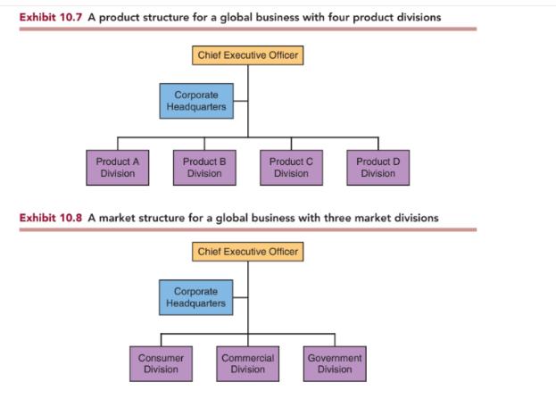

Figure 1: Shows the difference between a market structure and a product structure
Organisational Culture
Hilton’s culture is defined by a set of core values which is practiced by across the company by all employees. Its core values are as follows:
- Hospitality: They are passionate about delivering the best guest experience
- Integrity: Doing the right thing all the time
- Leadership: Becoming the leaders in the hotel industry within the community
- Teamwork: Team players in every task that is carried out
- Ownership: Becoming owners of their own actions and decisions
Hilton believes its core foundation of business starts with creating a global culture around mission, vision and values. Hilton is very proactive in working towards this goal on a daily basis, and they always try to integrate their daily work with their mission, vision and values. For example, Hilton brought in food trucks from downtown Washinton, DC, to its headquarters the week before Thanksgiving. This was a very proactive and generous way to appreciating their team at head office. (4) It is very important to make sure the company’s values and missions align with the company’s vision. From the beginning Conard N. Hilton instilled the concept of treating his customers as “guests”, and encouraged all his colleagues to treat them as if they were guests at their own home. He even actively encouraged his staff to help guests find alternative hotels if there were not enough room available at the Hilton during World War II. He believed creating such culture within the business would ensure customers would return back to Hilton when they needed a hotel in the future. (5)
Businesses in the hospitality sector must be able to instil appropriate work culture. Without the presence of work culture, people will then start to form their own, and without a common set of values it makes it more difficult to achieve the end goal. There maybe some barriers in the hospitality sector which can make it challenging to create an organisational culture. For example, hospitality work can sometimes be classed as unskilled, temporary, seasonal or part-time with reduced benefits and working conditions. These factors can lead to employees having a mindset that it is not a “serious” job which in turn can have an impact on the brand rep. (6)
Organisational Goals
All business organisation must always clarify their mission, goals and objectives. The mission is the brief summary of why the organisation was created in the first place. In the mission statement it should be clarified the purpose and the reason for the organisation’s existence. On other hand, vision is slightly different from their mission. The vision states where the organisation wants to go from where it’s currently at. Hilton defines its vision as “To be the first choice of the world’s travellers”. Goals on the other hand are more specific, it defines what the organisation aims to achieve in a definite period of time in order to be able to accomplish its mission and vision. Organisations goals are set over a time period, this could either be short or a long-term goal. (7) In the hospitality sector goal setting is absolutely essential as it helps to establish “where you are now and where you want to go and when you want to be there”. Goals help to give clarity towards the aim and each goal can be set for different aspects of operation. For example, guest satisfaction, employee satisfaction, food quality, service, profitability etc.

When setting goals there should always be four key ingredients present:
- It should be specific and measurable
- It should have time limits
- Participation should be required for setting goals
- Feedback should be given on performance
A good method to establish a goal is through SWOT analysis. SWOT analysis breaks down the strength, weaknesses, opportunities, and threats. This analysis helps to break down the two internal factors of the company, its strength and weaknesses, and oversee any external factors such as new opportunities and threats, in order to either defend or increase market share. (8)
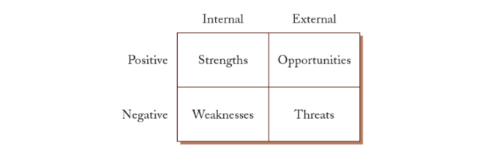

Figure 2: Shows SWOT analysis of strengths, weaknesses, opportunities, and threats to a hospitality organisation
Recent change initiatives
COVID-19 has had enormous impact in the hospitality sector globally. Despite all these challenges Hilton has seen continued growth and development across all sectors in 2020. (17) There are specific strategic plans which have helped Hilton grow during the pandemic. During the pandemic they have opened new hotels, outsized demand for extended stay properties in drive-to leisure markets, and frequent updates to its guest loyalty programme, known as Hilton honours. During the pandemic Hilton made strategic changes in order to thrive during these difficult times. They quickly developed a number of initiatives to ensure guests feel as safe as possible during their stay. By teaming up with big companies like Mayo clinic during the early days of the pandemic they created Hilton clean stay, which was key to reassuring to their guests that they were COVID safe. (9) Despite the COVID-19 challenges Hilton showed significant growth in 2021 as they added another 414 new properties to their portfolio. Even though travel and hospitality sector were massively affected during the pandemic Hilton firmly believes that there will be a strong rebound. (10)
Alongside using the promise of a cleaner rooms as their strategic plan, Hilton also capitalised on social media aspect in order to engage with their customers. As many people were working from home during the pandemic, Hilton created a distraction-free environment for their guests who were working remotely. The facilities that were provided include day-use room with spacious desk, ergonomic chair and enhance WiFi for work. In order to promote this extra support provided for guests who were working remotely, Hilton asked them to post a photo of themselves with the hashtag #upgradeyourview, this helped to create a better connection with their customers virtually. (11)
Strategic direction
Hilton’s 2030 vision is to move towards environmental, social and governance (ESG) strategy in order to have a more sustainable travel globally. Also known as Travel with purpose strategy, its aim is to achieve goals that has been set out by United Nation’s Sustainable Development Goals (SDGs). (18) They have quantified the actions they need to take in order to be able to achieve these goals. To achieve the goals set Hilton need to utilise 6,800+ hotels that use Lightstay. In order to ensure these goals are achieved by 2030 they are using help from their partners such as Hilton’s primary international philanthropic arm by encouraging them to invest in this programme. (12)

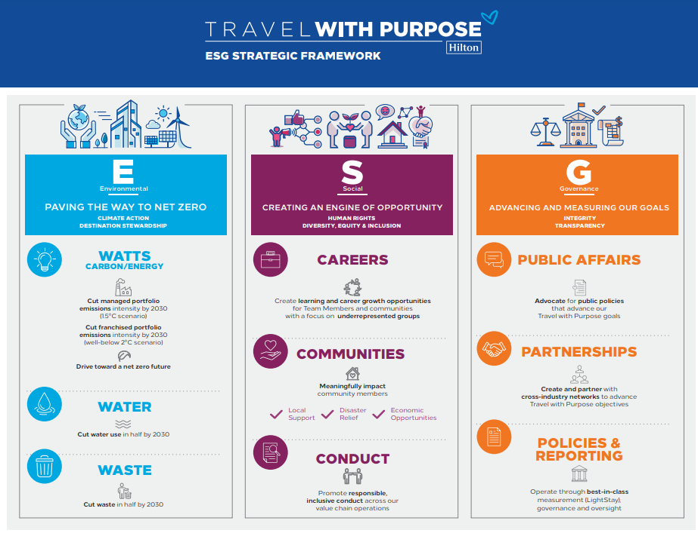
Figure 3: Shows the framework Hilton aims to follow in order to achieve their sustainable goals by 2030.
In order make a goal become a reality there needs to be a solid plan set. In order for Travel with purpose plan to succeed it needs to be assigned to competent managers. After plans have been developed by managers they need to be often approved by higher-level managers. The plan should be detailed and should include details such as list of needed resources such as technology, personnel, capital, equipment and supplies. (19) Some of these resources may be readily available within the business whereas some may need to be sourced from external organisation. Alongside this there should also be some form of reward system for achieving these goals, rewards do not necessarily have to be monetary but can also be professional advancements, more responsibility or public recognition. (13)
Current business performance:
Hilton is constantly growing, in the fourth quarter of 2021 it opened 94 new hotels which equated to 16,100 rooms and managed to achieve net unit growth of 13,100 rooms. If we go back even further during the year 2021 they opened 414 new hotels. The expansion of new hotels has been very steady during the year 2021. Hilton has also seen expansion of its service brands, Hampton by Hilton which has opened over 30 hotels. (14)
Hilton’s current net income was $240 million which showed an increase of 132% from the year before but down 19% compared to 2019, pre COVID times. The CEO Christopher J. Nassetta was very optimistic of the business recovery post pandemic. He also said with the increase rate of vaccination rates and consumer spending business prospects were looking very promising for Hilton. (15)
Conclusion:
In conclusion this report shows the importance of different factors in order for a multimillion company like Hilton to succeed. It is essential to make sure the organisation structure, culture and goals are in line with the vision of the company. Customers and employees are life and soul of the company and without the presence of them both the company would not be successful. Therefore, a structure organised work environment with work friendly culture is essential for a company to thrive in this business. The report also illustrates that Hilton with its strong brand reputation along with smart strategic plans during the pandemic has thrived under them circumstances, and has managed to bounce back even with all the obstacles faced because of COIVD-19.
References:
- En.wikipedia.org. 2022. Hilton Hotels & Resorts - Wikipedia. [online] Available at: <https://en.wikipedia.org/wiki/Hilton_Hotels_%26_Resorts#:~:text=Hilton%20Hotels%20%26%20Resorts%20%28formerly%20known%20as%20Hilton,The%20original%20company%20was%20founded%20by%20Conrad%20Hilton> [Accessed 3 July 2022].
- Smith, L. Murphy., Smith, Katherine T.., Kolari, James., Bierman, Leonard., Gaspar, Julian. Introduction to Global Business: Understanding the International Environment & Global Business Functions. New York : Cengage Learning, 2022.
- Educational Strategies for the Next Generation Leaders in Hotel Management. New York: IGI Global, 2015.
- Gay, W., 2022. 4 Things Companies Can Learn From Hilton's Award-Winning Culture. [online] Forbes. Available at: <https://www.forbes.com/sites/wesgay/2016/12/31/4-things-companies-can-learn-from-hiltons-award-winning-culture/?sh=37b57a8b745c> [Accessed 3 July 2022].
- Nickson, Dennis. Human Resource Management for the Hospitality and Tourism Industries. Amsterdam: Butterworth-Heinemann, 2007.
- Lee-Ross, Darren., Lashley, Conrad. Entrepreneurship and Small Business Management in the Hospitality Industry. Amsterdam: Taylor & Francis, 2010.
- Okumus, Fevzi., Altinay, Levent., Chathoth, Prakash. Strategic Management in the International Hospitality and Tourism Industry. N.p.: Taylor & Francis, 2010.
- Miller, Jack E.., Walker, John R.. Supervision in the Hospitality Industry: Leading Human Resources. London: Wiley, 2010.
- Skift. 2022. 5 Reasons Why Hilton Continues to Grow Its Global Footprint, Despite Covid-19 Challenges. [online] Available at: <https://skift.com/2021/02/25/hilton-grows-global-footprint-despite-covid19/> [Accessed 3 July 2022].
- Business Chief. 2022. Hospitality giant Hilton celebrates growth and expansion. [online] Available at: <https://businesschief.com/leadership-and-strategy/hospitality-giant-hilton-celebrates-growth-and-expansion> [Accessed 3 July 2022].
- Sprout social. 2022. Social Spotlight: Hilton’s pandemic strategy proves the business value of social. [online] Available at: <https://sproutsocial.com/insights/social-spotlight-hilton/> [Accessed 3 July 2022].
- Hilton. 2022. Hilton. [online] Available at: <https://esg.hilton.com/our-approach/> [Accessed 3 July 2022].
- Enz, Cathy A.. Hospitality Strategic Management: Concepts and Cases. London: Wiley, 2009.
- Size, F. and WIRE, B., 2022. Hilton Reports Fourth Quarter and Full Year Results. [online] Businesswire.com. Available at: <https://www.businesswire.com/news/home/20220216005103/en/Hilton-Reports-Fourth-Quarter-and-Full-Year-Results> [Accessed 3 July 2022].
- Hilton reports revenue improvements in Q3. 2021. Hotel Managment. [online] Available at: <https://www.hotelmanagement.net/operate/hilton-reports-revenue-improvements-q3> [Accessed 3 July 2022].
- Ellefson, Paul V.. Forest Products Research and Development Organizations in a Worldwide Setting: A Review of Structure, Governance, and Measures of Performance. Washington DC: U.S. Department of Agriculture, Forest Service, Forest Products Laboratory, 2006.
- Ons.gov.uk. 2022. Coronavirus and its impact on UK hospitality - Office for National Statistics. [online] Available at: <https://www.ons.gov.uk/businessindustryandtrade/business/activitysizeandlocation/articles/coronavirusanditsimpactonukhospitality/january2020tojune2021> [Accessed 3 July 2022].
- ON, H., 2022. Hospitality ON. [online] Hospitality ON. Available at: <https://hospitality-on.com/en/worldwide-hospitality-awards/hilton/hilton-travel-purpose-2030-goals> [Accessed 3 July 2022].
- Social Tables. 2022. Hotel Industry Success Starts With These 7 Things. [online] Available at: <https://www.socialtables.com/blog/hotel-sales/hotel-industry-success/> [Accessed 3 July 2022].
- Bizfluent. 2022. What Is Hotel Organizational Structure?. [online] Available at: <https://bizfluent.com/about-5063797-hotel-organizational-structure-.html> [Accessed 3 July 2022].

