HTML & CSS Web development

Josh Lloyd (2205191)

Table of Contents
INTRODUCTION. 2
REQUIREMENTS 2
IMPLEMENTATION 2
VALIDATION 3
Corrections 3
Evaluation 3
Website usability 3
Website accessibility: 4
Search engine optimization(SEO) 4
My web evaluation 5
Usefulness (Usability and utility) 5
Search engine optimization (SEO) 5
Accessibility 5
References 6
Appendices 7

INTRODUCTION.
In this assignment I have been asked to hand code a website on a topic of my choosing from scratch to achieve this goal I aim to first off create a framework which I can work from which I can add information of my choosing and correctly structure the website and add some design features to it as for my chosen topic I have decided to design my website around one of my favorite bands "THE 1975".

REQUIREMENTS
The topic I have chosen for this website is a band called "THE 1975" I have chosen this topic as I enjoy their music and I thought it would be a good idea to make a website to reflect that and also learn a bit more about them in the process the aim of this website is to inform a reader of who they are, what they do and how is in the band.
To achieve my goal of informing a reader of the band I will first need to research them and included informative information such as how they came about, the music they make, how many albums they have, and who is included in the band.
I will include this information in separate sections to make it more user-friendly and readable. It also helps take in the information if it is split into sections as the information isn't clustered together and looks like a new topic that will grab the attention of the user.

IMPLEMENTATION
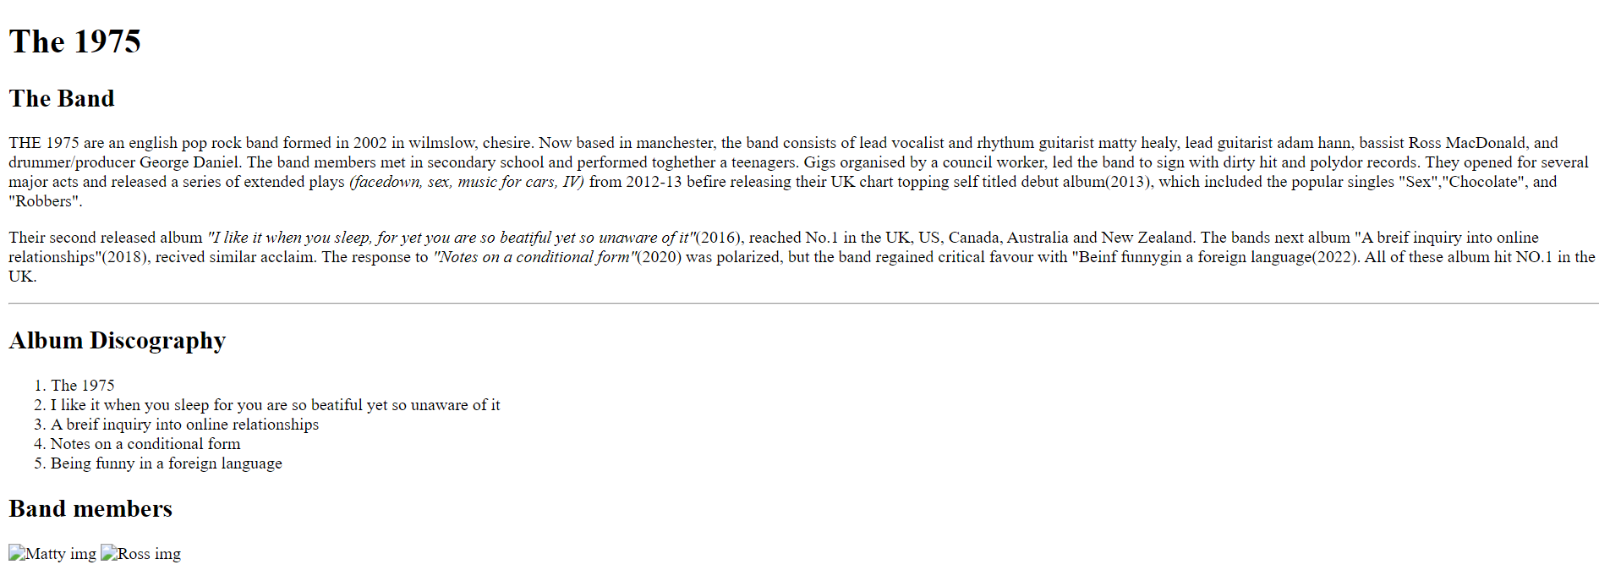
Above is an image of my website as you can see I have added information about the band and divided it into different sections to make it easily readable.

VALIDATION
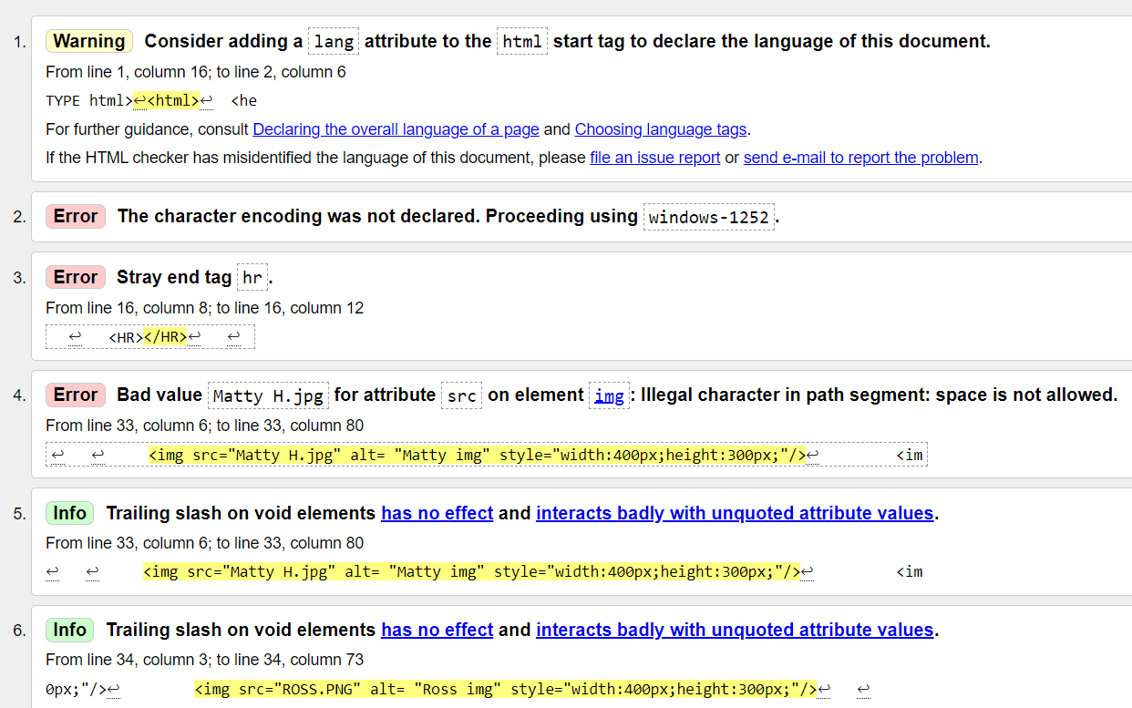
This image shows a list of errors within my program I aim to correct these mistakes and display the changes results in the program.

Corrections
Corrected the spaces in between the values and added more informative “alt”

Evaluation

Website usability
Website usability is a feature of websites and also a way of designing them that focuses on the user's needs. It makes use of user-centric design to make sure that the website you have made is efficient and easy to use for the target audience, rather than the developer.
The two main goals of website usability are clarity and utility, web designers need to prioritize both of these points. To put it simply web designers are tasked with creating websites that don't just look appealing but work to their intended function, which is not easy even for an experienced web developer.
There are 5 principles of website usability which include:
- Availability- The availability of a website is just how easy it is to access your website. Your availability can also be affected by the hosting platform and how compatible it is with your users’ devices.
- Clarity- Clarity is considered to be the core of a website’s usability. As visitors will be coming to your website with a specific goal in mind. If the design of your website distracts or confuses the visitors, they will either take longer to find what they may be looking for or they may just leave the site entirely. Which would leave the visitor unsatisfied, and they will be unlikely to return to the site.
- Recognition- Recognition is a way of describing a process of learning that your users may undertake when they visit a new site. You may feel that your site needs to be observed and studied to be used, however, in reality, all websites on the internet will at least require a few seconds of assessment from users to be able to interact and navigate them.
- Credibility- Even if a user can easily find the content and functionality they seek if they don't trust it, the site is useless for them. There are many ways you can demonstrate credibility within your work like being honest about your goals.
- Relevance- Relevance is quite possibly one of the hardest issues to tackle as it describes whether your website is engaging or not to a user. Creating engaging content involves carefully defining your targeted audience, and then determine what they want, and then meeting their needs.[1]

Website accessibility:
The Internet is designed to work for all people, no matter the hardware or software they possess or language, location, or ability.
Web accessibility means that websites and tools on the internet are designed so that people will disabilities can access them. More specifically it will allow them to:
- Perceive, understand, navigate, and interact with the web
- Contribute to the web
The web or(the internet) is a crucial resource in nearly all aspects of life such as education, employment government, etc. It is essential that the web be accessible in order to provide equal access and opportunity to individuals with diverse abilities.[2]

Search engine optimization(SEO)
In simple terms, SEO means the process of improving your website to increase its visibility within a search engine such as Google and other engines whenever a user searches for:
- Products you sell.
- Services
- Information on topics
The higher visibility your page has in search results, the higher the likelihood you are to be seen and clicked on generating more visits to your site. Ultimately the goal of SEO is to attract more visitors who will become customers/audiences that will keep coming back.[3]

My web evaluation

Usefulness (Usability and utility)
As for the usefulness of my website, I believe it provides some insight into the band and some key information about them, if a user came to the site for some simple quick information on them they would find that here.
Although the website provides the information it is extremely basic in its design as it is just text on a white background, this could be improved in the future with different fonts, colors backgrounds, etc and also the implementation of different pages to have specific information on each so that users can pinpoint specific information they may be looking for and also to improve the functionality.
As for usability, as previously stated the website in nature is extremely basic which makes it easily accessible however it would not be accessible to someone with a disability such as blindness as they would need to be able to see the page, this however can be improved upon in the future.

Search engine optimization (SEO)
There were no SEO techniques implemented within the website.

Accessibility
There is very limited accessibility within my website, and I believe it can be quite hostile to an individual with a disability this can be mitigated by adding certain features and functions in the future such as text-to-speech processing.

References
[1] 9. Team. (-01-15T15:30:59+00:00). The principles of website usability. Available: https://99designs.com/blog/web-digital/website-usability-principles/ [Accessed May 15, 2023].
[2] W. W. A. I. (WAI). (). Introduction to Web Accessibility. Available: https://www.w3.org/WAI/fundamentals/accessibility-intro/ [Accessed May 15, 2023].
[3] Anonymous (). What Is SEO - Search Engine Optimization? Available: https://searchengineland.com/guide/what-is-seo [Accessed May 15, 2023].
[4] Anonymous "The 1975," 2023. Available: https://en.wikipedia.org/w/index.php?title=The_1975&oldid=1154588587.

Appendices

<!DOCTYPE html>
<html>
<head>
<title>THE 1975</title>
</head>
<body>
<h1> The 1975</h1>
<h2> The Band</h2>
<p> THE 1975 are an English pop rock band formed in 2002 in Wilmslow, Cheshire. Now based in Manchester, the band consists of lead vocalist and rhythm guitarist matty healy, lead guitarist Adam Hann, bassist Ross MacDonald, and drummer/producer George Daniel.
The band members met in secondary school and performed together a teenagers. Gigs organized by a council worker, led the band to sign with dirty hit and Polydor records. They opened for several major acts and released a series of extended plays <i>(facedown, sex, music for cars, IV)</i> from 2012-13 before releasing their UK chart topping self-titled debut album(2013), which included the popular singles "Sex","Chocolate", and "Robbers".[4]
</p>
<p> Their second released album <i>"I like it when you sleep, for yet you are so beatiful yet so unaware of it"</i>(2016), reached No.1 in the UK, US, Canada, Australia and New Zealand. The bands next album "A breif inquiry into online relationships"(2018), recived similar acclaim.[4]
The response to <i>"Notes on a conditional form"</i>(2020) was polarized, but the band regained critical favour with "Beinf funnygin a foreign language(2022). All of these album hit NO.1 in the UK.
</p>

<HR></HR>

<!-- ALBUM INFO -->
<h2> Album Discography</h2>

<ol>
<li>The 1975</li>
<li>I like it when you sleep for you are so beatiful yet so unaware of it</li>
<li>A breif inquiry into online relationships</li>
<li>Notes on a conditional form</li>
<li>Being funny in a foreign language</li>
</ol>

<!-- Band member info -->

<h2>Band members</h2>

<img src="Matty H.jpg"alt="Image of Matthew Healy(Frontman)"style="width:400px;height:300px;"/>
<img src="ROSS.PNG"alt="Image of Ross MacDonald(Bass Guitarist)"style="width:400px;height:300px;"/>

</body>
</html>

