Alana Nicholl
University of Wales Trinity Saint David 2022
The Learner: Who Am I Teaching?

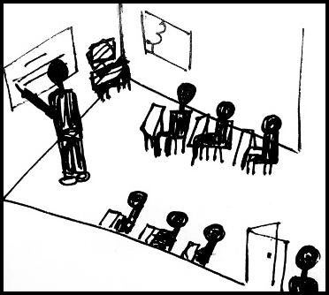

Within the past academic term, I have learned of the importance of being a reflective practitioner.
The significance of being a reflective practitioner has been illustrated in my professional reading of pedagogical theory, strategies and planning.
This willingness to reflect and re-evaluate can and should be done by all teachers and educators as a means of learning. How can an educator understand a student’s experience without it? Without this insight, they would not have the necessary information to adapt their teaching and learning strategies to meet the needs of their young people. When teachers put themselves in the shoes of their pupils, they can gain a real insight into what their pupils need to learn and achieve.
Critical thinking is not solely for the benefit of the pupil, in fact, it is just as beneficial for the educator. Critical reflection is a way you can resolve the issue for future reference. You cannot create a plan without acknowledging the past. This plays a huge part in the definition of critical reflection. In this report I explore an incident that I observed in my bridging experience. I will be using this incident as a focal point for my research into pedagogy, educational psychology and theories around educational sociology.

Addysg Cymru (Education for Wales) has a national initiative to boost critical reflection for teaching professionals, through their Pedagogy for Professional Learning, they state, “learning provision should subscribe to…being open to others’ reflections on how practice can be improved or developed” (Hwb, 2022).
The critical incident I am exploring is one that unfortunately did not enable a pupil to engage with the lesson. With this, I conducted research on reflective models to help clarify my thoughts. (Bassot, B. 2022) spoke about the work of (Osterman and Kottkamp 2004) and interpreted their work in saying they “…argue that we learn most from experiences that are problematic” and with this “...reflective practice takes an optimistic perspective: Real change is possible”(Osterman and Kottamp 2004) comment on the fact that we as educators will never know a student’s full story, and that incidents are merely snippets of much wider perspective.

Before starting my writing process, I studied the (BERA-Ethical-Guidelines-for Educational-Research 2018) to adhere to their guidelines and I have anonymised this piece of academic writing. This is to retain the dignity and respect of my placement school, staff and imperatively, the students. It states under code 40. “Researchers should recognise the entitlement of both institutions and individual participants to privacy.” This observation took place in a mixed gender, mixed ability, English medium comprehensive school in South Wales with approximately 1,300 pupils enrolled from ages 11-18. This school has an additional needs facility that includes a sixth form facility and just over 25% of students entitled to free school meals.
(Walker, R., Adelman, C. 1990) provided me with the scaffolding for my structure in my time in bridging and tips for what to look out for in this experience. In this, they talk about a school being an individual topic for research and the classroom environment.

The class this incident was observed in was a Year 8 English class. The average age of pupils in this class was 12/13. I came in before the class arrived. I greeted the teacher who was a young female, I mention this as I feel this could be of relevance to my reflections. I sat on the seat against the left wall in the middle row as the teacher advised. The classroom was relatively small in comparison to other classes in the school, but there were around 15 pupils in this class with around a 50/50 male to female ratio. This lesson was the second period of the day at around 10.10 am on a Monday morning. This is the fourth week into the first term. It is worth considering the way this timescale may have affected the pupils as environmental factors such a socialising with peers may have impacted their engagement.
Pupil A was observed coming into class feeling relaxed and safe, it seems they have a good relationship with this teacher which is shown by their relaxed conversation with Pupil A asking their teacher how they are. The class was interrupted by a peer from another class at the door looking for pupil A. The teacher dealt with this situation very calmly and when the interruption ended the teacher quickly carried on with the lesson. Ignoring the incident. This to me was the critical incident of Pupil A’s disengagement as this moment could have been used to acknowledge the interruption and apologise for it. Even by making an example of why disruptive behaviour would not be tolerated. Instead in this incident the teacher decided to carry on with the lesson. Pupil A often made comments referring to the interruption and asked the teacher questions about the interruption on 3 occasions
E.g., Teacher: Can anybody give me a good example of a betrayal? Pupil (A): Miss, you betrayed me for not letting me go. (Out of the class)
Although this approached worked for most of the class. This was detrimental to Pupil A’s learning experience who withdrew through the lesson and ended the class being totally disengaged.

I want the research path I have followed to talk about alternative teaching strategies, strategies that allow for inclusivity and equity, giving every student the platform, they require to learn in such situations. (Donaldson 2022)
The Welsh government released the guidelines for the new curriculum and in that it gives a depiction of why we are teaching and educating young people and what we want them to aspire to be. Donaldson talks about pupils across Wales and states they should be. "Healthy, confident individuals. Ready to lead fulfilling lives as valued members of society” With hindsight I would state that it seemed that Pupil (A) was not feeling as though she was confident or ready. This was due to her lack of trust in her surroundings and her insecurity about the situation that unfolded. She did not feel as though she was being heard and therefore, she did not feel valued. There are many reasons why this situation unfolded, but I am researching to hopefully prevent the outcome as seen in the critical incident. All students should have the equal opportunity to learn.

The aftermath of the interruption is where the critical incident lay Was there no room in the timeframe for emotional needs to be met?
“Through individual consideration, school leaders may help to link teachers’ current needs to the school’s goals and mission and enhance teachers’ sense of self-efficacy. “(Geijsel et al., 2009)
This quotation enabled to develop my understanding, as well as my perception of the teacher’s other tactics utilised during the lesson. It refers to the relationship between a teacher and organisation and how this can directly impact their teaching approach. A teacher will be paid to complete a job each day, that job is what exactly? Is it efficiency in its entirety?
Should each lesson have an amount of time dedicated to meeting the needs of the class holistically? Whether this be at the beginning, middle or end or just to be used as and when needed. This could be an answer to the question of how we can prevent such incidents of pupil disengagement.
Regarding the sixth principle of Piaget’s constructivist theory (Piaget, J. 1954) further explained by (Wadsworth, B.J. 1989) “An atmosphere for thinking must be established”. The objective of Wadsworth’s research is to further explain and elaborate on the effectiveness and necessity of Piaget’s work while addressing “misinterpretations of Piaget’s theory” in that "the teacher has no role”, when in fact “the teacher is in the best position to decide which children are ready for what experiences”.
In contrast to (Geijels et al.,2009) research into educational psychology and sociological factors do conclude that a teacher is in the best position to make key decisions regarding how a class is taken and that the school’s overarching policies and objectives should not sacrifice the needs of the learner. Overall, the needs of the learners are being met both collectively and individually. Therefore, I would like to direct your attention to a diagram I have created using information from (Taormina & Gao, 2013) that talks through Maslow’s Hierarchy of needs (Maslow, A.H. 2019).

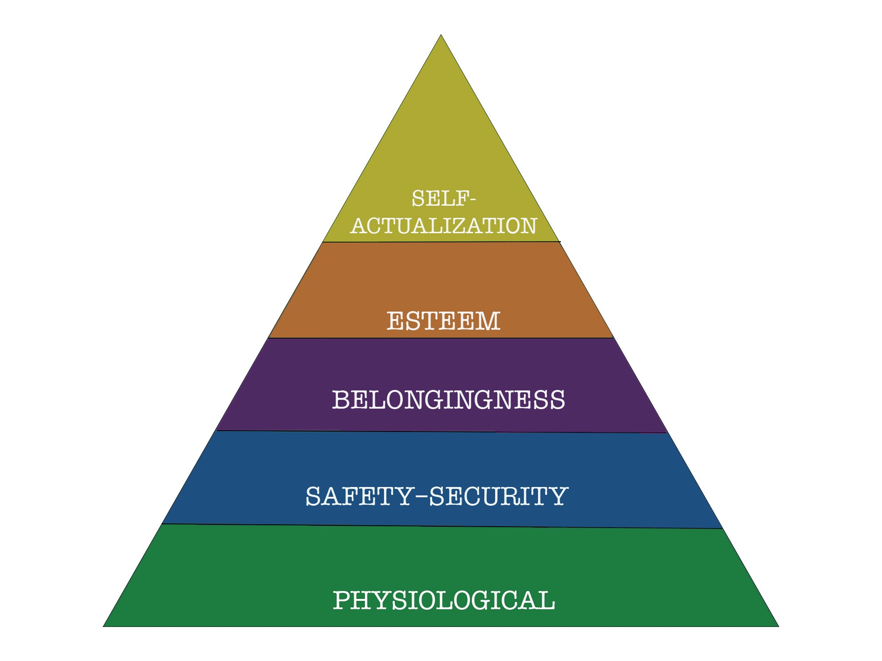
Fig 1, Maslow’s Hierarchy of Needs (Taormina & Gao, 2013)

Within the hierarchy of needs, the theory discussed is that a person cannot succeed in retaining new knowledge or information until their emotional state can be regulated and their human needs are met. This is the pinnacle point that I will be evaluating at the end of this section, regarding the incident in question.
When following this research, I decided to investigate the work of (Holt, J.C. 1982), believing that this would allow me to further understand humanistic psychology. I thought that some of the overarching views of “why children fail?” to be of immense value and insight however, upon further reading, I cannot help but see the use of words to be outdated and dehumanising. Holt’s main objective is to be child centric in his approach and nearly defames the objective of a “school” but, when talking in summary about a child’s ability, I cannot help but feel uncomfortable with his method of comparing a “bright” child to a “dull” one. Though there may be truth in what he is saying, I feel this type of language, and his recollections of personal experience, is objectifying and talks about children in a proximate way, separating children into categories or stereotypes. This is not a conducive attitude towards equity for all students and therefore cannot be seen as humanistic. Instead, I see this linking to the behaviourist theory.
“Behaviourists assume that the internal, mental life of the individual is irrelevant to their learning” (Winch et al., 2008)
(Skinner, B. F. 1969), is well known as a founding father for the behaviourist theory. Behaviourist theory is known for two main concepts which are “classic conditioning”, which aims to manipulate instinctual reactions in a way the trainer wants, and “behavioural conditioning”, which aims to reward the person of or eradicate, things the study cherishes, according to the type of behaviour displayed. (Winch et al., 2008)
As far as I have researched, this is not only a cruel and emotionally damaging type of experimental approach, but it also does not comply with the legal regulations for Children’s basic human rights. In accordance with the Welsh Government and the United Nations. (Comisiynydd Plant Cymru, 2019) “Article 12 - Your right to say what you think should happen and be listened to.”

The focus for wellbeing has been clearly addressed by Neagle (2018) in the National Assembly for Wales' recent report “Mind over matter” which estimates that approximately three pupils in the average classroom in Wales are suffering from a mental health issue.
Consequently, not only is it our job as educators to acknowledge these issues, no matter how they interfere with our schemes of work, it is also imperative that we support the students in our care.
The Onwurah Inquiry into Equity in STEM education (2020) has published a full report on the lack of equity within the schooling systems in the United Kingdom and how this can be improved. It will only be possible for pupils to “self-actualise” and actively improve their education when their basic human needs are met (Maslow, A.H. 2019).
The idea that certain aspects of behaviouralism having a harmful effect on children and young people could not be more evident than now giving the current climate post the Covid 19 pandemic and the direct effects this has had on the education of young people. (Minister for
Education, Renew and reform: Supporting learners' wellbeing and progression: Update for September 2021 [HTML] 2021).
(Reitman, 1998) has demonstrated this as he talks about how an “intrinsic reward” can be “damaging” for the growing mind of a student. Similarly, Skinner (1969) argues that using methods of operant conditioning can have a lasting detrimental impact on the students' view on school. This can be further supported by Holt's (1982) ideology that school can be detrimental to children's lives. However, this only applies if the teacher does not put the emotional needs of the pupil before the need to change their behaviour.
(Reitman, 1998) reinforces the pedagogical idea that for students to gain subject knowledge, they must understand the lesson's aims and objectives. However, if you introduce the operant conditioning theories, you may actually distract your pupil further and prevent them from fully accessing teaching and learning.
I also found it interesting that Reitman speaks about how the reward system can create a sense of goals and aspirations leading to an egocentric point of view which could possibly ingrain a thought process of superficiality and materialism. He discusses this through “rewards in other media” which could be particularly relevant to the generation of pupils we are teaching now in 2022 due to their over-reliance on social media, and their need for validation through something tangible. Creating bribing tactic of rewards may only contribute to this unhealthy mindset and furthermore obstruct the learning process.
(O’Donoghue & Ferguson, 2001) question the fact that, in the behaviourist theory, how can we really know if this approach has benefit? How do you rate the level of success within trying an operant conditioning theory? Would the level of success be determined by the knowledge retained by the end of class? This does not seem to give a realistic overview scientifically. As the process of trying this process in a modern classroom would likely be deemed as a direct violation of Article 12, Children’s Rights (Comisiynydd Plant Cymru, 2019).
The Brizio et al. (2015) study was conducted by a collective of professors studying the neuroscience and cognitive science of what a young female adolescent's brain might look like. They concluded that a young woman at this age has not yet gained a full understanding of the new social responsibility handed to her, yet she is expected to control it. The study further talks about an adolescent girl as being cognitively overloaded with information; particularly socially, as they are expected to handle themselves correctly and manage their time efficiently with very little time to grasp the concept. So, where is the leeway? When I first read (Collins & Drakeford, Because we're worth it! Enhancing self-esteem in young children, 2001) I nearly dismissed it due to the fact it is directed towards children aged 4 - 9. However, having just read the (Brizio et al., 2015) article I felt that this was worth my time. In the report, they explain that a teenage young person should be treated at times as an adult, but also respectfully as a child by giving them the same patience we would treat a child with.
(Collins & Drakeford 2001) wrote a very clear instructional book giving advice on how to teach children in a way that boosts their confidence. They talk about a constant acknowledgement of feelings about the situation. This is something that adults don’t practice enough in a constructive way, and is an approach that should be adopted and adapted in a way that would be beneficial to a young adult.
Smuts, J.C. (1926) is a founder of the sociological approach to education and its holistic approach to view each learner in their entirety, and for the educator to put themselves metaphorically into the student’s shoes. This theory in turn pathed the way for a new approach to education that includes an understanding of emotional literacy.
“Every child is more than a future employee; every person’s intelligence and abilities are far more complex than his or her scores” (Miller, R. A brief introduction to holistic education, 2000). This article takes you on a journey through how (Smuts, J.C. 1926) theory has evolved through time, and of which has led us to ground-breaking theories and findings; including that of (Dewey, 1938) and the principles of Progressive Education.
(Gibbon, 2019) depicts that Dewey accredited academic curriculum to aristocracy but questioned its place in the vast average of schools and the purpose it has on the average pupil’s life outside of the establishment.
(Koliba & Reed's 2003) manual, created as a guidance in liege to Dewey’s progressive educational philosophy, aims to be an educational bible for modern, progressive and liberal educators.
This brings me to the work of (Schön, 2016) and their theory on reflection. In reference to the beginning of this essay, I questioned the role of critical reflection. After reading “How professionals think in action”, I can conclude that my findings have cohesively demonstrated a use of reflection through all educational theory.
Finally, in reading the “four approaches to the analysis of incidents”, (Tripp, D. 2012) talks about the theory of “Non-events” and how they can be a beneficial strategy for the analysis of an incident. For example, by looking at the negative space of an incident, we should not just consider what did not happen, but what could have.
This ideology is crucial to developing pedagogy through self-assessment and reflection and is explained in detail through Tripp’s work. He goes on to conclude that “critical incidents” and their analysis is crucial to the progression of education.
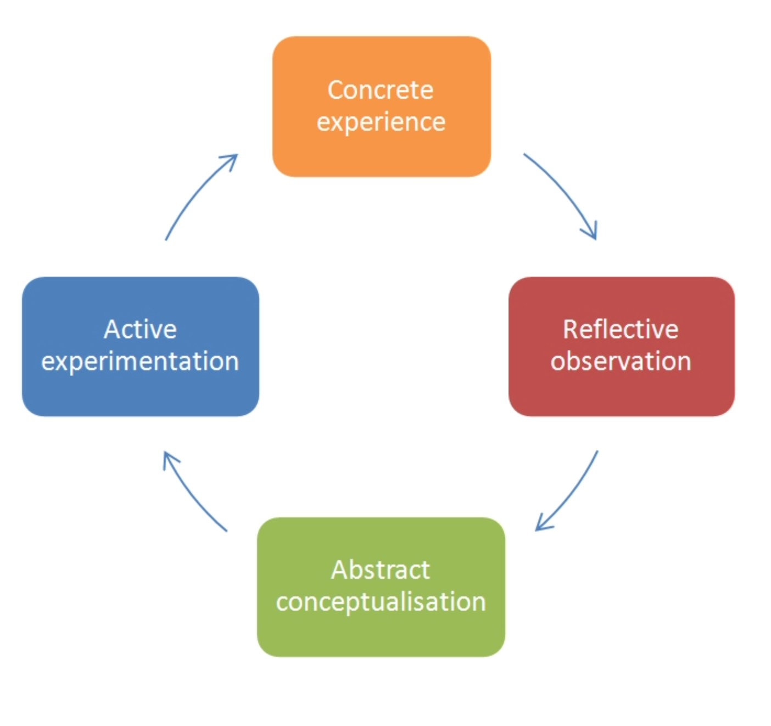
Fig 2, Reflective model: (Kolb, D.A. 1984)
Brown, N. (2022)

In figure two you can see a reflective model created by (Kolb, D.A. 1984). Their theory on education, of which has socialist and progressive values, are illustrated through this model. I have used this model to create an effective path through my essay.
The placement of the teacher within the room. In reading the book “Getting the buggers to behave” (Cowely, 2010), I found the section on tips for “The Teacher within the space” very interesting. Cowley talks about the importance of how a teacher's positioning within the room can reflect in the behaviour of students. By the teacher in this incident adapting a relaxed and comfortable approach in their class, they also underhandedly created a space that did not feel controlled. This is possibly a reason the interruption occurred as the class may have looked vulnerable to interruption by an outsider due to the teacher's positioning. When the interruption occurred, the teacher's positioning could have changed to address the interruption. Cowely talks about this as “creating a physical barrier”. After the interruption had occurred, the teacher physically moving around the room may have created a sense of safety in the class.
The teacher within this critical incident was using a form of behaviouralist approach in the hope that Pupil A would become less focussed on the interruption and more focussed on the task.
However, by not responding to Pupil A’s line of questioning, this pupil felt their “needs” were not met by the teacher and therefore she was not able to progress in her learning.
In contrast, the other children in the class seemingly managed to learn efficiently and completed their work with interest and engagement. They might have gained a deeper ingrained knowledge and a more rounded schooling if the teacher did decide to take a moment to address the class and apologise for the interruption. Moreover, Pupil A may have possibly been able to move past the interruption if she had felt it was acknowledged and she had her emotional needs met.
Regarding (Fig 1) the safety and security of your surroundings is highly important when it comes to the learning process as you will not retain new knowledge if you are feeling on edge or alarmed. Pupil A or any other child in this class did not have this need met as there was no physical barrier to the class, but even more importantly, there was no sense of control and authority from their leader. This caused Pupil A to lack confidence in their teacher; therefore, they began to move up the hierarchy subconsciously by then turning to “Belongingness”. Here the child attempted to participate in the group activity, while relating it to the interruption but failed to align with her peers’ responses and attitudes, critically Pupil A was aware of their social appearance, and this made her question her position within the group. In turn this began to knock her sense of esteem that if she did not belong why would this be, and would this be due to her own failure? And as her role model and person of guidance had outcasted her she felt concreted in her opinion.
This is the point where Pupil A’s head went down to the table and into her folded arms. This was the moment the child had disengaged with the activity as she seen no point in trying and that the activity was at this point irrelevant to her. So, for the final and pinnacle point of the hierarchy the pupil was not able to come to an enlightenment or “Self- actualisation” therefore there was no urge or want to learn.
This could be prevented by using methods of progressive education (Schön, 2016) and (Dewey 1938)’s methods of holistic education.
In aid to create a relevance to a pupil’s life and allow them to have a conducive opinion on how they want to learn.
Reflecting to (Fig, 2) I would like to clarify that the last stage of this cycle would be “active- experimentation”. This would be highly unprofessional and could be regarded as manipulation and emotional abuse if I was to employ this tactic. Furthermore, I feel that the wording of this section is highly outdated and in need of further development. However, I would like to use this stage to explain a hypothesis: that the moment of critical incident was immediately following the interruption. The teacher could have chosen in that moment to acknowledge:
- The behaviour of Pupil B and how this behaviour is harmful and unacceptable.
- Why we treat each other respectfully and allow our peers to learn.
- That you (the teacher) are sorry for not being able to secure the space around you.
This could only take five minutes. For example, if a pupil has a question that steers attention away from the topic and back to the incident then listen to their question before explaining to the class why you need to learn from what you experience in order to mature wisely and aim to be “Ethically informed citizens” who are "Ready to lead fulfilling lives as valued members of society” (Donaldson, 2022).
I feel a holistic child centred approach would have best suited this scenario; however, overall, I feel that there are aspects from many or indeed all types of teaching strategy that could be adopted. Every teacher will prefer different styles, but the bottom line is that the approach best suited will be individual to the pupil and the most important part of deciding this will be to acknowledge their hierarchy of needs.

I have read through the work of Jarvis, P. and Griffin, C. (2006) and their thoughts on the professional training of teachers. It is interesting to think about my role as a learner while studying the philosophies of being a reflective practitioner. They talk about the key topics a trainee teacher will learn about and how this is for their benefit when working practically.
When you summarise this clearly, it is evident that the teacher is no different to a pupil, in the fact that we are both on learning journeys. Me learning about the theory of education and their creators is just as important as a teenager learning how to become a well-rounded individual. Being perfectly well rounded is impossible, but the aim is to role model what well rounded can look like, i.e. acknowledging your surroundings and being resilient, even when you feel out of your depth.
The pinnacle is the pupil- teacher relationship and in turn this will be the focal point of how you can really help a young person understand their value and why they deserve an education. The overarching question during the writing of this essay is to understand who I am teaching. In conclusion to my findings, the learner will always be one of a kind. Each pupil needs their teacher to show a genuine interest in their journey. They don’t want to feel you are their friend, but an ally. A person they can look up to turn to and lean on when they are experiencing success, difficulty or failure. Overall, you need to be on the learning journey together. So, let your pupil tell you what they need to learn.

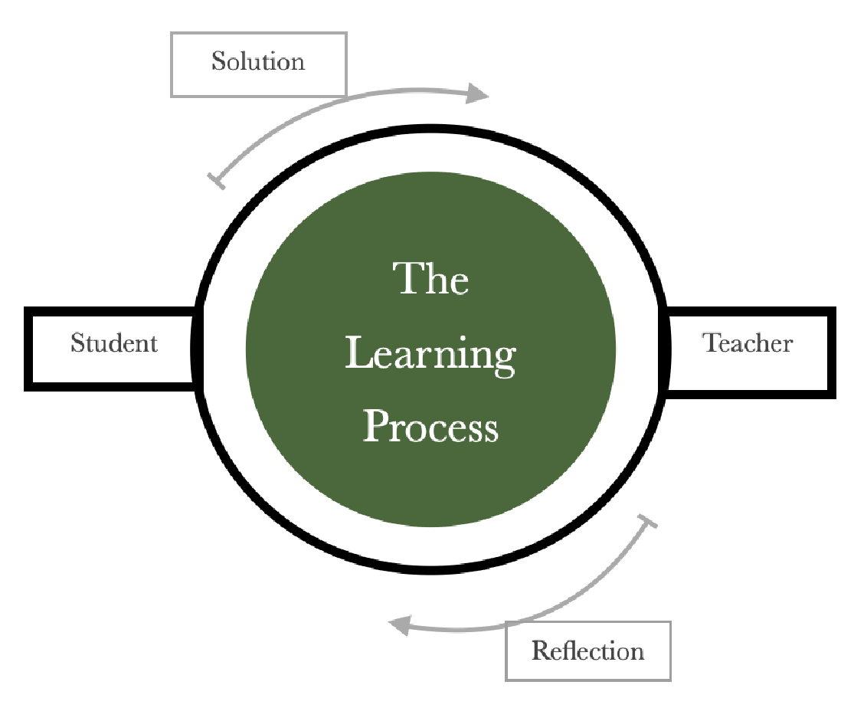

“If you think about the nature of the world our young people are going to become
adults in, then it is a very big question facing all of us thinking about what it is we
can do best for them.” (Wightwick, 2017 Professor Graham Donaldson)

Bibliography

- Bassot, B. (2023) “Chapter 5 - Learning from positives and negatives: Critical Incidents,” in The Reflective Practice Guide: An interdisciplinary approach to critical reflection. Abingdon, Oxton: Routledge, pp. 57–63.
- British Educational Research Association [BERA] (2018)
- Ethical Guidelines for Educational Research, fourth edition, London. https:// www.bera.ac.uk/researchers-resources/publications/ethical- guidelines-foreducational-research-2018
- Brizio, A. et al. (2015) “‘no more a child, not yet an adult’: Studying social cognition in adolescence,” Frontiers in Psychology, 6. Available at: https://doi.org/10.3389/ fpsyg.2015.01011.
- Brown, N. (2022) Reflective model according to Kolb, Dr Nicole Brown Social Research & Practice and Education Ltd. Available at: https://www.nicole-brown.co.uk/reflective-modelaccording-to-kolb/ (Accessed: November 4, 2022).
- Collins, M. and Drakeford, P. (2001) Because we're worth it!: Enhancing self-esteem in young children. London, London: Paul Chapman.
- Cowley, S. (2010) “The teacher within the space,” in Getting the buggers to behave. London, London: Continuum, pp. 154–155.
- Dewey, J. (1938) Experience and education. New York, NY, NY: Touchstone.
- Donaldson, G (2022). | GOV.WALES, Successful Futures Looking at the Curriculum and Assessment Arrangements in Wales. Available at: https://gov.wales/sites/default/files/ publications/2018-03/succesful-futures-a-summary-of-professor-graham-donaldsonsreport.pdf (Accessed: October 30, 2022).
- Entwistle, H. (1979) Child-centred education. London, London: Methuen.
- Geijsel, F.P. et al. (2009) “The effect of teacher psychological and school organizational and leadership factors on teachers' professional learning in Dutch schools,” The Elementary School Journal, 109(4), pp. 406–427.
- Gibbon, P. (2019) John Dewey: Portrait of a progressive thinker Volume 40, Number 2, The National Endowment for the Humanities. Available at: https://www.neh.gov/article/ John-Dewey-portrait-progressive-thinker (Accessed: November 5, 2022).
- Goddard, G. and Walton, A. (2012) Supporting every child: A course book for foundation degrees in teaching and supporting learning. Los Angeles: Sage/Learning Matters.
- Holt, J.C. (1982) How children fail. New York, NY: Delta/Seymour Lawrence.
- Hwb.gov.wales. 2022. Pedagogy for professional learning - Hwb. [online] Available at: <https://hwb.gov.wales/professional-development/nationalapproach-to-professional-learning/pedagogy-for-professional-learning> [Accessed 11 October 2022].
- Jarvis, P. and Griffin, C. (2006) “the pedagogical challenge: what's the use of lectures,” in the theory and practise of teaching. 2nd edn. Oxton, Oxfordshire: Routledge, pp. 78–79.
- Kolb, D.A. (1984). Experiential learning: experience as the source of learning and development. Englewood Cliffs, NJ: Prentice Hall.
- Koliba, C. and Reed, J. (2003) Facilitating Reflection: A Manual for Leaders and Educators, Welcome to the John Dewey Project on Progressive Education. The University of Vermont. Available at: https://www.uvm.edu/~dewey/reflection_manual/index.html (Accessed: November 5, 2022).
- Maslow, A.H. (2019) A theory of human motivation. first. Daryaganj, New Delhi: General Press.
- Miller, R. (2000). ‘A brief introduction to holistic education’, The encyclopaedia of pedagogy and informal education. [https://infed.org/mobi/a-brief-introduction-to-holistic-education/. Retrieved: 5 November 2022].
- Minister for Education, W. (2021) Renew and reform: Supporting learners' wellbeing and progression: Update for September 2021 [Available at: https://gov.wales/renew-andreform-supporting-learners-wellbeing-and-progression-update-september-2021-html (Accessed: November 4, 2022).
- National Assembly for Wales and Neagle, L. (2018) Mind over matter A report on the step change needed in emotional and mental health support for children and young people in Wales. Wales, UK: National Assembly for Wales Commission Copyright 2018.
- O’Donoghue, W.T. and Ferguson, K.E. (2001) “Operant Conditioning and the Experimental Analysis of Behaviour,” in The psychology of B.F. skinner. Thousands Oaks, CA: Sage, pp. 73–96.
- Onwurah, C. (2020) “Inquiry on Equity in STEM education,” STEM Education: An Emerging Field of Inquiry, (final report), pp. 1–8. Available at: https://doi.org/https:// diversityuk.org/wp-content/uploads/2020/06/
  - Final_report_Inquiry_on_Equity_in_STEM_education.pdf.
- Osterman, K.F. and Kottkamp, R.B. (2004) Reflective practice for educators: Professional development to improve student learning. Thousand Oaks, CA: Corwin Press, a Sage Publications Company.
- Piaget, J. (1954) The construction of reality in the child. Oxfordshire, G.B: Routledge.
- Plant Cymru, C. (2019) UNCRC, Children's Commissioner for Wales. Available at: https:// www.childcomwales.org.uk/uncrc-childrens-rights/uncrc/ (Accessed: November 4, 2022).
- Reitman, D. (1998) “The real and imagined harmful effects of rewards,” Journal of Behaviour Therapy and Experimental Psychiatry, 29(2), pp. 101–113. Available at: https:// doi.org/10.1016/s0005-7916(98)00011-1.
- Schön, D.A. (2016) The reflective practitioner: How professionals think in action. Abingdon, England: Routledge.
- Skinner, B. F. (1969). Contingencies of reinforcement: A theoretical analysis. New York: Appleton-Century-Crofts.
- Smuts, J.C. (1926). Holism and Evolution. London: Macmillan & Co.
- Taormina, R.J. and Gao, J.H. (2013) “Maslow and the motivation hierarchy: Measuring satisfaction of the needs,” The American Journal of Psychology, 126(2), pp. 156–159. Available at: https://doi.org/10.5406/amerjpsyc.126.2.0155.
- Tripp, D. (2012) “Chapter 3 Four approaches to the analysis of incidents,” in Critical incidents in teaching developing professional judgement. Abingdon, Oxton: Routledge, pp. 43–55.
- Wadsworth, B.J. (1989) Piaget's theory of cognitive and Affective Development. New York city, NY: Longman.

Walker, R., Adelman, C. (1990) A guide to classroom observation. London: Routledge.
- Wightwick, A. (2017) The man behind Wales’s new curriculum on education, exams and stats, WalesOnline. Available at: https://www.walesonline.co.uk/news/education/grahamdonaldson-interview-wales-curriculum-13812153 (Accessed: November 4, 2022).
- Winch, C., Gingell, J. and Winch, C. (2008) “Behaviourism,” in Philosophy of education the key concepts. second. London, London: Routledge, pp. 21–23.

Cover Image | Alana Nicholl Illustration
Fig 1 | Hierarchy of Needs (Taormina & Gao, 2013) & (Maslow, A.H. 2019)
Fig 2 | Fig 2, Reflective model: (Kolb, D.A. 1984)
Last Diagram | Alana Nicholl Personal Reflection

