

University of Wales Trinity Saint David
School of Engineering

Module : Control Systems (ACMA6001)
Title : Factory Control 1
Name: Adam Hill (1904039)
Date: 15/07/2022

Content

Introduction ~ Page 3.

Literature Review ~ Page 4-5.

Lader Logic ~ Pages 6-16.

HMI Screens ~ Pages 17-18

Conveyor Layout ~ Pages 19.

PLC Flow Diagram ~ Page 20.

Refrences ~ Page 21.

1.0 Introduction
This report inclues a brief literature review covering what a PLC is, The different types of communication methods to a PLC as well as the different types of PLC’s currently available on the market. Using pro’s and Con’s of both to help identify the differences. With a detailed break down of ladder logic written in Siemens TIA Portal which was used to run a boc sorting production line on Factory IO. Looking at the different functions used such as timers and pre sets to control certain components in the production line. Followed by a process flow diagram showing the flow of mterial through the production line.

2.0 Literature review
“PLC stands for “Programmable Logic Controller”. A PLC is a computer specially designed to operate reliably under harsh industrial environments – such as extreme temperatures, wet, dry, and/or dusty conditions. PLCs are used to automate industrial processes such as a manufacturing plant’s assembly line, an ore processing plant, or a wastewater treatment plant. (Muthukrishnan, 2021) “Programmable logic controller is a special form of microprocessor-based controller that uses programmable memory to store instructions and to implement functions such as logic, sequencing, timing, counting, and arithmetic in order to control machines and processes” (Bolton, Programmable Logic Controllers, 2015) PLC are divided into three types based on output namely Relay output, Transistor output, and Triac Output PLC. The relay output type is best suited for both AC and DC output devices. Transistor output type PLC uses switching operations and used inside microprocessors. (Muthukrishnan, 2021) “A very commonly used method of programming PLCs is boned on the use of ladder diagrams. Writing a program is then equivalent to drawing a switch circuit. The ladder diagram consists of two vertical lines representing the power rails. Circuits are connected as horizontal lines, that is, the rungs of the ladder, between two verticals” (Bolton, Programmable Logic Controllers, 2015)

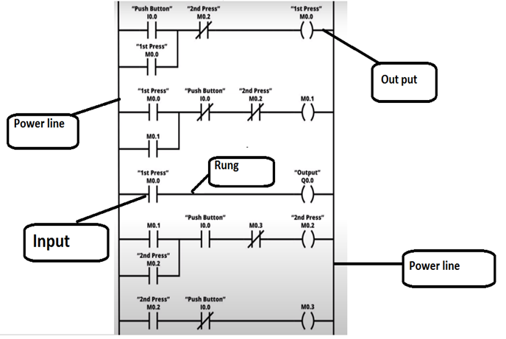
Fig.1 – Diagram of ladder logic showing the power trails, rungs, inputs and outputs (Ashlin, 2020)

Two example of PLC’s used in industry are modular/rack and rail or brick/Compact PLC’s. “Brick/Compact PLCs are commonly used for small programmable cotnrollers and is supplied as an integral compact package complete with power supply, processor, memory, and input/output units. The modular type consists of separate modules for power supply, processor and other modules. Which are often mounted to rails within a metal cabinet. the rack type has the capability to be used for all sizes of prorammable controllers and has the various functional units packaged individucall modules that can be plugged into sockets in a base rack.” (Bolton, PLC Systems, 2015)

PLC Types | Pro’s | Con’s
Compact/Brick | - Small in Size.  - All in one unit.  - Low Cost. | - Limited number of inputs/Outputs.  - Can only operate one programme at a time.
Modular/Rack | - Can add extra modules to increase functionality and flexibility of PLC.  - Robust and long life time.  - Large number of inputs and outputs available.  - The ability to creae very complex PLC systems | - Larger in size than compact PLC.  - Slower communcation.

Table.1 – Table comparing compact PLC and Modular PLC. [Microsoft Powerpoint]

3.0 Lader Logic

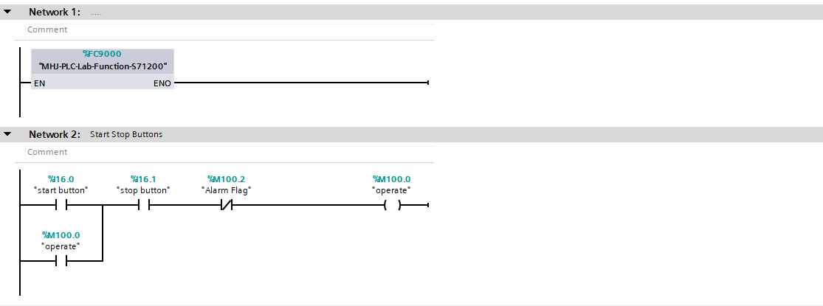
Fig.2 – Network 1 [Siemens Tio Portal]
Network 1 – “MHJ-PLC-Lab-Function-S71200” is the interface between TIA Portal and Factory IO
Fig.3 – Network 2 [Siemens Tio Portal]
Network 2 – This rung represents the start stop function of the programme. Using a latch system to keep the contacts closed when the start button is pressed. When the stop button is pressed the contacts are opened cutting the power to the line.

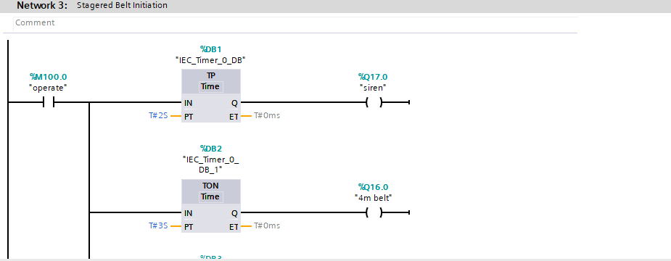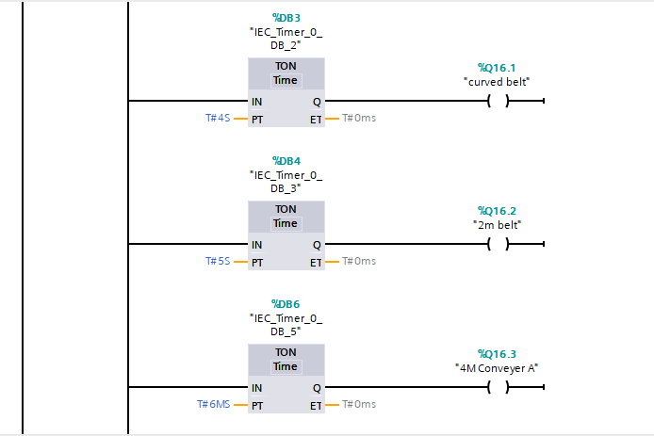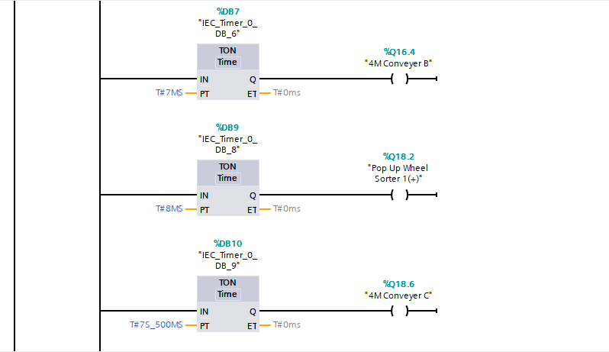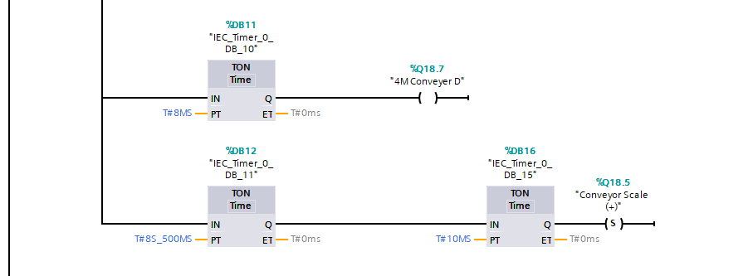
Fig.4 – Network 3 [Siemens Tio Portal]

Network 3 – These rungs show the activation of the conveyor belts. Firstly, the Siren will ring 2 seconds after the start button has been pressed, followed by the conveyor belts starting 1 second after the siren in a staggered fashion. The staggered activation reduces the stress on the electrical supply preventing a power cuts or power surges.
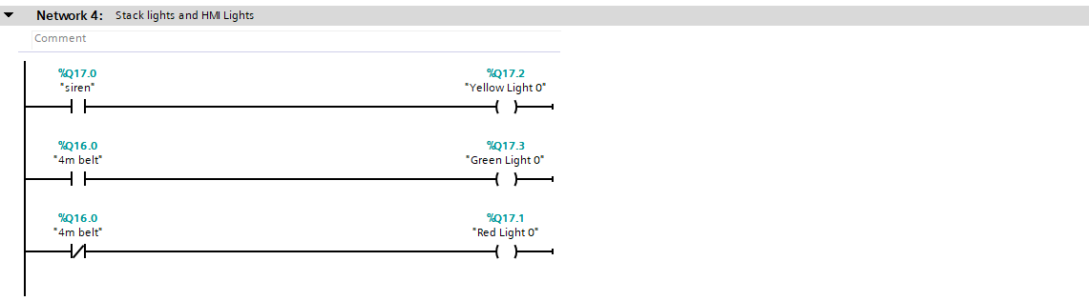
Fig.5 – Network 4 [Siemens Tio Portal]
Network 4 – The stack lights are required to warn personnel if the line is on, off or about to start. “Yellow Light 0” is on a normally open contact when switched off. When the “siren” is activated the contact is closed switching on “Yellow Light 0”. “Green Light 0” is on a normally open contact when switched off, However, when the “4m belt” is activated the contact is closed resulting in “Green Light 0” switching on. “Red Light 0” is on a normally closed contact therefore, when “4m belt” is switched off the contact remains close switching the light on. Also, If the “4m belt” is switched on the contact will open and switch “Red Light 0” off.
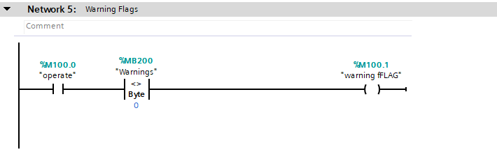

Fig.6 – Network 5 [Siemens Tio Portal]
Network 5 – This rung relates to the warning flag or warning lights. If the memory byte is not equal to 0 the Square warning pilot light on the HMI home screen is activated.
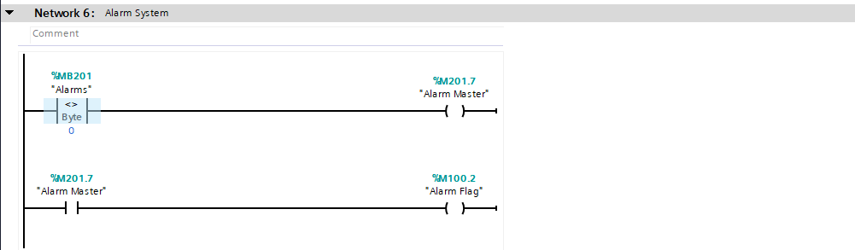
Fig.7 – Network 6 [Siemens Tio Portal]
Network 6 – Like the warning flags this rung relates to the other Square pilot light on the HMI home screen. If the memory byte is not equal to 0 the Alarm master is activated switching on pilot light.
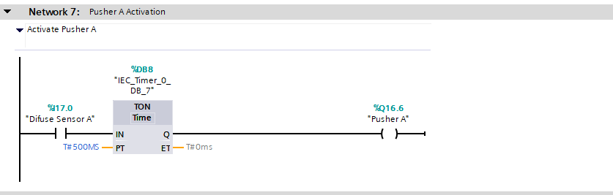
Fig.8 – Network 7 [Siemens Tio Portal]
Network 7 – The pushers on the line are used to move boxes onto different conveyors to be sorted. “Pusher A” is activated when “Difuse sensor A” detects an object and closes the normally open contact. The signal is sent to the timer, which puts a 500ms delay in the signal before sending it to “Pusher A” which will move the box detected by “Difuse Sensor A”.

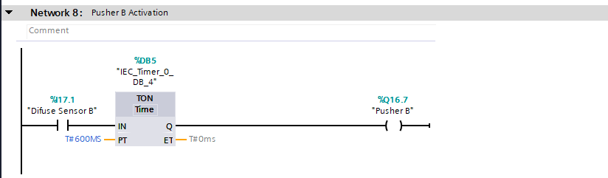
Fig.9 – Network 8 [Siemens Tio Portal]
Network 8 – The pushers on the line are used to move boxes onto different conveyors to be sorted. “Pusher B” is activated when “Difuse sensor B” detects and object and closes the normally open contact. The signal is sent to the timer, which puts a 600ms delay in the signal before sending it to “Pusher B” which will move the box detected by “Difuse Sensor B”.

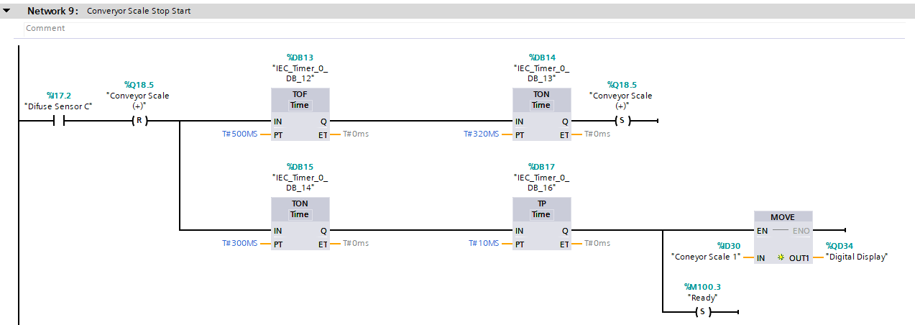
Fig.10 – Network 9 [Siemens Tio Portal]
Network 9 – The input signal “Ready” is sent to the time. The set point of 2ms in PT, stops the signal for the set amount of time before sending it through Q. This set point stops the conveyor from moving giving it enough time to measure the weight of the box. When the measurement is taken it is stored as “Weight” and displayed on a digital display above the conveyor. The weight measured also determines the direction of the “Pop up Wheel Sorter” once the box is stored the conveyor is reset”(R)”.

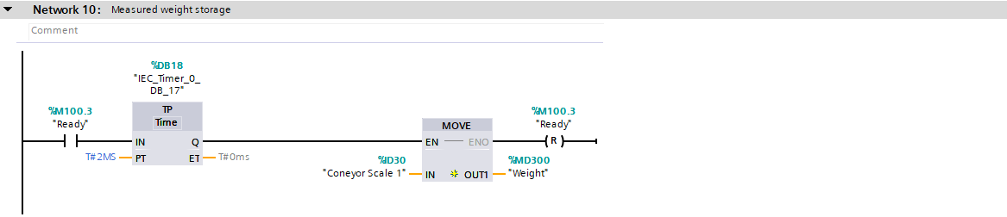
Fig.11 – Network 10 [Siemens Tio Portal]
Network 10 – This rung indicates when the conveyor scale has captured the measurement it is to be stored in memory as “Weight” and then Reset (R).

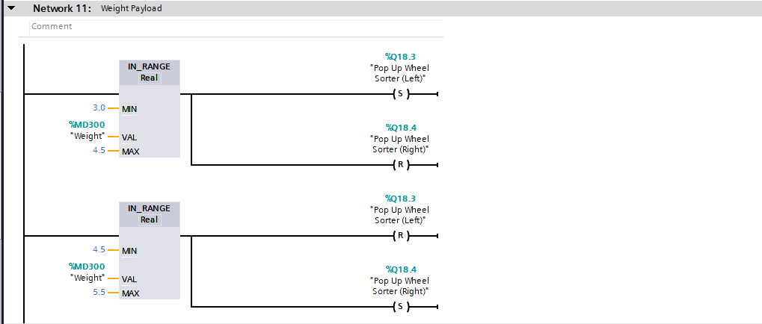
Fig.12 – Network 11 [Siemens Tio Portal]
Network 11 – The first rung in this network shows a parameter set to detect small boxes. If the “Weight” is between 3-4.5Kg “Pop up Wheel Sorter (Left)” Is set and “Pop Up Wheel Sorter (Right)” Is reset. Resulting in the box going left and sorted onto the small box conveyor. If the “Weight” is between 4.5-5KG “Pop Up Wheel Sorter (Left)” is reset and “Pop Up Wheel Sorter (Right)” is set. Resulting in the box going right onto the medium box conveyor.

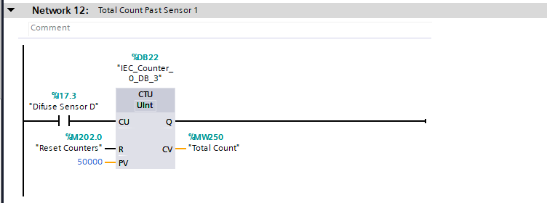 Fig.10 – Fig.13 – Network 12 [Siemens Tio Portal]
Network 12 – The total count is counted using a count up counter linked to “Difuse Sensor D”. If “Difuse Sensor D” detects and object, the normally open contact is closed resulting in a signal being sent to the counter. Which then stores the count as “Total Count” in memory.
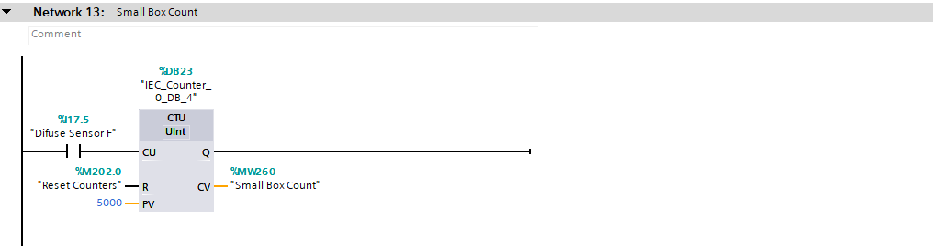
Fig.14– Network 13 [Siemens Tio Portal]
Network 13 – The Small Box count is counted using a count up counter linked to “Difuse Sensor F”. If “Difuse Sensor F” detects and object, the normally open contact is closed resulting in a signal being sent to the counter. Which then stores the count as “Small Box Count” in memory.
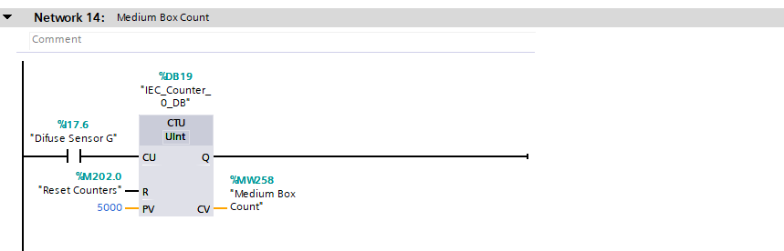
Fig.15 – Network 14 [Siemens Tio Portal]
Network 14 – The Medium Box Count is counted using a count up counter linked to “Difuse Sensor G”. If “Difuse Sensor G” detects and object, the normally open contact is closed resulting in a signal being sent to the counter. Which then stores the count as “Medium Box Count” in memory.

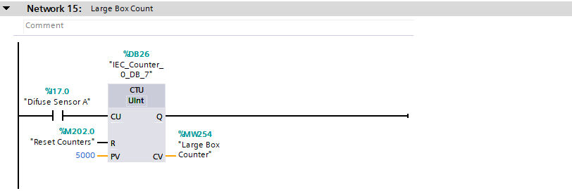
Fig.16 – Network 15 [Siemens Tio Portal]
Network 15 – The Large Box Count is counted using a count up counter linked to “Difuse Sensor A”. If “Difuse Sensor A” detects and object, the normally open contact is closed resulting in a signal being sent to the counter. Which then stores the count as “Large Box Count” in memory.
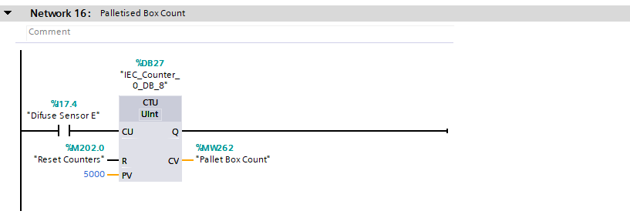
Fig.17 – Network 16 [Siemens Tio Portal]
Network 16 – The Palletised Box count is counted using a count up counter linked to “Difuse Sensor E”. If “Difuse Sensor E” detects and object, the normally open contact is closed resulting in a signal being sent to the counter. Which then stores the count as “Pallet Box Counter” in memory.

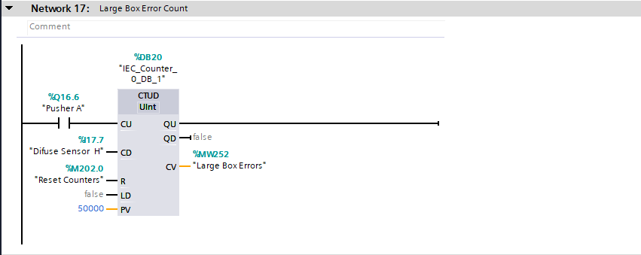
Fig.18 – Network 17 [Siemens Tio Portal]
Network 19 – This rung counts the errors on the Large box conveyor. Errors in this instance are the number of boxes which enter the large box conveyor but have fallen off and not made it to the pickup point. The normally open contact for “Pusher A” only sends a signal to the counter when the contact is closed. When the contact is closed the counter will count up. “Difuse Sensor H” is set up at the end of the large box conveyor to ensure the box counted at “Pusher A” makes it to the end. If “Difuse Sensor H” detects a box reaching the end the counter will count down 1. Removing the box from the error count indicating the box has made it to the end.
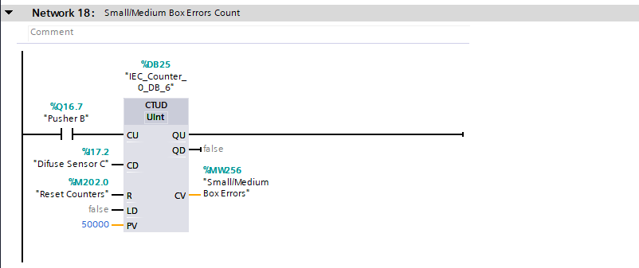
Fig.19 – Network 18 [Siemens Tio Portal]
Network 20 – This rung counts the errors on the small/Medium box conveyor. Errors in this instance are the number of boxes which enter the small/medium box conveyor but have fallen off and not made it to the Weighing conveyor. The normally open contact for “Pusher B” only sends a signal to the counter when the contact is closed. When the contact is closed the counter will count up. “Difuse Sensor C” is set up at the end of the large box conveyor to ensure the box counted at “Pusher B” makes it to the weighing conveyor. If “Difuse Sensor H” detects a box reaching the end the counter will count down 1. Removing the box from the error count indicating the box has made it to the weighing conveyor.
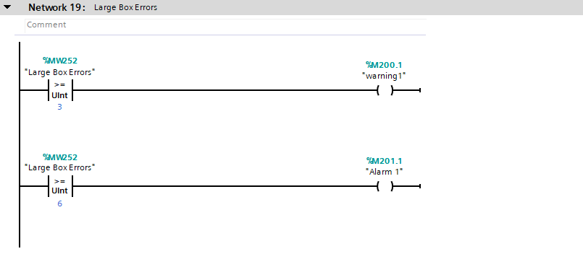
Fig.20 – Network 19 [Siemens Tia Portal]
Network 19 – “Large box error” is a set point set up in memory. The first rung indicates the set point which the warnings will activate on the HMI. If the “Large Box Errors” it greater than or equal to 3 the warning signal is activated. A red light will switch on the HMI indicating boxes have not made it to the end of the Large box conveyor. The alarm has be set to activate if “Large Box Errors” is greater than or equal to 6. If this occurs the line will automatically stop.
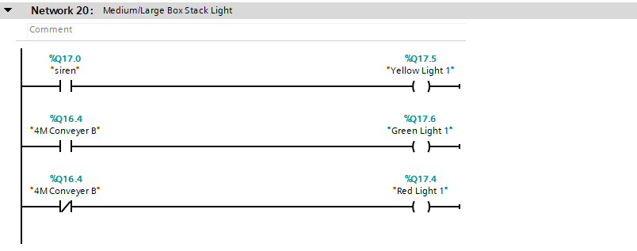
Fig.21 – Network 20 [Siemens Tio Portal]
Network 20 - The stack lights are required to warn personnel if the line is on, off or about to start. “Yellow Light 0” is on a normally open contact when switched off. When the “siren” is activated the contact is closed switching on “Yellow Light 0”. “Green Light 0” is on a normally open contact when switched off, However, when the “4m belt” is activated the contact is closed resulting in “Green Light 0” switching on. “Red Light 0” is on a normally closed contact therefore, when “4m belt” is switched off the contact remains close switching the light on. If the “4m belt” is switched on the contact will open and switch “Red Light 0” off.
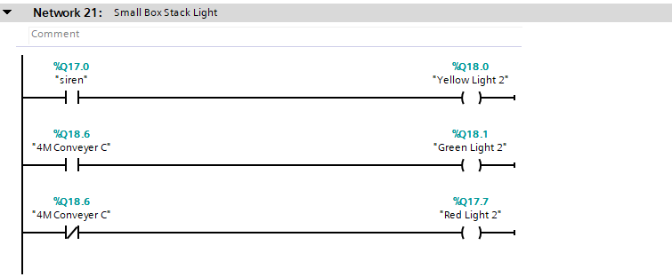
Fig.22 – Network 21 [Siemens Tio Portal]
Network 21 - The stack lights are required to warn personnel if the line is on, off or about to start. “Yellow Light 0” is on a normally open contact when switched off. When the “siren” is activated the contact is closed switching on “Yellow Light 0”. “Green Light 0” is on a normally open contact when switched off, However, when the “4m belt” is activated the contact is closed resulting in “Green Light 0” switching on. “Red Light 0” is on a normally closed contact therefore, when “4m belt” is switched off the contact remains close switching the light on. If the “4m belt” is switched on the contact will open and switch “Red Light 0” off.
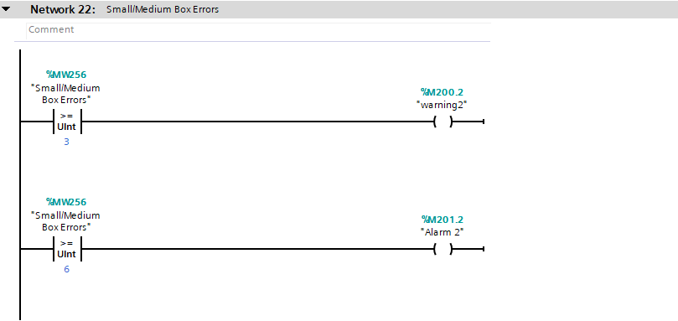
Fig.23– Network 22 [Siemens Tio Portal]
Network 22 – “Small/Medium box error” is a set point set up in memory. The first rung indicates the set point which the warnings will activate on the HMI. If the “Small/Medium Box Errors” it greater than or equal to 3 the warning signal is activated. A red light will switch on the HMI indicating boxes have not made it to the end of the Large box conveyor. The alarm has been set to activate if “Small/Medium Box Errors” is greater than or equal to 6. If this occurs the entire conveyor system will stop.

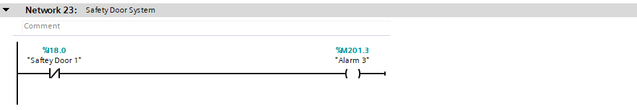
Fig.24– Network 23 [Siemens Tio Portal]
Network 23 – The safety door is set on a normally closed contact. Therefore, if the safety door was open alarm 3 would signal highlighting the door is open preventing the line from starting up.
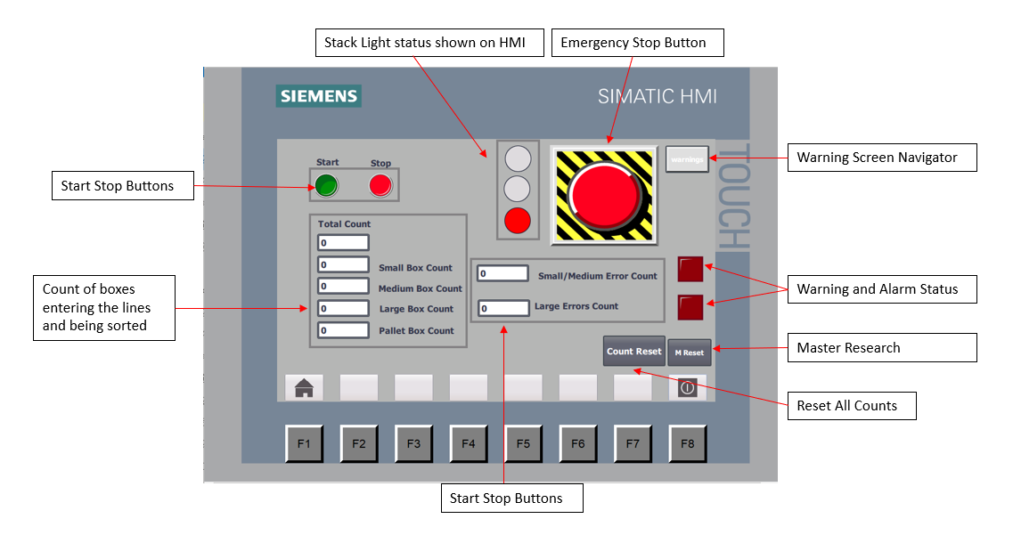
3.1 HMI Screens.

Fig 25. – Diagram of HMI Home screen with box and error counters, lights indicating line status, Emergency stops reset functions and navigation buttons [Siemens 7]
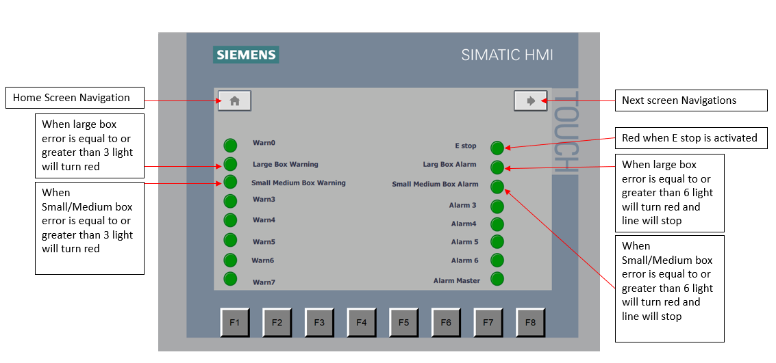
Fig 26. – Diagram of HMI screen with warnings lights, alarm lights and navigation buttons. [Siemens 7]

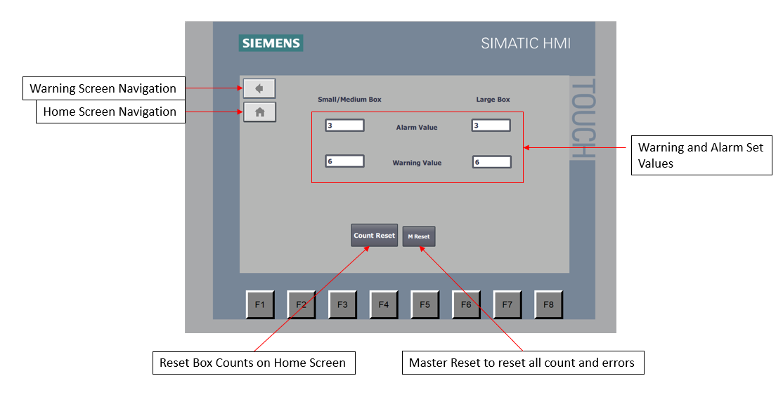
Fig 27. – Diagram of HMI screen with Set Points, reset functions and navigation buttons. [Siemens 7]

4.0 Conveyor Layout
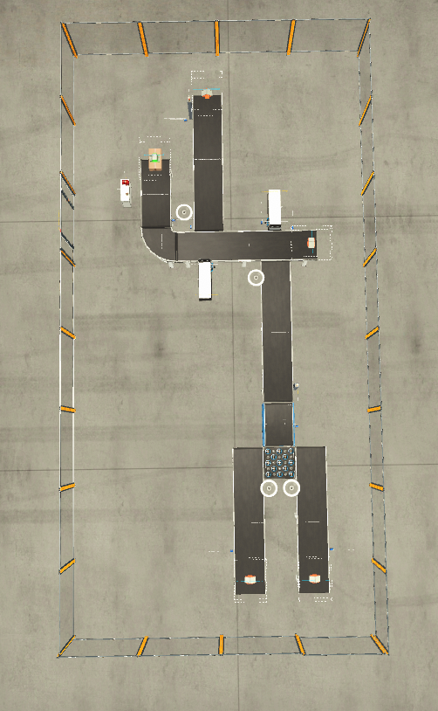
Palletised box conveyor
Large box conveyor
Medium box conveyor
Small box conveyor
Fig.28 – High level process flow map of how the conveyors operate. [Microsoft Powerpoint]

4.0 Process Flow Diagram
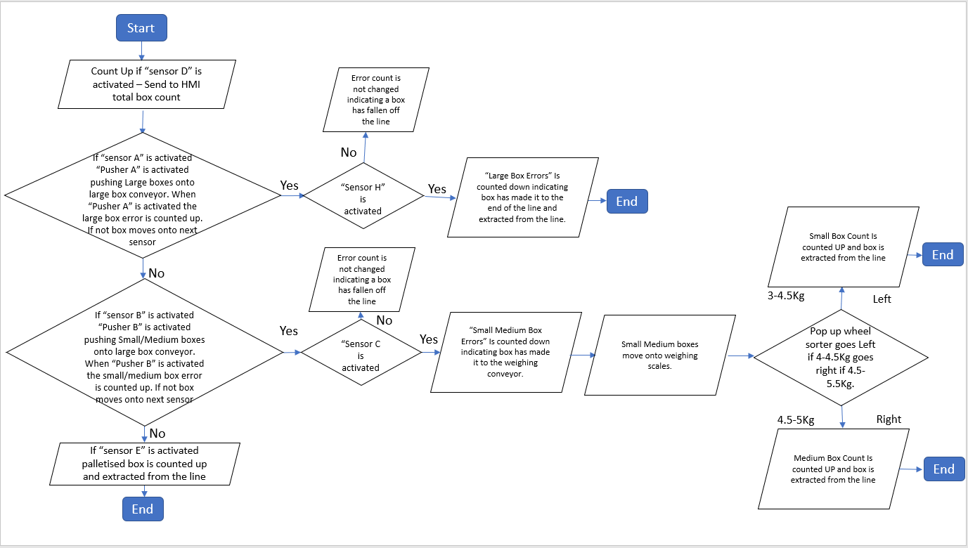

Fig.29 – High level process flow map of how the conveyors operate. [Microsoft Powerpoint]

References
Ashlin. (2020, July). Forum Automation. Retrieved from Wha is laddr logic and what is ladder logic diagram in PLC's: https://forumautomation.com/t/what-is-a-ladder-logic-and-what-is-ladder-logic-diagram-in-plc/8496
Bolton, W. (2015). PLC Systems. In W. Bolton, Programmable Logic Controller (p. 13). ELSEVIER.
Bolton, W. (2015). Programmable Logic Controllers. In W. Bolton, Programmable Logic Controllers (p. 1). Oxford: ELSEVIER.
Bolton, W. (2015). Programmable Logic Controllers. In W. Bolton, Programmable Logic Controllers (p. 12). Oxford: ELSEVEIR.
Muthukrishnan, V. (2021, April 11). Programmable Logic Controllers (PLCs): Basics, Types & Applications. Retrieved from Electrical 4 U: https://www.electrical4u.com/programmable-logic-controllers/#:~:text=PLC%20are%20divided%20into%20three,output%2C%20and%20Triac%20Output%20PLC.

