

MODULE CODE: Digital Skills for Personal Development and Business Growth BMSW4008

ASSESSMENT COMPONENT: PORTFOLIO

STUDENT NAME: Miguel E. Martinez

STUDENT NUMBER: 2528533

LECTURER: Philippa

DATE: 16/03/2026
Contents
Task 1 3
Assessment of Digital Skills 3
References 6
Task 2 7
LinkedIn Learning Certificates for Office365 7
Task 3 9
Essay on Relevance of Excel in professional and personal life. 9
References 12
Task 4 13
7 Minute Reflective Presentation 13
References 15

Task 1

Assessment of Digital Skills
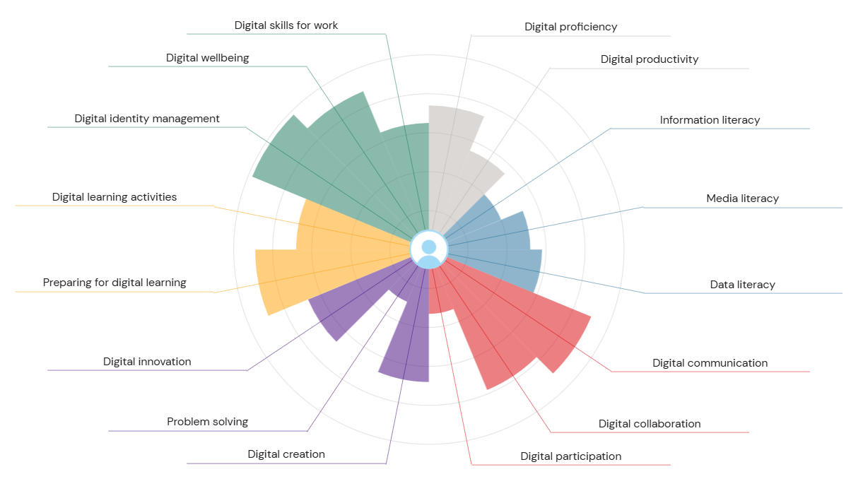
The world today is different from three, five, ten years ago. Technology keeps developing throughout the years in response to that big impact in today’s world, we need to adapt and we do it by developing digital skills. On a digital era, we need digital skills. “Digital skills are how we communicate, collaborate, and complete our daily tasks in contemporary workplaces [studies, and more] that rely on computers and other critical technologies” (Coursera, 2025). Therefore, we see the importance, need, and urgency of developing, learning, and teaching digital skills.
Through the JISC self-assessment I can look at, analyse, my digital competence or digital skills profile. The chart presents those skills grouped into categories, which are the following digital:
- Productivity and Proficiency (Grey)
- Information and Data Literacy (Blue)
- Communication and Collaboration (Red)
- Creation and Problem Solving (Purple)
- Learning (Yellow)
- Identity and Wellbeing (Green)
The chart shows the set of digital skills that I have. My strongest areas (management, wellbeing, communication and collaboration), neutral/moderate areas (literacy, productivity, creation), weakest areas (innovation and advanced data/media skills).
We will look at two strengths and two weaknesses and at the same time create and provide a plan to improve the weak areas.
Digital Identity Management. It is “how you develop and project a digital identity – or several identities – and how you manage your digital reputation” (JISC. 2026). “A digital identity is a virtual representation of an individual in the digital world” (Oneidentity, 2026). I completely agree with the JISC result. I am someone who cares the way I ‘present’ myself online, but I care the most about the information I allowed to be use or that I personally use online. For example: Social media accounts (Facebook, Instagram, Linkedin, etc.), Google accounts, Microsoft accounts, etc. It is something I care about and I pay attention to. Therefore, it is becoming one of my strengths.
Digital communication. It is “the procedure of exchanging information, messages, and ideas via digital technologies and platforms” (Wilson. 2025). Digital communication offers or allows ‘live’ conversations or interactions with multiple people no matter where they are or when (time and place). The communication can be made through text, videocall, audio, etc. Also allows sharing content during the interaction. This is part of my daily life now – at work, university, family, etc. Thanks to the daily use and how it has become something essential on my day-to-day life. It has become a strength.
Digital problem solving “refers to the ability to leverage digital resources and tools in order to identify, understand and address complex challenges” (Acorn. 2026). Problem solving is also about searching and evaluating information, using digital solutions effectively, and seeking ways of improvement from feedback. I do agree with the results of the JISC. It is an area of my digital skills that is developing.
Digital participation “involves using digital tools and platforms to engage people in decision-making” (Participation playbook, 2026). The participation can be taken through different ways like surveys, social media quests, etc. This is made with the end to engage with communities and collect date from those communities. As well as the skill mentioned above this is being develop too. I am not someone who engages on those kinds of participations/interactions.
My plan to improve those two skills are the following, using SMART:
(A being problem solving and B digital participation)
Specific
A) Learn how to use and use digital tools to verify information. Review feedback to find ways of improvement and improve weaknesses.
B) Participate more in online forums, quests, Q&A, etc.
Measurable
A) It will be measurable trough the assignments and research that I will use to make it. It will be clearer through the references that I will provide in future assigmnets.
B) Short term it will be measurable through the communication and interactions with classmates through group chats.
Achievable
A & B) Both are achievable in the period of the Employability Skills course. I do have the necessary skills to develop these two and also the teachers that are able to support, give feedback and tips.
Relevant
A & B) They are very relevant in today’s world but not just that with the purpose of the course, which is to prepare students for the workforce in a modern society.
Time-Bound
A & B) It will mainly be during the period of the course. Until December.

References
Coursera. (2025) Digital Skills: What They Are and How to Improve Yours Available at: https://www.coursera.org/articles/digital-skills (Accessed 02 March 2026).
JISC. (2026) Your digital capability report (Higher Education Student Question Set) Available at: https://uwtsd.potential.ly/playlists/question-bank-for-students/assessments/current-students-higher-education/report (Accessed 09 March 2026).
Oneidentity. (2026) What is a digital identity? Available at: https://www.oneidentity.com/learn/what-is-a-digital-identity.aspx#:~:text=Digital%20identity%20management%20begins%20with%20registration%20and,and%20access%20rights%20to%20the%20user's%20identity. (Accessed 09 March 2026).
Wilson, Charlotte. (2025) What is Digital Communication: Explained with Examples Available at: https://www.theknowledgeacademy.com/blog/digital-communication/#:~:text=Digital%20Communication%20is%20the%20procedure%20of%20exchanging,sharing%20of%20multimedia%20content%20across%20vast%20distances. (Accessed 09 March 2026).
Acorn. (2026) Digital Problem-Solving Available at: https://acorn.works/capability/digital-problem-solving#:~:text=Digital%20Problem%2DSolving%20refers%20to,desired%20outcomes%20within%20the%20organization. (Accessed 09 March 2026).
Participation playbook. (2026) Digital Participation Available at: https://participationplaybook.org/digital-participation#:~:text=Digital%20participation%20involves%20using%20digital%20tools%20and,the%20digital%20literacy%20needed%20to%20effectively%20engage. (Accessed 12 March 2026).

Task 2

LinkedIn Learning Certificates for Office365
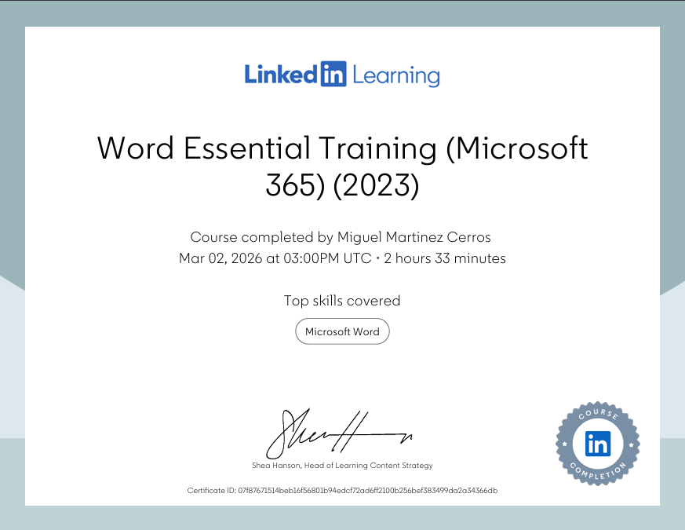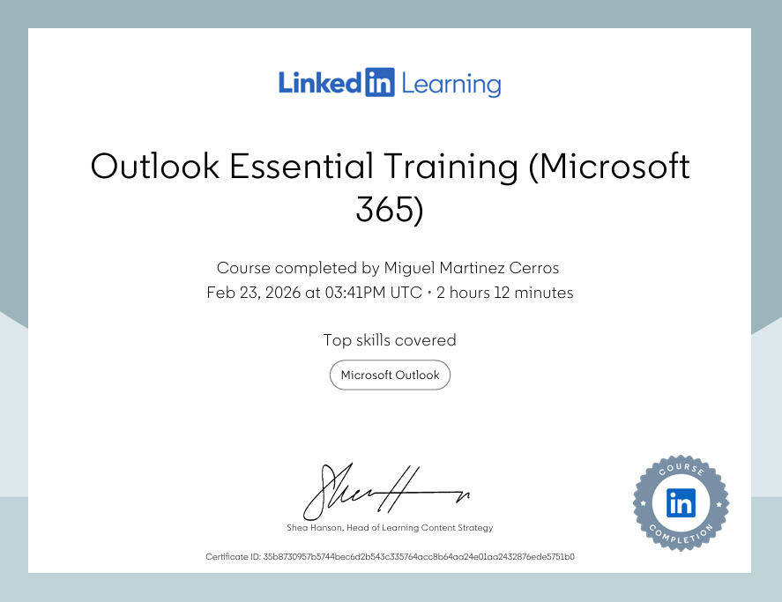
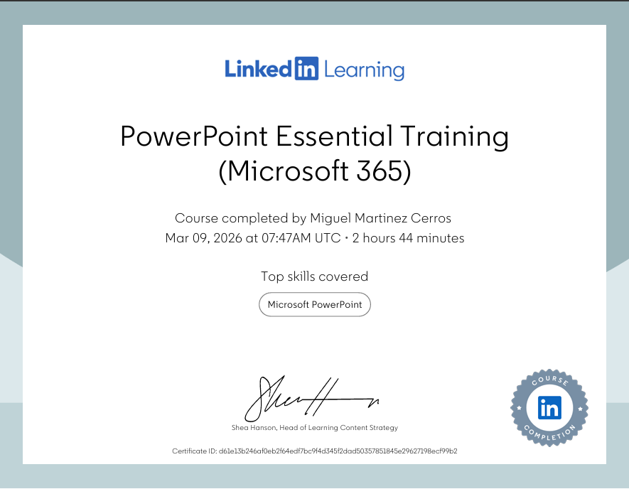

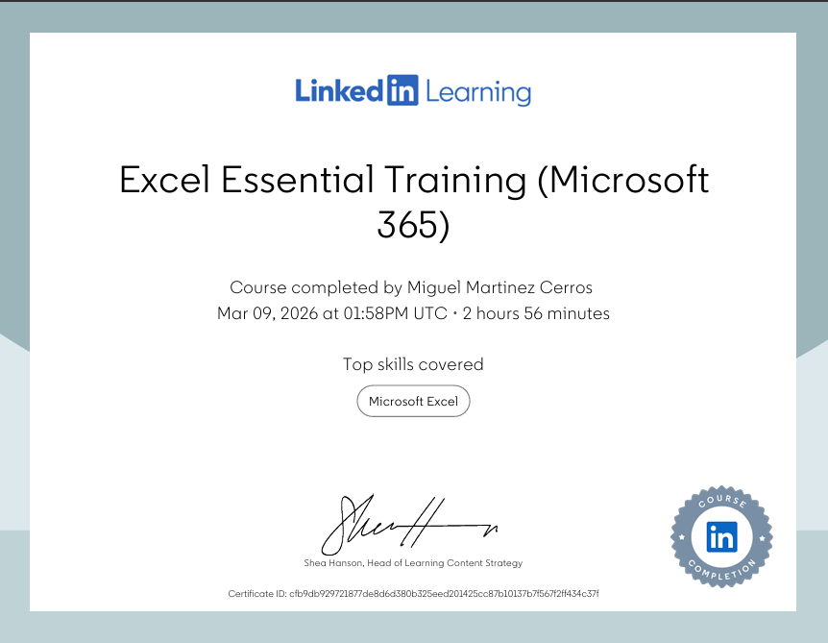

Task 3

Essay on Relevance of Excel in professional and personal life.
Microsoft Excel is an invaluable tool for business in today’s world, and it can also be used on a more personal way. In the following it is explained what Microsoft Excel is, the relevance that it still has for business in the way the carry about their finances, analysis, etc. It also discusses the relevance that it has because of constant updates that Excel receives. The importance of Excel as an invaluable tool for multiple tasks that requires precision and effectiveness for better decision making within a business environment or more personal way. It also addresses the way it can be used to analyse data, budgeting, reporting and decision making.

“Microsoft Excel is a versatile and powerful spreadsheet software developed by Microsoft” (Insight software, 2026). It is known as a top tool for analysing, managing and presenting data on both aspects of life, personal and professional. Excel enables users with tools to make complex calculations, creating graphs and charts, and building data patterns. Excel is not just a simple programme/software for spreadsheets, it is an essential tool for businesses, and it can become useful for day-to-day basis. It is still relevant as the software is continuously updated to give the best results to its users. It is important as there are Microsoft Excel courses available online, this allowing people to better understand and prepare to be the workforce needed in the industry. There are also skills development such as: Data management, data analysis, visualisation, etc. It is not just for the impact to an individual but beyond that to a group, department, company, etc.
Excel as a data analysis tool:
Excel “makes data analysis simpler, faster and more intuitive” (Microsoft, 2026). When analysing data in Excel enables you to understand the data through “natural language queries” (Microsoft, 2026). Allows you to ask questions, questions that are already programmed within the software, about the data. Excel is used “for many tasks: adding numbers, calculating medians and averages, finding minimums and maximums, and more” (Efron. 2024). It also provides visual summaries, trends, and patterns on high-level.
Excel a budgeting tool:
It seems overwhelming and hard to create a budgeting plan for your household, but with Excel is easier, it can help the user get organized. “Using a budgeting spreadsheet can help make your financial health a priority by keeping spending in check and savings on the rise!” (Microsoft, 2026). It allows you to categorize expenses and set goals.
Reporting with Excel:
Excel allows you to “create reports using different methods, depending on your purpose for using the application” (Indeed, 2025). For your Excel reports you can:
- Display data in charts: Create reports is about displaying your data in a graph or chart. Excel allows you to use line graphs, pie charts and tables.
- Create a pivot table to organize data: “A pivot table in Excel creates a table of summarized values from large sets of data” (Indeed, 2025). If there is more information/data to add, a pivot table can be created to make the information more accessible.
- Separate the data types of your reports: “Excel allows you to create multiple sheets within a workbook and multiple pages within a sheet” (Indeed, 2025). Meaning that you can visualize data in graphs and charts on one sheet, tabular data on another one and any other values on a different sheet.
- Add page headers: Whenever you are printing or exporting reports you need to page headers.
- Format and print reports: As needed you can change the layout, so you are able to fit it within the printer paper margin.
Excel reports are mainly used for finance and accounting, sales and marketing, and human resources.
Microsoft Excel also allows:
“Planning and tracking templates for streamlined projects” (Excel, 2026).
- Planners and trackers.
- Timelines.
- Schedules.
- Gantt charts.
“Professional accounting and business templates” (Excel, 2026).
- Inventories.
- Business timesheets.
- Invoices
- Accounting
“Education templates for smart studying” (Excel, 2026).
- Student trackers.
- Charts
“Simple and intuitive personal budget templates” (Excel, 2026).
- Financial management.
- Personal budgeting.
- Calculators
Decision making with Excel: Decision making in a business can be a complex process. Data needs to be right and accurate to make the best decision. “Excel can help to make sure the data is accurate, informative and organized in a way that leads to better and faster decision making” (Tap solutions, 2026). Essential part of decision-making is to analyse and organize data. Excel enables you to quickly analyse big amounts of data and make comparisons between multiples sets of data. It also allows the user to quickly and effectively calculate the outcome of a decision.
To conclude with we see how important and useful Microsoft Excel is and it can be when used the proper way and making use of all the tool that the software provides the user with. Excel is vital for businesses. It helps businesses owners have a more organised planner and track of their products, services, finances, employees, etc. All that allows them to succeed in their goals and competition within their own fields. This success can also be transmitted to the household environment, having habits, skills and tools for managing finances. Allowing users to make plans on an organized manner, being able to track and even create possibles scenarios with different data. Also, users are boosted by being able to develop many skills that allowed them to be better prepared to work, manage, lead, and organise. These skills can be gain through the easy access to on-line courses, which many of them are free, or simply by using and exploring the software and implementing it in their professional and personal life.

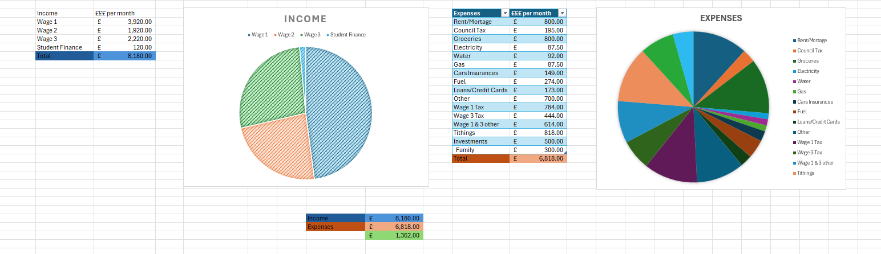
Embed your excel here

References
Charlesworth, Lewis. (2024) What is Microsoft Excel used for and is it still relevant? Available at: https://kaplan.co.uk/blog/features/is-microsoft-excel-still-relevant#:~:text=Microsoft%20Excel%20is%20a%20vital%20tool%20for,Data%20management%20*%20Data%20analysis%20*%20Visualization (Accessed 15 March 2026)
Insight Software. (2026) Why Do We Use Excel? Available at: https://insightsoftware.com/blog/why-do-we-use-excel/ (Accessed 15 March 2026)
Microsoft (2026) Analyze Data in Excel Available at: https://support.microsoft.com/en-us/office/analyze-data-in-excel-3223aab8-f543-4fda-85ed-76bb0295ffc4 (Accessed 16 March 2026)
Efron, Margaret (2024) My Top Excel Functions for Data Analysis (with examples!) Available at: https://medium.com/learning-data/my-top-excel-functions-for-data-analysis-with-examples-037c78f8c52c (Accessed 16 March 2026)
Microsoft (2026) Manage your household budget in Excel Available at: https://support.microsoft.com/en-us/office/manage-your-household-budget-in-excel-6b30a89b-b5ff-4cfe-944f-a389a40c3174 (Accessed 16 March 2026)
Indeed (2025) How To Make Reports in Excel: Steps, Uses and Tips Available at: https://www.indeed.com/career-advice/career-development/how-to-make-reports-in-excel (Accessed 16 March 2026)
Tap Solutions (2026) Enhance Decision Making With Microsoft Excel Available at: https://www.tapsolutions.net/published_Enhance_Decision_Making_with_Microsoft_Excel.html (Accessed 16 March 2026)
Excel (2026) Create Templates Available at: https://excel.cloud.microsoft/create/en/templates/ (Accessed 16 March 2026)

Task 4

7 Minute Reflective Presentation
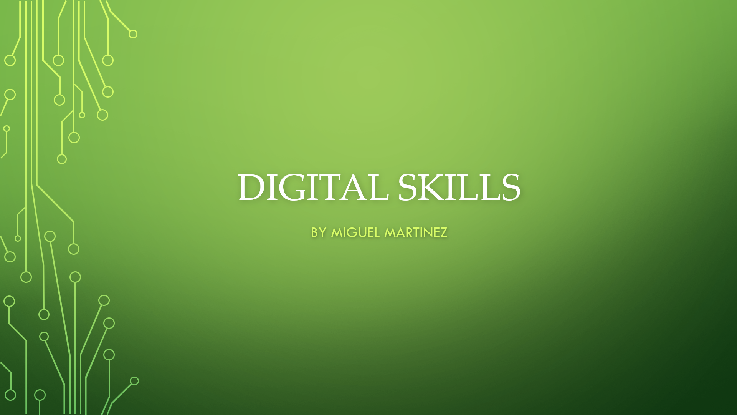
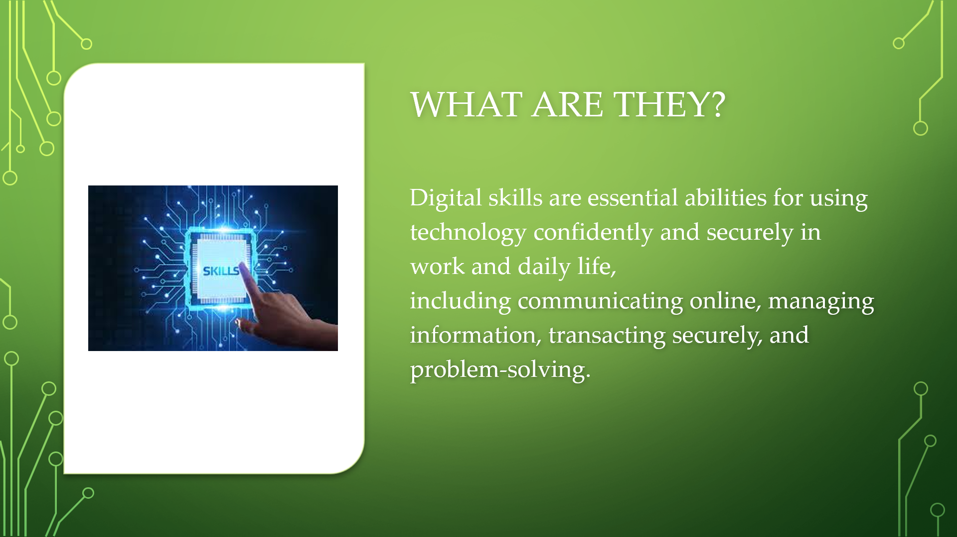
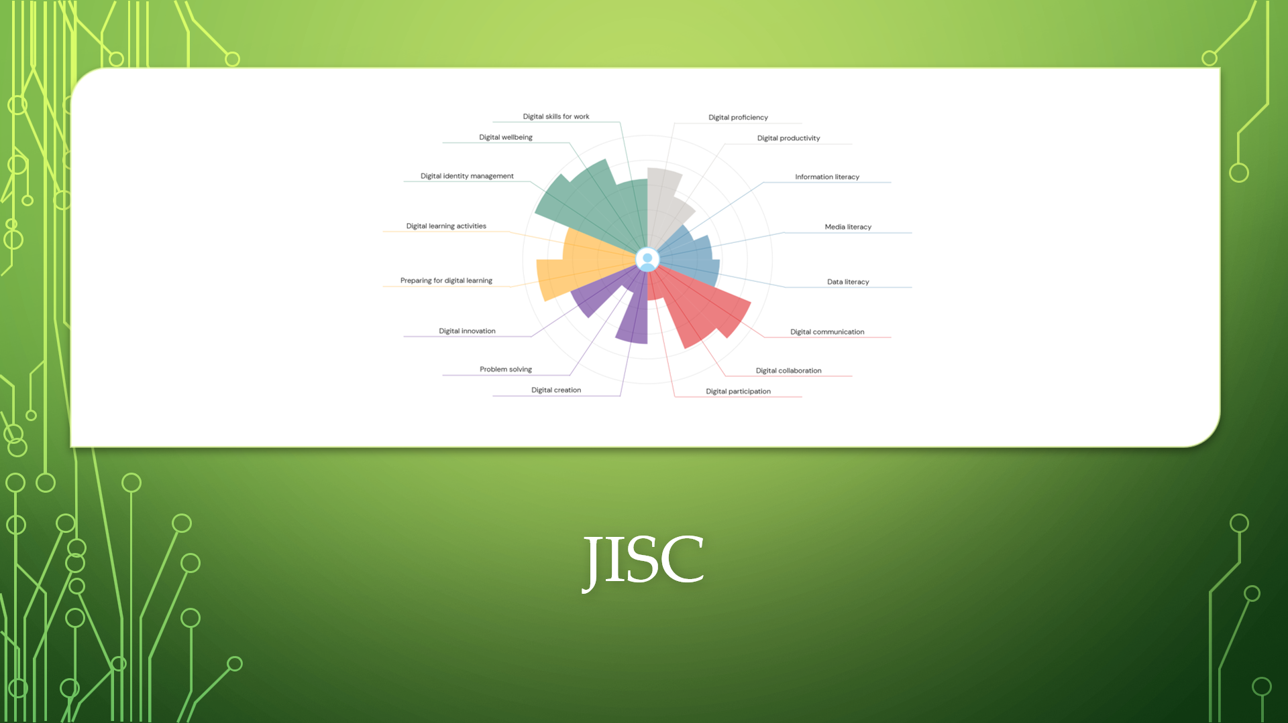
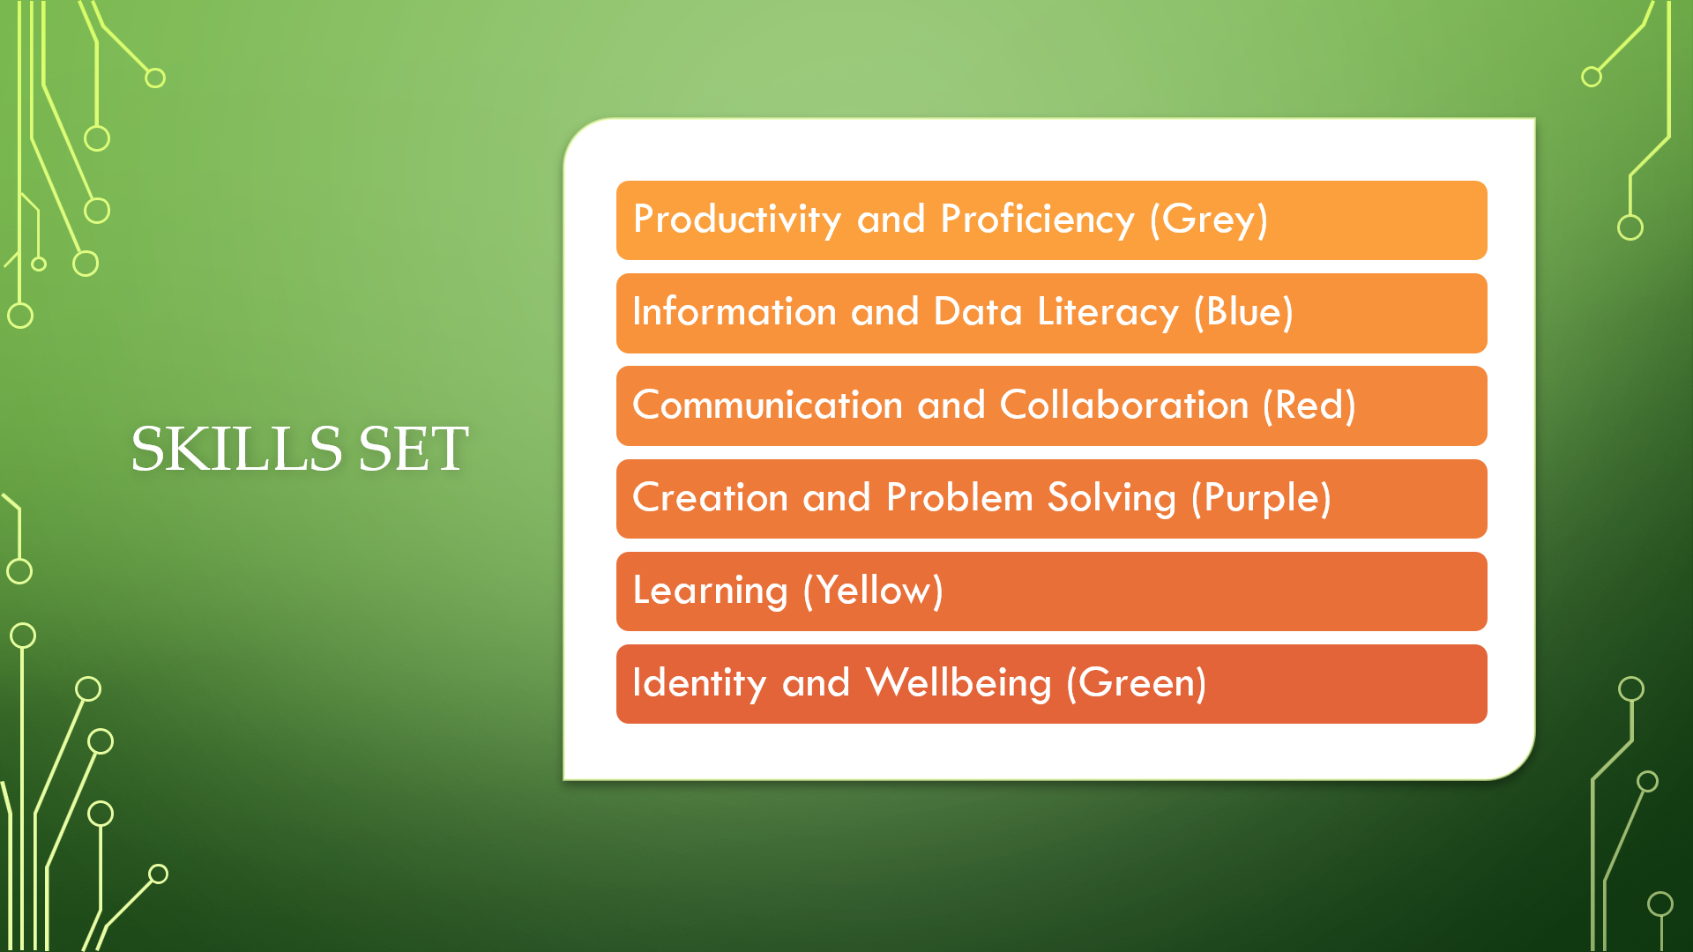
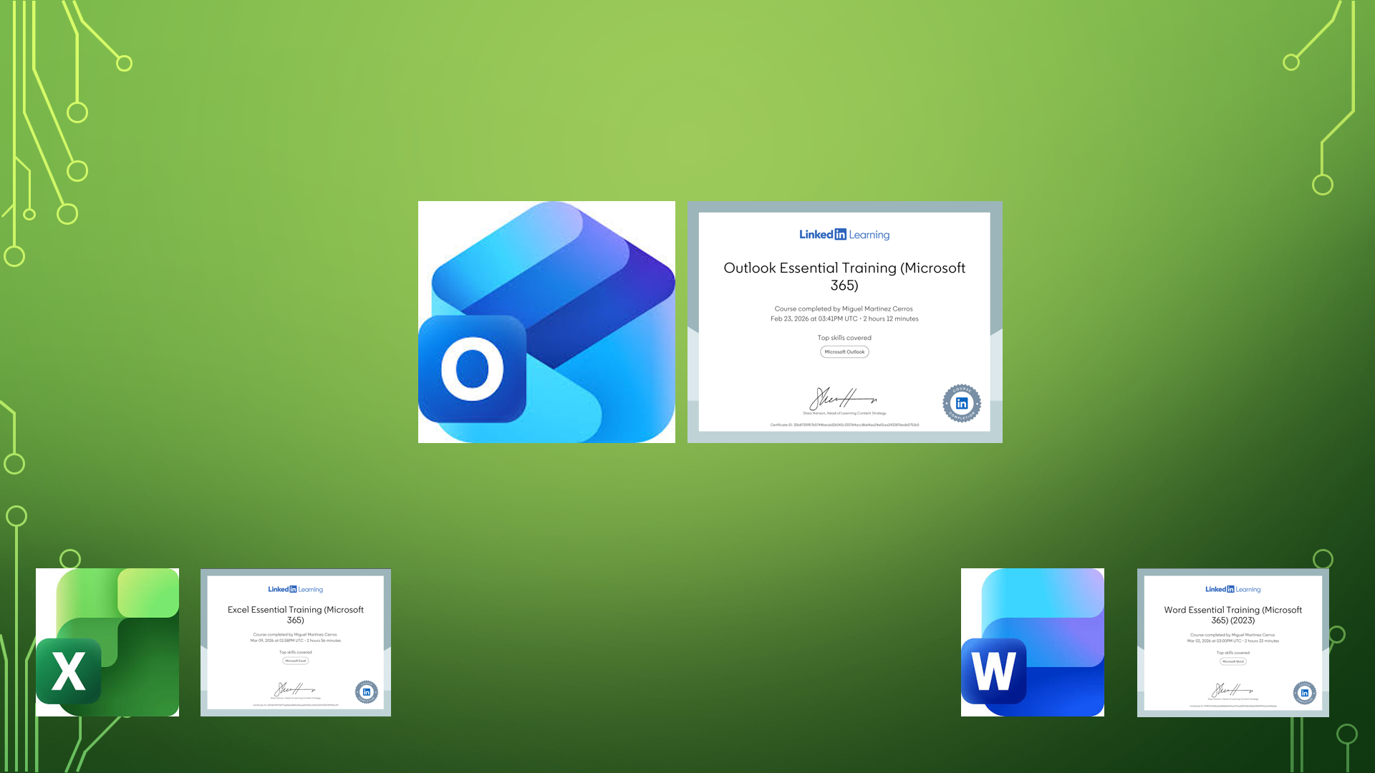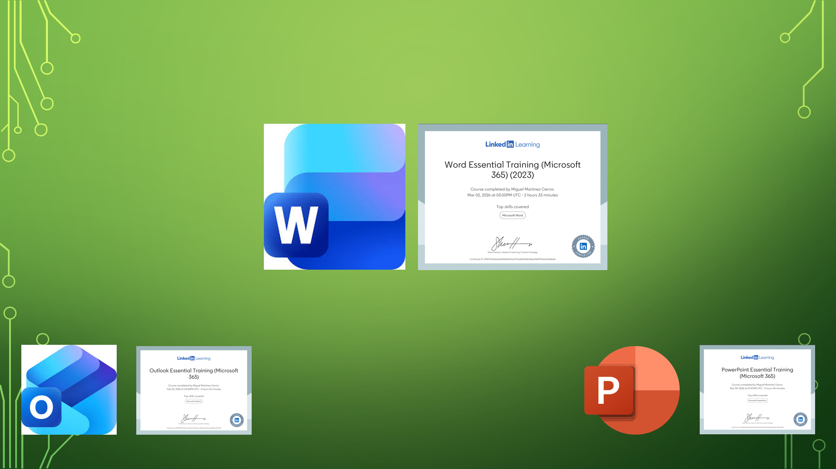

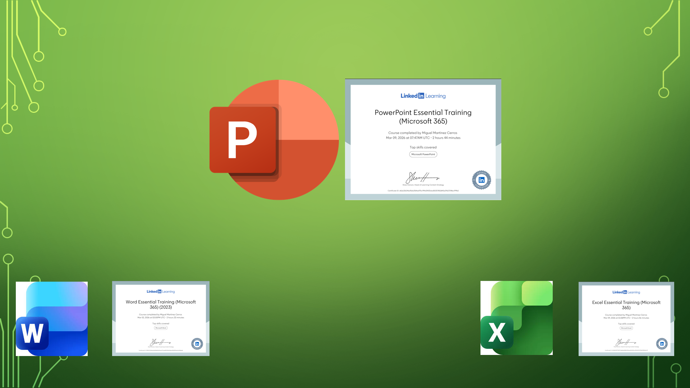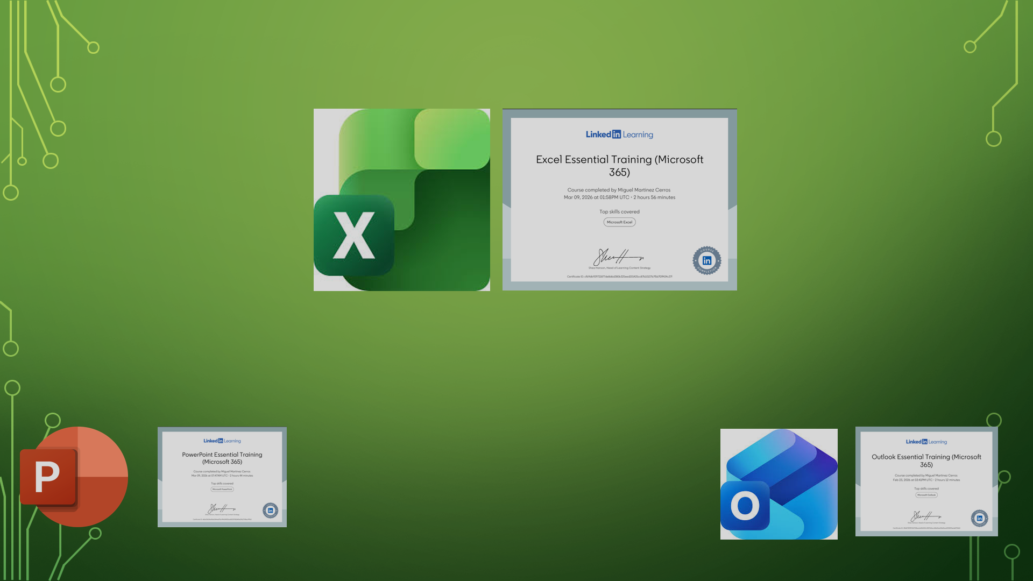
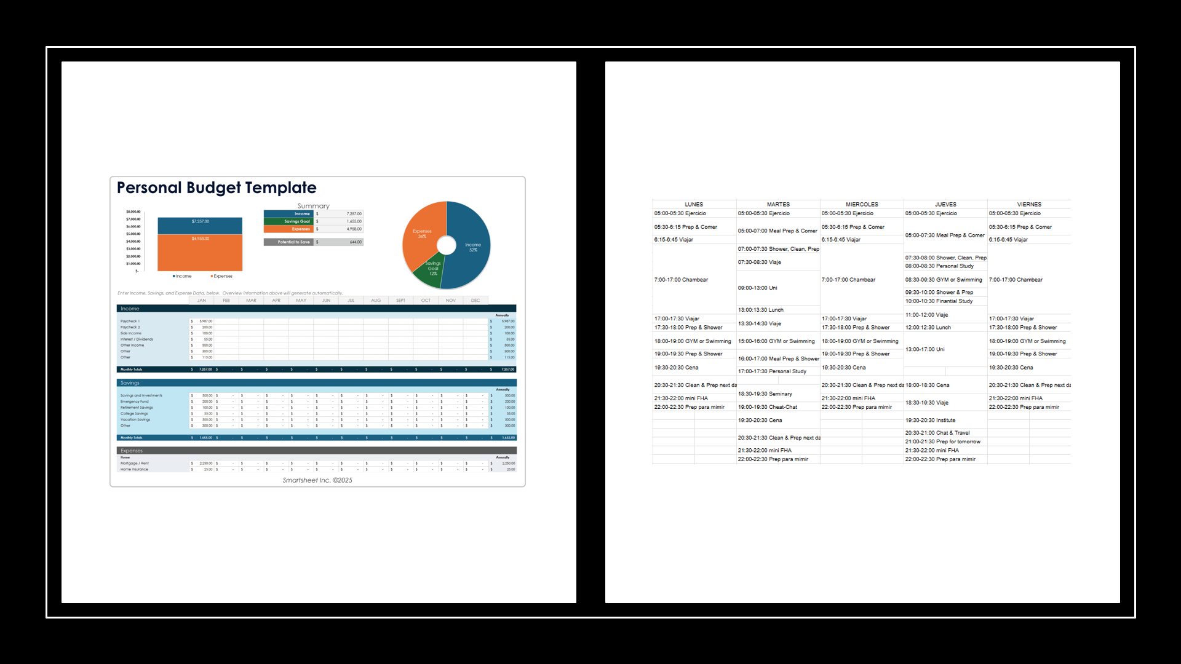

References
No references (information used from this same portfolio).

