An exploration into nostalgia and authenticity and their key role in
retro print design.

Emily Boyce
1702475
Independent Inquiry ADAD6001
Julia Lockhart

Submitted in partial fulfilment of the requirements for the degree of BA (Hons) Surface Pattern Design
University of Wales Trinity Saint David, Swansea.
date of submission:17th December 2019
Word count: 6335

Contents
Pages
Chapter 1 – Retro … … … … … … … 1
Chapter 2- Nostalgia … … … … … … … 9
Chapter 3- Authenticity … … … … … … … 19
Chapter 4- Conclusion … … … … … … … 28

List of Figures
Figure 1: Inkbot Design: Client Resources, Design Tools, Working with Designers. (2017) Silk Screen Printing Vs. Digital Printing on Fabric. [Photo] Available at: https://inkbotdesign.com/screen-printing-vs-digital-printing (Accessed: 26 October 2017). … … … 5

Figure 2, (2017) Inkbot Design: Client Resources, Design Tools, Working with Design, Digital printer printing a textile repeat print design [Photo]. Available at: https://inkbotdesign.com/screen-printing-vs-digital-printing (Accessed: 26 October 2019). … … … 6

Figure 3, (2019) [website] V&A, William Morris and wallpaper design, [Photo] Available at: https://www.vam.ac.uk/articles/william-morris-and-wallpaper-design (Accesses:31 October 2019)
… … … 9

Figure 4, H&M magazine Online (2018) Introducing Morris & Cox H&M. [Photo] Available at: https://www2.hm.com/en_gb/life/culture/inside-h-m/introducing-morris---co-x-h-m.html (Accessed:7 November 2019)
… … … 11

Figure 5, (2018) Refinery 29 [Website], The story of Alexa Chung’s new collection in Virginia Woolf quotes, [Photo] Available at: https://www.refinery29.com/en-gb/2018/03/192576/alexa-chung-clothes-virginia-woolf. (Accessed:9th November19) … … … 12

Figure, 6. (2018) The evolution of fashion history, Lavers Law, [Photo] Available at: https://fashion-history.lovetoknow.com/fashion-clothing-industry/fashion-designers/james-laver (Accessed:11 November 19)
… … … 14
Figure.7 (2017) Festival of Britain display at South Bank exhibition, over seen by Thomas. H (1949) [Photo] Available at: https://medium.com/designscience/1951-c37a7ceb6aae (Accessed 26th October)
… … … 17

Figure. 8. (2019) Mini Modern [website] [Photo] Available at: https://www.minimoderns.com/product/festival-wallpaper (Accessed: 11th November 2019) … … … 17

Figure 9, & Other stories (2019) [Website] Georgia Lupi Co-lab- Based on true stories. [Photo] Available at: https://www.stories.com/en_gbp/giorgialupi.html (Accessed: 22/11/19)
.… … … 18

Figure 10, (2018) [website] to left, Agnes Choi’s collection Limitation [Photo]. Available at: https://www.itsnicethat.com/articles/agnes-choi-nostalgia-and-memory-through-fashion-work-fashion-051218 (Accessed: 5th December 2019) … … … 21

Figure 11, (2018) [website] Portrait of collection with coral, green and baby blue, prints, [Photo] Available at: https://www.itsnicethat.com/articles/agnes-choi-nostalgia-and-memory-through-fashion-work-fashion-051218 (Accessed: 5th December 2019) … … … 21

Figure 12, Vogue Online, Spring 2005 ready to wear Eley Kishimoto [Photo]. Available at: https://www.vogue.com/fashion-shows/spring-2005-ready-to-wear/eley-kishimoto, (Accessed 12/11/2019)
… … … 25
Figure 13, Vogue Online, Spring 2012 ready to wear Burberry, [Photo] Available at: https://www.vogue.com/fashion-shows/spring-2012-ready-to-wear/burberry-prorsum (Accessed 12th November 19)
… … … 25

Introduction
This independent enquiry will be exploring nostalgia and authenticity and their key roles in retro print design; how the designer conveys this within their practice and discovering why retro is so popular in the twenty- first century. Furthermore, it will examine why the consumer may have this desire for retro prints and fashions and what makes these trends fashionable time and time again.

Chapter one will investigate what is surface pattern design and print design and why is it relevant today in reference to its relationship with Gestault theory. It will examine the traditional methods of William Morris and the relationships between his ideas with Walter Benjamin’s theory of the ‘aura and hand-made’, exploring the over reliance of digital technologies. These key themes will be illustrated with examples from Alexa Chung’s collection inspired by prairie fashion questioning how the designer ‘updates past forms’, The theoretical concept of Laver’s Law, a theory of the twenty-year time period it takes for a fashion/print to become fashionable again will be explored also, in terms of understanding what makes retro fashionable.

Chapter two will examine the idea ‘Heimlich’ and ‘Hiraeth’ and their links to culture and identity, familiarity and how these are connected to nostalgia. Furthermore, it will investigate how nostalgia conveys itself through inspiring brands in order to find identity and culture illustrated by Mini Moderns collection inspired by the festival of Britain and how this is a common design process. The unlikely relationship between science and art will be explored, drawing comparisons to Georgia Lupi, (the information data designer) who collaborated with ‘& Other stories’ taking the narratives of inspiring women to create print.

Chapter three will consider the many forms of authenticity such as personal nostalgia, cultural nostalgia, interpersonal nostalgia and virtual nostalgia, and their individual processes. The work of Agnes Choi will be examined, a designer who uses nostalgia to inform her ideas around her mixed-race identity, creating new narratives from her exploration of this. An in-depth exploration of cultural appropriation in Batik prints will be completed and how the designer may have to consider retrospective design as something that should also respect other cultures as well as appreciating them.

From this exploration there is the intention of gaining a better understanding of the practice of surface pattern and how the designer gains a greater understanding of their own identity, culture and history when retrospectively designing. The role of authenticity and nostalgia within design will be investigated with reference to theory and examples in fashion determining how these influence retro print design and its continued resurgence within a contemporary context.

Chapter 1- Retro
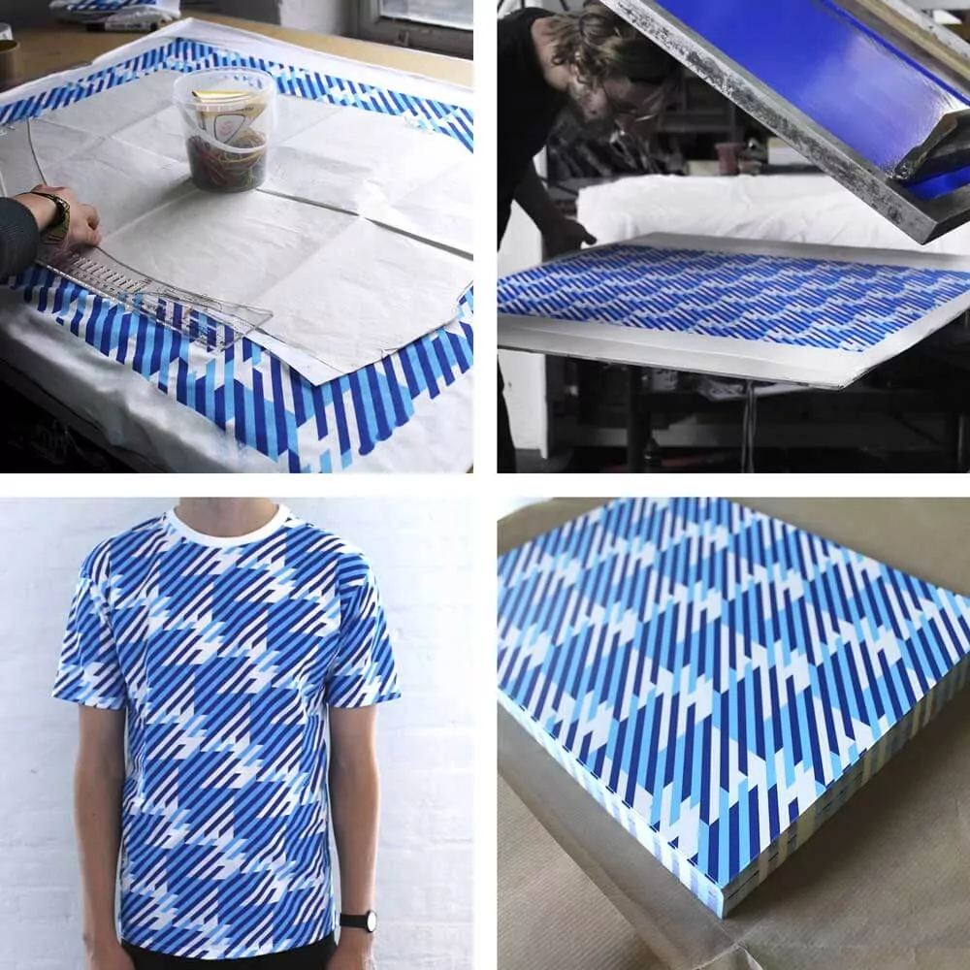
For the purpose of this dissertation surface pattern design will be defined as artwork specifically for the areas of interiors, fashion, stationaries, gift wraps, wall displays, fashion objects and many others. This is usually in the form of a pattern repeat or illustration/motif. Surface pattern is a series of processes that change and manipulate textiles, such as dyeing, resist dyeing, fabric manipulation, applique, embroidery hand and digital, free machine embroidery, patchwork, embossing and beading. These processes aid the design to an outcome. Print design, conversely, is where a repeat motif is organised into a specific repeat such as a half drop and is printed onto fabric using a silk screen or digitally printed. “Patterns are simply a repetition of more than one design element working in concert with each other. A seamless pattern is one where every element within a design (no matter how often it’s repeated) combines to form a whole” (Soegaard, 2018). Initial authentic retro prints were created using screen printing as there would not have been the technology for digital print at the time. The purpose of pattern design is to add a richness of colour and interest to adorn a given product adding value to that product, or as Morris states
Figure 1: [photo] illustrating screen printing technique
“The true secret of happiness lies in taking a genuine interest in all the details of daily life” (Morris, 1858, p.330- 333). This may relate to a type of mindfulness in taking in the details of pattern or finding the repeat; or just the act of repeating a continuous cycle of motifs. “mindfulness is, quite simply… being aware of what is going on around you” (Rowan, 2013, p.5). There could also be a correlation to creating a pattern repeat which can be quite cathartic.

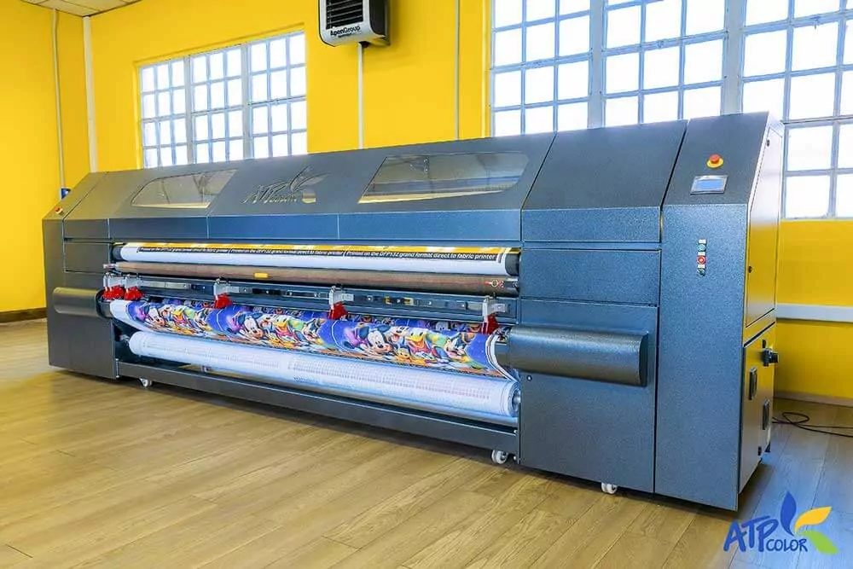
In contemporary society, Pattern design is everywhere whether we are mindful of it or not, even in non-traditional placements such as packaging, cars and advertisement making it unavoidable, and serving a clear purpose in our lives: to enhance our experience of the world. Indeed, pattern design has a duel role of fulfilling a need or desire innate within people, to see things that are beautiful which in turn makes the item more personal to the consumer. Indeed, within Gestalt theory, this is described as a “set of laws addressing this natural compulsion to seek order amid disorder, where the mind “informs” what the eye sees by making sense of a series of elements as an image, or illusion” (Koffka, 2019). Through describing the processes innate within us, this seeks to find reason or relationships in imagery or designs to better connect and understand them. This instils further
Figure 2: [photo] Digital printer printing a textile repeat print design.
the use of patterns in non-traditional placements working to help the consumer relate to and understand what the information is telling them. This is expressed through reasonable order in their use of pattern or imagery.

Print design is imagery based and is used commonly in the textile industry as is demonstrated within figures 1 and 2 which show part of the process of screen printing onto an item of clothing or fabric. In the context of fashion textile design, digital processes are more commonly used in the twenty-first century, demonstrative of the evolving nature of pattern design. Screen printing is a great way of finding imagery and a means to later scan into applications such as Photoshop which can be digitally manipulated. Authentic retro design production would not have had this flexibility; instead all hand rendered work would have been reworked by experienced designers who had mastered their craft, which although more time consuming arguably created greater authentic works. As Walter Benjamin argues, “Reproductive technology, might say in general terms, removes the thing reproduced from the realm of tradition” (2008, p.5); what was previously a designer’s time and
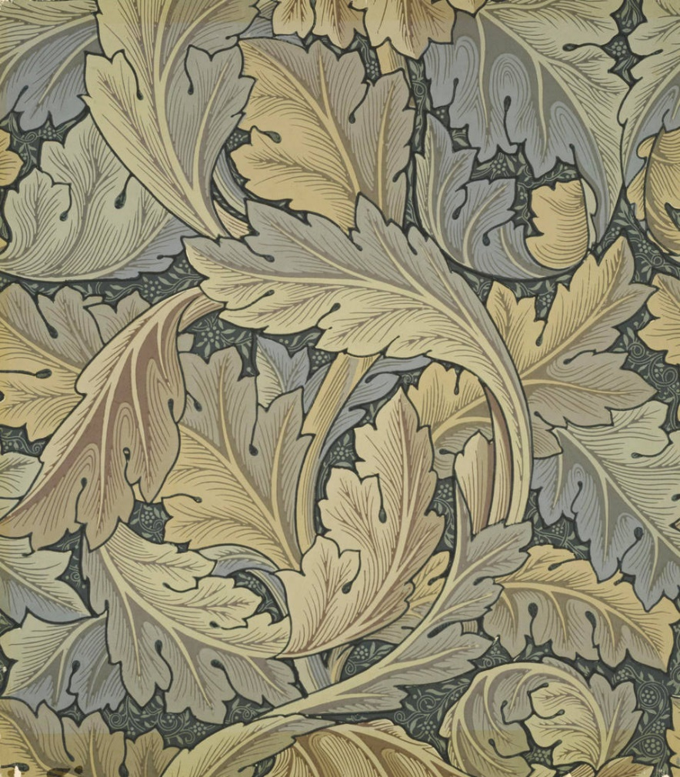
investment into an outcome, has since been replaced with digital technologies and therefore is not as precious as authentic retro print design. Similarly, the designer may have become complacent
Figure 3: [photo] William Morris Acanthus wallpaper
in their process as technology has opened the designer to laziness in their decision making. “[T]he primacy of instrumental reason is also evident in the prestige and aura that surround technology
and makes us believe that we should seek technological solutions even when they’re not called for” (Taylor,1992, p.6); This concept of ‘aura’ can be linked to Benjamin’s (2008) theory of handmade and the idea that something is lost when not hand crafted and digitally reproduced. However, with the use of traditional techniques it is not paramount to utilise technology in all aspects of design, or to a means to an end. Yet, designers still often over rely on this technology to advance their designs in a time sensitive era.

Retro is a word derived from ‘retrospective’ or retrograde to look back on or directed and moving backwards (OED, 2011). In the context of print, it could be considered that any design made by a designer of the last century, that is additionally made within the pre-digital age and reflective of that time, could be considered retro. “retro means a style that is derived from the recent past” (Bautista, 2014). Retro is also the idea of updating and remaking of past ideas and influenced by new designers leading the trends. It is as Jenn’s states “a revisiting or updating of past forms” (Jenn’s, 2015, p.29). The idea of updating and revisiting are common themes that are present in print design today utilised by such designers as Orla Kiely (2019), Marc Jacobs SS20 show (Marc Jacobs, 2019) , and moving to interior brands such as Mini Moderns (Mini Moderns, 2019). Retro is often associated with the 1960’s and 70’s but this is inaccurate as it encompasses the whole history of textile design and is not limited to a single twenty-year period. Design, however, can become known as retro after a period of twenty or more years (Carter, 2018).

According to the Victoria and Albert Museum (V&A, 2019) William Morris was a keen enthusiast of the traditional methods used in a time where progress was allowing for design to become far more accessible. He had mastered the traditions of screen printing and even favoured block printing. “Morris championed a principle of handmade production that didn't chime with the Victorian era's focus on industrial 'progress” (V&A, 2019). Morris influenced a wave of British designers to traditionally produce images through these means and be influenced by nature within their own garden. However, this period is not considered in the term retro, although it is still retrospective of pattern design and its continuing progress. Today Morris & Co are reimagining his design potentials in his latest H&M collaboration and still proving popular today, as shown in the H&M William Morris collection see figure 4, (H&M, 2018).
The Morris & Co prints are some of the most recognised and loved around the world, while William Morris is not only synonymous with the Arts and Crafts movement, but also a strong advocate of beautiful design. We’re thrilled to be collaborating on a collection with this iconic British brand and to be able to share these designs with our customer (H&M, 2018).

In the context of the 21st century he continues to inspire collections; “Morris’s work offer’s them (the designer) [the opportunity] to expand and develop it” (Bennett, 2010, p.5) which is what is seen within retro brands being appropriated into modern garment designs, even when they are considered for other contexts like interiors such as Morris (See figure 3).
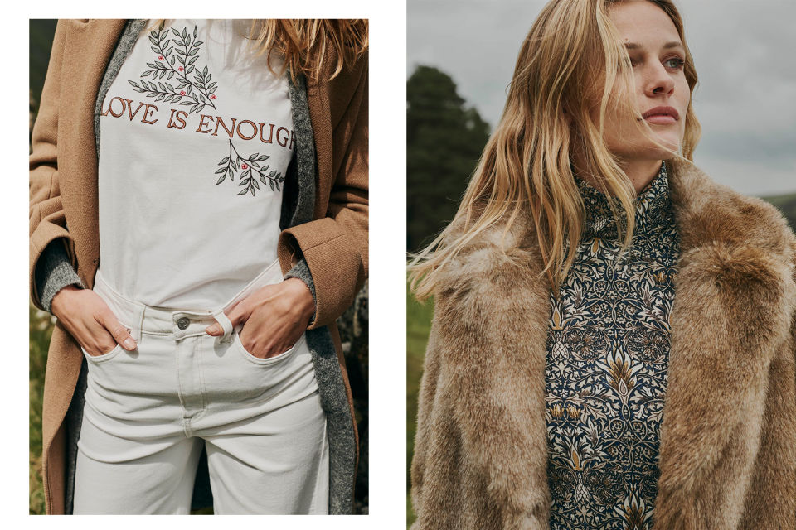
Figure 4: [photo] H&M collection collaboration with William Morris.
This is an example of what is being seen today in contemporary designs thus, fuelling our desire for heritage and retro, as also proposed by Jenss;
the incorporation of the sartorial past in contemporary appearance making has become one of the major developments in fashion and popular culture in recent decades, tying in with the promotion of ideas of individuality and authenticity” (Jenss, 2015, p.1).

It is in this postmodern way of designing, that we are seeing this development of a type of nostalgia in these products and a resurgence of what was once before. Older print trends and pattern designs are now becoming fashionable as the past amalgamates with the future. Other brands like Alexa Chung, seek their inspiration from looking back at periods that already have a rich history such as her 1920’s collection ‘Virginia’; this looks at the author Virginia Woolf and her literary works. The collection features over 100 pieces which is in ode to the Bloomsbury set who were, authors, poets, philosophers and writers, who Virginia was associated with in 1920s London. This inspired the materiality in which is used and the sourcing of the print’s; “Pay close attention to the piping, frills, embroidery and all of the Charleston inspired prints that make up this collection” (Refinery 29, 2018). Figure 5 illustrates Chung’s use of that inspiration and the appropriation of prairie fashion design which became a key trend within Spring Summer 2018.

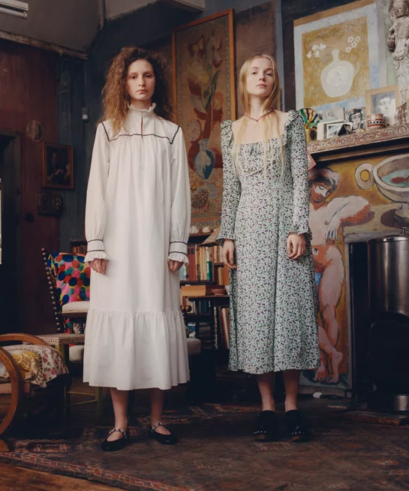
Figure 5: [photo] Alexa Chung: ‘Virginia and the Bloomsbury group’ collection.
The trends are what make the retro designs and prints so popular and persistently on the catwalks reinventing the theme of retro and maintaining this idea of updating of past forms or adding relevance to them making them current.
We now live in a fast-paced consumer society. Pictures of what's on the catwalks of London Fashion Week today will be on the internet today. Everything is absorbed quicker and we want it quicker. Looks hit the High Street much faster (BBC, 2009).

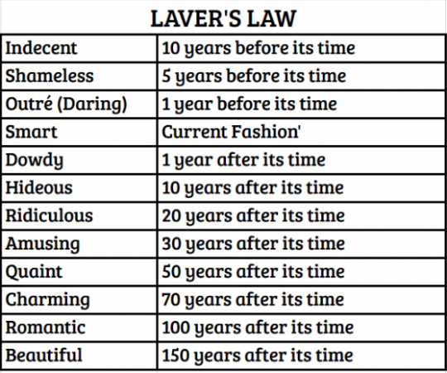
Designers are actively opting to source inspiration from past eras to re-fashion our memories of these fashions or prints. Print design that spans back 100 or more years can be non-existent in consumer memory so when these prints are refashioned, they become relevant again; brands like Alexa Chung reinvent them continuing the cycle and fuelling a lust for all things retro. This cycle is thought to work in a twenty-year period; “the 20-year rule – the time it takes for a trend to die, then become fashionable again” (Thread, 2018). It is in that time that a trend in print or any other art form re-emerges and becomes fashionable once more and proceeds to penetrate the mainstream, henceforth influencing further younger designers who bring new and interesting ideas to those past eras of print design. This is referred to as Lavers Law in which fashion related designs including print, are forever in and out of fashion. Laver was interested in how design, once considered dowdy, can then be later recognised as beautiful. He thought that everything designed by people is increasingly subject to "time consciousness" (Carter, 2018). He describes current trends as a time scale in that they are considered in trend and out of trend. This could give rise to understanding retro as something that is completely inevitable.
Figure 6: [photo] Laver’s Law on fashion evolution.

Wilson states that retro is a way of following a trend without the commitment; it is a way of “finding style but obliquely…and to find an ironic distance of fashionableness between the wearers and their clothes” (Wilson, 1985, p. 250). Retro in these terms can be viewed as ironic allowing for a sense of individuality and a means to explore different narratives. Retro could also be considered as a design tool and process, a way arguably to bring nostalgic interpretations of pattern from decades past back into the modern day.

Chapter 2- Nostalgia
To fully comprehend the concept of retro, the underlying role of nostalgia within this must be identified and considered. For retro to exist this involves a desire for a time past, a nostalgic yearning for something forgotten or displaced. In “The Uncanny” Freud discusses ‘Heimlich’ or homely being familiar and the unhomely ‘unheimlich’ being considered strange.
The German word unheimlich is obviously the opposite of heimlich, heimisch, meaning “familiar”,” “native”, “belonging to the home”; and we are tempted to conclude that what is “uncanny” is frightening precisely because it is not known and familiar (Freud,1919, p.2).

In relation to the uncanny this idea best describes that same familiarity or feeling that is displayed when feeling nostalgic for a design or print or even a reference. This could also describe the coincidental nature of nostalgia, the understanding that nostalgia is not always linear in its reference and conjures memories and objects that are deep within our memories. Nostalgia ultimately conveys in uncanny ways and modes to later surprise us. Furthermore, Heimlich has a synergy with the concept of ‘Hirateh’ which cannot be fully translated into the English language because of its complete reliance of the sense of hiraeth which is to yearn for home (Wales). "I, too, know what hiraeth means. To me, it is a longing for a feeling that may not truly exist, a misty blend of nostalgia and dream, and for a place that invokes this elusive feeling." (BBC, 2019) There is the underlying understanding of identity that plays out in the uncanny and hiraeth, in that it displays this dream like version of reality, which could describe retrospect and nostalgia. Retro for many, is this sense of recollection for a past era and this reflects in the clothing they choose and the fabrics they desire. Reclamation of a time passed through clothing entitles the wearer to become a part of that era evoking, as Freud states, uncanniness regarding déjà vu and its familiarity. Nostalgia is arguably the underlying motivation behind retro; the desire to all be united in an understanding of the same past, “a recurrence of the same situations, things and events” (Freud, 1919, p10). Moreover, when talking of nostalgia people may describe Déjà vu as like a dream because of its surreal like quality and its similar feeling. Nostalgia remains in people’s consciousness as an essential influence reflected in the desire for retro that has become prevalent in contemporary society.

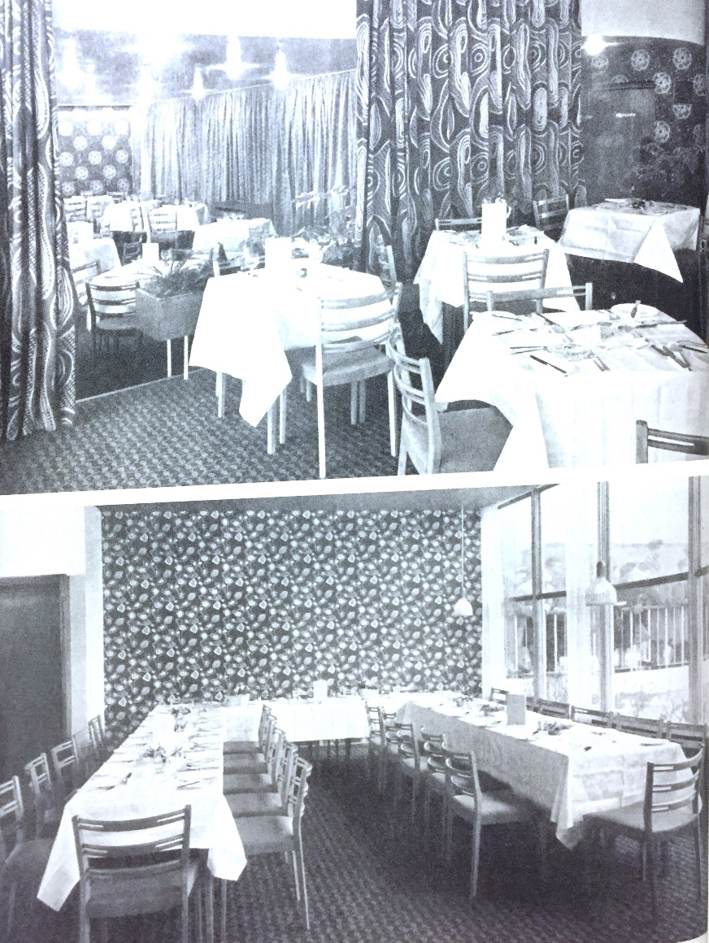
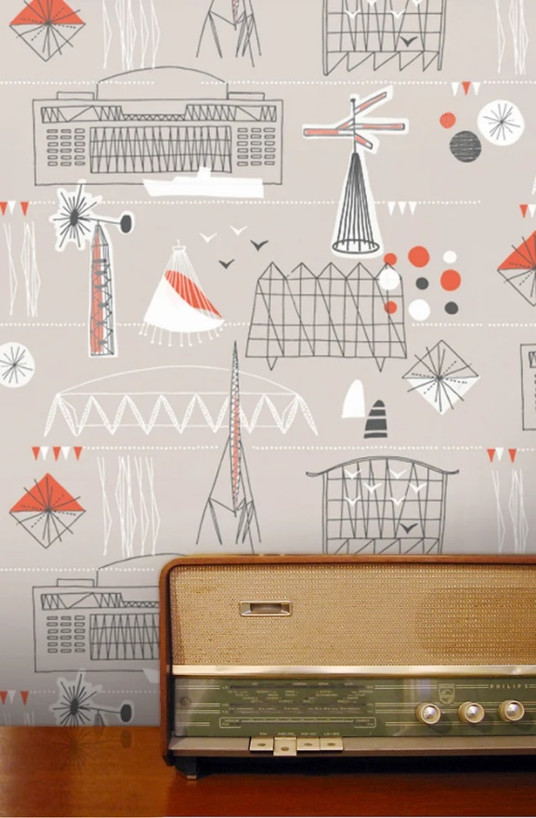
Retro has been “Used to describe cultural predisposition and personal taste, technological obsolescence and mid-century style, ‘retros’ neologism rolls off the tongue with an ease that transcends slang” (Guffey, 2006, p.224). This neologism of ‘mid-century’ has arguably inspired a revalue of the idea of retro and has therefore become widely acknowledged in advertising and interior design as of the latter half of the early 2000’s. Brands like Mini Modern take influence from and pay homage to the mid-century, from furniture to surface pattern or even product design. They seek inspiration from the period to add a richness to their designs insistent that “it’s all about the story” (Stephenson and Hampshire, 2019,p.17) and that the period allows “a journey of discovery that transcends aesthetics” (Stephenson and Hampshire, 2019, p.17). Part of this journey is understanding the appeal of this era and some of the common variables of social history, travel, TV, film and literature. For example, a key theme of 1950s society was a celebration of links between science and art. One of the key visual links was in the work of Helen Magaw who sought to use contemporary technology of the time, X- ray crystallography to create pattern. With the help of “Sir William Henry Bragg’s invention of X-ray crystallography, enabled scientists to study structure at a sub-microscopic level and to discover the arrangement of atoms within molecules” (Jackson, 2008) of which they repeated indefinitely. The final designs were later shown at the Festival of Britain. The relationships between contemporary technology and design allowed for a new understanding of pattern design as something that can be informed by social change or the development of atoms, insulin and penicillin and their structures in this case; almost the retrospective being the contemporary. This was later followed by designers utilising the aesthetics influenced by the space race for example.
Figure 7 and 8: [photo] Mini Modern Festival wallpaper, in ode to 1951 Festival of Britain.
As seen above (Figure 7) patterns adorn wallpapers and curtains but still appear very retro and nostalgic in their design. This type of design has helped the Mini Modern brand “shape [their] approach to print design, since we embrace a similarly eclectic palette of source material as inspiration” (Stephenson, Hampshire, 2019, p.17). The connotation and denotation of print design are important to consider as they offer an additional element to understanding design origins. Denotation refers to the definition of the signifier, which in this context would be the literal meaning of the print; the connotation is the associated signs or relationships with the signified (Mambrol, 2016). In this context Mini Modern launched their own collection in celebration of this British feat (Figure 8) instilling further that retro has a connotation to identity and culture and the celebration of this, through using nostalgia to create a contemporary design process. The denotation is therefore the literal meaning of the print whereas the connotation is what is being signified so the historical context of the Festival of Britain; the signifier is the contemporary rendition of that period and design process by Mini Moderns. This understanding is a theory proposed by Roland Barthes. He talks of connotation as being ‘poetic’; “it is defined one might say, by the coming together of matter and language: this is the situation we shall term poetic” (Barthes, 1990, p.235). He further goes on to state “denotation is pure as long as description remains functional, produced with the view to an actual use” (Barthes, 1990, p.235). This may also be viewed as the connotation and. denotation in the concept of time; the connotation being the past and denotation being the present relating to nostalgic design, hence, showcasing the effects of nostalgia and its repetitiveness in history and design and the relationships it holds in its exploration of culture.
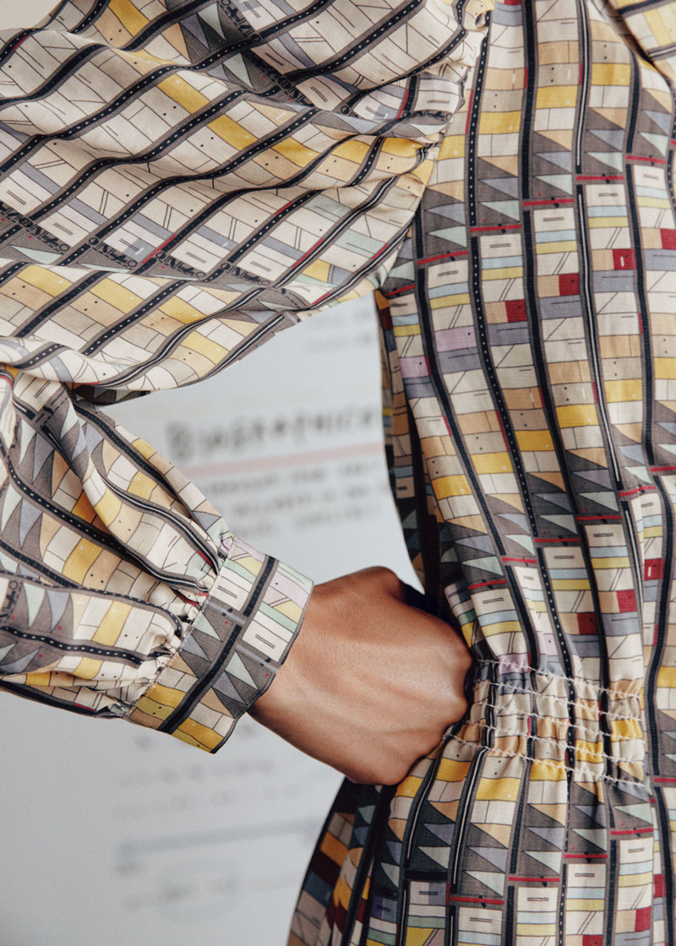
This concept is also evident today with textile ‘information’ designers like Georgia Lupi who looks at taking influence from three female scientists in history; Ada Lovelace (The Mathematician), Mae Jemison (The Astronaut), and Rachel Carson (The Conservationist) (& Other stories, 2019) to inform her designs. Lupi works with their narratives and “turns data visualization’s into wearable stories” (& Other stories, 2019). This also reflects the idea of poetry in that she is appropriating women’s narrative’s and taking them into a design process which emits visuals that are later consumed by other women. This could be thought of as a poetic process, which is to celebrate women through the narrative of print in fashion. As her primary focus she works with the elements . Figure 9: [photo] The algorithm Ada Lovelace of human narrative and language through data. “As a designer, I work with data as my primary tool and material. I try to find art in science and science in art, and to do so, I often blend techniques, styles and media” (Lupi, & Other stories, 2019). This is nostalgic of the same process as Mini Moderns when looking at celebrating nostalgia in the narrative of the Festival of Britain. Ada Lovelace inspired design figure 9 is of her algorithm.
Recognized as a pioneer for the discipline of computer science, Ada Lovelace used her gift for mathematics to translate and write instructions, imagining how to program a machine to do complex calculations. Her print visually represents the algorithm she wrote (& Other stories, 2019).

Ada also recognised its many potentials even citing in her journal that the analytical engine could not only compute a number or algebra but also has use in the arts and its potential to “weave[s] algebraic patterns just as the Jacquard loom weaves flowers and leaves” (Finding Ada network, 2019); this arguably finds the same correlation between sciences and the arts as did the Festival of Britain and Helen Magaw. This process is also nostalgic of a bygone era of the huge contemporary culture shift in innovation and design. The creation of this language and algorithm have allowed for progress ever since Lovelace’s understanding that the computer could adapt and understand the language of weaving or any other language. This roused future designers to explore her narrative and sparked a romanticism and heroism in her legacy, which is easy to understand because of the heavy use of technology and computer design today. “The perennially childlike quality of romance is marked by its extraordinarily persistent nostalgia, its search for some kind of imaginative golden age in time or space” (Frye 1973, p. 186). Being of that golden age of innovation and design, the collection has a perfect synergy with the current times. It is visually modern but retains the ability to have relevance many centuries later. Within textile design, nostalgia has a way of subverting the past into the present using historical motifs, used to inform the future.

Nostalgia is commonly used in the context of “a feeling of pleasure and also slight sadness when you think about things that happened in the past” (CED, 2019). The term could be used to refer to a memory and its emotive nature. In print this could be understood within the process of retrospectively designing with nostalgia or even within its stylistic quality of the pattern. Nostalgia in print design is seen in many modern houses and highstreets because of its ability to evoke the feeling of a golden era and of happy memories; “tapping into strong memories can be one of the most powerful ways to elicit emotion – particularly if you’re targeting a millennial audience” (Harvey, 2019). This way of creating a personal connection to a print or garment is what makes the consumer more likely to buy; it is less about the print you’re buying instead it’s the idea or an experience or lost memory that it is evoking. Harvey goes on to state “Nostalgia can stimulate a wistful desire for an era before your lifetime that in our collective imagination—from photos, television, and films—is one we perceive as being simpler” (Harvey, 2019). Within the millennium society is seeing a revival of all things 60’s, 70’s, 80’s and 90’s inspired, through all popular culture including print. Consequently, there is an immense connection with the idea of nostalgia and fashion/ print today but also, a rising understanding of cultures who have not previously been explored in design in a modern sense because of their lack of globalisation.

Agnes Choi’s collection Limitation SS/19 (Spring/Summer 2019) signifies her Chinese and Australian identity weaving nostalgia and memory in her print designs. She is heavily inspired using coral, green and blue floral motifs as they are what is seen commonly in Chinese prints that she had seen in markets over the years. In doing so she is reimagining the East Asian aesthetic from her grandmother’s generation of what is quintessential Asian to the more contemporary audience. Using the themes of her upbringing;
The SS19 collection reimagines the ‘woven crystal toys that Aunties would gift’ youngsters into fashionable beaded tops. The garments see cheap, mass-manufactured commodities transformed through high-end design. And in turn, the collection evokes sentimental nostalgia for anyone that’s had an East Asian granny who pottered around in a wide-brimmed hat and a silk collared shirt buttoned up to the top (it’s nice that, 2019).

This sets the mood of her collection as being something that she pinpoints into the specific textures and materials and cultural understanding of China’s mass production industry and transforms this into wearable designs. She summarises all this through the processing of her own memory and nostalgia, creating a very personal response to her theme of identity as a mixed-race woman.

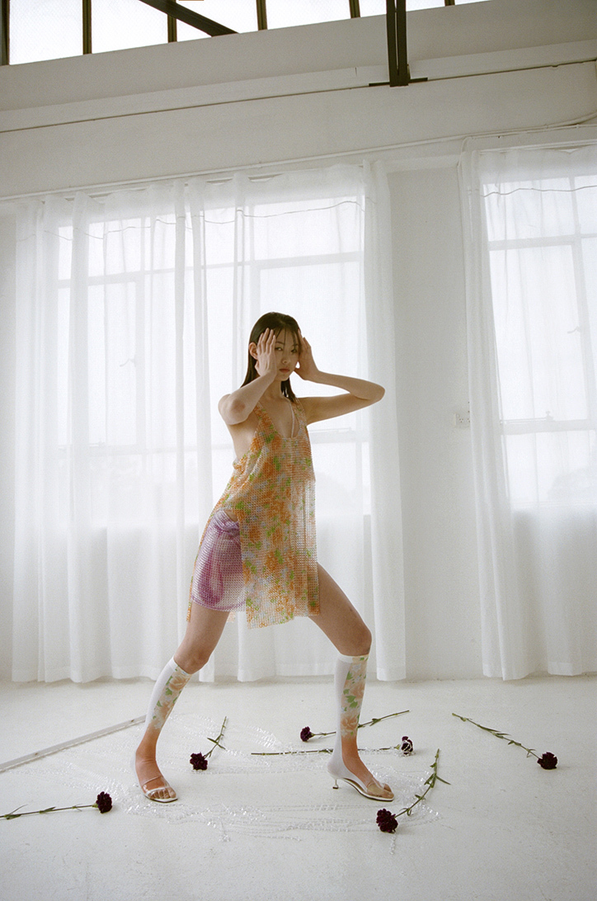
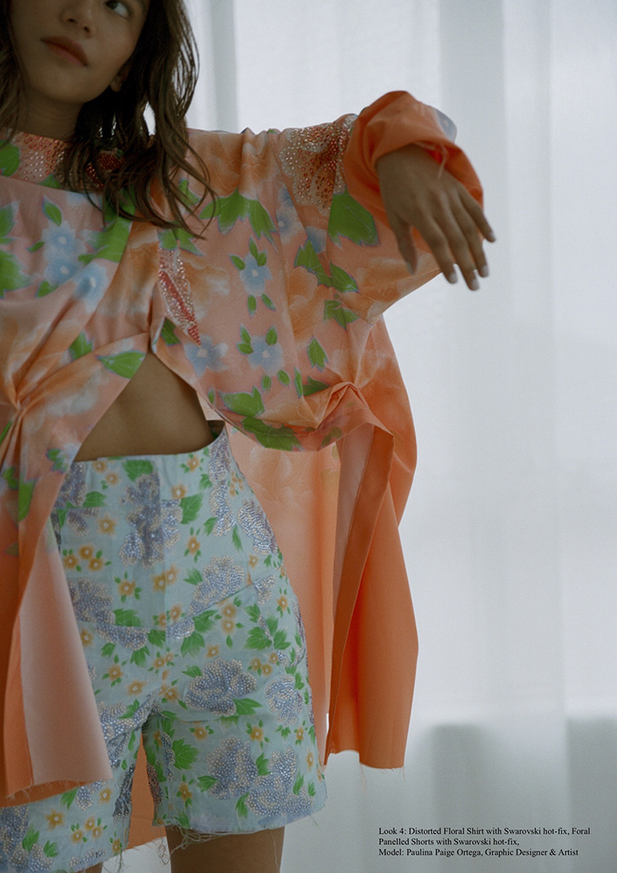
Figure 10: [photo] Agnes Choi’s collection Limitation. Figure 11: [photo] Portrait of collection with coral, green and baby blue, prints.
Nostalgia in the context of identity, culture and memory is often reimagined through new experiences or migrations that offer a recall of the past thus, interfering with the experiences of new cultures and identity, providing a constant reminder of memories. Ritivoi says that nostalgia is the ability to:
make sharp distinctions between past and present. Yesterday and today, there and here cannot be collapsed together. To the extent that the nostalgic’s remembered vividly their past experience- which included the experience of home that was not available to them in the present (Ritivoi, 2002, p.20).

Though Choi works on the idea that she is depicting authentic Asian print and borrowing the inspiration to grow a new aesthetic combining with a contemporary take on the motif, she is also displaying a uniquely cross-cultural, mixed racial background. She is uniting elements from her heritage and cultures to offer a unique ‘folding’ perspective foreshadowing her materiality. Pennina Barnett describes this foreshadowing in writing structurally, to the rhythm of cloth and the action of folding in ‘folds, fragments and surfaces. “what if the poetics of cloth were composed of ‘soft logics’, modes of thought that twist and turn and stretch and fold? And in this movement new encounters were made, beyond the constraint of binaries?” (Barnett, 2012, p.187). Like the material with which Choi is working she is adaptable, non-linear in her heritage and identity. Also, her use of language in her design process is very poetic. This process is what could be known as personal nostalgia which is defined by individual experience and is something that varies person to person. Personal nostalgia is particularly a current theme in most people’s lives and is probably the most common type of nostalgia. “The effects of personal nostalgia rely upon triggering the perceiver's memory in order to stimulate identification with cherished reminders of the one's past” (Stern, 1992, p. 388-389); within this context of print the idea of colour and motif triggered this memory for Choi and sparked this interest for her allowing for parallels to be drawn when they may not obviously be there. This may also relate to Gestalt theory in that designers see in other ways, the potential in an image or colour pallet. There are also other forms of this nostalgia such as interpersonal nostalgia being described as something that is shared interpersonally with others relating to topics that are within shared memory and the communication of this. ‘Cultural nostalgia’ is shared culturally as a collective group of people or as a nation and ‘virtual nostalgia’ is shared through other means like film, books, radio and social media. This is proposed by (Holak and Havlena, 1996, p.35-42) describing these into four categories of nostalgia. In print design most designers would be using these types of nostalgia to inform their work, recalling on a print seen in a museum or from another culture much like Choi. Choi also cites that an influence of her work is that of Ilya Parkins who realises that nostalgia “prompt[s] reflection on the relationship between present and former identities, whether those be personal, group or even national identities” (Parkin’s, 2012, p.121). A significant source of inspiration can be provided by using nostalgia as a subject matter and therefore it can be understood why the designer may use nostalgia as a tool to support their design process.

The term ‘anachronism’ is a depiction of this idea of a time or era that is misinterpreted and inauthentic. “A person, thing, or idea that exists out of its time in history, especially one that happened or existed later than the period being shown” (CED, 2019). This allows for the opportunity to recreate inaccurate or inauthentic narratives of retro print/fashion and to the furthest extent our memories of those times. Sprenger states “a form of pastiche that involves self-conscious simulations as well as reinterpretations of past visual styles” (Sprenger, 2009, p.140); this conscious anachronism is how the updating of these retro styles is seen and is therefore at the forefront, creating a sense of nostalgia. This enables a collective understanding of why it is so appealing for a designer to use cross references that may not have previously been explored when examining identity and culture, and its intersections of past meets present, like Choi.

Chapter 3- Authenticity
Authenticity’s definition is anything that is “genuine…known to be true” (OED, 2011) and in relation to design may consider the original creator or product; “a product is authentic when its promises are matched by its reality, and when its appearance and reality correspond” (Designboom, 2016). This language of corresponding with its intended uses and its original aesthetics is what makes a design authentic. Yet, in the world of print and the designer, there are many unauthentic works which penetrate the market at knock off prices trying to appear to be as the original however,
various studies conducted over the past decade tend to suggest that counterfeiting not only doesn’t harm the economy but can also stimulate the sector and help sell the genuine brand (Bukolovska, 2015).

Yet, there may be an argument as to the morals behind counterfeiting or inauthentic design as it loses its intellectual ‘aura’ (Walter Benjamin). This could also be described as a type of appropriation. Unlike Choi who is directly Chinese, some designers appropriate from other cultures of which they have no association with. Hence, the textile designer may have to consider social, ethical, political and historical context when revisiting authentic prints or a collection to ensure a Fairtrade mentality. An example of this can be seen with Burberry, a British designer label who revisited western African prints, commonly known as Batik prints, using a method of wax resist in their 2012 resort collection. They may not have considered the appropriation of the design’s nostalgic connotation to western Africa and their culture;
Burberry created a collection featuring African prints nearly a decade ago. Something like that wouldn’t go as well today, out of fear of cultural appropriation, unless it was done in collaboration with a local African artist. More sensitivity is needed when pursuing certain trends these days (Thread, 2018).

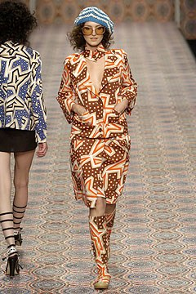
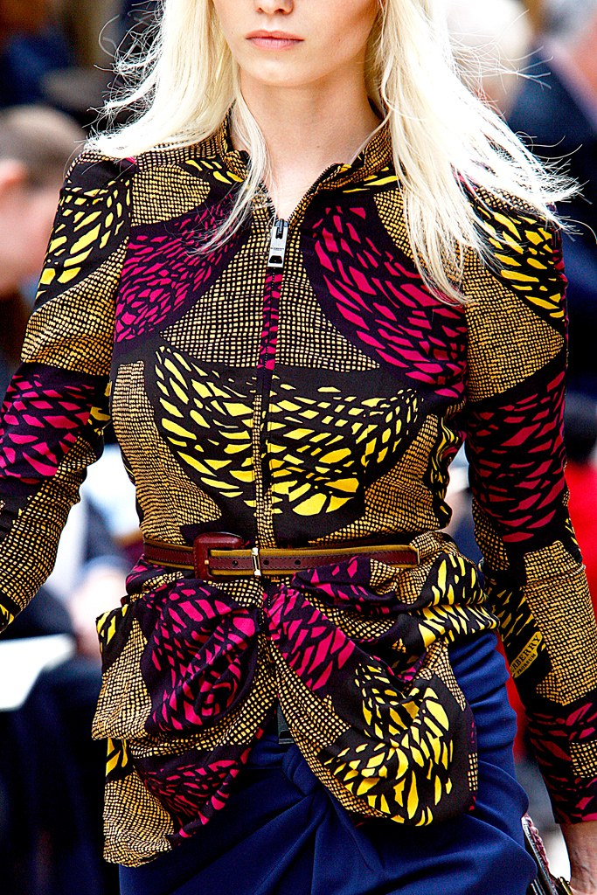
This is now commonly known as cultural appreciation; “Cultural appreciation is when you work with people from that culture that you are taking something from” (ID, 2019). Even though this was less than twenty years ago, it is easy to see how the political climate can so easily discredit and discourage the use of nostalgic prints, when not working with those same people who made the authentic prints in the first instance. This may instill the idea that only print that is unassociated with culture or a movement, may feel safer and more authentic or even accessible to a designer to
Figure 12. [photo] Eely Kishimoto ‘Local’ collection 2005 Figure 13. [photo] Burberry Ready to wear collection 2012
want to develop further. Conversely, Fogg states, that “Western fashion has always appropriated and reassemble[d] elements of other cultures” (Fogg, 2006, p.100), using indigenous inauthentic designs in the contemporary context, handcrafted techniques and decorative design, as inspiration. Arguably, if a print has become synonymous with a culture that has historically been oppressed, they may need to understand the ignorance of mass producing an element from other cultures and grossing capital from it. This is also reflective in our colonial past. Another collection that also appropriated authentic design within culture was that of Eely Kishimoto in their 2005 collection ‘Local’, focusing around the Brixton area where their offices are based. Brixton historically has been a very multicultural place and can be sourced as inspiration particularly because of the high rates of Afro-Caribbean people.

In figure 12 the use of those prints in a contemporary fashion context can be seen and how westernised the garments are. This is also what has become known as ‘Fashion Colonialism’ as stated by ID magazine. “Fashion is a political tool to set a norm, suggesting that the west elevates, civilizes, ennobles and enhances the rest of the world -- the continuation and justification of a long colonial mentality” (ID, 2019). This arguably is the mentality of creating narratives retrospectively for others who may not have been able to outwardly create their own, rewriting history and western connections with the rest of the world, therefore creating an inauthentic image of what Batik is. Other thinkers have a similar understanding of the concept such as Charles Jencks who speaks on the theory of ‘Double coding’. This can be defined as ‘Any sign or text which is open to two different interpretations depending on the frame of reference which is used to interpret it’ (OED, 2019). His theory dissects the idea of culture and how appropriation conveys it as a process. Jencks argues the designer “may be constantly tempted to simplify their message, edit out it’s irony and double coding, and appeal to the largest group with the falsely consoling idea of an integrated culture” (Jencks, 1991, p.165). He further states “This oversimplification betrays the basic goal of the movement (modernism), which is to enhance pluralism and cultural difference” (Jencks, 1991, p.165). In terms of retrospective textile design, it is important for the designer to become introspective and understand their sources; to clearly give reference when using retro as a process for inspiration so, to not inauthentically communicate to their consumer what they believe African culture is.

The role of authenticity in retro print design, therefore, is the idea that nothing is completely authentic, as seen in all figures; there is not a single unique source of inspiration or print that is completely new and modern. This is how double-coding or retrospective design works in its appropriation and cross reference of many eras and people. However, it may create a new notion that there is a ‘double consciousness’; “double-consciousness is a concept in social philosophy referring, originally, to a source of inward “twoness” putatively experienced by African-Americans because of their racialized oppression” (Stanford Encyclopedia, 2016) Double- Consciousness does not necessarily relate to minority people, but the idea of one eye looking back and one forward in design; the narratives that come from mixed culture, era, time, memory, history, identity, heritage and culture which are the many facets of the designer’s double- consciousness in their designs.

Conclusion
To conclude, this independent enquiry was intended to understand the designer and why there may be a desire for retro inspired design in print and how nostalgia and authenticity play key roles in retrospective design. The designer plays a key role in creating the trends that are followed by many and therefore it is important to understand the provenance of why retro is so prevalent and desired. Through this research, it has become clear that the desire for retro is the desire for something shared, meaningful and emotional. The shared narratives of history, politics, identity, culture, or cultural difference, familiarity and unfamiliarity all in their own way form a tangibility to a design and the designer. That tangibility allows for a ‘poetic’ connotation to reach the consumer and have a lasting effect on memory (nostalgia). Retro allows for celebration of identity and inspires upcoming designers to explore their own narrative as seen in the Festival of Britain and Mini Moderns. However, the designer may make anachronisms or misinterpretations of retro influences in their designs yet, this may lead to the exploration of mixed identity’s and ideas that have not yet been explored allowing for a new space for a designer to investigate. Still it is to be expected that, through the ideas of identity and culture of retrospectively designing, there are only so many distinctions that can be made from one design to another and all have very much the same retro connotations; as designers often work within similar themes it is to be expected that there is some type of inauthentic design and for it to be inevitable.

Bibliography
Ange, O. and Berliner, D. (2014) ‘Anthropology of Nostalgia – Anthropology as Nostalgia’. Place of publication: Berghahn Books.
Barnett, p. (1989) ‘Folds, fragments, surfaces’, in Hemmings, J. (ed) The Textile Reader. London: Berg.
Barthes, R. (1990) The Fashion System. Berkeley: University of California Press. p.235.
Baschiera, S., & Caoduro, E. (2015). Retro, faux-vintage, and anachronism: When cinema looks back at Its Analogue Past. NESCUS: European Journal of Media Studies
Bautista, G. (2014) [Website] Retro Design Styles. UCreative. Available at: https://www.ucreative.com/articles/retro-design-styles/. (Accessed 5/12/19
BBC (2009) [website] The life cycle of a fashion trend. Available at: http://news.bbc.co.uk/1/hi/8262788.stm (Accessed: 9 November 2019).
BBC (2019) [website] Hiraeth. Available at: http://www.bbc.co.uk/wales/arts/yourvideo/media/pages/val_bethell_01.shtml (Accessed: 8/12/19)
Benjamin, W. (2008) The work of art in the age of mechanical reproduction. Place of publication: Penguin.
Bennett, P, (2010) William Morris in the 21st century, Peter Lang AG, Internationaler Verlag der Wissenschaften; New edition, pp.5.
Bukolovska, J. (2015) [website] Knitting industry, Available at: https://www.knittingindustry.com/counterfeiting-at-the-heart-of-global-textile-and-clothing-industry/ (Accessed:16th December 2019)
Cambridge English Dictionary (2019) Nostalgia. Available at: https://dictionary.cambridge.org/dictionary/english/nostalgia (Accessed: 30 November 2019).
Carter, M. (2018) [Website]. Fashion history: Love to know. Available at: https://fashion-history.lovetoknow.com/fashion-clothing-industry/fashion-designers/james-laver (Accessed: 11 November 2019).
Davis, F. (1979) ‘Yearning for Yesterday: A Sociology of Nostalgia’. New York: Free Press.
Dazed Magazine. (2019) This Colonialism fashion collection is the worst thing ever. Available at: https://www.dazeddigital.com/fashion/article/39623/1/colonialism-themed-fashion-collection-jumper-big-uncle-petition (Accessed 13 November 2019).
Designboom (2017) [website] defining authentic design within today's digitally driven age, Available at: https://www.designboom.com/design/museum-london-defining-authentic-design-10-01-2017/ (Accessed at:16 December 2019)
Dooner, M. et al. (2011) Oxford essential English Dictionary: Oxford University Press.
Figure 1: Inkbot Design: Client Resources, Design Tools, Working with Designers. (2017) Silk Screen Printing Vs. Digital Printing on Fabric. [Photo] Available at: https://inkbotdesign.com/screen-printing-vs-digital-printing (Accessed: 26 October 2017).
Figure 10, (2018) [website] to left, Agnes Choi’s collection Limitation [Photo]. Available at: https://www.itsnicethat.com/articles/agnes-choi-nostalgia-and-memory-through-fashion-work-fashion-051218 (Accessed: 5th December 2019)
Figure 11, (2018) [website] Portrait of collection with coral, green and baby blue, prints, [Photo] Available at: https://www.itsnicethat.com/articles/agnes-choi-nostalgia-and-memory-through-fashion-work-fashion-051218 (Accessed: 5th December 2019)
Figure 12, Vogue Online, Spring 2005 ready to wear Eley Kishimoto [Photo]. Available at: https://www.vogue.com/fashion-shows/spring-2005-ready-to-wear/eley-kishimoto, (Accessed 12/11/2019)
Figure 13, Vogue Online, Spring 2012 ready to wear Burberry, [Photo] Available at: https://www.vogue.com/fashion-shows/spring-2012-ready-to-wear/burberry-prorsum (Accessed 12th November 19)
Figure 2, (2017) Inkbot Design: Client Resources, Design Tools, Working with Design, Digital printer printing a textile repeat print design [Photo]. Available at: https://inkbotdesign.com/screen-printing-vs-digital-printing (Accessed: 26 October 2019).
Figure 3, (2019) [website] V&A, William Morris and wallpaper design, [Photo] Available at: https://www.vam.ac.uk/articles/william-morris-and-wallpaper-design (Accesses:31 October 2019)
Figure 4, H&M magazine Online (2018) Introducing Morris & Cox H&M. [Photo] Available at: https://www2.hm.com/en_gb/life/culture/inside-h-m/introducing-morris---co-x-h-m.html (Accessed:7 November 2019)
Figure 5, (2018) Refinery 29 [Website], The story of Alexa Chung’s new collection in Virginia Woolf quotes, [Photo] Available at: https://www.refinery29.com/en-gb/2018/03/192576/alexa-chung-clothes-virginia-woolf. (Accessed:9th November19)
Figure 9, & Other stories (2019) [Website] Georgia Lupi Co-lab- Based on true stories. [Photo] Available at: https://www.stories.com/en_gbp/giorgialupi.html (Accessed: 22/11/19).
Figure, 6. (2018) The evolution of fashion history, Lavers Law, [Photo] Available at: https://fashion-history.lovetoknow.com/fashion-clothing-industry/fashion-designers/james-laver (Accessed:11 November 19)
Figure. 8. (2019) Mini Modern [website] [Photo] Available at: https://www.minimoderns.com/product/festival-wallpaper (Accessed: 11th November 2019)
Figure.7 (2017) Festival of Britain display at South Bank exhibition, over seen by Thomas. H (1949) [Photo] Available at: https://medium.com/designscience/1951-c37a7ceb6aae (Accessed 26th October)
Fogg. M, (2006), Print in fashion design and development in textile fashion, , Anova Books Company ltd, London, p.100.
Freuds, S. (1919) ‘The uncanny’ UK ed. Edition Penguin Classics, p2-10. (31 July 2003)
Frye, Northrop. (1973) ‘Anatomy of Criticism: Four Essays’: Princeton: Princeton University Press
Guffey, E. (2006) ‘Retro the culture of revival’, Reaktion Books pp. 224
H&M magazine [website], (2018), Introducing Morris & Cox H&M. Available at: https://www2.hm.com/en_gb/life/culture/inside-h-m/introducing-morris---co-x-h-m.html (Accessed:7 November 2019)
H&M magazine Online, (2018), Figure,4. Introducing Morris & Cox H&M. Available at: https://www2.hm.com/en_gb/life/culture/inside-h-m/introducing-morris---co-x-h-m.html (Accessed:7 November 2019)
Harvey, S. (2017) [website] Passion for the past; Nostalgia marketing and the retro revolution Available at: https://fa brikbrands.com/nostalgia-marketing/ (Accessed: 30th November19)
Havlena, W. J., & Holak, S. L. (1996). Exploring Nostalgia Imagery Through the Use of Consumer Collages. Advances in Consumer Research, 23(1), pp 35-42.
Holbrook, M.B. (1993) ‘Nostalgia and Consumption Preferences: Some Emerging Patterns of Consumer Tastes’ journal of Consumer research, Vol.20, pp. 245- 256
I-D, 2019, [website] What defines cultural appropriation? (Video) Available at: https://www.youtube.com/watch?v=PwEMVEmeubk (Accessed:13th November 19)
Its nice that (2019) [website] Agnes Choi’s latest collection weaves nostalgia and memory into fashion Available at: https://www.itsnicethat.com/articles/agnes-choi-nostalgia-and-memory-through-fashion-work-fashion-051218 (Accessed:17th December 2019)
Jackson, Lesley. [website] From Atoms to Patterns: Crystal structure designs from the 1951 Festival of Britain. Somerset, UK: Richard Dennis, 2008.
Jackson, Lesley. From Atoms to Patterns: Crystal structure designs from the 1951 Festival of Britain. Somerset, UK: Richard Dennis, 2008.
Jenss. H, (2015) ‘Fashioning memory, Vintage style and youth culture’, Bloomsbury Academic; Reprint edition, p.1-29.
Koffka, k. (2019) [website] Gestault Theory, Interaction Design Foundation. Available at: https://www.interaction-design.org/literature/topics/gestalt-principles (Accessed: 21 November 2019)
Mambrol, N. (2016) [website] Connotation and Denotation, Literary theory and criticism, Available at: https://literariness.org/2016/03/18/connotation-and-denotation/ (Accessed: 22th November19)
Marc Jacobs, (2019) [website] Available at: https://www.marcjacobs.com/about-marc/collections/spring-2020/?from=Top_Navigation&lcat=L2 (Accessed:17th December 2019)
Morris B. Holbrook and Robert M. Schindler (1991) "Echoes of the Dear Departed Past: Some Work in Progress on Nostalgia", in NA - Advances in Consumer Research Volume 18, pp.330- 333)
Morris, W. (1858) [website] The wood beyond the world, Oxford and Cambridge magazine.
Orla Kiely (2019) [website] Available at: https://orlakiely.com/?gclid=EAIaIQobChMIg4aRzf685gIViLbtCh2opwBwEAAYASAAEgICK_D_BwE (Accessed at: 17th December 2019)
Parkins, I. (2012) ‘Poiret, Dior and Schiaparelli: Fashion, Femininity and Modernity’ Canada: Bloomsbury academic, p.121.
Refinery 29, (2018) [website] The story of Alex Chung’s new collection in Virginia Woolf quotes, Available at: https://www.refinery29.com/en-gb/2018/03/192576/alexa-chung-clothes-virginia-woolf. (Accessed:9th November 19)
Ritivoi, D, A (2002) Yesterdays self: Nostalgia and the immigrant identity, Rowman & Littlefield Publishers, p20.
Rown, T. (2013) The little book of mindfulness, Quadrille publishing ltd, 1st Ed, pp.5
Soegaard, M (2018) [website] Interaction design foundation, repetition, pattern and rhythm Available at: https://www.interaction-design.org/literature/article/repetition-pattern-and-rhythm (Accessed:12/4/19)
Sprengler, (2009) ‘Screening Nostalgia: Populuxe Props and Technicolor Aesthetics in Contemporary American Film’. US: Berghahn Books, p.140.
Stanford encyclopedia of philosophy (2016) [website] ‘Double Consciousness’ Available at: https://plato.stanford.edu/entries/double-consciousness/ (Accessed:16 December 2019)
Stephenson, K. and Hampshire. M (2019) Mid- Century Modern Living: The Mini Modern’s Guide to pattern and style, Kyle Books, p.17.
Stern, B. (1992) ‘Nostalgia in advertising text: Romancing the past’, Advances in Consumer Research, 19, pp. 388-389. (Accessed: 5 December 2019). http://www.acrwebsite.org/volumes/7325/volumes/v19/NA-19.
Taylor, C. (1991) The ethics of authenticity, Harvard University Press, pp.6.
Thread (2019) [website] How the 20 year rule predicts how you dress, Available at: https://www.thread.com/tips/how-the-20-year-rule-predicts-how-youll-dress/ (Accessed:17th December 2019)
V&A, (2019) Introducing William Morris, Available at: https://www.vam.ac.uk/articles/introducing-william-morris (Accessed: 17th December 2019)
Wilson, E (1985) Adorned in dreams, I B Tauris & Co Ltd, p.250.

