introduction to health and social care!
Iqrah asghar
Module: LCH4003
Student number : 2505023
Page 1


Context
Cover page 1
Context page 2
Poster 3
Poster 4
Essay 5
Essay 6
Essay 7
Essay references 8

Page 2
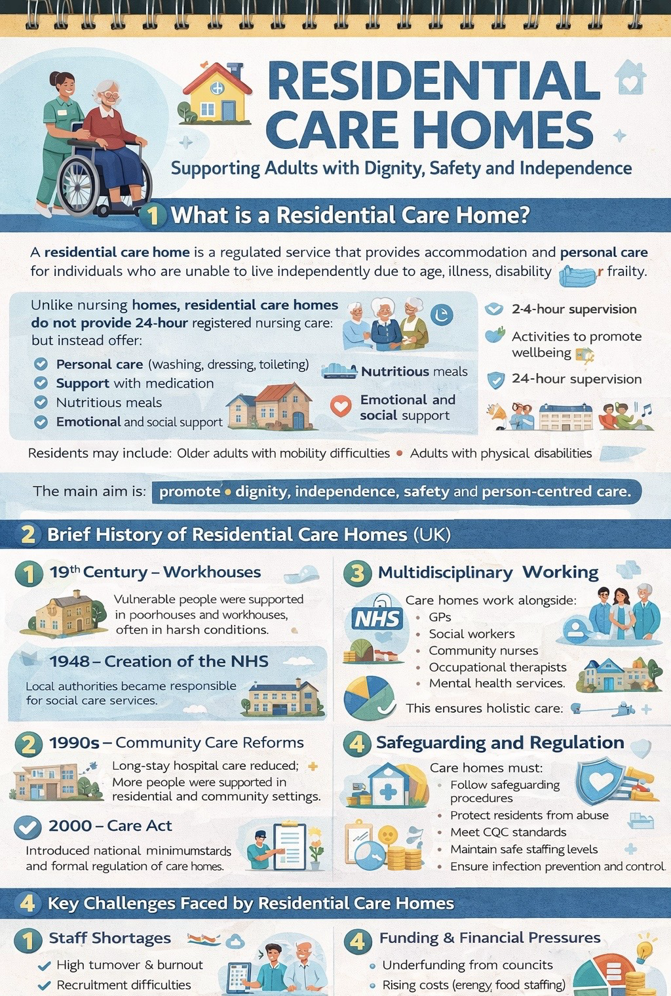
Page 3


Page 4
Essay – pharmacy services
Pharmacy services have evolved significantly from traditional apothecary practices to highly regulated, patient-centred healthcare services. Historically concerned with the preparation and supply of medicines, modern pharmacy services now encompass clinical care, public health interventions and medicines optimisation. This essay explores the origins of pharmacy services, the historical context that shaped their development, critically evaluates how they function today, and discusses their significance in enhancing the quality of life of service users.

The origins of pharmacy can be traced back to ancient civilisations, where healers and apothecaries prepared herbal remedies and medicinal compounds. Early records from Mesopotamia and Ancient Egypt demonstrate organised systems for compounding and dispensing medicines (Anderson, 2005). However, pharmacy began to emerge as a distinct profession in medieval Europe, particularly following the separation of medicine and pharmacy in the 13th century under Emperor Frederick II, who mandated that physicians prescribe and apothecaries dispense medicines (Porter, 1997). This division laid the foundation for professional accountability and regulation.

In the United Kingdom, pharmacy developed more formally in the 19th century. The establishment of the Pharmaceutical Society of Great Britain in 1841 marked a key milestone in professionalisation (Berridge and Thom, 1996). The Pharmacy Act 1868 introduced legal controls over the sale of poisons and dangerous drugs, strengthening public protection. Industrialisation and scientific advances in chemistry during the 19th and early 20th centuries transformed pharmacy from small-scale compounding to large-scale pharmaceutical manufacturing. The discovery of antibiotics, such as penicillin in 1928, further revolutionised medicine supply and clinical outcomes (Weatherall, 1990). The creation of the National Health Service (NHS) in 1948 integrated community pharmacies into a publicly funded healthcare system, ensuring universal access to prescribed medicines (Webster, 2002). These historical developments shaped pharmacy into a regulated, science-based profession embedded within public health systems.

Today, pharmacy services operate across community, hospital and primary care settings. Community pharmacies are often the most accessible healthcare locations, offering dispensing services, advice on minor ailments, medication reviews and public health interventions such as vaccinations and smoking cessation support (NHS England, 2023). Pharmacists are trained healthcare professionals registered with the General Pharmaceutical Council (GPhC), ensuring standards of education, ethics and practice are maintained (GPhC, 2022). The role has shifted from a product-focused model to a patient-centred approach known as pharmaceutical care, which prioritises safe, effective and appropriate medicine use (Hepler and Strand, 1990).
Page 5
A critical evaluation of contemporary pharmacy services highlights both strengths and challenges. One significant strength is accessibility. Community pharmacies often operate extended hours and do not require appointments, reducing pressure on general practitioners and accident and emergency departments. Services such as the Community Pharmacist Consultation Service enable patients to receive timely care for minor illnesses (NHS England, 2023). Furthermore, independent prescribing rights granted to pharmacists in recent years have expanded their clinical responsibilities, allowing them to assess, diagnose and prescribe within their competence (Royal Pharmaceutical Society, 2021). This enhances multidisciplinary collaboration and improves patient outcomes.

However, challenges persist. Increasing workload pressures, funding constraints and workforce shortages can affect service delivery. Community pharmacies in deprived areas are particularly vulnerable to closure due to financial pressures, potentially widening health inequalities (Todd et al., 2018). Additionally, while the expansion of clinical roles is positive, it requires adequate training, support and integration with other healthcare professionals to avoid fragmentation of care. There are also concerns about commercial pressures within retail pharmacy environments potentially conflicting with healthcare priorities. Thus, while pharmacy services have expanded significantly, sustainable funding and strategic workforce planning are essential for long-term effectiveness.

Pharmacy services play a crucial role in enhancing the quality of life of service users. Access to safe and effective medicines is fundamental to managing acute and chronic conditions, from infections to diabetes and cardiovascular disease. Pharmacists contribute to improved medication adherence through counselling, medication reviews and tailored advice, reducing hospital admissions related to medication errors (World Health Organization, 2019). Public health services delivered through pharmacies, such as vaccinations, emergency contraception and harm reduction programmes, directly improve population health outcomes and reduce inequalities.

Moreover, pharmacies often serve as trusted community hubs. Their accessibility allows vulnerable populations, including older adults and individuals with limited mobility, to seek advice without stigma or barriers. Medicines Use Reviews and the New Medicine Service support patients when starting long-term therapies, improving confidence and self-management. By promoting health literacy and empowering patients to make informed decisions, pharmacy services enhance autonomy and wellbeing.
The COVID-19 pandemic further demonstrated the value of pharmacy services. Community pharmacies remained open throughout lockdowns, ensuring continuity of medicine supply and delivering millions of vaccinations across the UK (NHS England, 2022). This highlighted their resilience and integral role within primary care. The pandemic accelerated digital innovations such as electronic prescribing and remote consultations, which may continue to shape future practice.
Page 6
In conclusion, pharmacy services have developed from early apothecary practices into an essential, regulated and patient-focused component of modern healthcare. Historical milestones, including professional regulation, scientific advancement and NHS integration, have shaped their evolution. Today, pharmacy services provide accessible, clinically advanced and public health-oriented care, although challenges relating to funding and workforce sustainability remain. Ultimately, pharmacy services significantly enhance quality of life by ensuring safe medicine use, improving health outcomes and supporting community wellbeing. As healthcare systems face increasing demand and complexity, the continued development of pharmacy services will be vital in promoting equitable, high-quality care.

Page 7
Essay references
Anderson, S. (2005) Making medicines: A brief history of pharmacy and pharmaceuticals. London: Pharmaceutical Press.
Berridge, V. and Thom, B. (1996) Medicines and society in Britain 1700–1900. London: Routledge.
General Pharmaceutical Council (GPhC) (2022) Standards for pharmacy professionals. London: GPhC.
Hepler, C.D. and Strand, L.M. (1990) ‘Opportunities and responsibilities in pharmaceutical care’, American Journal of Hospital Pharmacy, 47(3), pp. 533–543.
NHS England (2022) Community pharmacy’s role in the COVID-19 vaccination programme. London: NHS England.
NHS England (2023) Community Pharmacy Contractual Framework. London: NHS England.
Porter, R. (1997) The greatest benefit to mankind: A medical history of humanity. London: HarperCollins.
Royal Pharmaceutical Society (2021) A competency framework for all prescribers. London: RPS.
Todd, A. et al. (2018) ‘The positive pharmacy care law: An area-level analysis of the relationship between community pharmacy distribution, urbanity and social deprivation in England’, BMJ Open, 8(8), e022082.
Webster, C. (2002) The National Health Service: A political history. Oxford: Oxford University Press.
World Health Organization (2019) Medication safety in polypharmacy. Geneva: WHO.

Page 8

