Name: Noah Cooper

Student Number: 2501949

WORKSHEET 4 – TESTING (Dice Duel)

- Original code:
[Copy and paste your original code from Moodle into this box. Do not change it.]

#define _CRT_SECURE_NO_WARNINGS
#include <stdio.h>
#include <Windows.h>
#include <time.h>
#include <math.h>

void main()
{
int ranUser,userMath=0, ranOppenment,comMath=0, userPoints=0, comPoints=0;
int low = 1, high = 6;
int roundCounter=-1, stat[25]; //1,win2,lose,3draw

char roll='q';

while (roundCounter <= 25 && roll != 'n')
{
printf("Are you ready to roll the dice? ");
scanf(" %c", &roll);

if (roll == 'y')
{
while (roll == 'y')
{
roundCounter++;

printf("You Rolled...\n");
srand(time(NULL));

for (int i = 0; i < 3; i++)
{
Sleep(500);
ranUser = rand() % (high - low + 1) + low;
printf("%d ", ranUser);
userMath = userMath + ranUser;

}
printf("Now here is the computer\n");
for (int i = 0; i < 3; i++)
{
Sleep(500);
ranOppenment = rand() % (high - low + 1) + low;
printf("%d ", ranOppenment);
comMath = comMath + ranOppenment;
}

printf("THE COMPUTER ROLLED IN TOTAL %d WHILST YOU HAVE ROLLED %d\n", comMath, userMath);

if (userMath > comMath)
{
userPoints++;
printf("YOU WON!! YOU HAVE %d AND OPPENMENT HAS %d", userPoints, comPoints);
stat[roundCounter] = 1;
}
else if (userMath < comMath)
{
comPoints++;
printf("COMPUTER WON!! OPPENMENT HAS %d AND YOU HAVE %d", comPoints, userPoints);
stat[roundCounter] = 2;
}
else
{
printf("NO BODY WON! OPPENMENT HAS %d AND YOU HAVE %d", userPoints, comPoints);
stat[roundCounter] = 3;
}
printf("\nDo you want to roll the dice ");
scanf(" %c", &roll);
}
}
else if (roll == 'n')
{
printf("NO WORRIES! HAVE A GREAT DAY!!!");

for (int i = 0; i < roundCounter; i++)
{
printf("\nHere %d", stat[roundCounter]);
}
}
else
{
printf("WRONG INPUT EITHER PRESS Y/N");
}

}
roundCounter++;
for (int i = 0; i < roundCounter; i++)
{

if (stat[roundCounter] == 1)
{
printf("ROUND %d WIN",stat[roundCounter]);
}

if (stat[roundCounter] == 2)
{
printf("ROUND %d LOSE", stat[roundCounter]);
}

if (stat[roundCounter] == 3)
{
printf("ROUND %d DRAW", stat[roundCounter]);
}
}
}

- Code Testing
For each test below (i – ix), run your code and show the results of the scenarios below. Present a screenshot of what happened when the programme ran. Did the programme behave correctly or did it do something unexpected, and if so, why?

Part a)
- Computer wins round
- User wins round
- Draw
- “Go again” – enter y
- “Go again” – enter n
- “Go again” – enter Y
- “Go again” – enter b

Part b)
- Show score/score tracking (depending on how you have implemented your program)
- Show an overall win (however this is achieved eg first to 5, best of 12 etc)

Part c)
x. Analyse your code and write a short paragraph commenting on the efficiency of the original code. Could efficiency be improved and if so comment on what is currently inefficient?

Template for tests:
Test: i Computer wins round

Screenshot(s) of output:
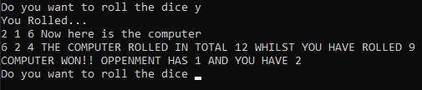
The computer beat the user by having 3 more points over the player, this works as intended

Test: ii User wins round

Screenshot(s) of output:
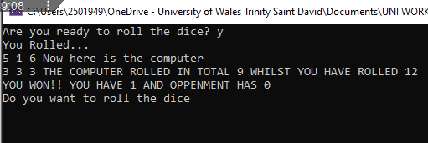
The user one by having more numbers in total compared to the opponent, this works as intended

Test: iii Draw

Screenshot(s) of output:
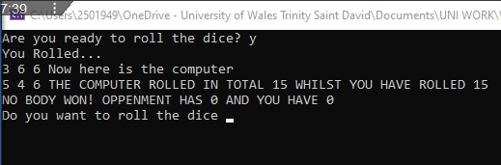
The user and computer both drew as they both had 15, this works as intended

Test: iv “Go again” – enter y

Screenshot(s) of output:
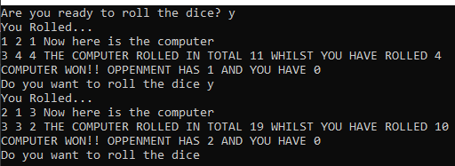
The program does what it is told and works as well, would like to make the interface more readable, however there seems to be an issue where the previous score is carried over to the new game

Test: v “Go again” – enter n

Screenshot(s) of output:
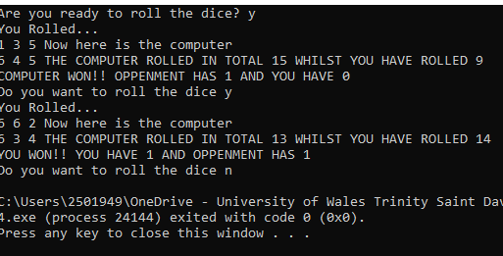
The program allowed the user to leave although I do think a simple message

Test: vi “Go again” – enter Y

Screenshot(s) of output:
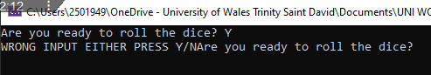
Whilst the input is technically expected the program wont allow this input as that it doesn’t have the ToLower function!

Test: vii “Go again” – enter b

Screenshot(s) of output:
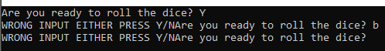

Test: viii Show score/score tracking (depending on how you have implemented your program)

Screenshot(s) of output:
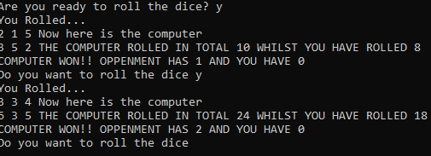
Although this COULD be considered a design choice by keeping the score of previous games, this does not work as it should be for mine due to it not having a reset at the end/start of the loop

Test: ix Show an overall win (however this is achieved eg first to 5, best of 12 etc)

Screenshot(s) of output:
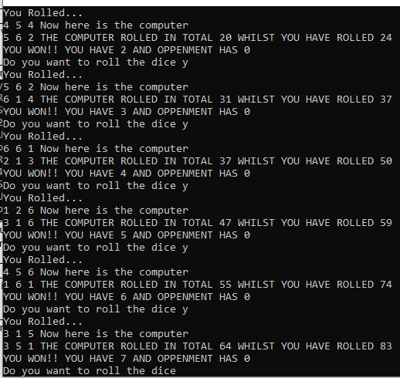
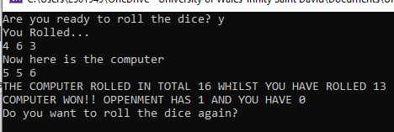
- For Clarification I changed that it can only go for 5 rounds, since originally it was 25!
The program is not working correctly since I was using 1 variable for 2 tasks making the program run forever since it was never going to hit the limit

It is keeping score however on whose winning and how many wins both players have

- Consider the results of the above tests and your analysis of program efficiency and revisit your original code in order to address any tests that failed and/or improve code efficiency.

(Note: you may not be able to solve all of the problems that were encountered, but solve as many as you can.)

Paste your full revised code here :

[Copy and paste your full revised code here – note, do not use a screenshot]
#define _CRT_SECURE_NO_WARNINGS
#include <stdio.h>
#include <Windows.h>
#include <time.h>
#include <math.h>

void main()
{
int ranUser,userMath=0, ranOppenment,comMath=0, userPoints=0, comPoints=0;
int low = 1, high = 6;
int roundCounter=-1, stat[25],gameEnd=1; //1 win,2 lose, 3 draw

char roll='q';

while (roundCounter <= 25 && roll != 'n')
{
printf("Are you ready to roll the dice? ");
scanf(" %c", &roll);

if (roll == 'y')
{

while (gameEnd <= 25 && roll == 'y')
{
comMath = 0;
userMath = 0;
roundCounter++;

printf("You Rolled...\n");
srand(time(NULL));

for (int i = 0; i < 3; i++)
{
Sleep(500);
ranUser = rand() % (high - low + 1) + low;
printf("%d ", ranUser);
userMath = userMath + ranUser;

}
printf("\nNow here is the computer\n");
for (int i = 0; i < 3; i++)
{
Sleep(500);
ranOppenment = rand() % (high - low + 1) + low;
printf("%d ", ranOppenment);
comMath = comMath + ranOppenment;
}

printf("\nTHE COMPUTER ROLLED IN TOTAL %d WHILST YOU HAVE ROLLED %d\n", comMath, userMath);

if (userMath > comMath)
{
userPoints++;
printf("YOU WON!! YOU HAVE %d AND OPPENMENT HAS %d", userPoints, comPoints);
stat[roundCounter] = 1;
}
else if (userMath < comMath)
{
comPoints++;
printf("COMPUTER WON!! OPPENMENT HAS %d AND YOU HAVE %d", comPoints, userPoints);
stat[roundCounter] = 2;
}
else
{
printf("NOBODY WON! OPPENMENT HAS %d AND YOU HAVE %d IT'S A DRAW", userPoints, comPoints);
stat[roundCounter] = 3;
}
gameEnd++;
if (gameEnd > )
{
roll = 'n';
}
else
{
printf("\nDo you want to roll the dice again? ");
scanf(" %c", &roll);
}

}
}
else if (roll == 'n')
{
printf("NO WORRIES! HAVE A GREAT DAY!!!");

for (int i = 0; i < roundCounter; i++)
{
printf("\nHere %d", stat[roundCounter]);
}
}
else
{
printf("WRONG INPUT EITHER PRESS Y/N");
}

}
roundCounter++;
for (int i = 0; i < roundCounter; i++)
{

if (stat[roundCounter] == 1)
{
printf("ROUND %d WIN",stat[roundCounter]);
}

if (stat[roundCounter] == 2)
{
printf("ROUND %d LOSE", stat[roundCounter]);
}

if (stat[roundCounter] == 3)
{
printf("ROUND %d DRAW", stat[roundCounter]);
}
}
if (roll == 'n' && gameEnd > 3)
{
printf("\nCongrats on Completing the game! HAVE A GREAT DAY!!!\n");

}
}

