Name: Katie Rees
Student Number: 1903413
Date: 27th February 2022

Network and operating systems and services (NOSS)

Contents
1/ Task 1: Building a Virtual LAN Using Type 2 Hypervisor Management Software 2
2/ Task 2: DEPLOYING A NETWORK DIRECTORY SERVICE AND CREATING AND UNDERSTANDING ACTIVE DIRECTORY NETWORK OBJECTS 12
3/ Hypervisors 25
3.1/ Example Vendors 25
4/ Cloud Computing 26
4.1/ Example Vendors 26
5/ Domain Name System (DNS) & Active Directory Domain Services (ADDS) 26
6/ Critical Roles in an Enterprise Network 27
7/ Windows Firewall 28
8/ Reflection 28
References 28

1/ Task 1: Building a Virtual LAN Using Type 2 Hypervisor Management Software

The first part of task 1 required the creation of a virtual server within a type 2 hypervisor: Oracle VM VirtualBox Manager.
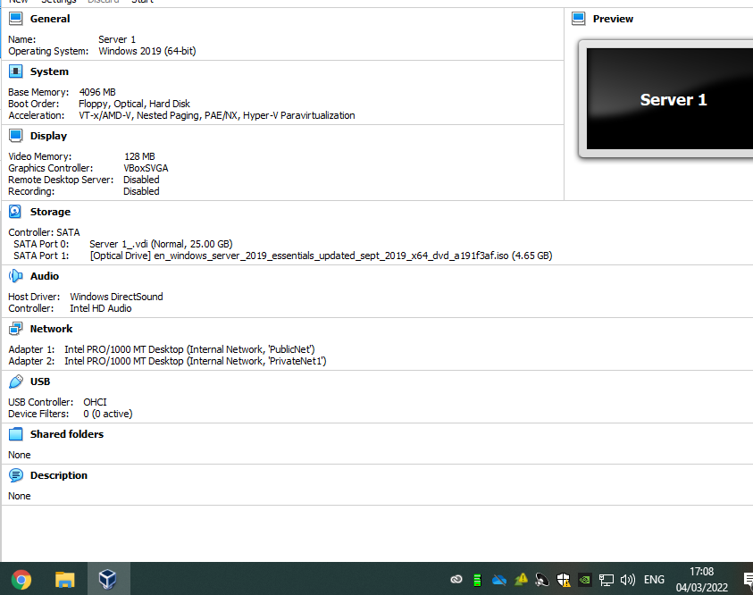
For a virtual server to function successfully, the following specification was installed: -
- 4GB of vRAM - suffice for Microsoft Server 2019.
- 2 virtual CPUs to allow high performance.
- 25GB of virtual hard disk is more than acceptable for virtual server installs.
- Dynamically allocated was chosen for storage on physical hard disk so that the memory isn’t used until required.
Once created, there are several tasks that should be carried out to confirm that the virtual machine is running to the best of it’s ability as shown below:
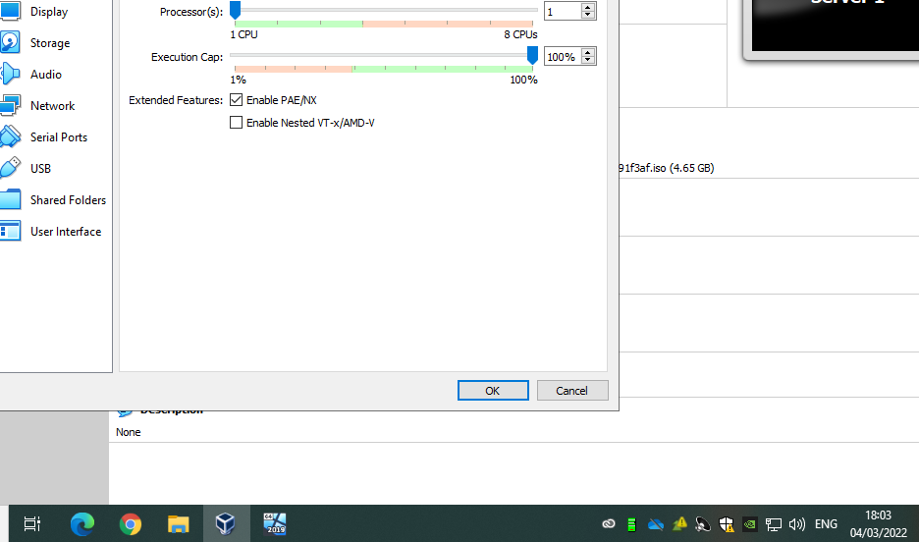
Enable PAE/NX gives the virtual machine high priority on the host machine’s CPU.
Server 1 then required the setup of Windows server 2019:
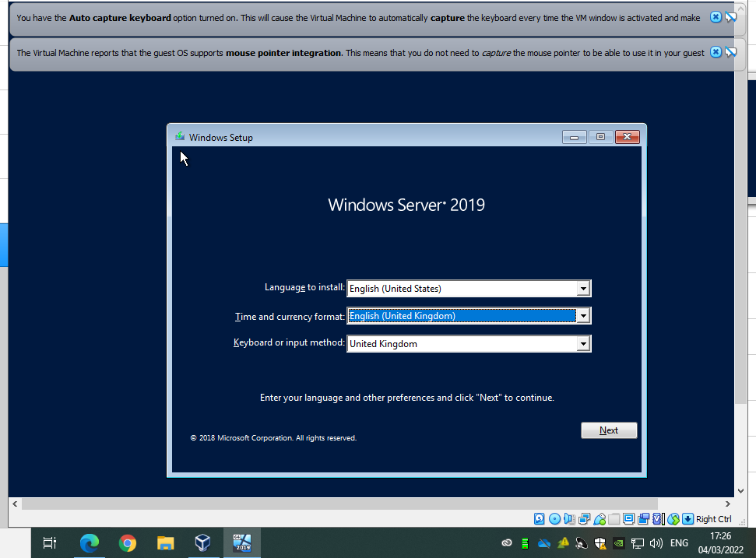
The correct virtual disk to install Windows Server onto should be selected.
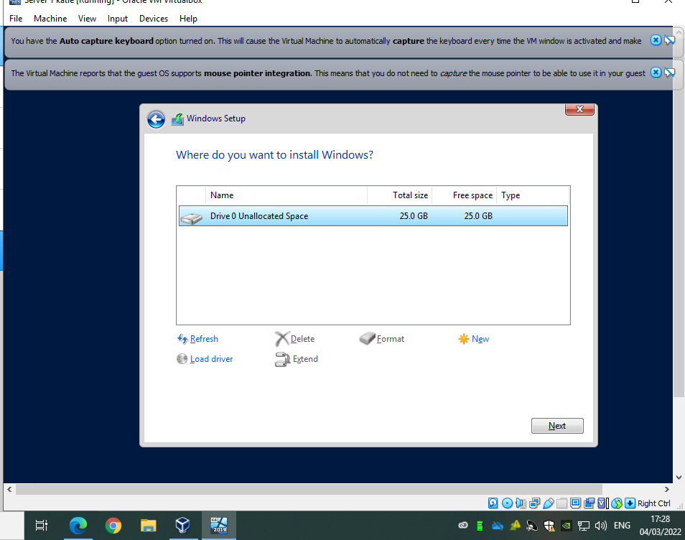

Once Windows Server 2019 had setup successfully, the creation of Server 2 was required. To carry out this task efficiently, server 1 was cloned.
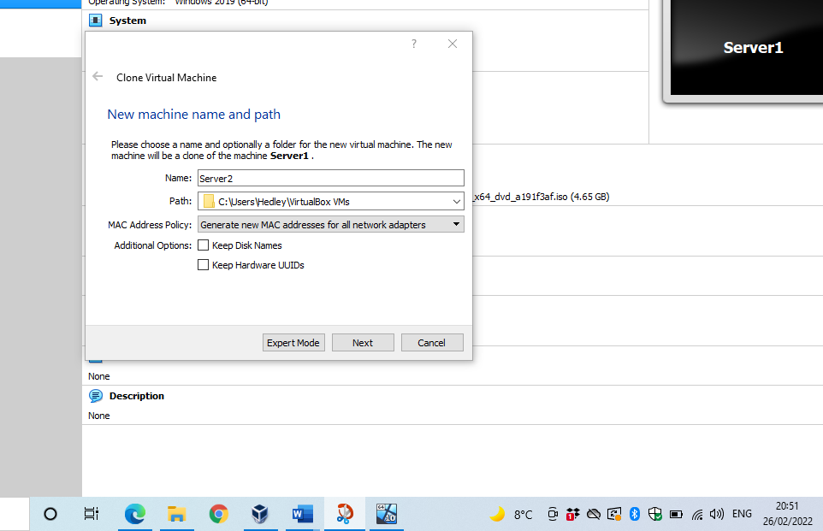
It is imperative to ensure ‘Generate new MAC addresses for all network adapters’ is selected to ensure that all network adapters within the system have their own MAC addresses and they are not cloned from server 1 (address resolution protocol). If this is not selected when cloning a system, then they will not communicate with each other. By selecting this, server 2 is treated as a completely different system.
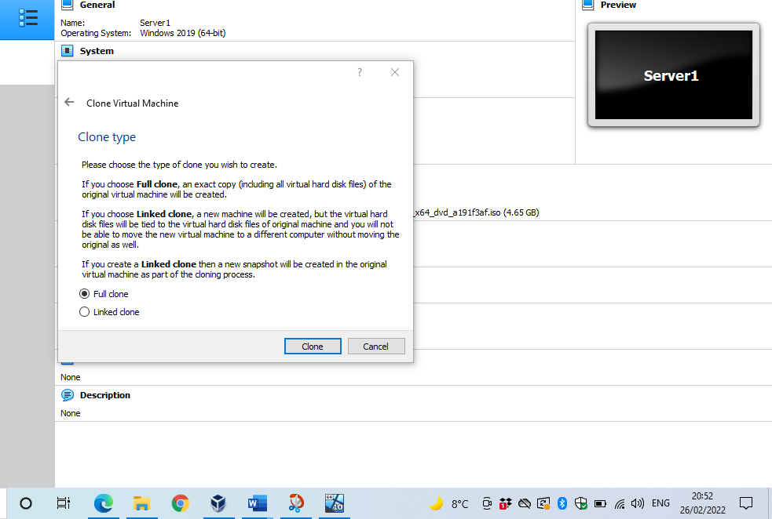
Full clone should be selected so that all of server 1 attributes ie. 25GB virtual hard disk are copied, including server 2019.
Once Server 2 has been setup successfully, client 1 is created.
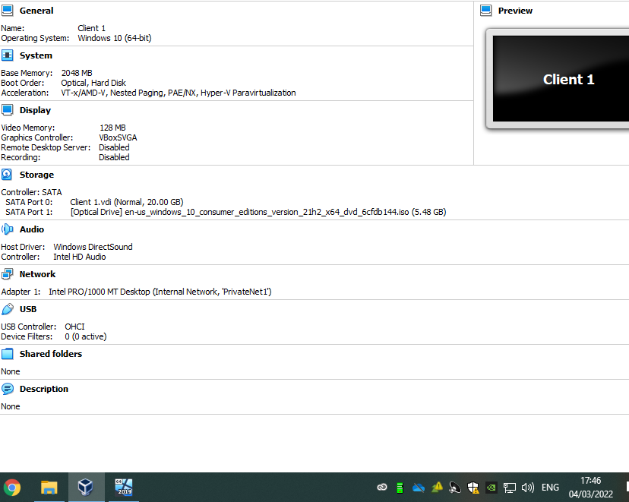
The client machine is setup running windows 10 (x64). This client machine does not require as much RAM as the server therefore 2GB has been selected. This can be increased once created, if required. Like the server, VDI has been selected as it’s the most portable format and dynamically allocated has been chosen so that the memory is used on demand. 20GB has been selected to hold windows 10 OS. Boot order has been updated to remove floppy disk as it’s not required.
Once setup, Windows 10 operating system should be installed.
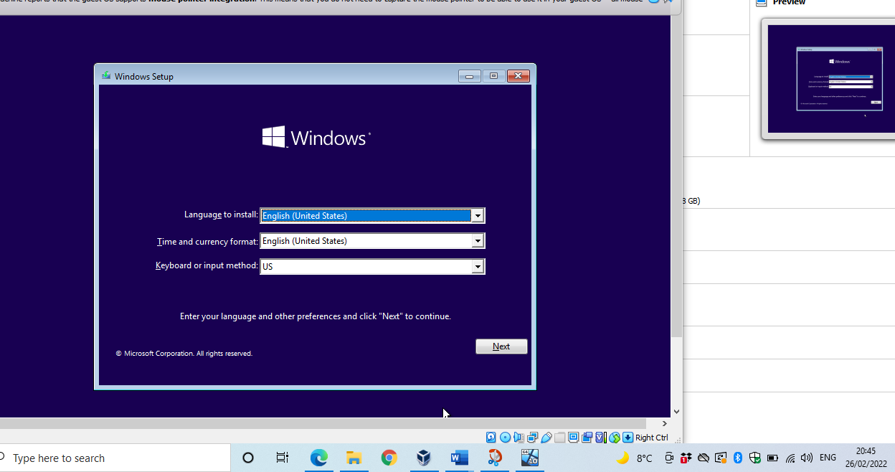
Once Windows 10 has successfully installed on client 1, it was cloned to create client 2.
The cloning process is no different to server 1 and 2 and as discuss previously, it is critical when cloning that new MAC addresses are generated for it to act as a separate device in the LAN.
Next it was required to set up the network adapters in server 1 as shown below: -
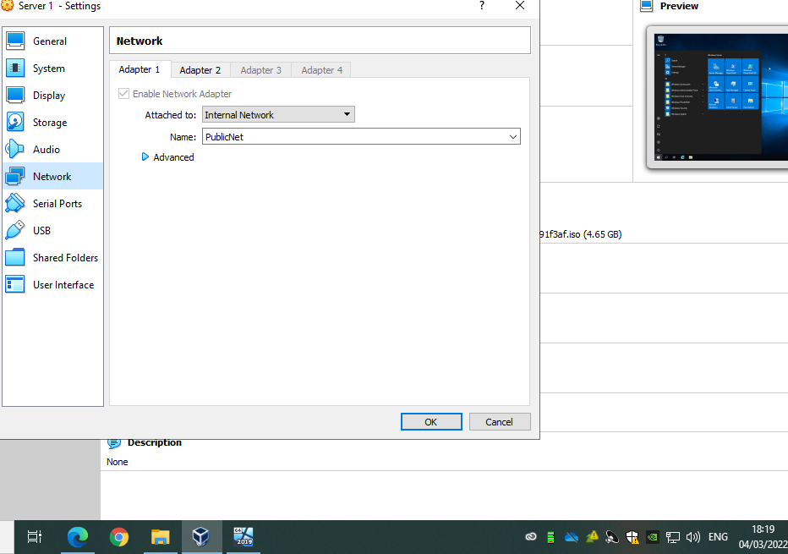
PublicNet was created first and assigned IP address 192.168.10.200, as per diagram in task 1.
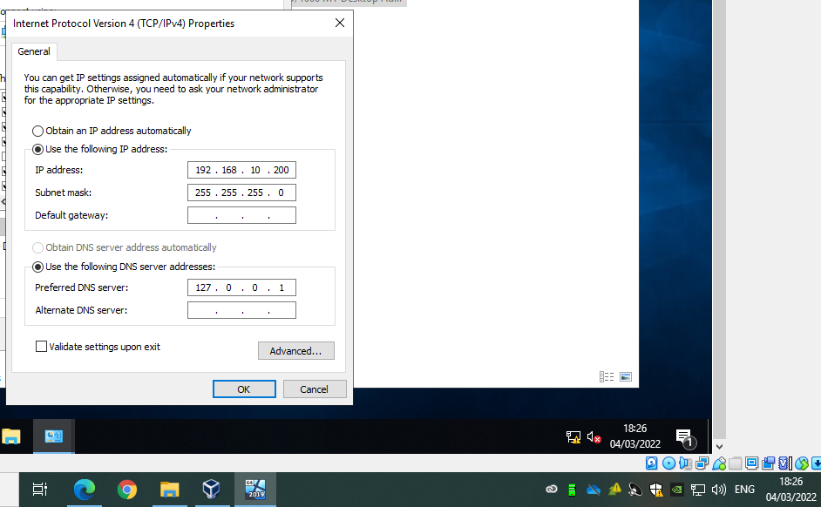
The same process was carried out for server two and assigned IP address 192.168.10.201. To confirm both servers can communicate, server 1 should attempt to ping server 2, as shown below.
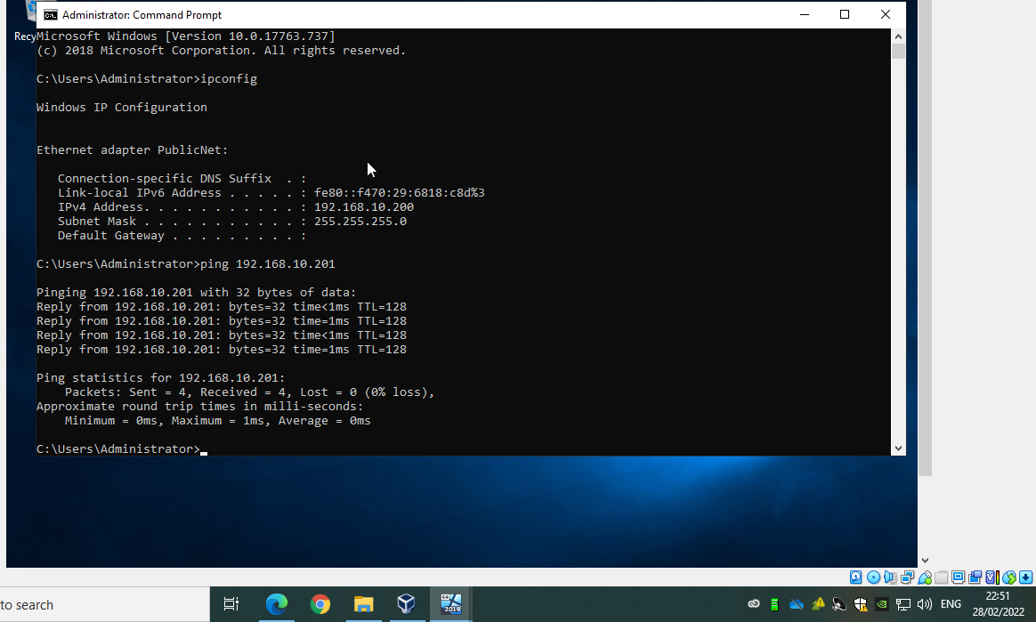
Once it was confirmed that servers 1 and 2 can communicate, privatenet1 needed to be created on server 1 and client 1. Creating the privatenet1 means that server 1 and client 1 can communicate with each other.
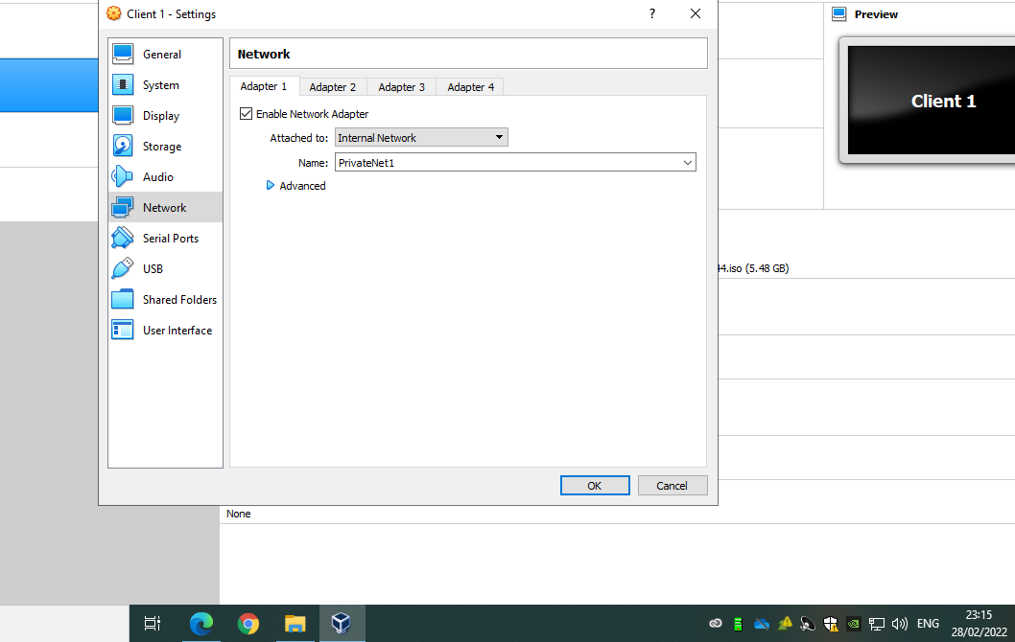
Screenshot below shows a successful ping from server 1 to client 1 following the creation of PrivateNet1.
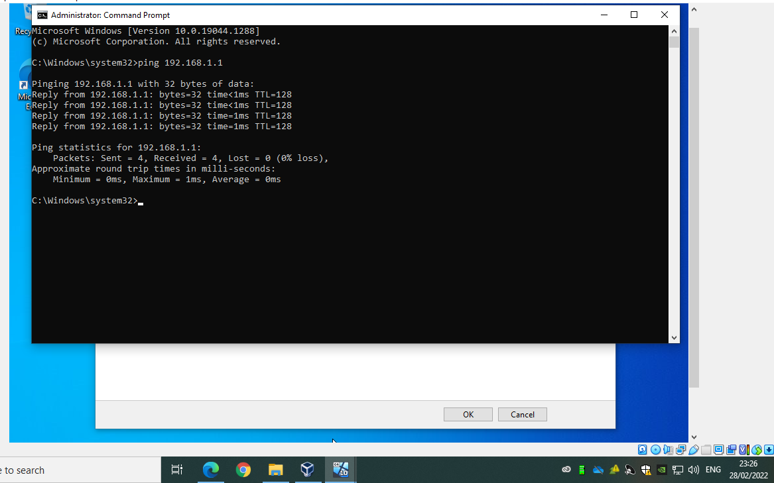
This confirms that server 1 can communicate with client 1 however it also needs to be tested that client 1 can communicate with server 1. To do so, client 1 needed to ping server 1 as shown below.
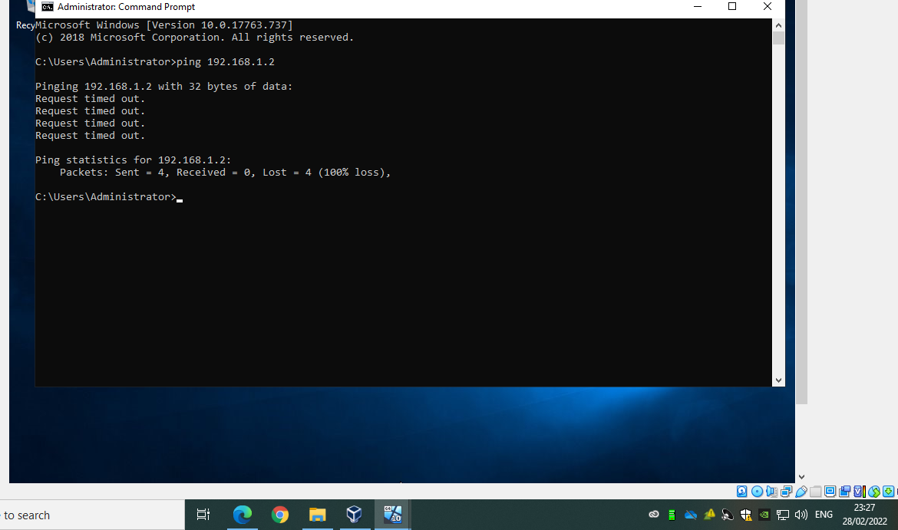
Client 1 has unsuccessfully pinged server 1.
To troubleshoot this issue, it is required to check firewall settings on server 1 as it is likely that a firewall is blocking the successful ping.
On logging onto server 1, it is apparent that there are firewall settings setup, therefore these should be turned off.
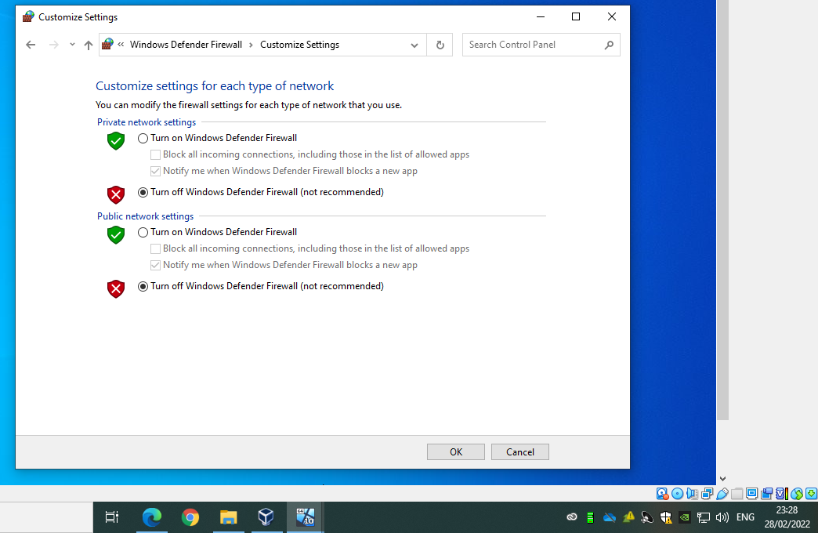
Once the firewall settings have been switched off, client 1 successfully pinged server 1.
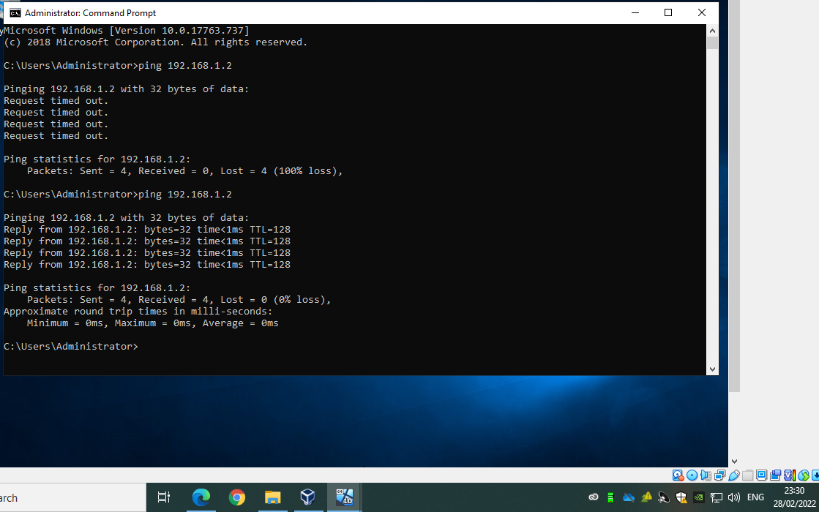
The same process should then be followed for setting up PrivateNet2 between Server 2 and Client 2. Unsurprisingly, the ping from client 2 to server 2 was unsuccessful until the firewall had been switched off.

Unsuccessful ping from client 2 to server 2
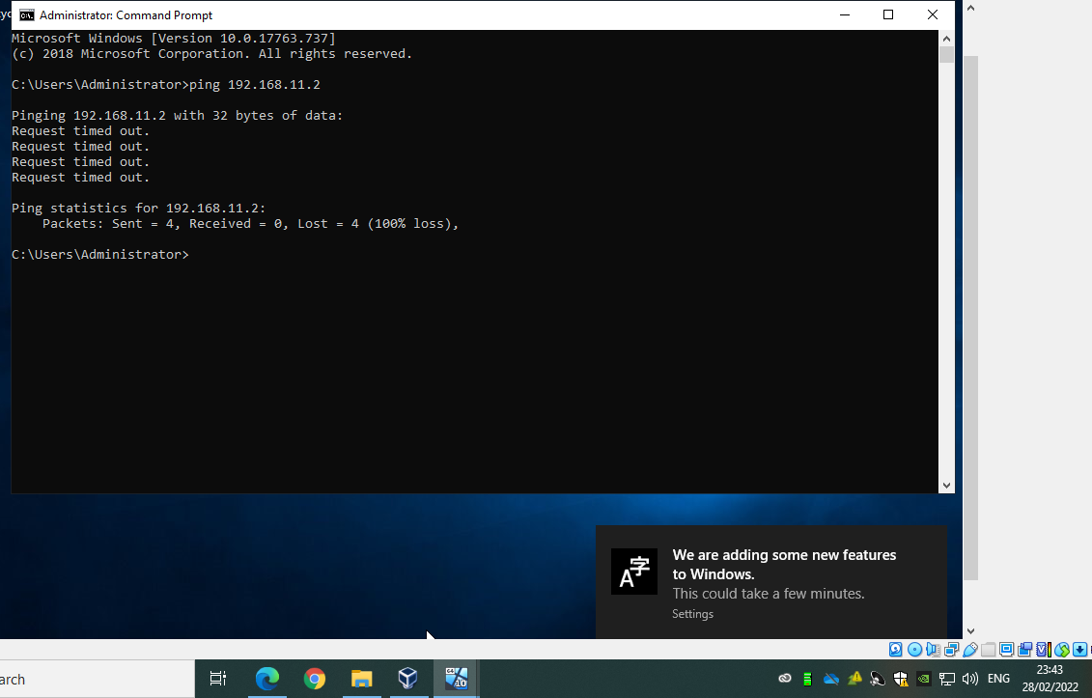
Successful ping following turning the firewall on server 2 off:
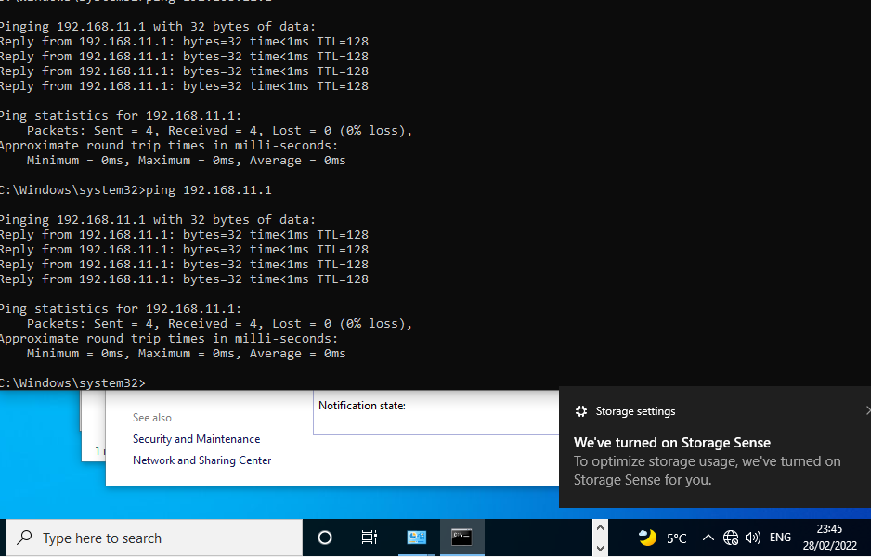

2/ Task 2: DEPLOYING A NETWORK DIRECTORY SERVICE AND CREATING AND UNDERSTANDING ACTIVE DIRECTORY NETWORK OBJECTS
Next it was required to setup AD DS on server 1.
Below confirms that no DNS server addresses have been setup previously in publicnet or privatenet1:
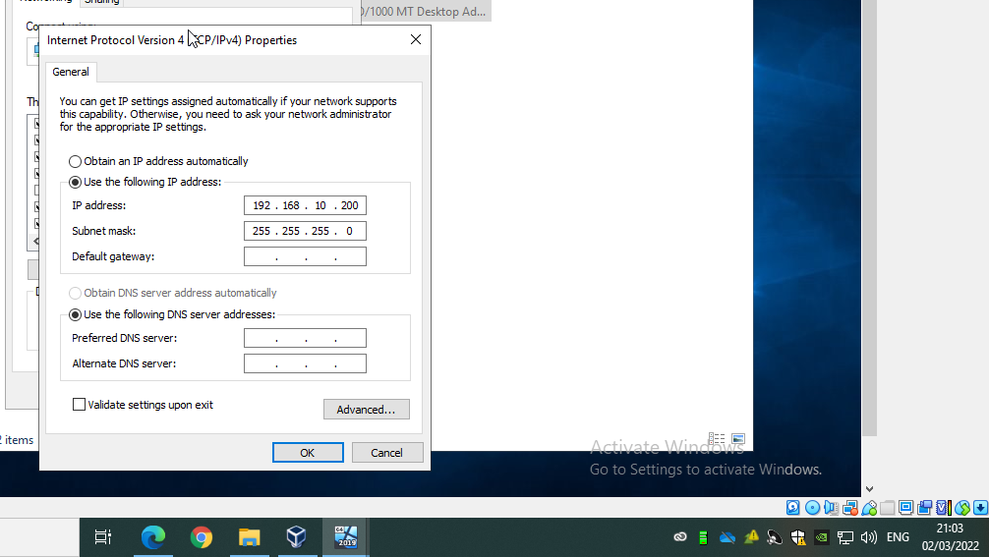
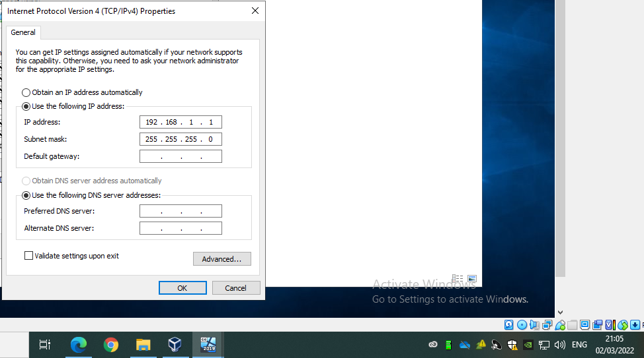
The firewall should also be turned off:
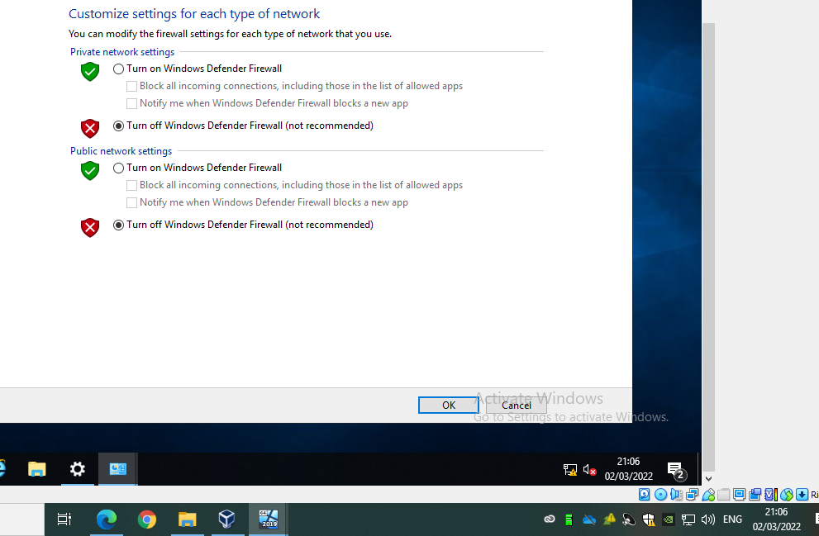

Next the computer needs to be renamed so that it is easily identifiable.
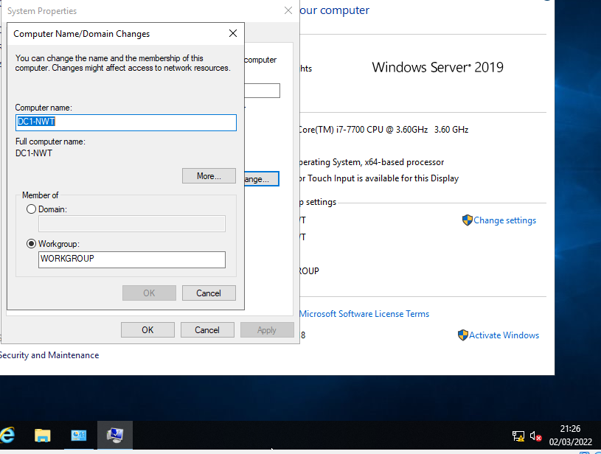
To confirm the name has been changed following a computer restart, the following command was run:
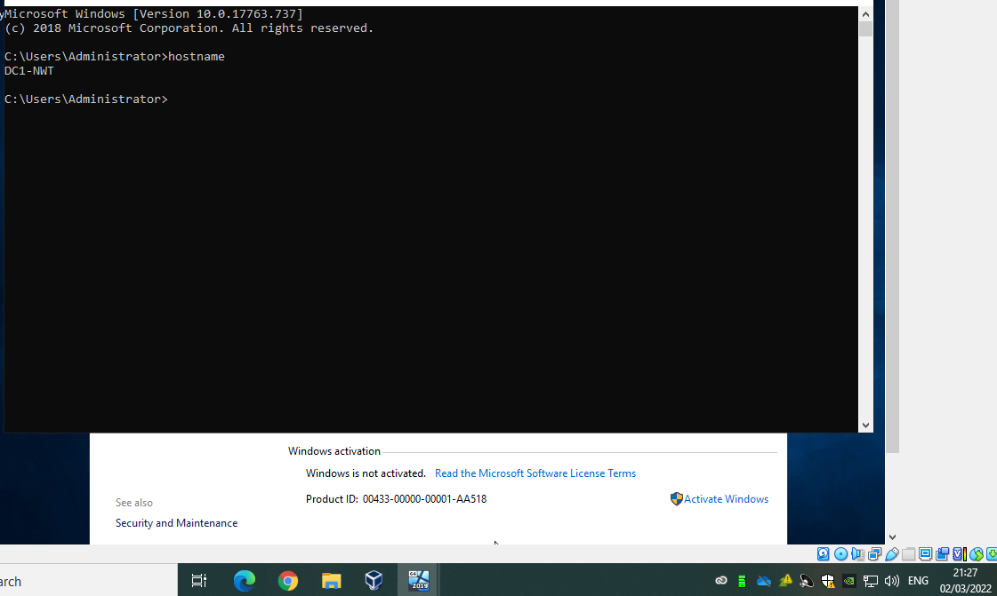
Next, it was required to install active directory onto server 1.
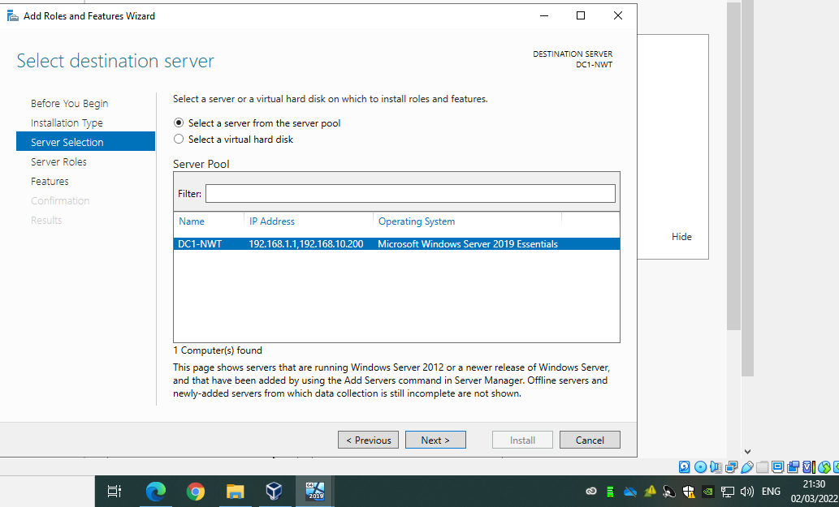
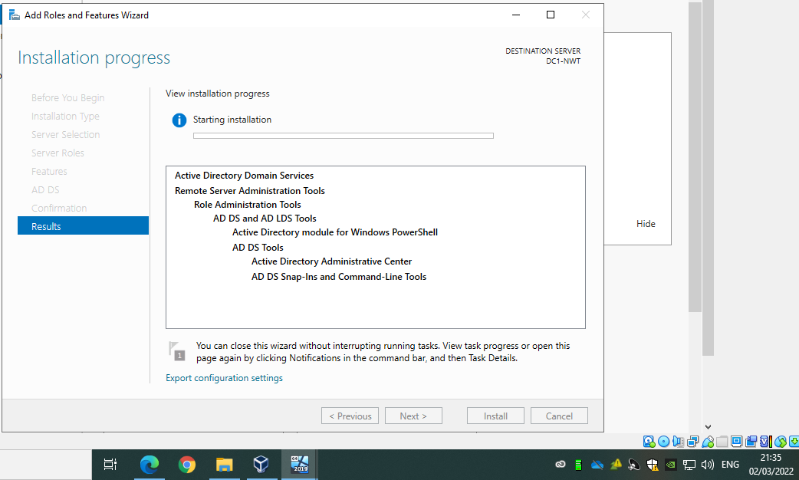
Once successfully installed, it is required to carry out post deployment configuration.
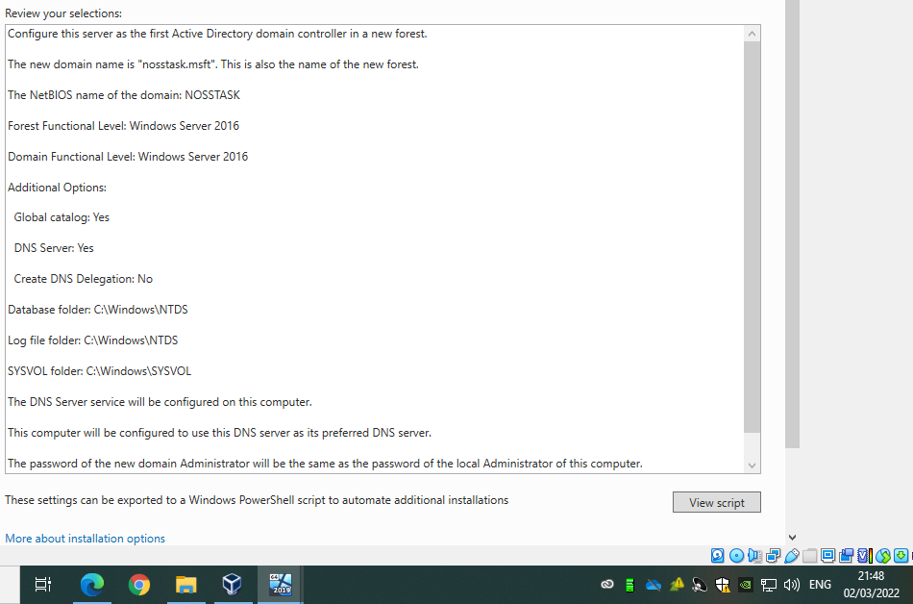
The above shows the configuration selection including the new forest with the root domain name ‘nosstask.msft’. Any forest or domain controller links must be running on at least Windows Server 2016. As it is required to define the types of objects being stored, global catalogue is set to yes and as AD is run on DNS then DNS Server is also set to yes.
Once prerequisites checks are passed, the installation can begin.
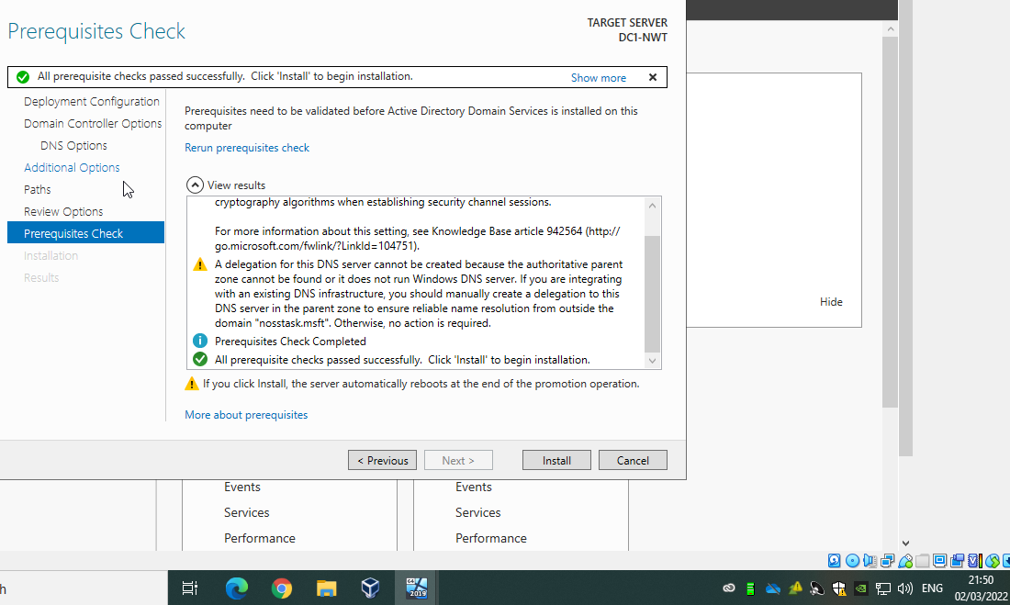
Once installed, the domain name nosstask.msft will display. DC1-NWT will display under as a domain controller.
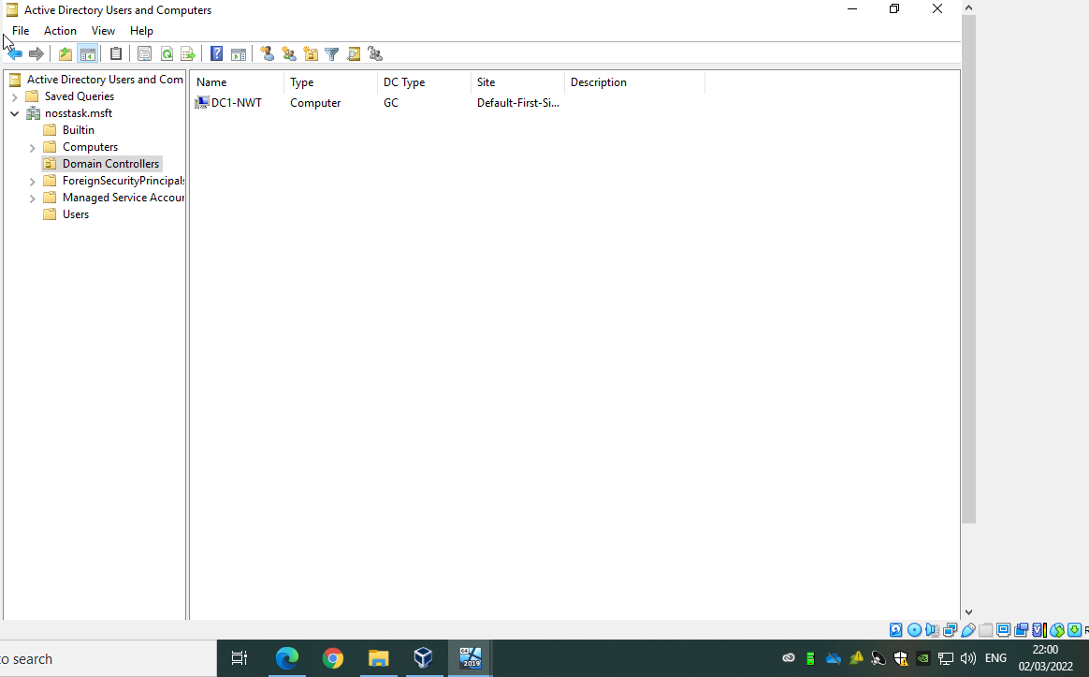
Next a new user has been setup within active directory.
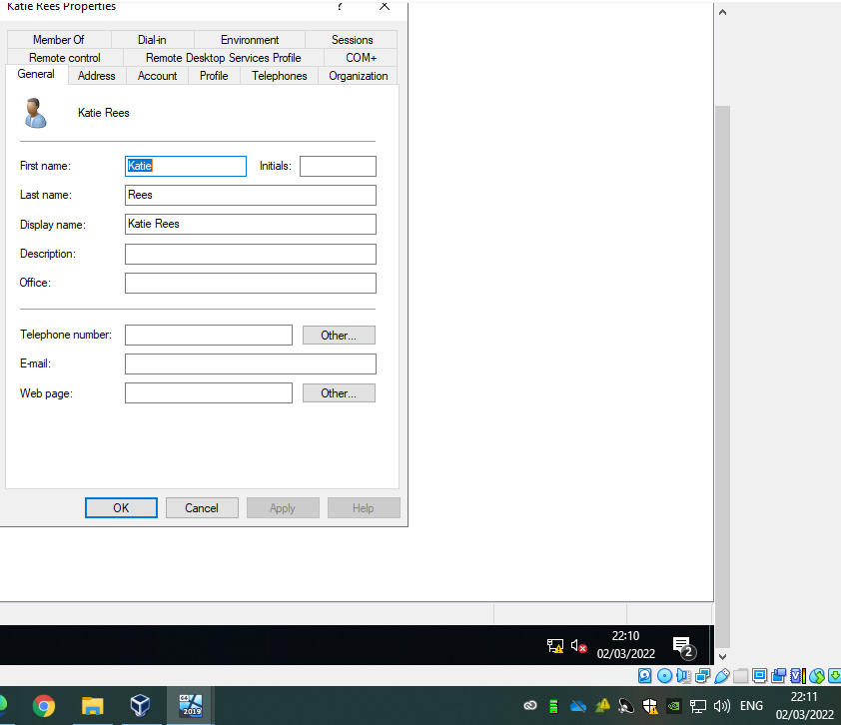
To allow the new user to access the domain controller they must be setup as a member in the domain admin group.
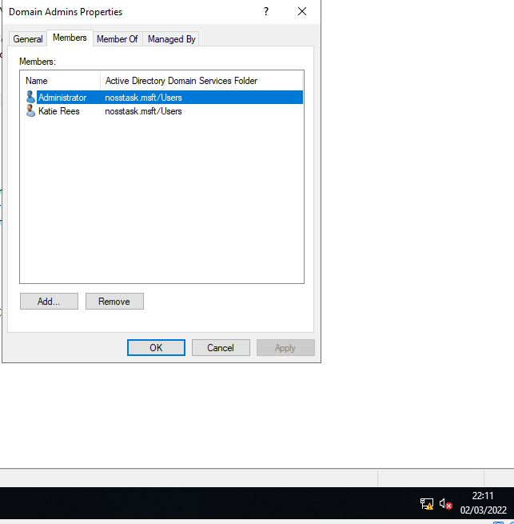
Once a domain admin, the user can log into server 1 on the domain.
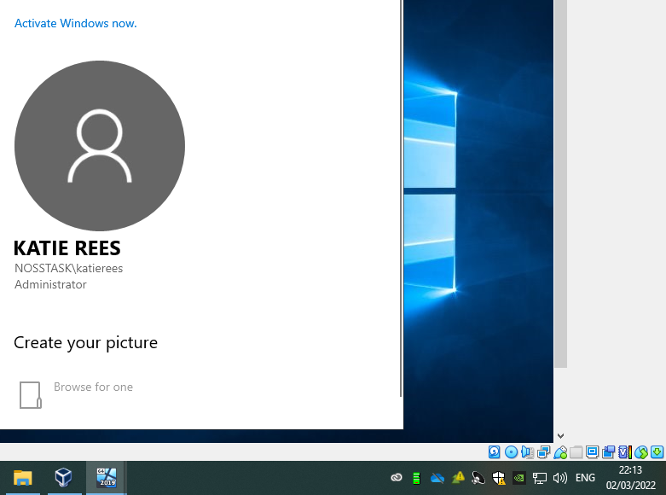

Active Directory offers the ability to restrict user activities. To demonstrate this, a new user Joe Bloggs has been created. Joe Bloggs is not a member of the domain admin group as confirmed in the screenshot below.
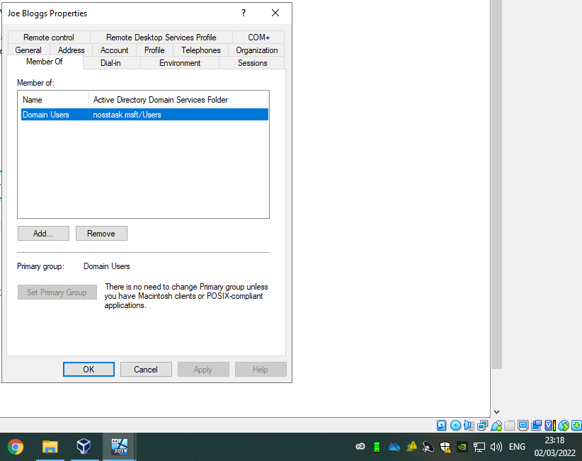
Joe Bloggs logon hours can be limited using AD.
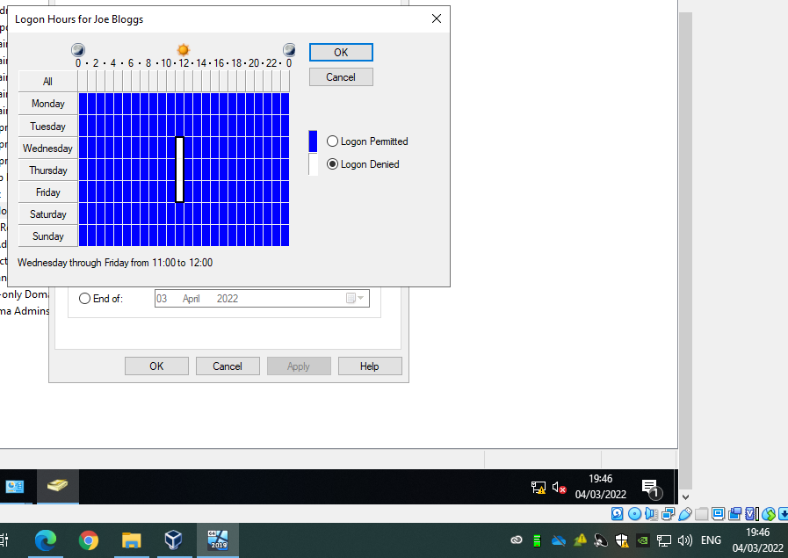
He can also be denied of the ability to change his password.
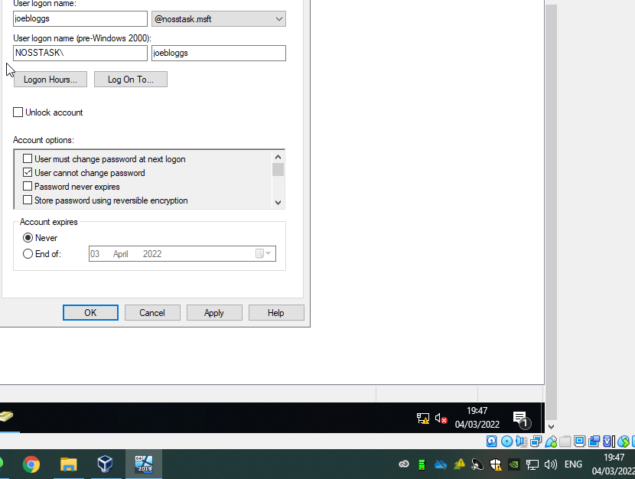

Next, the client computer was set up in AD as shown below: -
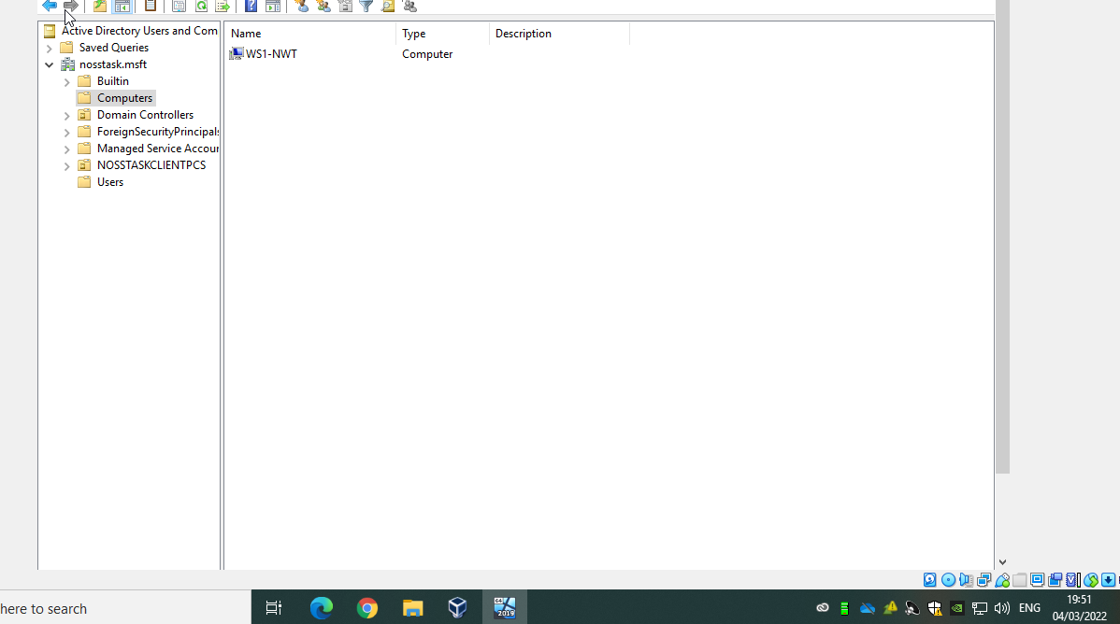
Client 1 now needs to be setup to the domain. To do this, an administrator account needs to add a preferred DNS server address on client 1. The IP address should be the PrivateNet1 address for server 1.
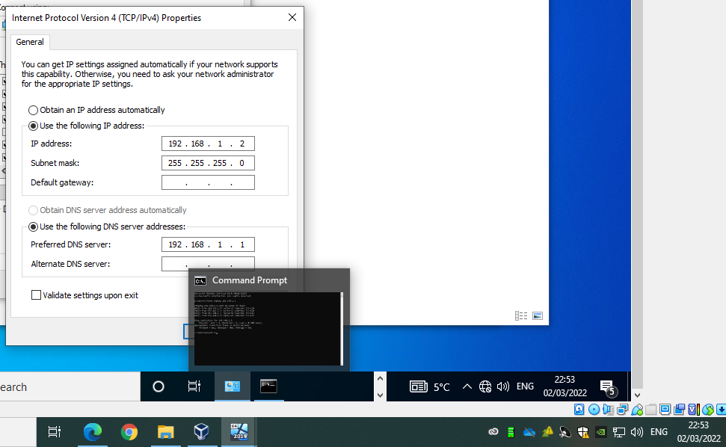
The client 1 machine now needs to become a member of the domain nosstask.msft
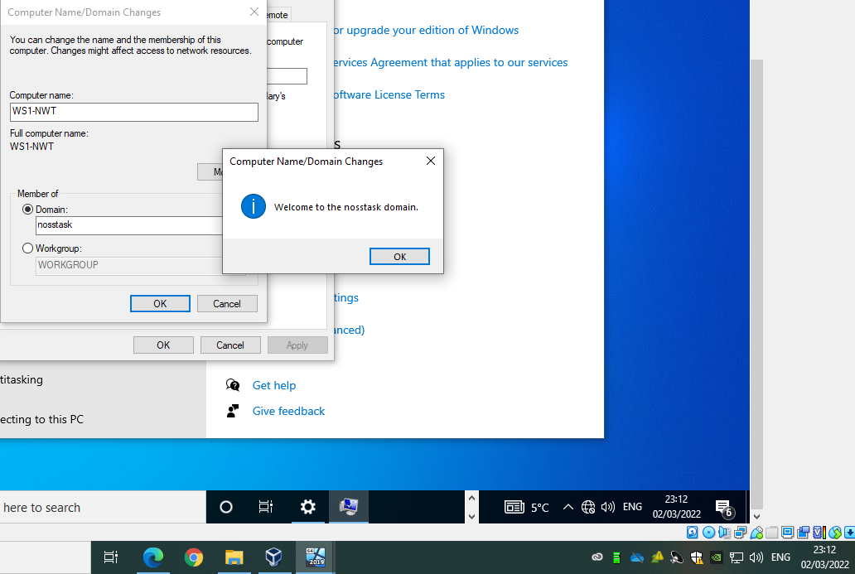

Now that the client machine is part of the domain, non-administrative accounts, such as Joe Bloggs, can log on successfully:
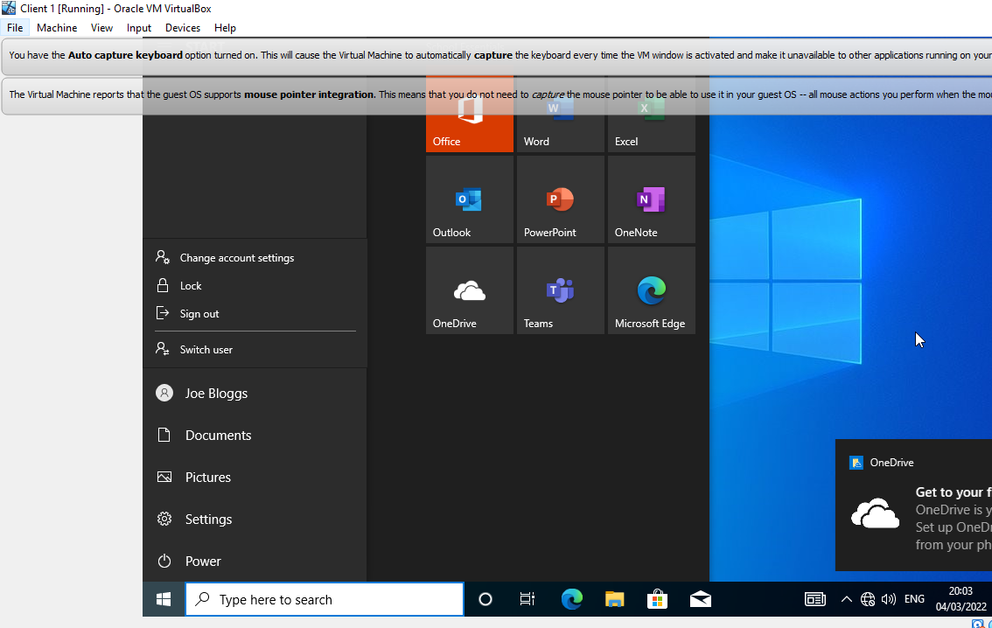
However, Joe Bloggs, a non-administrative account, is still unable to log onto server 1 as only domain admins can access server 1.
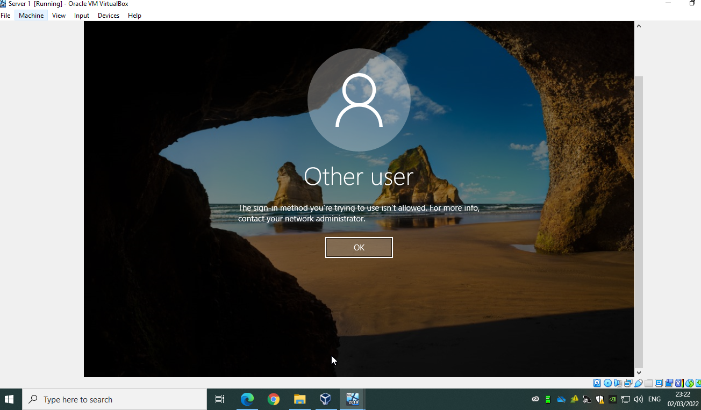

3/ Hypervisors
VMWare [1] defines hypervisors as software which allows you to construct and run virtual machines. By virtually splitting the resources of the host machine, it allows you to assist several guest virtual machines. The two main types of hypervisors are type 1 and type 2. Type 1 hypervisors run using the host’s physical hardware whereas type 2 hypervisors are installed on top of the host’s operating system, acting as a software layer. Bigelow [2] explains type 1 hypervisors have direct access to the host’s hardware and do not require underlying operating system installation, so they offer peak performance, are efficient and secure. As each guest machine has its own operating system, any attacks mean that it’s isolated to the one virtual machine. Type 1 hypervisors however typically require a level of management [3] as they use the host’s CPU/RAM so interfaces such as VMware vCenter can be imperative to reach the hypervisors full potential. Contrary, type 2 hypervisors don’t require management of the VMs and can be considered as management consoles. They run as an application within an operating system and not on host hardware and therefore offers the host’s OS as well as immediate access to an alternative operating system [3]. This makes them very useful for test engineers who wish to test running in different environments [4]. As type 2 hypervisors must use the memory of the host OS, they can cause issues with performance and latency. It can also provide a host of security issues as if the host OS is compromised, then any guest OS could be compromised also. [3]

3.1/ Example Vendors
Type 1: -
- VMware vSphere/ESX/ESXi: a front runner for type 1 hypervisors and offers a free version and 5 commercial versions [5].
- Microsoft Hyper-V: offers live and storage mitigation as well as dynamic memory. [5]
- Citrix Hypervisor: offers a range of features such as conversion tools and power management. [5]
Type 2: -
- Oracle Virtual Box: offers virtualization on a budget. Even though it’s hosted, it contains similar features to VMware vSphere. [6]
- VMWare Workstation: a free hypervisor that is ideal for developers that require sandboxing environments. [6]

4/ Cloud Computing
Cloud computing is the use of IT resources over the internet. This includes (not limited to) resources such as applications, databases, networks, and storage. [7] Cloud computing is popular with several online services such as email and banking as it can provide quick access to computing services from any device that has internet access, such as a mobile phone. There are three different cloud computing services: public, private and hybrid clouds. Public clouds are owned and controlled by a provider, ‘rented’ to multiple consumers via the internet making it popular for less-sensitive applications and those that don’t require constant traffic. [8] Private cloud is owned and controlled by a single organisation and hybrid clouds are a mix of both. [7] Cloud computing can be hugely cost effective by removing the cost of buying hardware and software, as well as maintaining datacentres. Another benefit is performance due to most well-known cloud service providers using the most up-to-date and fast hardware. Cloud computing also offers increased security. Again, well-known providers will ensure that any data and apps stored with them are at minimal risk by offering up to date technologies and providing policies and strong controls. [9] Although cloud computing can offer a high level of security, it can also be dangerous if the right provider isn’t chosen. By using cloud computing, it means trusting the provider with potentially sensitive data and can open you up to data loss and leakage. Cloud computing can also incur technical issues including network outages and reboots. Tenants have minimum control over security, server shell access and firmware management. [10]

4.1/ Example Vendors
- Amazon Web Services: the most popular cloud provider used by millions of customers. It offers a range of services include virtual private cloud and simple storage service, and security is of utmost importance. [11]
- Microsoft Azure: one of the fastest growing cloud providers offering cloud services in numerous divisions such as AI+ Machine Learning and Developer Tools. [11]

5/ Domain Name System (DNS) & Active Directory Domain Services (ADDS)
DNS is described by Cloudflare [12] as the “phonebook of the internet”. Users search the web using a domain name such as google.com. DNS then translates domain names into IP addresses so that web browsers can download the internet resources and therefore removes the unrealistic need for users to memorise IP addresses. When users search for a webpage, the first check made is to see if the DNS record can be found in the DNS cache. If this is the case, then users can go straight to the webpage. However, if the DNS record is not in the cache, then a request is made to the to the local DNS server which is also known as the resolving nameserver. If the DNS record is not found on the local DNS server, then another request is made to the root nameserver. These servers hold DNS data and can be found across the world. Once the DNS record is found, the user will be directed to the webpage requested and the DNS record will now be cached in their computer’s DNS cache. [12] Please see figure 1 below which illustrates the above.

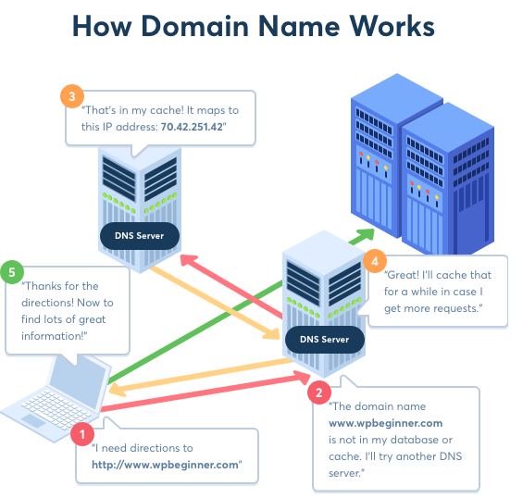
Figure 1. How Domain Name Works [13]
AD DS records everything on a network, including information about users, systems, and shares. It uses DNS to allow clients to identify domain controllers and allows communication between the domain controllers that host the directory service. DNS allows active directory a hierarchical design which mirrors the structure of the organisation. AD DS and DNS together means that windows and internet domains are compatible, therefore a domain name can identify AD domain controllers that are responsible for that domain. Addresses which display both the domain and service provided are published by Active Directory using Service Resource Records. This provides users with the ability to search for any number of services within active directory. [14]

6/ Critical Roles in an Enterprise Network
An enterprise network contains both physical and virtual networks which connect users and systems to applications in the cloud and/or data centre. [15] One critical role would be TCP/IP (transmission control protocol/internet protocol). TCP/IP is a set of protocols which allows software and hardware to exchange messages by sending packets across the internet and ensure they have been successfully delivered. IP on the other hand is a different protocol which allows you to send data between devices over the internet. An IP address is assigned to every device, uniquely identifying it to allow it to communicate with other devices on the internet. Both protocols are used in unison; the IP address to identify a device, and TCP to send the data packet through the network and ensure a safe delivery. [16] Another critical role would be DHCP (Dynamic Host Configuration Protocol) which introduces automatic IP address assigning. This is useful as manually assigning IP Addresses can be very time consuming. Automatic IP addressing also introduces a level of flexibility by providing devices in the network with addresses from a DHCP server. [17] It also removes a margin of error that may happen when manually configuring IP addresses such as mistyping or assigning an IP address that has already been assigned to another device. [18] DHCP however can introduce a single point of failure if only one DHCP server is in place. If the server fails, then this will cause a system wide failure until the server is restored. [19]

7/ Windows Firewall
Windows Server 2019 Firewall provides a level of security which is built into a device protecting computers and networks against any unwanted requests to connect to your computer. Windows firewall blocks all connection requests however it can also be switched off. When turned on, windows firewall can successfully block malicious activity and creates a log which can be monitored of successful and unsuccessful connections to a device. [20] Windows firewall differs to other firewalls on different operating systems, such as Linux, as windows is controlled by a program that runs in user mode whereas Linux uses Netfilter Linux kernel subsystem, even though they both manage incoming traffic using routing tables. Another difference is that Windows firewall is installed on all windows Operating Systems, which is not the case for Linux. A major advantage of Linux over Windows is that Linux offers ICMP echo request delaying which allows admin users to control sending packets making it very difficult for attackers to identify them. Whilst that is an advantage of linux firewall, Microsoft firewall does allow third party programs to install this feature. [21]

8/ Reflection
Task one allowed the understanding of how to implement virtualisation using a type 2 hypervisor. This was completed using virtual box and it was quickly discovered that when using a type 2 hypervisor, the host machine has to offer enough memory to supply the VMs. As the original host machine only has 4GB RAM, using RDP onto host machines with more RAM was essential for completion. The use of Windows Firewall was demonstrated the importance of it being switched on to reduce the risk of any malicious connection requests. Task two allowed in depth understanding of the use of active directory along with DNS and how it can manage the level of access users within the network can have, often restricting access to sensitive material. AD can also restrict the hours users can access these domains and specific administration tasks such as changing passwords can be forbidden and kept to domain controllers only, if required. The importance of ARP was also observed when creating a clone of a server/client machine that you want to act as a complete separate device. ARP is a procedure that connects an IP to the MAC (static) address in a LAN and therefore when creating clones, new MAC addresses must be generated otherwise the new server or client will not be given it’s static MAC address and therefore will not be considered a separate device in the network. [22]

References

[1] | [Online]. Available: https://www.vmware.com/topics/glossary/content/hypervisor.html. [Accessed 15 February 2022].
[2] | S. J. Bigelow, “What's the difference between Type 1 vs. Type 2 hypervisor?,” TechTarget, 21 January 2021. [Online]. Available: https://searchservervirtualization.techtarget.com/feature/Whats-the-difference-between-Type-1-and-Type-2-hypervisors. [Accessed 22 February 2022].
[3] | IBM, “Hypervisors,” IBM, [Online]. Available: https://www.ibm.com/cloud/learn/hypervisors#toc-type-1-vs--Ik2a8-2y. [Accessed 22 February 2022].
[4] | “Type-1 and Type-2 Hypervisors explained,” Vembu, 12 December 2019. [Online]. Available: https://www.vembu.com/blog/type-1-and-type-2-hypervisor/. [Accessed 28 February 2022].
[5] | “The Top 5 Enterprise Type 1 Hypervisors You Must Know,” Actual Tech, 12 April 2021. [Online]. Available: https://www.actualtechmedia.com/io/top-5-enterprise-type-1-hypervisors/. [Accessed 28 February 2022].
[6] | “What is Hypervisor and what types of hypervisors are there,” Vapour Apps, 13 May 2016. [Online]. Available: https://vapour-apps.com/what-is-hypervisor/. [Accessed 28 February 2022].
[7] | “Cloud Computing,” SUSE, [Online]. Available: https://www.suse.com/suse-defines/definition/cloud-computing/?utm_source=google&utm_medium=cpc&gclid=EAIaIQobChMIlsGO-t-q9gIVtIBQBh3RCQ1BEAAYAiAAEgKokfD_BwE. [Accessed 1 March 2022].
[8] | “What is Public Cloud?,” VMWare, [Online]. Available: https://www.vmware.com/topics/glossary/content/public-cloud.html. [Accessed 1 March 2022].
[9] | “What is cloud computing?,” Azure, [Online]. Available: https://azure.microsoft.com/en-gb/overview/what-is-cloud-computing/. [Accessed 1 March 2022].
[10] | “Cloud computing,” NIBUSINESSINFO.CO.UK, [Online]. Available: https://www.nibusinessinfo.co.uk/content/disadvantages-cloud-computing. [Accessed 1 March 2022].
[11] | “Top 10 Cloud Service Providers in 2021,” C# Corner, 15 July 2021. [Online]. Available: https://www.c-sharpcorner.com/article/top-10-cloud-service-providers/. [Accessed 1 March 2022].
[12] | “What is DNS? | How DNS works,” Cloudflare, [Online]. Available: https://www.cloudflare.com/en-gb/learning/dns/what-is-dns/. [Accessed 1 March 2022].
[13] | “What is: DNS,” wpbeginner, [Online]. Available: https://www.wpbeginner.com/glossary/dns/. [Accessed 1 March 2022].
[14] | “DNS and AD DS,” Microsoft, 29 July 2021. [Online]. Available: https://docs.microsoft.com/en-us/windows-server/identity/ad-ds/plan/dns-and-ad-ds. [Accessed 1 March 2022].
[15] | “What is enterprise networking?,” VMWare, [Online]. Available: https://www.vmware.com/topics/glossary/content/enterprise-networking.html. [Accessed 2 March 2022].
[16] | “What is a Transmission Control Protocol TCP/IP Model?,” Fortinet, [Online]. Available: https://www.fortinet.com/resources/cyberglossary/tcp-ip. [Accessed 2 March 2022].
[17] | “Core network guidance for Windows Server,” Microsoft, 29 July 2021. [Online]. Available: https://docs.microsoft.com/en-us/windows-server/networking/core-network-guide/core-network-guide-windows-server. [Accessed 3 March 2022].
[18] | “Dynamic Host Configuration Protocol (DHCP),” Microsoft, 29 July 2021. [Online]. Available: https://docs.microsoft.com/en-us/windows-server/networking/technologies/dhcp/dhcp-top. [Accessed 3 March 2022].
[19] | S. Laverty, “The Disadvantages of DHCP,” Techwalla, [Online]. Available: https://www.techwalla.com/articles/the-disadvantages-of-dhcp. [Accessed 3 March 2022].
[20] | S. jeremiah, “What Are the Benefits of Windows Firewall?,” Techwalla, [Online]. Available: https://www.techwalla.com/articles/what-are-the-benefits-of-windows-firewall. [Accessed 3 March 2022].
[21] | “Differences Between Windows Firewall And Linux Firewall,” 21 October 2021. [Online]. Available: https://emartbd.biz/difference-between-windows-firewall-and-linux-firewall/. [Accessed 3 March 2022].
[22] | “What is Address Resolution Protocol (ARP)?,” fortinet, [Online]. Available: https://www.fortinet.com/resources/cyberglossary/what-is-arp. [Accessed 3 March 2022].
[23] | “Active Directory Role-Based Security,” ADAXES, [Online]. Available: https://www.adaxes.com/active-directory_role-based-security.htm. [Accessed 2 March 2022].

