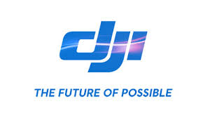

Marketing Plan for DJI

MODULE NAME: Marketing Planning & Practice
Name: jingxian wu
Student Number: 1702293

Executive Summary
The overarching aim of this report is to develop an integrated and coherent marketing plan for DJI, a commercial unmanned drone developer, and manufacturer in China.
Followed by the logic chain of SOSTAC model (situation, objectives, strategy, tactics, action, and control), the report utilized various theoretical framework to perform the internal environments and external environments, which forms the basis for the development of marketing plan for DJI. The emerging opportunities, such as a positive outlook on the drone industry and emerging middle class, encourages DJI to formulate a new marketing plan with the objective of promoting awareness and sales. Based on the predetermined marketing objectives, the report developed an integrated marketing plan for DJI through the marketing mix. Issus concerning plan implementation, and performance evaluation and risk control are also discussed at the end of the report.

Table of Contents
Executive Summary
1. Introduction 1
2. The Situation Analysis of DJI 1
2.1 Macro-environment Analysis-PEST 1
2.2 Micro-environment Analysis-Porter's Five Forces 4
2.3 Internal Analysis 5
2.4 SWOT Analysis 6
3. Marketing Objectives of DJI 9
4. Market Segmentation, Targeting, and Positioning 10
5. Marketing Strategy Fformulation 11
6. Strategy Implementation 13
7. Evaluation and control 15
7.1 Marketing Evaluation 15
7.2 Risk Control 15
8. Conclusion 16
Reference List 17

Introduction
The report is a marketing plan developed for DJI. The report will cover the promotion of the marketing scheme for DJI based on a detailed environmental analysis, followed by the development of new marketing objectives and marketing strategy, strategy implementation, as well as evaluation and control. The report will organize according to the six most fundamental facets of marketing- the SOSTAC model (situation, objectives, strategy, tactics, action, and control) (Smith, 2011).
DJI Innovations is China's first drone company, and its primary business covers the development, manufacturing, distribution and customer services of unmanned aerial vehicles (UAV). It takes "The Future of Possible" as the primary organization culture and committed to continuous research and innovation (DJI, 2019a). DJI UAV products include commercial drones, professional aerial photography platform, multi-rotor flight platform, etc. (DJI, 2019a) Value offerings produced by DJI are also constantly innovating to adapt to the use of emerging industries and improve the user experience. Since 2015 till now, DJI has contributed to over 70% of the global market for commercial drones (The Verge, 2020). By 2019, DJI's innovative customers have spread to more than 100 nations (DJI, 2019a).

The Situation Analysis of DJI

Macro-environment Analysis-PEST

Political
In response to the needs of China's domestic economic restructuring, national policies and local governments encourage technology companies to innovate. The UAV industry has been included in the country's strategic emerging industries, and this guidance will support the development of the high-end manufacturing industry (Bloomberg, 2020). The State Council issued "Made in China 2025" in 2018, and unmanned drones will be the key areas supported by the state in the future, and the government has made clear plans and supporting policies for the future of the drone industry (Li, 2018).
Taking into account the safety factors of drones, various regions are actively promoting new regulations for drones. At present, domestic cities have different regulations, and some regions have separately issued safety regulations to restrict flight. At present, regulations such as "Regulations for Civil UAV Pilots," "Regulations for Operation of Light and Small UAVs (Trial)," "Administrative Measures for Air Traffic of Civil Unmanned Aircraft Systems" and other regulations have been issued to provide more integrated regulations on unmanned drones (Hovhannisyan, Efendyan and Vardanyan, 2018).
From the perspective of drone policy, support, and risk coexist. The current policy environment is more conducive to the further development of drone companies. Although there are some regulatory and legal policy uncertainties, with the continuous improvement of policies, UAV manufacturers still have a large room for growth.

Economic
China's GDP growth rate in the first half of 2019 was 6.1% compared with 6.6% in 2018 (The World Bank, 2020). Although the Sino-US trade war and the outbreak of COVID-19 will increase the risk of economic downturn, and restricted the export of American high-tech industries to China, it also will stimulate domestic demand for local high-tech products (Financial Times, 2020). Meanwhile, China has been the largest exporter in the world. In recent years, China's foreign investment has also grown rapidly through initiatives such as the "Belt and Road" (Zhang, 2019). The increasing engagement of China in the international market will bring more oversea opportunities for DJI.

Social
Until 2000, only 4% of Chinese cities belonged to the middle class, and it is estimated that by 2022, the number will to around 45% (Zhang, 2019). Middle-class consumers are featured by their willingness to pay the price premium for high-quality products and often spend more on non-essential necessities and services mid(Di, 2018). The emerging middle-class with more disposable income will be the future growth engine of the UAV industry. In addition, the consumer of electronic goods is showing a shift into younger age, who have also demonstrated a higher rate of consumption (Lardy, 2016).
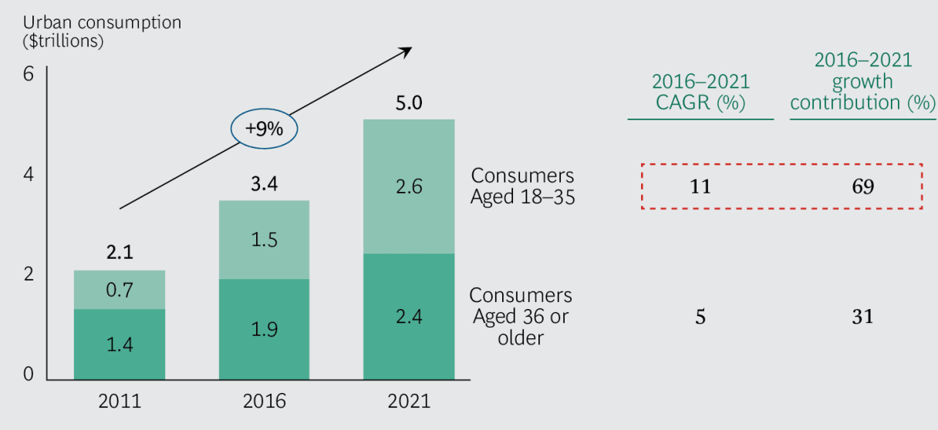
Figure 1. The estimation of the number of upper-middle-class in China (Left); The consumption rates of young consumers (Right) (BCG, 2018)

Technological
The domestic electronics industry chain is getting mature with a more integrated supply chain and production network. The materials needed for production can basically be supplied in time instead of relying on imports. Hence, drones' manufactures can produce at a relatively lower cost thorough, realizing economies of scale. Moreover, the advances in the three-dimensional environment perception, advanced flight assistance system enhance the UAV's automatic obstacle avoidance ability and makes it easier to control (Bloomberg, 2020).
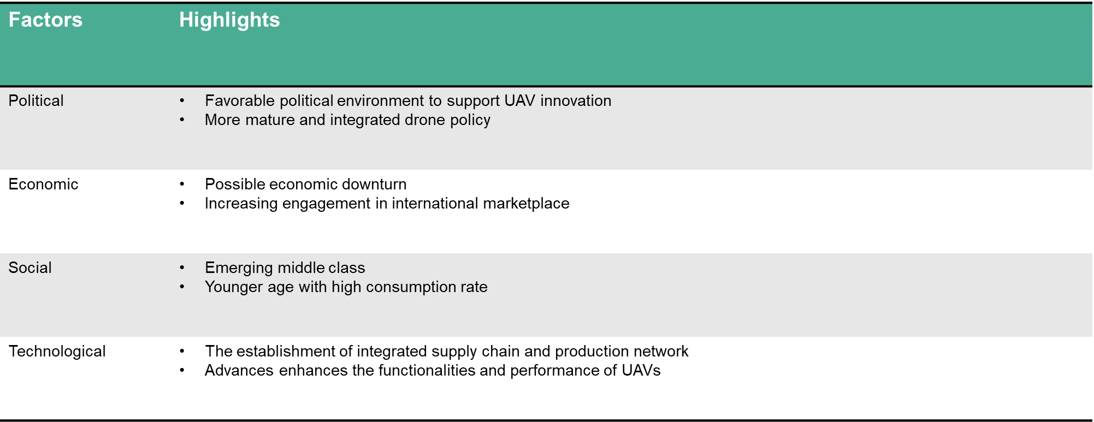
Figure 2. PEST Highlights

Micro-environment Analysis-Porter's Five Forces

Bargaining power of the Supplier
In the distribution of the entire drone industry, only a small number of companies in the domestic market have a complete production chain. DJI is in the industry leader position in the industry. From the perspective of the current domestic drone industry chain distribution, DJI mainly focuses on the research and development of gimbals, cameras, and video transmission systems. In terms of other accessories, DJI procures from suppliers. DJI have stronger bargaining power against suppliers, which is manifested in the following aspects: Among DJI suppliers, well-known suppliers include Qualcomm, Intel, Samsung, Texas Instruments, etc., and lens manufacturers GoPro, Parrot, Hasselblad, etc. (Nikkei Asian Review, 2020) DJI can actively choose its cooperators due to its strong market position and great reputation. Moreover, most of the similar suppliers are currently in a competitive relationship, and they are not likely to realize backward integration. DJI's current position at the leading position of the industry, and suppliers often actively seek to cooperate with DJI for cooperation.

Bargaining power of suppliers
From the consumer drone market, ordinary buyers do not have much bargaining power. Consumers purchase drones through online or offline channels, and the prices are uniform. Although the conversion cost between different drone brands is almost zero, consumers are less willing to switch because of DJI's industry-leading position and premium quality.

Threats of Substitutes
From the perspective of the consumer drone market, the current consumer drone product market is in the growth phase. The products are mainly aerial drones. In the past, aerial photography required a cameraman to shoot on the aircraft, which was expensive. The advent of aerial drones has changed this situation. At present, there are no alternative products for the aerial drone.

Threats of entrants
From the current distribution of companies in the drone market in China, it can be seen that the consumer-grade drone market DJI has an absolute advantage, and this advantage has formed high industry barriers, such as extensive initial setup capital, and technological know-how in producing drones.

Existing Competitions
In China's consumer drone market, DJI has a clear competitive advantage and is in a leading position in the industry. Its aerial drone market share in China exceeds 70% (Business Wire, 2019). At the same time, most DJI competitors focus on specific market segments such as software market or low-end markets. DJI has a diverse portfolio that covers a wide range of markets, and it has competed in both software and hardware markets, which has undoubtedly improved its overall competitiveness (Business Wire, 2019).
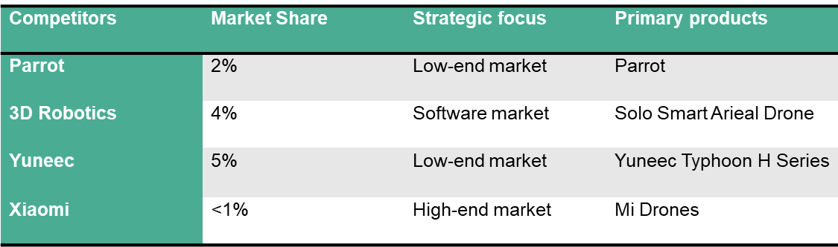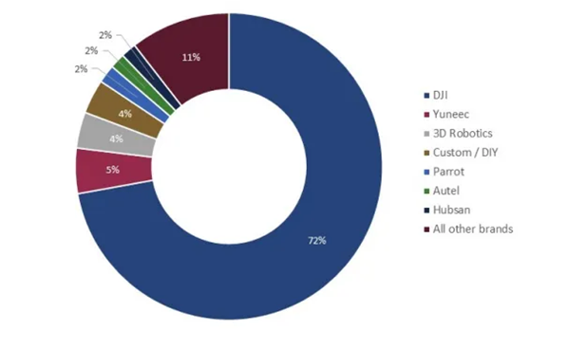
Figure 3. Primary competitors of DJI (Left); Market Share (Right) (Business Wire, 2019)

Internal Analysis
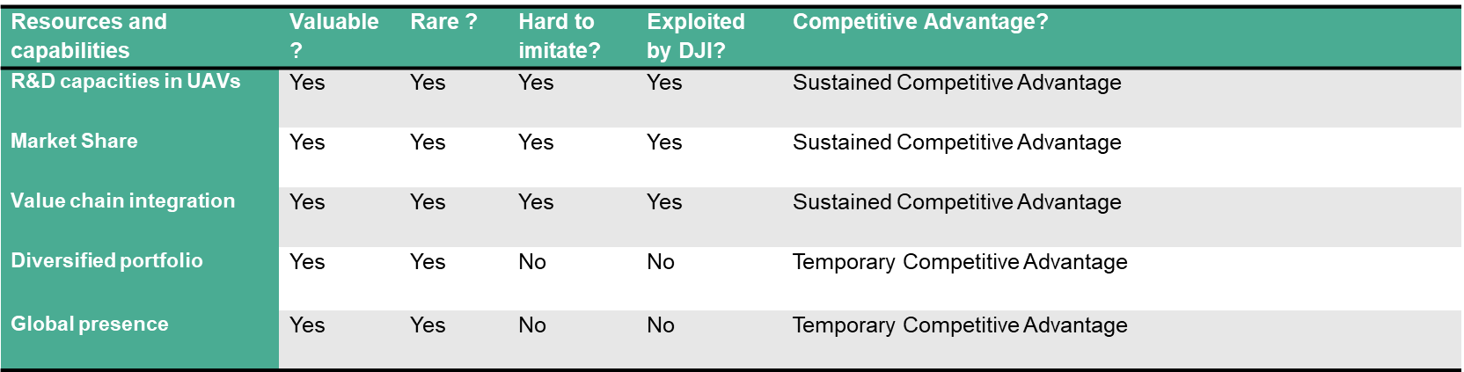
Figure 4. VRIO Analysis
The VRIO model indicates sustained competitive advantage of an organization stems from resources or capabilities that are valuable, rare, hard to imitate, and exploited by the organization. The internal scanning over DJI's resources and capabilities indicates one essential source of sustained competitive advantage of DJI comes from its strong R&D capabilities in commercial UAVs and other related products (MarketLine, 2018). As a modern technology company, DJI has set its corporate philosophy as innovation (DJI, 2019a). Meanwhile, the high market share has also been exploited by DJI to roll out new series and seek cross-industry cooperation with other business partners such as Hasselblad to create value-added offerings (Bloomberg, 2020). Through engagement in different aspects of the value chain, DJI realized value chain integration, so that it tightly controls the essential knowledge about manufacturing and distribution (Avionics International, 2020). Although a diversified portfolio and global presence are valuable and rare, but it can be easily imitated with capital investment.

2.4 SWOT Analysis

Strengths
- Outstanding R & D and design capabilities: DJI was the earliest engaged in the research and development of flight control technology, and has obvious technical advantages in tripod head and image transmission. At present, DJI has begun to develop in the field of intelligent flight, including computer vision, machine learning, and other technologies. More than a quarter of DJI employees have their work related to R&D (Digital Innovation and Transformation, 2020). Besides R&D center in Shenzhen, DJI also established R&D centers in other places such as silicon valley to exploit the global talents in developing cutting-edge technologies continuously (The Verge, 2020).
- The engagement of each node of the value chain: unlike other high-tech enterprise who only focus on R&D, DJI’s presence can be found in also manufacturing, sales, maintenance, logistics. DJI only outsource the manufacturing of some unimportant parts to other companies. On the one hand, such a business model can enable all links from research and development to after-sales to have higher autonomy, improve feedback efficiency, and obtain greater profit margin (CKGSB Knowledge, 2017). On the other hand, the business model enables DJI to meet the consumer demands and respond to the changing environment timely. This is very important as the target customer of the unmanned drones is quite niche.
- High brand value and market share: a survey conducted by Business Wire (2019) indicates that more than 90% of consumers knew about DJI or its products. The market share of DJI in the global drone market reached an astonishing 70%. The market shar is even higher in the domestic market, as there are less competitors.
Weaknesses
- High pricing: Due to technological leadership and the high brand value accumulated over the years, DJI has been adopting the skimming pricing model. However, major competitors such as Parrot and others started a price war in an effort to gain more advantages at price, especially in the mid-end market (Business Wire, 2019). Therefore, in the long run, DJI Innovations will lose part of its market due to its excessive pricing.
- Loose Management: DJI has been suffered from internal corruption, and it was expected to lose more than 1 billion yuan, and the number of management involved is 45 (DJI, 2019b). DJI Innovations is an R & D-focused enterprise, and the management is also a large proportion of R & D personnel. The management's focus on R&D is extremely open to lower-level authorization, which leads to a less professional management approach. Meanwhile, the rapid growth and high-end positioning of DJI indicates the huge profit margin in all nodes of value chain, but it is evidently that DJI lacks a strong and effective monitor and control system (The Verge, 2020).

Opportunities
- A positive outlook on the drone industry
The fourth industrial revolution in the world, which is dominated by artificial intelligence, robot technology, clean green energy, and the Internet of Things, has impacted industry across of life. The UAV, and technological advances that combined a series of technologies, is regarded as the representative of industrial 4.0 (Business Wire, 2019). Countries around the world has shown their ambition in entering this market. Meanwhile, as the application scenarios of drones has been continuously explored and widened into areas such as logistics (Amazon Air), agriculture, etc. the demand for drones in industrial application is estimated to increase significantly.
- Emerging middle-class consumers
It is expected that by 2022, more than 54% of the total consumption in China will be contributed by middle class (Di, 2018). The middle class is more willing to pay for their favorite products, but also shows a preference for consumer electronics. As the application scenarios of drones become more and more extensive, the rise of the middle class will bring huge opportunities for the future drone market.
- Strategic alliances
DJI has managed to forge strategic alliances with parnters from other industries to explore the new application senarios of its products. In November 2016, DJI partnered with JW Marriott Hotel & Resorts to launch the Drone Experience Program (DJI, 2016). It allows the hotel guests to view the JW Marriott's properties through a new perspective and also allows them to capture and share these experiences with friends and family. Through this partnership, the company could widen its opportunities by exploring its technologies with the partnered hotel. More cross-industry strategic alliances can provide more unprobed opportunities for DJI in the future, and expand the application scenarios of its products.
- Technological advancements
Due to the development of emerging technologies such as machine learning, face recognition, and remote sensing detection, consumers can quickly get started with drone software through simplified drone software, which is more conducive to the application of drone products and expands the audience (Business Wire, 2019).

Threats
- Security and privacy issues
The disorderly or even illegal use of drones, frequent safety problems, and the hidden dangers of privacy infringement have aroused strong concern in the international community and brought great importance to society and civil aviation (CNN, 2019). The increase in no-fly zones and the regulations on consumers to use to drones have hit consumers' desire to buy, and have brought unprecedented pressure on the drone industry (Digital Innovation and Transformation, 2020).
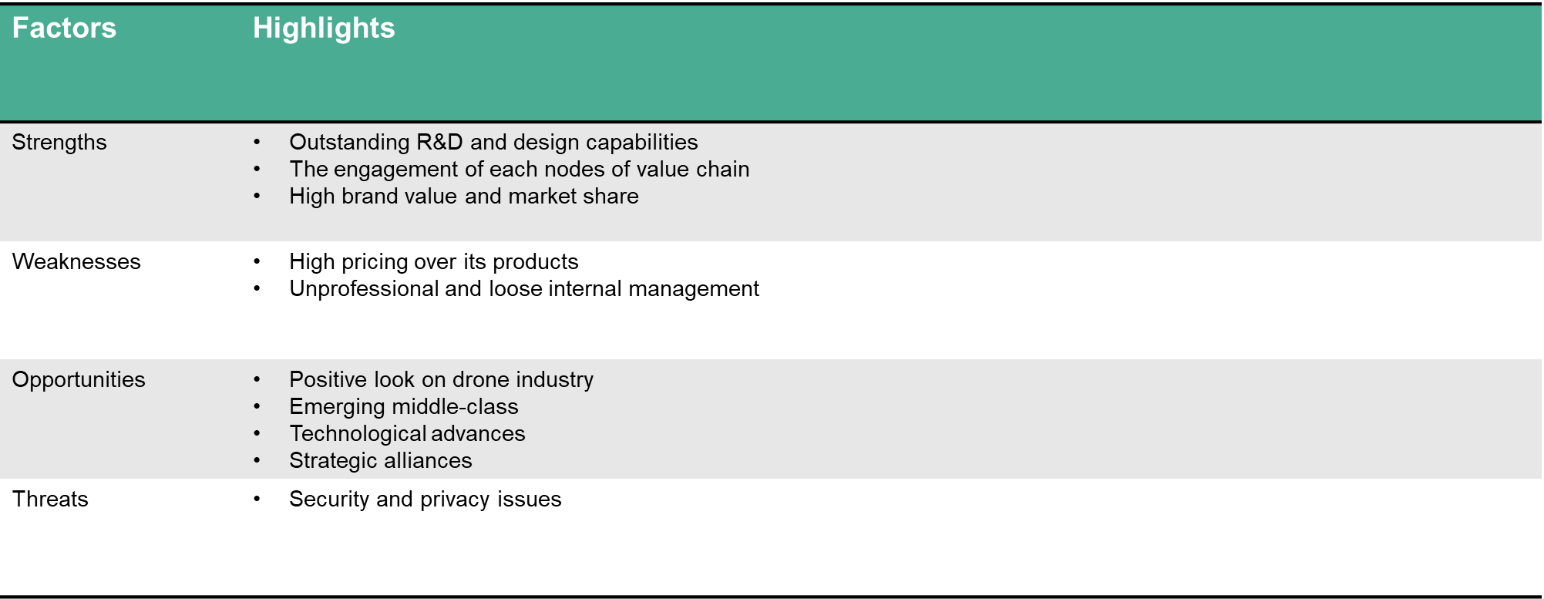
Figure 5. SWOT Highlights

Marketing Objectives of DJI
The formulation of DJI’s marketing objective will be based on the aforementioned analysis. SMART principles, standing for specific, measurable, achievable, realistic, and timed, provides an good guiding principle in setting marketing objectives.
DJI Innovation faces the following dilemmas: 1. DJI's main sales come from offline stores, with higher operating costs; online stores have low traffic and conversion rates, and online sales urgently need to increase; 2. The market is mainly concentrated in Beijing and Shanghai, the popularity and sales volume of other secondary markets are not high and need to be developed.
Based on the above issues, DJI's marketing goals will be: 1. Increase the conversion rate and ROI of online stores by 50% and increase the sales of online channel products. 2. Raise DJI's brand awareness and recognition in the drone market nationwide, and achieve a 15% year-on-year increase in sales.

Market Segmentation, Targeting, and Positioning

Segmentation
The marketing segmentation is performed based on the investigation of the drone consumer market. according to the different variables such as geographical, demographical, psychographic and behavioral variables, the consumer market of DJI products can be divided into different segments. The consumer market segmentation can help DJI to found the most suitable and profitable segments. The consumer market of DJI is subdivide into different segments according the variables including geographical location, gender, age, hobbies, and wiliness to pay.
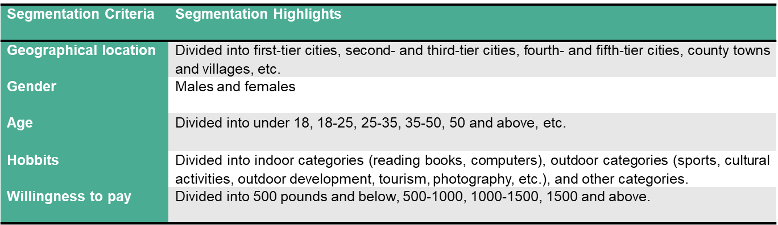
Figure 6. Market segmentation

Targeting
The target market is that DJI selects the segment with a high degree of matching with its products as the target market according to its actual situation so that the product can better meet the customers and match the needs of the customers, thereby exerting the greater advantages of the products And features. According to DJI's marketing objectives, select the target market as follows:
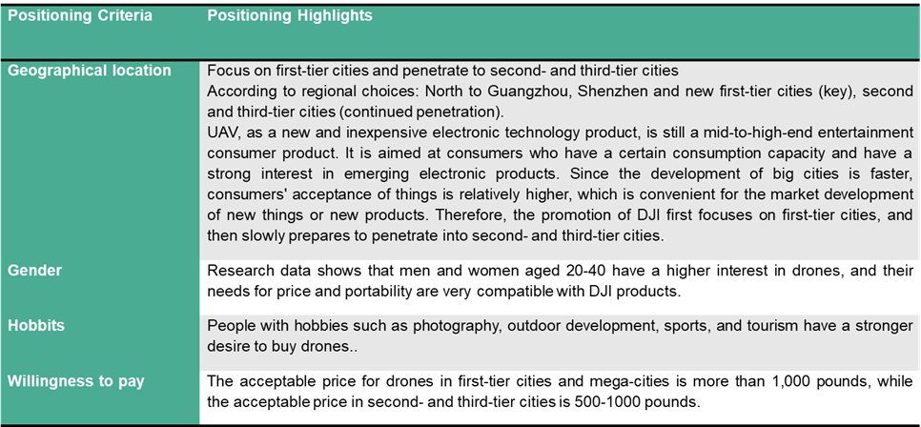
Figure 7. Market Targeting

Positioning
Market positioning is the perception or awareness that DJI wants to deliver so that DJI can distinguish its products and brand images from its competitors. Therefore, DJI will strongly emphasize its superior product quality and product performance, as well as its unique shape design. In terms of market positioning, DJI should emphasize its market-leading position to attract consumers.

Marketing Strategy Formulation

Product
Implementing a product differentiation strategy will help DJI improve its competitive advantage, increase industry barriers, and ensure better market share while ensuring market share. Specifically, DJI should provide mid-range drone series with more affordable prices for consumers in second- and third-tier cities. DJI should actively deploy drones in the industry in the future, produce more different types of drones, and develop related products. By expanding the product portfolio strategy, DJI can expand the scale of the enterprise, increase the total sales, and enrich its product system to better meet the different needs of market consumers. At the same time, DJI's existing product line is mainly aimed at male consumers. DJI can create lighter and more aesthetic products for female consumers.

Price
DJI's current gross profit margin is as high as 48%. According to the price demand elasticity curve, overpriced products affect most consumers' purchase demand. DJI's previous skimming pricing strategy failed to attract middle-class consumers in second- and third-tier cities. DJI's competitors are targeting this huge market. Therefore, DJI needs to lower the price of the previously launched product series and introduce a cheaper version that more appeals to consumers in the middle class and second- and third-tier cities.

Place
DJI should use a combination of online and offline channel diversification strategies. Online distribution can be realized through DJI official mall, major e-commerce platforms in China such as Tmall, JD; offline distribution can be realized through flagship stores, authorized agents, authorized experience stores, and experience areas. In addition, in order to expand DJI's online presence, DJI can seek cooperation with its strategic alliances, such as Hasselblad, Apple, Fuji, to use their online channels for joint marketing.

Promotion
DJI can hold product launches worldwide. This is the method commonly used by technology companies. At product launches, DJI can introduce media, photographers, and extreme sports hobbies to the launch site to introduce DJI product usage scenarios. These consumers from different industries make the audience feel genuine and credible, especially consumers in the same industry, it is easier to trust each other and then transfer to trust in the DJI. At the same time, DJI can invite professional media or key opinion leaders to evaluate products and use their influence on the Internet to market themselves. At the same time, DJI can hold drone photography enthusiast activities. The proportion of photography enthusiasts in the drone consumer group is very large, and most of the active objects are users of DJI products. DJI can collect purchaser information, and hold photography events to make customers more familiar with DJI products and increase customer stickiness to DJI products.

Process:
The good process management will balance the demand and supply to ensure the services are produced and provided at the same time. Hence, it is necessary for DJi to establish its internal information system and business intelligence center to capture real-time data about sales volume, sales location, etc. The intelligent system will allow DJI to check the in-store inventory in real time and make up for the produtcs that are not in stock to ensure that customers can get products on the spot within the order. For customers who order online, DJI should cooperate with well-known domestic logistics providers to provide the fastest and high-quality logistics and after-sales service.

People:
People, especially frontline employees, can completely influence customers' perceptions of DJI’s image and significantly impact customers’ purchase experience. DJI should deploy employees with an in-depth understanding of DJI products and employees with sale experience in their flagstone to answer general inquires of potential customers and provide professional and premium services for them.

Physical evidence:
The tangible display of services includes the service environment, location, and any tangible performance used for service communication. DJI can present the photos taken by its previous employees by using DJI products, DJI should also set up experiential zooms within their flag stores to provide hands-on experiences for potential customers.

Strategy Implementation
DJI first needs to establish a perfect marketing organization, including marketing strategic planning department, business support department, after-sales service department and set up regional business departments based on each region. DJI should be guided by marketing objectives, and organize various powerful resources to be transmitted to the regional business departments. Secondly, DJI should strengthen coordination and cooperation among various departments within the company and enhance communication awareness at the business level. Regularly or irregularly hold inter-departmental and intra-departmental business seminars, discover problems encountered in the implementation of marketing plans, and discuss solutions to problems.
DJI's finance department is responsible for marketing budgeting, which includes assumptions about budgeting, coordinating the budgets of various departments, comparison with the company's goals and the revision of the budget; in addition, DJI's senior management personnel, such as the general manager of the sales company and the general manager of the financial control department, should evaluate and approve the marketing budget. Before making the final approval of the marketing budget, executives need to check the total budget in order to ensure the enforceability of the marketing budget. For example, it is necessary to check whether the finance department can provide corresponding resources to ensure that the marketing plan is implemented.
Besides, for many customers, the quality of the salesperson's service directly affects the consumer's purchase intention, and for the enterprise, the salesperson represents the image of the enterprise (Kristensson et al., 2016). The service level of sales personnel is directly related to the performance of the company, so the training and management of sales personnel are of great significance to the enterprise. According to DJI's marketing plan, DJI will need to add flagship stores and online distribution channels. DJI needs to recruit more sales staff and assign them to supplementary outlets in various cities and in charge of customer services of online stores. Hence, DJI should organize sales staff to conduct training to improve the sales ability of store staff, the manager's management ability, and the ability of business personnel to connect with dealers. DJI should also regularly conduct employee drone knowledge training so that they can better understand the company's products.

Evaluation and control

7.1 Marketing Evaluation
Many problems will arise during the implementation of the marketing plan. DJI must constantly monitor and control various marketing activities so that the established marketing goals can be successfully achieved. DJI can use five tools to evaluate and monitor the execution of marketing plans.
- Sales analysis measures and evaluates actual sales based on sales goals. Sales analysis Through the establishment of a complete system of the sales reporting system, monthly and effective analysis of the completion of sales goals, such as regional business department sales completion, including sales targets, profit targets and market activity completion, etc.
- Market share analysis is to show DJI performs against its competitors. Market share includes total market share and relative market share. DJI can calculate the market share of the Volkswagen brand every month based on the completed sales data and the total market sales, and compare and analyze it with competitors and the same period in previous years
- The market-based scorecard, which records: new customers, dissatisfied customers, lost customers, target market perceptions, target market preferences, related product quality, and Related service quality. Standards are established for each item based on marketing objectives and historical performance. If current results deviate from the standard, corrective measures such as more intensive advertising campaigns should be taken.

7.2 Risk Control
It is particularly important for DJI to implement controls at a strategic level when the market and environment are both changing. The control process provides feedback information for the future planning process. DJI's marketing strategy department continuously analyzes the overall market, always paying attention to the sources that may pose the greatest threat, especially the emergence of new products and technologies and the emergence of new entrants. DJI needs to constantly review its overall strategy and implementation status to adjust its marketing strategy timely to respond to any market changes.
The risk of revenue loss caused by an underestimated sales volume of an enterprise is called sales risk (Tomczak, Reinecke and Kuss, 2018). The causes of sales risk mainly come from changes in demand, supply chain structure, and unexpected changes in the competitive environment. Because all DJI's financial data predictions are based on target sales and previous years' performance, if the sales volume of the final product fails to reach the profit balance point, it will make the company's marketing plan completely fail, and the company will face losses. In response to the above risks, DJI mainly reduces its risks in two ways: First, it strengthens its own market position and strengthens its brand promotion to ensure the company's stable market share in the industry. Secondly, DJI to actively expand new product markets and use its diversified portfolio to hedge unpredicted risks.

Conclusion
Based on the critical investigation on the external environment of DJI through PEST on macro level and Porter's five forces, as well as the scanning on the internal environment through VRIO and SWOT, the report is able to develop marketing objectives for DJI. The primary objectives of DJI are to increase both online and offline sales (especially offline), as well as raise brand awareness. In order to realize the marking objectives, an integrated marketing plan based on 7P is developed. Meanwhile, issues concerning plan implementation, performance monitor, and risk control are also discussed at the end of the report.

Reference List
Avionics International (2020) Will Open-Source Development Help the Drone Industry Fight Back Against DJI? -. Available at: https://www.aviationtoday.com/2020/05/05/will-open-source-development-help-drone-industry-fight-back-dji/ (Accessed: 12 May 2020).
BCG (2018) Five Profiles That Explain China’s Consumer Economy Localized Page Metadata. Available at: https://www.bcg.com/publications/2017/globalization-accelerating-growth-consumer-products-five-profiles-that-explain-chinas-consumer-economy.aspx (Accessed: 6 May 2020).
Bloomberg (2020) DJI’s Drone Supremacy Comes At a Price . Available at: https://www.bloomberg.com/news/features/2020-03-26/dji-s-drone-supremacy-comes-at-a-price (Accessed: 6 May 2020).
Business Wire (2019) China Drone Market Report 2019: Market will Grow from $14 Billion in 2018 to Over $43 Billion in 2024 at a CAGR of 20.5% . Available at: https://www.businesswire.com/news/home/20191101005200/en/China-Drone-Market-Report-2019-Market-Grow (Accessed: 6 May 2020).
CKGSB Knowledge (2017) The DJI Business Model: Industrialize and Diversify. Available at: https://knowledge.ckgsb.edu.cn/2017/07/24/technology/drone-maker-dji-innovation-business-model/ (Accessed: 6 May 2020).
CNN (2019) DHS warns of ‘strong concerns’ that Chinese-made drones are stealing data . Available at: https://edition.cnn.com/2019/05/20/politics/dhs-chinese-drone-warning/index.html (Accessed: 6 May 2020).
Di, Z. (2018) Consumption Patterns of the Middle Class in Contemporary China. World Scientific.
Digital Innovation and Transformation (2020) DJI: Winning in consumer drones . Available at: https://digital.hbs.edu/platform-digit/submission/dji-winning-in-consumer-drones/ (Accessed: 6 May 2020).
DJI (2016) DJI and JW Marriott Hotels & Resorts Partner To Launch Drone Experience Program. Available at: https://www.dji.com/newsroom/news/dji-and-jw-marriott-hotels-resorts-partner-to-launch-drone-experience-program (Accessed: 6 May 2020).
DJI (2019a) DJI – About Us. Available at: https://www.dji.com/dk/company (Accessed: 6 May 2020).
DJI (2019b) New Statement on Employee Fraud Investigation. Available at: https://www.dji.com/newsroom/news/new-statement-on-employee-fraud-investigation (Accessed: 6 May 2020).
Financial Times (2020) Chinese economy . Available at: https://www.ft.com/chinese-economy (Accessed: 6 May 2020).
Hovhannisyan, T., Efendyan, P. and Vardanyan, M. (2018) ‘Creation of a digital model of fields with application of DJI phantom 3 drone and the opportunities of its utilization in agriculture’, Annals of Agrarian Science. Elsevier, 16(2), pp. 177–180.

Kristensson, P. et al. (2016) ‘Linking service design to value creation and service research’, Journal of Service Management. Emerald Group Publishing Limited, 27(1), pp. 21–29.
Lardy, N. R. (2016) ‘China: Toward a consumption-driven growth path’, in Seeking Changes: The Economic Development in Contemporary China. World Scientific, pp. 85–111.
Li, L. (2018) ‘China’s manufacturing locus in 2025: With a comparison of "Made-in-China 2025" and "Industry 4.0"’, Technological Forecasting and Social Change. Elsevier, 135, pp. 66–74.
MarketLine (2018) Commercial Drones: Numerous Industries to be Transformed by Unmanned Flight . Available at: https://store.marketline.com/report/ml00028-019--commercial-drones-numerous-industries-to-be-transformed-by-unmanned-flight/ (Accessed: 12 May 2020).
Nikkei Asian Review (2020) Chinese drone maker DJI gears up for global expansion . Available at: https://asia.nikkei.com/Business/Startups/Chinese-drone-maker-DJI-gears-up-for-global-expansion (Accessed: 6 May 2020).
Smith, P. R. (2011) ‘The SOSTAC(R) Guide to Writing the Perfect Marketing Plan’, PR Smith.
The Verge (2020) Go read this Businessweek story about the downsides of DJI’s drone dominance . Available at: https://www.theverge.com/2020/3/30/21199842/bloomberg-businessweek-dji-drone-market-share-china-government-security (Accessed: 6 May 2020).
The World Bank (2020) China Overview. Available at: https://www.worldbank.org/en/country/china/overview (Accessed: 6 May 2020).
Tomczak, T., Reinecke, S. and Kuss, A. (2018) ‘Marketing Implementation and Management Control’, in Strategic Marketing. Springer, pp. 223–244.
Zhang, J. (2019) Driving toward Modernity: Cars and the Lives of the Middle Class in Contemporary China. Cornell University Press.

