DATA HANDLING AND BUSINESS INTELLIGENCE
BA Hons BUSINESS AND MANAGEMENT
LCBB5000
GABRIELE CERTINI
2018242

Lecture: Dr. Anupam Mazumdar

Task 1: EXCEL
As a Data Analyst, I perform a few functions to analyze the big data on hotel reservations. Below are screenshots of how I performed the functions.
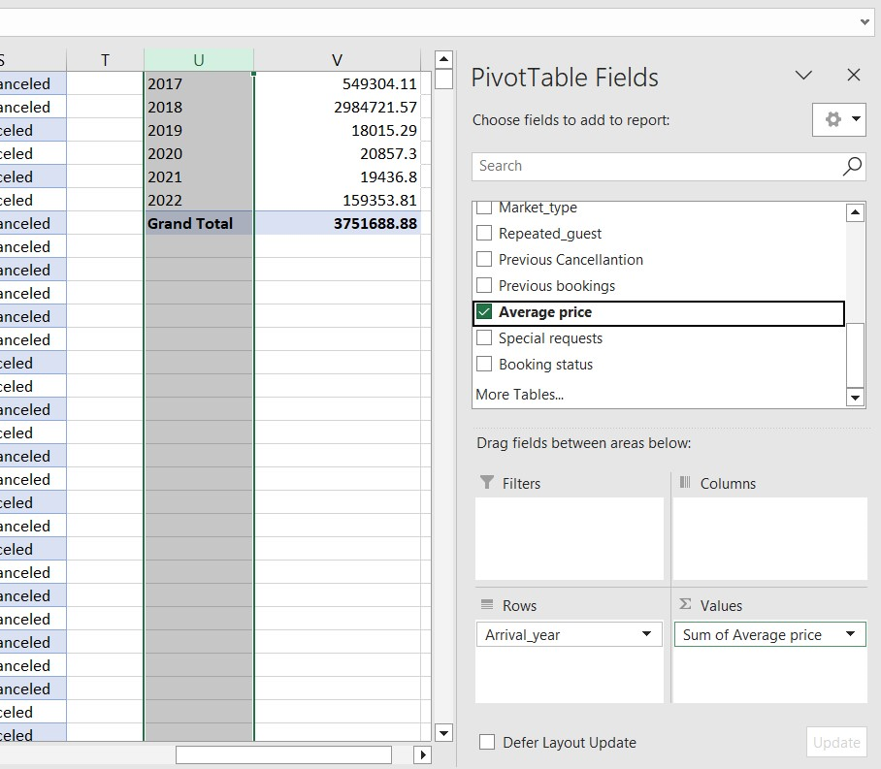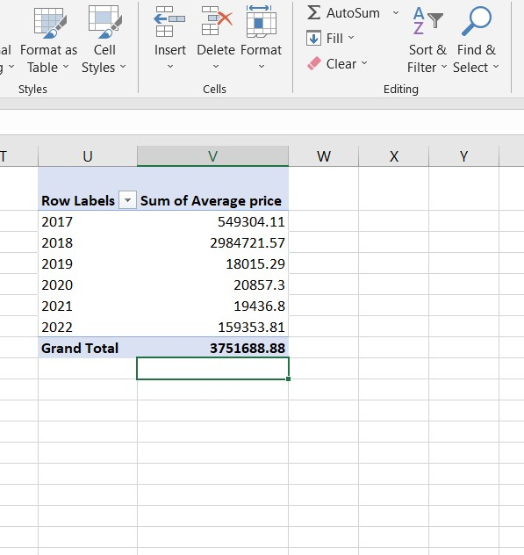
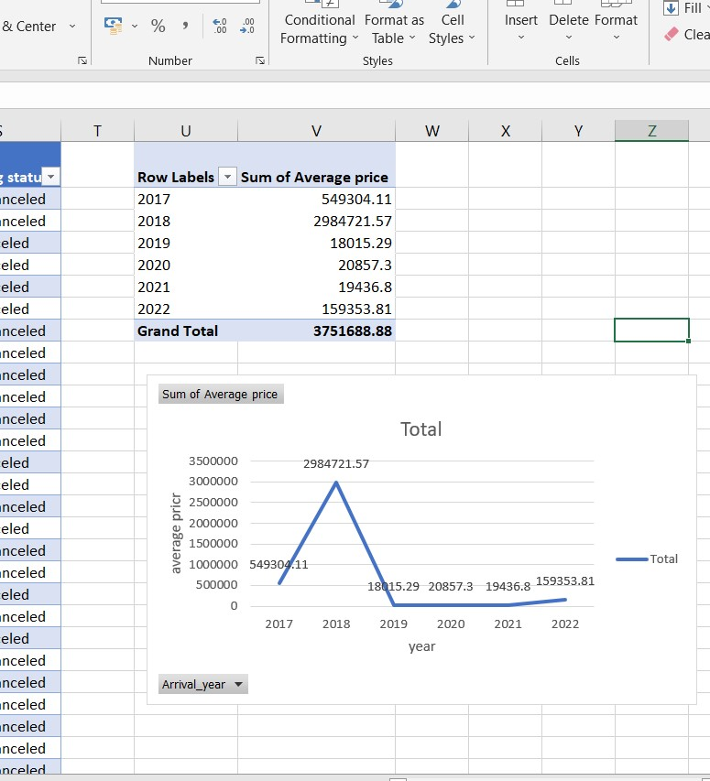

To perform the pivot table function we first select the entire database including headers and then go to the insert tab and click on the pivot table, In the PivotTable Field List we will then drag Year to the Rows area and " Average Price" to the Values area. Set the value field settings to show the average. This will further create a pivot table summarizing the average room reservation price for each year. The result of the summary table looks like the below table.
Next in order to visualize the data based on the pivot table we will first select the pivot table to create the chart and will go to the insert tab and choose a suitable chart here we have selected the line chart and get the result shown below. We can also customize the title, X Axis, Y axis labels and legends according to our preference.
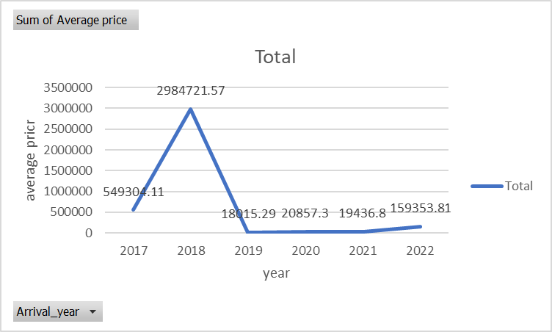

Task 2 SPSS
- How many students are male and female?
Gender
 |  | Frequency | Percent | Valid Percent | Cumulative Percent
Valid | male | 1056 | 49.5 | 49.5 | 49.5
Valid | female | 1077 | 50.5 | 50.5 | 100.0
Valid | Total | 2133 | 100.0 | 100.0

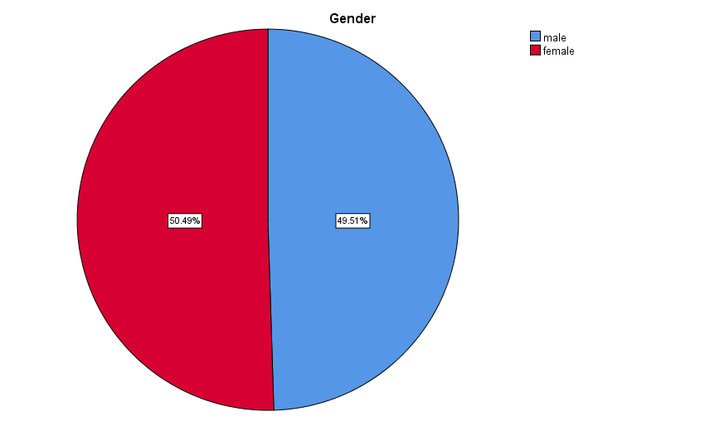
According to the chart above around 49.51% students are male that in number means 1,056 students are male out of 2,133 students and the rest 49.51% of the students are female that in number means there are 1,077 female students.
To find this we select the gender column using SPSS and then go to analyze, then you further go to descriptive statistics and select frequencies from there and select gender as variables and choose the option chart and click on continue and we will get the above results.
- How many student qualifies and does not qualify for reduced/free lunch?
Lunch
 |  | Frequency | Percent | Valid Percent | Cumulative Percent
Valid | qualified | 1215 | 57.0 | 57.0 | 57.0
Valid | not qualified | 918 | 43.0 | 43.0 | 100.0
Valid | Total | 2133 | 100.0 | 100.0

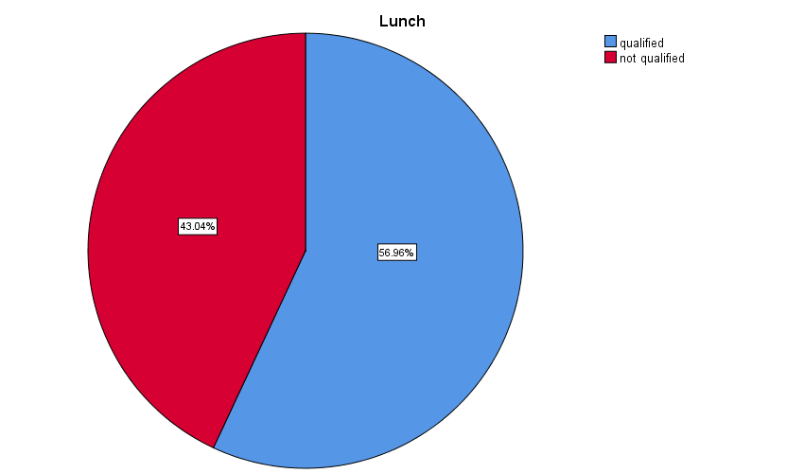
According to the chart above out of 2,133 students only 1,215 students are qualified for reduced/free lunch whereas 918 students are not qualified for the same.
To find this out we first select the column lunch and then will go to analyze from analyze will go to descriptive statistics and select frequencies and a dialogue box will appear from there we select lunch as variables and select the chart option and click on continue.
- What are the mean and median of students who qualify and do not qualify for reduced/free lunch?
Statistics
Lunch
N | Valid | 2133
N | Missing | 0
Mean |  | .43
Median |  | .00

The mean of students who qualify and does not qualify for reduced/free lunch is .43 and the median of students for the same is .00 as per the table above.
To get the mean and median, we click on analyze and then select descriptive statistics from there select frequencies after which a dialogue box will appear, we select lunch as a desired variable from which we wish to calculate the mean and the median and then press continue and click OK to get the above result.
- What are the mean and median differences of student's pre-test and post-test scores?
Statistics
Pretest
N | Valid | 2133
N | Missing | 0
Mean |  | 54.96
Median |  | 56.00

Statistics
Posttest
N | Valid | 2133
N | Missing | 0
Mean |  | 67.10
Median |  | 68.00

To find out the mean and median differences between student's pre-test and post-test scores we will first calculate the mean and median individually. First, we will get the mean and median of the pre-test. And to find this out we will first click on analyze and then select descriptive statistics from their select frequencies after which a dialogue box will appear, we select pre-test as a desired variable from which we wish to calculate the mean and the median and then press continue and click OK to get the above result.
After we get the mean and median of the pre-test, we will find out the mean and median if the post-test. To find this out we will first click on analyze and then select descriptive statistics from their select frequencies after which a dialogue box will appear, we select post-test as a desired variable from which we wish to calculate the mean and the median and then press continue and click OK to get the above result.
The difference between the mean of the pre-test and post-test is 12.14 whereas the difference between the median of the pre-test and post-test is 12.
- Using the dataset Student_Score.csv provided in conjunction with SPSS, give a specific example of Clustering (ex. K-Means Clustering). Show your workings with screenshots and clearly explain your results.
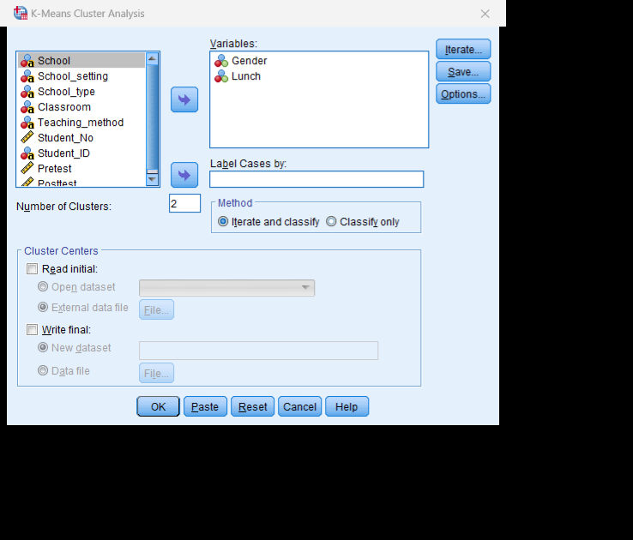
To perform K- mean cluster analysis we first select the analyze from there we select classify and choose K-mean cluster after which a dialogue box will appear there, we will select the variable we want the K-mean cluster to perform its operation here we have selected Gender and Lunch as are desired variables now after selecting it we will click on the OK option.
The result came up as initial cluster centers, iteration history, number of cases in each cluster and final cluster centers.
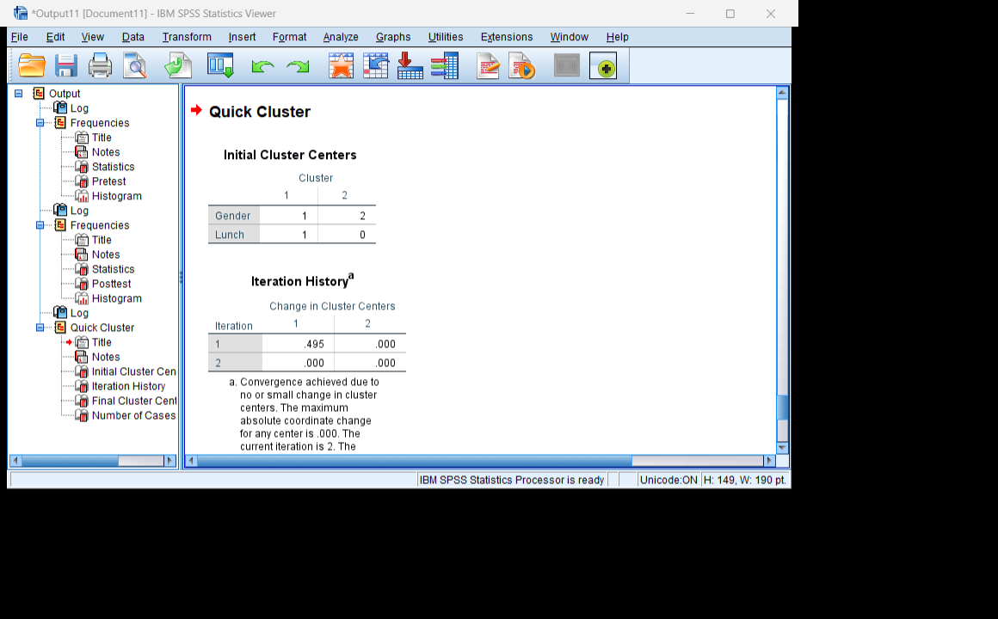

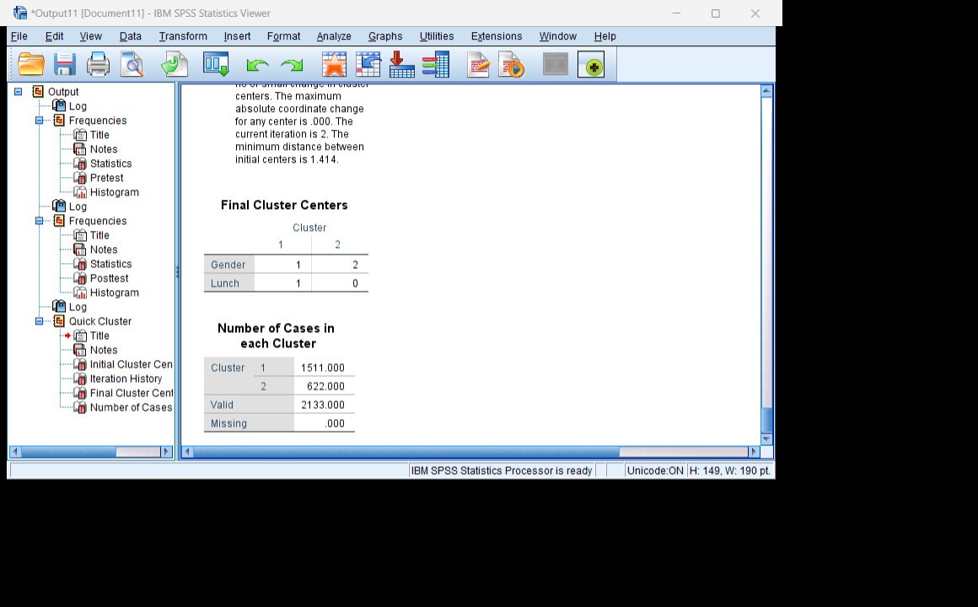

Iteration Historyª
Iteration | Change in Cluster Centers
Iteration | 1 | 2
1 | .495 | .000
2 | .000 | .000
a. Convergence achieved due to no or small change in cluster centers. The maximum absolute coordinate change for any center is .000. The current iteration is 2. The minimum distance between initial centers is 1.414.

Final Cluster Centers
 | Cluster
 | 1 | 2
Gender | 1 | 2
Lunch | 1 | 0

- With real-world (practical) examples, explain minimum 5 most common data mining and text mining methods for each that can be used in the contemporary business.
The 5 most common data mining and text mining methods that can be used in contemporary business are clustering, classification, named entity recognition, text summarization and association rule mining.
Clustering generally groups similar data together without predefined labels it can be used to identify behaviour or patterns (Allahyari et al.,2017). Above we have used K-means clustering which is a very popular AI or ML algorithm to cluster or group the dataset based on similarity.
Classification generally categorizes the data into different labels that are already predefined based on their features. It can be helpful for businesses to recognize patterns and make decisions based on them, it can also help them to manage the risk and filter according to their preference.
Named entity recognition helps identify the data, and names and ease the extraction of data or information especially when a business has huge data to deal with (Team, 2017).
Text summarization summarizes the text and helps businesses to Organize the content In different categories and helps them to deal with huge chunks of data and increase effectiveness (Crangle,2002). It also helps to get insights from the body as it conveys meaning to the text by summarizing the data and making it or converting it into a piece of useful information.
Association rule mining is the method that helps businesses identify hidden relationships between items in the data (Patel et al.,2018). It also helps to analyze the behaviour by knowing the frequency or occurrence of the data or item. It is a very helpful method when a business wants to make any strategic decision and needs guidance based on the available information.
- Discuss the advantages and disadvantages of using SPSS and Excel using relevant practical examples and present your discussions in a table.
Excel | SPSS
Excel is a spreadsheet editor. | SPSS is a statistical software suite
ADVANTAGES  - Excel is easy to perform calculations all you need is to apply in-build formulas provided in Excel.  - It is also easy to create data visualizations with a variety of charts available.  - It is easy to understand and makes the process easy to work with data as we can modify the data according to need. | ADVANTAGES  - SPSS helps to perform complex calculations and analytics (EDUCBA, 2019).  - It is easy to perform statistics because the software has built-in functions and add-in tools for data analysis.  - It provides detailed charts and graphs and in case any value is missing we can still get accurate results.
DISADVANTAGES | DISADVANTAGES
- In Excel it is hard to perform complex calculations and analytics.  - It does not provide detailed charts and graphs.  - it shows error or inaccurate results if any value is missing.  - Excel cannot help business to make quick decisions. | - SPSS cannot be used to analyze big or huge data sets.  - SPSS is a paid resource and it can be costly for people to use.  - It provides limited graphs and it does not allow customization as well.  - It is hard for beginners to learn how to use SPSS and requires training which is time consuming.

Reference
EDUCBA. (2019). What is SPSS? | Features, Types, and Statistical Methods Of SPSS. [online] Available at: https://www.educba.com/what-is-spss/# [Accessed 19 Aug. 2023].
Allahyari, M., Pouriyeh, S., Assefi, M., Safaei, S., Trippe, E., Gutierrez, J. and Kochut, K. (2017). A Brief Survey of Text Mining: Classification, Clustering and Extraction Techniques. KDD Bigdas, [online] 13. Available at: https://arxiv.org/pdf/1707.02919.pdf.
Team, Expert. ai (2017). Text Mining Alorithms: Examining Two Main Techniques. [online] expert.ai. Available at: https://www.expert.ai/blog/text-mining-algorithms/# [Accessed 19 Aug. 2023].
Crangle, C.E. (2002). Text Summarization in Data Mining. [online] ResearchGate. Available at: https://www.researchgate.net/publication/# [Accessed 19 Aug. 2023].
Patel, B., Bhemwala, V.H. and Patel, A. (2018). Analytical Study of Association Rule Mining Methods in Data Mining. [online] ResearchGate. Available at: https://www.researchgate.net/publication/329562766_Analytical_Study_of_Association_Rule_Mining_Methods_in_Data_Mining# [Accessed 19 Aug. 2023].

‌

‌

