
APPENDIX GA36b

LEVEL 5 ASSESSMENT SPECIFICATION
Student name: |  | Student ID number:
Programme: | BA Leadership and Management Skills for the Workplace
Module: | Workplace Culture and its Impact on Organisational Efficiency
Module code: | BMSW5105 | Contribution to Overall Module Assessment (%): | 100%
Module Coordinator: | Dr Oluwaseun (Olu) Adegbite | Internal Verifier: | Dr Sujeewa Herath
Assignment Title: | Component 1  Individual Written Report & Oral Performance | Word count (or equivalent): | Task 1: 3,000  words (+/- 10%)  Task 2: 5-10 min Oral Performance
Submission deadline: | Task 1: Submission on Turnitin 10th November 2023, 2PM  Task 2: Oral Performance  W/C 12th November, 2023 | Return date of provisional marks & written feedback: | Task 1: 08/12/2023  Task 2: 21/11/2023
Submission method: | All written assessments, where practical and possible, must be submitted via Turnitin unless otherwise instructed by the Lecturer. (Please DO NOT put this assessment specification into Turnitin or it will match many similarities with other students’ submissions.)
Academic honesty / referencing: | Academic honesty is required. In the main body of your submission you must give credit to authors on whose research and ideas your work is based. Append to your submission a reference list that indicates the books, articles, etc. that you have used, cited or quoted in order to complete this assessment.

TASK

DESCRIPTION

General

Submission

Guidance

1.

2.

3.

4.

All

of

your

submissions

must

include

a

title

page

that

clearly

states

your

name,

your

student

number,

the
module code and title, your lecturer’s name, and your assignment title.

All
of your submissions should be typed in Arial font, size 11.
All
of your submissions should be typed with 1.5 line spacing.
All
of your submissions should have an appropriate structure, include page numbers, and have a
reference

list.

Module

Learning

Outcomes
(
from module syllabus
)

LO1

-

Critically

assess

the

culture

and

context

of

an

organization.

LO2 - Evaluate an organisation within its broader environment using appropriate environmental
and organisational analysis techniques.
LO3 - Critically appraise the cultural and ethical behaviour present in one or more organisations.

10%)
+
Task 1 – Individual Written Report (3,000 words

Prepare a report based on:” Culture inside Google” - https://www.youtube.com/watch?v=l-QpUVTzfHE
You are required to produce a 3,000-word academic report that demonstrates your understanding of the workplace culture in the context of Google.

In your report, consider the following:

1
.
Using your knowledge of various concepts learnt on this module, discuss:
Organisational culture, ethos, and values of Google.

2
.
Would you agree with the fact that Google with its organisational cultural practices
promotes sustainability within the workplace?

Justify your view(s) with appropriate framework/theory/ies.

3
.
Provide areas of organisational improvements for Google’s culture including
recommendations that may enhance the company’s workplace culture in the future, and
clearly indicate how the recommendations will positively impact organisational efficiency.

The report should contain at least a cover page, table of content, introduction, main body with sub-headings, recommendation, conclusion, and list of references.
.
Total Marks (75%)

Task 2 – Individual Practical (Oral) Presentation (5 to 10 Minutes)

During your practical performance, you are expected to identify and explain the key points you have
uncovered in your written report. You should be able to demonstrate strong evidence of knowledge.
and analytical thinking on the key areas mentioned above. Note: You can use relevant aids/tools to
buttress your points.
Total Marks (25%)
)
Please see PAGE 5 on how marks will be allocated
(

Page
2

of
9

GUIDANCE FOR STUDENTS IN THE COMPLETION OF
TASKS

NOTE: The guidance offered below is linked to the five generic assessment criteria overleaf.

Engagement with Literature Skills
Your work must be informed and supported by scholarly material that is relevant to and focused on the task(s) set. You should provide evidence that you have accessed an appropriate range of sources, which may be academic, governmental and industrial; these sources may include academic journal articles, textbooks, current news articles, organisational documents, and websites. You should consider the credibility of your sources; academic journals are normally highly credible sources while websites require careful consideration/selection and should be used sparingly. Any sources you use should be current and up-to- date, mostly published within the last five years or so, though seminal/important works in the field may be older. You must provide evidence of your research/own reading throughout your work, using a suitable referencing system, including in-text citations in the main body of your work and a reference list at the end of your work.

Guidance specific to this assessment:
- Please pay attention to the words that are placed in BOLD and italics in the above paragraph.
- As a general rule, you are expected to have a minimum of 10 academic, good-quality references.
- Use Harvard referencing norms when referencing.

Knowledge and Understanding Skills
At level 4, you should be able to demonstrate knowledge of the underlying concepts and principles associated with your area(s) of study. Knowledge relates to the facts, information and skills you have acquired through your learning. You demonstrate your understanding by interpreting the meaning of the facts and information (knowledge). This means that you need to select and include in your work the concepts, techniques, models, theories, etc. appropriate to the task(s) set. You should be able to explain the theories, concepts, etc. to show your understanding. Your mark/grade will also depend upon the extent to which you demonstrate your knowledge and understanding.

Guidance specific to this assessment:
- You should provide appropriate definitions and should demonstrate your knowledge of environmental and cultural analysis tools and models such as PESTLE, Porter’s Five Forces, and the Cultural Web.
- You should demonstrate your knowledge of how culture affects organisational efficiency.
- You should demonstrate your understanding of business ethics and corporate social responsibility.
- You should also pay attention to words/sentences in BOLD letter above.

Cognitive and Intellectual Skills
You should be able to present, evaluate and interpret qualitative and quantitative data, in order to develop lines of argument and make sound judgements in accordance with basic theories and concepts of your subject(s) of study. You should be able to evaluate the appropriateness of different approaches to solving problems related to your area(s) of study and/or work. Your work must contain evidence of logical, analytical thinking. For example, to examine and break information down into parts, make inferences, compile, compare and contrast information. This means not just describing what! But also justifying: Why? How? When? Who? Where? At what cost? You should provide justification for your arguments and judgements using evidence that you have reflected upon the ideas of others within the subject area and that you are able to make sound judgements and arguments using data and concepts. Where relevant, alternative solutions and recommendations may be proposed.

Page 3 of 9
Guidance specific to this assessment:

•

You should demonstrate your ability to analyse the culture and context of your chosen organisation using
appropriate tools and explain the impact on the organisation.

•

You should provide logical recommendations for the organisation, based on comparisons with other
organisations based on your research.

•

You should also pay attention to words/sentences in BOLD letter above
.

4
.
Practical Skills
At level 4, you should be able to
apply the basic underlying concepts and principles to evaluate and
interpret these within the context of your area of study
. You should be able to demonstrate how the
subject-related concepts and ideas relate to real world situations and/or a particular context. How do they
work in practice? You will deploy models, methods, techniques, and/or theories, in that context, to assess
current situations, perhaps to formulate plans or solutions to solve problems, or to create artefacts. This is
likely to involve, for instance, the use of real world artefacts, examples and cases, the application of a model
within an organisation and/or benchmarking one theory or organisation against others based on stated
criteria.

Guidance specific to this assessment:
•

Pay attention to the given scenario/ context (e.g.: Your action plan should be logical and achievable for the
organisation.)

•

Apply the theories/concepts that you have learnt to the context given in each task.

•

Use examples where appropriate to support your points/arguments.

•

Demonstrate originality and creativity/innovative thought in your work.

5
.
Transferable Skills for Life and Professional Practice
Your work must provide.
evidence of the qualities and transferable skills
necessary for employment
requiring the exercise of some personal responsibility. This includes demonstrating that.
you can
communicate the results of your study/work accurately and reliably, and with structured and coherent
arguments
; that you can initiate and complete tasks and procedures, whether individually and/or
collaboratively, fluency of expression; clarity and effectiveness in presentation and organisation. Work should
be coherent and well-structured in presentation and organisation.

Guidance specific to this assessment:

•

Follow the generic submission guidelines provided on page 2.

•

Use an appropriate structure to present your work depending on the task.

•

You should also pay attention to words/sentences in BOLD letter above
.

Page
4

of
9

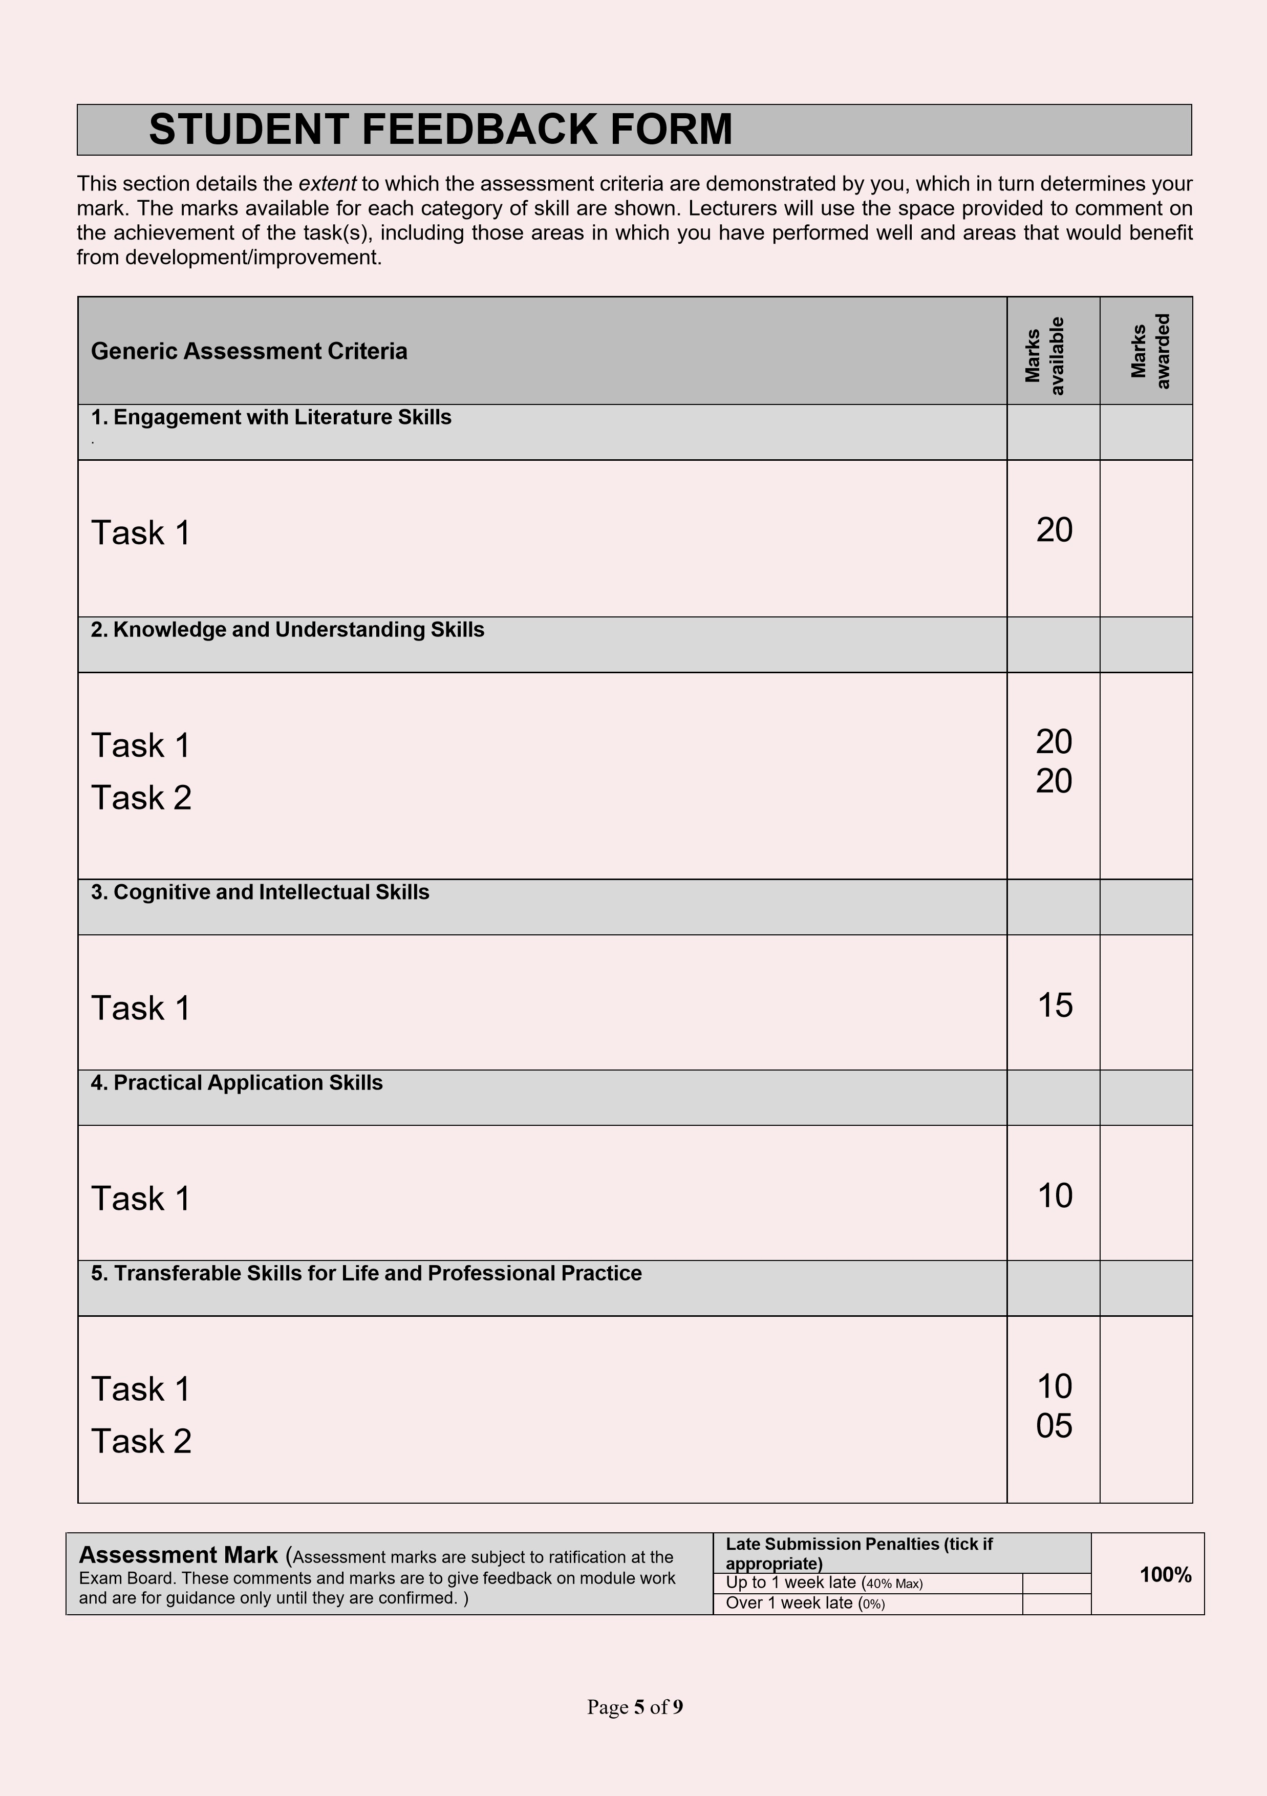

GENERIC ASSESSMENT CRITERIA
Level 5
In accordance with the Framework for Higher Education Qualifications, at the end of Level 5 students will be expected to have developed sound knowledge and critical understanding of the well-established concepts and principles in their field of study, and of the way in which those principles have developed. They will have learned to apply those concepts and principles more widely outside the context in which they were first studied, including, where appropriate, the application of those principles in an employment context. They will have knowledge of the main methods of enquiry in the subject area, and ability to evaluate critically different approaches to problem solving. They will possess an understanding of the limits of their knowledge, and how this influences their analyses and interpretations. They will be able to use a range of established techniques to initiate and undertake critical analysis of information, and to propose solutions to problems arising from that analysis. They will be able to effectively communicate information, arguments and analysis in a variety of forms to specialist and non-specialist audiences, and deploy key techniques of the discipline effectively. They will be able to undertake further training, develop existing skills and acquire new competences that will enable them to assume significant responsibility within organisations. They will have the qualities and transferable skills necessary for employment requiring the exercise of personal responsibility and decision-making.

Level 5 | FAIL | MARGINAL FAIL | SATISFACTORY  (3rd / Pass) | GOOD  (2.2 / Pass) | VERY GOOD  (2.1 / Merit) | EXCELLENT  (1st / Distinction) | EXCEPTIONAL  (1st / Distinction)
Category | 0-29% | 30-39% | 40-49% | 50-59% | 60-69% | 70-84% | 85-100%
Engagement with  literature (including reading, referencing,  academic conventions and academic honesty) | Little or no evidence of reading and/or reliance on inappropriate sources. Views and findings mostly unsupported and non- authoritative. Referencing conventions used incoherently or largely absent. | Poor engagement  with essential reading. No evidence of wider reading. Reliance on inappropriate sources, and/or indiscriminate use of sources. Heavily reliant on information gained through class contact. Inconsistent and weak use of referencing. | Engagement  with a limited range of mostly relevant and credible sources. Some omissions and minor errors. Referencing conventions evident though not always applied accurately or consistently. | Engagement with an appropriate range of  literature, including sources retrieved independently. Some over- reliance on texts.  Referencing may show minor inaccuracies or inconsistencies. | Engagement with a wide range of  literature, including sources retrieved independently. Selection of relevant and credible sources. Very good use of referencing, with no/very few inaccuracies or inconsistencies. | Engagement with an extensive range of relevant and credible literature.  Consistently accurate application of referencing. | Exceptional engagement with an extensive range of relevant and credible literature. High- level referencing  skills consistently applied
Knowledge and understanding  (Sound knowledge  and  Critical  understanding of the | Major gaps in knowledge with unsatisfactory, uncritical understanding of the subject matter. Much | Fragmentary knowledge, with  only superficial critical understanding. Some  significant | Limited but adequate knowledge and  critical  understanding  of | Knowledge is reasonably detailed and accurate. A good critical understanding of the well- | Knowledge is reasonably extensive. Exhibits very  competent  critical  understanding | Excellent,  detailed knowledge and  highly critical understanding of the well- established | Exceptionally detailed knowledge and  outstanding  critical  understanding of the well-

Level 5 | FAIL | MARGINAL FAIL | SATISFACTORY  (3rd / Pass) | GOOD  (2.2 / Pass) | VERY GOOD  (2.1 / Merit) | EXCELLENT  (1st / Distinction) | EXCEPTIONAL  (1st / Distinction)
Category | 0-29% | 30-39% | 40-49% | 50-59% | 60-69% | 70-84% | 85-100%
well-established  concepts and  principles in their field of study; knowledge of the main methods of enquiry in the discipline.) | irrelevant material. Substantial inaccuracies. Significantly flawed understanding of the main methods of enquiry in the discipline. | inaccuracies and/or irrelevant material. Incomplete or partially flawed understanding of the main methods of enquiry in the discipline. | the well- established concepts and principles within the subject area, with a few gaps in the selection of material. A narrow critical understanding of the main methods of enquiry. | established concepts and principles and the main methods of enquiry, with minor gaps in the selection of material. | of the well- established concepts and principles of the subject and the main methods of enquiry. Breadth and depth of knowledge. | concepts and principles of the subject and the main methods of enquiry. | established concepts and principles of the subject and the main methods of enquiry. May go beyond established theories.
Cognitive and intellectual skills  (Critical evaluation and analysis of concepts and principles; argument and judgement; the  limits of their  knowledge, and how this influences their  analyses and  interpretations.) | Wholly or almost wholly descriptive work. Little or no critical evaluation and analysis of concepts and principles. Failure to develop arguments, leading to illogical or invalid judgements. Unsubstantiate d  generalisations or opinion, made without | Largely descriptive work, with superficial use of critical  evaluation and analysis of concepts and principles.  Weak development of arguments and judgements. Information accepted  uncritically, uses generalised statements made with scant evidence | Limited attempt  at critical  evaluation and analysis of concepts and principles, tending towards description.  Some evidence to support arguments and judgements but these may be underdeveloped  d, with a little inconsistency / mis- interpretation or failure to fully recognise limits of knowledge. | Some critical evaluation and analysis of concepts and principles, though descriptive in parts.  An emerging awareness the  limits of their  knowledge and  ability to use evidence to support the argument though with some tendency to assert/state opinion rather than argue on | Sound critical evaluation and analysis of concepts. Is selective in the range of evidence used and synthesises rather than describes. Ability to devise arguments that show awareness of different stances, and use evidence convincingly, to support appropriate and | Excellent critical  evaluation and analysis of concepts and principles leading to logical, evidence- based, reasoned arguments and judgements.  Explicit recognition of other stances and a strong  awareness of the limits of their knowledge. | Outstanding  critical  evaluation and analysis of concepts and principles. Uses evidence exceptionally well to connect ideas, and support highly logical and persuasive, arguments and judgements. Evidence of independent  thought and  ability to ‘see beyond the question’,

Level 5 | FAIL | MARGINAL FAIL | SATISFACTORY  (3rd / Pass) | GOOD  (2.2 / Pass) | VERY GOOD  (2.1 / Merit) | EXCELLENT  (1st / Distinction) | EXCEPTIONAL  (1st / Distinction)
Category | 0-29% | 30-39% | 40-49% | 50-59% | 60-69% | 70-84% | 85-100%
 | use of any credible evidence. | and unsubstantiated opinions. Ideas sometimes  illogical and contradictory. |  | the basis of reason and evidence. Mostly valid arguments and  logical judgements. | valid judgements. | A capacity for independent thought and  ability to ‘see beyond the question’, suggesting some grasp of the broader field and wider concepts. | suggesting a clear grasp of the broader field and wider concepts. Perceptive recognition of the limits of  their  knowledge, and how this influences their analyses and interpretations.
Practical skills  (Apply underlying concepts and principles more widely outside the context in which they were first studied; use a range of established techniques; propose solutions to problems arising from analysis.) | Limited or no use of established methods, materials, tools and/or techniques. Little or no appreciation of the context of the application. Limited understanding of the application of theory to practice or making appropriate links between the two. | Rudimentary application of established methods, materials, tools and/or techniques but without consideration and competence. Flawed appreciation of the context of the application.  Weak understanding of the application of theory to practice, with | An adequate awareness and mostly appropriate application of established methods, materials, tools and/or techniques. Basic appreciation of the context of the application. Theoretical knowledge and understanding applied in practice, but not  always making logical links | A good and appropriate application of established methods, materials, tools and/or techniques. Clear appreciation of the context of the application. Mainly consistent, accurate and logical application of theory to  practice, making appropriate | A very good application of a range of established methods, materials, tools and/or techniques. Very good consideration of the context of the application, with perceptive insights. Consistent, accurate and logical application of theory to practice, making | An advanced  application of a range of established methods, materials, tools and/or techniques. The context of the application is well considered, and insightful. Consistent, accurate and logical application of theory to practice, making well- developed links | Exceptional levels of application and deployment skills using established methods, materials, tools and/or techniques. Consistent, accurate and logical application of theory to practice, making highly developed links between the two. Can identify routine

Level 5 | FAIL | MARGINAL FAIL | SATISFACTORY  (3rd / Pass) | GOOD  (2.2 / Pass) | VERY GOOD  (2.1 / Merit) | EXCELLENT  (1st / Distinction) | EXCEPTIONAL  (1st / Distinction)
Category | 0-29% | 30-39% | 40-49% | 50-59% | 60-69% | 70-84% | 85-100%
 | Very weak problem-solving skills outside the context in which they were first studied. | only occasional evidence of making appropriate links between the two. Weak problem-solving skills outside the context in which they were first studied. | between the two.  Can identify problems and propose basic solutions outside the context in which they were first studied. | links between the two. Can identify problems and propose mostly appropriate solutions outside the context in which they were first studied. | appropriate links between  the two. Can identify  problems and propose appropriate solutions outside the context in which they were first studied. Evidence of some creativity. | between the two. Can identify  problems and propose excellent, creative solutions outside the context in which they were first studied. | and non-routine problems and propose quite sophisticated, creative solutions outside the context in which they were first studied.
Level 5 | FAIL | MARGINAL FAIL | SATISFACTORY  (3rd / Pass) | GOOD  (2.2 / Pass) | VERY GOOD  (2.1 / Merit) | EXCELLENT  (1st / Distinction) | EXCEPTIONAL  (1st / Distinction)
Category | 0-29% | 30-39% | 40-49% | 50-59% | 60-69% | 70-84% | 85-100%
Transferable skills  for life and professional practice  (Effectively communicate in a variety of forms to specialist and non- specialist audiences; the qualities and transferable skills necessary for employment requiring the exercise of personal responsibility and decision-making.) | Communication medium is structured, disorganised and/or confusingly expressed. Very weak use of language and/or very inappropriate style. Failure to work effectively as part of a group. Little or no evidence of the skills for employment  requiring the exercise of personal responsibility and decision- making. | Communication medium is poorly designed and/or not suitable for the audience. Work is poorly presented in a disjointed manner. It is loosely, and at times incoherently, structured, with information and ideas often poorly expressed. Weak use of language and/or inappropriate style. Flawed approach to group work,  meeting only partial obligations to others. Limited  evidence of the skills for  employment  requiring the exercise of personal | Can communicate in a suitable medium for the audience but  with some room  for improvement. Mostly ordered presentation and structure in which relevant ideas / concepts are reasonably expressed. Work may lack coherence in places. Can work as part of a group, meeting most obligations to others but perhaps with limited involvement in group activities. Demonstrates  the basic skills for employment requiring the exercise of personal responsibility | Can communicate  effectively in a suitable medium for the audience, but may have minor errors. Mostly coherent, organised work, in a suitable structure and is for the most part clearly expressed. Can work effectively independently and/or as part of a team, with clear contribution to group activities. Demonstrates  the skills for employment  requiring the exercise of personal responsibility and decision- making, with some areas of strength and | Can communicate  well, confidently and  consistently in a suitable medium for the audience. Work is coherent,  fluent, well- structured and organised. Can work very well autonomously and/or as part of a team, with very good contribution to group activities. Demonstrates very good skills for employment requiring the exercise of personal responsibility and decision- making, with just occasional  minor weakness. | Can communicate  professionally confidently and consistently in a suitable medium for the audience. Work is coherent, very fluent and is presented proficiently.  Can work autonomously with initiative. Where relevant can work professionally within a team, showing leadership skills as appropriate, and meeting obligations.  Demonstrates  excellent skills for employment requiring the exercise of personal responsibility and decision- making and an appetite for | Can communicate with an exceptionally high level of professionalism , highly suitable for the audience. Work is exceptionally coherent, very fluent and is presented professionally. Can work exceptionally well within a team, showing leadership skills.  Demonstrates  exceptional skills for  employment  requiring the exercise of personal responsibility and decision- making and an appetite for further development.
Level 5 | FAIL | MARGINAL FAIL | SATISFACTORY  (3rd / Pass) | GOOD  (2.2 / Pass) | VERY GOOD  (2.1 / Merit) | EXCELLENT  (1st / Distinction) | EXCEPTIONAL  (1st / Distinction)
Category | 0-29% | 30-39% | 40-49% | 50-59% | 60-69% | 70-84% | 85-100%
 |  | responsibility and decision- making. | and decision- making, with some areas of minor weakness. | some of minor weakness. |  | further development.

