

University of Wales Trinity Saint David
Prifysgol Cymru Y Drindod Dewi Sant
School of Engineering

Engineering Design Project: Drill Press Main Sliding Unit
Engineering Design (ACMA4008)

Aneurin (Nye) Evans
(1907963)
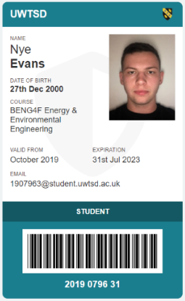
30/04/2021

Contents
1 Critical Appraisal of initial ‘Concept’ 1
1.1 Needs of the Customer 1
1.2 Functional Requirements 1
1.3 Aesthetic Considerations 2
1.4 Serviceability Requirements 2
1.5 Ethical Considerations 2
1.6 Codes of Practice 2
2 Design Specification 3
3 Manufacturing Method & Material Choice Recommendations 4
3.1 Manufacturing Method 4
3.2 Material Choice 5
4 New Concept Design 6
5 Marketing & Ethics 7
6 Summary of ‘Cost Drivers’ 8
7 References 9

Critical Appraisal of initial ‘Concept’
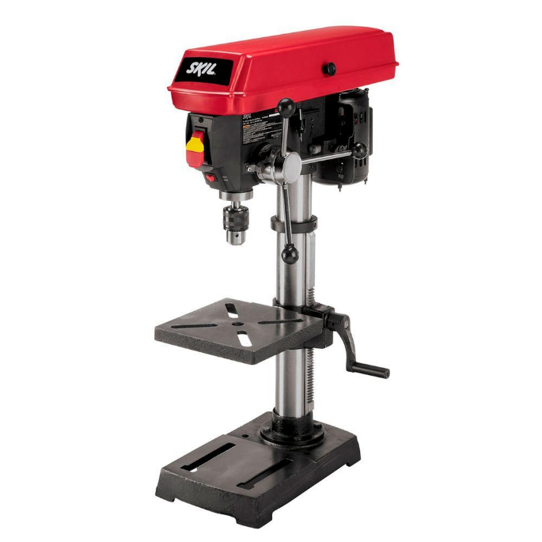
The following is an appraisal of the concept design of the Drill Press Main Sliding Unit (DPMSU). It will analyse and scrutinise as well as praise and criticise areas that are worthy of praise or criticism. Six main areas have been outlined for this. Going through these will allow for a thorough analysis into the suitability and effectiveness of the component from a number of different aspects, the importance of which may vary, which will also be outlined.
Figure 1 - Picture of a typical drill press [3]

Needs of the Customer
On initial viewing, the DPMSU concept design shows a need for a strong, sturdy component, which has the correct concentric dimensions to fit and be able to reciprocate (i.e., ‘slide’ up and down) the assembly smoothly. The functionality of the component is more than likely going to be a priority of the customer over any aesthetics, which is not to say it will not be considered. However, the main focus for the customer is that it fulfils its function well and is durable, as well as being easy to maintain/replace if the need to do so arises.

Functional Requirements
As stated already, the function of the DPMSU is going to be given a higher priority over aesthetics. It is a key component in the drill press and has several important functions. The first of these is to connect the lever arms to the base. The second function being able to slide up and down the main shaft smoothly, with no jolts and a consistent resistance. Thirdly, the DPMSU holds the drill itself and is the only thing separating the drill itself from the part being drilled. This means that it must have the correct dimensions in order for it to be lowered to an exact, constant distance from the base. This ensures that the customer can use the drill with confidence it will always lower to their desired distance from the part being drilled. It is also worth noting that the DPMSU should be a reliable component of the drill, with it being the component that is likely to go through the most use (regarding compression and fatigue). It should then be very durable and have a high fatigue limit and the design allow for easy replaceability if needed.
In an article by N K Srinivasan, the consistency of the usage is discussed, with measuring reliability easier when something is used at a consistent frequency rather than sporadic. In the case of the drill press it is hard to say and will of course depend on the customer. A builder or carpenter will most likely use it far more frequently than a casual ‘tinkerer’. Therefore, there will likely be more studies on the reliability of the part that cater for the customers that will use it more frequently. [1]

Aesthetic Considerations
Considering aesthetics is not a high priority but will still be considered when deciding on design and material elements. It must be relatively in keeping with the other components. It will likely benefit both functionally and aesthetically from a simple, clean look that will not overly stand out when observing the entire piece. The material choice will have a bearing on aesthetics, but the material choice will be decided with functionality in mind more than aesthetics.

Serviceability Requirements
The component needs to be easily fitted and removed, this will not only make the customers life easier, but it will make servicing easier too. Clearly though, this mustn’t be in any way detrimental to the safety and function of the component. Given the nature and complexity of many sections of the entire assembly, it is very important that it is exactly that, an assembly! Making the entire drill press as one part would certainly not be the most efficient, convenient or cost-effective method of manufacture. Not only are there the complications with making the entire unit as one piece, if any section of the drill press failed, the entire unit would need replacing. This would not only be aggravating to the customer, who may feel ripped off. Looking at the wider picture, there would be an environmental impact too. Making larger quantities of material at a time when not necessary would not be the correct way to do things in this instance.

Ethical Considerations
Using recyclable, reusable materials whose extraction and manufacturing process has a lowered impact on the environment is also something big to consider. Even if this is low on the customers priorities, we as engineers have a duty to do things wherever possible that help the planet in any way. There will certainly be some criteria for the environment in the design specification, but as anything else, cost may become an implication.

Codes of Practice
There’ll be a range of boxes to tick regarding the safety and ethics of the design, materials and manufacturing proces. Some of these things will be wholly unsuitable for this specific purpose, even if they are acceptable in other components. There will also likely be some processes that are simply not allowed.

Design Specification
A design specification has been developed based on the findings from the critical appraisal of the concept DPMSU and is shown below. It will set out the must haves of the product and the level of importance of the many different criteria it should or need to meet.
Said design specification is shown below:
DPMSU Design Specification
Customer Interests | Metric | Importance (1-5) | Target
Easy to manoeuvre | Manoeuvrability | 5 | Mass is <1Kg
Movable up and down main shaft | Precision clearance fit with suitable tolerances | 5 | H7 h6 fit, tolerance = [+0.021mm +0] [-0 -0.013mm]
Must be affordable | Cost | 4 | Price is  < £25
Able to withstand the high forces applied to it during use | Strength | 4 | 100MPa Minimum
Long lasting/durable | High fatigue strength | 3 | 200MPa Minimum
Aesthetically pleasing and in keeping with the rest of the drill press | Aesthetics | 1 | In some way pleasing to the eye (Subjective)
Easily serviceable and replaceable | Serviceability | 3 | Must be easily detachable
Environmentally friendly | Environment | 3 | Made from a recyclable material
Potentially high demand | Manufacturing efficiency | 4 | 1000 units per week
Figure 2 - Design specification for DPMSU

Manufacturing Method & Material Choice Recommendations

With choosing what process to use to make a part and what material to make it from is usually a fine balance between performance and cost. Here is no different. The following sections will make suitable suggestions for materials and processes for the DPMSU that fit the needs and wants that were set out in the design specification. Each choice will have an impact on the other within reason. For example, if soldering was chosen as a good manufacturing process, then wood would not be an accompanying material choice (and vice versa).

Manufacturing Method
From casting to moulding, making multiple components and joining via adhesive, welding etc, to carving and sculpting - there are a lot of different methods. Each of these come with unique advantages and disadvantages.
Considering the brief being a goal of manufacturing 1000 units per week, a process that can be done on mass with relatively high precision is needed. The 1000 units per week target will require 200 units to be made (minimum) per day, this figure being based off a 5-day working week. From that, considering an 8-hour working day, a production of 25 units per hour will need to be consistently achieved. The process will need to be mass production rather than custom production, due to the simple nature of the design and need for precision and low tolerances.
Based off these parameters, the following processes are recommended:
- Machining
- Casting
- Moulding

Material Choice
Much like manufacturing, there are many things to consider when choosing potential materials. One of the main ones here is that it is strong and durable. To be more specific, the material chosen must be able to withstand at least 25MPa of stress applied to it. It must also be able to cope with high fatigue due to the continuous stress applied during its use. It must obviously also conform with the selected manufacturing process, as highlighted in that section. As well as all of that, there is a clear emphasis on the environment, specifically through recyclability which will be considered appropriately.
Based off these parameters, the following materials are recommended:
- Low-carbon steel
- Aluminium
- Acrylonitrile butadiene styrene (ABS)

New Concept Design
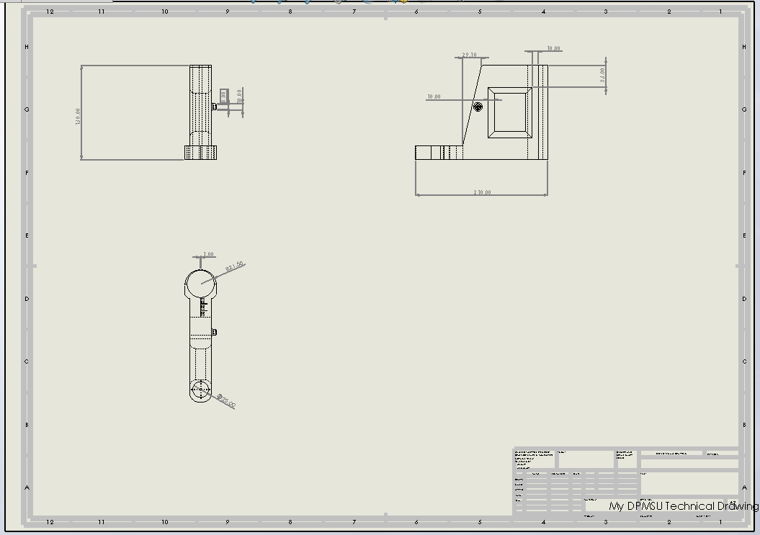
Figure 3 - Technical drawing of new concept DPMSU. Source: SolidWorks

Marketing & Ethics
The following are some marketing tools that could be used to help give the product an edge in the market:
- An integrated measuring system in the design
- Being compatible with a range of products, not just a drill press
- Coming in a range of colours to encourage ‘custom’ drill presses (material dependent)
- Incorporate recyclability into design (possibly engrave it onto the model itself)
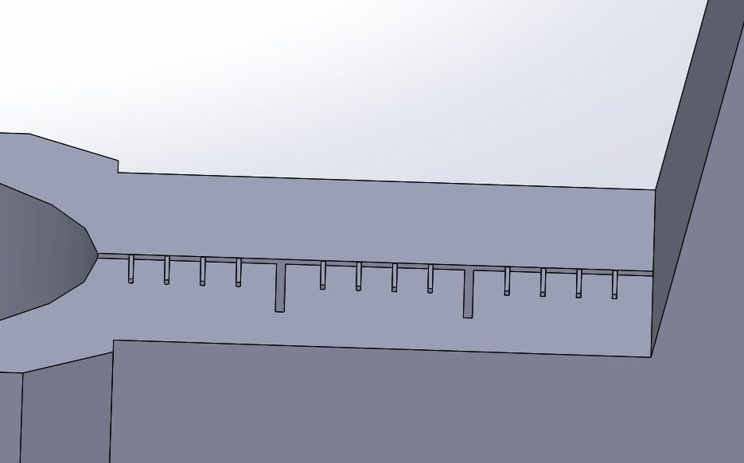
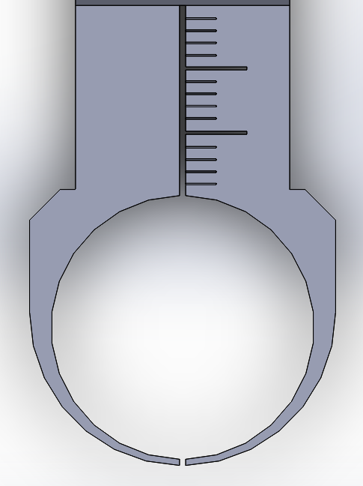
Figure 4 - Two views of integrated measuring guide. Source: SolidWorks

The Royal Academy for Engineers published a very useful piece in which ethics was specifically focussed on, it discussed the need for engineers to stay “up to date” on current codes of practice and always be in a position to make decisions with “responsible leadership”. [2]

Summary of ‘Cost Drivers’
For what material will be required, the costs of the suggested materials fit the design specifications price of under £25. Each individual material will have its own specific price range, which will naturally vary based where its originally sourced. However, the price for the material alone will also have a knock-on effect on the manufacturing process, which itself has its own cost drivers. But for now, the analysis of all of the methods indicate that the desired maximum price should not be exceeded and the marketing price of the product should suit all, in terms of being affordable to the customer and yielding a worthwhile profit for the company.

References

[1] | N. K. Srinivasan, “Reliablilty - How to Quantify and Improve? Improving the Health of Products,” no. May 2000, p. 9, 2000.
[2] | The Royal Academy of Engineering, Engineering ethics in practice: a guide for engineers, London: The Royal Academy of Engineering, 2011.

Images:
[3] – Home Depot, Image of Drill Press, [Online] Available at: https://www.bing.com/images/search?view=detailV2&ccid=rEoWJfSX&id=45FD760B441F3C243D199F04CBA6048EB58017AB&thid=OIP.rEoWJfSXu0kdORARzrWCdgHaHa&mediaurl=https%3a%2f%2fimages.homedepot-static.com%2fproductImages%2fef7e1221-6dee-42c4-b3a8-da0055979151%2fsvn%2fskil-drill-presses-3320-01-64_1000.jpg&cdnurl=https%3a%2f%2fth.bing.com%2fth%2fid%2fRac4a1625f497bb491d391011ceb58276%3frik%3dqxeAtY4EpssEnw%26pid%3dImgRaw&exph=1000&expw=1000&q=drill+press&simid=607988513886269877&ck=552500ABE391358A9A87D6AA14C68620&selectedIndex=4&FORM=IRPRST&ajaxhist=0

