Business and Management
Entrepreneurship

Module Code: LCBB5001

Student: 2114611

Student Name: Irina Caraus

Business Plan:
Virtual Clothing Shop Try – On

BUSINESS PLAN TEMPLATE: THIS TEMPLATE MUST BE USED FOR THE ASSESSMENT. YOU MAY INCLUDE PICTURES TO IMPROVE THE PROFESSIONALISM OF YOUR WORK
BUSINESS DESCRIPTION / MARKET OPPORTUNITY

The business description section provides a general description of the company. It should include your mission statement, description of the product or service with a focus on the innovative element that makes it relevant in a post-Covid 19 world, which may be in its design or delivery, need for the product and milestones achieved thus far if any. The ownership and legal structure should also be laid out.
A business plan refers to the innovative approaches and strategies which the management of an organization documents and follows for deploying and executing a defined kind of business idea so that the available market opportunity might be exploited effectively by delivering a competitive product or service (Moro Visconti, 2019). The research work is carried out to have an in-depth analysis of the feasibility of a proposed business plan, development and retailing of Virtual Clothing Try-On, from the perspective of both financial and non-financial metrics so that appropriate investment decisions might be made. Virtual Clothing Try-On is an interactive virtual device with the support of which customers can decide the suitability of a defined kind of fashion or clothing items digitally without wearing the item in real(Yu, et al., 2019). The first and foremost reason behind the selection of the business plan, Virtual Clothing Try-On, for the research work is the rising trend of online shopping behaviour of the British population. With the support of the assessment, the competitiveness of the proposed business plan is analysed by evaluating its industry and rivalry level of the industry of the UK along with highlighting its marketing plan. Apart from it, the financials of the Virtual Clothing Try-On development and retailing business plan are forecasted using the contemporary economic trend of the UK and this is eventually used to conclude the work.
The primary motive of the proposed business plan is the production and retailing of Virtual Clothing Try-On related software and interactive device to the fashion lifestyle retailing companies of the UK so that they might augment the shopping experience of their customers competitively. In the business plan, a customized kind of Virtual Clothing Try-On related software will be developed as per the individual needs of fashion and clothing retailing companies of the UK and this will be implemented by integrating the feature within their e-commerce portals. The mission of the proposed business is to augment the dependency of global customers on Virtual Clothing Try-On for buying any fashion items digitally by preferring the mode as the number one priority so that their time shopping might be saved. The name which is planned for the business plan which is about production and retailing of Virtual Clothing Try-On is “e-try” and the nature of the company is manufacturing and retailing both. Since the number of companies dealing in Virtual Clothing Try-On product is limited in the UK due to which for exploiting the existing and upcoming market opportunity, respective product will be developed and retailed to the e-commerce and conventional companies dealing in fashion products.
In the proposed business plan, the intellectual property is the algorithm and code which are supposed to be used for developing a competitive kind of Virtual Clothing Try-On so that customers might be empowered to try desired kind of cloth digitally without wearing the item physically. For curbing the possibility of breach in protecting the intellectual property, code to develop Virtual Clothing Try-On, copyright process will be used as it will help in inhibiting others to use same model in future and this will eventually assist in capturing the larger market share of the industry (Peng, et al., 2017). For incorporating the proposed business plan, sole proprietorship is selected as legal structure for the Virtual Clothing Try-On developing and retailing company as it will assist in minimizing monthly legal obligation costs along with reducing the possibility of sharing profit with other partners. The ownership structure of the Virtual Clothing Try-On developing and retailing business is mentioned as follows in graphical format-

Figure 1: Ownership Structure of the Proposed Business Plan "e-buy"; Source: Author;
For having a higher degree of competitiveness in executing the business plaforof the development and retailing of Virtual Clothing Try-On, a functional organizational structure will be followed in which authority will be provided to each functionality team so that any delay in respective function can not be faced.

INDUSTRY ANALYSIS – Porter’s 5 forces

Porter’s five forces framework has been selected for the assessment and identification of the factors threat create a competitive threat for the virtual clothing-trial enabler business within the market of the UK.
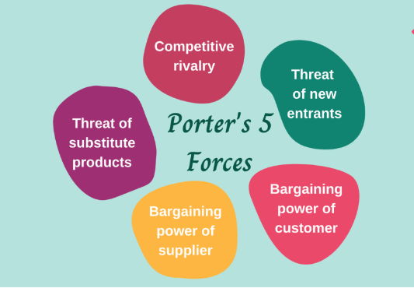
Figure 2: Porter's five forces analysis, Source: Invalid source specified.
The threat of new entry
Along with the increase in the demand for online shopping within the fashion industry, the customer requirement for virtual trail facilities has increased. The leading fashion retailers operating online like Asos have been successful, for which the inclusion of the online trial facility has been a great determinant. Therefore, the industry of developing such smart software is high in demand as most of the online retailers within the fashion industry now possess to implement such advanced features in the business proceedings to ensure a higher ability to attract customers. Therefore, the market might be a key attraction for new IT firms and start-up companies offering smart solutions to retail companies. Therefore, the threat of new entrants will be a strong threat to the firm.
Bargaining strengths of the customers
The bargaining power of the customers will be a weak force. As the start-up business will offer the service of virtual fashion retail product trial software at an economic price, the businesses to use these services might prefer this software over the industry rivals.
Bargaining strengths of the suppliers
The bargaining power of the suppliers will be a high threat to the business. The business takes supplies of software equipment from suppliers able to deliver supplies in the most cost-efficient way. Hence, the business will face a high threat to the bargaining power of the suppliers. Moreover, as a start-up business, it might face a higher bargaining power from the suppliers as they have a large brand switch option.
The threat of substitute products
The threat of substitute products will be a strong threat to the business. The leading fashion retailers in the market already use different software applications that enable users to try online. Therefore, the threat of substitute products will be a strong threat
Industry rivalry
The threat of industry rivalry will be a strong threat as well due to the presence of a number of efficient software-developing companies in the market. As the leading software developers have already engaged leading fashion businesses as customers of their online trial software, this will be a tough threat for the organisation.

Competitive Rivalry:
Identification of the competitive rivalry here is done based on the VRIO analysisInvalid source specified.. It supports showing the differentiated values of the business deliverables that reduce the competitive threat and produce greater value propositions with deliverables that are valuable, rare, inimitable, and organised.
Competitors | Differentiation
CoreBlue | The software produced by the planned firm might be more efficient in delivering real-time trial experience, which will be a valuable aspect (V)
AppDrawn | The software will e accessible from any kind of device connected to the internet even without installing the application, but on the website too, which will be a rare quality (R)
One Beyond | It will include options for goggles, footwear etc as well, which will be an inimitable characteristic of the firm’s offering (I)
Imobisoft | The developers will be working within the team of the clients, which will support the organisation of the operations

OPERATIONS AND MANAGEMENT TEAM
OPERATIONS
What is your business process like – detail the process? E.g., if it is a bakery – what are all the processes involved? Where will you get your supplies from? What supplies and equipment will you need? How will you transport them to your production site? Where will you make the cakes and scones? How will you get them to your customers? Will anyone else be involved in this process?

The business process involving the organisation under review is associated with virtual clothing techniques. It is also involved in the production of devices which shall be used for virtual try facility for customers in the clothing industry. The main model associated with the process is associated directly with the revenue generation scope under definitive outcome and is associated with sustainable clothing options. The e-try software will be installed in the device which shall outline the economic activities and scale. The products activeness. The organisational support which has been provided by the company. Try out is associated directly with the business opportunity under the role of definitive outcome.
How would you generate revenue for your business ( Upselling, Upgrading, Economies of Scale) ? How would you prevent loss of revenue?
The main revenue generation model will be associated with of selling of the devices and then this shall outline the economic skill activity for companies which shall install the device into their software or also associate with a virtual option for buying. The loss of revenue will be prevented by the renting model which shall ensure heavy cash flow from the customers.

MANAGEMENT TEAM

Name | Skills | What do they bring to the firm
Jonathan | Sales | The sales figure which shall help in revenue generation
Martin | Technical skills | The maintenance of the e-try software.
Mindie | Human resource management | The team’s performance will be strengthened, and this shall be actively engaging
Oscar | Marketing | The marketing pitches that shall increase sales.
You may add more names if you wish

MARKETING:

The competitive USP (Unique Selling Proposition) of the Virtual Clothing Try-On will be promoted using social media marketing handles like Facebook, Twitter, Instagram as around 83 % population of the Uk are using the portals for making any buying or shopping related decision(Statista, 2023). For increasing the reach of the product or service of the proposed business plan, both e-commerce and conventional business model will be followed as the intervention of internet and respective enabled portals are higher in the society of the UK. Apart from it, competitive pricing strategy will be followed along with discount pricing scheme for influencing the buying decisions of the corporate and individuals’ customers of the UK. Besides this, for increasing the reach and demand of the Virtual Clothing Try-On product in the UK, the virtual or digital try on feature of the proposed product will be used as a point of difference while promoting the product using social media marketing, BTL (Bellow the Line). Above all, for augmenting the efficiency of the supply of the innovative product, a dedicated supply chain system will be developed by having an alliance with a logistic team which have deep access across the UK.

FINANCIALS

Financial plan refers to the estimating about the present and future expense of a business which will be used for carrying out defined kind of operational activity in the future without facing any capital shortage related issue(Ng, et al., 2022). The financials of the proposed business plan are presented as follows-
Start-up Cost
e-try
Particular | Value
Land and office leasing cost | £ 22,905.00
office set-up cost | £ 3,500.00
equipment and furniture | £ 1,500.00
e-commerce portal | £ 1,200.00
Recruitment | £ 800.00
Other | £ 1,000.00
Total Start-up cost | £ 30,905.00

The projected profitability of the proposed business plan for the next 6 month is presented as follows in tabular form-
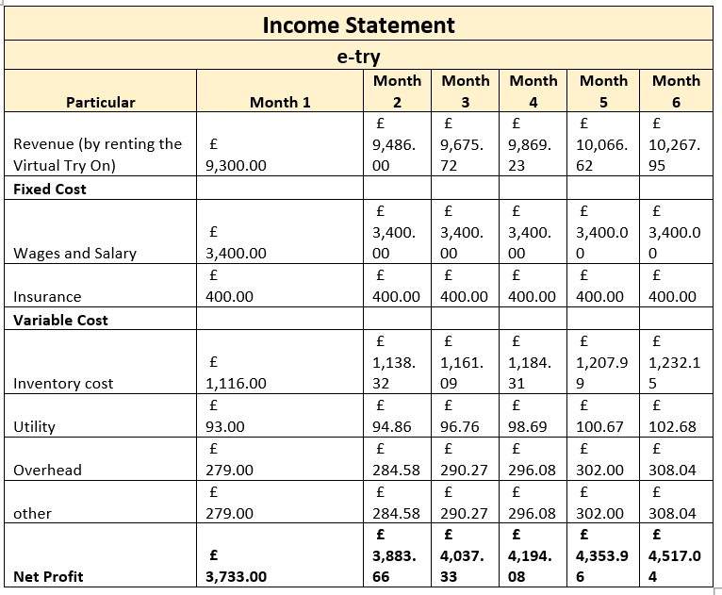
Source of the fund- Bank Loan
The repayment plan of the business is as follows-
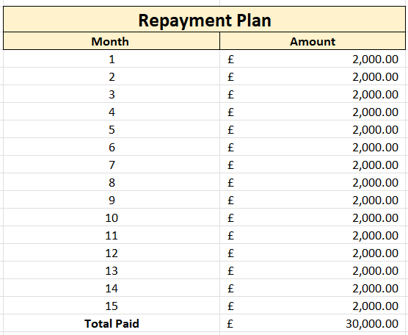

It is concluded that the proposed business plan of virtual clothing try-on is financially viable as the business will support the investor to get its invested amount recovered within 15 months and this will eventually help in augmenting return on employed capital. It is summarized that the demand for the proposed virtual tries one service is comparatively higher than its supply and this increased substantially after the pandemic situation. It means that in the context of the demand and supply theory of economics, the proposed business plan for the production and retailing of virtual clothing try-on is competitive from the perspective of both financial and non-financial performance metrics.

MARKET RESEARCH
The external environment and the market research associated with the macro environment are performed with the help of the PEST model.
Political
Politically, the government in the UK is stable and the conditions are associated with a positive impact on the country. It is therefore outlined that it is well implicated under the business activity and has objectivity under the effective outcome. However, activities like Brexit have impacted the overall British economy and political conditions which has created tensions. The virtual start-up associated with this case has no threat from the political outline of British conditions (Heclo, 2010)
Economic
The economic measures under the government have been impacting the overall outcome and this helps in overall growth strategies being taken. The organisational approach under the review of a sophisticated mechanism has been well considered and this directly aligns with the situation of mechanism. The spending capacity of individual British community members has increased after the pandemic due to the activities which has been taken up by the government (Pickard, 2019).
Social
The social conditions have been helpful for improving the overall technical ability of the country and this is associated with the culture of the people to try out new things. The business has the point of survival because it entails the organisational approach and focuses on direct customer acquisition (Newton, 2020). Companies also have a social advantage as the social media is involved in this thing and the business activities are overall growth oriented in nature.
Technological
In terms of technology, the country has been growing rapidly which means that the organisation under review has a potential of growth. In addition to this, it is also possible to review the circumstances and overall mechanisms of certain approach of group is also oriented. In such cases, the organisational approach under consideration has been well developed in terms of the effective circumstances under the growth mechanism and technical usage is also higher.
REFERENCES
Heclo, H., 2010. Modern social politics in Britain and Sweden. ECPR press.
Isabelle, D., Horak, K., McKinnon, S., and Palumbo, C. (2020). Is Porter's Five Forces Framework Still Relevant? A study of the capital/labour intensity continuum via mining and IT industries. Technology Innovation Management Review, 10(6), 66-98; DOI: 10.22215/timreview/1366.
Miethlich, B., and Oldenburg, A. (2019). The employment of persons with disabilities as a strategic asset: A resource-based-view using the value-rarity-imitability-organization (VRIO) framework. Journal of Eastern Europe Research in Business and Economics, 1(1), 1-13; DOI: 10.5171/2019.667087 .
Moro Visconti, R. (2019). How to prepare a business plan with excel. . Available at SSRN, 12(1), 20-39 ; DOI : 10.2139/ssrn.2039748.
Newton, K., 2020. Government communications, political trust and compliant social behaviour: the politics of Covid‐19 in Britain. The Political Quarterly, 91(3), pp.502-513.
Ng, P., Raghavan, S., Zhang, C., Pan, J. Y., O’Rourke, P., and Wong, R. (2022). Money talks: Pilot financial wellness programs to promote positive financial planning behaviors among residents. Academic Medicine, 97(3), 380-384; DOI :10.1097/ACM.0000000000004429.
Peng, M. W., Ahlstrom, D., Carraher, S. M., and Shi, W. S. (2017). History and the debate over intellectual property. Management and Organization Review, 2(1), 15-38; DOI : 10.1017/mor.2016.53.
Pickard, S., 2019. Politics, protest and young people: Political participation and dissent in 21st century Britain. London: Palgrave Macmillan UK.
Statista. (2023). Active social media audience in the United Kingdom (UK) in January 2023. Retrieved March 10, 2023, from https://www.statista.com/statistics/507405/uk-active-social-media-and-mobile-social-media-users/#:~:text=Active%20social%20media%20users%20in%20the%20United%20Kingdom%20(UK)%202023andtext=The%20United%20Kingdom%20(UK)%20was,the%20population%20of%20the%20UK.
Yu, R., Wang, X., and Xie, X. (2019). Vtnfp: An image-based virtual try-on network with body and clothing feature preservation. Proceedings of the IEEE/CVF international conference on computer vision, 6(1), 10511-10520; DOI :10.1504/IJTM.2023.128872.

