Strategic Management for Public Organisations

This assignment will demonstrate an understanding on strategic management and the way it is incorporated into the public organisations. Another aspect which will be observed is management theorists and how they relate to strategic management. The limitations and difficulties will also be researched as to why some organisations may find it hard to follow these through effectively.

‘Strategic management can be described as the identification of the purpose of the organisation and the plans and actions to achieve that purpose’ (Lynch 2012:7).
Strategic management is something that takes place continuously through a process of strategic analysis, monitoring, implantation. The purpose of this process is to accomplish and continue to keep up a competitive gain. The aim for this is that all parts of the organisation works effectively together to achieve their overall goal.
There are three core areas of strategic management, strategic analysis which is the organisations competition and what aims they would like accomplished, these both have to be analysed.
Strategy development which is when the strategy options have been chosen and developed. The last area is strategy implementation
There are a many different views on Strategic management, each have different opinions on the outcomes on an organisation. The first view being a prescriptive view, they believe that an organisation has an aim and the purpose for strategic management is to achieve that aim. The example which is used is that a doctor gives out a ‘prescription hoping that it will fight that infection’. This is why this view is called ‘prescriptive’ view.
The next view is called an emergent view, they believe that strategic management is a tactical and self-motivated, with a component of risk. They believe that an organisation changes over time and so does the strategy.
The last view is called a modern consensus view, this view has shared beliefs with the two above.

Below is a strategic management model called the Mckinsey Model, This produces an insight into the seven different parts, these are then divided into the “soft ss and the Hard ss”. The purpose of this model is to help and solve a variety of situations when organizational design is the question. The model supports enabling organizational change, to help bring forward new strategy, to distinguish how ample each area may differ in the future and to enable the fusion of organisations. There are seven areas which are divided into ‘soft Ss’ which are the areas which are a lot more difficult to achieve as they are the groundwork of the company, these enable the circumstances to become a lot easier to create the constant competitive gain. The 7’s stand for shared values, structure, systems, style, staff, skills and strategy.

Below is an image of the 7’s:
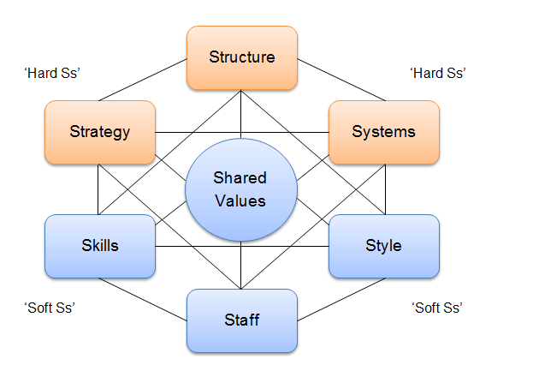

An example of a strategic management model is SWOT. This was invented by Albert Humphrey. This approach was tested in the 1960’s and 1970’s, this was held at the Stanford Research institute. This model is used fundamentally throughout a wide variety of organizations providing support and making decisions. It is used as a base to accomplish strategic management. This is achieved by discovering ways to succeed in areas which have not been reached previously, and to also identify the threats before they become a big problem in the organization. An example of where this model can be interpreted is when a person is working their way up their job role to promotion.
The SWOT model would encourage the person to point out their strengths and weaknesses and help them focus the issues that need developing to help them become a better leader. SWOT analysis stands for strengths- What the organisation already does brilliantly, Weaknesses- What does the organisation need to improve on, opportunities- what trends can increase sales and threats- what strengths do other organizations have compared to yours.

Below is a chart demonstrating SWOT:
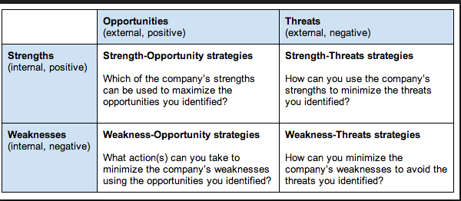
There are many theorists that support management. A theorist called Henri Fayol produced his theory in 1916 but it was not translated into english untill 1949. Fayol was known as ‘famous’ due to the classical school of management.This was called General and industrial Management. He divided his theory into five key areas which he believed where the main functions of management. These were called planning, organising, commanding, coordinating and controlling. He also created fourteen principles of management.
A theoriest called Frederick Winslow Taylor created a sceintific management movement in 1909. Him and his work collegues were the first to sudy the work process sceintifically. He observed how work was performed and the after effect this had on worker productivity. This philospophy concentrating on the thoiught that pushing people to work to their full potential was less effective on the performance rather than concentrating on the way the work is actually done. He believed that a vital aspect of a buisness was that workers and management should work effectively together discusiing all aspects together. Within this period of time managers didn’t have a relationship with their workers, they didn’t discuss anything. The workers had to use their own initative to get the job down. This meant that the workers had no motivation to get the job done this was due to no-one was promting them to get it done quicker or to make any adjustments to the product. He believed that all workers motivation was run by money. This is why he came up with the idea of “a fair days pay, for a fair days work.” By this he meant that workers should only get paid for their work that they achieved,and the workers who have achieved more should get paid more. He allocated four principles these were; replacing working by “rule of thumb”. Certain aspects of the job should be given out to workers relating to their capabilities and motivation and that workers have the necessary training. That the performance of the workers are observed and feed back is available to support the worker to improve different elements about themselves. To share out the responsibilites with managers and workers so that the managers can plan effectivly and have the correct training, and this would then allow the workers to carry out their tasks correctly.

Public organisations such as the police depend on strategic management immensely. The aim of this is to improve working efficiencies by indicating the problems. These problems include internal issues and external issues that have a large impact on organizational sustainability. The key concentration on this is that management is held responsible for putting into practice that customers are the main priority and that performance is at the maximum it can be. The strategic mangers then incorporate their planning and ideas with a selection of management systems.
In July 2012 a Strategic policing requirement was issued. This piece of requirement was created based on the thoughts of the Home
Strategic management is a vital part of today’s law enforcement environment, police executives are held responsible to incorporate strategic management into their course. This was known as the ‘institutional brain’ of a modern public organization. The role of strategic management is to take into consideration the way in which the
Company thinks, and also to have an understanding into the different emotions that are shown by humans which determine a difference in the organisation itself.
Strategic managers are created by a group of individuals who are known as leaders, their responsibility is to inflict change throughout the organizational limitations.
Taylor’s theory is incorporated into public organisations. This is reflected into the police through many ways. For example: no matter what rank you are in the police all police officers communicate and discuss things including any issues or things that they need to improve on. This relates back to Taylor’s theory as he believed that the boss should talk to its workers. These days management holds regular meetings with its staff discussing different aspects with them. Asking them if their unhappy with anything and if there is anything that they can suggest to be done better. There are also regular reviews done on its staff assessing their progress looking into if anything can be improved or if they need to do anything in a different way.
Staff are also allowed to go into jobs that their mostly interested in for example if you have worked within a police station for a couple of years and can prove to them that you are a dedicated person then you can apply for jobs that come up in the area that you would like to work in for example child protection. This relates back to his theory as he believes that workers should be assessed and should be put into jobs depending on their capabilities and interests.
If strategic management is carried out correctly then it can imply a lot of advantages. These being: Making sure that the company is able to prevent problems this includes creating a solution for any problem that arises. Enables companies to think ahead so if a threat was to arise then how would you overcome it, so that the company is prepared on what tactic they will use to solve the problem. The most important advantage is that it expressively creates improvements on the financial and economic results of the company which endures fast improvement and making the marketing position a lot stronger. This also increases the companies competitiveness as their results keep getting better. Studies which have been undertaken discovered that a company which follows these through are a much better company rather than a company that doesn’t comply with any of the above.
There are many limitations that come with the use of strategic management for example it does not impose an accurate picture of the future, it is believed that although a company outlines the future stating what will be done it is more of what they would like to be done rather than reality. Although many theorists support strategic management they only explain what can be done to solve a problem and how, they do not put into place any set rules or guidelines to follow this is left for the manager of the organisation to organise. Lastly for an organisation to follow strategic management it is very cost efficient, and also takes up a lot of managements time and resources to do so.
A Police and Crime Commissioner of Thames Valley police gives a descriptive account on what responsibilities he has to incorporate strategic management within the police service. His duty was to create a Police and Crime plan which would set an outline for the following five years. This included strategic priorities and also the path which should be taken for crime and policing in their police service. His responsibility was to also create an annual report which incorporates their achievements and also how well they have done with the plan if they have reached all their aims and also how well he has carried out his role during this.
Whilst conducting this plan there are objectives that are created these include: the policing of the area, crime and disorder reduction, and the discharge by Thames Valley of its national or international functions and

Conclusion
Strategic management overall is an excellent idea as it helps public organisations solve many problems that they will be facing in the oncoming years and supports them to come up with a solution before the problem actually arises. Historical theorists now outline many organisations in the way they lead their group, for example management works closely with their workers discussing any problems they have. Although there are many advantages from using strategic management there are also some disadvantages for example the amount of money it costs an organisation, the amount of time and resources it requires. The amount of pressure it has on the management to make sure that all of the requirements are met. Although these organisations create a plan, it is believed to be a problem that the plan is put into place for the next five years, what if financial problems occur. A recommendation that could be imposed could be that the plan is done yearly so that If there are any changes then it will be easier to amend. There may be some managers who don’t have a very effective relationship with their workers this can have a large effect on the organisation as the workers will not be motivated to reach their full potential as there is no one there encouraging them to do so.

References

- Strategic Management (2013) What is that strategic management, Available at: https://www.strategicmanagementinsight.com/topics/strategic-management-planning.html Accessed on: 10th February 2018

- The police chief magazine (2010) Strategic management in policing, Available at: http://www.theiacp.org/Portals/0/documents/pdfs/LBL%20Resource%20Toolkit/Strategic%20Management%20in%20Policing.pdf Accessed on: 10th February 2018

- SearchCIO (2008) SWOT analysis, Available at: http://searchcio.techtarget.com/definition/SWOT-analysis-strengths-weaknesses-opportunities-and-threats-analysis Accessed on: 10th February 2018

- Lynch RL (2012) Strategic management 6th edition, Harlow Pearson

- Business basics (2017) Management theory of Henri Fayol, Available at: https://www.business.com/articles/management-theory-of-henri-fayol/ Accessed on: 10th February 2018

- Henri Fayol, General and industrial management, Pitman, 1949.

- Mind tools (ND) Frederick Taylor and Scientific Management, Available at: https://www.mindtools.com/pages/article/newTMM_Taylor.htm Accessed on: 10th February 2018
- Fred R. David, Strategic management concepts and cases,
Ed. Prentice Hall, New Jersey, (2011).
- Hill C.W., Jones G. R., Strategic management, 4th Edition,
Boston: Houghton Mifflin Company, (1998)
- Vihanskii O., Strategic management, Ed. Gardarica,
Moscova, (1998)
- Thames Valley Policing (ND) Role of the police and crime commissioner, Available at: https://www.thamesvalley-pcc.gov.uk/about-us/role-of-the-police-and-crime-commissioner/ Accessed on: 25th February 2018
- Thames Valley Policing (ND) Police and Crime plan, Available at: https://www.thamesvalley-pcc.gov.uk/police-and-crime-plan/ Accessed on: 25th February 2018

