

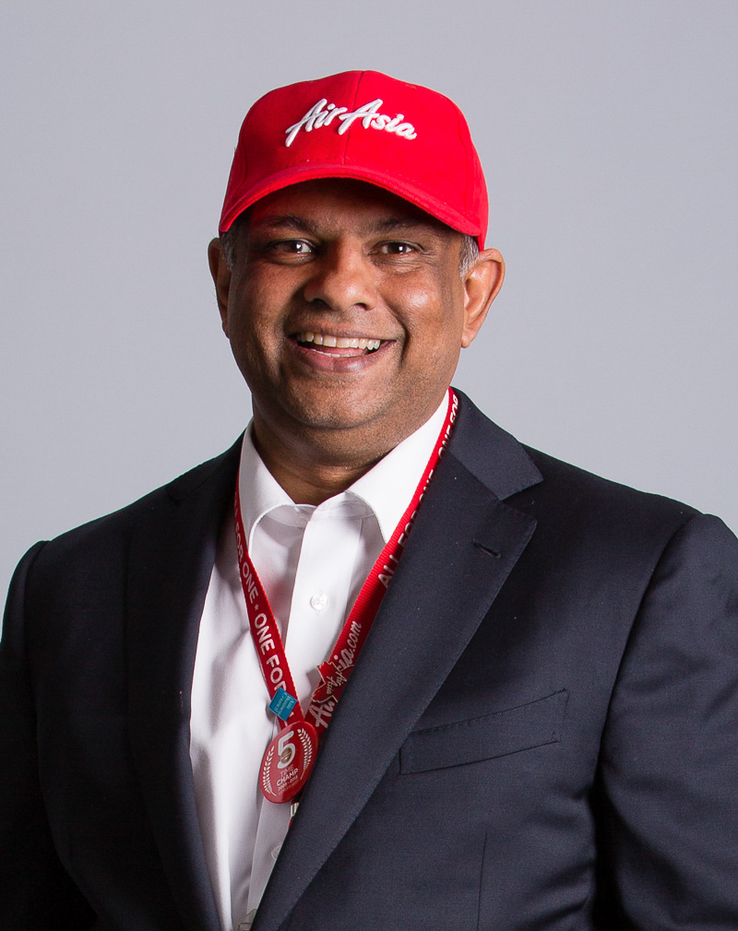



An Analysis of AirAsia's Leadership Model and Its Contribution to Corporate Success
Zhi Yan Tan 2226088
BMBM6012 - Leading and Developing People

Table of Contents
1.0 Introduction 1
2.0 Tony Fernandes is a Transformational, Adaptive, and Innovative Leader. 4
2.1 What is Leadership? 4
2.2 Tony Fernandes the Transformational leader. 5
2.3 Adaptive Leadership in Tony Fernandes 8
2.4 Tony Fernandes is an Innovative Leader 11
3.0 Conclusion 13
4.0 References 14

1.0 Introduction
Tony Fernandes, who is currently 58 years old, was born on April 30, 1964, in Kuala Lumpur. He is a successful entrepreneur from Malaysia, with an estimated current net worth of 335 million dollars by 2020 (Forbes, 2020). Fernandes had a brief stint at Virgin Atlantic where he held the position of Finance Controller. Before establishing Tune Air Sdn. Bhd. and entering the airline industry, he was the youngest CEO of Warner Music Records Malaysia (Pusiran & King, 2013). In 2001, Fernandes made the shocking decision of quitting a successful career as a top executive at Warner Music and plunged right into the airline industry. At that time, Air Asia was a government-owned conglomerate, but eventually heavily indebted. Fernandes and his business partner, Kamarudin Meranun had made a decision to acquire the indebted airline with a token sum of one Malaysian Ringgit, along with their debts that are worth 40 million Malaysian Ringgit. Fernandes, acting as the CEO of Air Asia made innovative changes to their operation and remodeled AirAsia based on the highly successful Irish budget airline, Ryanair. In fewer than two years, the corporation was successfully rescued from its financial predicament and in 2018, the company reported total earnings of 10.6 billion Malaysian ringgit (MYR). For the thirteenth year in a row, AirAsia has been named the best low-cost airline in the world by Skytrax's Global Airline Awards (Carongoy, 2022). He also established the Tune Group in 2007; it has businesses in the hotel, communications, financial services, sports, media, and creative industries sectors. In recent years, he has been exploring AirAsia Santan (restaurant), AirAsia Ride (e-hailing), and AirAsia Super App. One of the quotes from Fernandes that best describes his leadership is "Good leadership is to know when to go, and you only succeed as a good leader if you've transported someone else in and the company gets stronger. Then you've succeeded as a leader." (BBC, 2010).
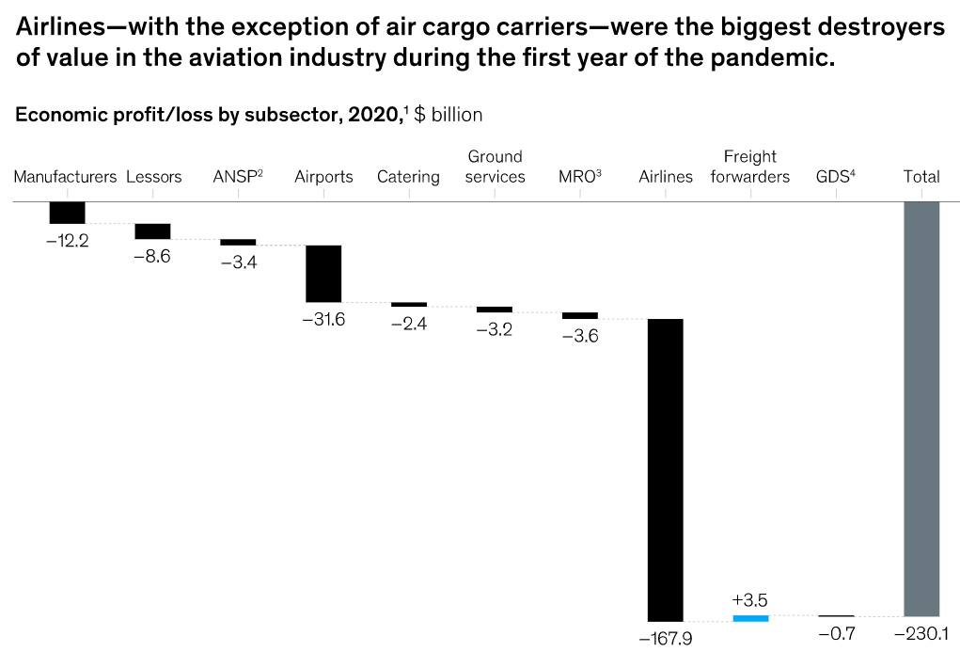
Figure 1. (Bouwer et al., 2022)
In 2020, as illustrated in figure 1, airlines lost an estimated $168 billion in revenue because of the COVID-19 pandemic, which was nearing its chronic stages in various regions of the world (Bouwer et al., 2022). As can be seen in this complex operating environment, the whole aviation value chain felt the effects of the pandemic's financial wrath, but airlines were hit particularly hard. According to Maroof et al., (2021) research, the aviation industry worldwide has been severely impacted by Covid 19, resulting in massive losses that have brought many companies to the point of insolvency. In that time period, AirAsia and the entire aviation industry are fighting for survival rather than a resurgence. Because of this, a leader's influence is crucial in ensuring an organization's survival during times of extreme difficulty. At one point during the pandemic, Fernandes was quoted as saying that no business school — not even one with a Harvard MBA — could teach aviation businesses how to survive the pandemic (Pesek, 2021). Everything is dependent on the capabilities of the leader in terms of supporting innovation, adapting to the crisis, and high performance. The following sections will highlight some of the reasons why Tony Fernandes is such a transformational, adaptive, and innovative leader when it comes to confronting the complexity that exists within the aviation industry.

2.0 Tony Fernandes is a Transformational, Adaptive, and Innovative Leader.

2.1 What is Leadership?
The first step in the study is to discuss the numerous definitions of leadership that have been proposed by previous researchers. House (2013), defines leadership as the capability to inspire, empower, and inspire one's peers to contribute to the growth and development of the group with which one is affiliated. Leadership, in Blagoev & Yordanova, (2015) opinion, consists of an individual's capacity to transform ideas into tangible results. According to Kruse, (2022), leadership is an approach that entails persuading other people to put up their best effort in order to achieve the group's objectives. Ismail et al., (2010) made the assertion that the degree of trust that develops between a leader and his supporters is directly proportional to the amount of success that an individual achieves. As was mentioned earlier, leadership can be conceptualized as a process that involves exerting an influence over the activities of individuals and groups that are working towards the accomplishment of a particular objective in any given circumstance. Hence, leadership is seen as a process by which an individual is capable of inspiring followers to achieve shared aims and ambitions (Northouse, 2021).

2.2 Tony Fernandes the Transformational leader.
Transformational leaders are charismatic and motivate followers to modify their standards and principles by encouraging them to place the firm's interests ahead of their own (Edirisooriya, 2020). Individuals are encouraged into working together cooperatively rather than independently when a transformational leader is in charge. It has been determined that transformational leadership is comprised of four distinct aspects: idealized influence (II), inspirational motivation (IM), intellectual stimulation (IS), and individualized consideration (IC) (Siangchokyoo et al., 2020). Leaders inspire people to connect with them through their ability to set a positive example and exert an idealizing impact (Nuel et al., 2021). Leaders that are inspirational incite their people to share their own optimism, zeal, and excitement (Guhr et al., 2018). A leader who is intellectually stimulating inspires followers to come up with their own creative ways to challenge established ways of doing things and raise standards (Reza, 2019). To assist their followers to reach their full potential, leaders can use IC to create an encouraging environment and offer tailored guidance and instruction (Chan et al., 2019). These four qualities assist transformational leaders to not only meet the immediate demands of their supporters but also help them grow as individuals, which in turn helps them focus on the more fundamental requirements of themselves and their communities.
Tony Fernandes demonstrated his capacity for intellectual stimulation when he was in charge of the aftermath of the disaster of flight QZ8501 off the coast of Borneo briefly after it lifted off on December 28, 2014. The accident took the lives of all 162 people on board. The tragedy was caused by the pilots' response to a computer breakdown, which resulted in a loss of control and ultimately led to the catastrophe (Jamieson, 2015). Fernandes, the CEO of AirAsia, expressed regret and a desire to absorb all liabilities following the accident. In dealing with accidents, Fernandes decided on involving himself and being the spotlight of the issues than running from the responsibilities. Thus, he is known as a transformational leader and can be defined as a strategy in which a leader transforms his subordinates by inspiring them, building trust among them, encouraging them, admiring their creative ideas, and developing them (Khan et al., 2020).
Furthermore, individualized consideration is at the center of transformational leadership, which involves actions like coaching, mentoring, and developing subordinates to reach their full potential. Staff at AirAsia have an open line of communication with the company's founder, Tony Fernandes, giving them a chance to voice any concerns or share any novel ideas they may have about the company (Fickry et al., 2020). In his place of employment, he did not institute any bureaucratic procedures. Any member of his office employees may enter his room at any time if there is an urgent concern that needs to be addressed immediately. All of Air Asia's workers feel like they are part of a family and are pleased to work for the company. Employee suggestions are given careful consideration, and those that are deemed to be in the company's best interest are implemented. On top of that, the best ideas will be recognized as well. Given the cutthroat nature of modern business, Fernandes thinks that excessive bureaucracy can slow expansion (Fickry et al., 2020). Employees are more at ease and more respectful of him because of his transparent leadership approach.

2.3 Adaptive Leadership in Tony Fernandes
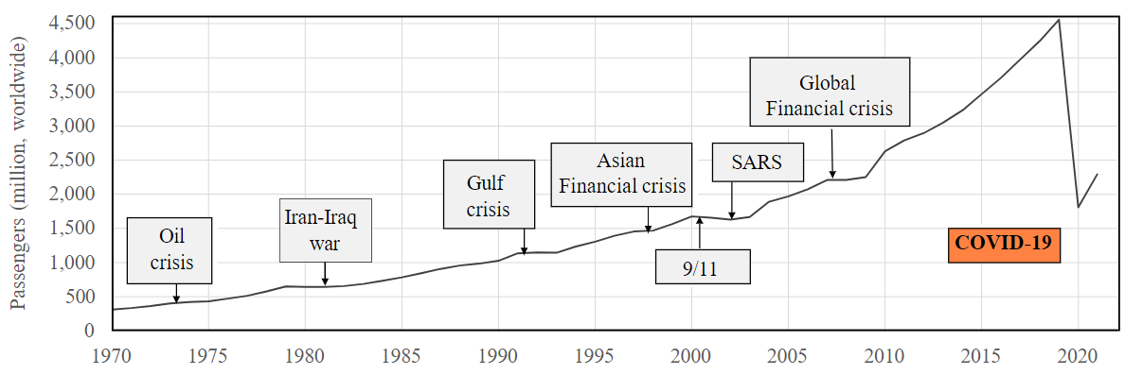
Figure 2. Analysis of COVID-19's peculiar effect on aviation in light of other catastrophes, measured by the number of travelers moved around the world. (Sun et al., 2022)
A successful leader is especially important during times of widespread resource depletion and rising demand, such as the recent COVID-19 pandemic. Especially in the midst of this pandemic, which, as illustrated in figure 2, adds a great deal of complexity to the aviation business compared to other previous crises. As a leader, adaptability and readiness for adjustment are of extreme significance given the chaotic and unforeseen nature of crises, which are characterized by limited rationality, uncertainty, time pressure, and potentially life-or-death stakes (Bajaba et al., 2021). An adaptive leader is one who adopts a complex systems perspective, which serves as a prism that openly recognizes the interdependency and relations management of all enforcers within the organization where simple rules or adjustments can have enormous impacts and where an adjustment to one element of the structure can have far-reaching, unintended repercussions elsewhere in the organization (Obolensky, 2016).
During the pandemic caused by COVID-19, many countries chose to seal their borders. As a result, Fernandes employs inventive thinking to find a solution to this problem by providing two alternatives to individuals who are constrained by travel rules (Yin, 2021). Customers of Air Asia who make a reservation for a flight departing between March 3 and June 30, 2020, will now be eligible for a credit account refund or unrestricted rebooking. Soon, the grace period for credit accounts has been increased to two years, which could encourage more customers to fly with AirAsia in the following months in order to use their credit accounts (Mui et al., 2021). With this strategy in place, customers will feel cared for even when the pandemic strikes, increasing the likelihood that they will buy tickets on AirAsia in the future. The airline sector as a whole has been massively damaged by the epidemic, and AirAsia is not excluded from this either. As a consequence, Fernandes must also lay off some of his staff. On the other hand, he has made an effort to salvage the situation by retraining 500 AirAsia employees and assigning them new job duties via means of the RedBeat Academy, in which AirAsia Digital collaborated with Google Cloud as a component of collaborative attempts to improve digital talents on a national scale (Othman, 2020). The academy was initiated initially for the purpose of enhancing the skillsets of existing AirAsia staff, the training program is now available to the general public with a concentration on big data, infrastructure technologies, and cybersecurity, as well as machine learning, software engineering, and artificial intelligence (Roy, 2020). Fernandes has let go of 10% of the company's overall workforce, and he plans to prioritize rehiring all of these employees as soon as the airline's performance improves (Parkaran, 2021). Tony Fernandes's capacity to adapt to the pandemic in order to maintain the viability of his company despite the epidemic served as evidence that he possesses the skills necessary to be an effective leader.

2.4 Tony Fernandes is an Innovative Leader
By definition, innovation is the creation of something new that can be used to create value, whether it be a product, service, concept, environment, or procedure (Oster, 2011). It follows that an innovative leader is a visionary who inspires his team members to join his lead by setting a good example and encouraging teamwork. The leader acts as a role model, inspiring those surrounding them to think creatively, while also making sure that they are working in an atmosphere that is open to new ideas and provides opportunities for them to be examined and tested (Davis, 2019). Especially in today's ever-evolving global market, only the most creative and forward-thinking leaders can hope to achieve lasting success. A leader that can think beyond the box will be someone who puts a premium on connections and exhibits empathy. This is due to the fact that they are aware that developing new concepts requires first gaining knowledge of the target audience, and the sole way to accomplish this is through the cultivation of personal connections. When a leader puts forth the effort to cultivate relationships with their subordinates and clients, they increase the level of trust that exists between themselves and their organization (Şen & Eren, 2012). And when employees feel respected and secure in making mistakes, they are more inclined to improve their performance.
While the no-fly ban was extremely inconvenient during the Covid-19 period, Fernandes exploited it to move forward with his intentions to turn the company into a conglomerate of travel and lifestyle businesses. Capital A’s AirAsia Super App will be crucial, as it will allow users to book flights, hotels, ferries, food delivery, taxi hailing, and insurance all in one convenient place (Kaur, 2021). Fernandes's goal with his app is to replicate the success of regional powerhouses like Grab and GoTo (Burgos, 2023). The service was introduced in 2020, and the corporation has been progressively expanding it ever since, making its offerings available in many nations, and it has formed a partnership with Google to assist in expanding the app's features. In addition, the application has released a new premium membership tier called SUPER+ where subscribers are able to take advantage of limitless flight redemption, free delivery of AirAsia meals, and Covid-19 predeparture insurance protection for the duration of their membership (Ikram, 2022). Fernandes claims this is the first annual pass of its kind to include both air travel and food delivery services (Mardhiah, 2022). It replaces the earlier introduced unlimited pass, according to him, and is their counterpart to Amazon Prime and Netflix. As an inventive leader, Fernandes is able to both implement and design superior plans, putting him ahead of his competitors as well as the clock (Alharbi, 2021). Thus, these steps that Fernandes took in order to retain AirAsia's sustainability throughout the pandemic are able to keep the aviation company's strong performance as well. Nonetheless, just as it is said that one never forgets how to ride a bicycle, a serial innovator is likely to maintain equilibrium regardless of the challenges that lie ahead (Pesek, 2021).

3.0 Conclusion
It was beyond any reasonable doubt that Fernandes was able to survive the Covid-19 epidemic, which was the complexity in the aviation sector, by applying all of these different approaches. After completing a comprehensive analysis of the style of leadership that Tony Fernandes used, I have come to the conclusion that his innovative leadership style is the strategy that is the most successful in generating high levels of performance, innovation, and adaptation in the aviation business. This is due to the fact that Fernandes' forward-thinking strategy involves him exploring technology-related industries including e-hailing, mobile delivery services, and fintech. As more consumers move their everyday spending online, including grocery shopping and the use of electronic wallets, these sectors have emerged as the most promising for global economic growth. Especially after the AirAsia Super App entered into a collaboration with Google, the most widely used search engine in the world, the company was quickly in a position to develop more inventive and adaptable services, which led to high levels of performance. Although it has been suggested that this innovative leadership strategy is the most successful method for encouraging high performance, creativity, and adaptability, it would be ideal if all three strategies (including transformational and adaptive) could be applied simultaneously in order to achieve the most fruitful results.

4.0 References
Alharbi, I.B. (2021) “Innovative leadership: A literature review paper,” Open Journal of Leadership, 10(03), pp. 214–229. Available at: https://doi.org/10.4236/ojl.2021.103014.
Bajaba, A. et al. (2021) “Adaptive Managers as emerging leaders during the COVID-19 crisis,” Frontiers in Psychology, 12. Available at: https://doi.org/10.3389/fpsyg.2021.661628.
BBC (2010) How air asia founder Tony Fernandes' dream came true, BBC News. BBC. Available at: https://www.bbc.co.uk/news/business-11647205 (Accessed: March 17, 2023).
Blagoev, D. and Yordanova, Z. (2015) “Company Innovative Leadership Model,” Economic Alternatives, (2), pp. 5–16. Available at: https://www.researchgate.net/publication/299394585_Company_Innovative_Leadership_Model (Accessed: March 16, 2023).
Bouwer, J. et al. (2022) Taking stock of the pandemic's impact on Global Aviation, McKinsey & Company. McKinsey & Company. Available at: https://www.mckinsey.com/industries/travel-logistics-and-infrastructure/our-insights/taking-stock-of-the-pandemics-impact-on-global-aviation (Accessed: March 17, 2023).
Burgos, J. (2023) AirAsia boss Tony Fernandes pushes Digital Business, Southeast Asia expansion amid post-pandemic recovery, Forbes. Forbes Magazine. Available at: https://www.forbes.com/sites/jonathanburgos/2023/02/21/airasia-boss-tony-fernandes-pushes-digital-business-southeast-asia-expansion-amid-post-pandemic-recovery/ (Accessed: March 2, 2023).
Carongoy, C. (2022) AirAsia voted World's best low-cost airline for 13th straight year, airasia newsroom. airasia newsroom. Available at: https://newsroom.airasia.com/news/2022/9/26/airasia-voted-worlds-best-low-cost-airline-for-13th-straight-year (Accessed: March 17, 2023).
Chan, S.W. et al. (2019) “The Influence of Transformational Leadership on Organization Innovation in Malaysian Manufacturing Industry,” Int. J Sup. Chain. Mgt , 8(2), pp. 971–976. Available at: https://www.researchgate.net/publication/332780293_The_Influence_of_Transformational_Leadership_on_Organization_Innovation_in_Malaysian_Manufacturing_Industry (Accessed: March 16, 2023).
Davis, M.W. (2019) “Innovative leadership,” Journal of Leadership, Accountability and Ethics, 16(4). Available at: https://doi.org/10.33423/jlae.v16i4.2370.
Edirisooriya, W.A. (2020) “The impact of transformational leadership on talent retention with Special reference to information communication technology industry in Sri Lanka,” Sri Lanka Journal of Management Studies, 2(1), p. 120. Available at: https://doi.org/10.4038/sljms.v2i1.31.
Fickry, A. et al. (2020) “Leadership and Organizational Success: A Study of AirAsia,” Advances in Global Economics and Business Journal (AGEBJ), 1(1), pp. 12–25. Available at: https://agebj.org/index.php/agebj/article/view/4 (Accessed: March 16, 2023).
Forbes (2020) Tony Fernandes, Forbes. Forbes Magazine. Available at: https://www.forbes.com/profile/tony-fernandes/ (Accessed: March 17, 2023).
Guhr, N., Lebek, B. and Breitner, M.H. (2018) “The impact of leadership on employees' intended information security behaviour: An examination of the full-range leadership theory,” Information Systems Journal, 29(2), pp. 340–362. Available at: https://doi.org/10.1111/isj.12202.
House, R.J. (2013) Culture, leadership, and organizations: The Globe Study of 62 societies. Thousand Oaks: SAGE Publications, Inc.

Ikram, I. (2022) AirAsia Super App Launches Super+ subscription plan with Unlimited Flight Redemption, The Edge Markets. Available at: https://www.theedgemarkets.com/article/airasia-super-app-launches-super-subscription-plan-unlimited-flight-redemption (Accessed: March 3, 2023).
Ismail, A.B. et al. (2010) “Transformational and Transactional Leadership Styles as a Predictor of Individual Outcomes,” Theoretical and Applied Economics, XVII, pp. 89–104. Available at: https://www.semanticscholar.org/paper/Transformational-and-Transactional-Leadership-as-a-Ismail-Mohamad/7d98d0e32ee8aef834270889d3390ce4501c09f2 (Accessed: March 16, 2023).
Jamieson, A. (2015) AirAsia crash report blames computer failure, pilot response - NBC news, NBC News. Available at: https://www.nbcnews.com/storyline/airasia-plane-crash/airasia-crash-report-blames-computer-failure-pilot-response-n471831 (Accessed: March 3, 2023).
Kaur, D. (2021) How AirAsia pivoted its airline business to survive a pandemic, Tech Wire Asia. Available at: https://techwireasia.com/2021/02/heres-how-airasia-pivoted-its-airline-business-to-survive-the-pandemic/ (Accessed: March 2, 2023).
Khan, H. et al. (2020) “Impact of transformational leadership on work performance, Burnout and Social Loafing: A mediation model,” Future Business Journal, 6(1). Available at: https://doi.org/10.1186/s43093-020-00043-8.
Kruse, K. (2022) What is leadership?, Forbes. Forbes Magazine. Available at: https://www.forbes.com/sites/kevinkruse/2013/04/09/what-is-leadership/ (Accessed: March 16, 2023).
Mardhiah, A. (2022) AirAsia Super App Launches Super+ Subscription Plan - The Malaysian Reserve, Everyone will get their refund, Fernandes says as SUPER+ subscription plan launched. Available at: https://themalaysianreserve.com/2022/03/29/airasia-super-app-launches-super-subscription-plan/ (Accessed: March 3, 2023).
Maroof, Z. et al. (2021) “The impact of covid-19 on the aviation industry: A post covid econometric analysis,” International Journal of Innovation, Creativity and Change, pp. 490–510. Available at: https://doi.org/10.53333/ijicc2013/15829.
Mui, D.H.K. et al. (2021) “The Struggles and The Survival of Airasia during The Covid-19 Pandemic,” Advances in Global Economics and Business Journal, 2(1), pp. 1–12.
Northouse, P.G. (2021) Introduction to leadership: Concepts and practice. Thousand Oaks, CA: SAGE Publications, Inc.
Nuel, O.I. et al. (2021) “Transformational leadership and organizational success: Evidence from tertiary institutions,” Journal of Economics and Business, 4(1). Available at: https://doi.org/10.31014/aior.1992.04.01.329.
Obolensky, N. (2016) Complex Adaptive Leadership: Embracing paradox and uncertainty. ROUTLEDGE.
Oster, G.W. (2011) The light prize: Perspectives on christian innovation. Virginia Beach, VA: Positive Signs Media.
Othman, A.F. (2020) 'My priority is to rehire all my staff who were let go', New Straits Times. Available at: https://www.nst.com.my/business/2020/12/651486/my-priority-rehire-all-my-staff-who-were-let-go (Accessed: March 15, 2023).
Parkaran, K. (2021) Rehiring everyone laid off is my priority, says AirAsia Boss, Free Malaysia Today. Available at: https://www.freemalaysiatoday.com/category/nation/2021/06/24/rehiring-everyone-laid-off-is-my-priority-says-airasia-boss/ (Accessed: March 15, 2023).
Pesek, W. (2021) How AirAsia's Tony Fernandes smashed a COVID-19 home run, Nikkei Asia. Nikkei Asia. Available at: https://asia.nikkei.com/Opinion/How-AirAsia-s-Tony-Fernandes-smashed-a-COVID-19-home-run (Accessed: March 2, 2023).
Pusiran, A.K. and King, B.E. (2013) “Transactional and transformational leadership: A comparative study of the difference between Tony Fernandes (AirAsia) and Idris Jala (Malaysia Airlines) leadership styles from 2005-2009,” International Journal of Business and Management, 8(24). Available at: https://doi.org/10.5539/ijbm.v8n24p107.
Reza, M.H. (2019) “Components of Transformational Leadership Behavior,” EPRA International Journal of Multidisciplinary Research (IJMR) , 5(3), pp. 119–124. Available at: https://www.researchgate.net/publication/333798276_COMPONENTS_OF_TRANSFORMATIONAL_LEADERSHIP_BEHAVIOR (Accessed: March 16, 2023).
Roy, S. (2020) AirAsia wants to accelerate acquisition of tech skills among staff and Youth, Tech Wire Asia. Available at: https://techwireasia.com/2020/01/airasia-wants-to-accelerate-acquisition-of-tech-skills-among-staff-and-youth/ (Accessed: March 15, 2023).
Siangchokyoo, N., Klinger, R.L. and Campion, E.D. (2020) “Follower transformation as the linchpin of transformational leadership theory: A systematic review and future research agenda,” The Leadership Quarterly, 31(1), p. 101341. Available at: https://doi.org/10.1016/j.leaqua.2019.101341.
Sun, X., Wandelt, S. and Zhang, A. (2022) “Covid-19 pandemic and Air Transportation: Summary of recent research, policy consideration and future research directions,” Transportation Research Interdisciplinary Perspectives, 16, p. 100718. Available at: https://doi.org/10.1016/j.trip.2022.100718.
Şen, A. and Eren, E. (2012) “Innovative leadership for the twenty-First Century,” Procedia - Social and Behavioral Sciences, 41, pp. 1–14. Available at: https://doi.org/10.1016/j.sbspro.2012.04.001.
Yin, A.C.P. (2021) AirAsia extends validity of credit accounts, offers free unlimited date changes for selected flights, RinggitPlus. Available at: https://ringgitplus.com/en/blog/travel/airasia-extends-validity-of-credit-accounts-offers-free-unlimited-date-changes-for-selected-flights.html (Accessed: March 2, 2023).

