University of Wales Trinity Saint David
Wales Institute of Science and Art


Electronic Circuit Testing and Applications

Electrical control systems ACHA4010

Jay Hodson
2404496
25/02/25
Contents
1. Task 2 1
1.1 Scope Time Division Calculations (3) 1
1.2 Scopes Outputs (3) 1
1.2.1 Square Wave 1
1.2.2 Sin Scope Wave 2
1.3 Basic capacitor calculations (3) 2
1.4 Table of Data (4) 2
1.5 Capacitor use in Automotive applications Question. (5) 3
1.6 Inaccuracies Question (4) 3
2 References 5

Table of Figures
Figure 1-Square Wave 1
Figure 2-Sin Scope Wave Graph 2

Task 2

Scope Time Division Calculations (3)
$$Period\left(τ\right)= \frac{1}{f}$$
$$Time per Division=\frac{1}{f}÷10$$
$$Time per Division= \frac{1}{250}÷10=400×{10}^{-6}$$

Scopes Outputs (3)

Square Wave
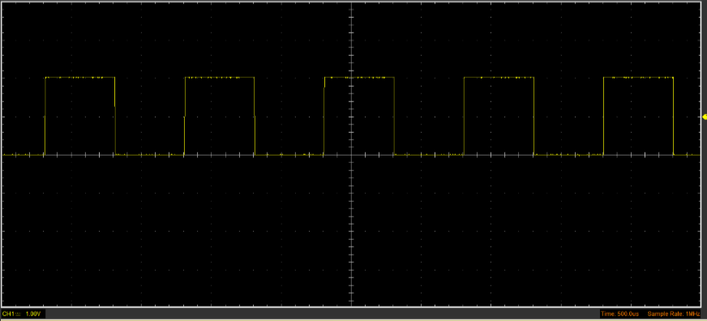
Figure 1-Square Wave

Sin Scope Wave
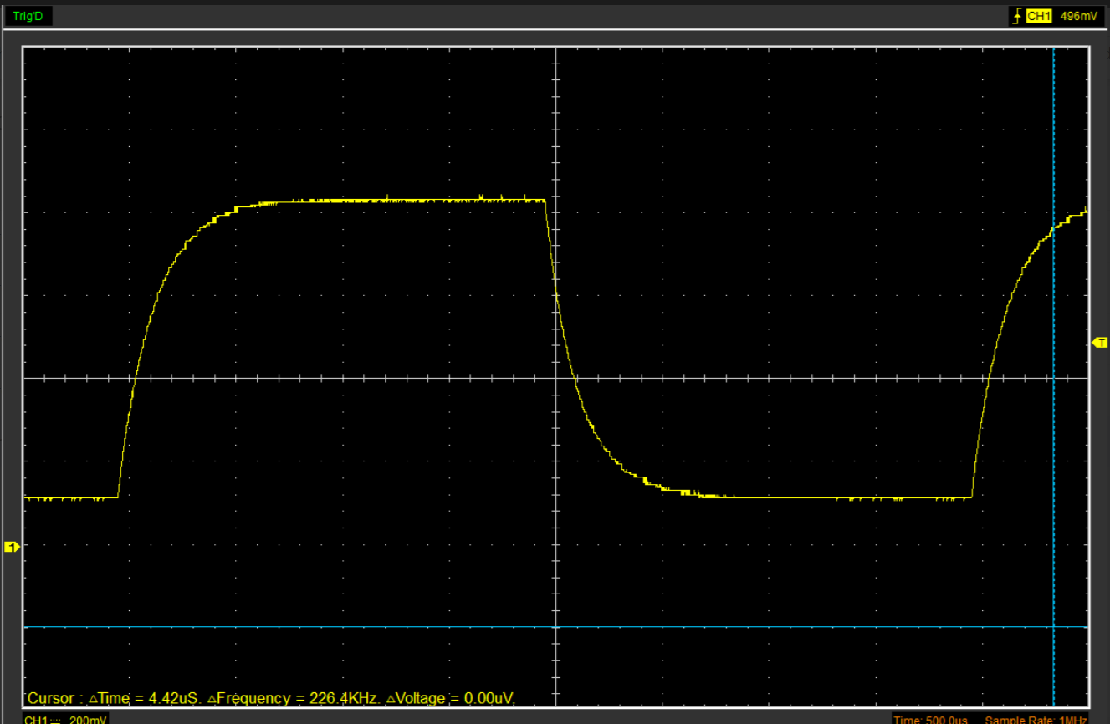
Figure 2-Sin Scope Wave Graph

Basic capacitor calculations (3)
$$C=\frac{τ}{R}$$
$$C=\frac{60×{10}^{-6}}{100}=0.602μF$$

Table of Data (4)

Unsure on how to do the table.

Capacitor use in Automotive applications Question. (5)

In the automotive industry there are many uses for capacitors, like providing energy storage, filtering, and noise suppression. Some uses for capacitors in vehicles especially are;
- Ignition system, the way the capacitors work in the ignition system is that they help regulate voltage spikes and improve spark timing for more efficient combustion (Projects, 2017)
- Audio system, the capacitors needed are large so they can stabilize power delivery to amplifiers, reducing voltage drops and improving the bass response especially in high performance car audio systems.
- LED Lighting, what the capacitors do for this system is that they smooth out the voltage which reduces the flickering in the headlights.
- Electric vehicle power systems, the capacitors that are used are supercapacitors because they provide rapid energy storage and discharge which improves the vehicles acceleration (Matthews, 2024)
- Alternator, the capacitors help filter and stabilize the output from the alternator so it ensures that there is a steady voltage.
- ECU protection, capacitors are able to prevent transient voltage spikes from damaging any sensitive electronic components in the ECU (Wilson, 2022)
- Battery, what the capacitor does for the battery is that it assists in supplying power during peak loads which reduces strain on the battery (films, 2023)
- Fuel Pump, capacitors help regulate power delivery to the fuel pump, ensuring a steady flow of fuel under different driving conditions (Owner, 2025)
- Anti-Lock Braking System (ABS), capacitors help maintain stable power in the ABS, ensuring proper brake modulation during emergency braking.
- Wiper circuits, Capacitors reduce electrical noise and voltage fluctuations in their circuit ensuring there is smooth operation.

Inaccuracies Question (4)

Capacitor measurements can vary from their stated values due to several reasons, including environmental influences, and testing limitations. Manufacturers usually provide a tolerance range, allowing for acceptable differences caused by material and process variations during manufacturing (Electronics Tutorials, 2018). Also, external conditions like temperature, humidity, and the voltage applied can also impact the capacitance. For example, ceramic capacitors may experience noticeable changes in capacitance with temperature shifts. Testing inaccuracies often arise from equipment limitations. Basic LCR meters might not fully compensate for elements such as inductance or resistance, particularly at higher frequencies. Measurement errors can also result from abandoned capacitance in leads or using unsuitable test frequencies. Furthermore, the test voltage applied during measurement may differ from the capacitor's actual working conditions, leading to discrepancies in the results (Electronics Tutorials, 2018).

References
(Format to Harvard style as per handbook)
Electronics Tutorials (2018) Introduction to Capacitors, Capacitance and Charge, Basic Electronics Tutorials. Available at: https://www.electronics-tutorials.ws/capacitor/cap_1.html (Accessed: 13 April 2025).
films, cosmo (2023) The Role of Capacitor Films in the Automotive Sector, Cosmo Films. Available at: https://www.cosmofilms.com/blog/the-role-of-capacitor-films-in-the-automotive-sector (Accessed: 13 April 2025).
Matthews, P. (2024) Exploring the Capacitor Technologies Needed in Electric Vehicles, Knowlescapacitors.com. Knowles Precision Devices. Available at: https://blog.knowlescapacitors.com/blog/exploring-the-capacitor-technologies-needed-in-electric-vehicles (Accessed: 13 April 2025).
Owner, R. (2025) Fuel Pump Capacitors, ROTAX-OWNER.COM. Available at: https://www.rotax-owner.com/en/912-914-technical-questions/7340-fuel-pump-capacitors (Accessed: 13 April 2025).
Projects, E. (2017) Capacitor Discharge Ignition System : Construction, Types & Working, ElProCus - Electronic Projects for Engineering Students. Available at: https://www.elprocus.com/capacitor-discharge-ignition-cdi-system-working/ (Accessed: 13 April 2025).
Wilson, A. (2022) The Essentials of Capacitor Selection in Automotive Designs, Electronicdesign.com. Electronic Design. Available at: https://www.electronicdesign.com/technologies/analog/article/21245735/vishay-intertechnology-the-essentials-of-capacitor-selection-in-automotive-designs (Accessed: 13 April 2025).

