Defence-in-Depth Data Security and Governance Framework for HealthPlus Analytics
  - ACCA4024 Networks and Cyber Security Essentials Level 4 Coursework Report

Student Name: Fateh Tschroub
Module Code: ACCA4024
Student ID: 2422144
Course/Module Name: Networks and Cyber Security Essentials
Date: 27 March 2026
Course Name: Networks and Cyber Security Essentials
Lecturer/Tutor: Muhammad Azeem Abbas
Table of Contents
Abstract 2
1. Introduction 2
2. Threat Identification and Risk Context 3
3. Defence-in-Depth Security Architecture 4
4. Security Policy Framework 5
5. Mitigation Measures and Implementation Plan 6
6. Monitoring and Incident Response 7
7. Staff Training and Awareness Programme 8
8. Governance, Assurance, and Success Metrics 9
9. Conclusion 9
References 10
Appendix A. Board Presentation 11

Abstract
HealthPlus Analytics (HPA) processes sensitive patient data for hospitals and clinics throughout the UK and thus has high cloud exposure, ransomware, insider misuse, supplier dependency and strict data protection obligations in its mix. This report creates a defence-in-depth framework that corresponds with the assignment scenario and the connected board presentation. This proposed solution starts from governance and policy controls, implementing additional layers of security across identity and access management, networking, endpoints, applications, and data. It determines possible internal and external threats, develops a suitable policy suite, identifies actionable mitigation measures and sets a monitoring and incident response framework that supports evidence preservation, recovery and regulatory reporting. In addition, the report outlines a role-based training and awareness programme which would transform security into an organisational behaviour instead of a document only exercise. Finally, it elaborates on assurance metrics, board obligations, and a ninety day roadmap for implementation to assist HPA to make enhancements to confidentiality, integrity, and availability and improve compliance with UK GDPR, NHS Data Security and Protection Toolkit, NIST guidance and ISO 27001. [3]-[6]

1. Introduction
Healthcare providers are appealing targets given that patient data is of long-term value, medical services cannot afford to endure prolonged downtime, and digital environments increasingly rely on cloud platforms, remote access, connected devices, third-party vendors and data sharing. The reported incidents of unauthorised access to cloud-stored patient data and ransomware on analytics servers also reflect both the failure of confidentiality and availability for HealthPlus Analytics. So the board is right to want a comprehensive data security and governance framework rather than another isolated technical fix. Reaching a high-mark response to this situation is, therefore, not just a description of controls. It will need to describe how security policies enable operational measures, how those measures lower certain threats, how monitoring and response are structured and how staff's behaviour changes through training and accountability. This report is based on that logic. There is a CIA triad model applied: confidentiality can safeguard patient privacy and commercial trust; integrity can safeguard accuracy of datasets, analytics output, logs, and audit evidence; availability can protect critical analytics services and downtime. The report is also consistent with current healthcare and cybersecurity guidance, such as NIST CSF 2.0, NIST SP 800-66 Rev. 2, ISO/IEC 27001:2022, UK GDPR/ICO breach guidance and the NHS Data Security and Protection Toolkit. [1]-[5]

2. Threat Identification and Risk Context
HPA encounters external attacks by competitors and internal control failures. The two are interrelated: a phishing email will compromise credentials, but the seriousness of such an attack depends on bad role design, poor logs, and excessive permissions that already exist inside the business.
Threat Source | Examples in the HPA scenario | CIA impact | Why it matters
External | Phishing, business email compromise, ransomware, cloud account takeover, exploited internet-facing flaws, supplier compromise | C, I, A | Such threats can exfiltrate patient information, encrypt analytics servers, or establish persistence through pilfered credentials.
Internal | Excessive privileges, cloud misconfiguration, weak BYOD controls, slow patching, accidental disclosure, poor escalation culture | C, I, A | Numerous breaches turn serious as staff may have access to excess, systems are misconfigured, or incidents are not reported in a timely fashion.
Strategic / compliance | Weak governance and a lack of policy ownership, untested backups, no audit trail, poor retention controls | I, A, C | Even good tools fail unless controls are reviewed, evidenced or integrated with board oversight and legal obligations.
Table 1. Principal internal and external threats to HPA
The Key Risks in this situation are Ransomware, Phishing-led Credentials Theft, Cloud Misconfiguration, Insider Exploitation and Supplier Compromise. Availability is directly threatened by ransomware, as analytics servers and shared services could be rendered unusable. Phishing and business email compromise are primary entry points to credential theft and bypass perimeter assumptions. Misconfigured storage, identity roles, or security groups in cloud environments are particularly risky. In one mistake, large amounts of patient information could be exposed to the outside world. Insider threats are not limited to malicious staff but also encompass negligence, poor reporting behaviour and misuse by mistake. Supplier risk is particularly critical since current healthcare analytics relies on hosted services, support providers, software libraries, and data integration services today to enable modern-day healthcare analytics services. [1], [7]-[9]

3. Defence-in-Depth Security Architecture
HPA should be built on a defence-in-depth model with governance & policies serving as the outer layer of control and patient data as the protected core. This is better than a perimeter-only approach because it takes into account that not all controls will work, and so one or more redundant and mutually reinforcing defences are needed. This logic is used in the accompanying board presentation, and the revision of architecture below enables a simplified hierarchy. [4], [6]
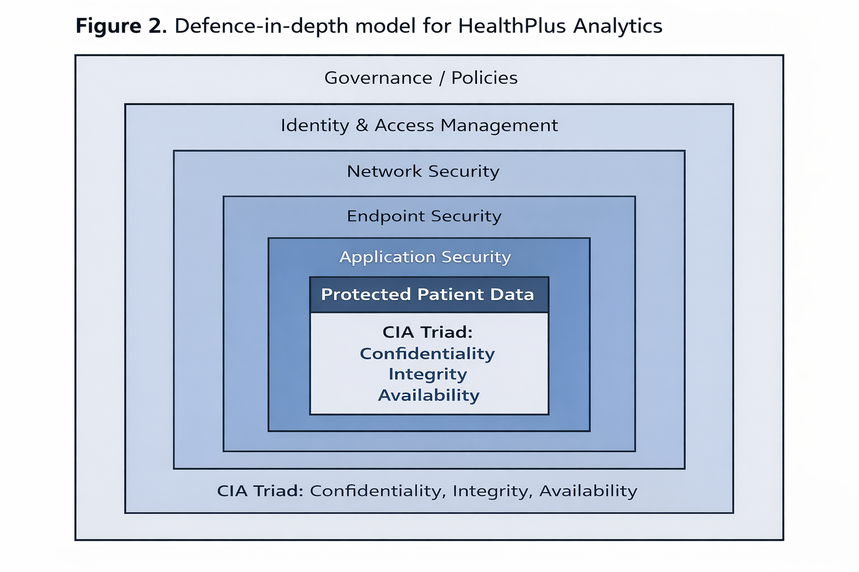
Figure 1. A defence-in-depth model for HealthPlus Analytics
The sequence of control layers is crucial. Governance and policies will determine risk appetite, ownership, and review cycles. Identity and access management subsequently minimises the exposure of the user, service accounts, and any administrator to other users. Network security restricts lateral movement, ensures secure network connectivity. Endpoint security defends servers, laptops and mobile devices. Application security protects portals, APIs, analytic products and changes in software. And data security applies encryption, classification, retention, and recovery controls directly to the information asset itself. The CIA triad applies across all layers rather than operating as a separate technical product.

4. Security Policy Framework
The assignment requires clear and practical security policies. The policy suite for HPA will be succinct, with named owners, annual approval and operating standards placed below each policy. The following policies represent the minimum necessary to back up our scenario.
Information security governance policy: Defines board oversight, control ownership, risk appetite, review frequency, and reporting lines.
Access control and identity policy: MFA, least privilege, role-based access, privileged access management, joiner-mover-leaver controls, quarterly access reviews.
Data classification and protection policy: Classifies patient records, requires encryption, controls data sharing, sets retention and disposal rules, and restricts copying to unmanaged locations.
Endpoint and server security policy: Establishes hardening requirements, vulnerability management, EDR deployment, approved software requirements, and patching due dates.
Cloud and network security policy: Secure baselines and segmentation and logging, key management, authorised remote access, change control for cloud resources.
Incident response and resilience policy: Describes types of incidents, severity rating, who is responsible for reporting them, priority for recovery efforts, backup testing, evidence collection and recovery and what is learned from incidents.
Supplier assurance policy: Supplier assurance policy requires due diligence, security clauses, breach notification obligations, and evidence of effectiveness from supplier controls.
Security awareness and acceptable use policy: Staff responsibilities on phishing, passwords, BYOD, handling data, reporting, mandatory training; etc.
These policies address an issue as they correspond readily with the marking criteria. They are explicit, applicable and specifically pertinent to HPA. They also support established frameworks and do not need to create controls in a vacuum. ISO/IEC 27001 is the management-system framework; NIST CSF 2.0 is a way to structure governance, identify, protect, detect, respond and recover activities; and NHS/ICO requirements keep the framework up to standards of care for UK healthcare data management. [3], [4], [6]

5. Implementation Plan: Mitigation Measures
Policies alone fail to mitigate risk. Specific controls with a realistic implementation sequence would be helpful to HPA. This could be achieved through prioritising high-impacting controls in the initial 90 days and testing and validating those controls afterwards. [4], [6]
Priority area | Specific measure | Implementation detail | Threats reduced
Identity | Enable MFA for all cloud, email, VPN, and privileged accounts | Start with administrators and remote access; then extend to all staff; remove legacy authentication where applicable | Phishing, account takeover, supplier misuse
Privilege control | Adopt role-based access control and PAM | Separate user and admin accounts; time-limit privileged sessions; review access quarterly | Insider misuse, ransomware spread
Endpoints and servers | Deploy EDR/XDR and enforce hardening baselines | Cover analytics servers, laptops, and remote devices; quarantine unmanaged or unsupported systems | Ransomware, malware, lateral movement
Cloud and data | Classify patient data, encrypt at rest and in transit, fix storage permissions | Use secure cloud templates, data loss prevention rules, and key-management procedures | Data exposure, accidental disclosure
Vulnerability management | Patch internet-facing and high-risk systems to a defined SLA | Prioritise external exposure and known exploited vulnerabilities; report exceptions to management | Exploited flaws, persistence
Resilience | Maintain immutable offline backups and perform restore tests | Test critical services quarterly and record evidence; separate backup credentials from production | Ransomware, availability loss
Suppliers | Run supplier due diligence and contract security clauses | Assess access routes, data flows, breach notification obligations, and assurance evidence | Third-party compromise
Logging and detection | Centralise logs from cloud, endpoints, identity, email, and servers | Tune SIEM alerts for privileged misuse, ransomware indicators, unusual sign-in patterns and data exfiltration | Delayed detection, weak investigation
Table 2. Prioritized reduction measures and implementation guidance
A realistic guidance is stated below. On days 0-30, HPA should freeze privileged access sprawl, enforce MFA, validate offline or immutable backups, and harden exposed remote access paths. On days 31-60, it should deploy EDR/XDR on servers and endpoints, set cloud baselines, classify patient data, and open supplier reviews. Days 61-90: HPA shall configure SIEM detections, conduct tabletop test, complete full restore and policy sign-off with named owners. This sequence is attainable because it deals with the most substantial risks first and generates some evidence for the board to review. [1], [4]

6. Monitoring and Incident Response
The brief requests a monitoring and response plan, and here is something to look for: a diagram. HPA should rely on a central monitoring model that logs on identity systems, cloud infrastructure, servers, endpoints, email security and applications. Rules to detect should be based on suspicious sign-ins, privilege escalation, ransomware activity, unusual actions on the API system, mass file modifications and attempts to exfiltrate data. But logging is only useful with triage ownership, escalation thresholds, and practiced recovery moves. [2], [4]
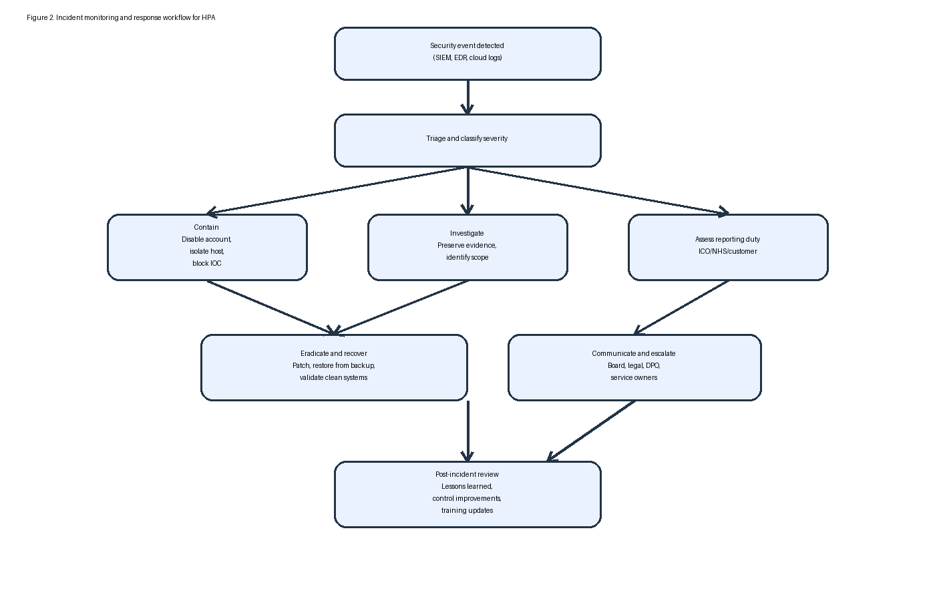
Figure 2. Incident monitoring and response workflow for HPA
The response workflow should encompass six stages. First, detect and triage the event. Second, contain it by disabling accounts, isolating hosts, or blocking indicators of compromise. Third, investigate scope and preserve evidence. Fourth, make clear and time limitations should be set on the reporting duties of the DPO, legal team, customers and, where applicable, ICO. Fifth, eradicate the cause, restore clean systems and validate recovery from backups. Sixth, carry out a lessons-learned review within 10 work days. Both technical resiliency and readiness for compliance are enhanced through this process, as it provides audit trails, assists in breach assessment and contributes to enhancements in the form of both policy, detections and training. [2], [4], [5]

7. Staff Training and Awareness Programme
The training requirement included in the brief carries a significant weight as the task must be more than annual awareness slides. HPA should introduce a security awareness-led role-based approach to security that focuses on behaviour change and evidence-based compliance. [11], [12]
Mandatory induction: All entry level members are given training in the following within ten days covering phishing, data handling, acceptable use and incident reporting, and working from home.
Role-based modules: Governance and decision making content can be delivered to executives; developers should be given secure coding and change control; analysts must be familiarised with data handling rules; IT and service desk staff should be trained on how to escalate incidents and identity management.
Quarterly phishing exercises: Simulated phishing campaigns with targeted coaching for repeat failures.
Monthly micro-learning: Short modular units on BYOD, password hygiene, data sharing, AI/tool usage, and reporting suspicious activity.
Tabletop exercises: Leadership and operational teams experience ransomware, cloud breach, and supplier compromise scenarios.
Manager accountability: Completion rates, repeat click behaviour, and overdue training are reviewed by managers and reported upward.
The programme should be assessed through completion rates, prevalence of phishing susceptibility, reporting speed and quality of audit evidence. It makes the training more credible and more directly correlated to risk reduction. A strong training section earns marks not because of theory, but because it is good for the application. [11]

8. Governance, Assurance and Success Measures
To allow the new approach to operate effectively, each control layer must have an owner and a review cycle, as well as expected evidence. A board or audit committee should have a policy on cyber risk appetite and review quarterly security dashboards. The CIO or security lead should own implementation and coordination of incidents. Data protection evidence and breach assessment and privacy impact should also be owned by the DPO or information governance lead. IT ops should be responsible for patching, hardening, access review support, backup testing. Business managers need to mandate compliance from their staff with training and policy. [4], [6]
Key metrics include: MFA coverage of privileged and cloud accounts; patching compliance for internet-facing systems; quarterly restore-test completion; mean time taken to react and contain incidents; completion of access reviews; supplier assurance status; and staff training completion. These measures indicate whether controls are working over time. They additionally allow board members to distinguish between compliance and full operational readiness.

9. Conclusion
One product and a perimeter attitude does not suffice for protecting patient data for HealthPlus Analytics. The threat scenario demonstrates that cloud exposure, ransomware, and poor governance can all lead to legal, operational and reputational damage. The best solution is a defence-in-depth framework from governance & policies – protects access & platforms; secures data, enhances detection & recovery practice, rehearses and embeds security awareness into normal business. The policy suite, a range of mitigation measures, ongoing workflow monitoring, a training programme, as well as assurance measures established in this report could ensure that HPA can lower the potential risk of breaches, meet UK healthcare expectations, and recover more quickly if incidents occur. This renders the framework both technically defensible and useful for board-level decision making. [1]-[6]

References
[1] Department for Science, Innovation and Technology and Home Office, “Cyber Security Breaches Survey 2025,” GOV.UK, Jun. 2025.
[2] The Information Commissioner’s Office, “Personal data breaches: a guide,” ICO, 2025.
[3] NHS England, “Data Security and Protection Toolkit,” 2025/26.
[4] C. Pascoe, S. Quinn, K. Scarfone, "The NIST Cybersecurity Framework (CSF) 2.0," NIST CSWP 29, Feb. 2024.
[5] National Institute of Standards and Technology, "Implementing the Health Insurance Portability and Accountability Act (HIPAA) Security Rule: A Cybersecurity Resource Guide," NIST SP 800-66 Rev. 2, 2024.
[6] International Organization for Standardization, ISO/IEC 27001:2022 Information Security, Cybersecurity and Privacy Protection - Information Security Management Systems - Requirements, 2022.
[7] D. M. Sridevi, "A recent review of ransomware attacks on healthcare industries," Journal of Data, Information and Management, vol. 6, 2024.
[8] T. M. Chalasani et al., "Ransomware Attacks and Data Breaches in US Health Care Systems," JAMA Network Open, vol. 8, no. 5, 2025.
[9] A. Shamsujjoha et al., "Vulnerability to Cyberattacks and Sociotechnical Solutions for Health Care Systems: Systematic Review," Journal of Medical Internet Research, vol. 26, 2024.
[10] W. Stallings, Effective Cybersecurity: A Guide to Using Best Practices and Standards, 1st ed. Boston, MA, USA: Addison-Wesley, 2024.
[11] M. Alhajri et al., "A systematic review of current cybersecurity training methods," Computers & Security, vol. 136, 2024.
[12] M. E. Whitman and H. J. Mattord, Principles of Information Security, 7th ed. Boston, MA, USA: Cengage, 2021.

Appendix A. Board Presentation
The assessment brief recommends embedding the board presentation as an appendix to the report. The subsequent contact sheets present the finished slide deck that was used to summarise the suggestions to the board of the directors. [3]
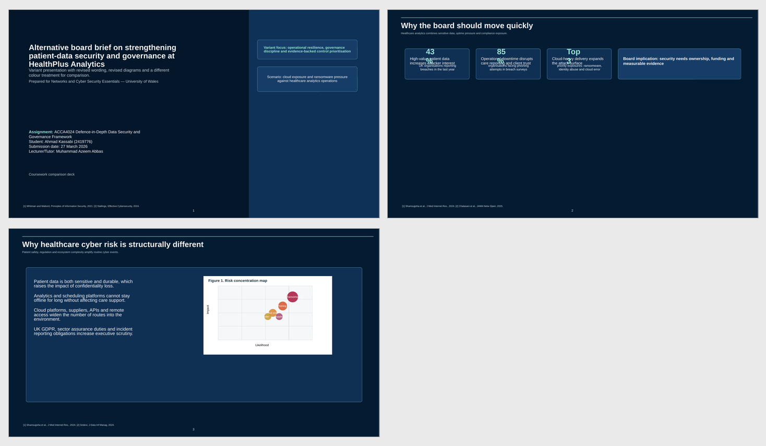
Appendix Figure A1. Contact sheet of presentation slides

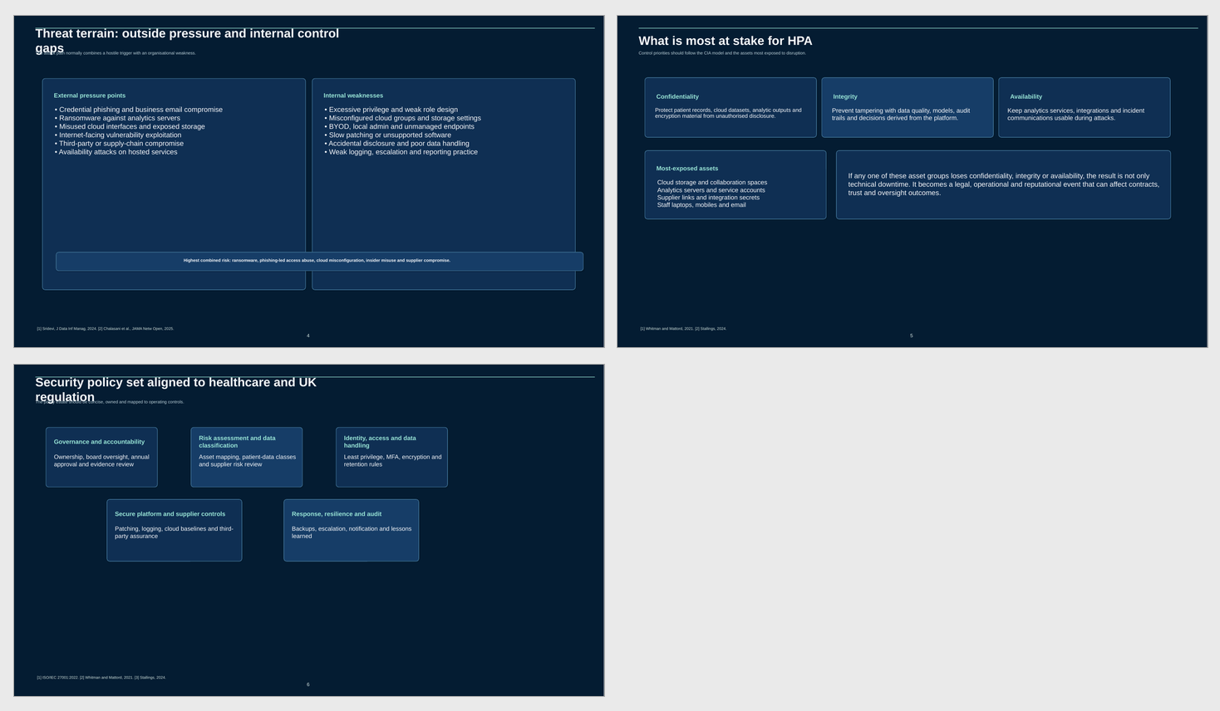
Appendix Figure A2. Contact sheet of presentation slides

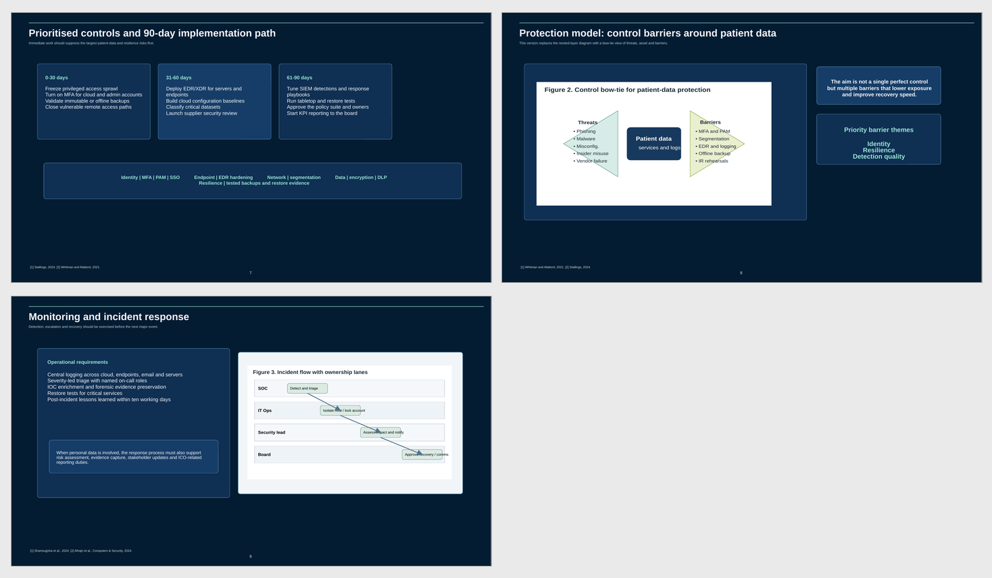
Appendix Figure A3. Contact sheet of presentation slides

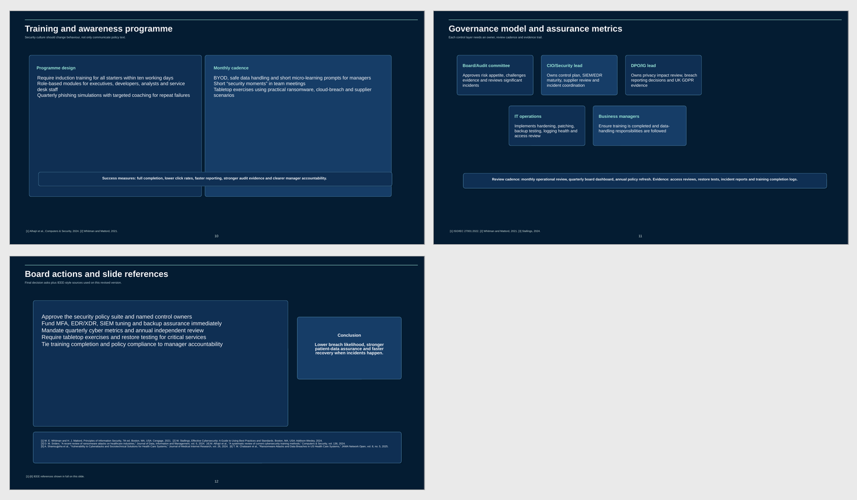
Appendix Figure A4. Contact sheet of presentation slides

